The Fire Restoration Group
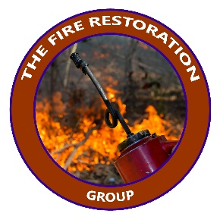
January 6, 2020
Re: Eastern Sierra Fire Restoration and Maintenance Project on the Inyo National Forest.

The Fire Restoration Group is submitting the following scoping comments on the Eastern Sierra Fire Restoration and Maintenance Project.
We are strong advocates for expanding fire restoration across the Sierra Nevada and the West and welcome the opportunity to engage with the Inyo National Forest to restore fire on a landscape scale. We helped create the 770,000-acre prescribed fire proposal on the Sierra National Forest and I authored the June 14, 2018 Conservation Coalition letter of support for that project before retiring from Sierra Forest Legacy in 2018. https://www.sierraforestlegacy.org/Resources/Community/PrescribedFire/SierraNF_PrescribedFireEA_Scoping.pdf
Today, the Fire Restoration Group is solely focused on fire restoration and in supporting the staffing levels, policy changes, media and outreach, and extended funding to achieve fire resilience and restored ecological function to the greatest degree possible in California.

I. Public engagement and integration into fire restoration effort
We strongly encourage the Inyo NF fire staff and leadership to engage the local community in this fire restoration effort. A good example of the Forest Service doing solid public engagement on an 8,800-ac prescribed fire project is on the Eldorado National Forest where interested parties became chain-saw certified and worked with the Iron Mountain Hot Shots thinning and piling ladder fuels and raking boles of the larger old trees placed at risk from a century of fire exclusion in the Caples Creek Watershed.
We think the best way to implement a forest-wide categorical exclusion for restoring fire should include:
1. Building a fire restoration collaborative that includes those interested in expanding and maintaining funding for extended burning, forming year-around Rx fire crews, working on smoke management policy (emissions tradeoffs, smoke science, communication, public outreach, smoke alert notification, etc.), cross-jurisdictional burning, managing longer-term burns that extend beyond the predictive capacity of meteorology forecasting, pre-and-post fire monitoring and the integration of high school students into the project like UC Davis has done with Sage Grouse research and monitoring on the Inyo NF.
2. Providing more specificity regarding ecological fire-shed assessments that lay out 5-10 years of prioritized areas with flexibility for making changes so the Forest Service, interested stakeholders and the public can support the effort in local communities and more broadly in terms of funding, prep work, communication and outreach support.
3. There should be a clearer discussion of potential impacts (risks and benefits) of restoring fire. Recent fires in California have made it more challenging for securing public support for expanded burning making it even more important to broaden the delivery of publicly accessible information regarding what our choices look like in managing natural resources in historically fire-associated landscapes, in our naturally very fire-prone climate, now exacerbated by climate warming. See some examples below:

The slide below of a November 2017 prescribed burn in the Caples Creek Watershed on the Eldorado National Forest offers a persuasive visual reference of what fire behavior and emission choices look like on a day when fire managers have some say in the outcome:

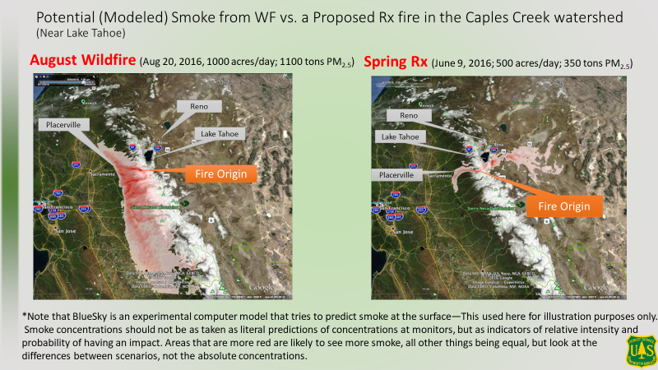* Slide 1 courtesy of Becky Estes and Lee Tarnay, USDA Forest Service

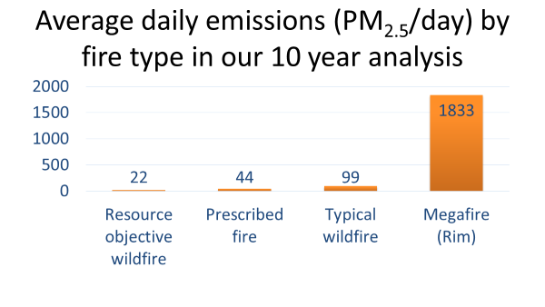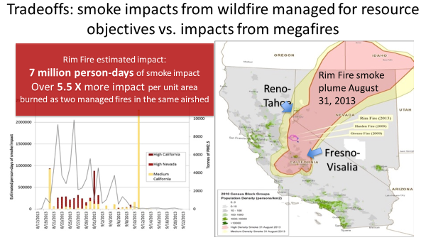
*Slides from presentation to Mono Co. Board of Supervisors June 2017-Lee Tarnay, USFS
The scoping document notes that the forest will complete an analysis for prescribed fire potential across the project area but does not include what such an analysis will consider and if it will be available to the public. We strongly recommend that this report and other subsequent documents be developed collaboratively and become the foundational effort of a fire restoration collaborative. Besides the report being available on the project web page for the general public, fire and smoke science, public health science and public health protection links should be developed with the GBAQMD and should be included in the project website.
The idea of annual field trips to proposed burn sites and monitoring of post-burn environments would make a great annual event to share project information to build continued support for this effort.
4. Environmental risks, solid design measures, and thoughtful and transparent risk-taking should be disclosed both in terms of implementing larger burns and disclosing reasonable, science-based scenarios related to NOT doing the project, i.e., what it means (risks to public health, community safety, water quality, wildlife habitat, recreation opportunities, climate resilience, etc.) to live in a fire-departed landscape with high fuel-loading.

II. Integration of Fire Management Zones
The Inyo NF-Forest Plan allows for wildfires to be managed for resource benefit in the wildfire maintenance and restoration zones outside of designated wilderness. Since most of the maintenance and restoration zone is within designated wilderness, we encourage the use of managed wildfire for resource benefit within protection zones as well, where feasible, as on the Lake Tahoe Basin Management Unit in their recent revised forest plan. North et al. 2012 describes the necessity of using managed wildfire from natural ignitions to achieve fire restoration objectives. A successful recent example on the Inyo NF was the Springs Fire last summer. In addition, places previously treated for fuels reduction should be prioritized for fire maintenance—whether from wildfire managed for resource benefits or planned burning.
Fire maintenance is a critical part of large landscape fire restoration and must be factored into the budgets, staffing and planning. Historically, this hasn’t been the case and then we squander resilience for the sake of the next project down the road. Workforce issues, budgets, social license and accountability are all at play here and need to be addressed together to make and maintain this landscape restoration effort a lasting success. Ultimately, planned fire and unplanned wildfire managed for resource benefits should be available for Forest Service managers across the landscape based on professional judgement, resource availability, weather, fuel conditions and other factors. Currently on the Lassen NF, we are working with ecologists and fire staff to implement a prescribed burn in the Ishi Wilderness under a general understanding that suppressing fire in designated wilderness can create conditions (trammeling) that run counter to the Wilderness Act.

III. Fire Regimes and Restoration Objectives
We understand that there is variability in fire regimes and therefore fire frequency in a natural system and in one that is departed you have to rely on the professionalism of the fire staff, input form fire scientists and ecologists, collaborative partnerships and a realization that there is risk involved in restoring large (often fire regime-departed) landscapes. The only thing riskier is not doing the restoration work.

IV. Design Features and Planned Fire
Limited Operating Periods (LOPs) can make it difficult to conduct spring burns. Spring fire events were a relatively rare occurrence in the Sierra Nevada historically. Due to summer/fall air pollution concentrations and public health impacts, spring burn windows are being used more and more on the forests of the Sierra Nevada (North et al. 2009). On the Inyo NF spring burn windows should be used with caution in special species habitat where specialist clearance is achieved. In season burning also has risks and the goal of restoring fire regime-fire frequency must be weighed carefully and transparently. The forest should conduct as much (in season) fall burning and expanded winter burning whenever possible along with night-time burning whenever possible.

A stated goal in the scoping letter is to increase age class diversity including the increase in the proportion of old forest (p. 4) (large diameter trees) and early seral age classes. Prescribed burning within Marten and Goshawk habitat should increase these important habitat elements and reduce canopy where it fosters fire resilience while supporting the other values stated above.

In compliance with the Forest Plan’s plan components, pre-treatment surveys for rare plants should be conducted and sensitive plants flagged for avoidance unless they need appropriate fire for their own propagation regime, in the fire seasonality they evolved with.

We’d like to see a statement that when larger, fire-killed trees may occur during the project and they remain on site.

Within riparian and meadow habitats please include best management practices for erosion prevention, soil protection and maintenance of water quality such as those stated for the SNF (PA, p.9). Van Der Water and North’s (2011) research suggest that efforts need to be made to carefully reduce fuel in riparian areas to prevent severe fire effects. Reduced fuels eventually should lead to lower concern for allowing fire to burn in these areas, which was historically not significantly different to upland areas in the Sierra Nevada. We support design criteria for no direct lighting in riparian vegetation and habitats as it is fairly common practice to allow fire to back into these areas creating less intense fire effects.

A large area of the fire restoration proposal overlaps active grazing allotments, particularly sheep. These areas should be rested after burning until native perennial grasses return, typically a 2-3-year period or longer during periods of drought.

We understand the mechanical treatments are generally outside the scope of this CE and such design criteria should reflect that, other than mastication and some felling of ladder fuel trees for pile burning before broadcast burning an area, mechanical treatments are limited.

Finally, we request the Inyo NF consider including cultural burning projects within this larger effort, in collaboration with Native American community members where timing, intensity and location of fires may provide cultural benefits while achieving the INF ecological objectives.

V. Staffing and Collaborative Burning
Based on the efforts of the Fire MOU Partnership, we would hope the Inyo NF will reach out to local CAL FIRE Units, BLM and Native American partners to expand capacity and training for larger landscape burn efforts. It is all one fire-associated ecosystem where fire doesn’t care much about human ownership patterns or area response authorities.

VI. Memorandum of Agreement for Smoke Management and working with the GBUAPCD
One of the major barriers to achieving fire goals within this proposed action is the restrictions placed on air quality and smoke management by Great Basin United Air Pollution Control District. This stems from an even deeper issue when the Federal Clean Air Act was developed in the early 1970’s. Literally no one knew what a fire scientist or fire regime was or why restoring fire mattered.
We are encouraged by conversations happening between GBUAPCD and the Inyo National Forest regarding the current Smoke Management MOA. The MOA (version signed in 2001) is very limiting of planned and unplanned fire. Section 5. Restrict burns to forecasted periods when the smoke plume will not impact any populated or smoke sensitive areas, is unrealistic and along with other sections that limit acreage, demand 24 hour/daily approvals, limit the use of your own authority to manage wildfires for resource benefits when >10-acres, all follow the misguided idea that we can prevent fire (a natural process) in fire-associated ecosystems. The idea that rules can control nature is not holding up well on several fronts. We support the concept of “living with fire” and avoiding or de-linking from the misguided notion that not burning is going to protect the public’s health. This is where emissions trade-offs must enter the discussion. Its not that Smoke Management doesn’t matter or that working together collaboratively to protect public health isn’t important, but it also matters that we recognize the key aspects of the ecosystem one lives in which is essential to understanding and promoting well-planned fire restoration. We also must be transparent about burning for ecological goals of resilience that will limit mega-emissions over the long run. This will require much longer burn windows and a discussion about the emission baselines being the fire regime level of smoke. See (Schweizer and Cisneros 2017) Forest fire policy: change conventional thinking of smoke management to prioritize long-term air quality and public health.
The Governor, CAL FIRE, and the California Air Board’s 500,000-acre/year commitment is a statewide attempt to expand needed fire restoration and resilience and expresses an understanding that surface and ladder fuels play a key role in driving fire behavior. The current Smoke Management MOA should be renegotiated to resolve these issues which are far better understood today.
Title 17 of the Clean Air Act requires a reinterpretation to align with statewide fire restoration goals where fire is thought of as a key tool for fostering resilience in a warming climate and not as simply a tool for permitting agricultural burning or strictly for burning logging slash. There are statewide resources available through CAPCOA and CARB to help air boards obtain equipment and training that can increase their ability to monitor air quality and quantifiably measure smoke impacts in a more precise manner. We hope to engage the GBUAPCD with you to establish a clear path for the air board be incorporated into planning for prescribed fires through this proposed action.

Thank you for this opportunity to comment and for taking on large landscape fire restoration on the Inyo National Forest.

Sincerely,
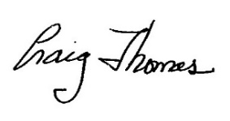
Craig Thomas, Director
The Fire Restoration Group

References
Collins, B. M., and Stephens, S. 2010. Stand replacing patches within a ‘mixed severity’ fire regime: quantitative characterization using recent fires in a long-established natural fire area. Landscape Ecology Published online 30 March 2010.
Long, J.W., Tarnay, L. W., North, M.P., 2017. Aligning smoke management with long-term ecological and public health goals. Journal of Forestry. 115. http://www.fs.fed.us/psw/publications/jwlong/psw_2017_Long002.pdf.
North, M.P., K.M. Van de Water, S.L. Stephens, and B.M. Collins. 2009. Climate, rain
shadow, and human-use influences on eastern Sierra Nevada fire regimes. Fire Ecology 5(3): 20-34.

North, M., Collins, B.M., Stephens, S. 2012. Using Fire to Increase the Scale, Benefits, and Future Maintenance of Fuels Treatments. Journal of Forestry 110(7): 392-401.
North, M., A. Brough, J. Long, B. Collins, P. Bowden, D. Yasuda, J. Miller and N. Suighara. 2015. Constraints on mechanized treatment significantly limit mechanical fuels reduction extent in the Sierra Nevada. Journal of Forestry 113: 40-48.

Schweizer, D.W. and R. Cisneros. 2017. Forest fire policy: change conventional thinking of smoke management to prioritize long-term air quality and public health. Air Quality, Atmosphere and Health Vol. 10:1
The Fire MOU Partnership https://www.sierraforestlegacy.org/CF_ManagingFire/FireMOU.php
Van de Water, K and North, M. 2011. Stand structure, fuel loads and fire behavior in riparian upland forests, Sierra Nevada Mountain, USA; a comparison of current and reconstructed conditions. Forest Ecology and Management 262 (2011) 215-228.

