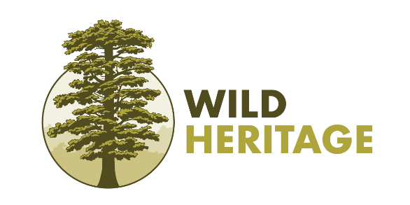
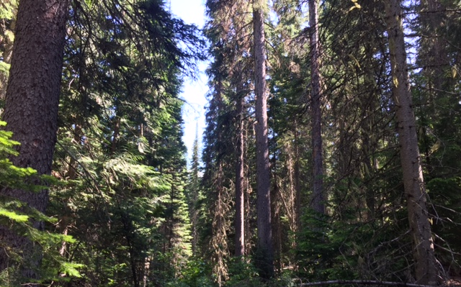
August 25, 2022

Re: Observations and Concerns About the USFS Approved Black Ram Logging Project

I am a conservation scientist with four decades of global experience in forest ecosystems, including the US and Canadian Rockies. Much of my work has focused on leading “bioblitzes” into old-growth forests (also known as primary forests) to catalogue their biodiversity and carbon benefits as natural climate solutions. I have published over 300 peer-reviewed science articles and books on forest ecology, endangered ecosystems and species, wildlife and wildfire ecology, and climate change. I am currently a co-PI on a team of international scientists investigating the world’s primary forests as forest carbon sinks. The worlds older forests provide unmatched climate benefits as natural climate solutions and need to be included in nationally determined contributions to the Paris Climate Agreement along with country-specific protections given how rare and important these forests are to slowing down the global biodiversity and climate crises. We will be presenting our global primary forest mapping at the upcoming Convention of the Parties (COP 15) in Montreal this December.

My current project is focused on cataloguing mature and old-growth forests (MOG) in Canada and the US. We have two articles in peer-review responding to the president’s executive order 14072 (Tackling the Climate Crisis at Home and Abroad). And we have already published our findings for the Tongass rainforest in Alaska and BC’s inland primary rainforest just across the Montana border along the western flanks of the Rockies. Thus, please consider my report herein as an expert opinion on the Black Ram Project impacts.

At the invitation of the Yaak Valley Forest Council, I walked the controversial logging Unit 72 on August 18-19, 2022. While I was somewhat familiar with this sale on its poor merits alone, I purposely did not read any background materials so I would have as unbiased a position as possible on whether it was MOG or not. Appended to my report are some exemplary photos with explanation.

Whenever I approach MOG evaluations like this one, I first look at the site within its surroundings (context). That is – what is the role of the specific site relative to the landscape? During my visit, I was alarmed by what I saw on my drive in (extensive logging along the Yaak River road) and along the approximately 2.5-mile fireline-access road into Unit 72. The surroundings and the immediate logging have both contributed cumulative effects to the environment and climate. The surrounding logging has seriously severed linkages among MOG and natural areas that are increasingly vital for species seeking climate refugia in a time of unprecedented change. More immediate, fire-line damages included a large swath of trees cut down on the uphill slope of the road that clearly impacted soils and unique wetlands, which had dried out due to excessive sun exposure.

The upslope roadside area – once a forest – is prone now to substantial soil erosion, weed infestations are evident, and there is heavy soil damage from pile burning especially at log landings. I am concerned that even though conifers are coming back in some of these areas, fire hazards along the road have been elevated due to flammability of weedy invasive plants and the loss of fire-resistant older trees. In addition, sediment leakage into streams is likely to occur as the fire-line is now a gated road and roads can permanently alter hydrology. And while fire hazards were elevated by roadside logging, Unit 72 poses no danger to any nearby town as its remote and most of the site is on poorly drained (wet) soils.

The north-facing aspect of Unit 72 receives relatively high annual precipitation and is likely to function as a critical climate movement corridor and species refuge, as the surrounding clearcut and fragmented areas heat and dry up. Notably, it was 96 degrees in the valley on the day of my trip, unusual for Montana, but noticeably cooler in the interior of Unit 72. Given the site has poorly drained wet soils with facultative wetland species like sedges and horsetails in moist pockets, it is on very long (centuries) fire rotation intervals so its fire refugia properties are readily apparent.

Unfortunately, the Forest Service plans to clearcut and type-convert Unit 72 to a dry-site white pine mix that is clearly incompatible with the ecology and climate refugia properties of the site especially when compared to its altered surroundings. The agency claims this is for climate resilience, while my observations show it would have the opposite effect. Moreover, extensive logging in the surroundings means that Unit 72 – and the Black Project area in general – are likely functioning as one of the only connectivity corridors.

Once I entered Unit 72, I was immediately amazed by the complexity of forest structures and richness of older tree species growing in close proximity to one another (some of which had fused root systems). This included trees that normally do not grow together due to competition for nutrients and light and is likely indicative of highly productive soils rich in nutrients. I also observed a number of very large (~5-6 ft diameter) western red cedar, western hemlock, subalpine fir, Engelmann spruce, and western larch. Tree heights towered to an eye-estimated 130-150 feet, which is what I would expect on a productive site with old-growth characteristics. There were many large snags (dead trees) with evidence of pileated woodpecker activity (this species is found mainly in older forests), abundant large and small downed logs (i.e., coarse woody debris), including many that were nearly completely decomposed serving as “nurse logs” for developing seedlings. There was evidence of vertical layering in the canopy with large overstory trees mixed in with mid- to lower-story trees within gaps created by blow down of shallow-rooted large trees on wet soils. In other words, classic old-growth structure was present and the site was quite varied in tree species composition, tree diameter distributions (although I did not measure them), and site topography indicative of gentle moraine typical of high growth site potential – meaning the trees grow big, tall, and fast.

I also observed mound-and-pit micro topography in much of the unit. This kind of topography occurs only in older forests created when large, old trees fall over from natural causes (e.g., blow down in shallowly rooted pockets). When that happens, the pit is formed where the root mass of the fallen tree and attached soil once were, while the mound forms from layering of decomposing dead trees and coarse woody debris stacked over time. Rich soils like these have characteristically well-developed mycorrhizae fungi that symbiotically attach to the roots of plants allowing plants to efficiently exchange nutrients, water, and stress hormones when under insect attack. That kind of topography and well-developed mycorrhizae connections is lacking in logged areas. It is often missed in forest inventories that are focused narrowly on above ground structure to define old growth.

Based on my expertise from bioblitzes in numerous regions, and the importance of the site itself plus its contextual role as a key connectivity and climate/fire refugia, I would peg this as a “no brainer” old-growth forest with many characteristic elements of structural variation. The presence of old trees is due to very long intervals between natural disturbance events like fires and insect infestations due to the site’s north-facing exposure and high moisture content.

In closing, I was initially drawn to this controversial site to see with my own eyes whether it should qualify for MOG protections and meets the intent of EO 14072. I can say unequivocally that this site is old growth, is critically important to its surroundings, has key climate and refugia properties, including the potential for large amounts of above and below ground carbon to continue to accumulate over centuries. EO 14072 specifically pertains to the importance of protecting carbon stores and carbon sequestration. What better place then this to carry out that order?

The Black Ram Project unfortunately is among the millions of acres of old forests that we have identified in our mapping as vulnerable to logging but critical to EO 14072 and climate strategies involving natural climate solutions. My organization has been very active in calling for a moratorium on timber sales in MOG like this one as they are inconsistent with the intent of EO 14072. Meanwhile the Forest Service continues to ignore the EO’s intent to conserve and protect MOG.

We have been asking for initiate national rulemaking that would protect all the nation’s MOG forests on federal lands concurrent with the inventory process underway. We also have requested a suspension of approved sales in MOG at least until the national inventory process plays out. I am deeply concerned that the Forest Service has planned a 95,000-acre Black Ram Project that would commercially log ~4,000 acres, including clearcutting ~1,800 acres and >400 acres of MOG forests. The area would forever be damaged at the expense of many vulnerable species that need unaltered climate refugia to persist in a rapidly changing climate. In no way does this project meet the spirit or intent of the executive order.

Due to the current state of the Black Ram Project (fast-tracked to final approval with no EIS), additional action must be considered in order to ensure permanent protection. Any national rulemaking process would take at least a year to completion. In the interim, key MOG forests like Black Ram would be cut down and their capacity to provide climate/fire refugia, clean drinking water, wildlife habitat, and public enjoyment unduly compromised. The nation, the world, need MOG forests like the Black Ram Project area more than ever as natural climate solutions and they should be protected from logging to avoid contributing to catastrophic climate change and local community losses.

Sincerely,
Dominick A. DellaSala, Ph. D
Chief Scientist

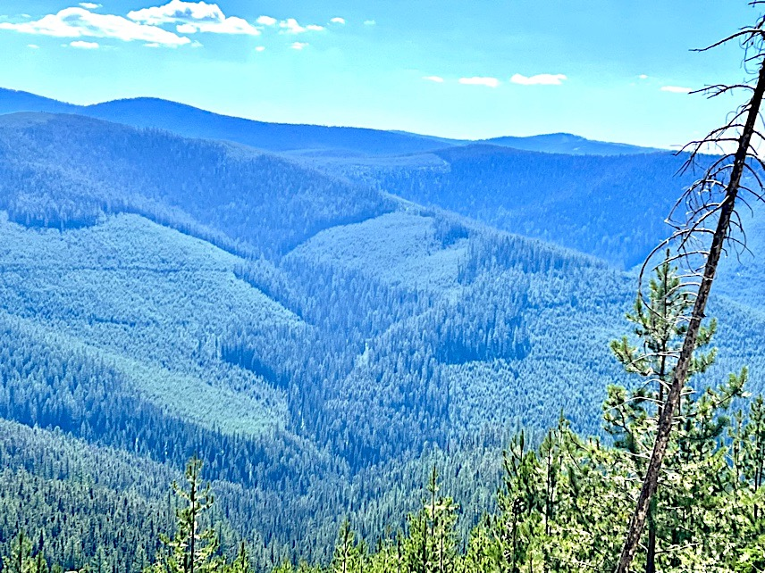
Extensive forest fragmentation along the Yaak River road, Kootenai National Forest, on my drive in. Logging like this has eliminated most of the MOG forests in this region and comes with a heavy price to the climate, imperiled species, and clean drinking water (D. DellaSala).

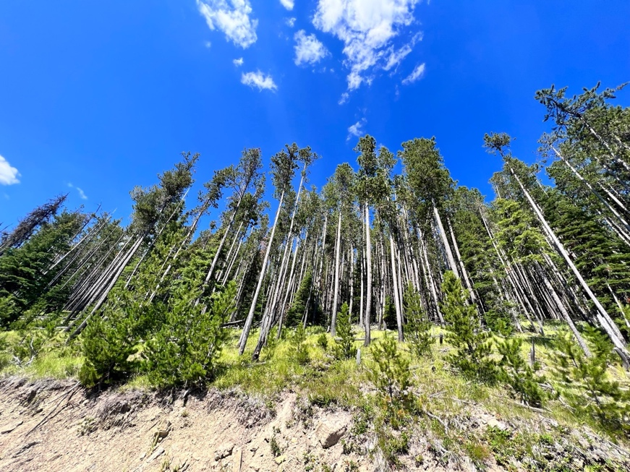
Fireline-roadside logging uphill on steep topography causes soil damage, alters hydrology, enables weedy infestations and elevates fire risks from flammable weed-infested growth (D. DellaSala)

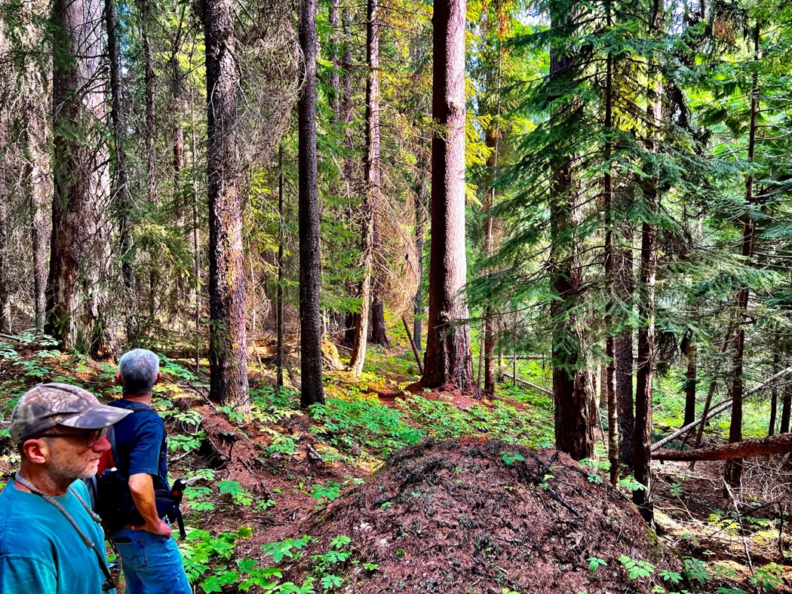
Old-growth trees on a north-facing site in the Black Ram Project area. These trees are planned to be logged as the Forest Service claims the site is not old growth.

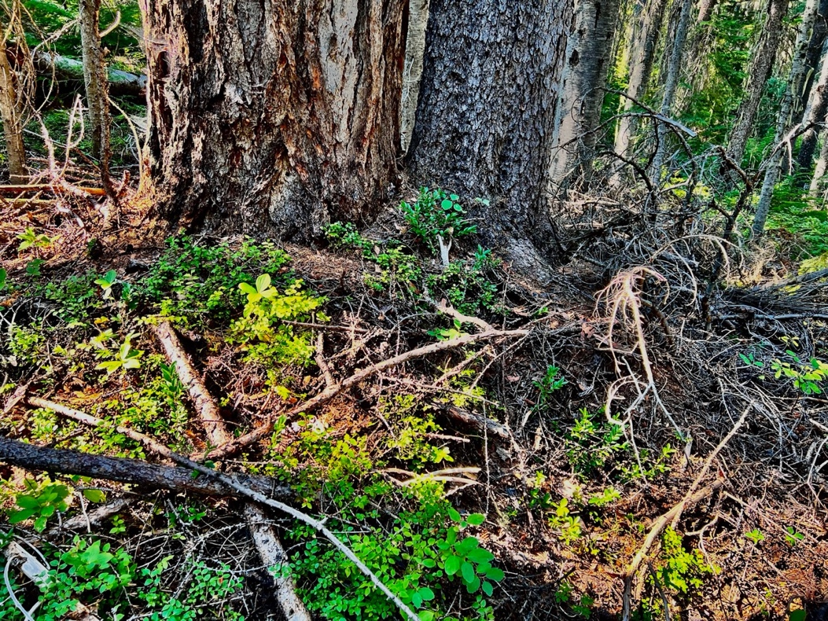
Mound and pit microtopography in Unit 72 – the photo shows mainly the mound formed by centuries of large tree decomposition that produces rich soil and well-developed mycorrhizae.

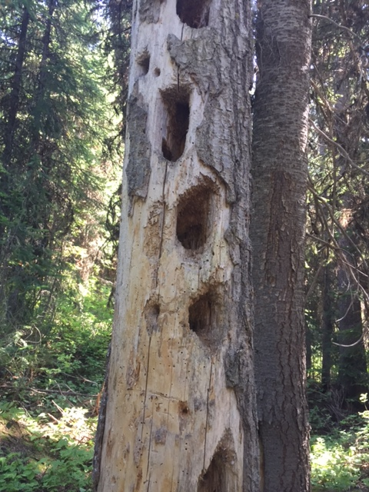
Pileated woodpecker activity (foraging holes) in old forests in the Black Ram Project area (R. Bass).

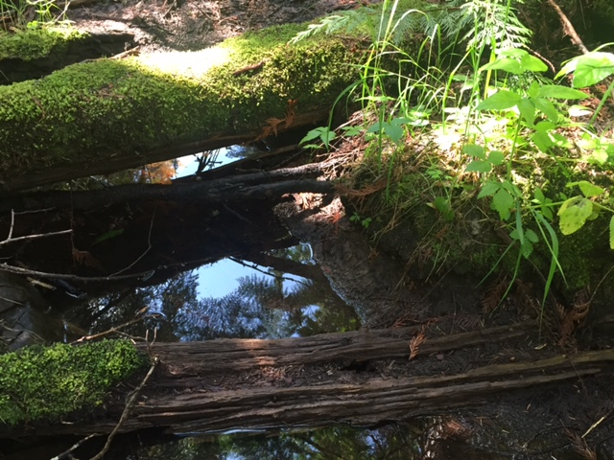
Large “nurse logs” like this were present in many places in Unit 72. Note the extensive moss build up indicative of moist site conditions that include many seeps like this one. Converting the site to dry white pine as planned is clearly inappropriate (R. Bass).

Primary forests are forests of any age class where ecosystem integrity is highest because there are no signs of industrial activities. The forests are part of Indigenous Peoples traditional territories and are essential for traditional cultural values. They are places where biodiversity and cultural significance intersect.
https://www.climate-forests.org/worth-more-standing

