May 21, 2020

Connie Cummins, Forest Supervisor
c/o Michael Jimenez, Project Leader
Superior National Forest
8901 Grand Avenue Place
Duluth, MN 55808

comments-eastern-superior@usda.gov

Subject: Comments on the Lutsen Mountains Ski Area Expansion Project

Dear Mr. Jimenez,

I am writing today to provide comments on the Forest Service proposed Lutsen Mountains Ski Area Expansion project.

As a regional economic development organization, we have partnered with Lutsen Mountains in past expansion efforts. We know the value they bring to Cook County—and our entire Arrowhead region—as a primary economic engine of the Northshore for decades. We have found this business to be thorough in their planning and execution, customer focused, and an excellent corporate citizen in their community and region.

Lutsen Mountains helps provide a stable economy for Cook County—in the winter months especially—allowing for more year-round employment opportunities. With the COVID-19 pandemic, we are feeling the impact our tourism economy has in our region and state. Now more than ever, we need continued investments and expansions of our trusted, well-run businesses. I would put Lutsen Mountains on the top of that list.

Thank you for considering my comments. I hope we are able to see this well thought out project move forward for the good of our region.

Sincerely,

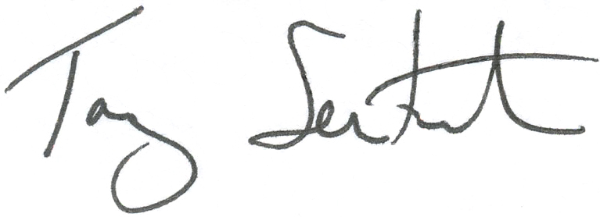
Tony Sertich
President

