FROM: Maury W. Johnson 3227 Ellison Ridge Road Greenville, WV 24945 February 20, 2023

To: Dr. Homer Wilkes, Under Secretary, U.S. Department of Agriculture. George Washington & Jefferson National Forests

Dear Mr. Wilkes and Others Whom It May Concern:

I am a former teacher with a background in history and science. I am a farmer who has been engaged in farming my entire life. I am also a resident, citizen scientist that has undergone training by Trout Unlimited and the WV Rivers Coalition to document water contamination and other problems across WV and VA, I was born in Giles County VA and have lived nearby in Monroe County WV on my families multi-generation farm my entire life. I am a member of the Appalachian Trail Conservancy and an avid outdoorsman. The Mountain Valley Pipeline crosses my farm and neighborhood. I can see the Appalachian Trail and the Jefferson National Forest from the hilltops on my farm. Therefore I believe that I have expertise on several issues regarding the permit request by MVP to cross the JNF. These would be from on the ground observances and other pertinent information that may not be available from any other source..

First I would respectfully ask that the United States Forest Service (USFS) extend the comment period in regards to the permit requested by Mountain Valley Pipeline (MVP) to cross the Jefferson National Forest by 30 Days. The extremely short 45 day comment periods is unfair and insufficient for anyone wanting to make a thoughtful and well researched comment either for or against the permit request, especially when it spans the holiday season at the end of December and the beginning of January. Many people and organizations that want to make substantive comment were actually out of the office or on holiday vacations for up to two weeks of this short 45 day comment period. It seems like given the fact that MVP has had two years to prepare its case and the agencies have had application materials since at least last summer it is only fair that an additional 30 days be granted to allow for a thorough review of all the material in MVP’s permit request.

This letter is not a letter in support or opposition to the permit in question but just a letter to address what I feel are concerns that must be addressed by the USFS in determining what action to take in this matter and to keep more resources from being wasted from issuing a permit that will not withstand further scrutiny by FERC or the Courts. It is also a letter to address information that the USFS may need to consider that I did not see addressed in the Supplementary Environmental Impact Statement (SEIS).

The requested permit to irreparably damage the pristine forest and the critical water resources and fragile ecosystem found within the forest that it harbors, including many unique and even endangered species in WV and VA is a very serious matter that the USFS must determine if it is in the best interest of the Forest and the citizens most impacted by this decision.

The following excerpt was taken from a filing I made with FERC in 2016 and again in 2019 (Document Accession #: 20190812-5018 Filed Date: 08/12/2019). I have also raised my concerns repeatedly to the USFS and the USFWS over the last several years. I firmly believe that the Rusty Patch Bumble Bee is present in the old field and orchard adjacent to the MVP ROW on Peters Mountain in Monroe County WV and that no actual on the ground survey has ever been conducted in that area. “Bees such as the Rusty Patch Bumblebee are important pollinators of wildflowers and are the chief pollinator of many economically important crops. Even in crops that can be self-pollinated, the plant produces more and bigger fruits with the aid of bumblebees for pollination. In natural areas, bumble bees pollinate plants that provide food for other wildlife. By conserving this species, other species of pollinators will also benefit. In the September 22, 2016 news release, the USFWS listed IN, ME, MD, MA, MN, NC, OH, PA, TN, VA, WI and Ontario, Canada as probable ranges for these bees. I live in Monroe County WV, near the town of Greenville. I have very solid evidence that the Rusty Patch Bumblebee exists in my area. I plan to address this with the USFWS in a meeting I have scheduled with the Elkins WV Field Office on December 8th 2016. I have others in the area who have reported to me that they believe that this bee exists in this rural, pristine area of WV. Area bee keepers have reported to me (and hopefully to the USFWS) their belief that this bee exists in the area, although the population is decreasing. One local bee keeper has already contacted the Entomology Department at nearby Virginia Tech concerning this bee and it is my understanding that they have made a site visit and believe we could very probably have this bee.”
I believe that a survey for that species and the now threatened American Bumble Bee, bombus pennsylvanicus should be completed before a permit is even considered for the MVP in the Jefferson National Forest.
According to information supplied by the USFWS, the “American bumble bee losses amount to an 89% reduction in abundance relative to other bee species that share their habitat. These declines are most pronounced towards the northern extent of the species' range. Like most bumble bees, this species faces threats from multiple sources including pesticides, habitat loss or degradation, urban development, climate change, and diseases that can be introduced by non-native bee species.” According to the Center for Biological Diversity it and has disappeared entirely from eight states and is critically endangered in several others.

Again, it is the duty of the USFS to ensure that any habitats for endangered or threaten species are protected on or near USFS property.

I also wrote about the endangered Candy Darter in this filing with FERC. I still have great concern that the E & S Controls for the MVP on and off the JNF property is not adequate to ensure that this incredibly unique and endangered fish is protected. “The second species of concern is the newly listed Candy Darter. According to the USFWS own data - Nearly half of the 35 known candy darter populations have disappeared since the species was first described in 1932. Candy Darter habitat historically declined when land conversion activities removed the forested and riparian habitat that sustained healthy stream conditions for the fish. Biologists are now most concerned about the significant negative consequences of the candy darter breeding with an introduced species, the variegate darter. (copied from the USFWS website- https://www.fws.gov/northeast/candydarter/ ) Also from this same website it states “Visit the waters of Virginia and West Virginia’s upper Kanawha River Basin, and you might find yourself witnessing flashes of underwater rainbows. With their vibrant teal, red and orange colors, candy darters are a small freshwater fish native to the Gauley, Greenbrier, and New River watersheds. Although darters in general make up 20 percent of freshwater fish species in North America, candy darters are found nowhere else on earth.” This fish was placed on the USFWS Endangered Species List in late 2018. I have included the following link and request that this news report from the Center for Biological Diversity be made part of the FERC Record. https://www.biologicaldiversity.org/news/press_releases/2018/candy-darter-11-20- 2018.php I wrote about the Candy Darter in several documents that I submitted to the FERC Record in the MVP pre-filing period and in the Docket CP16-10. In my filing found here file:///C:/Users/maury/Downloads/20161221-5284(31853640).pdf you will find my brief comment on the bottom of page 17 of 67.”

Finally, I have concerns with the apparently new species of crayfish which has only been found on the high ridges of Monroe County, WV and Giles County, VA. The area near the MVP ROW on Peters Mountain is one of the spring/wetland areas where it lives. That spring is less than 500 feet from the MVP ROW and proposed Bore Area on Peters Mountain in the JNF.

I also wrote about this in numerous filings since 2018 to FERC, the USFS and the USFWS, “ I request that all activity cease on Peters Mountain due to not only the probable presence of the Rusty Patch Bumble Bee, but also due to the very probable likely hood of a unique species of Crayfish that has been photographed twice since 2018. This Crayfish is found in a remote spring/wetland very near the location where MVP wants to cross the Appalachian Trail. In fact this crayfish is located beside the AT. It was first photographed by chance by Dr. Emily Saterwhite while walking on the AT on May of 2018. When seeing this photograph posted on Facebook, I instantly realized that it was a significant discovery that needed further research. I tried to get several different people to look into this with no success.

In May of 2019 it was photographed by a team of researchers lead by WVU Professor Dr Dorothy Vesper. I have been attempting to get renowned Cray Fish researchers from Marshall University and the West Liberty University Crayfish Conservation Laboratory. Here are the two pictures I have from these people Here are the two pictures I have from these people. Document Accession #: 20190812-5018 Filed Date: 08/12/2019. Document Accession #: 20190812-5018 Filed Date: 08/12/2019 Document Accession #: 20190812-5018 Filed Date: 08/12/201”.
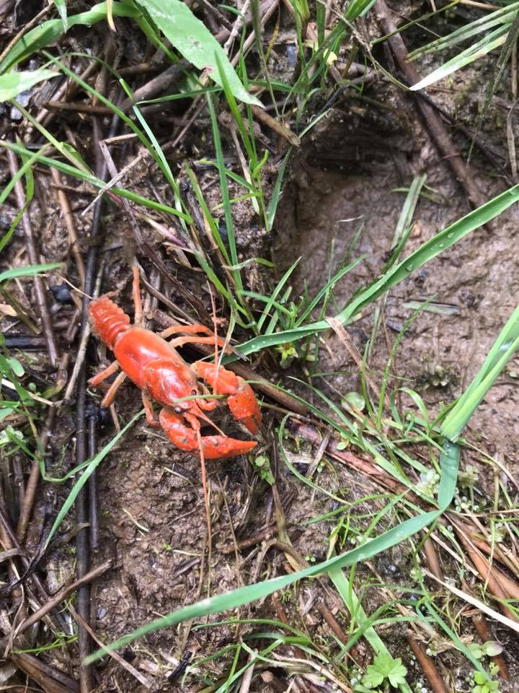
Above Crayfish Photographed by Virginia Tech Professor Dr, Emily Saterwhite in May of 2018

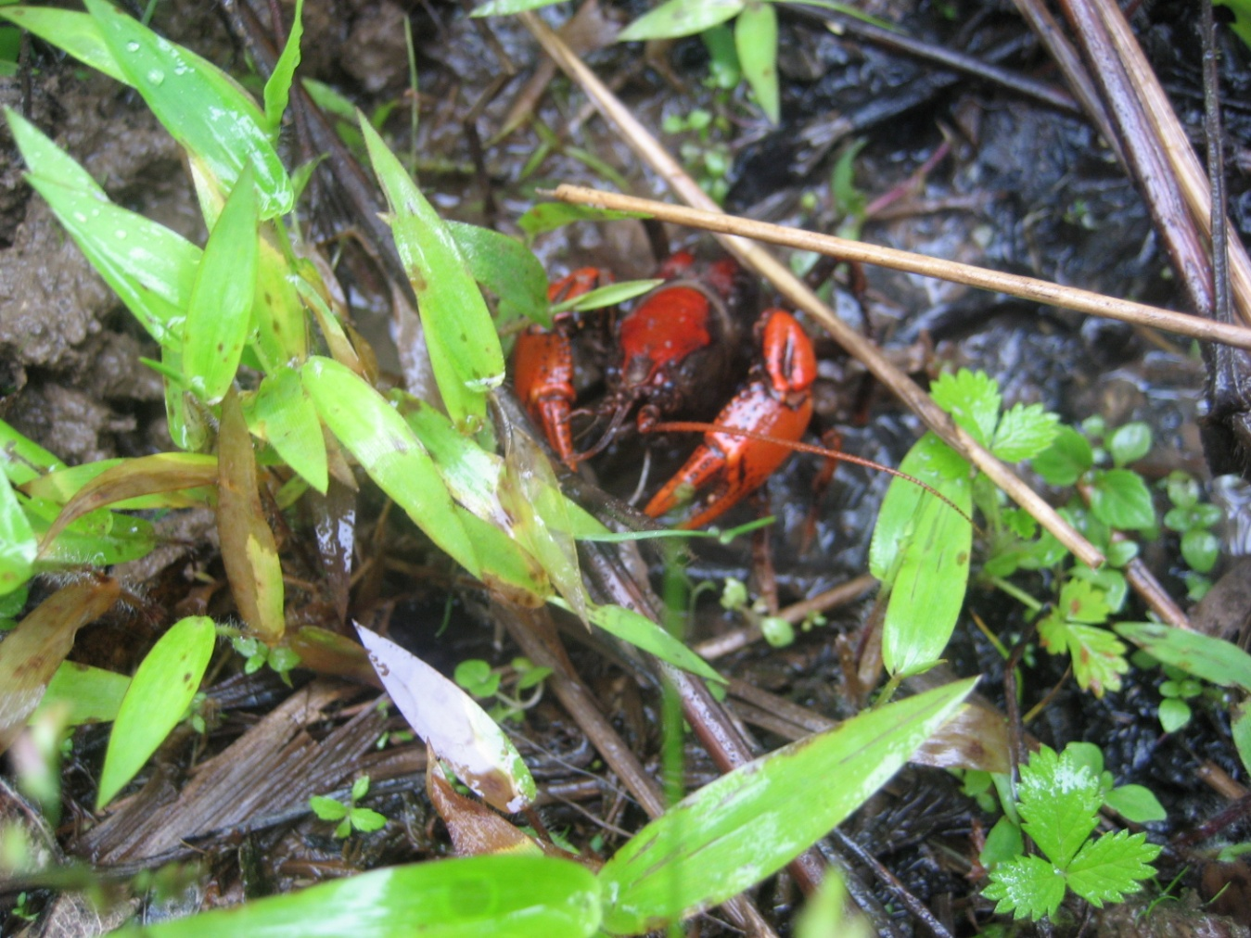Above Crayfish photographed by Water Research Team on Peters Mountain in May of 2019. Photograph supplied by Dr, Dorothy Vesper from West Virginia University.

Once again, the above mentioned Crayfish is so new it doesn’t even have a name yet. Therefore it is not listed as either endangered or threatened, but is probably considered a “Globally Significant Species”. For more information you need to contact Zachary J. Loughman, Chairman of the Dept. of Organizational Biology, Ecology & Zoo Science at Wheeling Jesuit University.
Contact Info:
Office: Arnett Hall 213
Phone: (304) 336-8923
E-Mail: zloughman@westliberty.edu

Address:
West Liberty University
208 University Drive
College Union Box 139
West Liberty, WV 26074

Regardless of the decision of the permit request by MVP for crossing the JNF, a thorough analysis is required for these and any other endangered or threaten species that maybe impacted by the construction and operation of the MVP on National Forest land or adjacent property.

The Mountain Valley Pipeline and Equitrans Expansion Project Draft Supplemental Environmental Impact Statement #50036 propose amendments to 11 crucial standards that are essential for protecting the Jefferson National Forest. Several environmental organization have stated that they have found that the company’s newly submitted documents does not provide sufficient assessment, monitoring, modeling, or real-world analyses to support changes to the Forest Plan and therefore the USFS must ask for more information before making their decision.
As a citizen whose home and environment is directly impacted by the current proposed path of the MVP and who lives close to the JNF in Monroe County WV, I have witnessed impacts to soil health, old-growth forest, forest edge, species competition and scenic viewshed across the two Virginias path of the MVP, including on National Forest Land. I strongly believe that changing the 11 crucial standards to the forest management plan would bring even more significant harmful impacts to the Jefferson National Forest. I wonder why these changes are even being proposed. Are they necessary for the management of the forest for the citizens or are they merely just for the convenience of the developer of the MVP. This is a question that must be answered by personnel of the USFS before making a decision about whether to approve or to deny this special request by MVP.
After President Jimmy Carter signed H.R. 8803 - The Appalachian Trail Act of 1978 the Federal Government expanded the Jefferson National Forest into Monroe County, WV and the nearby counties in Virginia. Appalachian Trail Bill Statement on Signing H.R. 8803 Into Law. | The American Presidency Project (ucsb.edu)
Their reason for doing this was to protect critical habit and water resources and to protect the Appalachian National Scenic Trail corridor aka the Appalachian Trail or AT for short.. I will attach one such deed sent to me by as friend several years ago. It is for the very parcel of land that is the proposed boring area under the AT in Monroe County WV. That makes me wonder how allowing the MVP to cross the AT, especially on this piece of land is protecting the Appalachian Trail or its corridor?
Furthermore the USFS should carefully consider whether or not to allow MVP to cross the Appalachian Trail (AT) —officially the “Appalachian National Scenic Trail” (ANST)—at this location. Making an exception for MVP to cross the ANST in the Jefferson National Forest, especially at this scenic and unsafe location should be something that the USFS carefully considers. No large pipeline has crossed the ANST on national forest land since the AT was designated as a National Scenic Trail in 1968. Allowing the MVP to cross the ANST, especially in such a high-profile location, degrades the ANST and threatens trails across the country. There are now 11 National Scenic Trails in the U.S. and allowing for this to happen on Peters Mountain in the Jefferson National Forest would set a bad precedent for National Scenic Trails across the country.
The MVP crossing is not in an out-of-the-way corner of the ANST. It is on top of Peters Mountain on the border of WV and VA close to an iconic scenic viewpoint. The original Appalachian Trail did not include this segment but starting in the 1940s, the Appalachian Trail was began a process of rerouting some of the trail in our area in order to provide more scenic views and protect the AT from further destruction. In 1967 the AT was reroute to the top of Peters Mountain after the Roanoke Appalachian Trail Club (RATC) got an easement from the Celanese Corporation to access the crest of Peters Mountain. At that time the Appalachian Trail Conservancy (ATC) Vice President Tom Campbell stated that the view from Symms Gap, (looking over Monroe and Summers County WV) “…is one of the most beautiful views east of the Mississippi. I will attach to this letter his report to the 17th Triennial Conference of the ATC, which contains the quote.

In the 1970’s and early 80’s I helped maintain this section of the AT. I heard firsthand from those who had help to build this section of the trail, how the AT was diverted to the top of Peters Mountain in order to see this iconic view across Monroe and Summers County WV. This view is now highly impacted by the Mountain Valley Pipeline. It is evident that the MVP’s wide, unnatural corridor undermines the JNF’s Scenic Integrity Objectives. This is another factor that must be considered by the USFS when making a decision about permitting or not permitting the MVP.
Another issue that has been raised by me and many others for nearly a decade is that this crossing of the AT through the entire Jefferson National Forest is in heart of the Giles County Seismic Zone.
MVP plans to bore 90 ft under the AT but considerable pipeline safety is at risk on both sides. In 2017, before FERC approved MVP for construction, the steep slopes below the bore pits were identified by the Forest Service as High Hazard sites, with landslide risks one of the factors. Since 2017, two earthquakes were recorded within miles of the MVP. One was centered near the AT in Bland County VA and the second was actually very near the MVP Corridor and the AT route in Monroe County WV. This was a 3.2 magnitude earthquake in Lindside, WV about 4 miles from the ANST crossing. The blast zone for MVP’s 42-inch pipeline is approximately 1,100 feet, but recent evidence suggests the impact radius could be greater. Should the MVP have a catastrophic failure brought about by an earthquake or landslide or both on Peters Mountain you could have hikers along the AT injured or killed. Some of these hikes could be people from other countries, which could become an international incident. This danger must be considered when considering the permitting of the MVP to cross the JNF in this “High Hazard Area”.
Building a pipeline across this location has been deemed unsafe for the environment, for the pipeline, and for anyone hiking on the AT across Peters Mountain.
It has been suggested by MVP that MVP crossing of the AT could be abandoned if the boring though the 600 feet through hard ridge rock formations fails. The proposed bore channel located 90 feet below the AT and the rock that would be needed to bore through is Tuscarora Sandstone - Wikipedia, which is possibly the hardest rock to be found along the entire MVP Route. MVP says that it will not attempt to cross the AT by an open-cut method, but it has not provided any information about alternate plans if the bore attempts fail. MVP should be required to provide its alternate plans and those plans must be part of the Forest Service’s Draft Environmental Assessment open to review and comment by the public before the USFS considers issuing a permit to cross the JNF and AT on Peters Mountain. .
With so much unknown, so much at risk, and MVP’s record of violations and ineffective controls so far, the Forest Service must carefully consider if they can legally permit the MVP to cross the JNF at this time. It must take its duty to the safety of those who use or live near the forest carefully before deciding to issue a permit the MVP to cross the JNF.
Allowing the Forest Service to break 11 of its own rules to accommodate Mountain Valley Pipeline, LLC, sets an alarming precedent for similar rule-breaking on national forests across the country. These exceptions run counter to the Forest Service’s mandate to “sustain healthy, diverse and productive forests and grasslands for present and future generations.” It also does exactly the opposite from the reasons given to extend the Jefferson National Forest into this pristine area. It also allows the Mountain Valley Pipeline to destroy some of the AT’s most scenic views, including but not limited to the view from Symms Gap on Peters Mountain in Monroe County, where you can see the MVP crossing Monroe and most of Summers County WV. This view is one of the main reasons that the AT made a 22 mile course change in order to cross Peters Mountain along the VA/WV border.
Even though the Appalachian Trail Conservancy (ATC) dropped their opposition to the MVP after receiving a “settlement agreement” that will net the ATC up to 19.5 million dollars, the damage that could be cause to Appalachian Trail is of great concern to not just me but to thousands of hikers who hike the AT both past, present and into the future. It is known as “America’s Most Scared Trail”.
Despite the ATC “Secret Agreement” with MVP these words from the ATC local representative needs to be revisited and considered: Downs: Mountain Valley Pipeline disrespects our landscape, our opinions (roanoke.com).
The applicant has a demonstrated a history of improper and inadequate sediment and erosion control practices during construction, leading to more than 500 violations of permit conditions and environmental standards in Virginia and West Virginia. I myself have filed over 240 Erosion & Sediment Control Complaints and Concerns with the West Virginia Department of Environmental Protection (WVDEP) over the past 5 years. Even though active construction has been halted over the past several months I still continue to document problems occurring across the WV MVP Route. I fear that if the USFS decides to issue this permit under the conditions of the current permit request that these impacts will continue in the JNF and adjacent to the forest. It is important that the USFS proceed with caution when deciding what action to take in deciding whether to issue this permit or not and/or if MVP’s E & S Control plan is adequate to protect critical water resources in and near the JNF.
Let’s review what we know: Building a pipeline across the steep western slope of Peters Mountain has proven difficult for pipeline developers. In 2014 a small 12 inch diameter pipeline, known as the Celco Pipeline was constructed across Peters Mountain less than 10 miles from the current path of the MVP ROW in Monroe County, WV. This $150 million project was undertaken to replace seven coal-fired boilers at the Celco plant between Narrows & Pearisburg VA with five new boilers fueled by natural gas. The boilers provide steam to generate power and run factory processes. The pipeline across Peters Mountain follows and replaced a smaller pipeline that was routed across the mountain more than 50 years prior. The pipeline across Peters Mountain was completed in April of 2014.
During construction of this project citizens could observe the difficulties that developers were having crossing the very steep slope of Peters Mountain, located in a karst laden landscape at the base of the mountain. The pipeline across Peters Mountain was completed in April of 2014. In early July of 2015, only 3 months after the pipeline was completed the WV based Red Sulphur PSD (Public Service District) suffered its worst ever water contamination. Although a cause was never actually determined by VA DEQ it was discovered that improper construction practices by the pipeline builder was a prime suspect in the contamination. Here is a news report from the Roanoke Times who covered this news story. Pipeline opponents cite contamination of drinking water supply as cautionary tale (roanoke.com)

Below are some additional photographs taken and labeled by the Dominion Pipeline Monitoring Coalition.
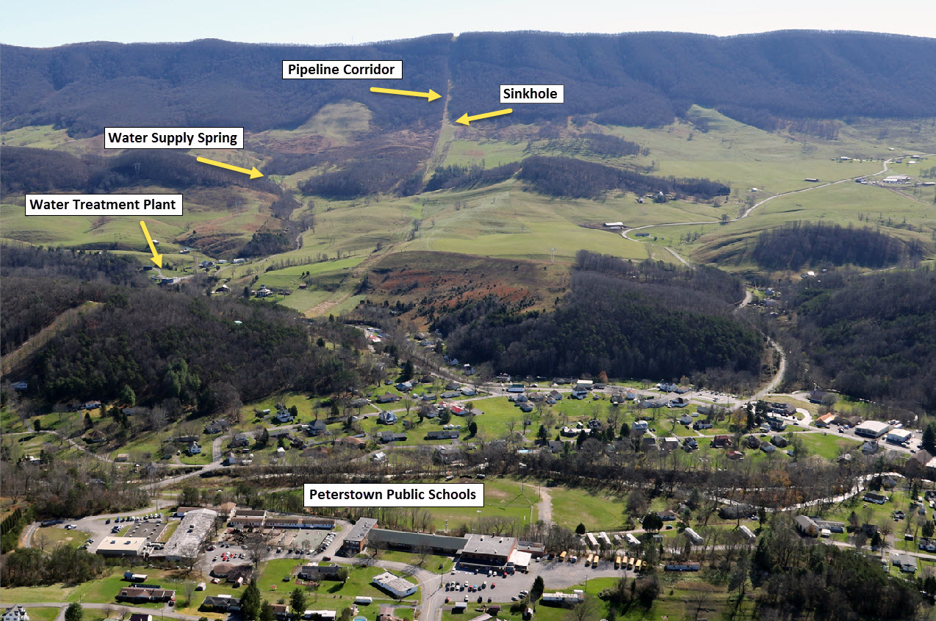
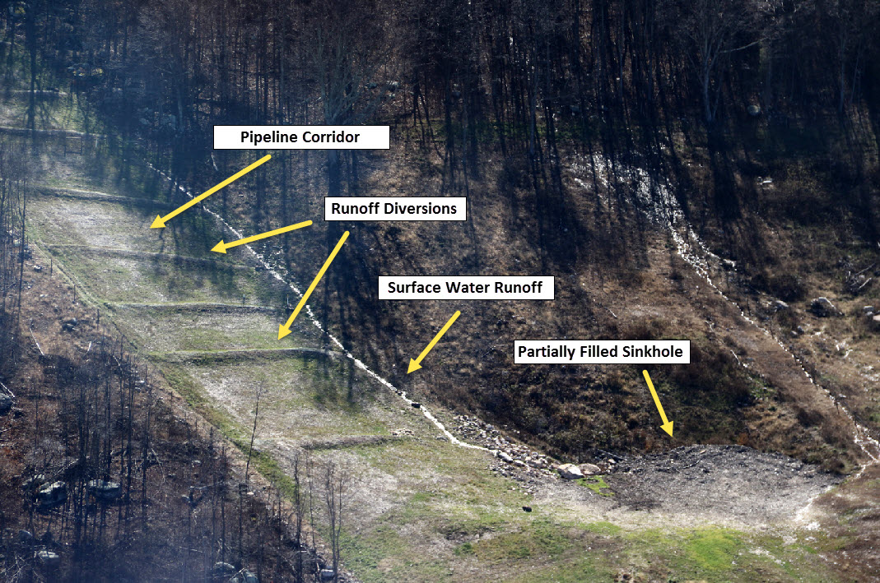
In a correspondence from the DPMC citizens and other interested organizations shared this information:
The DPMC's Pipeline Air Force obtained aerial photos of the sinkhole-water-supply problem area yesterday. There was heavy rain Wednesday and we expected to document that there is, in fact, an ongoing problem with stormwater discharge to the sinkhole that is part of the recharge system for the Red Sulphur PSD water supply system.
We had to delay our flight until Friday due to low cloud cover. However, surface water runoff from the pipeline corridor was still evident, and it was draining into the sinkhole. You can see this in one of the photos.
The question for the VA DEQ and other responsible VA officials (e.g., the Secretary of Natural Resources): is this an acceptable situation?
We contend that this represents an unacceptable risk to both public health and to environmental systems. We also contend that a stormwater discharge permit is required.
Our larger concern is that it will be impossible to build large pipelines across this type of karst terrain without significant discharge of stormwater runoff into karst systems. It will be extremely difficult even when, as in this case, the presence of the sinkhole complex was known.
We also have the problem that pipeline construction companies, and perhaps the DEQ, don't acknowledge that this as a problem.
This material will be posted on the DPMC website. Higher resolution photos are available. Meanwhile, feel free to share, etc.
Additional information about this problem, including a complaint to the VA DEQ, was posted on November 11th at: http://pipelineupdate.org/2015/11/11/regulatory-system-test/
In the following months problems persisted along the pipeline path on Peters Mountain. Erosion and Sedimentation problems were report to the VA DEQ and a fairly large mudslide was observed on the western slope. Here are some photo’s taken by my neighbor, Paula Mann who is a professional photographer after the pipeline was completed. The pictures below taken in May of 2015 clearly show the ongoing problems on the western side of Peters Mountain. 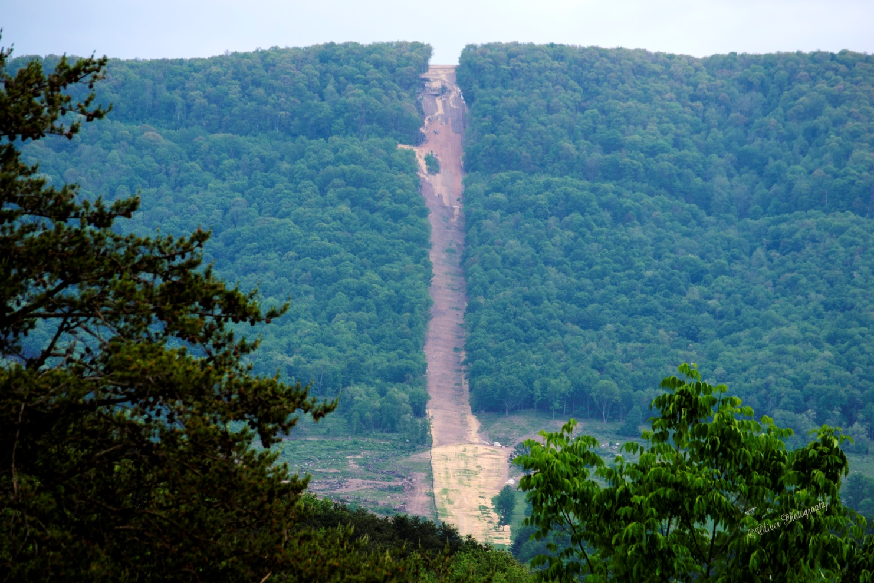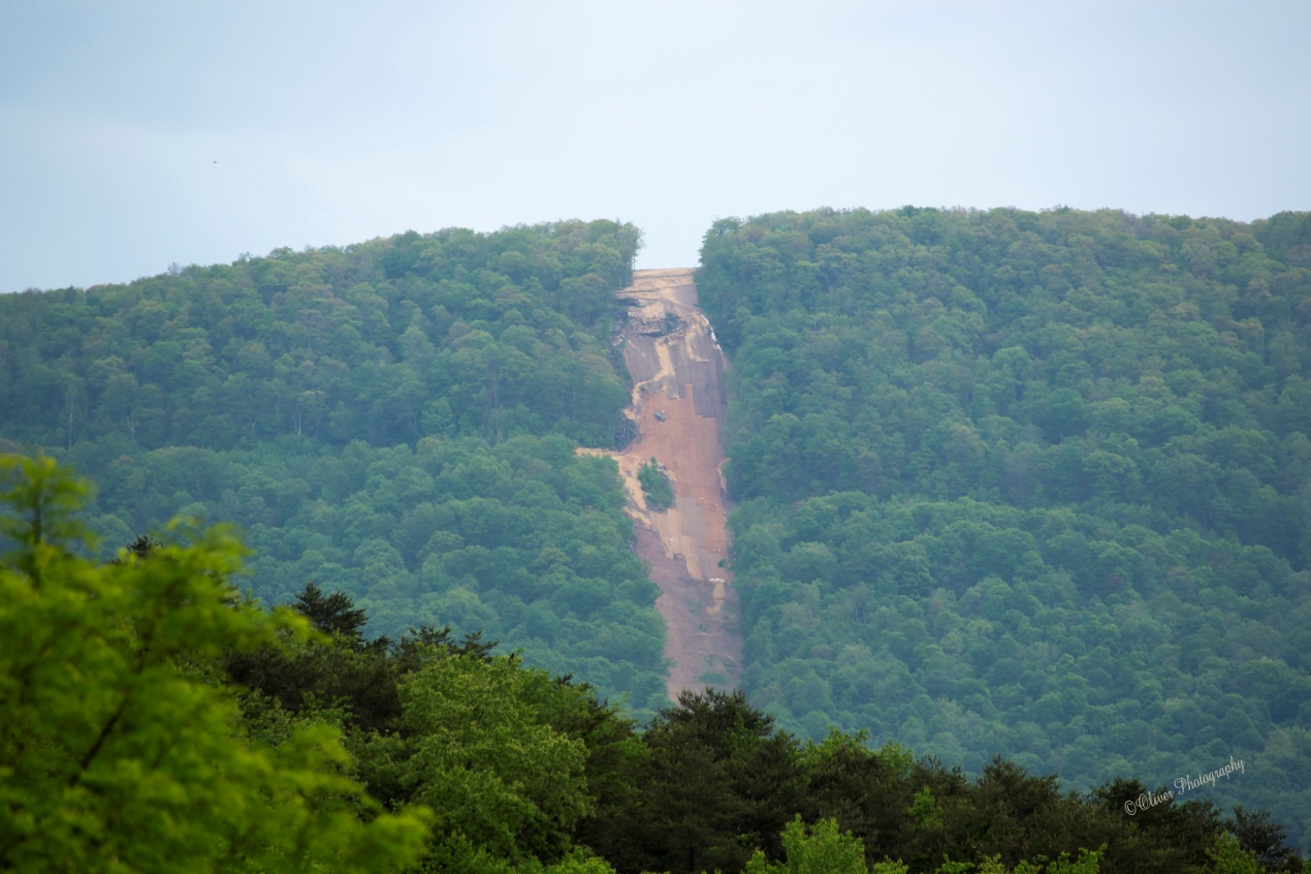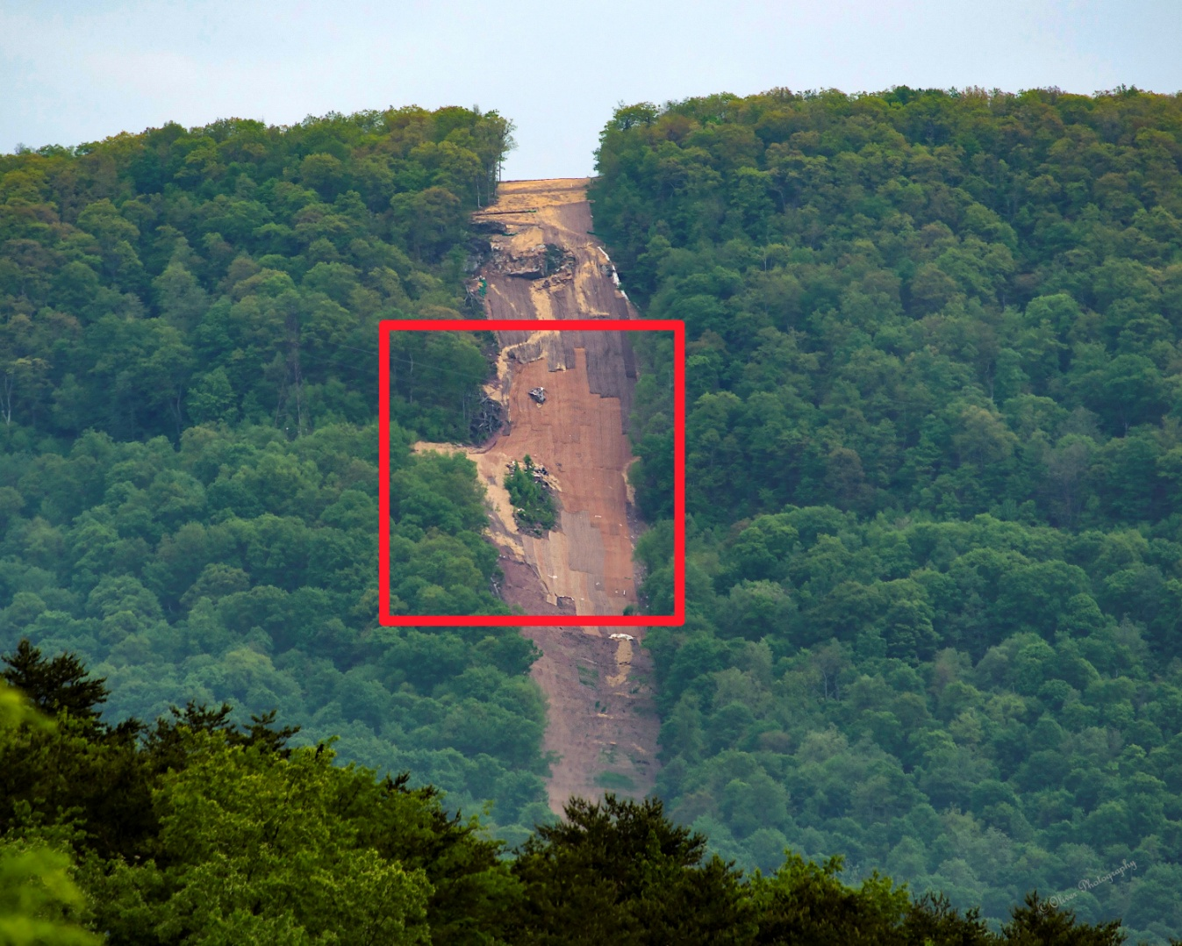
area highlight in the red box shows the problems associated on steep slopes in the Appalachian Mountains.
In 2015, debated raged around this mudslide which led me to write the following Op-Ed for The Roanoke Times to refute the misinformation being spread by the pipeline developer.
Johnson: The problems on Peters Mountain (roanoke.com)
The following picture was taken by Paula Mann in March of 2016. It shows the continuing problems with the stabilization and vegetation on the western slope of Peters Mountain, nearly 2 years after the pipeline was suppose to be completed.
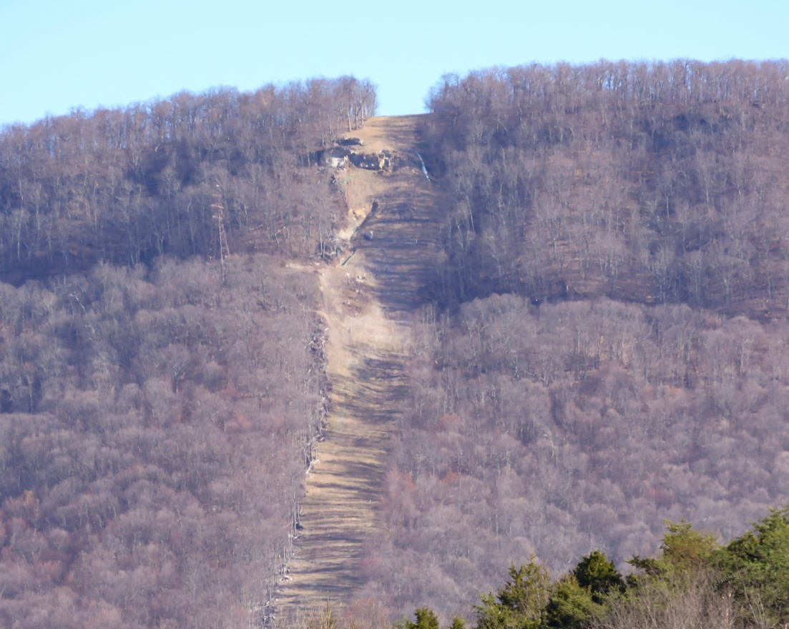
Here is a video I took in February of 2016. You cannot hear the audio very well but I was explaining how you can see the storm water runoff streaming down the ROW and into the sinkhole at te base of the mountain. Celco Pipeline across Peters Mountain Feb 24 2016 - YouTube. I took this video from US Route 219 near the where the pipeline cross the highway.
Below are some photos I took on February 18, 2023 with two different cameras of the “Celco Pipeline” across the western slope of Peters Mountain. The ROW appears to be worse now than it was in 2014, 2015 or even 2016.
With this comment letter I want to share recent photographs of the Columbia gas pipeline that delivers gas to the Celco manufacturing plant in Giles County. The pipeline was constructed through the Jefferson National Forest across Peters Mountain in 2014. An organization called the Dominion Pipeline Monitoring Coalition (mentioned above) published online a case study about the construction of the pipeline corridor and its impact on a public drinking water source. The DPMC’s work is published on the internet at this link http://pipelineupdate.org/case-study-no-1/, with the case study reported in many layers on the website. The DPMC’s records include the Environmental Assessment which found that there would be no significant impact from the construction of the Columbia pipeline.
In the case of the MVP, the Forest Service plans to require MVP to plant saplings and grasses in the corridor after the pipeline is constructed. The condition of the Celco pipeline corridor visible in the photographs below shows that vegetation has not been restored to the Columbia gas pipeline corridor. It seems that the condition of the nearby Celco pipeline corridor, also constructed on Peters Mountain, would be an indication of the capacity of these mountainsides to recover from industrial pipeline construction.
All the photographs included below were taken on February 18, 2023, with two different cameras. They are of the Western slope of Peters Mountain which can be seen from US Rt 219 and other areas near Peterstown WV. Even with the challenging lighting and distance, the barren condition of the pipeline corridor is evident in the photographs. These are the best photos of over two dozen that I took on 2/18/23. These were all taken from the Peterstown area of Monroe County WV. The sun cast a shadow on the mountain for most of the day at this time of the year. But as I stated above --- The condition of the Celco pipeline corridor visible in these photographs shows that vegetation has not been restored to the Columbia gas pipeline corridor. It seems that the condition of the nearby Celco pipeline corridor, also constructed on Peters Mountain, would be an indication of the capacity of these mountainsides to recover from industrial pipeline construction. 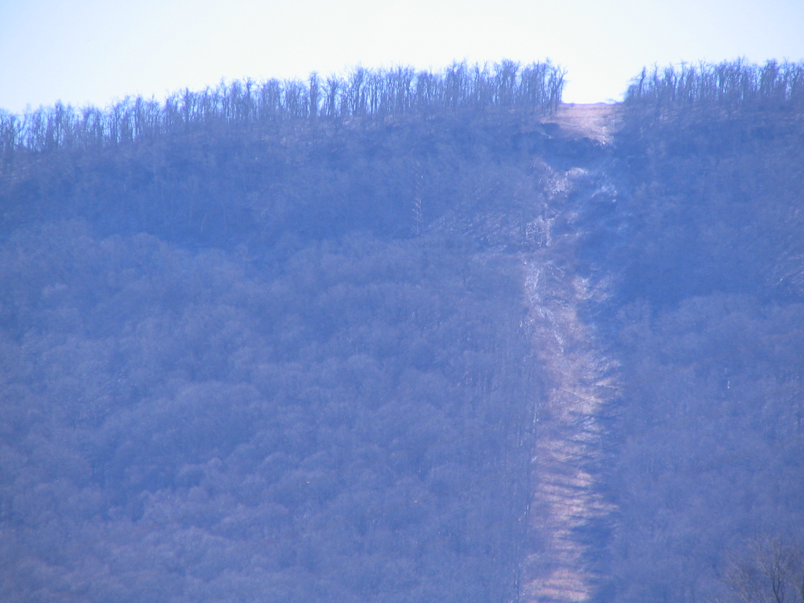
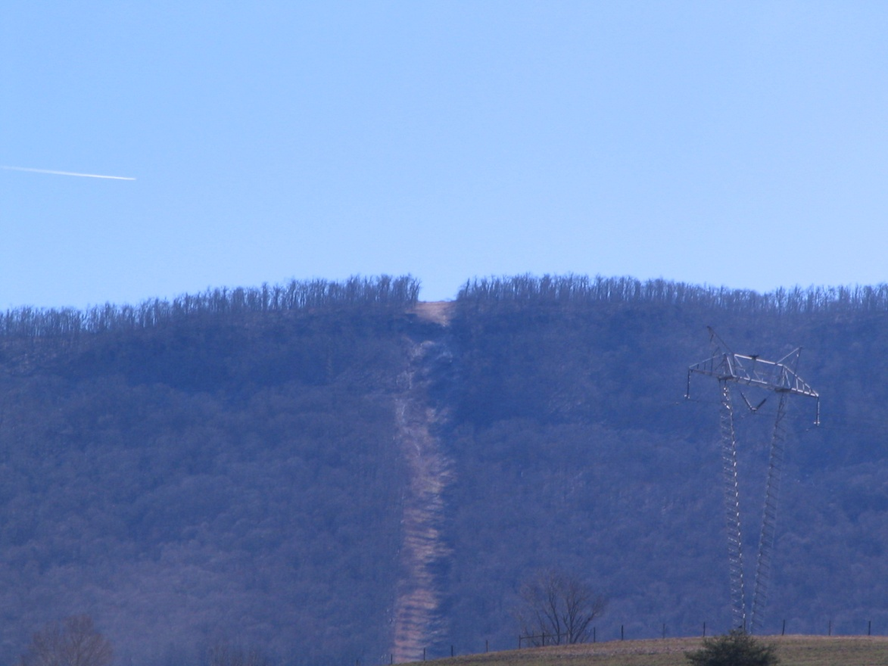
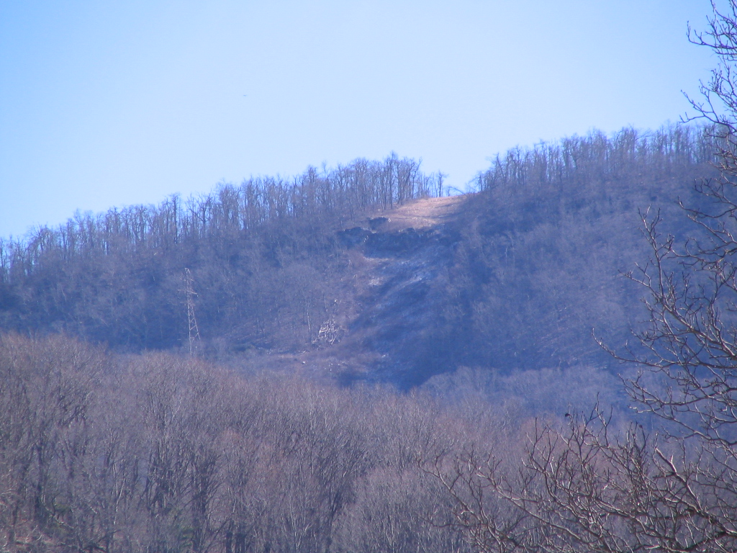
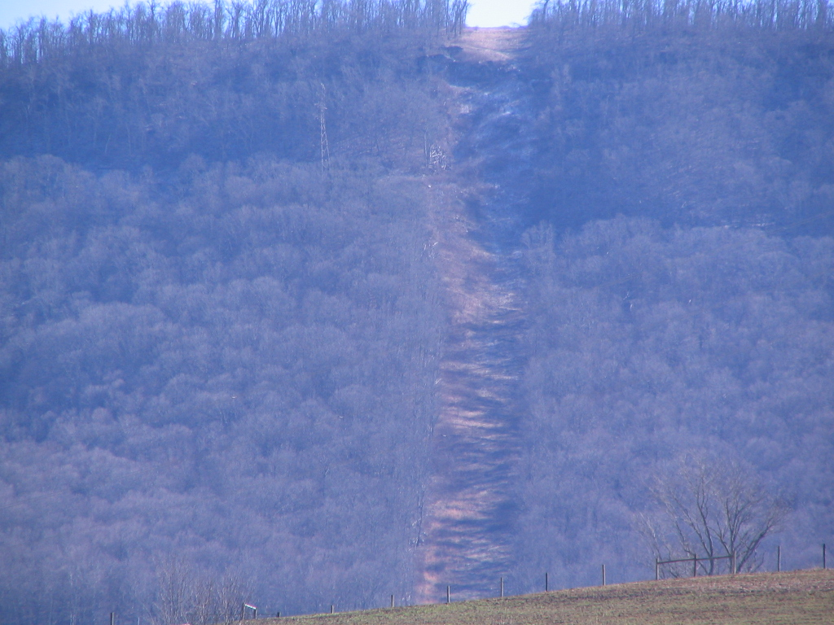
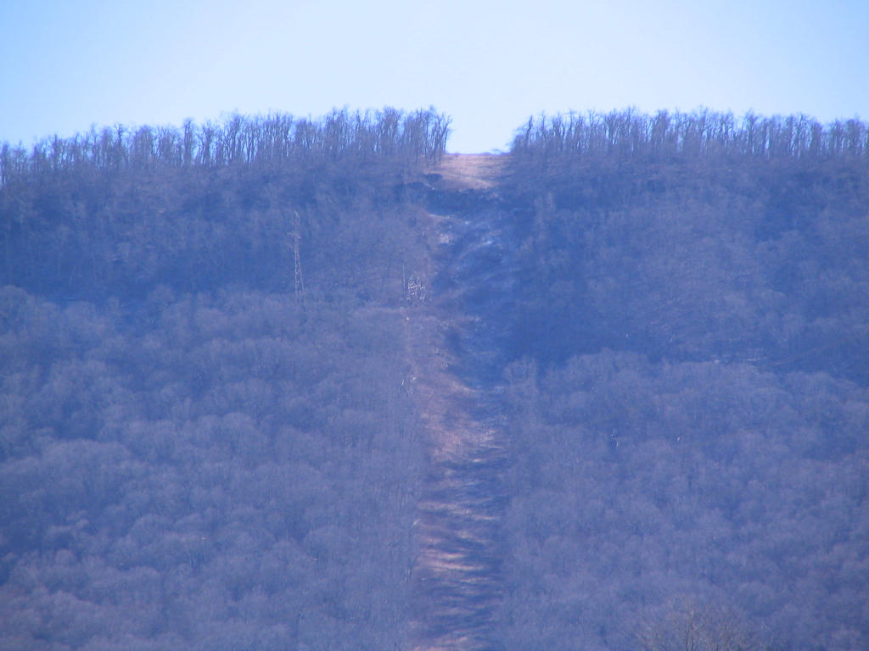
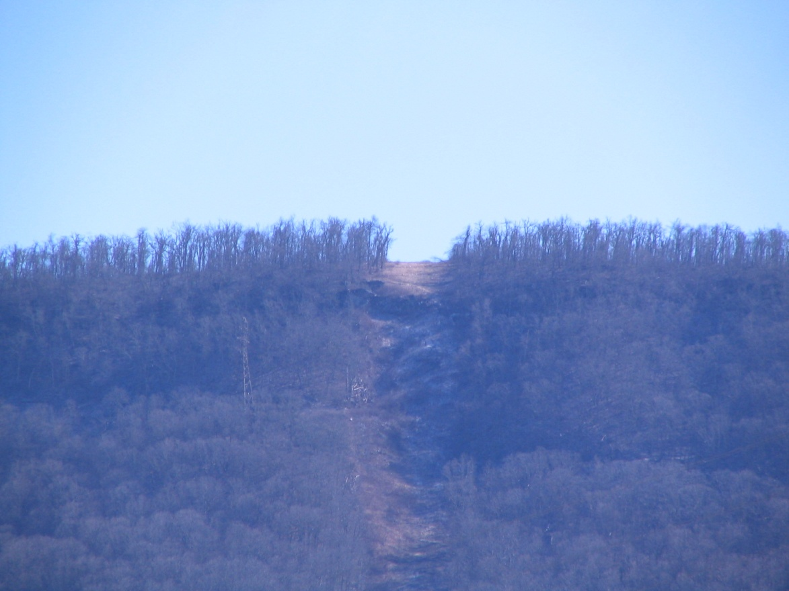
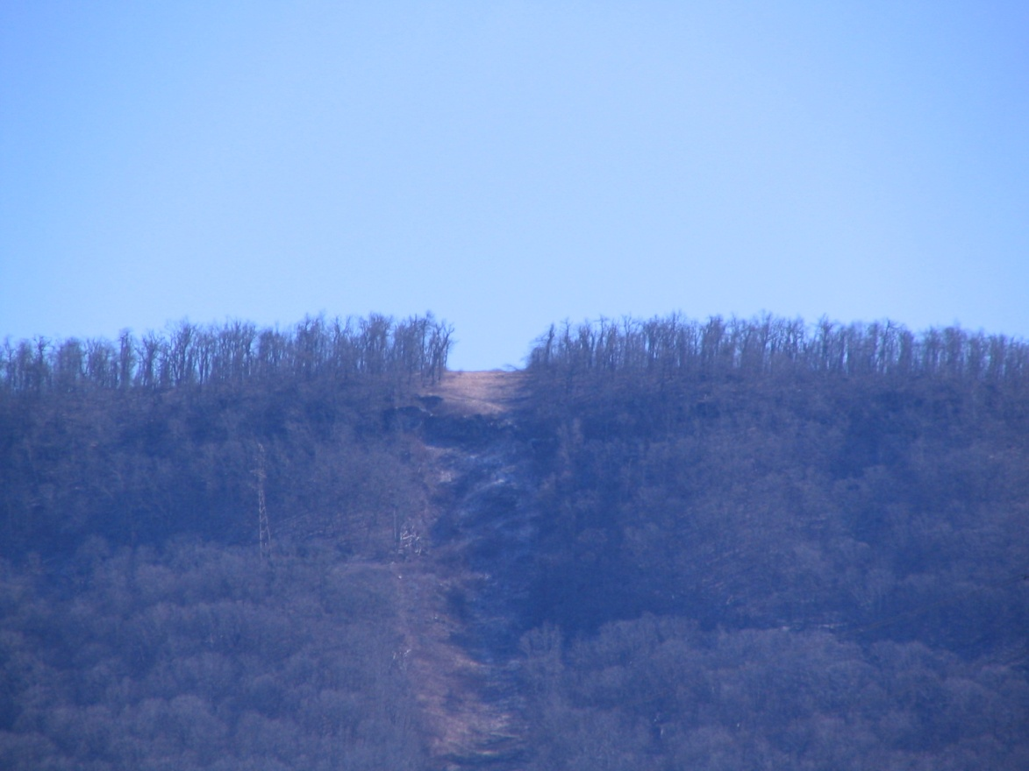

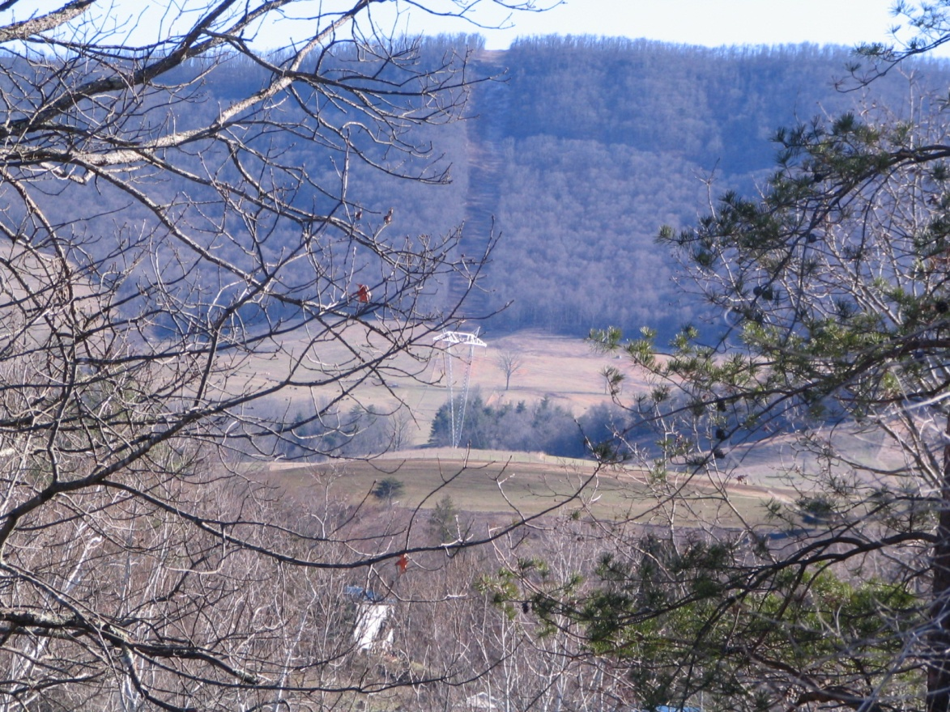
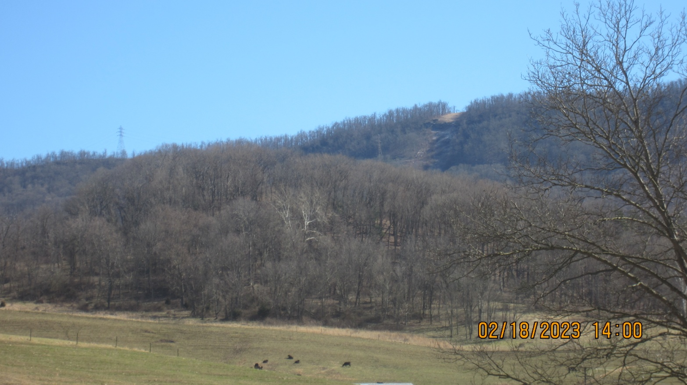
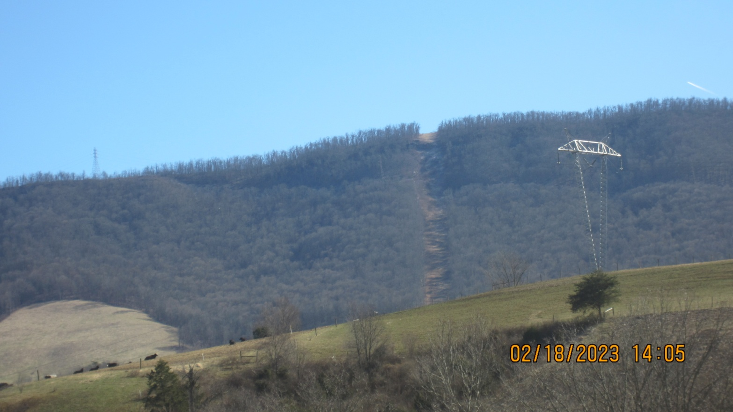
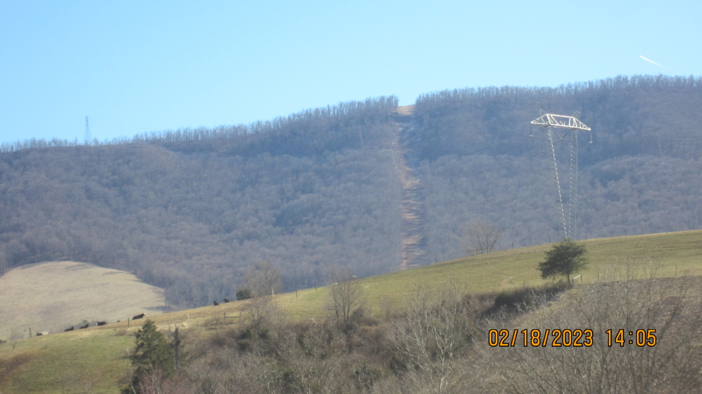
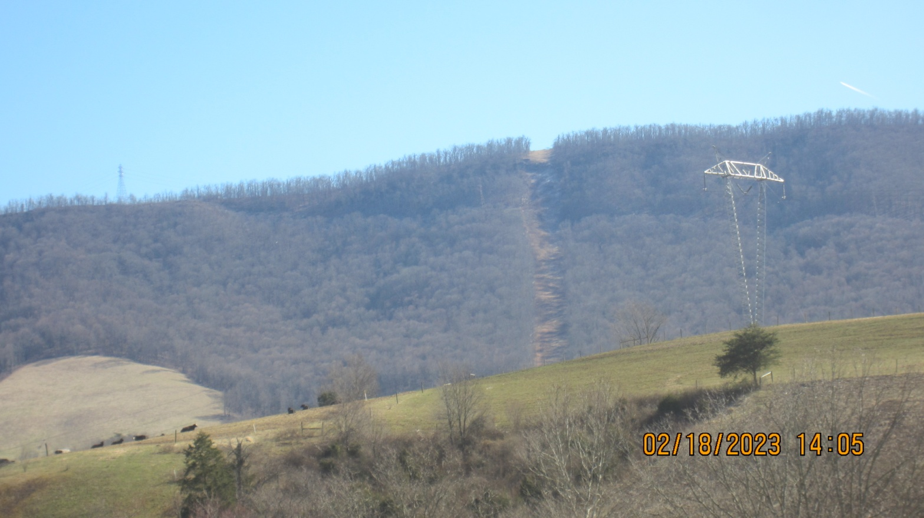
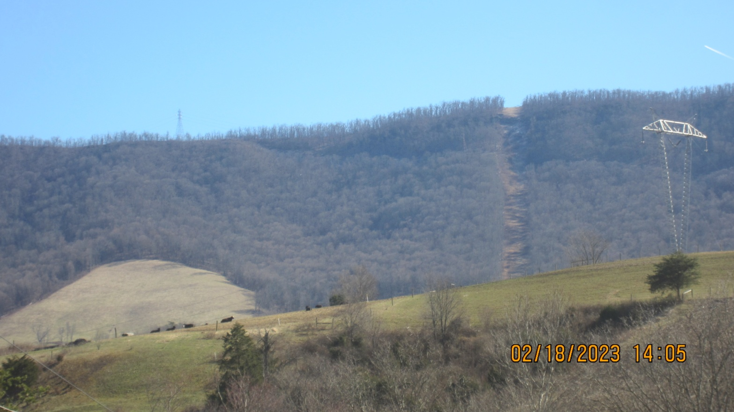
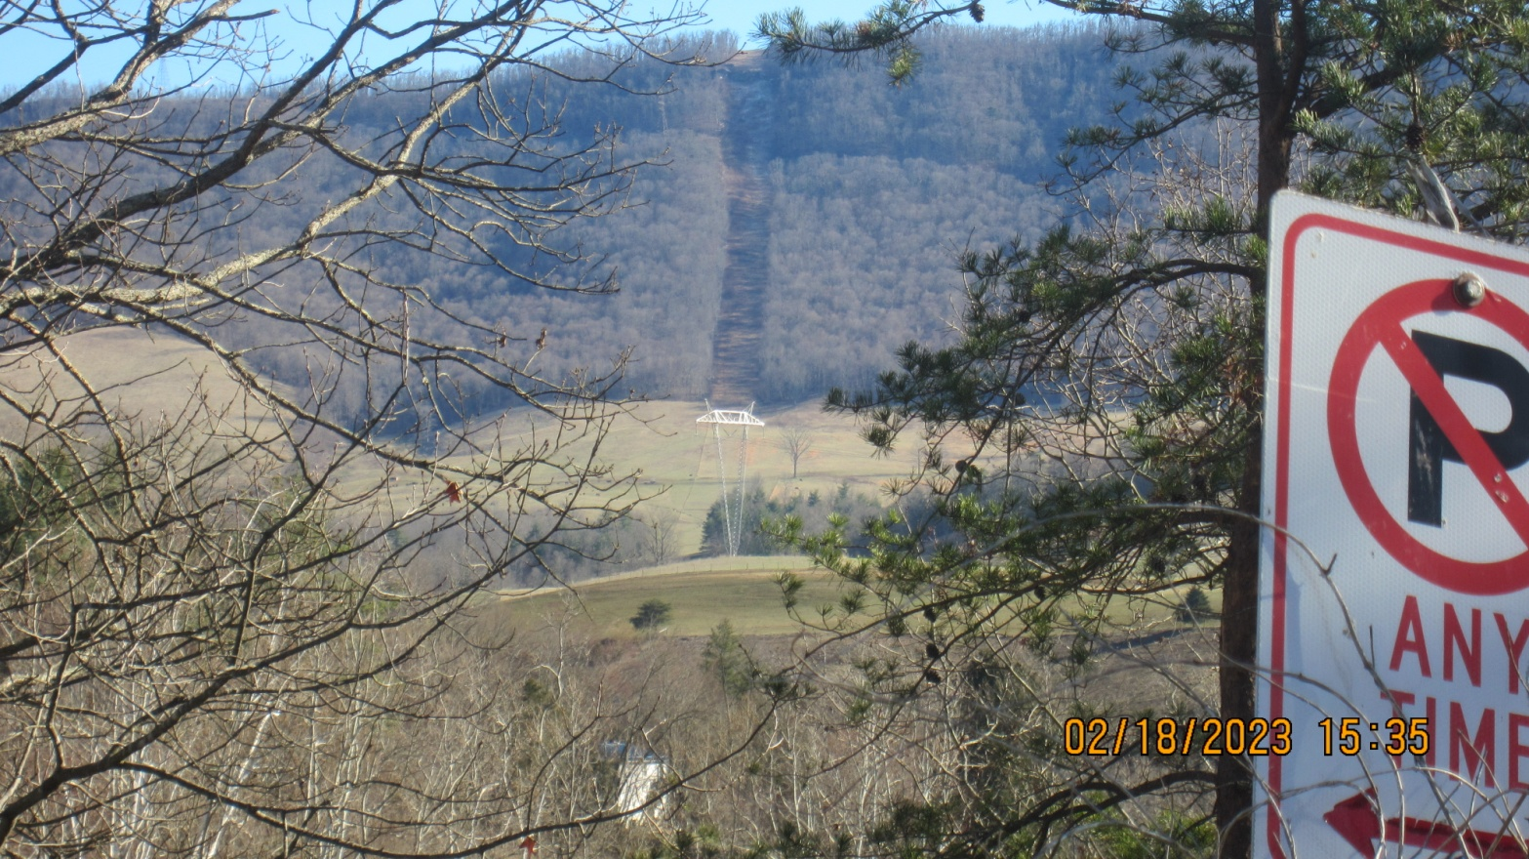
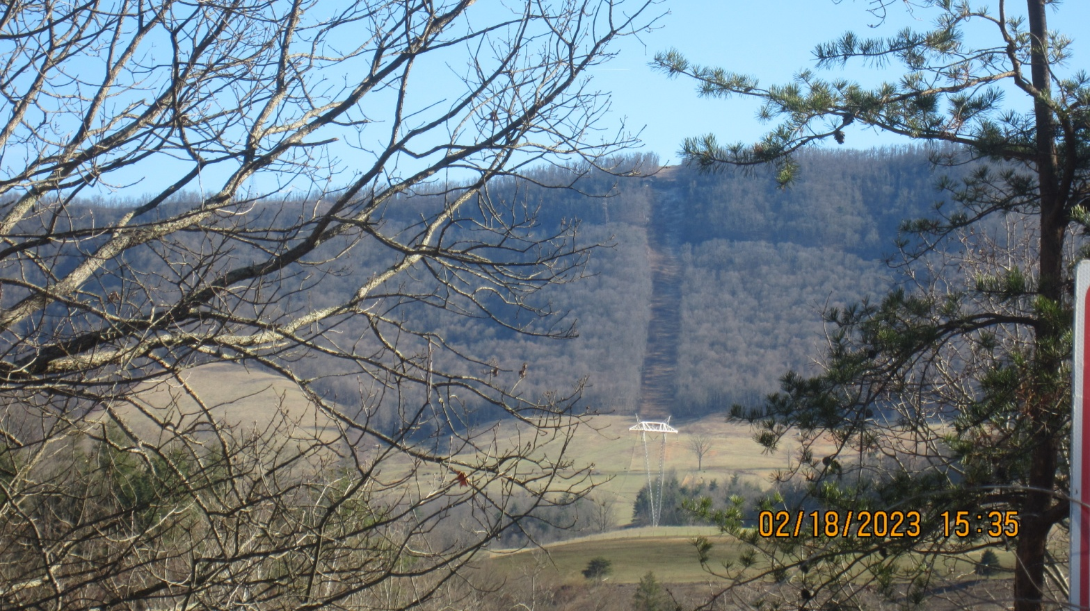

In 2014 after this water contamination, the Red Sulphur PSD officials expressed concerns about the crossing of the Mountain Valley Pipeline in their secondary water resource area. The Jefferson National Forest and adjacent lands on Peters Mountain is the recharge area for this resource. That concern is still relevant today. Here is a news story from the Beckley Register Herald from December of 2014 Red Sulphur PSD airs pipeline concerns | News | register-herald.com
I am sharing this information and concerns to highlight the perils of constructing any pipeline across terrain like the steep, slip prone slopes found on or near the Jefferson National forest in this karst region where if anything goes wrong you can contaminate the water that is depended upon by a large population of people and farms. This information should be considered in making a determination if the risk harm analysis is acceptable.
Another issue that the USFS must consider is that the MVP Crossing across Peters Mountain is directly in the Giles County Sesmic Zone. Here is some information about that area:
The Giles County, Virginia, seismic zone | U.S. Geological Survey (usgs.gov)
VTSO: Giles County Seismic Zone
Magnitude 2.5 quake rattles Pulaski County in wee hours (roanoke.com)
No damage reported from early-morning Pulaski earthquake (roanoke.com)
2.8 magnitude earthquake near Narrows, Virginia, United States and Charlotte, North Carolina, United States : May 12, 2017 04:31 (earthquaketrack.com)
Earthquakes and pipelines: recipe for disaster - Roanoke Appalachian Trail Club (ratc.org)
Small quake reported in Bedford County on Wednesday evening (roanoke.com)
Belleville: Earthquake zone? No place for a gas pipeline (roanoke.com)
Mountainous karst landscape should be a 'no build' zone for pipeline, geologist says (roanoke.com)
kastning-report-on-the-geo-hazards-of-the-proposed-mvp-final-july-5-2016.pdf (powhr.org)
Latest Earthquakes (usgs.gov) Earthquakes from 1982 until the present in the region, many are within the area where MVP Right of Way travels.
Another consideration is the vulnerable forest ecosystems. The loss of old-growth forest, which plays a crucial role in the creation of topsoil and filtering rainfall, cannot be mitigated and would impair biodiversity and water quality.
Additionally, it has been stated by many that the need for the Mountain Valley Pipeline is speculative and unproven, given existing supply alternatives and market shifts towards non-fossil alternatives. This is a question that the USFS must answer before either approving or rejecting this permit.
It has also been suggested that is inaccurate for the agency to equate the damage done to treasured national forest land with “economic benefit.” This again is a question that the USFS must fully explore before issuing or rejecting the permit for the MVP to cross the JNF. I have questions about exactly how is this determination is being made?

It is my understanding that the U.S. Forest Service motto is: “Caring for the Land and Serving People” which captures the Forest Service mission. It includes the statement, “Advocating a conservation ethic in promoting the health, productivity, diversity, and beauty of forests and associated lands.”
The entire mission statement is found here: What We Believe | US Forest Service (usda.gov)
There are a couple of “Cultural Resource Areas” located on Peters Mountain that should have had a Phase 2 Archeological Study. I first saw the area in February of 2018, just days before MVP cut the trees in the MVP Corridor. I asked USFS Official in the Forest Service Office in Roanoke about this area and was told a Phase 2 study was indeed scheduled for that area. When I went back to the area in mid March of 2018, MVP Tree Cutters had already cut the trees. How does MVP intend to do the Phase 2 Study that would need to be completed before a Permit could be issued? Has the appropriate Native American Tribes been consulted about this area? Below are my pictures from 2018 and a video that was recently completed by my neighbor who ventured up to Peters Mountain on February 7, 2023. 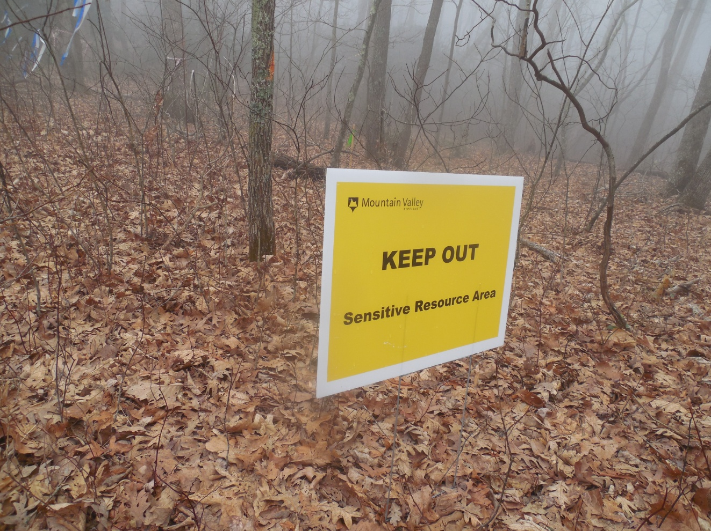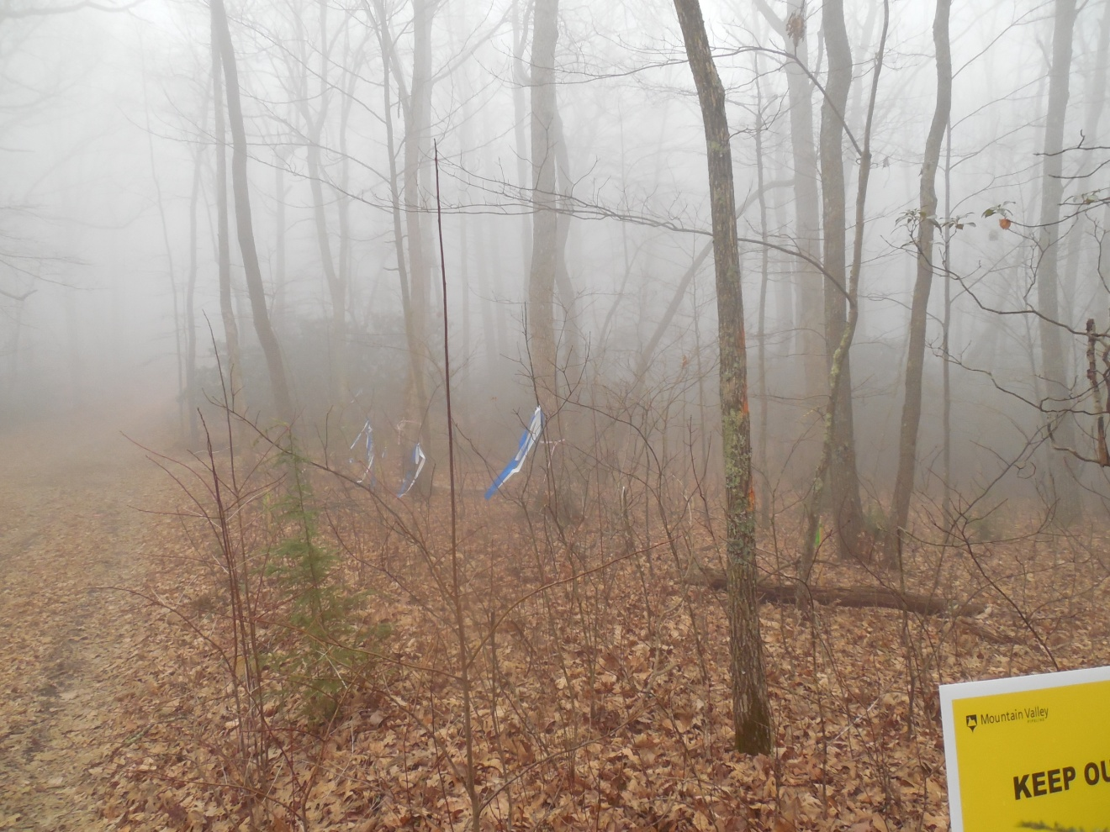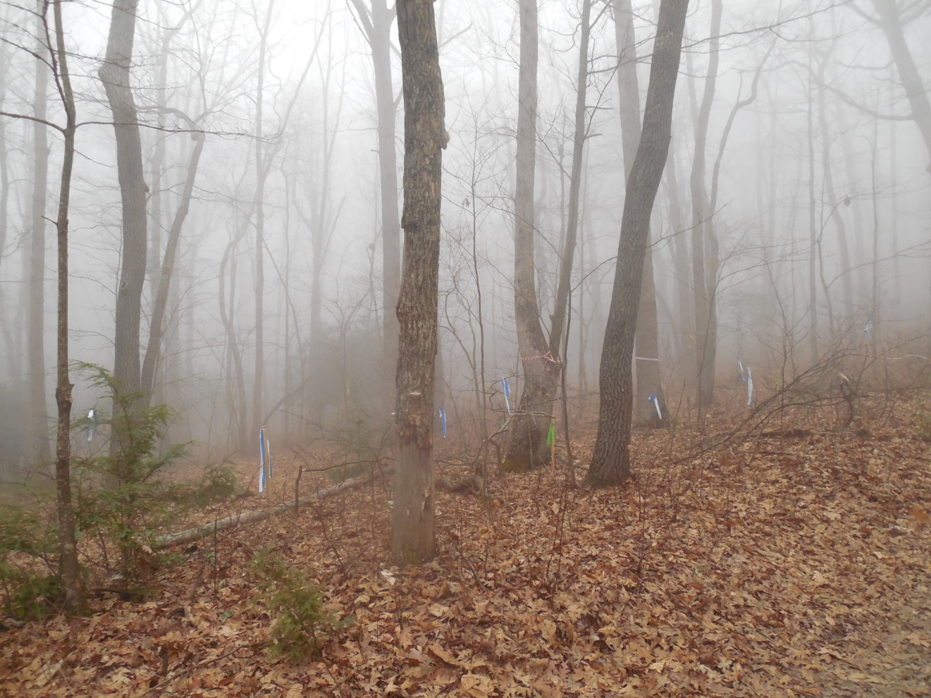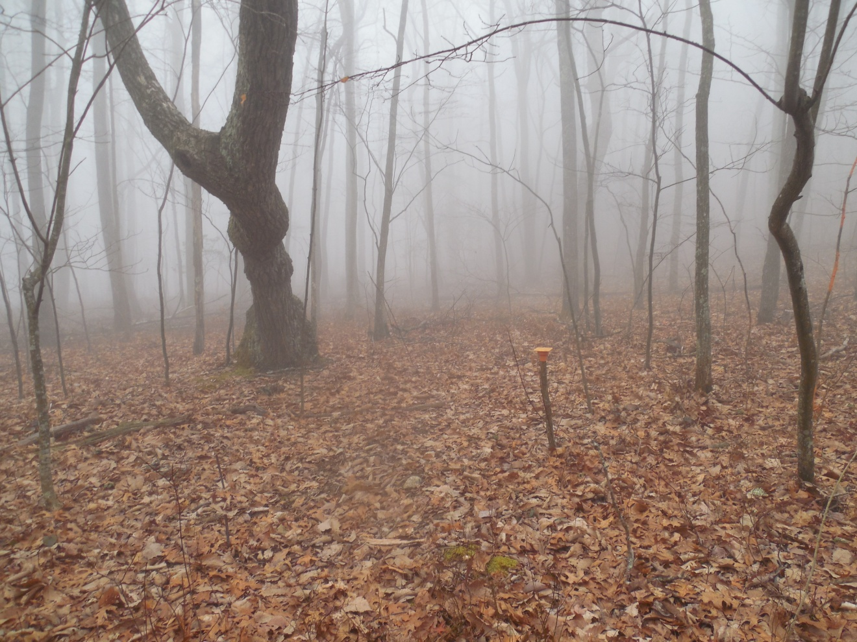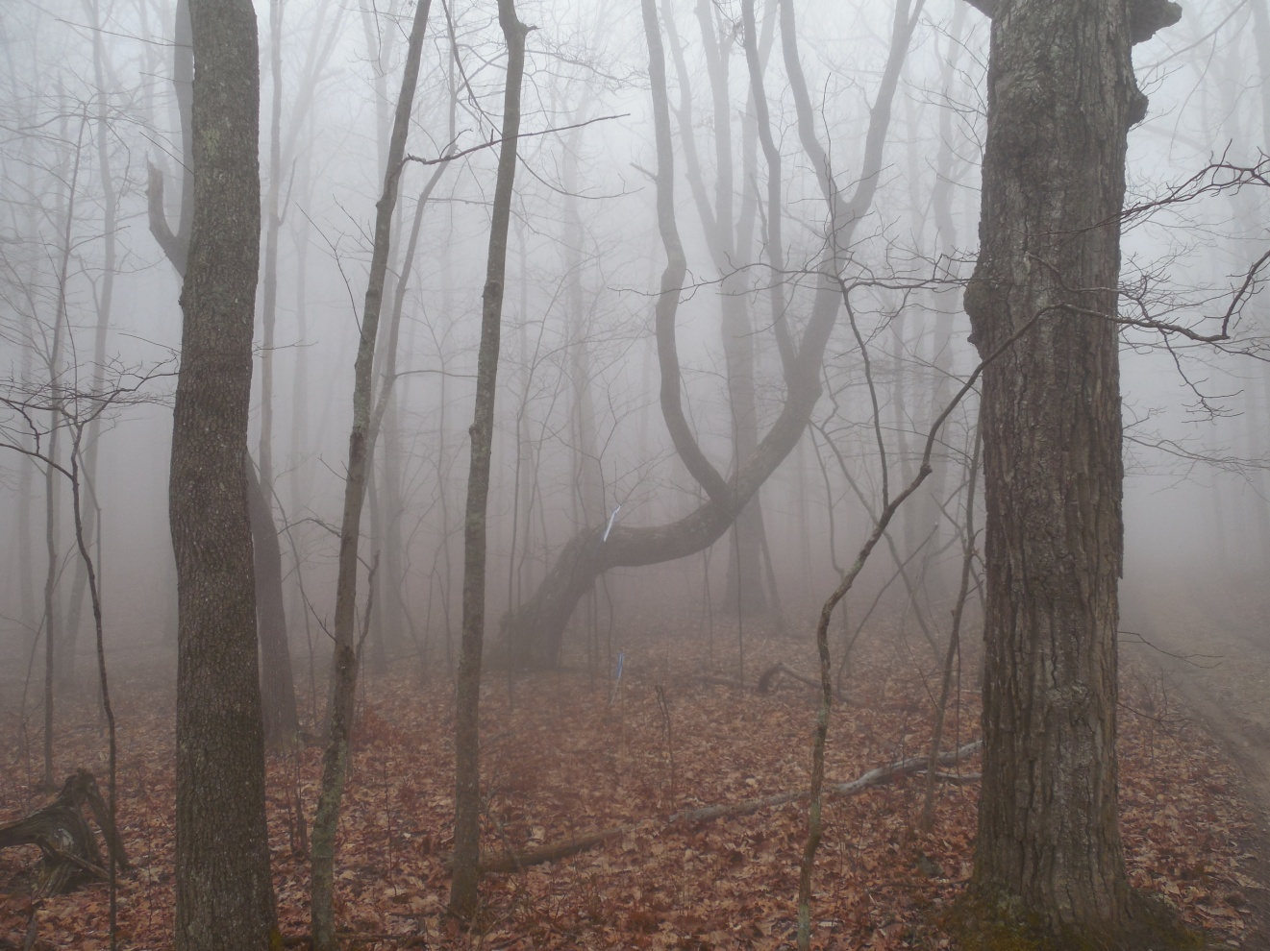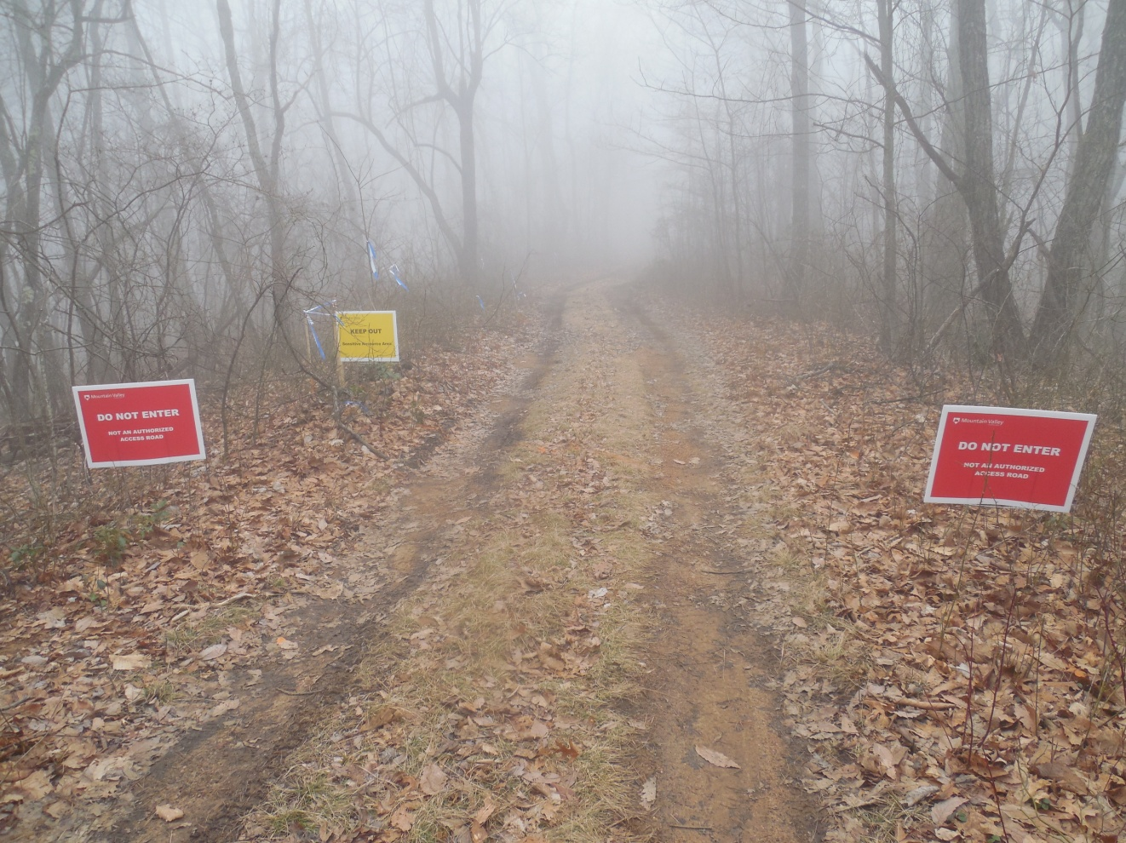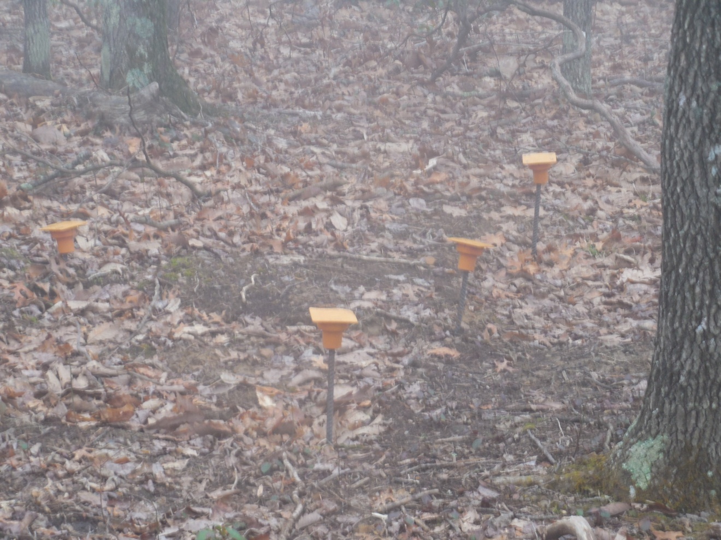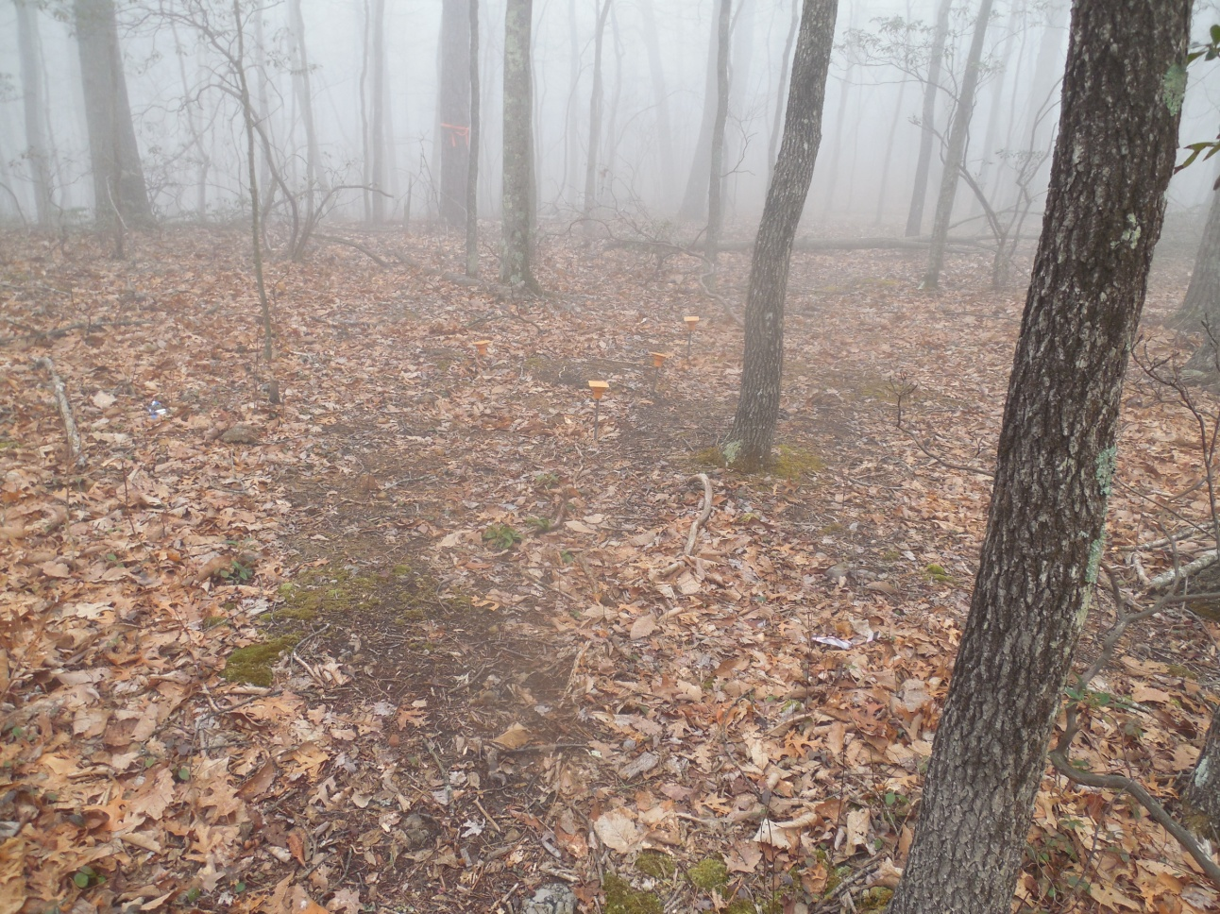
This is what this area looks like as of February 7, 2023
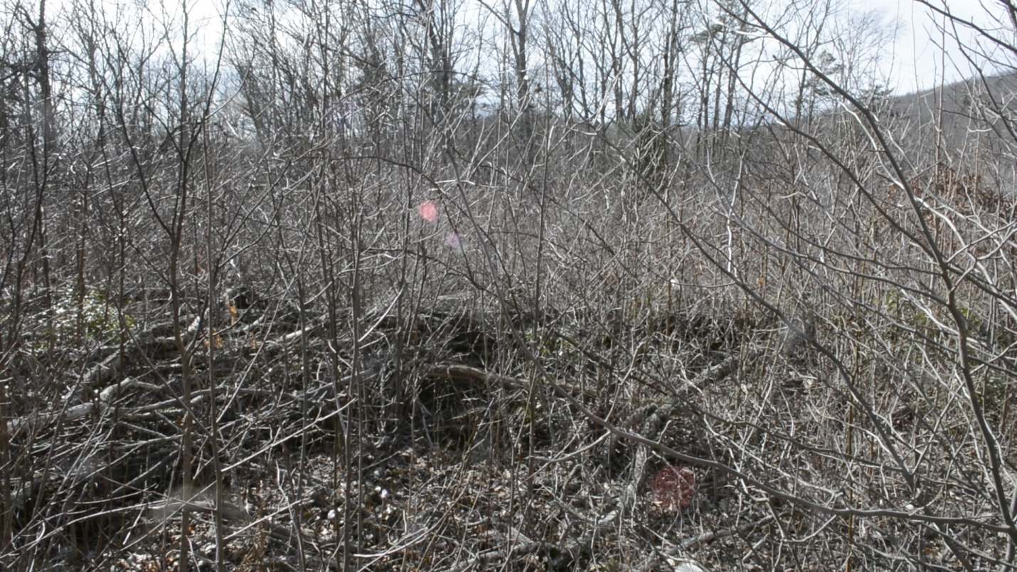
Picture taken by Paula Mann on February 7, 2023
YOUTUBE VIDEO LINK: https://www.youtube.com/watch?v=YmwjYRM63pk
This video addresses Native American Site, Viewshed from the Appalachian Trail and Sediment and Erosion Control Issues.
There is also the issue of degraded pipe that MVP wants to place in the Jefferson National Forest and adjacent property. I have taken many photos of this pipe including this past week. I will submit the video made by Paula Mann this past fall that addresses this concern. Will the Forest Service require that MVP replace this unsafe pipe if it issues a permit to cross the JNF ?
YOUTUBE VIDEO LINK HERE: Degraded MVP Pipe in Monroe County, West Virginia - YouTube
This leads me to my final question, How is breaking or amending 11 of its own conservation rules governing old-growth forests, scenic viewsheds, soil health and more to accommodate any single project staying true to the USFS mission or the law?.
America's National Forests are held in the public trust as special lands. They are the headwaters for our rivers and streams as well as springs and wetlands which are critical for our drinking water and other uses. They are provide habitat for animals and plants including threatened and endangered species. They provide us with scenic beauty and recreational spots where we go to rest, relax and recreate.

As I have stated above, this letter is not in support or opposition of the permit in question, but rather a letter to raise questions and to supply the USFS with information it may not have. With that said the USFS must make a precedent setting decision in whether to make the changes to the Forest Management Plan to accommodate MVP and by default any other project that comes along in the future wanting similar concessions. It must decide whether it is in the public interest to approve or to deny the MVP Permit Request to cross the Jefferson National Forest and the AT in the JNF. This is not my decision but is a decision that the US Forest Service must considered very carefully.

Sincerely,

Maury W. Johnson
3227 Ellison Rdg
Greenville, WV 24945

