GOLD CREEK POND-MODIFIED ALTERNATIVE B
Attention: Project Partners

We support the following proposal for the United States Forest Service’s (USFS) plan to enhance bull trout habitat in Gold Creek valley, so that bull trout populations may increase and flourish in the upper Yakima basin. This proposal primarily focuses on the plan for the Gold Creek pond, with a few general comments relating to Gold Creek. Additional comments on Gold Creek will be forthcoming as more information becomes available from the USFS and its partners.
We support a plan to enhance the Gold Creek pond area. This area presents a unique recreational experience adjacent to the Alpine Lakes Wilderness. Because of Gold Creek pond’s proximity to I-90 it is an area that many travelers and visitors can enjoy. The alpine setting is a true treasure, framed by Rampart Ridge on the east side of the valley, Chikamin Peak at the head of the valley and Kendall Peak and other mountains on the westside. On clear days, these mountains (and the sky) are reflected on the surface of Gold Creek pond. Currently there is a combined asphalt and elevated wooden trail around the pond that is ADA accessible. Way stations around the pond provide information to those who are walking around the pond, information related to the history of the pond and the animals that inhabit the area. Picnic faculties are present at the south end of the pond.

To date (July 2021) the USFS has proposed three alternatives for the restoration of Gold Creek pond; referred to as alternatives A, B and C. These alternatives can be found on the USFS’s website. We support a modified alternative B as discussed here and as shown on the attached graphic, figure 1.

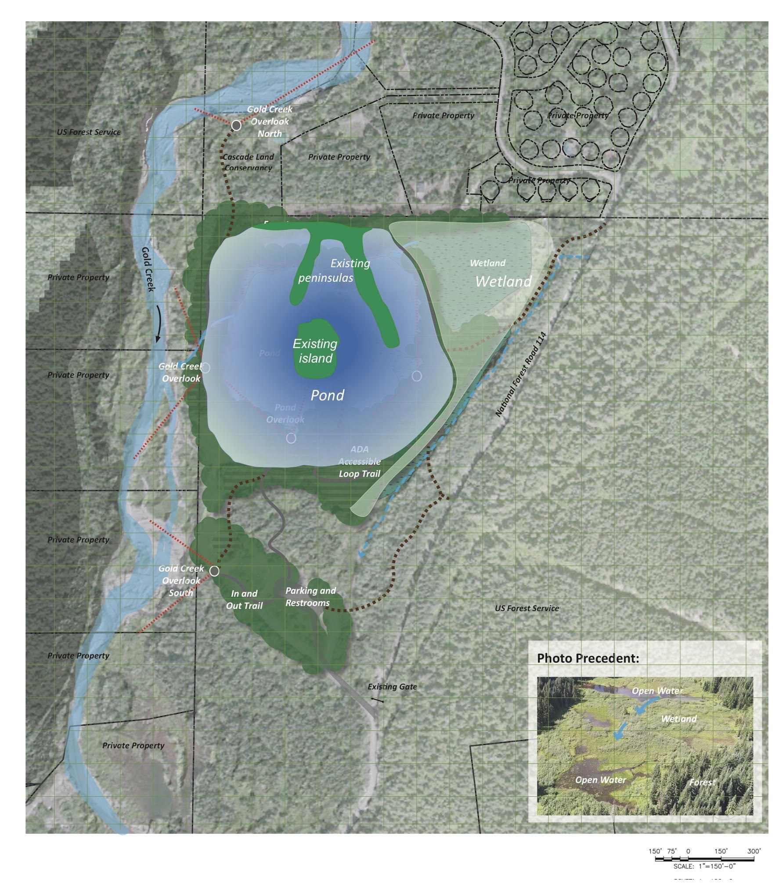
Figure 1

Figure 1 Modified alternative B-Key features of this modified plan compared to alternative B include leaving the pond’s footprint essentially as it exists today (note below, that if it is shown that the pond lowers the groundwater and water in the stream in the identified dry reach, the pool elevation can be raised which will cause the groundwater table to rise, resulting in better exchange between groundwater and surface water in the creek. See Figure 2.
This proposed plan would not involve any fill material being placed in the pond, either to reduce the footprint or reduce the depth of the pond. In addition, this plan presented below meets the NEPA purpose and need.
The modified alternative B plan would relocate the pond outlet from the eastside to the westside of the pond as shown in Figure 2. This relocated outlet flow would be directed into Gold Creek such that the outlet flow channel length would be minimal. Moving the outlet ensures that colder water from the pond enters Gold Creek. Consideration should be given to raising the pond surface elevation if it can be determined that the pond is lowering the groundwater table in the immediate vicinity of the pond. This could easily be accomplished by allowing the water level in the pond come to equilibrium with the ground water table.
Figure 2
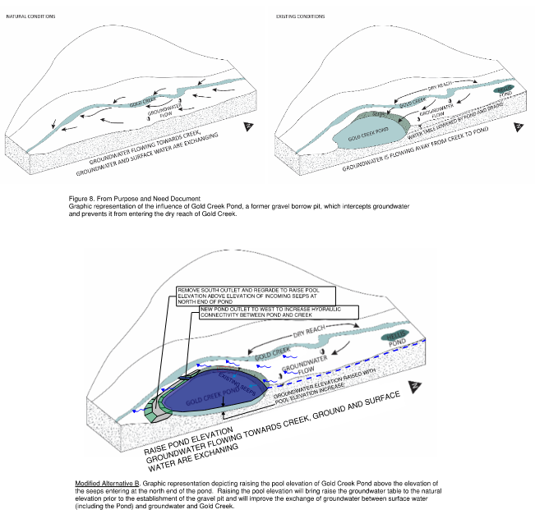
Figure 2

For example, the new westside outlet for the pond would be constructed with a simple vee-shaped concrete flow control structure whereby the bottom of the vee would correspond to the elevation of the ground water table. After the westside outlet and flow control structure are constructed, the east side outlet would be filled in, and the water in the pond would rise (if it is lower than the groundwater table) until it is at the same elevation as the groundwater table. Material excavated from constructing the westside outlet would be used to fill in the east side outlet. Fill material would not need to be trucked in for this proposal.
With a flow control structure, water flowing out of the pond would not allow the water in the pond to drop below the elevation of the groundwater table, allowing the pond to function independently from flows in Gold Creek. The cost to relocate the pond outlet from the eastside of the pond to the westside and install a concrete flow control structure is on the order of $400,000. The timeframe to construct the new outlet (and fill in the existing easting outlet) would be several months.
Advantages of modified B compared to current alternatives A, B, C
- Cost- $400,000 vs $14,000,000 to $20,000,000 or more. The money saved could be applied to other fishery habitats in the Yakima basin.
- Time to construct-3 months vs 2 or more construction seasons for alternatives A, B or C.
Environmental impacts-none (or very minimal) for the modified B alternative vs the following large temporary (2 seasons or more) impacts associated with the construction of alternatives A, B or C
  - Noise, dust, air pollution, and water quality degradation/turbidity in Gold Creek due to discharging pond water that is displaced by the infilling operation,
  - These impacts will have a direct effect on the USFS’s recently established wildlife corridor, which is immediately adjacent to Gold Creek Pond and adjacent to the roads which will be traversed by dump trucks and other construction traffic,
  - Consumption of resources
    - Between 190,000 to 320,000 gallons of diesel fuel from hauling material to the site (and from other construction equipment), and the resultant contribution to climate change.
    - The placement of approximately 750,000 cubic yards gravel borrow used for the fill material in the pond.
  - Recreational users of the site would be prohibited from accessing the site during this timeframe due to the large scale of construction at the pond.
  - Construction traffic would create congestion along the roads accessing the site affecting the communities of Ski Tur and Starwater.

The benefits of the modified B alternative (in addition to low cost, short construction duration, recreational use during construction and no temporary environmental impacts)
- Cold water discharged from the pond into Gold Creek in the modified B alternative vs warmer water discharged to Gold Creek due to infilling the pond.
- Maximizes recreational use vs reduced recreational use after construction. It is assumed that there will be a reduced desire on the part of recreational users to visit the site if the pond is filled in or a large wetland replaces the pond.
- Reservoir pool for Wildfires: Since Gold Creek pond and Heli’s pond would not be filled in, both ponds could be used as a source of water if there were wildfires in the valley or surrounding area vs not having pond water as an option for fire suppression water. The Ski Tur Valley community maintains its own water system and there is not enough flow in the existing system to fight wildfire and/or structure fires. Both ponds act as critical reservoirs for fighting fires either by firefighting equipment from Fire District 51 or as a source of water for aerial drops from helicopters. If used as reservoirs for firefighting helicopters the location of the ponds significantly reduces the transit time from having to travel father to Lake Keechelus and will allow helicopters to stay on station longer and be more effective with reduced times between water drops.
Other relatively low cost features of this modified B proposal include enhancing the existing low-class wetland on the northeast side of the pond and constructing wetlands on the east side of the pond where the current pond outflow channel is, creating a continuous wetland on the east side of the pond. Topsoil and soil amendment would be brought in and placed around the area bordering the pond. Native plants would be planted and figure prominently in this area. More picnic tables and freestanding grills would be installed around the pond. Additional interpretative signing could be installed around the pond including signing discussing bull trout enhancements in Gold Creek, information on the Alpine Lakes Wilderness recreational area including a map of the valley highlighting the lakes and hiking trails, history in the valley including mining and logging, etc.
The asphalt trail around the pond should be widened while meeting ADA accessibility requirements. The wooden section of the trail should also be replaced and widened to the match the width of the asphalt trail.

These enhancements are not required for bull trout habitat and could be constructed if funding is available. The total cost of modified B including the enhancements would be about $4,000,000 compared to $14,000,000 to $20,000,000 plus for alternatives A, B and C.
Other features related to the modified plan B include relocating the Starwater storm drainage system so that it discharges into Gold Creek, assuming that the function of the storm drainage system is not degraded as a result of relocation. The parking capacity would remain as it is today. Finally, Heli’s pond should remain in its current state (or construct a flow control structure if it can be confirmed that the pond lowers the groundwater table).

The major issue with bull trout habitat in Gold Creek is the lack of flowing water in the stream during critical times in the life of bull trout. Because of the natural geomorphology of the stream and stream

flow conditions of the creek what water does enter the stream during late summer/fall infiltrates into the ground so that there isn’t stream flow to naturally support bull trout in most years (see photo below taken of Gold Creek in 1936 before the Gold Creek pond was constructed).
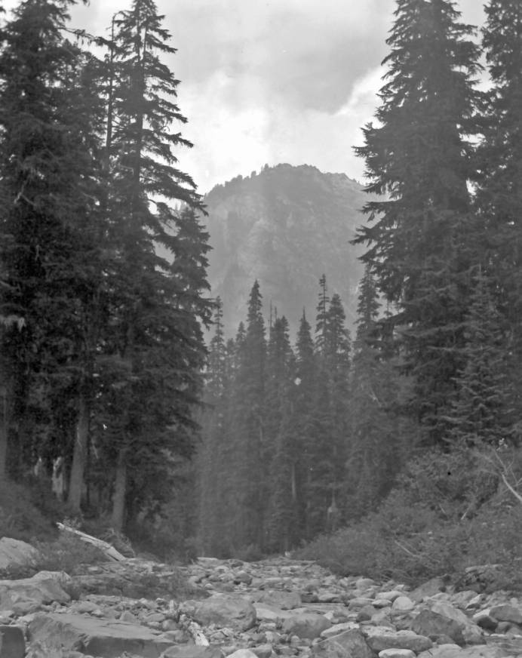
Photo by Pio Panieri taken at Gold Creek on August 13, 1936 (from the Washington Rural Heritage Digital Collection). Snowfall in the winter of 1935/36 was approximately 35% higher than the winter snowfalls of 2017/18 and 2018/19, and yet Gold Creek had sections where there was no stream flow.
Large sections of Gold Creek can be classified as “losing stream sections” which is a natural physical characteristic of a stream where it runs dry during periods of low streamflows because the streamflow infiltrates into the ground. Note, this photo was taken many decades before Gold Creek pond was constructed.
Filling in Gold Creek pond as proposed in alternatives A, B and C will not lead to an increase in stream flows which is the basis for putting forward alternatives A, B or C. In addition to the natural physical deficiency of Gold Creek, climate change will lead to decrease flows over the next several decades (or more), because of predicted reduced snowfall and faster melting of the snowpack in the Spring, and reduced rainfall in the Spring and Summer. Gold Creek has in the past been a challenging site for bull trout, and it will be more challenging with the effects of climate change. Spending $14,000,000 to $20,000,000 or more filling in Gold Creek pond as presented in alternatives A, B and C will not improve bull trout habitat. Modified B allows a modest improvement by discharging colder water into Gold Creek for a modest cost compared to A, B and C. In conclusion modified B is the best alternative. The money saved by constructing Modified B could be spent on fish habitat at other locations where a benefit in bull trout habitat could be realized. Constructing alternatives A, B or C have major environmental impacts, including discharging warmer water into Gold Creek after construction compared to modified B. Modified B maximizes recreational use during construction and post construction which is a win-win situation for bull trout habitat and recreational users of the site, as the majority of comments from recreational users at Gold Creek pond preferred that the pond is not filled in or altered.
One outcome could be that there is not a feasible solution to increasing bull trout populations in Gold Creek. The multi-disciplinary team should consider Cold Creek and Meadow Creek for bull trout habitat as these two creeks appear to have year-round stream flow. Both of these creeks discharge into the Keechelus Reservoir. Finally, the Native American term for Keechelus means “few fish”. This term came before there were man-made impacts in this section of the watershed.

Respectfully submitted,
Bruce Nebbitt-geologist, geological engineer, licensed civil engineer
Robert Mecklenburg-physician, biomedical scientist
Jim Sammet-licensed civil engineer, consulting engineer, fire commissioner
Peter Barry-geologist, hydrogeologist in the field of consulting engineering

