November 26, 2021
RE: Grand Mesa, Uncompahgre and Gunnison Forest Plan Revision #51806
Comments on the Draft Forest Plan and Draft Environmental Impact Statement for the Grand Mesa, Uncompahgre and Gunnison National Forests
My wife and I live in the 4th filing of Crested Butte South (CB South) and own the uppermost lots in the subdivision. We have been full time residents in CB South since the fall of 1994.
I would like to commend the preparers of this complex document, as it covers a vast area with many resources and uses. I understand that this is document is a Draft “Programmatic” EIS (DEIS), which covers broad management practices, but will require individual environment studies or actions, under NEPA, such as Environmental Assessments (EA) or Categorical Exclusions (CE) for specific actions within the domain of the Final “Programmatic” FEIS Record of Decision (ROD).
Because of the vast nature of DEIS my comments primarily focus on the area within the Gunnison National Forest.
- I support Alternative D in the DEIS. Which focuses more on the environmental effects and less on the economic benefits. I also support the comments presented by the Town of Crested Butte (dated November 1, 2021) and the Gunnison County Commissioners (dated November, 23, 2021).
- I would also recommend that the winter travel management mapping and language in the DEIS be completely taken out of the FEIS as this sets a preconception that these actions have been scrutinized under NEPA
- If discussion of winter travel management is included in the FEIS it should include stronger language explaining that it is only a “place holder” for the forthcoming Winter Travel Management Plan EIS. And that the winter travel management actions presented in the FEIS have not been fully analyzed and screened under NEPA.
I appreciate your consideration of my comments and I am looking forward to reviewing the FEIS.
Sincerely,
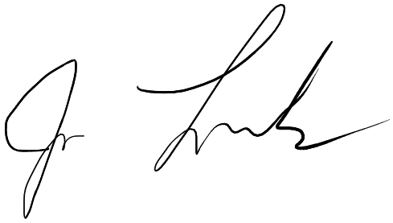
Joe Frank

