Comments for GMUG Forest Plan Revision:

Comments common to all Alternatives:
- Bear Creek NRA management areas:
  - The Bear Creek NRA corridor/area is too large. It looks to be 500+ feet from centerline. Make the distance from centerline similar to the 4.2 high-use recreation area corridor along Hwy 550 (perhaps 50 feet from centerline). This larger corridor may negatively impact other existing and proposed recreation opportunities. This corridor also overlaps other management area (i.e. General Forest) and the plan should clarify which management area takes precedence.

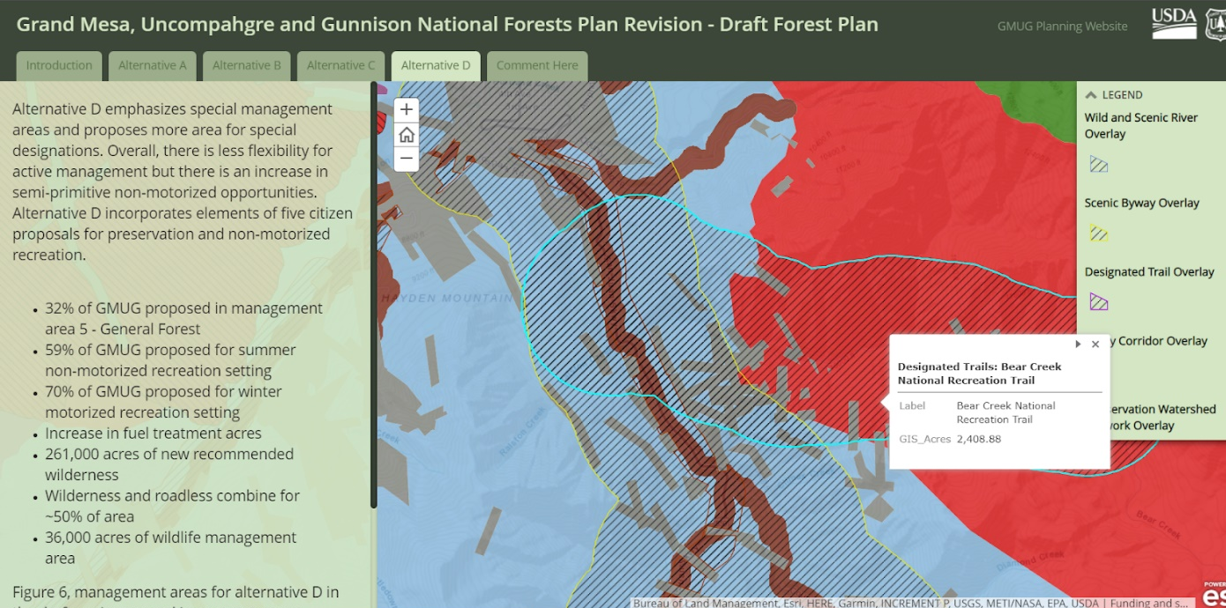

- Winter Over Snow Use
  - Why is Camp Bird Road listed as open for admin use only on the OSV map? Is this a change from the current plan/no action alternative? (FYI, A 2017 committee formed to address issues with winter season mine operation and winter recreation (ice climbers and skiers)). This group clearly wants this road open to recreation users. I support this road staying open to vehicles and OSVs during the winter.
  - Can you please confirm if Over Snow Vehicle (OSV) use is allowed on this road and allowed on Imogene Pass Road (to Telluride) and the Yankee Boy Basin summer TH? I support this road staying open to OSVs.
  - Please clarify if Engineer pass road (#878) and Poughkeepsie Gulch Road (#876) has any winter use restriction, if any, for all Alternatives. Also, please clarify if OSV use is open in these areas off the designated routes (i.e. Alaska Basin) for all Alternatives. I support this road and area staying open to OSVs to provide a diverse recreation experience.
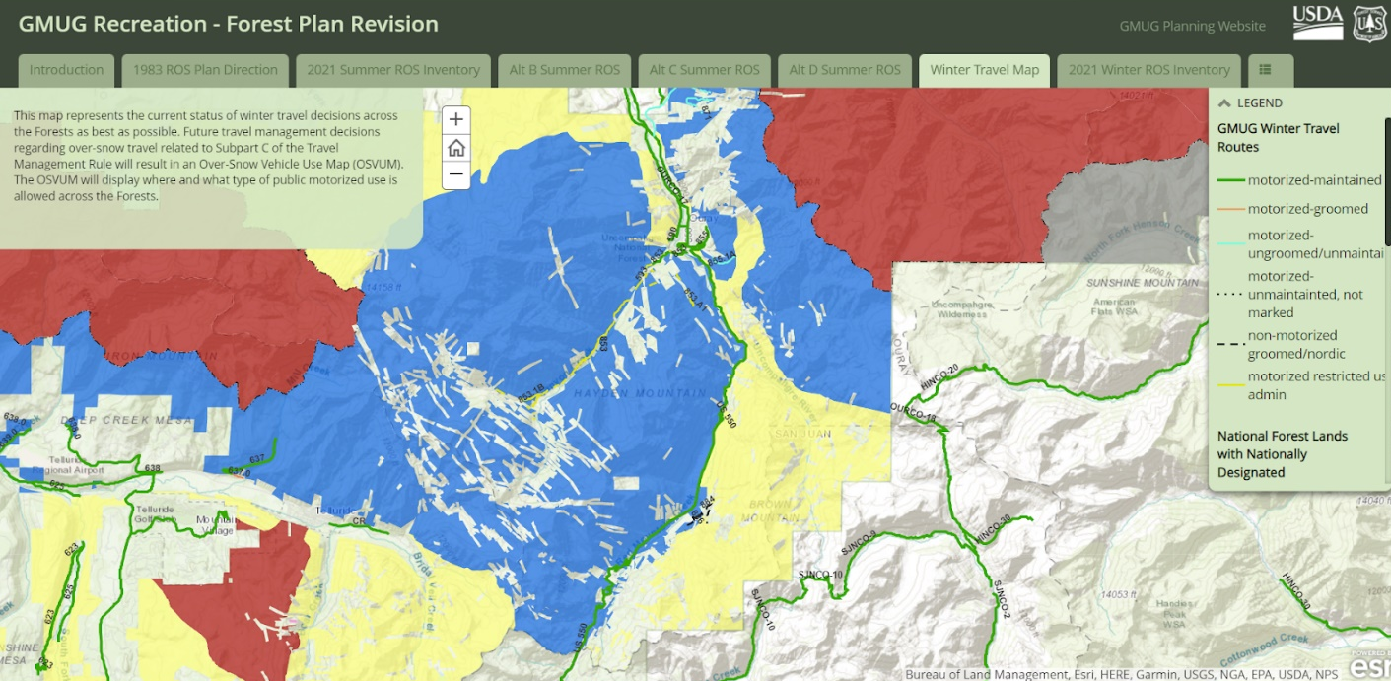

- Red Mountain Pass Backcountry Skiing area:
  - Please consider adding a management area specifically for non-motorized OSV use in the Red Mountain Pass area to allow for some easy access backcountry skiing with limited/no motorized use conflicts. Motorized users already have many more miles and acres of access both near the road and far from the road. Please consult with local backcountry skiers to delineate this area on a map. I’m happy to help and schedule a stakeholder meeting if needed. Coordinate with the San Juan NF on this boundary since the pass is on the Forest administrative boundary.

- Scenic Byway designation along Hwy 550
  - Are there any restrictions on recreation or trail proposals in this designation? I could not locate it in the draft. I generally do not support restriction on non-motorized recreation. Please clarify in the final.
  - For areas that overlap, I assume the most restrictive management area standard and prescriptions ally, but the plan should clarify this.

- Air Monitoring:
  - Please add elongated fiber analysis (i.e. Asbestiform and Erionite) mineral analysis to the air monitoring protocols, especially in areas of heavy OHV use which results in greater dust generation compared to other recreation activities and near larger populations which has the potential for greater impact to human health. These minerals may be found in the intrusive geologic formations of the San Juans Mountains. (Erionite has been found near Creede, CO and asbestiform minerals in Rico, CO and south of Gunnison, CO). This could be performed by a combination of bulk sample analysis and air sample analysis. Recommends proper mitigation (i.e. dust suppressants, reduced use) depending on the results.
Ice and Rock Climbing / Wilderness Management:
Alternative D Only:
- Please offset the Whitehouse Wilderness expansion/proposal boundary at least ½ mile away from camp bird road to eliminate impacts from existing rock and ice climbing anchors along camp bird road. This is represented in the area circled in black on the map below:

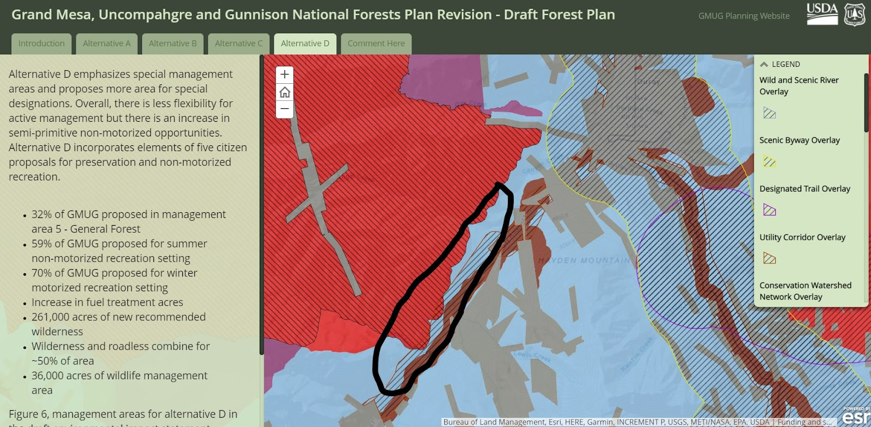

High Mesa / Baldy Mountain Area:
These comments below are in reference specifically to the High Mesa/Baldy Mountain area in relation to a local citizen proposed non-motorized trail network (open to MTB). Please see comments for each alternative below:

Alternative A: (No Action). High Mesa/Baldy Mountain Area
5A Big Game Winter Range - Non-Forested / 3.2 Roadless area (2232.66 acres, hashed dark purple)
5A Big Game Winter Range - Non-Forested (862 + 188.61 = 1050 acres, purple)
- General Questions about this polygon:
  - How was this polygon and its shape determined?
  - What species and season does this management area aim to protect?
  - In the current plan/No Action alternative, this management area is “5A/3.2 - Big Game Winter Range in Non-Forested Areas/General Colorado Roadless Area”, so why would this change to restrict trails in all seasons, not just winter? What changed?
- Please see the map below for the area online in light blue where there is a local citizen supported non-motorized trail (open to MTB) proposal. The No Action alternative would allow for this proposal if there is no restriction on the Miles Per Square Mile(MPSM). I can't find this in the old plan but perhaps it was a standard used. If so, please see my comments below for Alt B to change the MPSP.

Map of proposed trail area in light blue. This area should remain either as “General” or “Roadless” designation. If a “Wildlife Management'' area is designated for this area, please change the standards for Miles Per Square Miles so additional trail miles may be considered in this area in the future (Approx. 3.5 miles proposed here. Please see Alt B for more details)
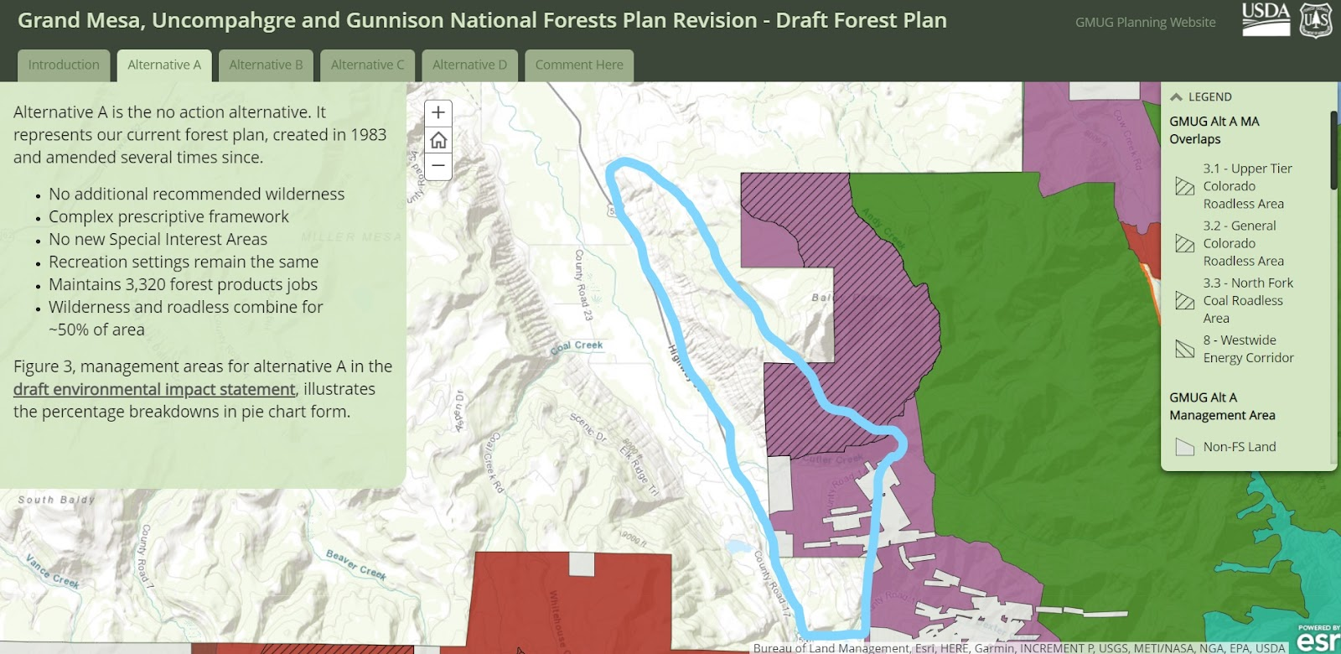

This Map shows locations of collared Bighorn sheep and migration patterns over seasons. The trail proposal would use mitigation techniques (i.e. careful trail prism design and seasonal restrictions) to reduce or eliminate impacts to wildlife such as these Bighorn sheep.
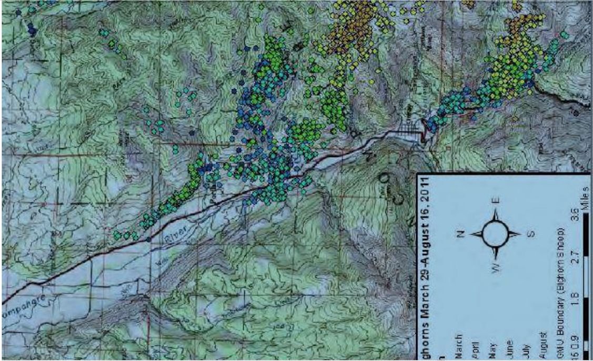

Alternative B: High Mesa/Baldy Mountain Area
3.2/3.1 - Wildlife Management Area/CO Roadless Area (2231.5 acres, hashed / dark blue)
3.2 - Wildlife management Area (430 + 189.73 = 620 acres, light blue)
- High Mesa/Baldy Statistics to determine allowable Miles Per Square Mile (MPSM):
  - Approximately 2900 acres (2851 actual?)
  - There are currently approximately 4.4 actual miles on trail in this area. (Baldy = 2.8 miles, Baldy Peak = .7 miles, Storm gulch = .4 + .5 = .9 miles)
  - Currently, with these 4.4 miles, the route density is 1.4 Miles Per Square Mile (Mpsm). This is higher than the standard of 1 MPSM. The plan must clarify if this means existing trail miles must be reduced to meet the standard and how proposed trails would be managed.
  - However, if the standard for 1 MPSM is used, only 3.23 miles would be allowed in this area based on the following calculations:
    - 2900 acres / ? miles = 1.4 Mpsm
    - 1 acre = 0.0015625 square miles
    - 640 acres = 1 square mile
    - 2900 acres / 640 acres = 4.53 square miles
    - 4.53 sq miles / X = 1.4 Mpsm
    - 3.23 miles of trail

- I support this for the local citizen non-motorized trail (open to MTB) proposal only if some standards were changed or the area boundaries changed. Please see proposed changed below:
  - I propose to increase the standard from 1 mile per 1 sq mile to 3-4 MPSM. Consider there could be a seasonal closure (i.e. winter) on some trails if increased to 3-4 MPSM.
  - Another option I propose is to increase this area by overlapping into existing Wilderness to the east to allow more miles.
  - Please reference map for Alt A / No Action for trail proposal area in light blue. I’m currently working with local stakeholders that would propose an additional 3.5 miles of new non-motorized trail (open to MTB) in this area. Changing the standards as proposed above or eliminating existing trails (with lower use) would allow for this proposal to be considered under the Forest Plan guidelines and possibly be approved.

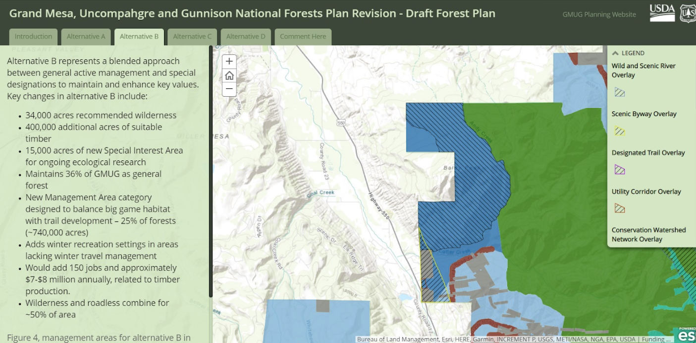

Alternative C: High Mesa / Baldy Mountain area
5 General Forest (830.12 acres, light blue)
3.1 Roadless (2231.66 acres, purple)
- I support this alternative being selected for the High Mesa/Baldy Mountain area (but not necessarily for other areas on the GMUG) because it will allow for the citizen supported non-motorized trail (open to MTB) proposal, but still offer a high degree of protection for this area. My support is conditioned on this alternative not expanding roads or trails for motorized use.
- Please reference map for Alt A / No Action for trail proposal area in light blue. I’m currently working with local stakeholders that would propose an additional 3.5 miles of new non-motorized trail (open to MTB) in this area.
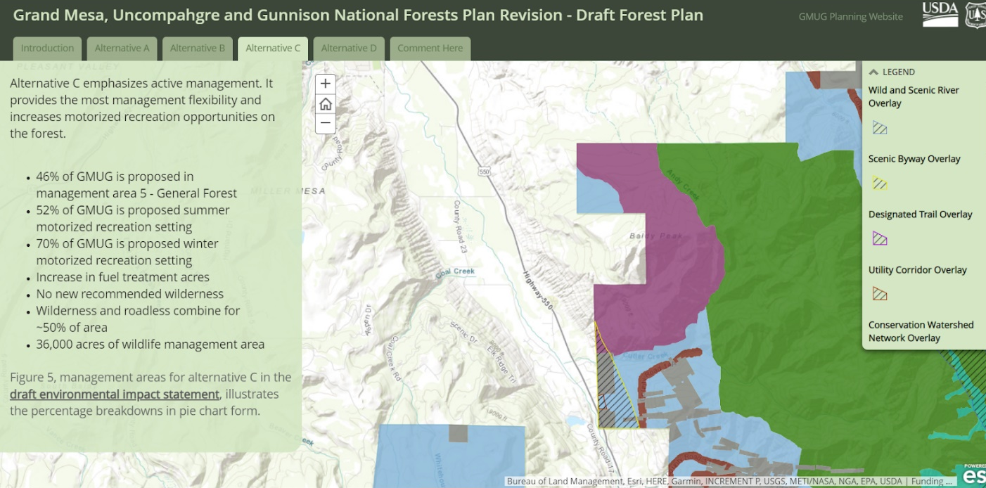

Alternative D: High Mesa / Baldy Mountain area (Proposed wilderness)
1.2 Roadless - Proposed Wilderness / 3.1 Wildlife Management Area (2231.5 acres, hashed, red)
3.1 - Wildlife Management Area (85.84 + 235 + 175 = 496 acres)
- I’m opposed to this designation as it currently is proposed, especially on the lower parts of the mountain (south the west) and near Cutler creek because it will prohibit a local citizen supported trail proposal open to non-motorized use (including MTB use).
- However, I could support this alternative if changes are made to the area boundaries. Specifically, please consider keeping the portion circled in light blue on the Alt A map as either a General or Roadless management area (which I believe still allows MTB).
- Please reference map for Alt A / No Action for trail proposal area in light blue. I’m currently working with local stakeholders that would propose an additional 3.5 miles of new non-motorized trail (open to MTB) in this area.

