Comments on the Grand Mesa, Uncompahgre and Gunnison Forest Plan Revision #51806

I support rivers and creeks being designated as Wild and Scenic.
- I support to continue to include Oh Be Joyful, West Elk Creek, West Soap creek, Copper Creek, Copper Lake, and Anthracite Creek as eligible.
- Also support to add in the following streams to be considered eligible for Wild and Scenic Designation: East River, Taylor River, Slate River, and Poverty Gulch

I support many of CBMBA comments regarding trails and management.

CBMBA has identified and proposed four specific areas that are ideal for stacked/looped trail systems. These proposed areas are close to population centers, are all identified as General Forest (5) or Mountain Resort (4.1) in the proposed Forestwide Management Area Maps, and are also either identified already as Roaded Natural, Rural, Semi-primitive Non-motorized, or Semi-primitive Motorized in the ROS alternatives. They do not contradict or overlap inadvertently with the GPLI proposal, and these areas are appropriate for more progressive stacked/looped trail and recreation amenities like trail features, directional travel (such as uphill only or downhill only), user-specific trails (such as hike or bike only), and decking/boardwalks. CBMBA’s Proposed Recreation Emphasis Corridors/Areas are indicated by the light blue boundaries in the images below, utilizing the Alt. B Summer ROS (Interactive Story Map) with imported polygons.
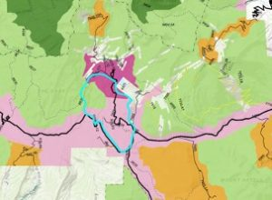Irwin Lake Area – Kebler Pass Drainage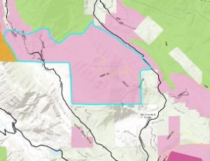Snodgrass Mountain Area – Mt. Crested Butte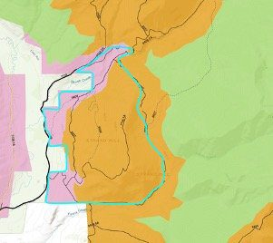Strand Hill Area – Brush Creek Drainage
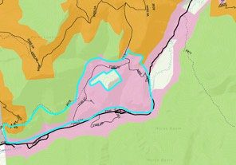
Walrod Gulch Area – Cement Creek Drainage

I support more trails to be purposely built for mountain biking. The sport has seen a major increase in popularity and more trails are needed.

E-Bikes: I think it is important to identify areas where E-bikes could be used and believe it wise to spend time on this subject as it is a growing sport. I would like to see this style of biking to be limited to trails that are open to motorized use. They travel faster than a typical mountain bike and the two user groups could be in conflict. Perhaps a few other trails that are currently not open to motorized could be consider but I do think it’s important to keep them off the majority of trails that are already popular.

I support GPLI.

I DO NOT support any mining or fracking! And, the mining vents that are spewing methane in Summerset need to be addressed. That gas could be captured and used. Or at the VERY least it must be flared. We must hold the mining companies responsible to deal with this NOW!

I do not support any additional user groups in Wilderness area including mountain bikes.

I support motorized use in the Slate River area in the winter. I think that limiting that corridor to non-motorized would be very limiting. That is the main area for backcountry skiing around Crested Butte.

I support CBMBA plans to get riders off the road to reduce the conflicts between cars and bikes/hikers.

I support a trail that connects Gunnison to Crested Butte.

I support a requirement for all campers not using campgrounds to be required to carry toilet systems or wag bags.

I would support more developed campgrounds in the GMUG. Ideal areas would be out Brush Creek, and Kebler Pass.

