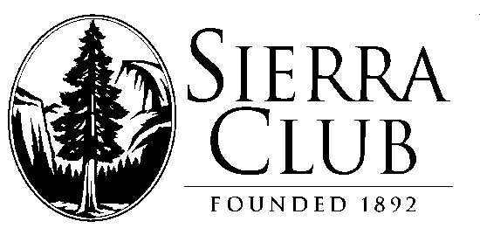

Mother Lode Chapter

909 12th Street, Suite 202

Sacramento, CA 95814

Tel. (916) 557-1100 ext. 108 Fax: (916) 557-9669
info@mlc.sierraclub.org – www.motherlode.sierraclub.org

August 14, 2020

Jason Kuiken, Forest Supervisor
Stanislaus National Forest
19777 Greenley Road
Sonora, CA 95370

Re: SERAL Project

On behalf of the Mother Lode Chapter of the Sierra Club, I submit these comments to emphasize our concerns about of some of the actions undertaken by the Stanislaus Forest in the SERAL project.
It is a wide-ranging plan taking in large swaths of the forest using a variety of treatments. Of serious concern is the departure of forest structure from the “natural range of variation” (NRV). In particular, this approach targets the thinning of Late Seral stages that are the most likely to have large (> 30” dbh) trees. We believe that opening up and thinning this late seral forest type does not necessarily require the removal of >30” dbh trees. Rather the creation of more open late seral forest can be accomplished by removing ladder fuels, shrubs and thick stands of small or mid-sized trees.
We do not agree with the potential removal of trees up to 40” dbh to benefit rust resistant sugar pine seed trees or to facilitate aspen regeneration. Such a practice is not supported by any scientific evidence presented in the project proposal.
Further, we oppose the construction of new temporary roads that are proposed in the project. There is a glut of already existing roads that should be able to allow the effective execution of the VDT treatments. Adding to the backlog of road maintenance does not seem to be reasonable.

Finally, and very important from the Sierra Club perspective, the SERAL project includes the use of prescribed fire, but the application of prescribed fire in the project appears to be unnecessarily linked to mechanical pre-treatment. We urge the USFS to start using prescribed burns as soon as the project starts and extensively in sites that are appropriate and do not require mechanical thinning before using fire. There are plenty of locations identified within the footprint of this project that could be burned without initial thinning (e.g. open stands mixed with brush and oaks). The SERAL project needs to get serious about using prescribed burns as a stand-alone treatment and present a concrete timetable and specific sites in the project footprint that could be burned without thinning.

We appreciate the opportunity to submit our comments.

Sincerely,

Barbara L Rivenes
Public Lands and Forest Stewardship Chair
Mother Lode Chapter of the Sierra Club

