Proposed project: El Jebel Administrative Site, Upper Parcel Conveyance Project
Responsible official: Scott G. Fitzwilliams, Forest Supervisor
National forest and/or ranger district: White River NF; West Zone/Sopris Ranger District

Lead objector: Stuart Fox
Address: 108 Quail Run, Carbondale CO 81623
Phone: 970-217-9185
Signature: 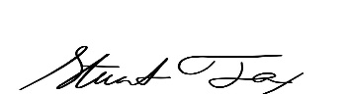

I object to the finding of no significant impact based on the context of the project and intensity of effects using the ten factors identified in 40 CFR 1508.27.

The “Draft Decision Notice and Finding of No Significant Impact” list explicitly that density and traffic would likely increase, this is not an acceptable short term or long-term consequences to the decision to sell these parcels.
The Forest Service must adhere to the USDA Forest Service mission of “sustain the health, diversity, and productivity of the Nation’s forest and grasslands to meet the needs of the present and future generations.”
I ask the Forest Service to only sell the parcels to another government entity which will hold the parcels as open space in perpetuity.
Thank you for your consideration.

