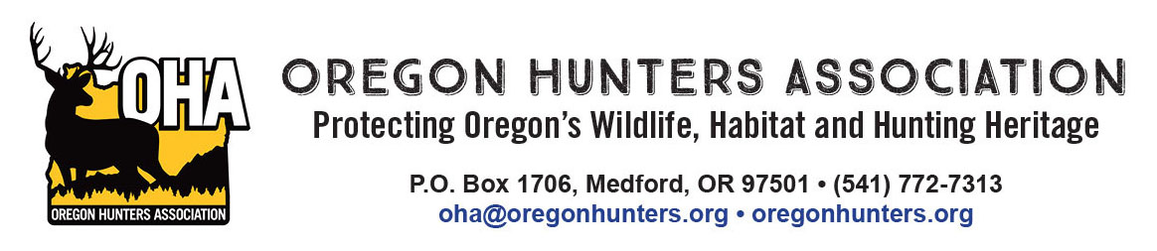
April 12, 2022

Doug McKay, Heppner District Ranger PO BOX 7 | 117 S Main St, Heppner, Oregon 97836

Subject: DEIS Ellis Vegetation Management Project

To: District Ranger Doug McKay and the Ellis Project Planning Team,

The Oregon Hunters Association (OHA) is writing to provide input on the Draft Environmental Impact Statement (EIS) for the Ellis Vegetation Management Project (Ellis Project). OHA is comprised of chapters and members from across Oregon that care about conserving and protecting Oregon’s wildlife, habitat, and hunting heritage.

The Ellis Project proposes to reduce tree density in overstocked stands and improve ecosystem health. The desired outcome of the activities is to enhance landscape resiliency by creating and maintaining diverse vegetative conditions at both the stand and landscape scales.

OHA supports Alternative 5 in the Draft EIS for the Ellis Integrated Vegetation Project. Of the alternatives proposed, we believe Alternative 5 will provide the best opportunity to achieve the following goals: (1) reduce the risk of uncharacteristic disturbances (wildfire, insect, and disease) to important values that are at risk; (2) enhance unique vegetative communities; (3) provide well-distributed, high quality wildlife habitat for big game specifically elk, and aid in reducing elk damage to surrounding private agricultural lands; (4) promote the health and safety of public and firefighters; (5) enhance public and traditional land uses through vegetation management and habitat improvement; and (6) provide jobs and products to support local communities, all which contribute to our social, cultural, and economic needs.

As the Draft EIS indicates; Alternative 5 was developed with partners to specifically address elk distribution concerns and develop an alternative to meet or exceed 30% of the area (the minimum) to be in "security", which is the recommendation of subject matter experts based on many scientific studies. Alternative 5 proposes to increase elk security by 21% to a total of 32% of the project area considered as "elk security", primarily by addressing open roads and road density. Alternative 5 would retain 71% of the open road network. According to research, Alternative 5 is the only alternative offered at this time that has the minimum needs/threshold for road density and elk security. We recognize that a reduction of road density could limit some individuals, but the benefits for elk security far outweigh this.

Alternative 5 will improving forage quantity and quality, particularly for big game. Elk distribution in the geographic area has been an issue for some time. Providing high quality forage along with adequate security cover will begin to address this issue. The large scale disturbance involved with implementing this will require specific attention to address invasive plant control, particularly annual grasses.

We also believe that Alternative 5 best addresses the needs of the highest number of recreation users. The Draft EIS recognizes that the largest recreation user on the Umatilla National Forest in this area are hunters. Strategies outlined in Alternative 5 to improve the distribution of elk will improve their experience. The Draft EIS thoroughly describes the economic benefits of elk to the region by way of elk hunting and viewing.

Alternative 5 of the Ellis Vegetation Management Project is the best and most proactive way for these public lands to contribute to the local communities. Coupling road management with vegetation treatments, implementation of Alternative 5 will improve fire resiliency of the forest and protect communities from catastrophic fires, benefit a variety of sensitive wildlife species, include proactive management to serve local industry/communities and generate revenue to address road management and maintenance needs, and link the Ellis Project area to the geographic landscape as a whole. Elk distribution will likely shift as the elk security acres increase, and the proposed vegetation treatments enhance available forage, both for summer range and winter range. This is our best opportunity to encourage elk to stay on public lands and minimize damage to private land agriculture.

Sincerely;

Mike Totey
Conservation Director
Oregon Hunters Association

