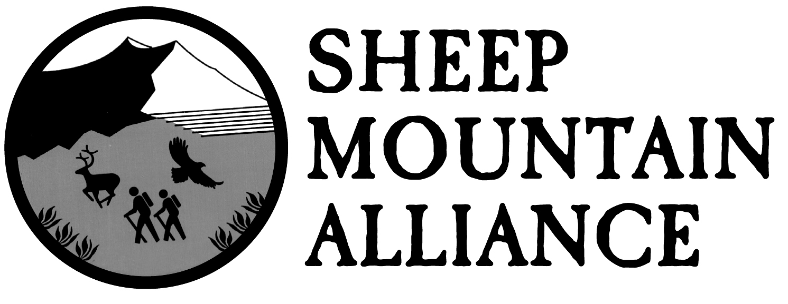
PO Box 389, Telluride, CO 81435 • 970-728-3729 • www.sheepmountainalliance.org

GMUG National Forests
Attn: Forest Plan Revision Team
2250 S. Main St.
Delta, CO 81416

Re: Scoping Comment

Dear GMUG Planning Team,

Sheep Mountain Alliance appreciates this opportunity to comment on the GMUG planning process. Sheep Mountain Alliance represents over 800 members and supporters who depend on the integrity of the ecosystems, watersheds, and public lands in our region for their recreation, well-being and livelihoods.

Sheep Mountain Alliance and its members believe that it is critical to provide additional wilderness, wild and scenic river, and other special designations within the GMUG. We have participated in the extensive research and ground-truthing that created the Citizen’s Wilderness and Special Designations Proposal, and fully support its recommendations. In particular, we ask the Forest Service to prioritize all the lands contained within the recently introduced San Juan Mountains Wilderness Act.

Climate change adaptation, mitigation, and resilience must be considered at every stage of the planning process, and we urge the US Forest Service to seize this opportunity to integrate this into both the NEPA and assessment process.

In addition, SMA endorses the comments of Rocky Smith et al, dated May 24, 2018. We believe that while some management is necessary, landscape-level conservation and wildlife habitat should be prioritized over large-scale logging operations that remove some of the largest and oldest trees from the forest.

Finally, we understand that the GMUG planning team is considering expanded recreation opportunities in many parts of the Forest, and we ask that it continue to take into account landscape connectivity and wildlife habitat fragmentation, while also trying to minimize the impacts of motorized recreation on the majority of quiet users on the Forest.

We look forward to supporting and providing additional feedback and information at each stage of the GMUG revision process going forward.

Sincerely,
Karen Tuddenham
Executive Director, Sheep Mountain Alliance

