June 1, 2018

Forest Planning Team
GMUG National Forest
2250 Highway 50
Delta, CO 81416

Dear Planning Team:

I am writing to offer some comments on the forest plan revision for the Grand Mesa, Uncompahgre, and Gunnison national forest.

I am a private property inholder with a particular interest in the Cataract roadless area. I own the half-dozen patented mining claims in Cataract Gulch on the BLM lands immediately north of the forest boundary. This includes two claims, USMS 312 George Washington lode and USMS 2637 No. 2 Ruby lode, that straddle the Cataract Gulch trail at the forest boundary.

I wholeheartedly encourage the GMUG to maintain its prior wilderness recommendation for the Cataract roadless area. The Cataract Gulch trail is a non-motorized and non-mechanized trail on BLM lands and where it crosses my property. The Cataract area is a spectacular, glacial-carved valley and includes pristine headwaters of the Lake Fork of the Gunnison. It is an integral part of the adjacent Handies Peak Wilderness Study Area.

In 2017, I sold three other patented claims I owned in Cuba Gulch to the GMUG National Forest. The Minnie Lee mill site Minnie Lee lode (USMS 1473 A and B), and Morning Star lode (USMS 12879) comprised the only private land in Cuba Gulch, and the Forest Service’s acquisition eliminated potential incompatible future uses within the Cataract roadless area. The Cuba Gulch trail is also a non-motorized and non-mechanized trail that originates at an adjacent BLM trailhead at the end of the Cottonwood Creek road.

I appreciate the opportunity to comment. I look forward to supporting a wilderness recommendation for Cataract.

Sincerely yours,
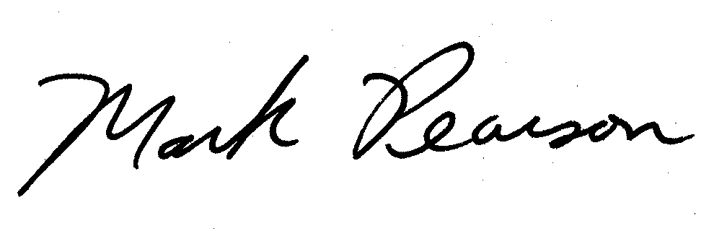
Mark Pearson
560 Clearview Road
Durango, CO 81301

