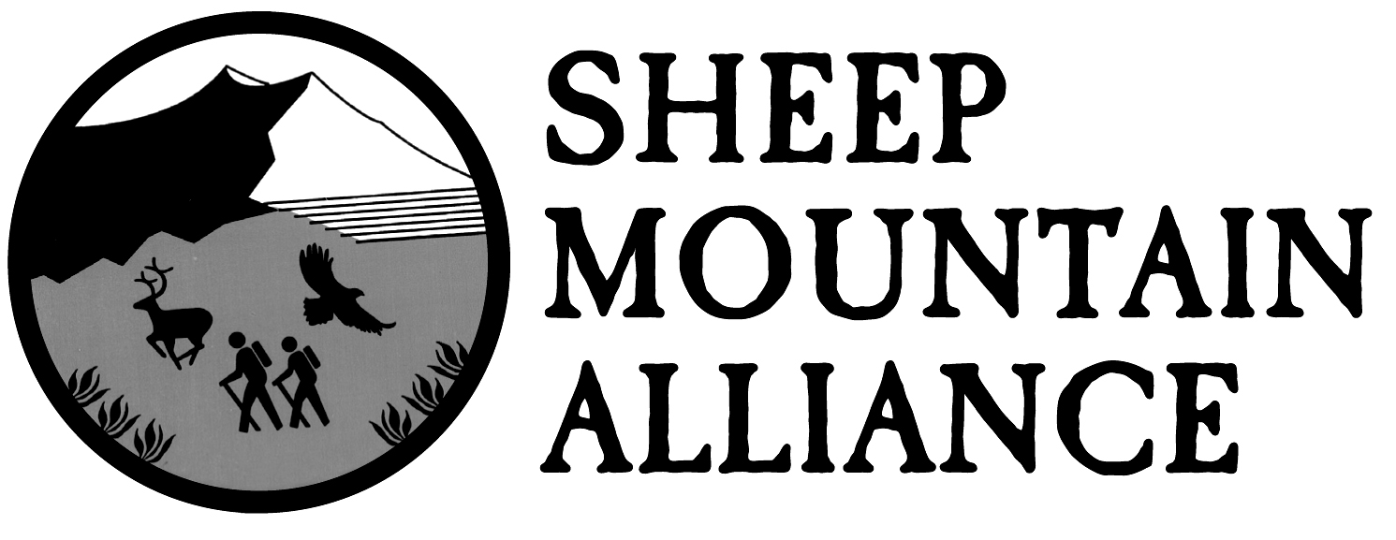
PO Box 389, Telluride, CO 81435 • 970-728-3729 • www.sheepmountainalliance.org

Sheep Mountain Alliance W &S Comments:

March 21, 2019
Comments:
Grand Mesa-Uncompahgre-Gunnison National Forest Draft Wild & Scenic Eligibility Evaluation

Plan Revision Team
2250 South Main Street
Delta, Colorado 81416
gmugforestplan@fs.fed.us
(submitted in electronic format)

Dear Revision Team,

Sheep Mountain Alliance appreciates the opportunity to provide input and feedback on the Draft Grand Mesa, Uncompahgre, and Gunnison National Forest Draft Wild and Scenic Rivers Eligibility Evaluation. We thank the staff of the GMUG National Forest staff for the extensive work that went into reviewing our waterways for Wild and Scenic eligibility.

Sheep Mountain Alliance (SMA) is a grassroots citizen organization dedicated to the conservation of the natural environment in Southwest Colorado and the San Juan Mountains region. SMA was formed in 1988 by a group of concerned citizens, and it now represents the interests of and serves as the primary environmental voice for over 750 members and supporters, as well as many more visitors and residents of our region who enjoy and in many cases rely on the outstanding and remarkable values on our streams and rivers.

We have additionally signed onto the comments made by American Rivers et. al.

We ask you to find all the streams listed in those comments—including those in the draft eligibility evaluation and the additional thirteen streams recommended for careful study—eligible for wild & scenic designation, granting administrative protections for this unique array of potential wild & scenic rivers.

Since this process happens only every 20 years at a minimum, the focus in this report should be on inclusion rather than exclusion of the many potentially eligible stream segments throughout the GMUG.

These streams variously provide essential habitat for riparian vegetation, including rare plant communities; habitat for diverse wildlife, including big game, birds, rare and common fish species, invertebrates, and insects, all essential to the dynamic ecological health of the forest; the aquatic essence and geological carving of designated wilderness areas and of other specially designated lands; clean water for municipal and agricultural uses; unique recreation opportunities; and inherent scenic and natural values.

We believe that there is a greater need for maps and context within the report, including consideration of stream and habitat information that may be available from State of Colorado’s Natural Heritage Program data and Colorado Natural Areas Program land identifications. We are also concerned that the standard for genetic purity of fish stock to be considered “outstanding” is set unrealistically high and should be revised.

We support a finding of eligibility on all sections included in the draft eligibility report, including sections of Tabeguache Creek, North Fork, the San Miguel River, the North Fork Escalante, and Kelso Creek. We think these areas are notable for both their ecological, scenic, and recreational values.

However, we also believe that all streams previously found wild & scenic eligible must retain their eligibility until and unless the Forest formally reconsiders that eligibility and presents detailed evidence of changed circumstances that have occurred relative to those eligible segments.

The draft eligibility evaluation includes no such documentation of stream-specific changed circumstances on the following streams (found eligible in 2005), or of other reasons for not including them in the current draft evaluation. Therefore, they should be included and found eligible. These places are particularly impressive in terms of their unique scenic values.
• Escalante Creek
• Bear Creek
• Bridal Veil Creek (falls)
• Ingram Falls

We additionally recommend that the Beaver Creek, Fall Creek, and Horsefly Creek be evaluated for wild & scenic eligibility. Each of these streams should then be found eligible. These unique streams are worthy of protection for their numerous values.

Finally, we ask that the GMUG Forest administer management on each section of river consistent with that of adjacent land agencies, when those sections of river has also been found to be eligible for Wild and Scenic. Non-eligibility on adjacent jurisdiction should not be grounds for exclusion. Our rare and unique rivers in this corner of the state are critical for the future of our ecosystems, wildlife, and communities. Please protect them accordingly.

Karen Tuddenham
Executive Director
Sheep Mountain Alliance

