Comments re: Evaluation and Authorization Procedures for Fixed Anchors and Fixed Equipment in National Park Service Wilderness Areas

Submitted by: Renny Jackson, NPS Ranger (Retired)

Background: I worked for the NPS as a seasonal Park Ranger (climbing) in Grand Teton National Park from 1976-1989. I applied for a permanent Park Ranger (mountaineering) position at Denali National Park in 1989 and worked at Denali from March 1990 to June of 1991. I then transferred back to Grand Teton where I worked as a permanent Park Ranger until 2010, retiring there in my position as the Jenny Lake Sub-District Ranger.
Additionally, I have been an active climber here in the Tetons since 1970, and have climbed in many other places throughout the US, Canada and abroad in the Alps and the Himalaya. A Climber’s Guide to the Teton Range, 4th Edition (published in September 2023 by Mountaineers Books) was coauthored by Leigh N. Ortenburger and me.
Thank you for the opportunity to comment on this important issue facing American climbing. My comments are focused on three main points: 1) the assumption that anything left behind by climbers falls under the section 4(c) prohibition of the Wilderness Act; 2) the impracticality of the MRA process from the land manager standpoint; 3) a one-size-fits-all approach to fixed anchor management does not make sense given the significant differences in climbing areas throughout the country.
Fixed Anchor = Installation?
First of all, it seems reasonable to begin to comment on the foundational (and I believe erroneous) premise made in the 4th paragraph of the draft Reference Manual 41: Wilderness Stewardship, The paragraph reads as follow:
“This Reference Manual 41 directive clarifies that fixed anchors and fixed equipment (hereinafter referred to as “fixed anchors”) are a type of installation under §4(c) of the Wilderness Act, consistent with the definition of that term in Reference Manual 41 §3.1 as “anything made by humans that is not intended for human occupation and is left unattended or left behind when the installer leaves the wilderness.” Fixed anchors fall into this definition because they are installed and remain in place long after the installer has left. Although fixed anchors may be small, there is no ‘de minimis’ exception to the Wilderness Act’s restriction on installations, and the combined impact of many fixed anchors in a single area or rock wall can have a significant effect on wilderness character. Therefore, fixed anchors constitute a prohibited use pursuant to the Wilderness Act §4(c) and may only be authorized if they are determined to be “necessary to meet minimum requirements for the administration of the area for the purpose of [The Wilderness Act]” through a minimum requirements analysis (MRA).”
It therefore follows, based on this premise, that a fixed anchor is a prohibited “installation” under section 4(c) of the Wilderness Act. Section 4(c) states, in relevant part, that “there shall be no temporary road, no use of motor vehicles, motorized equipment or motorboats, no landing of aircraft, no other form of mechanical transport, and no structure or installation within any [Wilderness area].”
What did Congress intend when it passed section 4(c) in 1964 and what does the specific verbiage in this section of the Act mean? The Wilderness Act itself does not define “installation.” In my interpretation, the two phrases “motorized equipment or motorboats” and “no structure or installation,” both of which use the conjunction “or,” seem to me to connote a connection between similar prohibited things. It would then logically follow that a “structure or installation” would indicate items of similarly large size. In my mind this would be synonymous with a building or facility.
In my opinion, the assumption that anything that is left behind by humans engaged in climbing and mountaineering or any other activity, for that matter, is an “installation” and is therefore prohibited by the Wilderness Act represents a quantum leap in the wrong direction by land managers. For my part, I believe that this major interpretation is a legal question that needs to be answered and I suspect that it will be litigated at some point in the near future. What was Zahnizer’s underlying intent and meaning within the language of the Act? I would hope that his journals, notes, etc. have been examined? Has the legislative record been scrutinized as the Act made its way through the Committee process and then on to passage? I have long admired the crafting of the language of the Wilderness Act and it follows that it would be logical to pursue the underlying meaning and intent of that language before making arbitrary judgements upon which sweeping, service-wide management decisions are then made-would it not? To my knowledge the public has not yet had the opportunity to weigh in and comment on this crucial premise (again, that fixed anchor equals installation) that seems to have been accepted as fact in the draft Reference Manual?
Grand Teton NP Wilderness
In 1971, almost the entire Teton Range within the Park and several of the lakes at the base of the Range, some 110,700 acres were proposed to be officially designated as wilderness. It is my understanding that, at the time, fourteen 2-acre areas, designated on the wilderness study map as “enclaves,” were excluded from the proposed wilderness unit to permit campground management development and ranger station locations. The bulk of these were backcountry patrol cabins many of which were constructed by the Civilian Conservation Corps and designed to be used by rangers conducting backcountry patrol and additionally for trail crew use. One of these enclaves, a spectacular 2-acre parcel located high on the shoulder of the Grand Teton at an elevation of 11,600 feet was excluded because, in addition to it being the highest bivouac site for climbers attempting the Grand, the area “required the use of helicopters for the removal of human waste.” At that time in 1971 there existed up on the Lower Saddle a metal Quonset hut, used by Exum Mountain Guides, the climbing concessioner that used that structure or installation to house their guests.
In May of 1978, the wilderness proposal became officially “recommended” after public hearings and debate and the thirteen 2-acre enclaves were included in the wilderness recommendation because although they were “structures” or installations (my word choice), they were considered to be the minimum necessary for the health and safety of the wilderness traveler, as well as for the protection of the wilderness area. The Exum climbing hut survived through to the Recommended Wilderness designation as did the ½ acre at the Lower Saddle, which reduced that enclave by an acre-an-a-half that was then added to the wilderness acreage total.
Today at the Lower Saddle there are two installations, both of which are WeatherPorts that are taken down during the winter months and both are located on the ½ acre enclave that was excluded from the Recommended Wilderness in Grand Teton National Park. This says to me that NPS administrators had it in their minds that they needed to exclude this area (which is surrounded by hundreds of thousands of acres of Recommended Wilderness) so that these structures (or installations or facilities) would not then fall under the Section 4(c) prohibition.
Fixed Anchors and Climbing
In both Director’s Order #41: Wilderness Stewardship (2013) as well as the new proposal by the NPS regarding fixed anchors, climbing, as well as its many sub-disciplines, is recognized as a “legitimate and appropriate use of wilderness.”
“For the purpose of this Order, climbing is defined to include rock climbing, snow and ice climbing, mountaineering, canyoneering, and caving, where climbing equipment, such as ropes and fixed or removable anchors, is generally used to support an ascent or descent. The NPS recognizes that climbing is a legitimate and appropriate use of wilderness. However, any climbing use or related activity must be restricted or prohibited when its occurrence, continuation, or expansion would result in unacceptable impacts to wilderness resources or character, or interfere significantly with the experience of other park visitors.” (DO #41, 1st paragraph)
“The National Park Service (NPS) has long recognized that climbing is an important and historically relevant recreational activity in many NPS wilderness areas.” (Draft Reference Manual 41: Wilderness Stewardship, 1st sentence)
Both documents further point out that during the regular conduct of climbing fixed anchors are an accepted use in order to safely facilitate ascent and descent. Here in the northwest corner of Wyoming within Grand Teton National Park, this pursuit of climbing as a recreational activity has gone on long before the establishment of the Park (1929), long before the existence of the Wilderness Act, and much longer before the recommendation that the bulk of the Teton Range be designated officially as Wilderness.
One of the first actions taken by members of the Snake River Division of the 1872 Hayden Survey Expedition was an attempt to climb the Grand Teton. Whether or not two of the members actually got to the summit of the peak is still clouded in an ongoing controversy. One thing that is known for sure is that they reached the summit of the Grand’s satellite peak, known as the Enclosure (13,280+), as they were the first to describe the archeological structure that they discovered up there.
Later on in August of 1898, W. O. Owen and his party of four reached the top and were able to document their ascent with photographs. During his earlier attempts to climb the peak, Owen emplaced two “fixed anchors,” one of which was a piton located high on the peak on what became the Petzoldt Ridge, and the other at their high camp in Shadow Peak cirque. This encampment can be found today along with its centrally-located large boulder with its large steel piton still set firmly in its drilled hole, standing Excalibur-like in a pristine wilderness setting (Recommended Wilderness, in this case).
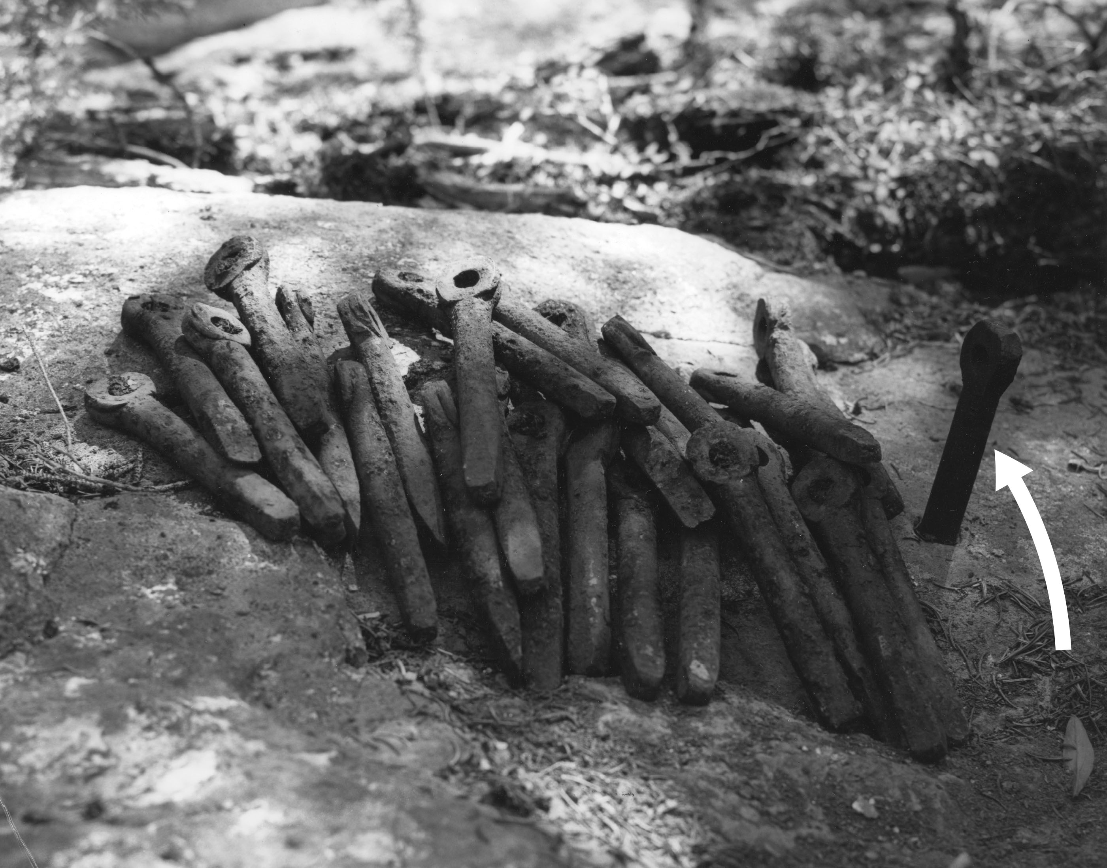
In 1969, this cache of pitons was discovered by Leigh Ortenburger at the site of William O. Owen’s wilderness campsite established for the 1st ascent of the Grand Teton. The arrow points to the first fixed anchor placed in the entire Teton Range in 1898.

So here we see two examples of the long-established legitimacy of both climbing and fixed anchors in National Park Proposed Wilderness. As a result of my experiences both as a ranger in the Tetons for some thirty-four years, as well as my experiences climbing there since 1970, I felt qualified and motivated to coauthor one of the guidebooks to the range. Since things like rappel anchors, belays stations that are fixed, etc. are important landmarks to route descriptions, it is safe to say that I have catalogued the majority of fixed anchors that exist within the Range. There is a great deal of variability as to type as well as quality of these fixed anchors. By taking the position that the fixed anchors here in the Tetons as well as all Wilderness fixed anchors in the country are prohibited installations and that an MRA is required to allow unsafe fixed anchors to be replaced seems to me to be not only ridiculous, but particularly onerous to land management agencies tasked with oversight.
Backcountry rehabilitation of heavily impacted campsites, elimination of social trailing created around these campsites or trails associated with climbing approaches and descents, and stabilization of existing trails are a few examples of efforts that I have both supervised as well as participated in during my 34 years of working for the Park Service here in the Tetons. I have been able to see a ton of changes here over several decades and the main impacts that occur here as well as other wilderness areas in which I have spent time consist primarily of vegetation loss due to backcountry camping and the creation of new trails. I can point to several examples here that illustrate how an established descent route on a cliff face using fixed anchors can mitigate or even eliminate some of these social trailing impacts. Examples of this here include the rappel descent from Guides’ Wall in Cascade Canyon and the rappel descent from the Snaz Buttress in Death Canyon. In both cases the old walk-off routes have not been used now for years and the vegetative impacts associated with both descent trails are gradually disappearing.
NPS personnel in the Jenny Lake District of Grand Teton NP have long enjoyed a high level of respect from visiting climbers as well as the local climbing population here. There are several reasons for this, the primary one being that the rangers who are hired are active climbers themselves who are paid to be out climbing throughout the range. These rangers also conduct backcountry patrols during the summer months. All of this time spent out in the wilderness of Grand Teton allows them to be able to dispense accurate, up-to-date route information to climbers and backcountry users throughout the year. This in turn gives the park managers a very difficult-to-obtain and rare commodity with the public- Credibility!
I mention this because any progress in reducing impacts from the pursuit of climbing and mountaineering have to come from the ground up. The imposition of a mandate such as that proposed by this draft document will not work and will only serve to inflict damage to the credibility that some agencies presently enjoy. The administrative burden of the proposed process is simply impossible for parks with thousands of established climbing routes, hundreds of thousands of climber-use days, and in some Park, USFS, and BLM units 10,000-20,000 existing fixed anchors. Who will write all of these required MRAs? Who will “review and manage” the safety of these thousands of fixed anchors? Should park rangers and others be tasked with this bureaucratic burden given the fact that they now face skyrocketing visitor use with all of its associated effects (increasing backcountry resource impacts, law enforcement incidents, wildland fire events, search and rescue, and so on)- I think not! I would also guess that in many units within different agencies employees who would have the necessary expertise, knowledge and experience to be able to catalog and assess the quality of these many thousands of fixed anchors simply do not exist.
The climbing areas throughout the United States are all uniquely different in terms of their remoteness or their accessibility, the geology within a particular place, the type and character of the rock, differences in elevation, glaciation, geographic location to name just a few. The managers and the folks tasked with the preservation of a particular Park or Wilderness unit are hired for their expertise in those areas. A sensible and logical approach to fixed anchor management would be to allow these individuals, working within their own area, to come up with their own Wilderness Stewardship Plan to address the perceived issues unique to their unit. It does not make any sense to have a blanket, one-size-fits-all inter-agency policy. Director’s Order #41 put it this way:
“The establishment of bolt-intensive face climbs is considered incompatible with wilderness preservation and management due to the concentration of human activity which they support, and the types and levels of impacts associated with such routes…. Fixed anchors or fixed equipment should be rare in wilderness. Authorization will be required for the placement of new fixed anchors or fixed equipment. Authorization may be required for the replacement or removal of existing fixed anchors or fixed equipment. The authorization process to be followed will be established at the park level and will be based on a consideration of resource issues (including the wilderness resource) and recreation opportunities. Authorization may be issued programmatically within the Wilderness Stewardship Plan or activity-level plan, or specifically on a case-by-case basis, such as through a permit system. Prior to the completion of the park’s Wilderness Stewardship Plan or other activity-level plan, the park superintendent may approve new fixed anchors or fixed equipment on a case-by-case basis.”
There are still, to this day, few bolts in the Recommended Wilderness of the Teton Range and I think that most climbers would like to see it remain that way here and in many other wilderness areas of the US. There are plenty of accessible, grid-bolted sport climbing areas in this country.
Summary
- The premise that a fixed anchor is an “installation” and is therefore prohibited under the 4(c) section of the Wilderness Act is an unsettled legal question.
- Climbing in all of its forms has long been recognized as a legitimate use of Wilderness and has been in practice long before the passage of the Wilderness Act.
- During the normal conduct of climbing, fixed anchors are used to safely permit the ascent and the descent of a particular route. In many cases a fixed anchor descent route from a crag or peak can significantly lessen other major impacts associated with climbing in that wilderness area.
- A blanket, one-size-fits-all policy based on an arbitrary interpretation of one word in the Wilderness Act does not makes sense from many different standpoints given the amount of diversity that exists across the climbing areas of this country.

