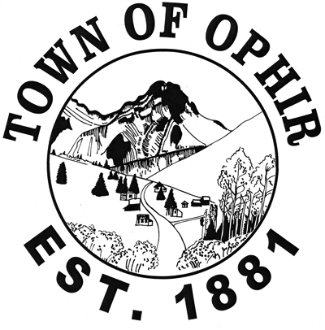

December 29, 2017

Scott Armentrout
Grand Mesa Uncompahgre Gunnison National Forest Supervisor
gmugforestplan@fs.fed.us
2250 South Main St., Delta, CO 81416

Thank you for this opportunity to submit comments to the scoping Assessment phase of the GMUG planning process.

The Town of Ophir is committed to protecting watershed and forest health, wildlife corridors, advocating for non-motorized recreation and the protection of scenic and wilderness landscapes that makes the Ophir Valley unique for residents and visitors alike. Our long-term vision for the Ophir valley - as outlined in the Ophir Master Plan - is to limit development to appropriate parts of the valley floor while insuring the rest of the valley is protected by wilderness and other protective designations. We would like the revised forest management plan to align with existing legislation and non-motorized travel management plans. Thus, we support the current and future restriction of motorized recreation on all lands, with the exception of the Ophir Pass Road.

We believe that the Ophir Needles Special Interest Area does not need to be designated as a Natural National Landmark. Such designation could restrict climbing and bolting access that would be detrimental and contrary to the wishes of local recreationists. The Draft Assessment notes that while the area has been previously considered, it is no longer being evaluated for designation.

The Town of Ophir supports the creation and management of wilderness areas in and around the region, and would like to see the expansion of roadless area designations where possible as consistent with San Miguel County’s High Country Zoning District. We believe that wilderness protections in the Ophir valley are critical for the protection of the Town of Ophir’s drinking water supply as well as forest, watershed and wildlife health and the exceptional recreational opportunities that currently exist. Therefore, we encourage and support these areas to be included in the proposed San Juan Mountains Wilderness Act and request the revised GMUG plan consider the Ophir Valley, with the exception of the Ophir Pass road be designated as non-motorized wilderness. Additionally, we do not believe mineral extraction or timber harvesting is appropriate in the Ophir valley as we have participated and advocated for public lands, open space and mine reclamation to improve the landscape, environment, wildlife habitat and watershed health.

Thank you for your time and consideration of these comments. Please let us know if you need any further information on any of the areas mentioned. We look forward to working with the Forest Service throughout the Forest Planning process

Sincerely,

Corinne Platt
Mayor, Town of Ophir

