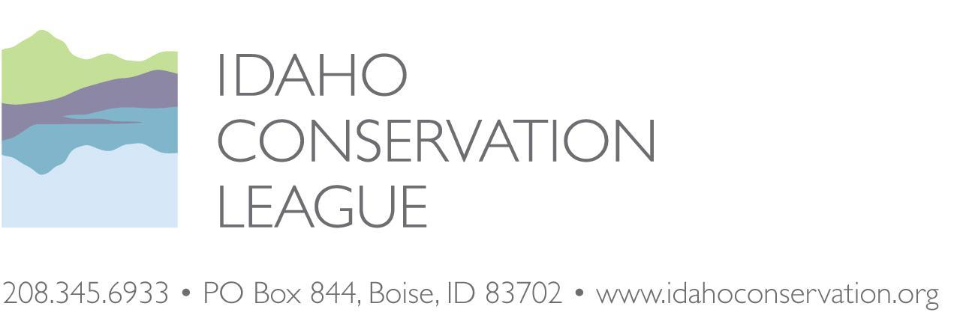
March 31, 2021

Ms. Erin Phelps
New Meadows District Ranger
Payette National Forest
P.O. Box J
3674 Highway 95
New Meadows, ID 83654
(208) 347-0300

Electronically Submitted Through Project Webpage: https://cara.ecosystem-management.org/Public//CommentInput?Project=36507

RE: Rapid River Travel Management Project Environmental Assessment

Dear Erin:

Please accept the Idaho Conservation League’s comments on the Environmental Assessment for the Rapid River Travel Management Project on the New Meadows District of the Payette National Forest. As Idaho’s largest state-based conservation organization, we represent over 30,000 supporters who advocate for responsible travel management and the protection and restoration of natural resources, particularly in wild and natural settings like those associated with the Wild Rapid River.

The Idaho Conservation League (ICL) has a long history of involvement with Rapid River Travel Management planning. Conflicting management direction, specifically between the Act establishing the Hells Canyon National Recreation Area in regards to Wild and Scenic Rivers (36 CFR 292.44(b)(2)) and the Payette National Forest Snow Free Travel Plan Record of Decision for the Council and New Meadows Ranger Districts (USDA Forest Service 2009), culminated in litigation and a subsequent settlement between ICL, The Wilderness Society, the Hells Canyon Preservation Council and the U.S. Forest Service. We appreciate the Forest Service dedicating resources to craft a lasting resolution on the issue of travel management in the Rapid River watershed through this Environmental Assessment.

We appreciate being part of pre-NEPA discussions with the Forest Service and other stakeholders about this unresolved issue. We believe the Forest Service did a superior job of public engagement, particularly in the midst of the pandemic, with hosting afternoon and evening virtual public meetings, creating a story map, and posting supporting materials like the Comprehensive Management Plan Appendix K on the project webpage. The comparison among alternatives in the story map and photo points were also helpful. We recommend applying similar public outreach efforts to other high interest projects.

Based on our review of the project purpose and need and the Environmental Assessment, we recommend that the Forest Service select Alternative 3, the Non-motorized use alternative. This alternative would designate 25.7 miles of trail as open to foot and horse traffic only and not convert any miles of trail as open to motorcycles.

We believe that an emphasis on non-motorized travel within the larger Wild Rapid River watershed - and not just within the narrower Wild and Scenic River corridor - is the best decision for several reasons, including the Payette Forest Plan direction emphasizing non-motorized recreation within this watershed: “(n)on-motorized trail opportunities are the recreation emphasis for the Rapid River Watershed (Payette LRMP pg. 111-143).” Despite the proposed design features, it is all too easy to imagine that motorcyclists will continue past the turn-around points in Alternatives 1 and 2 at the Wild and Scenic River boundary and illegally ride through the corridor to connect with trails on the other side. With the lack of backcountry enforcement, such alternatives are likely to result in violations and resulting resource damage in an extremely sensitive special area.

Thank you for considering our comments, and we look forward to working with the Payette National Forest on this and future projects. Should you have any questions regarding our comments or alternative proposals, please do not hesitate to contact us.

Respectfully submitted,
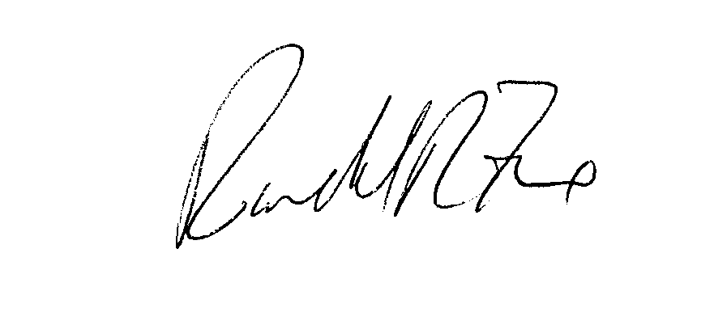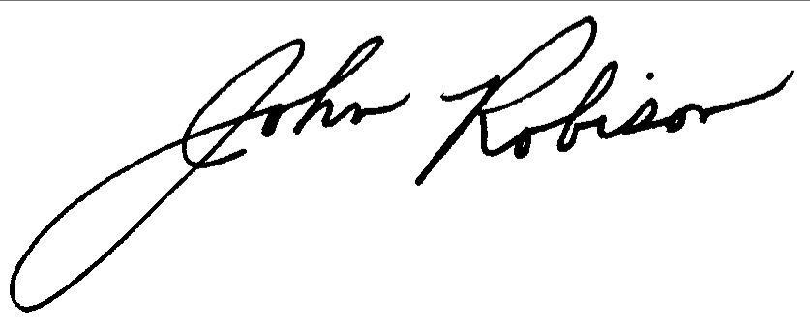
Randy Fox John Robison
Conservation Associate Public Lands Director
Idaho Conservation League Idaho Conservation League
rfox@idahoconservation.org jrobison@idahoconservation.org
(208) 345-6933 x 110 (208) 345-6933 x 113

The Idaho Conservation League’s Scoping Comments for the Rapid River Travel Management Project

Purpose and need
There are two main needs for this project. The first need is to finally resolve conflicting direction between the 2009 Travel Plan and the 2010 special order 0412-401 which was the result of a settlement agreement between ICL, The Wilderness Society, Hells Canyon Preservation Council and the Forest Service. Order 0412-401 was to remain in effect until the Forest Supervisor for the Payette National Forest issues a decision that reconsiders designation of routes for motor vehicle use within the wild river corridor in light of the HCNRA at 36 CFR, Part 292, Subpart F.

The HCNRA Act and its implementing regulations clearly supersede the Snow Free Travel Plan adopted by the Payette National Forest in 2009. As stated in 36 CFR 292.44(b)(2), motorized and mechanized travel are not allowed in the designated Rapid River Wild and Scenic River Corridor. All the alternatives in this Environmental Assessment resolve the conflicting management direction by officially closing motorized routes within the wild river corridor and removing the special order. We support the Forest Service’s proposed decision within the wild and scenic river corridor. This step is also consistent with the 2003 Forest Plan, although a little delayed in this case: “Make travel management planning a priority in the Rapid River Watershed” (Payette Forest Plan p. III-150).

The second need is to review the approximately 26 miles of trails adjacent to the wild river corridor that are included under order 0412-401. Providing increased motorized recreation opportunities is not a need of the project. In conducting this review, the Forest Service does need to be consistent with the Forest Plan and protect the outstanding remarkable wild and scenic river values. These consist of traditional use, cultural, prehistoric cultural resources, historic cultural resources, scenery, fisheries and water quality.

Outstanding Remarkable Values
When Congress established the HCNRA, designating the mainstem and West Fork of the Rapid River as Wild, it did so with the intent to protect water quality and fisheries habitat associated with anadromous fish species like Chinook salmon and steelhead, and native Bull trout. All three species have since been listed as Endangered, Threatened, or Sensitive since the Wild Rapid River was established, making this unique landscape even more critical for habitat conservation and water quality protection. The Conference Report for the HCNRA Act reflects the special attention paid to the Rapid River’s water quality and fisheries, and the Forest Service’s obligation to carefully manage adjacent public lands within the watershed. As stated on page 10 of the Committee on Interior and Insular Affairs, House Report No. 94-607 (October 31, 1975):

A specific provision is included which prohibits the Secretary from undertaking or allowing any activities on Federal lands which would impair the water quality of the Rapid River. Although the National Forest lands outside of the wild river corridor along the main stem and portions of the west fork of the Rapid River are not included in the recreation area, the Committee intends through this section that the Secretary exercise particular care in the management of the lands of this drainage. The salmon hatchery located along the river is vital to the management of this fisheries resource, and the water quality of the river must be assured.

While adjacent lands and watersheds are not directly supported in the Wild and Scenic Rivers Act of 1968, Congress provides us with its justification for including the Rapid River in the HCNRA Act, as well as their intent to protect the lands that support and maintain these justifications. We strongly recommend the Forest Service adopt a travel management policy that honors the intent of Congress who exhibited the foresight to protect this remote and pristine river and watershed.

Roadless attributes
The Rapid River Inventoried Roadless Area (IRA) encompasses 78,522 acres, split between the Payette National Forest (57,676 acres) and the Nez Perce-Clearwater National Forest (20,846 acres. With only 5.8 miles of unclassified road and 0.1 mile of classified road within the IRA boundary, the natural integrity and appearance of the area remains high. This remote IRA retains its natural complexity and wild character due to the, “limited access and the relative ease of control at access points...contribute to the manageability of the area,” (Appendix C, Payette National Forest Inventoried Roadless Areas, p. c-236). Amending the Rapid River Travel Management Plan to allow for single-track motorized/mechanized travel and recreation within the IRA and Rapid River watershed would effectively diminish these attributes, creating additional management challenges for an agency with ever decreasing and limited capacity. The downstream portion of the Rapid River watershed located on the Nez-Perce-Clearwater National Forest retains non-motorized travel management and we believe the Payette National Forest should maintain management consistency within the watershed, particularly in the headwaters region which encompasses the current project area where adverse effects can have magnified downstream impacts.

Rapid River is the only roadless area in Idaho with the Wild Land Recreation theme that is not managed as Recommended Wilderness by the Forest Plan. Inventoried Roadless Areas, and Wild Land Recreation themes, are particularly valuable in terms of naturalness and wilderness character:

Inventoried Roadless Areas (IRAs) contain natural landscapes where human activities have not had a significant impact, and the areas meet criteria for potential wilderness designation under the Wilderness Act of 1964 (Forest Plan IV-2).

Wild Land Recreation (WLR) – A classification of an Idaho Roadless Area assigned to lands that were generally identified during the forest planning process as recommended for wilderness designation. USFWS Biological Opinion and Conference Opinion for the Modified Idaho Roadless Rule, Sept. 2008, p. 27.

The Biological Opinion notes that limits on human disturbance in Wild Land Recreation areas would be beneficial to lynx:

Wild Land Recreation
Further, prohibition on new roads, temporary or permanent, should benefit the species in these areas by reducing disturbance and human access, which should preclude increased recreational impacts that might be facilitated by new roads. USFWS Biological Opinion and Conference Opinion for the Modified Idaho Roadless Rule, Sept. 2008, p. 184.

While the Idaho Roadless Rule deliberately avoided addressing motorized recreation, the USFWS recognized there is a correlation between increased human access and disturbance and negative impacts to lynx.

Although ICL and others had advocated that Rapid River be managed as Recommended Wilderness, the Forest Plan did not designate it as such. We believe the Forest Service determined that the inclusion of this area in the Hells Canyon National Recreation Area Act, the designation of the Wild River corridor, the selection of Management Prescription Category 3.1 (passive restoration and maintenance of aquatic, terrestrial and hydrologic resources), and the non-motorized emphasis within this area provided a somewhat comparable level of protection for this landscape and that Recommended Wilderness was not needed. Expanding motorized recreation would appear to be inconsistent with these overlapping priorities for continued conservation.

Although the Rapid River watershed has not been officially recommended for wilderness designation by the Forest Service, it has been identified by ICL and other conservation organizations as a potential wilderness area. Allowing motorized access in the Rapid River watershed would decrease the value of many of the identified Outstanding Remarkable Values and create obstacles that may affect a future wilderness recommendation and designation.

Congressional intent
As we mentioned in our scoping comments, the Conference Report for the HCNRA Act reflects the special attention paid to the Rapid River’s water quality and fisheries, and the Forest Service’s obligation to carefully manage adjacent public lands within the watershed. As stated on page 10 of the Committee on Interior and Insular Affairs, House Report No. 94-607 (October 31, 1975):

A specific provision is included which prohibits the Secretary from undertaking or allowing any activities on Federal lands which would impair the water quality of the Rapid River. Although the National Forest lands outside of the wild river corridor along the main stem and portions of the west fork of the Rapid River are not included in the recreation area, the Committee intends through this section that the Secretary exercise particular care in the management of the lands of this drainage. The salmon hatchery located along the river is vital to the management of this fisheries resource, and the water quality of the river must be assured.

While adjacent lands and watersheds are not directly supported in the Wild and Scenic Rivers Act of 1968, Congress provides us with its justification for including the Rapid River in the HCNRA Act, as well as their intent to protect the lands that support and maintain these justifications. We strongly recommend the Forest Service adopt a travel management policy that honors the intent of Congress who exhibited the foresight to protect this remote and pristine river and watershed. Roads and motorized trails are well documented sources of erosion and sedimentation that adversely impact water quality and fisheries habitats.

Key issues
The Environmental Assessment identified several key issues which informed development of the alternatives. These include an examination of how motorized use may impact water quality, fisheries, non-motorized, backcountry hunting experiences, and non-motorized and non-mechanized recreational experiences. The Forest Service also considered the loss of motorized recreation opportunities and capacity to maintain additional motorized trails.

When comparing alternatives, the effects to sediment are described as being relatively minor among alternatives, but the motorized alternative has greater effects to sediment/turbidity watershed condition indicator when compared to the other alternatives:

There is a potential that short pulses of sediment and turbidity from these fords could be transmitted downstream to chinook salmon, steelhead, and bull trout critical habitat. The increases in sediment are not expected to be to the extent that there would be any increases at levels to cause mortality to individuals of these species. - Rapid River Travel Management Project 32.

We point out that the definition of “take” under the ESA is not limited to causing direct mortality, but includes harass, harm, pursue, hunt, shoot, wound, kill, trap, capture, or collect, or to attempt to engage in any such conduct. Selecting the motorized alternative or any alternatives with greater motorized trails could be inconsistent with the ESA.

Furthermore, Objective 0432 in the Forest Plan calls the Forest Service to maintain high-quality fish habitat in the Rapid River watershed to maintain the aquatic stronghold for threatened fish species (III-148). When faced with an alternative that clearly maintains fish habitat and two others that could lead to even minor degradation of tributary streams, the Forest Service should select the most protective alternative that maintains fish habitat, the non-motorized alternative.

Maintenance
Regarding capacity to maintain motorized trails, both the motorized and proposed alternatives add motorized trails which could result in decreased resources to maintain the current motorized trail system:

Impacts from the motorized alternative could require more drainage and tread repair because of the potential for more use. The hardening of eight stream fords on trail 188 to accommodate motorcycles and help to reduce bank erosion and sediment delivery to stream would also result in additional maintenance needs over time, as the fords would need to be constructed initially and cleaned of debris every few years. - Rapid River Travel Management Project 53.

Heritage surveys
The Forest Service has not yet completed all necessary heritage surveys for a motorized turnaround on trail 362. It would be premature for the Forest Service to select the motorized use alternative without this survey being completed, as the findings may affect the feasibility of this alternative.

Effects of less than 100% compliance with travel plan
Rapid River is one of the only wild and scenic rivers in Idaho where the water is so pristine that the U.S. Congress precluded activities that may degrade water quality. If the Forest Service were to select the proposed or motorized alternatives and if there is less than 100% public compliance with the travel plan, water quality and fisheries would be at risk of degradation. Furthermore, the remote nature of these trails means that this activity could continue for weeks or months before the Forest Service became aware of or rectified the situation. The Forest Service would be knowingly setting the stage for violations and degradation of outstanding remarkable values.

There are innumerable examples of non-compliance with travel management plans in the roaded front country where environmental conditions are often somewhat degraded, particularly in relation to Rapid River. Even in these front country areas, the Forest Service has a difficult time with enforcement. The Forest Plan notes that OHV users have degraded water quality in adjacent watersheds:

Unauthorized use by ATVs has also caused erosion and sediment deposition problems (Payette Forest Plan, III-140).

Rapid River itself has also seen past unauthorized OHV use:

Unauthorized cross-country ATV travel has caused resource damage in riparian areas and created eroded non-system trails throughout the management area...Trails designed for 2-wheel motorized vehicles are being used illegally by 4-wheel ATVs. (Payette Forest Plan III-143).

Since the Forest Plan was published in 2003, ATV use overall has increased dramatically on National Forests. If illegal cross country travel and travel on 2-wheel motorized trails was a problem before 2003, it poses a greater threat today. Additional motorized trails will encourage this type of illegal use. None of the design features proposed seem adequate to address this threat. Should noncompliance occur in Rapid River, the effects would be harder to notice and correct, and the resources affected would be on a Congressionally designated landscape supporting ESA listed fish.

User conflicts
Both the proposed alternative and motorized alternative will lead to increased user conflicts among recreationists, an issue highlighted in the Forest Plan back in 2003: “(u)ser conflicts are escalating between motorized and non-motorized recreationists within the Rapid River Watershed (pg. 111-143).” Since the special order was passed in 2010, conflicts have decreased.

The proposed action and motorized alternatives mix potentially discordant uses across the landscape and increases the risks of travel management violations and resource damage compared to the status quo. With expanded motorized recreation to the edge of the corridor, the quality of the experience for recreationists on these trails will be degraded. The proposed action does not actually increase the number of high quality recreational opportunities for motorized recreationists because it does not result in the kinds of loop opportunities that motorcyclists and mountain bikers often seek. The Forest Service seems to be going through a lot of effort to create 2-6 miles of dead end motorized trails that do not add that much for motorized recreationists but do diminish the features that make the area special for non-motorized recreationists.

Non-motorized alternative
The non-motorized alternative essentially preserves the existing conditions on the ground and would be the most protective of water quality, fisheries, non-motorized, backcountry hunting experiences, and non-motorized and non-mechanized recreational experiences. Furthermore, no motorized recreation opportunities would be lost compared to the status quo.

ICL members often seek out larger areas or sound sheds with little to no motorized uses. While there are non-motorized trails outside of Rapid River, they are often interspersed with, parallel to, or in close proximity to motorized trails and recreationists seeking a non-motorized experience have a high likelihood of encountering or hearing motorized equipment. The Rapid River drainage provides the only significant non-motorized recreation opportunity, outside the Hells Canyon Wilderness, in the surrounding Weiser, Council, and New Meadows Ranger Districts.

Adding any more motorized trails to the Rapid River watershed mars this unique recreational experience for non-motorized recreationists. Converting 2.3 or 6.6 miles of non-motorized trails to out-and-back motorized trails would not appear to add a meaningful amount of additional recreational opportunities, particularly given the greater speed of motorized equipment. In addition, there is already a high density of motorized recreational trails outside of Rapid River. Converting 2.3 or 6.6 miles of non-motorized trails to motorized trails in the heart of an area that is a sought-out destination for non-motorized recreationists would cause a disproportionate loss to that user group compared to any minor gains by motorized recreationists.

The non-motorized alternative is the only alternative fully consistent with the 2003 Payette National Forest Land and Resource Management Plan: “(n)on-motorized trail opportunities are the recreation emphasis for the Rapid River Watershed (Payette LRMP pg. 111-143).”

While the trails under consideration for conversion to motorized uses are within the semi-primitive motorized category of the Recreational Opportunity Spectrum, the Forest Plan allows for some other considerations which are relevant to the non-motorized alternative:

Per the forest plan, areas where motorized use is prohibited or restricted may exist within the semi-primitive motorized class in order to enhance recreational experiences. (EA, p. 50).

Non-motorized recreation would certainly be enhanced by the certainty of a final decision closing these trails to motorized uses whereas non-motorized recreation experiences would be diminished by the proposed action or motorized alternative.

Travel management rule minimization criteria
We are concerned that the proposed and motorized alternatives violate the travel management plan as they fail to minimize the effects of off-highway vehicles to National Forest System Lands as required by 36 CFR § 212.55 and Executive Order 11644, as amended by Executive Order 11989
The Forest Service promulgated the 2005 Travel Management Rule because “[t]he growing popularity and capabilities of [off-highway vehicles (OHVs)] demand new regulations, so that the Forest Service can continue to provide these opportunities while sustaining the health of [National Forest System] lands and resources.” The regulations were not intended to allow for an easy pathway for resurrection of previous motorized routes.

Instead, the 2005 Travel Management Rule requires the responsible official to designate a system of roads, trails and areas “by vehicle class and, if appropriate, by time of year.” In designating roads, trails and areas (or closing them), the responsible official is required to consider generally the:

…effects on National Forest System natural and cultural resources, public safety, provision of recreational opportunities, access needs, conflicts among uses of National Forest System lands, the need for maintenance and administration of roads, trails, and areas that would arise if the uses under consideration are designated; and the availability of resources for that maintenance and administration.

(Emphasis added).

In addition to the general criteria described above, the responsible official shall minimize:

- Damage to soil, watershed, vegetation, and other forest resources;
- Harassment of wildlife and significant disruption of wildlife habitats; and
- Conflicts between motor vehicle use and existing or proposed recreational uses of National Forest System lands or neighboring Federal lands
In the current analysis of additional motorized trails, the Forest Service is not following the criteria found in the 2005 Travel Management Rule and Executive Order 11644, as amended by Executive Order 11989 (hereafter referred to as the “Executive Orders”).

One of the goals for the Payette Forest Plan regarding recreation access is to manage motorized and non-motorized travel and travel-related facilities to:
- Provide for public safety,
- Meet resource objectives and access needs
- Mitigate road and trail damage
- Minimize maintenance costs and user conflicts.

Elk security
The EA states that because of past wildfires in the area, there is no elk security remaining that can be degraded further by the addition of more motorized routes. Security is not purely a function of cover. This is a short-sighted perspective because vegetation will eventually recover and could provide elk security cover. However, if motorized routes are authorized, the quality of this elk security cover will be diminished or negated. The Forest Service should run an analysis of the motorized route densities by alternative and compare it to the scientific literature regarding the impacts of motorized use to elk and the displacement of elk both now and in 10, 20 and 50 years.

Adequacy of other design features
A number of issues were eliminated from detailed study in the Environmental Assessment. We remain concerned that the rationale for this elimination, such as design features, are inadequate to sufficiently address these issues. We are most concerned about potential user conflicts and safety concerns and the potential increase in user-created trails and lack of enforcement. The Forest Service states that trail designation signage and personal responsibility of trail users is sufficient to address this critical issue and that motorized use would continue to adhere to routes shown on the motor vehicle use map. This argument is particularly unconvincing given the Forest Plan’s statement about previous unauthorized motorized use in the area. If the Forest Service is incorrect in this assumption, outstanding remarkable values could be degraded. We are also unconvinced about design features to address noxious weeds, displacement of wildlife, and impacts to backcountry hunters.

Future actions
Please consider all our comments from scoping. In our scoping document, we had suggested that the Forest Service zoom out and select a larger project area that could allow for some additional enhancements of recreational experiences. We had suggested that the Forest Service convert several currently motorized trails into non-motorized trails within the Rapid River watershed, essentially improving the non-motorized experience within the watershed. We were also willing to entertain converting some current non-motorized trails on the perimeter of and outside of the Rapid River watershed to motorized trails to enhance motorized recreation opportunities in an already largely motorized landscape. This would have provided increased certainty for both motorized and non-motorized recreationists. We understand the reasons that the Forest Service limited the scope of this project to trails affected by the special order and support the non-motorized alternative as a reasonable solution to the project purpose and need. We do not believe that the proposed action and motorized alternatives should be considered further as the area surrounding the corridor is best suited for non-motorized recreation for all the reasons recounted in this letter.

Should the Forest Service select the non-motorized alternative, we recommend that the Forest Service amend the Forest Plan to classify the majority of the Rapid River watershed asas primitive or semi-primitive non-motorized under the Recreation Opportunity Spectrum (ROS) so the ROS is consistent with trail conditions on the ground. We note that the Payette Forest recently made a similar decision with the South Fork Recreation and Access Management Plan regarding non-motorized trails within the Needles Recommended Wilderness Area.

Should the Forest Service wish to examine a larger landscape and see if it is possible to further optimize non-motorized opportunities within Rapid River and motorized recreational opportunities on the perimeter and beyond, we would be interested in being part of that discussion.

We also encourage the Forest Service to address the challenges posed by the division of the Rapid River area into several Forest Service units. The headwaters area is managed by the Payette National Forest, the downstream area is managed by the Nez Clear National Forest, and the western part of the area is managed by the Wallowa Whitman National Forest in Oregon and a different Forest Service region. The Forest Service should reorganize management to increase efficiency and save costs.

2009 Snow Free Travel Plan Record of Decision for the Council and New Meadows Ranger Districts
70 Fed. Reg. 68264-68265
36 CFR § 212.51(a)
36 CFR § 212.55(a); Executive Order 11644, as amended by Executive Order 11989.
See Executive Order 11644 and 36 CFR § 212.55(b) (the responsible official “shall consider effects on the following, with the objective of minimizing . . .”)
Payette Forest Plan, REG05, p. III-62

