Forest Managers

Please accept my brief comments on the recently released revised Foothills Landscape Project Draft EA. It was my understanding that the Draft EA was revised as a result of public criticism of the failure of the original plan to comply with NEPA in that it did not identify site specific locations where various proposed activities would take place. Reading the following statement from page 1 it is still unclear to me if NEPA’s requirement that projects be analyzed on a site-specific basis and the public be given an opportunity to comment with that knowledge will be followed.
Projects will be implemented either based on the programmatic analysis or based on subsequent NEPA reviews tiered to the programmatic review (e.g., a site- or project-specific document). Project design features and appropriate reviews or clearances would be completed before a project is implemented on USFS-administered lands.
Which is it?
This revised EA contains a myriad of tables, maps and charts many of them of little use but adding a great deal of confusion. As best I can determine the FLP contemplates cutting over 80,000 acres of timber, of which over 12,000 acres will be cut to create Early Successional Habitat by removing most if not all of the forest cover. This action is, as are all proposed actions in the FLP tiered to the current CONF Forest Plan. The FP emphasizes adaptive management as did the original FLP EA. Adaptive management (AM) for some reason is not mentioned nearly as often in the revised EA. The FP is now over 20 years old from its conception and the limited harvest in recent years combined with the passage of time has moved the forest towards the steady state that Europeans encountered when they entered this area in the early 1700s. Adding to this aging of the Forest are the many violent storms that are increasing as the climate warms resulting in a significant increase in downed trees. The result of these factors is an increase of ‘natural’ ESH creation. Under AM should not this increase in natural ESH be measured and the need for timber harvests to create ESH be reevaluated? Consulting out of date stand information does not reveal accurate current information. Timber harvests reduce CO2 uptake as mature trees are cut and the machinery used to harvest timber emits carbon to the atmosphere as they burn diesel fuel. In addition, the large machines currently used to harvest timber compact soil and create erosion.
The bulk of the timber harvest appears to involve thinning to make the forest ‘more resilient’ tho the EA does not describe to what degree the stands will be thinned or why a thinned forest is more resilient. Once again AM should be employed to determine whether this thinning is required under current conditions given the acknowledged negative effects of commercial timber harvests noted above. A particularly unusual goal mentioned in the FLP is to thin 10,000 acres of late ‘successional’ forest. The very forest that left alone would thin itself while continuing to sequester carbon. The agency considers stands of trees uniform and to be old aged at 80 years. In fact these stands are not uniform but contain trees of different ages and will become more complex over time as a result of wind throw and natural mortality. Chestnut Oaks and White Oaks, are very common species in the Foothills project area, can live to be 400 years old and remain active acorn producers and sequesters of carbon well into old age. Acorns are the most important food source for wildlife in the forest. Pitch Pine and Shortleaf Pine can live to be 200 years old.
A significant amount of the timber cutting proposed in the FLP is intended to create/restore open woodlands. This despite the fact that there is no evidence that woodlands ever existed on this portion of the forest prior to European livestock grazing. A major project to create a woodland, the Brawley project, after 10 years has resulted in complete failure. Once again AM would dictate the prior projects be analyzed before embarking on more projects using the same and only tools available to the agency… cutting, burning and poisoning.
The FS acknowledges that its poorly maintained roads are a major source of sediment in streams. The FLP proposes to close a number of deteriorating roads and this is a good idea and long needed. The draft EA makes the statement that commercial timber harvests will improve failing roads. One assumes the implication is that funds from timber sales will be used to repair roads in the immediate area. Unfortunately, this has not been the case in recent timber sales as what money has been available for repair has not been enough to counteract the damage caused by increased erosion as a result of timber harvest activities and heavy truck traffic. FS road 35, used as the haul road for the Brawley timber harvest is in worse shape now then it was before the project. The same can be said for the ongoing Fightingtown ESH/timber sale project and FS 797.
The FLP contemplates continuing to burn thousands of acres in the project area. 40,000 acres were burned on the CONF last year. Many of the units are burned on 5-6 year rotation which in no way comports with historical fire frequency. The noted fire historian Cecil Frost estimated a fire return interval of 26-50 years for north Georgia.
Cecil C. Frost, 1998, "Presettlement Fire Frequency Regimes of the United States: A First Approximation," pp. 70-81 in Teresa L:. Pruden and Leonard A. Brennan (eds), Fire in Ecosystem Management: Shifting the Paradigm from Suppression to Prescription
Prescribed fire is appropriate in certain limited areas to aid in maintaining rare plants but not spread across the landscape on an unnatural frequency. The reasons advanced for this use of wholesale fire is to reduce the danger of wildfire and to aid in Oak recruitment. There is little danger of wildfire currently on the Forest. Has there ever been a structure lost to fire on this forest? I am unaware of any. An EPA report predicts that precipitation will increase on this forest as a result of climate change…

Projecting future precipitation for the Southeast is challenging because the region lies in the transition between an increasingly wet northern region and a drying southwest.^{[1]} Areas in southwestern portion of the Southeast region may experience drier conditions, while the northeastern areas may experience wetter conditions, with natural variability having a strong influence on patterns across the entire region.^{[1]}
ttps://19january2017snapshot.epa.gov/climate-impacts/climate-impacts-southeast_.htmlh
This prediction certainly seems to be accurate. On my farm bordering FS land east of Ellijay and close to the FLP area yearly precipitation over the past ten years averaged 71 inches as opposed to the 30-year average of 65 inches.
In addition, Rx fire as applied on this forest, consumes the leaf litter for the most part and kills but does not consume a variety of small saplings. Carbon is added to the atmosphere, fertility is reduced as leaf litter which would have decayed goes up in smoke and future fuel is created for wildfires (if you are concerned about that as the FS says they are) and erosion potential is increased during violent downpours due to the loss of leaf cover. A losing proposition all the way around.
The other principal reason given for the application of Rx fire on this forest is the idea that fire aids in Oak regeneration by destroying shade tolerant species that out compete Oak seedlings principally Red Maple. This year’s annual meeting of the North Georgia Prescribed Fire Council featured Forest Service researcher Dr. Callie Schweitzer from the Huntsville Alabama Research Station. Dr. Schweitzer’s research focuses on the ecological role of disturbance in the hardwood forest ecosystems of the Cumberland Plateau and associated highlands. In her presentation Schweitzer put forward the fact that results from her work indicated that contrary to conventional theory repeated applications of fire did not reduce Red Maple sprouting sufficiently in relation to White Oak sprouts and that remaining Red Maple seedlings continued to out compete Oak seedlings.
In light of this information adaptive management would result in a reassessment of placing wholesale fire on this forest given its contribution to global warming and other negative effects as noted above. Fire would only be applied to small special areas with unique ecological needs such as Pitcher Plant bogs and in a limited manner elsewhere and monitored closely to see what if any positive outcomes resulted from the treatment. Rx fire is expensive requiring a great deal of people on the ground, special equipment, fire trucks, helicopters and now drones. Money that should be spent on repairing the failing eroding road system. Unfortunately, local officials have little control over the appropriations process and have to take what they can get. With wildfires raging in the western US, appropriations for fire related activities apparently are flowing, regardless of whether the use that this money is put to on an eastern forest makes any sense.
The recent droughts and fires in the western US, the unprecedented heat waves as well as the floods in Europe signal to many observers that climate change is accelerating. This week the UN released an alarming study confirming this. The current administration has put forward a number of initiatives to combat climate change, among them the 30 by 30 plan. This plan calls for conserving 30% of federal land by the year 2030. All Agency projects that involve cutting timber should be examined in this light. Removing the existing canopy reduces CO2 uptake and depending on the condition the site was left in it will take a number of years before the same amount of CO2 will be sequestered. In addition, the process of cutting timber involves a number of large machines harvesting the timber as well log trucks hauling the logs some distance to be processed. All of these machines burn diesel fuel and add CO2 to the atmosphere.
Despite the alarming news about climate change this revised draft EA devotes little attention to the matter. On page 72, with no sources cited, the EA acknowledges that over the short term there would be a net loss of carbon storage but that somehow over time there would be a more resilient forest created that would sequester more carbon. The picture below shows the condition of a recent timber sale on this forest after logging using the giant machines employed these days to harvest timber.

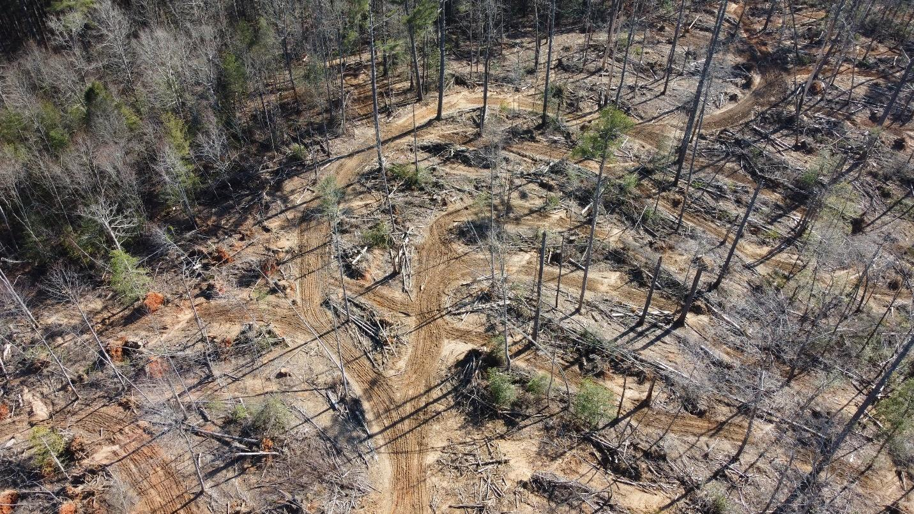
It appears that it will take quite a while for a new more resilient forest to grow back on this site that will come anywhere close to sequestering the amount of carbon that the existing forest did. The brief climate section of the EA on page 72 refers to an appendix D for more information where one finds this.
Climate Change • No additional assumptions identified
Clearly despite the current administration’s directive, little effort was put into the analysis of the effects that the burning and timber harvest envisioned in the Foothills Landscape project will have on climate change. More analysis is needed.
Public land, timber harvests, and climate mitigation: Quantifying carbon sequestration potential on U.S. public timberlands

Brooks M. Depro a,*, Brian C. Murray b, Ralph J. Alig c, Alyssa Shanks d

a RTI International, 3040 Cornwallis Road, P.O. Box 12194, Research Triangle Park, NC 27709, United States
b Duke University, Durham, NC, United States
c USDA Forest Service, Pacific Northwest Research Station, 3200 SW Jefferson Way, Corvallis, OR 97331, United States
d Alaska Department of Labor and Workforce Development, Research and Analysis Section, Juneau, AK 99801, United States

Received 8 March 2007; received in revised form 9 October 2007; accepted 10 October 2007
Abstract
Scientists and policy makers have long recognized the role that forests can play in countering the atmospheric buildup of carbon dioxide (CO2), a greenhouse gas (GHG). In the United States, terrestrial carbon sequestration in private and public forests offsets approximately 11% of all GHG emissions from all sectors of the economy on an annual basis. Although much of the attention on forest carbon sequestration strategy in the United States has been on the role of private lands, public forests in the United States represent approximately 20% of the U.S. timberland area and also hold a significantly large share (30%) of the U.S. timber volume. With such a large standing timber inventory, these forested lands have considerable impact on the U.S. forest carbon balance. To help decision makers understand the carbon implications of potential changes in public timberland management, we compared a baseline timber harvest scenario with two alternative harvest scenarios and estimated annual carbon stock changes associated with each. Our analysis found that a ‘‘no timber harvest’’ scenario eliminating harvests on public lands would result in an annual increase of 17–29 million metric tonnes of carbon (MMTC) per year between 2010 and 2050—as much as a 43% increase over current sequestration levels on public timberlands and would offset up to 1.5% of total U.S. GHG emissions. In contrast, moving to a more intense harvesting policy similar to that which prevailed in the 1980s may result in annual carbon losses of 27–35 MMTC per year between 2010 and 2050.

These losses would represent a significant decline (50–80%) in anticipated carbon sequestration associated with the existing timber harvest policies. If carbon sequestration were valued in the marketplace as part of a GHG offset program, the economic value of sequestered carbon on public lands could be substantial relative to timber harvest revenues.

# 2007 Elsevier B.V. All rights reserved.

Keywords: Public timberland; Forestry; Climate change; Carbon sequestration
Regards
David Govus
Ellijay,Ga

