May 16, 2023

Amanda Milburn
Revision Team Leader, R1 Ecosystem Planning
2880 Skyway Drive
Helena, MT 59602

RE: Draft wild and scenic rivers inventory, outstanding remarkable values framework, and draft wilderness inventory

Dear Amanda:

We are writing as a Coalition of forest products companies, counties, and partners who are interested in the Lolo Forest Plan Revision. The Forest Products industry supports over 7,000 jobs in Montana with earnings of over $300 million annually. We have a strong desire to see a revised Plan that maintains and builds a stronger and more viable timber program. Effective management to reduce hazardous fuels, improve forest health, and mitigate the risk of high-intensity wildfire is critical to this program. The inventory and potential designation of wilderness and wild & scenic rivers (WSR) will have a significant impact on active management. We strongly urge the planning team to consider the negative repercussions of creating additional designations, such as wilderness and WSR, that limit or discourage active forest management and constrain the flexibility in timely treatments intended under the new planning rule. We also urge the planning team to consider the intent of the underlying statutes when conducting this inventory and subsequent analysis.

Impacts to active management

In January 2022 the Forest Service released a Wildfire Crisis Strategy. This strategy outlined the current wildfire threat to our national forests and began building a framework for confronting that threat. Among other things, that strategy concluded that:

- Over the last several decades, the growing wildfires in the West only gradually reached the crisis proportions we see today.
- Fuel buildups have now reached crisis proportions. A degraded landscape needs treatment to restore forest health, much like an ailing patient needs treatment by a doctor.
- Land managers can increase forest resilience and minimize wildfire impacts through forest management activities based on sound science. The activities are called hazardous fuels treatments or fuels and forest health treatments because their purpose is to reduce dangerous fuel levels and restore forest health and resilience.
- The Forest Service has established a strategy for confronting the wildfire crisis by dramatically increasing fuels and forest health treatments by up to four times current treatment levels in the West.
- About half the land area of the National Forest System in the West is in wilderness areas, roadless areas, and other areas where forest thinning is restricted by law, regulation, or terrain.

We would like to draw attention to the fifth bullet in these conclusions. It is crucial that the planning team recognize that any acres designated as wilderness or WSR through the plan revision process will compromise and/or prohibit the Forest’s ability to conduct mechanical thinning that would mitigate the risk of catastrophic wildfire. The notion that these designations would “protect” the areas they encompass is an outdated concept that is out of step with the current threats and the current response strategies emphasized by the Forest Service to address the wildfire crisis. Forest protection in 2023 requires active management—we would like the planning team to acknowledge and highlight this reality.

In recent years there have been numerous assessments and other indicators of watersheds that are “at risk” of wildfire and/or insect & disease infestation. The planning team would be well advised to consider these resources when determining the environmental impacts of wilderness and WSR designations.

The Healthy Forests Restoration Act (HFRA) was enacted in 2003 to improve the Forest Service’s capacity to conduct hazardous fuels reduction projects on National Forest System lands aimed at protecting communities, watersheds, and certain other at-risk lands from catastrophic wildfire, to enhance efforts to protect watersheds and address threats to forest and rangeland health. Lands qualifying for the tools provided in HFRA must be designated by the Secretary. Only those lands experiencing declining forest health in need of hazardous fuels reduction or insect & disease mitigation treatments can be designated.

Since enactment, a significant amount of Forest Service land in Montana, including the Lolo National Forest, has been designated accordingly. Figure 1 below shows those designations in blue over the Lolo National Forest and neighboring Forests (green). Those designated lands serve as a valuable proxy for forests in poor health that are in need of active management treatments. Figure 2 is included in the Lolo Forest Plan Revision website and shows a forest-wide map displaying federal land within the Lolo National Forest administrative boundary that are included in the preliminary inventory of lands that may be suitable for recommendation to Congress for inclusion in the National Wilderness Preservation System. These polygons are listed in Appendix C of the Wilderness Process document, also posted on the Revision website, and amount to over 1.5 million acres, or 70% of the entire Lolo National Forest.

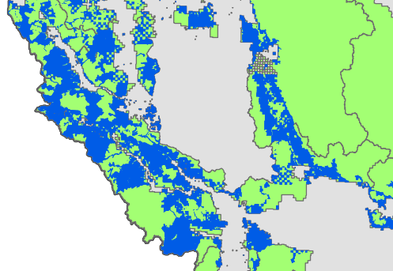
Figure 1: NFS lands designated under HFRA (blue) 2017

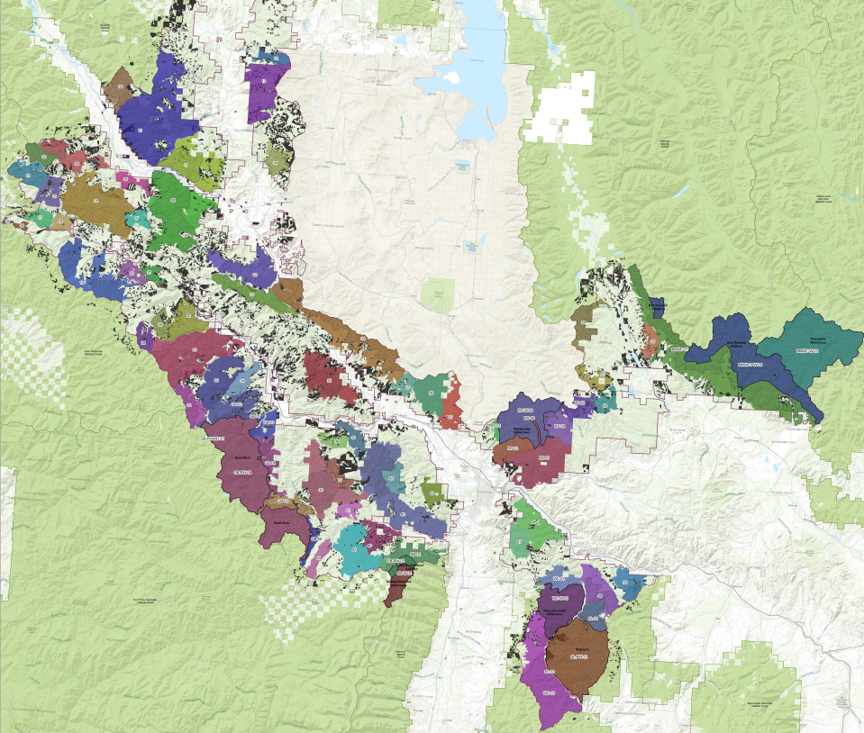
Figure 2: Polygons inventoried for wilderness designation

The Montana Forest Action Plan identified over 9 million acres of forested land that were termed “Areas with Elevated Fire Risk and Degraded Forest Health” outside of Wilderness or WSA’s, of which 65% were on Forest Service lands based on the geospatial data they provided. The figure below illustrates that portion of the Plan that overlays the Lolo National Forest. Red polygons indicate fire risk, yellow polygons indicate forest health risk, and orange polygons indicate both fire and forest health risks. Similar to the HFRA designations, experts have identified a need for active forest management on these acres to reduce fire risk and improve forest health. Wilderness designations would largely prohibit those needs from being met.

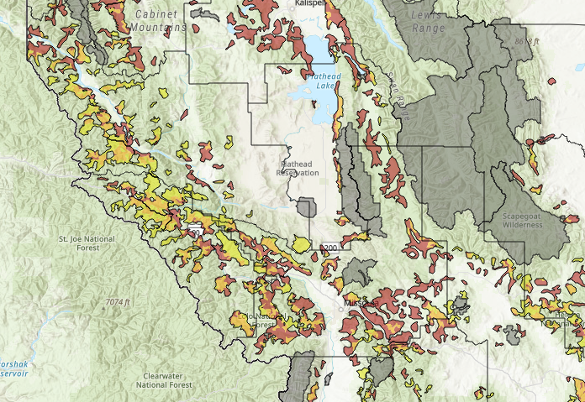
Figure 3: Areas with Elevated Fire Risk and Degraded Forest Health - Montana Forest Action Plan

We were unable to determine the exact amount of HFRA acres and acres identified in the Montana Forest Action Plan that overlay the polygons in Figure 2. However, it is clear from a visual review that the overlaid acres are substantial. We strongly urge the Lolo to avoid designation of any wilderness or WSR on these lands that overlay HFRA designations or areas identified as elevated fire risk and degraded forest health from the Montana Forest Action Plan. Not doing so would strongly undermine the pillars of the wildfire crisis strategy outlined above by unnecessarily constraining the agency’s ability to conduct proactive hazardous fuels reduction at the scale and level appropriate to address the crisis.

The same request applies to WSR designations. Although limitations on active management within WSR corridors are less restrictive than those in wilderness areas, such management is typically avoided due the cumbersome nature of analyzing such treatments and the strong pushback by special interest groups against such management.

For example, in 2016, the Oregon Bureau of Land Management (BLM) proposed a thinning project that included units that overlapped the proposed Molalla River Wild & Scenic River corridor. The purpose of the project was to reduce stand densities. As the corridor was not finalized, the BLM issued a Decision to move forward with the thinning treatments, including those that overlapped the proposed Wild and Scenic corridor. In response, the agency received 178 letters from the public claiming that the density reduction treatments were “not consistent with (proposed) Molalla River Wild and Scenic designation” and claimed that the thinning treatments would result in “degradation” that is inconsistent with the Wild and Scenic River designation.

In 2018 the Oregon BLM’s Siuslaw Field Office began planning a large-scale density reduction project on lands designated as Late Successional Reserve by the 2016 BLM Resource Management Plan. The purpose of the project was to improve stand complexity and to accelerate the development of late seral habitat through density management treatments. The initial planning area included all stands north of Highway 126 that the BLM determined were in need of treatment to meet these objectives. The final Environmental Assessment (EA) was published in 2020 following the designation of Lobster Creek as a Wild and Scenic River. That EA stated on pages 1-2 that “lands within ¼ mile of segment A of Lobster Creek were removed from the project area after it was designated as a wild and scenic river for recreation by the U.S. Congress.” The EA indicated that this deferral amounted to 600 acres (approximately one square mile) of stands in need of density management treatment that would reduce fuels and reduce the likelihood of high-severity wildfire.

Given these realities, it is clear that WSR designations ultimately discourage federal forest managers from conducting active forest management, and we urge the planning team to consider WSR corridors as off limits to active management for the purpose of the revision analysis and to consider the repercussions of active management limitations of such designations.

Technical comments on WSR inventory

The WSR Act states that it is the policy of the United States that certain selected rivers of the Nation which, with their immediate environments, possess outstandingly remarkable scenic recreational, geologic fish and wildlife, historic, cultural or other similar values, shall be preserved in free-flowing condition, and that they and their immediate environments shall be protected for the benefit and enjoyment of present and future generations. We believe that, based on the clear text of this Act, its intent is to select waterways classified as “rivers” for inclusion into this system. We also believe that the Forest Service clearly distinguishes waterways that are “rivers” and those that are “creeks”; this distinction is evident from the naming of such waterways. For example, Table 1 in the WSR Preliminary Inventory document includes segments such as Tyler Creek and Bateman Creek and also segments such as Blackfoot River and Bitterroot River. We believe that only those segments defined by the Forest Service as rivers should be included in this inventory. Expanding this inventory to include the vast network of creeks conflicts with the WSR Act.

Specifically, we would like the planning team to consider modifying some of the language in the inventory documents. These documents seem to use the term “stream” as a way to include waterways defined as creeks in addition to those defined as rivers. The word “stream” can refer to any waterway, including rivers, creeks, or gulches. The wording that refers to “rivers and streams” is confusing to us since a river is a stream. However, as we described above, the WSR Act does not refer to all streams, only to rivers. Therefore, we would like the planning team to modify these inventory documents to either omit the usage of the term “stream” or specify that the type of stream being referenced is the river variety. Resorting to the current wording of “rivers and streams” is akin to a reference of “Douglas-fir and trees.”

Ultimately, the current list of 153 waterways covering 645 miles is indicative that the planning team is indeed misinterpreting this Act and confusing and conflating important terminology. We presume that the Forest Service may assert that creeks and rivers are interchangeable. If that is the case, then please explain in your inventory and analysis why some segments are defined as rivers and others are defined as creeks. On the other hand, if the Forest Service believes that the WSR Act directs the inclusion of creeks, then please direct us to the corresponding portion of the Act.

Finally, the planning team should note that PACFISH/INFISH buffers and the Best Management Practices adopted by the Montana DNRC provide protection to existing waterways. Only those rivers possessing outstanding and remarkable values warrant additional protection under the WSR Act. In your analysis and inventory, please clearly describe those values deemed outstanding and remarkable for any waterway proposed for inclusion in the WSR system.

Technical comments on wilderness inventory

Similar to the WSR inventory, we urge the planning team to closely consider the intent of the original statute. The Wilderness Act defines areas suitable for designation as an area where the earth and its community of life are untrammeled by man, where man himself is a visitor who does not remain. An area of wilderness is further defined to mean in this Act an area of undeveloped Federal land retaining its primeval character and influence, without permanent improvements or human habitation, which is protected and managed so as to preserve its natural conditions. We would like the planning team to consider a contemporary interpretation of the terms “natural condition” and “primeval character” when conducting this inventory and analysis.

Today there are few areas of our nation that have not been directly or indirectly impacted by humans. A century of wildfire suppression has resulted in an unnaturally high level of fuels accumulation across national forests in the west. These areas should no longer be considered “natural” or “primeval.” In fact, removal of trees is likely the most effective way to attain natural and/or primeval conditions in these areas; and action that would be significantly hindered, if not prohibited entirely, though wilderness designation. Ultimately, these areas should not be included in the inventory of lands suitable based on the “improvements criteria.”

Specifically, we believe the Wilderness Process document outlines an incomplete description of “improvements” by focusing on direct human improvements and ignoring indirect human improvements. We believe that areas currently supporting an unnaturally high level of above-ground biomass due to human fire exclusion should be excluded from the inventory due to improvements. Just as areas with signs of roads and timber harvest, these areas appear the way that they do because of human improvements associated with wildfire suppression. Section 1.5 Step 2 (a) of the Wilderness Recommendation Process document includes areas where “past management activities have created a plantation style forest with trees of a uniform species, age, and planted in rows” as an example of an area not appropriate for wilderness designation due to the noticeable human impacts. We would recommend adding areas with unnaturally high levels of above ground biomass into Section 1.5 Step 2 (a). Section 1.5 Step 2 (b) does include language that supports our request, stating: the extent to which the area appears to reflect ecological conditions that would normally be associated with the area without human intervention. Areas experiencing a century of fire suppression certainly do not “reflect ecological conditions that would normally be associated with that area.”

We also believe that areas with operational maintenance level 2 forest roads should be excluded from the inventory. The existence of these roads indicates human developments and improvements not only due to the road itself, but also for the areas accessed by the road and the effect on them. Simply because level 2 roads are being regularly maintained does not mean they haven’t had a permanent impact on the land. In fact, the discussion in Section 1.8 of the Wilderness Recommendation Process document indicates that these roads are often heavily used. It states that level 2 roads are “open for use by high-clearance vehicles.” It also notes that “log haul may occur at this level.” It is difficult to rationalize how a road supporting log trucks could provide opportunities for solitude or qualify as “untrammeled by man” as the Wilderness Act outlines.

Conclusion

Our coalition supports appropriate designations consistent with the plain language in the Wilderness Act and the WSR Act. However, we believe that the current inventories are based on flawed interpretations of these two statutes. WSR inventories should be limited to those waterways defined as “rivers”, not those defined as “creeks.” Areas excluded from inventories for wilderness designation should include those where indirect human intervention has resulted in an unnatural forest condition, as well as those areas containing roads suitable for log truck haul. Finally, the planning team should strongly consider the tradeoffs and repercussions associated with finalizing any land designation that prohibits or discourages active forest management to reduce hazardous fuels and advance the agency’s wildfire crisis strategy.

Sincerely,

Lolo Forest Plan Revision Industry Coalition:

American Forest Resource Council
F.H. Stoltze Land and Lumber
Idaho Forest Group
Mineral County, MT
Montana Logging Association
Nine Mile Venture
Powell County, MT
Pyramid Mountain Lumber
Sun Mountain Lumber
Thompson River Lumber
Weyerhaeuser

Available at: Confronting the Wildfire Crisis | US Forest Service (usda.gov)
Available at: Montana Forest Action Plan | Montana Forest Action Plan
Available at: Final Decision and Decision Rationale (DR) for the Hole in the Road Timber Sale (blm.gov)
Available at: 20181203_N126_LSR_Ch_1&2_DRAFT_v1_For_Public_Scoping.pdf (blm.gov)
Available at: 20210219_N126 LSR Landscape Plan EA_EA_Final With Cost Updated.pdf (blm.gov)

