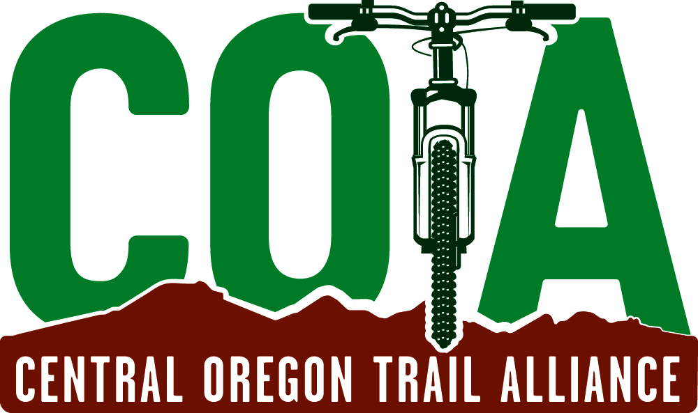

U.S. Department of Agriculture October 26, 2020
Director, Recreation Staff
1400 Independence Avenue SW
Washington, DC 20250–1124
(https:// cara.ecosystem-management.org/Public/ ReadingRoom?project=ORMS-2619.)

Re: FSM 7700 and 7710 E-bikes #ORMS-2619

Thank you for the opportunity to comment on the proposal to add e-bikes to the list of motor vehicle types included in your Travel Management Rules and to incorporate specific guidance to land managers on potentially including their use on USFS nonmotorized trails.

The mission of the Central Oregon Trail Alliance is to develop, protect, and enhance
the Central Oregon mountain bike experience through trail stewardship, advocacy, collaboration, and education and envisions a robust and diverse mountain biking experience that will endure for generations. COTA formed 28 years ago to build relationships and enter into cooperative volunteer agreements with area land managers that enable the mountain biking community to build and maintain a sustainable network of human powered trails. Under these agreements, we have cooperatively grown the recreational trail system into well over 500 miles of trails with a significant majority being on USFS managed land.

We completely agree that e-bikes should have their own designations in the list of motorized vehicles. We also applaud your approach to addressing the issue, especially your commitment to fully comply with the National Environmental Policy Act (NEPA) before allowing e-bikes on any existing nonmotorized trails on USFS managed land.

We also agree with the need outlined in Section 7751.03 paragraph 9. “Consider emerging technologies (such as e-bikes) that are changing the way people access and recreate on NFS lands. For example, where suitable for use, e-bikes may provide new opportunities for individuals who might otherwise be prevented from experiencing an NFS trail without assistance from an electrical motor.” We’d like to add the use of e-tech including 3 or 4 wheeled e-assist bikes for physically challenged riding community should also be a factor when addressing these considerations.

We’d also like to suggest that there be some emphasis on the idea of accommodating e-bikes on alternate trail systems built with their power and speed characteristics in mind.

We have concerns with Section 7715.15 paragraph 4. “Consider designating a class or classes of e-bike use, as appropriate, on NFS trails managed for bicycle use or where bicycle use is allowed, where effects from e-bike use would be comparable to effects from bicycle use.”

While the e-bikes in question are not motorcycles, they are a form of recreation more akin to other motorized activities that emphasize speed and distance than they are to non-motorized activities that emphasize the more physically demanding recreational pursuits. The following discussion of our concerns are based on the tamest class of e-bikes, Class 1, as they require the most user interaction and the slowest maximum speeds. Our concerns are greatly magnified when the Class 2 and 3 capabilities are considered.

Based on our experience we have the following comments regarding the idea that effects of e-bike use are comparable to nonmotorized bikes:

- User Conflict: When the e-bike manufacturers advertise their product as a game changer they are absolutely right. Allowing them on previously non-motorized trails as a default position will instantly change the user experience for all previous users not just other mountain bikers. Our trail systems are mostly composed of pack and saddle trails and, since our founding, a considerable number of trails built for mountain biking, hiking and trail running. As mountain biking became more popular, user conflicts developed between mountain bikers and other users, predominantly equestrians. We have been working with other user groups to minimize these conflicts through a variety of methods. These include cooperatively developed trail user education, modification of existing trails to reduce the dangers that some conflicts might entail, rerouting trails to minimize encounters between users and building alternate parallel trails in areas getting the heaviest incompatible use. These measures took years of cooperation and development to make a difference and all of them are based on the use of non-motorized mountain bikes. Intense cooperation is still and always will be required to address these user conflicts and minimize them.

- The user conflicts mentioned above don’t address the main issue of concern with e-bikes, speed. The introduction of e-bikes blurs some distinctions insofar as they are called bikes and have gears and pedals. But they also have motors. The weakest category of the bikes described in your classification (Class 1) have a top speed of 20 miles an hour. (This is added to the speed a rider generates on their own). Even some in the industry will admit that the top range of these, Class 1, bikes is too high. Most of our trails are shared with other users. Sightlines, corners, tread conditions only considered impacts and speeds of nonmotorized travel. The increased speed of even the tamest e-bike exacerbates the potential for dangerous encounters between the biking and non-biking users of the trails especially on trails shared with equestrians.

- Impact on physical sustainability. Sustainable mountain bike trails are developed to account for a certain amount of use and to minimize and sometimes improve ecological effects of the trail system. None of our trails were approved by land managers with the notion that they would be used by any sort of motorized transport. Usage patterns and differences in speeds will likely affect the sustainability of the current trail system. For example, some trails will see a dramatic increase in use as users take advantage of easier and quicker returns to the top of trails or trail sections featuring downhill technical features.

- We are concerned about the possible effects on more remote trails including impacts to, among other things, long term trail sustainability, wildlife, and watersheds/drainage. These trail environments will change because of the increased speed and range e-bikes afford a more casual user. We are also concerned that future trail proposals will face additional hurdles and more resistance because of these environmental impacts.

- The construction of several of our trail systems was funded by Recreational Trails Program (RTP) grants that mandated the trails were for non-motorized use. Contractually these trails cannot be re-designated just because the motorized vehicle looks more like a mountain bike than a motorcycle.

We notice you are monitoring the BLM’s approach to including e-bikes on nonmotorized trails and we offer the following from our response to their public comment invitation:

“The guidance provided in your solicitation for comment suggests that comments are more productive when they are based on facts. The basic fact is that there are no scientifically based, peer reviewed studies to point to for a truly factual analysis of e-bike impacts on current non-motorized trails. The e-mountain bike industry has funded extremely limited, biased studies focusing on pass-by-pass tread impact comparisons and not in the aggregate over the long term. Neither do these impact studies examine, on any level, social and environmental conditions.

We recommend the initiative to allow e-bike recreation on BLM land be postponed and the Department of Interior fund the appropriate scientific studies on the impacts
of e-bikes on the current recreational environment. Studies should address, at a minimum, the concerns outlined above and any others arising from the feedback you get on this proposal. The BLM could then provide appropriate guidance using the results of these studies to local managers for their use in determining the scope of recreational e-bike use on BLM-managed public lands.”

We make the same suggestion to you. Solid facts on how e-bikes effect the physical, environmental and social environments, would augment local land manager expertise and enhance their ability to accommodate the various users of the recreational trails system.

Thank you again for the opportunity to comment.

Bruce Schroeder, Board Chair
Central Oregon Trail Alliance

