October 12th, 2020

Mel Bolling
c/o Jay Pence,
Teton Basin Ranger District
PO Box 777
Driggs, ID 83401

Re: Grand Targhee Master Development Plan

Dear Forest Supervisor Bolling,

Thank you for the opportunity to provide scoping comments for the Grand Targhee Master Development Plan. The mission of Teton Valley Trails and Pathways is to promote a trails and pathways connected community. Our organization has worked in partnership with citizens, businesses, and government agencies for 22 years to advance our mission.

As a non-advocacy organization that builds and maintains trail and pathway connections, we recognize that recreation is an important economic driver, a quality of life benefit and a public health benefit. We also recognize that all the benefits have potential impacts to the ecosystem and user experience. We ask that those potentially competing issues are balanced and/or mitigated wherever possible.

Teton Valley Trails and Pathways has been grooming a multi-use winter trail in Teton Canyon for many years and are happy to share daily use numbers that we have collected to help in decision making. Additionally, we have collected trail counts on summer trails within the district that may help in understanding trends. We will happily share those as well.

Best,

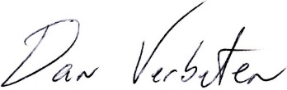

Dan Verbeten
Executive Director
Teton Valley Trails and Pathways

