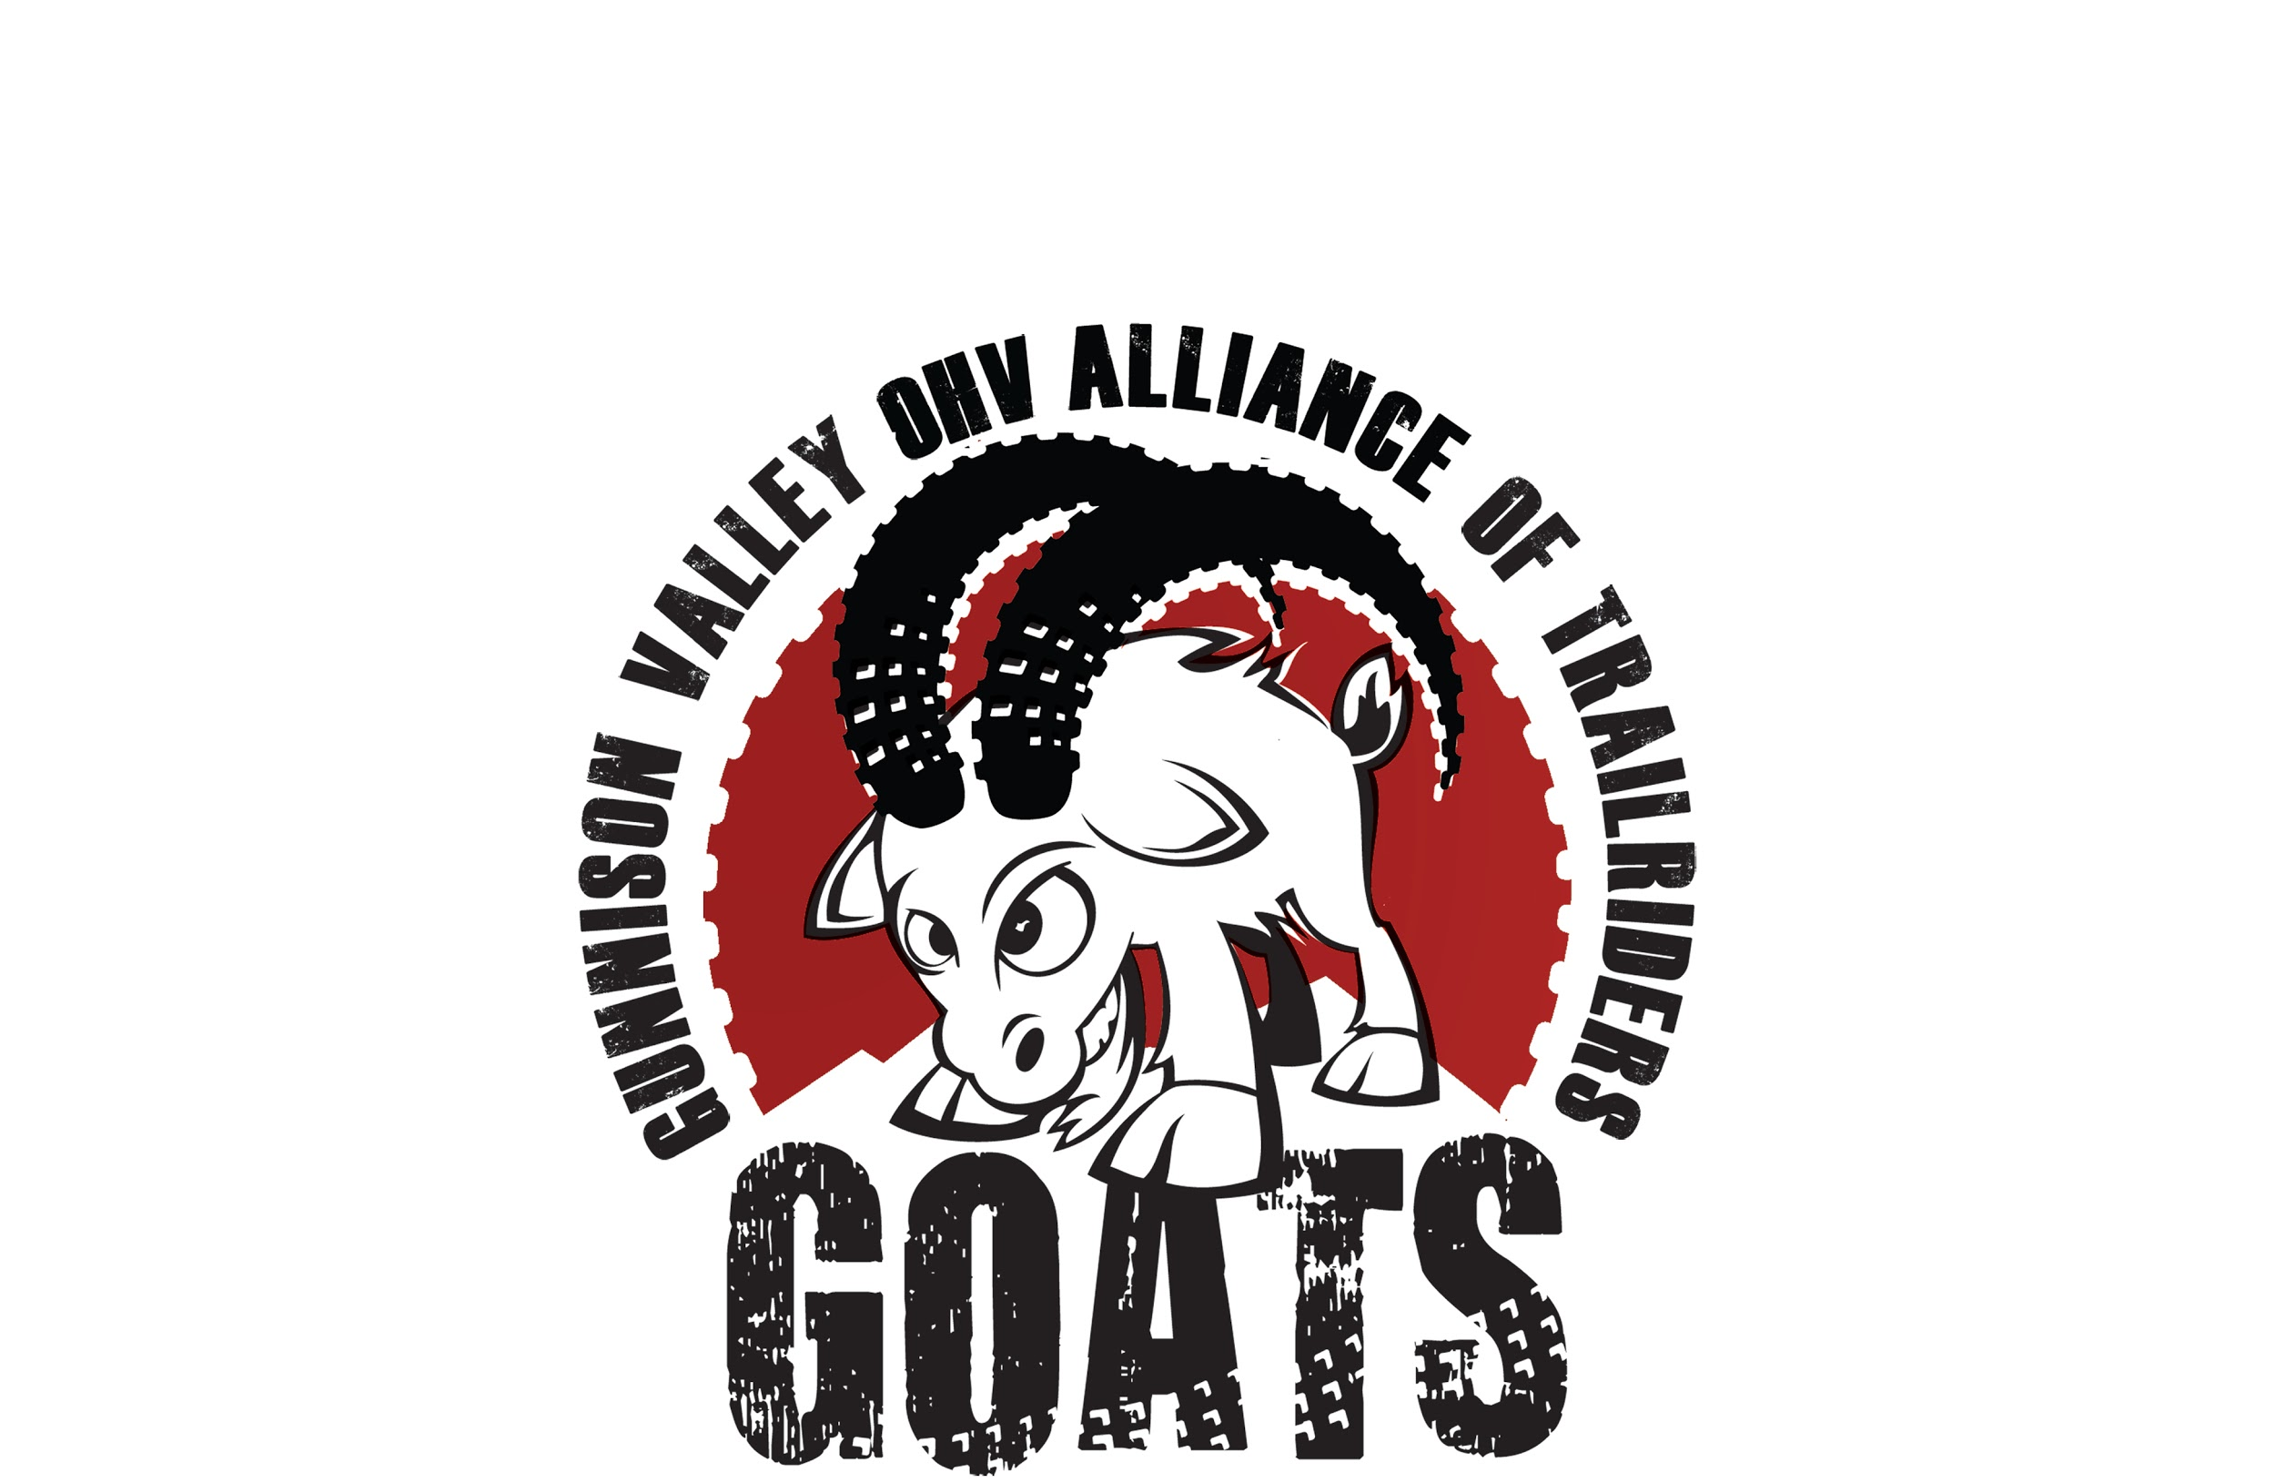
December 5th, 2017

GMUG National Forest

Attn Forest Plan Revision Team

The Gunnison Valley OHV Alliance of Trail riders are a non profit group of motorized users, mountain bikers and overall recreational users of public lands. We are one of many valuable assets to the Forest Service and the Bureau of Land Management in maintaining and planning sustainable multi use recreation on public land. Our volunteer efforts are responsible for several hundred hours of trail work every year. We seek to represent, educate and inform all motorized recreationists to further protect and promote multi use and off-highway motorized recreation in the Gunnison Valley.

We strongly believe in protecting our forests and natural resources while also ensuring opportunities are available for the public to get outside and enjoy travel on multiple-use trails or roads as part of their motorized outdoor recreational experience. These trails are utilized for motorized users to be able to find solitude in the mountains, something that all user groups are looking for. Although other user groups may believe that sharing the trails create conflicts, the GOATs believe all of us in the Gunnison Valley need to act with an attitude of cooperation, coexistence and tolerance toward other users and create a plan where all can recreate together. There are also miles of trails that are specific to non motorized travel.

Motorized off road recreation has proven to be sustainable in our area for over 40 years, and since the implementation of the OVH registration fund, millions of dollars have been put back into the sport and trails to help maintain the steady growth. We believe additional trails are needed to account for the increase of users. Some of the trails that were wrongfully closed in the 2009 forest service plan we feel should be reopened to allow motorized users to enjoy the trail options that we have had in the past.

We appreciate all of the years of hard work and cooperation we have seen from the USFS in the past, and look forward to working with you for years to come. To see further details on what we support please look at the letter in public comment submitted from COHVCO. We stand behind everything COHVCO has to say especially regarding the positive economic impacts of motorized use for Colorado.

Gunnison Valley OHV Alliance of Trailriders
info@gunnicbgoats.com
PO BOX 3772
Crested Butte, CO 81224
gunnicbgoats.com

