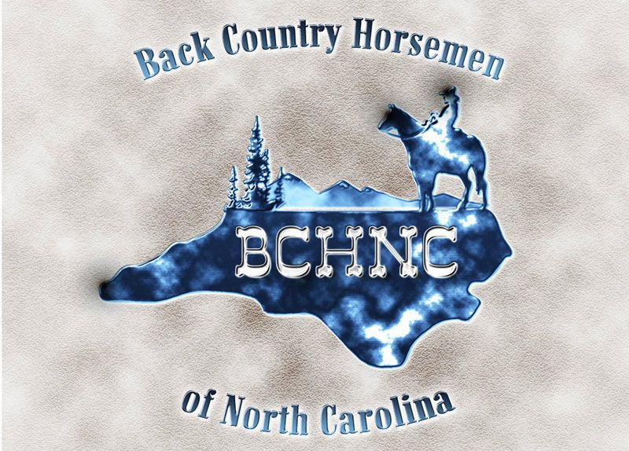
March 22, 2022

Ken Arney, Reviewing Officer
Regional Forester
USDA Forest Service, Southern Region

James Melonas, Responsible Official
Forest Supervisor
National Forests in North Carolina

Attn: Objection Coordinator
Nantahala and Pisgah National Forests
160 Zillicoa St., Suite A
Asheville, NC 28801

Submitted electronically via CARA Online Portal:
https://cara.ecosystem-management.org/Public/CommentInput?Project=43545

Notice of Objection to the Final Land Management Plan for the Nantahala and Pisgah National Forests by the Back Country Horsemen of North Carolina (BCH NC)

Objector Contact Information - Deirdre Perot, Public Lands Representative of the BCH NC is designated as the lead objector

Dear Mr. Melonas and Mr. Arney,

Thank you for the opportunity to engage in the plan revision process. Our organization appreciates the ability to give further feedback in this objection phase. It is our sincere belief that our suggestions will only serve to enhance recreation within forest management.

We have three separate areas for which we submit objections, below.

1st Objection - REC-S-11, Footnote 21 & REC O-07 (Pages 122,123 of Final Plan)

“REC-S-11 Equestrian (horse, stock, pack, and saddle) and bicycle use is only allowed on system trails designated for those uses, and on open or gated system roads; (see footnote 21, below) unless the road is closed to those uses by Forest Supervisor order. Equestrian use is allowed for big game retrieval in hunting seasons identified by the State.

(footnote 21) Standard REC-S-11 will be implemented forestwide through a Forest Supervisor order after Objective REC-O 07(a) has been achieved

REC-O-07(a) Tier 1: Within five years, begin collaborative trail planning to address equestrian and/or bicycle trail supply/demand issues in Bald Mountains, Black Mountains, Eastern Escarpment, and Highland Domes Geographic Areas.”

We feel the closure order could be “triggered” in the beginning of the collaborative trail planning process by footnote 21 in the current wording (S-11 implemented after O-07a achieved, which is begin trail planning). The Plan Revision REC-S-11’s footnote does not follow the intent of the FEIS and USFS Response to comments. Instead it leaves interpretation of the closure timing up for misunderstanding. “Issues will be addressed prior to completing a closure” and “Implementation of the standard….will then be deferred until trail objectives have been accomplished” are not consistent with “beginning” the collaborative trail process (full quotes below). We understand and support that the collaborative trail planning process will be the avenue that determines which trails could be sustainable and added to the designated trail system through the collaboration of user groups seeking funding, pledging long term maintenance and working together to mitigate user conflict issues.

FEIS Chapter 3, p.464 & 3-p.465

“Ch 3-p.465 - By clarifying that these supply and demand (p.465) issues will be addressed prior to completing a closure order to restrict equestrian and bicycle use to system trails, this alternative clarifies that restrictions to the trail system will not immediately begin with the signing of the plan. This will provide an opportunity to make needed adjustments to the trail system.."

Forest Service Response to Comments:
Pg 104/105 - Implementation of the standard restricting horse and bicycle use to designated trails will then be deferred until trail objectives have been accomplished.

As we mentioned in our June 2020 Draft Plan Revision comments (quote portion below, with full comment document referenced), implementation of the closure order without time to discuss “right sizing” trails in those GA’s will result in a less sustainable trail system and disengage the volunteer workforce of equestrians as well as mountain bikers . For instance, in the Eastern Escarpment, there are only 20 miles of designated trails open for horses but over 100 miles of "legacy/social" trails. This would force an equestrian to either ride 80% less trail miles with significantly more traffic or go "rogue" and ride and maintain undesignated trails. Neither situation is sustainable. BCH of NC understands increasing miles of trails and/or adding legacy/social trails to the designated trail system will be a result of collaboration of user/volunteer organizations on what infrastructure can be shown to be ecologically, financially and socially sustainable.

BCH of NC comments
Page 2: Specifically, we would like the Forest Service plan team to consider the following items: Restricting horses to designated trails (REC-S-11) should happen only after: Geographic-specific milestones are developed that reflect visitor needs and demand, and A collaborative trail planning process is completed for each Geographic Area, with the goal to identify high value routes and bring them into the formal trail system.
Rationale: Without these efforts, we feel frustration from unsatisfied need will result in "rogue" travel and maintenance that could cause more resource damage. This "carrot vs stick" method will result in engagement of a highly motivated workforce of volunteers

Seeking Resolution - We suggest that adding the verbiage in bold (below) to those sections and to the associated Geographic Area goals will serve to clarify the intent mentioned in the FEIS and FS response to comments. It was clear to us in many years of discussion with Erik Crews, USFS NC Dispersed Recreation manager that the intent was to delay implementation of the closure order until the collaborative trail planning process has had an opportunity to make needed adjustments to the trail system.

Proposed Solution

Footnote for REC-O-07(a) and REC-S-11 *Standard REC-S-11 will be implemented forestwide through a Forest Supervisor order after collaborative trail planning identified in Objective REC-O 07(a) and associated Geographic Area Goals have been completed.

REC-O-07a - Within five years, begin collaborative trail planning to address equestrian and/or bicycle trail supply/demand issues to meet associated Goals in Bald Mountains, Black Mountains, Eastern Escarpment, and Highland Domes Geographic Areas*. (Also see: Geographic Area Goals BAM-GLS-10, BLM-GLS-09, EE-GLS-09 and HD-GLS-13.)

Associated Geographic Area Goals
Address supply/demand issues for equestrian and/or bicycle trail opportunities within the geographic area through collaborative trail planning to identify appropriate trail mileage, new trail locations utilizing sustainable trail design principles, potential adoption of unauthorized routes, sources of construction funding, and long-term maintenance commitments by volunteer and/or partner organizations. Area-specific metrics for achieving this Goal should be identified by Forest Service managers and partners during collaborative planning for trails and trail complexes within this Geographic Area. (for GA’s - BAM, BLM, EE & HD)

2nd Objection - Dispersed Recreation, Final Plan pg 118

REC-S-07 “In developed recreation sites (campgrounds or roadside campsites), camping with horses and pack stock is restricted to designated and signed equestrian camping areas.”

While we agree that horse camping should be restricted to designated and signed equestrian camping areas, we pointed out in our June 2020 comments to the Draft plan that those equestrian camps are open to all users and we requested some prioritization method.

BCH of NC Comments June 2020 - The Standard REC-S-07 should specifically state that horse camping should be given priority over non equestrian campers in designated equestrian camps.
Rationale: Currently, there are six horse camps across the entire N-P forests, providing around 30 sites for equestrians but available to all user groups. Our organization would be glad to provide ideas on how to get that accomplished.

Other user groups occupying the horse camps greatly impact equestrian camping. There are currently only 30 total sites across the Nantahala and Pisgah Forests for equestrian camping. BCH of NC is a major volunteer organization, with hundreds of hours keeping trails open for all users. We utilize these camps to stage our work weekends and have often had to cancel work due to inability to secure camping. Several of these camps are on the reservation system and are booked for 6 months in advance by non equestrians.

FS Response to Comments Document Pg 100
Comment: Commenters request equestrians receive priority for camping at designated horse camps.
Response: Equestrian camping priority was discussed with District personnel and was concluded that non-equestrian campers don't negatively impact campsite availability for equestrians to the degree that would warrant the comment's recommended change. Additionally, campground utilization is paramount to financially sustainable operations. Wolf Ford, Wash Creek, and Harmon Den horse camps are reservable on Recreation.gov.

Objection

- USFS failed to determine to what extent this would negatively impact equestrian availability. No attempt was made to reach out to BCH, even though BCH has a long standing relationship in NC as a volunteer group and BCH of Pisgah has spent over ten years and thousands of dollars, volunteer time and equipment in cooperation with the Pisgah District creating structures in the horse camps (Wolf Ford and Wash Creek) to make them more sustainable for horse camping.
- No request was made by Back Country Horsemen of NC for exclusive access to horse camps by equestrians, only prioritization for equestrians over non-horse campers in horse camps, therefore financial sustainability of the operations would not be affected. Sites could still be filled by non equestrians after being first offered to equestrians, for whom the camps were designed.

Seeking Resolution

The Plan should address the displacement of this user group. This has been created by prohibition from use other than designated horse camps and lack of provision made to prioritize horse camping in areas that have been developed specifically to mitigate their impact on the resources. It has been exacerbated by the very improvements done by BCH of NC to combat the resource damage possible by horse camping, making the areas more attractive to all user groups. Please see the referenced “white paper” released by the USFS Nov 2021 for examples of best practices for prioritizing horse camping in horse camps. This displacement has been recognized as a problem Nationwide and many other Forests have made changes to their management plan to help address it.

Proposed Solution

- Add a new Goal under Developed Recreation that mirrors REC-G-06 but references camps: Guidelines clarify that mixed use camping facilities should be accompanied by educational efforts to reduce user conflicts, and that all user groups should be encouraged to share responsibility and work together in supporting the camping facility.
- Modify REC-S-07 to add the bold text - In developed recreation sites (campgrounds or road-side campsites), camping with horses and pack stock is restricted to designated and signed equestrian camping areas. In designated horse camps, develop and utilize a system to offer priority to horse campers for whom these areas were specifically designed, which will help mitigate resource damage.

Objection 3 - Lands and Special Uses LSU-S-03 & LSU-S-05

USFS Final Plan pg 103

LSU-S-03 Authorize special uses only if consistent and compatible with the desired conditions of the applicable management area.
LSU-S-05 Permitted special uses are compatible with visitor use, site capacity and recreation management.

In our June 2020 Comment, we noted the need to determine the compatibility of special use permitted events (such as bike races) with other recreation users as well as determine the impact of the resource damage of such events.

BCH NC Draft Plan Comment June 2020

Holders of Special Use Permits (SUPs) for trails-related events should be required to notify the public at least two weeks in advance of their event and the locations (trails, trailheads and parking areas) that would be affected. A monitoring plan should be enacted by the Forest Service to measure the impact of these events. In addition, requests for trails-related events and competitions should be granted only after securing a Performance Bond to mitigate potential damage to the affected trail system.

Rationale: Measures are needed to reduce user conflict and resource damage associated with SUP recreation events. Although the Code of Federal Regulations states that such requests must “not unreasonably conflict or interfere with….authorized existing uses…,” there currently is no uniform requirement by the National Forests of NC to inform the public about a special event, nor is there any requirement to collect a bond or deposit in case of damage caused during the event.

USFS Response Document
Comment: Commenters are concerned about the frequency and impact of mountain bike races.
Response: Forest Service permits are handled on a case by case basis. All special use permits state that the holder shall be liable for any damage or other costs connected with rehabilitation or restoration as a direct result of their use. In the Lands and Special Uses section of the plan it states that special uses will be managed to support and contribute to the protection of natural resource values and the promotion of public health and safety; and, compatible with visitor use, site capacity and recreation management.

Objection

Regarding LSU-S-03, we feel that Special use permits such as bike races are not consistent and compatible with the following stated Desired Conditions in management areas, specifically:

- Interface pg 210 INT- DC-02- Developed recreation experiences emphasize visitor safety and INT-DC-03 Main access corridors and contact points such as developed trailheads and observation points have high-quality visitor information available to enhance visitor safety and experiences
- Matrix pg 215 INT-DC-12 Non-motorized trail opportunities exist across the area and are designed for high quality user experiences and resource protection
- Backcountry pg 221 INT-DC-12 The desired recreation setting in Backcountry is semi-primitive non-motorized throughout the management area, which provides opportunities for solitude, risk, and challenge in remote areas, INT-DC-14 Non-motorized trail opportunities exist across the area and are designed for high quality user experiences and resource protection and INT-DC-15 Recreation facilities are generally limited to trailheads and provide for visitor health and safety or resource protection rather than user comfort or convenience.

Regarding LSU-S-05, Permitted special use events such as bike races have never been confirmed as compatible with visitor use, site capacity or recreation management. There exists no desired condition, objective, goal or standard within the plan to determine the compatibility or support the ability to gauge the impact of special use permit events such as bike races.

Seeking resolution -

- Require SUP promoters post advance notice at trailheads of the event impacting multiuse trails (INT DC02 & DC-03) As well, utilize the “alert” system in the USFS to which the public can subscribe that special use events impacting multi-use trails could be posted. This would enable recreationists to make decisions about which trails and trailheads to avoid during events in advance.
- USFS should monitor for resource impact of SUP events (MAT DC-12 & BAC DC-14) The monitoring program, category 5 measures the status of visitor use, visitor satisfaction, and progress toward meeting recreation objectives but does not extend to the impact of special use permits on those recreation objectives (stated above).

Proposed solution -

- Addition of a new Standard: LSU S XX - Special Use permit events that occur on multi use trail systems should be posted two weeks in advance and a USFS alert should be posted to all subscribers.
- Addition of 1 new Monitoring Question and Indicator for the Status of Visitor Use and Satisfaction: MQ 5 X T1 - How have SUP events in MA’s affected visitor safety & visitor satisfaction? and 1 new Monitoring Question and Indicators for tracking Best Management Practices: MQ8 X T1 - How have SUP events on multi use trails impacted resources (trail compaction, water quality, etc)?

In conclusion, we thank you for your consideration of the above objections and proposed solutions. It is the intent of the BCH of NC that we can help with the implementation of the Plan to help move the Forests to a more sustainable future. Please inform us in writing of any responses to these objections, opportunities to participate in an objection resolution meeting, or opportunities to submit additional comments.

Sincerely,

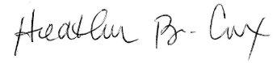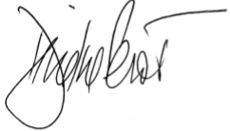

Heather Cox Deirdre Perot
BCH of NC President BCH of NC Public Lands Rep
Lead Objector

Supporting Documents also uploaded to CARA
1) BCH of NC Draft Plan comments
2) USFS : Recommended Best Practices for Managing Stock Use Sites at Developed Campgrounds

