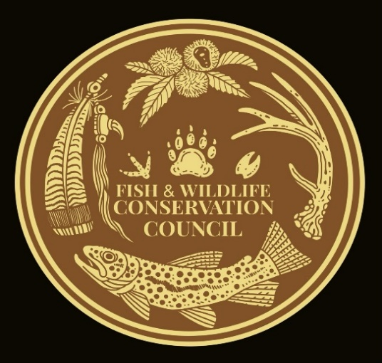
David Whitmire
Fish and Wildlife Conservation Council
2700 Flat Creek Valley Road
Lake Toxaway, NC 28747
avery@citcom.net
828-553-0083

January 25, 2024

US Forest Service
Washington Office
1400 Independence Avenue, SW
Washington, DC 20250

Re: Land Management Plan Direction for Old-Growth Forest Conditions Across the National Forest System #65356

To US Forest Service,

On behalf of the Fish and Wildlife Conservation Council thank you for the opportunity to review and comment on this land management decision.

While my council understands the appearance of simplicity in lumping 128 national forest plans into a consistent plan direction, our support ends with that for #65356. Our council will not comment on other forests outside our Nantahala and Pisgah National Forest and those bordering these two, in order not to speculate. Blanket decisions nationwide on such a diverse ecosystem leave a lot of room for mistakes. Reginal and local forest managers understand their induvial forest, thus their involvement in the public process of Forest Plans. Political inspired directives like #65356 undermine the public’s involvement in individual forest plans.

Our council finds the fact sheets provided left many questions unanswered. Much of the narrative was generic to the forest but seemed to focus on just old growth and not its role in the total forest. This decision could adversely affect wildlife habitat that needs young forest in our local region. Old Growth and mature forest will be over half the forest in the Nantahala and Pisgah National Forest according to the direction of the 2023 Forest Plan for these forest. We do not have enough information, comparisons, studies, or sideboards to management to support #65356. To achieve young forest goals in the forest we live in and manage is more challenging than old growth and is rarer on the landscape in our forest.

Our council was a part of one of the first collaborative forest plans in the nation. A ten-year investment by the USFS, a 10-year investment by our unpaid grass roots council. We were honored and appreciate the Forest Services’ efforts in bringing a together diverse groups and providing the level of science and public education to the new Nantahala / Pisgah Forest Plan. We felt the need for wildlife could be met through this plan. Our council feels #65356 will undermine the process of collaboration and the need for future collaboration as a productive process to Forest Service management decisions.

In closing we ask the US Forest Service to resend or revise the current #65356. To provide how each of the 128 National Forest lands will be affected by #65356. To exempt any forest plans that was developed and collaborated by the 2012 planning rules from #65356. It is very unclear to us the details and actions that #65356 will have on our forest and our current forest plan.

Best Regards,
David Whitmire

