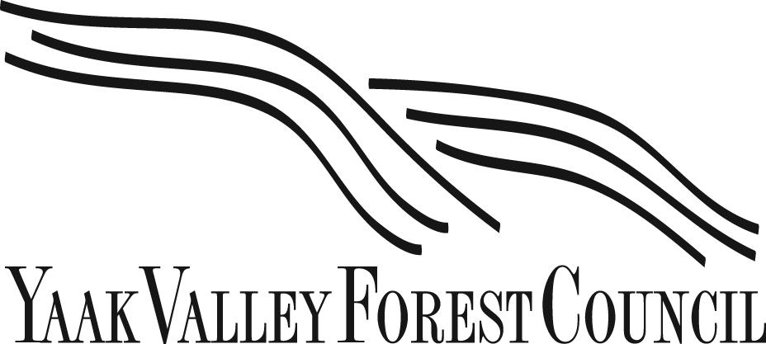

August 30, 2022

WORTH MORE STANDING: BLACK RAM PROJECT, KOOTENAI NATIONAL FOREST, MONTANA—SUB-BOREAL HIGH ELEVATIONS WET SOILS—ANCIENT LARCH, OLD GROWTH SPRUCE, CEDAR, HEMLOCK, SUBALPINE FIR

Greetings:
We write to you from the most northwestern valley in Montana—the Yaak Valley, on the Kootenai National Forest—which has long been the breadbasket of Montana. The reason for this is not complicated: remote and far from the public’s eye, and possessing pre-colonization as much as 50-% old growth, the Yaak once grew big ancient forests. It’s important—imperative—that we preserve all old and mature forests immediately, rather than giving the U.S. Forest Service (USFS) —which is currently working in opposition to President Biden’s climate policy and Earth Day executive order—more time to hurriedly liquidate the carbon investment that have been centuries in the making and which cannot be “recreated” or “restored” or made more “resilient through clearcutting” within the conditions of the current or foreseeable ecosystem. Black Ram, in particular., must be stopped immediately; we need a moratorium on all logging of old and large trees on public lands and must not reward the hurried thief-in-the-nigt operations/mentality of an agency that hurried to sign a record of decision upon hearing of the Biden E.O. Carbon is carbon and the old and mature forests of the Yaak Valley are among the best in the world at storing it.

In the Yaak Valley, along the Canadian border, we have gone from a historical range of variability of up to 50% old growth to a fragmented and farflung 10%, and not even a functional 10%, but instead a patchwork of often steep and rocky roadless country that was not easily accessible, hence the remnants. Their survival was certainly not any planned or programmatic conservation effort, and old and mature forests remain so unimportant to the Kootenai National Forest that there is not even any guidance or direction regarding old growth and mature forests in their (1995, severely outdated with regard to the climate emergency we inhabit) Forest Plan.

Hence the need for immediate action of a moratorium on all mature and old growth logging to align with President Biden’s executive order. Forests like the KNF are proceeding with egregious clearcut proposals of old and mature wet cedar and hemlocks forests such as those in the Black Ram project, identified as one of the ten worst logging proposals in the U.S. and the subject of intense and significant media attention nationally, and increasingly, abroad.

The Yaak Valley is a land of fire and rot; it possesses the lowest elevation in Montana, and one of the wettest valleys in the state. The Kootenai National Forest (KNF) also possesses far and away the lion’s share of threatened, endangered and sensitive species in Montana; fully 25% of the state’s listed species of concern are found on this one forest alone. And yet, the KNF steadfastly avoids the rigor of environmental impact statements, proceeding—blundering—along with cut-and-paste prescriptions for clearcuts far in excess of the 40-acre maximum directed by the outdated Forest Plan.

Primary forests such as those in the Black Ram project are rare enough; unbelievably, according to the USFS’ own maps, large sections of this forest show no recorded fire history. In an ecosystem dominated by fire, how has this massive stand of old and mature forests survived—prospered, in self-sustaining fashion—an island of fire refugia? How does clearcutting it provide us with scientific information or create “resilience?” And of the agency’s claim it will create forage—the threatened species on the Kootenai such as grizzly are not food limited, but rather, security-limited. And to represent this sale—50 miles downwind of the nearest incorporated town—as “fuels reduction” is simply unethical and untrue. Indeed, systemic nonconformities such as this are so prevalent throughout the KNF that a report is being prepared to submit to the Office of the Inspector General. This proposed/planned clearcutting-with-reserves and regeneration harvests are but one aspect of a similar trend of systemic mismanagement of public lands not in alignment with regard to the Biden administration’s commitment to climate change, fuels reduction, and endangered species.

The science of mitigating climate change is unmistakably and irretrievably political, for better or worse. Worse, during the Trump administration, not with the potential to be better, under the Biden administration. Cabinet level agencies such as Department of Agriculture must be in alignment with the administration; and it makes no sense, governmentally, for Department of Interior, with its executive order to analyze the effects of climate change on endangered species, to not be in alignment with Department of Agriculture which initially received no such direction. The rule-making should contain an immediate moratorium. These giants can only hold carbon if they are not logged. The aridification by the giant clearcuts currently on the books by the USFS will release further carbon into the atmosphere. What mill would risk sourcing such old and mature giants and carbon devastation? It will be remembered that logging on public lands, in addition to releasing far more carbon into the atmosphere than even the wildfires I the backcountry, provides only 3% of domestic timber supply—in a time of rising interest rates and housing starts’ plummeting—and that none of it need come from old and mature trees, which are worth more standing. No administration or country or government needs or desires a continuing national outcry at Black Ram; again, we’re grateful for the opportunity to provide this information to the rule-making process, and for the executive order to inventory and map. We will hold the agency accountable for seeing that through. President Biden is the Chief Executive. His directive must be honored; it may not be swept under the rug back in the hidden shadows along the Canadian border.

Some context: The USFS held up the Black Ram project for years because of numerous red flags—grizzly bears, old growth, water quality, wetlands, Border Patrol conflicts, Forest Plan violations, and more—only to then purposely and hastily sign it mere weeks after the Biden Executive Order. This project, spawned from a Trump 2018 executive order to increase volume of logging from public lands by 40% (an increase that could only be increased by large diameter trees and lots of them) or face reprisals to regional foresters, coupled with the Trump E.O. to avoid Environmental Impact Statements wherever possible—resulted in what has been identified by activists as one of the top ten worst logging proposals on public lands in the United States, and possibly the most egregious, eradicating as it would core designated habitat of a population of threatened grizzly bears identified by the U.S. Fish & Wildlife Service as the “least resilient” in North America. Black Ram, under the impetus of the Trump E.O., is part of six contiguous and cotemporaneous logging projects on one ranger district alone (Three Rivers Ranger District, on the Kootenai National Forest) totaling over 314,000 acres without a single environmental impact statement. Other threatened and endangered species affected by these sales—with Black Ram in the center—include Canada lynx, wolverine, and bull trout. Field reconnaissance by our Headwaters crew has identified breeding ponds for boreal toads and Couer D’ Alene salamanders that were destroyed by a “fireline” built right to the edge of these proposed units and resulting in a 2.5 mile arid clearcut stripe to the Canadian border. Similarly, our possible discovery of an endangered species, the jumping slug, has been ignored by the agency. No restoration has occurred to the wetlands that were destroyed in this action and the “fireline” is actively de-watering the ancient forests in the Rampike region, which are slated for clearcuts with reserves.

We are attaching a recent analysis of the region by Dr. Dominick DellaSala, one of the country’s leading old growth experts, which refutes agency claims regarding the absence of old growth in this proposal. (Though officially designated old growth is no safer in this project than is designated core grizzly habitat.

In short, this is a fuse the agency lit purposely after Biden’s pronouncement. It is a Keystone in waiting, as Bill McKibben noted a few years earlier. Rep. Chellie Pingree, a leader in climate justice legislation and oversight, at the request of her constituents, requested the Chief of the USFS confer with her about the project, given these many concerns and the disparity between the proposal and the alignment of the administration. The agency released the sale however without replying to her. It is this isolate and self-governing characteristic, of the Kootenai National Forest particularly, that demands immediate moratorium on old and mature timber to be inventoried before proceeding further. It should be noted also the recent long run of court losses by the USFS on cased lobbed forward by a KNF seemingly uninterested in crafting collaborative proposals that would operate within the law. It’s quite frustrating to our 2000-member organization, as we seek to defend the ecological integrity and sustainability of a million-acre landmass north of the Kootenai River and south of Canada. (Ironically, the agency’s own silviculturalist acknowledges their attempts to replant white pine in the clearcut units are certain to experience 80-90% “regeneration failure). Why, then? Why here? Even the next-state-over timber mill purchaser asked that question—unanswerable—on a field trip.

Another reason for the immediate moratorium lies in the soil itself, at Black Ram. This alpine and wet vegetative response units (VRUs) store incredible amounts if carbon I long-term safekeeping—not just in the towering giants that grow in these wet and even swampy soils, but in the moss-clad sarcophagi of humus that is centuries deep below, giants sleeping atop giants. What scientific marvels and discoveries await in this primary forest—miciro- and macro-nverterbrate species, mycorrhizal relationships where giant cedars grow shoulder-to-shoulder with giat larch, no longer seeming in “competition” but instead more sophisticated and mysterious relationships of cooperation? A recent visit to the units by leading mycologist Larry Evans left him shaking his head in awe at the uninventoried variety and density of fungi in this old wet forest, characterized again by just by diversity, but by diversity within diversity—species relationships he had not seen anywhere else. What is the agency racing to liquidate rather than inventory? This must not be allowed. We’re grateful to the rule-making process for the opportunity to correct this great wrong that is unscrolling as we speak.

Please do not hesitate to contact us if anyone in the administration would be interested in a field trip to any part of this signed proposal. The rule-making process offers our best opportunity to create an immediate and tangible step, an enormous one, to slowing the rate of climate change and preserving these refugia for carbon storage and endangered species.

Sincerely,

Rick Bass
Executive Director
Yaak Valley Forest Council
11896 Yaak River Rd.
Troy (Yaak), MT 59935

