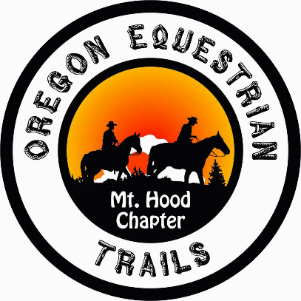
RE: Forest Service Manual 7700 Travel Management
Chapter 7700, Zero Code
Chapter 7710 Travel Planning
October 26, 2020

My husband and I are submitting comments about proposed changes to the directives above on behalf of Oregon Equestrian Trails, Mt. Hood Chapter. Our Mt. Hood Chapter has accomplished volunteer work in four different Forest Service Ranger Districts. Currently our focus is on a Federal Recreation site in the Columbia River Gorge National Scenic Area.
While the bicycle riders at this Recreation Site, the Sandy River Delta, are very polite stopping to let us pass and calling out when they need to pass, this sadly is not the case with many bicycle riders in other areas that we ride.
When you are on a trail with bicycle riders moving at a fast pace, it is nerve-racking not to know when one is going to show up. When there are short sight lines, switchbacks, or narrow tread, it is a race to see if we can yell loud enough to get their attention in order to execute a safe passing situation for all. With two-tracks the passing issue is better, but a shout-out is always appreciated as bikes are often very quiet and almost always moving fast compared to hikers and equestrians.

Our concerns about e-bikes are:
- e-bikes can travel much faster –both uphill and downhill-- than is safe on trails shared with hikers and horses.
- Many of our non-motorized trails are already overcrowded. Allowing e-bikes on these trails will worsen the situation. Consider the Resource.
- E-bike technology will evolve, allowing manufacturers to build lighter bikes with longer-lasting batteries. The e-bike of the future will reach remote areas that are currently inaccessible by e-bikes.
- As the technology improves, we expect the market for e-bikes to shift from older-people enjoying the outdoors to include younger riders seeking speed, challenge, and thrills. We ask that you take all of the various situations with users, types of trails, and consideration of the resources into account. We look forward to working with our Oregon public lands agencies as these changes are considered.

Thank you,
David and Barbara Adams
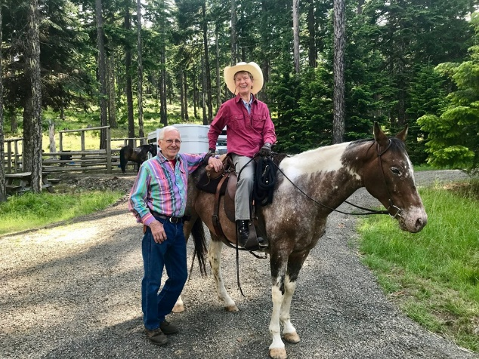
Dave, Barb, Skylla and Zippy, Mt. Hood National Forest

