

PO Box 521 | Conway, NH 03818
www.SkiNH.com | Phone. 603.745.9396

August 27, 2026

U.S. Forest Service
White Mountain National Forest
Pemigewasset Ranger District
Derek Ibarguen, Forest Supervisor, c/o Justin Preisendorfer, Winter Sports Team Leader
71 White Mountain Drive
Campton, NH 03223

Re: Waterville Valley Resort Proposed Expansion — Support from Ski New Hampshire

Dear Mr. Ibarguen:

On behalf of Ski New Hampshire, the statewide association representing more than 30 alpine and cross-country ski areas and resorts across New Hampshire, we are pleased to express our strong support for Waterville Valley Resort’s proposed expansion on National Forest System and private lands. Ski New Hampshire believes that thoughtful, long-term investment in New Hampshire’s established ski areas is essential to maintaining the strength and competitiveness of the state’s outdoor recreation and tourism economy. Waterville Valley Resort’s proposal represents exactly the kind of forward-looking investment that will help ensure New Hampshire remains a premier destination for skiing, riding, mountain recreation, and year-round tourism.

Continued capital investment is essential to competitiveness.
New Hampshire’s ski areas compete in an increasingly sophisticated regional and national marketplace. Resorts throughout New England and across the country continue to invest in lifts, terrain, snowmaking, lodges, dining, guest services, technology, and other infrastructure to improve the visitor experience and respond to changing guest expectations.

New Hampshire must be able to make comparable investments if its ski industry is to remain competitive. Capital investment is not simply about adding capacity; it is about maintaining and improving the quality of the experience that visitors expect when they choose where to spend their recreation and vacation dollars.
Waterville Valley Resort’s proposal would make meaningful investments in several of these areas, including new and improved mountain access, expanded terrain and snowmaking, and new guest-service facilities. The ability to implement carefully planned improvements over time is fundamental to the long-term viability of the industry.

A project of this scale demonstrates confidence in New Hampshire’s ski industry.
Part of the significance of Waterville Valley Resort’s proposal is what an investment of this scale represents. It demonstrates a long-term commitment to Waterville Valley and confidence in the future of skiing and mountain recreation in New Hampshire.

New Hampshire’s ski industry has demonstrated continued resilience and demand. Ski New Hampshire has consistently emphasized the importance of capital improvements across the state, with recent investments including new lifts, snowmaking improvements, upgraded lodges, and other guest-experience enhancements. A major, long-term master-planning effort such as Waterville Valley’s sends an important signal that established New Hampshire resorts are prepared to invest for the future rather than simply maintain the status quo.

Expanding year-round visitation and non-skier options is increasingly important.
The future of New Hampshire’s mountain resorts depends in part on their ability to attract visitors beyond the traditional winter ski season, and to also attract guests who may not be interested in skiing at all, even during the winter months. Ski areas have increasingly become four-season destinations, and one of the most compelling aspects of the proposal is the opportunity to provide mountain access to a substantially broader group of visitors.

Waterville Valley’s proposed village-to-summit lift and summit facility could substantially enhance their ability to make the mountain accessible to visitors regardless of whether they are there to ski or ride. A connection between the town and mountain can create new reasons for visitors to spend time in Waterville Valley and provide additional opportunities for local lodging, dining, retail, events, and other tourism businesses. A gondola can make experiencing a mountain summit available to people who otherwise might never have the opportunity to reach the summit. In that respect, the proposed lift is not merely a piece of ski infrastructure; it is an investment in broader recreational access and a potential catalyst for four-season visitation.

The economic benefits extend well beyond the resort.
Investment in a ski area does not benefit only the ski area itself. Ski visitors and mountain guests generate economic activity throughout surrounding communities and across the state.

A Ski New Hampshire economic contribution study estimated that ski-area visitors generated approximately $384 million in direct spending during the 2017–18 season, supporting a total economic contribution of approximately $508 million and 7,485 jobs when direct, indirect, and induced effects were included. Visitor spending reached far beyond lift tickets, with significant expenditures associated with lodging, restaurants, groceries, transportation, and other services.

Likewise, ski area investment supports lodging properties, restaurants, retail establishments, contractors, transportation providers, equipment suppliers, professional services, and countless other businesses. It also supports employment opportunities for residents throughout the region. As such, Waterville Valley Resort’s ability to be a more competitive mountain destination can contribute to increased visitation and spending throughout the surrounding community and region.

Thoughtful master planning is critical to New Hampshire’s future.
More broadly, Ski New Hampshire believes that the ability of established ski areas to thoughtfully implement long-term master plans is essential to the future competitiveness of skiing and outdoor recreation in New Hampshire, not just for Waterville Valley Resort, but for all of its ski areas.

The marketplace in which New Hampshire competes is not static. Other states and destinations continue to invest in their mountain resorts, outdoor recreation infrastructure, visitor amenities, and tourism offerings. At the same time, New Hampshire’s mountain destinations compete not only with other ski states, but also with a growing range of recreational and tourism opportunities available to consumers. Maintaining competitiveness therefore requires more than preserving what already exists. It requires the ability to responsibly evolve.

New Hampshire has built a strong reputation as a destination for skiing, outdoor recreation, and tourism. Protecting that reputation requires a balance between responsible stewardship and the ability of established businesses to innovate, invest, and respond to changing visitor expectations.
For these reasons, Ski New Hampshire supports Waterville Valley Resort’s proposed expansion and encourages the Forest Service to recognize the project's potential contribution to the long-term vitality and competitiveness of New Hampshire’s ski and outdoor recreation industry.

We appreciate the Forest Service’s careful consideration of the proposal and the opportunity to provide comments on this important project.

Sincerely,
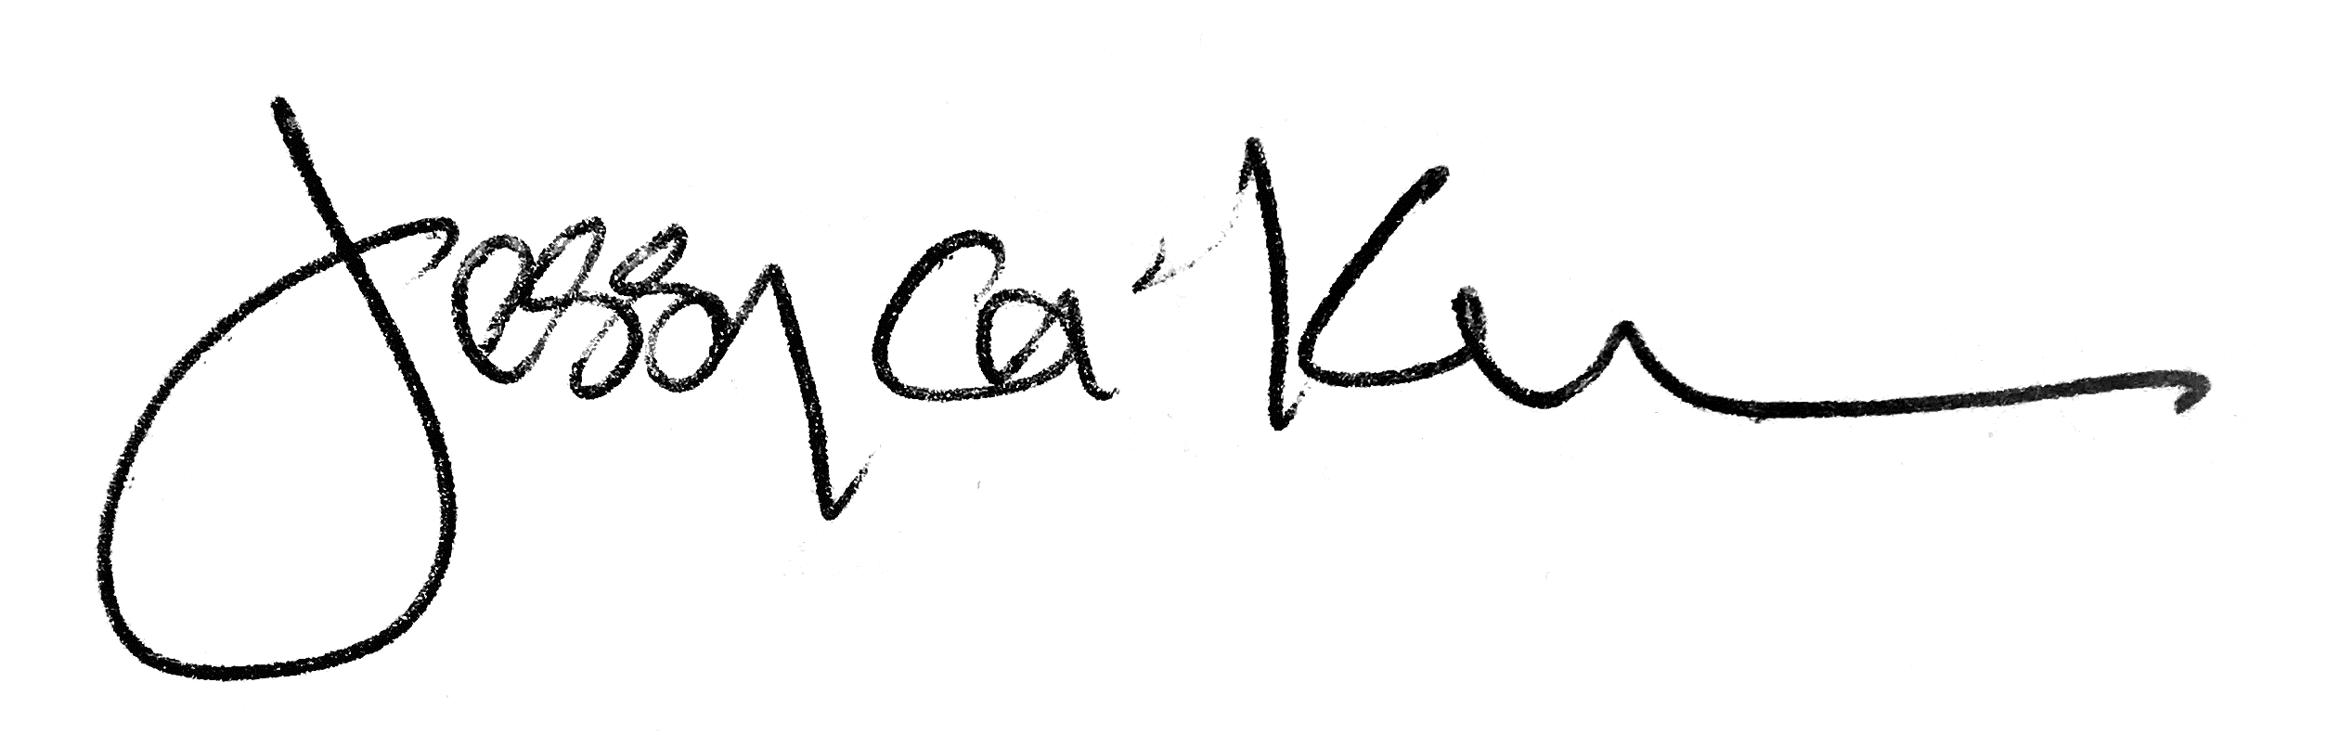

Jessyca Keeler
President
Ski New Hampshire

