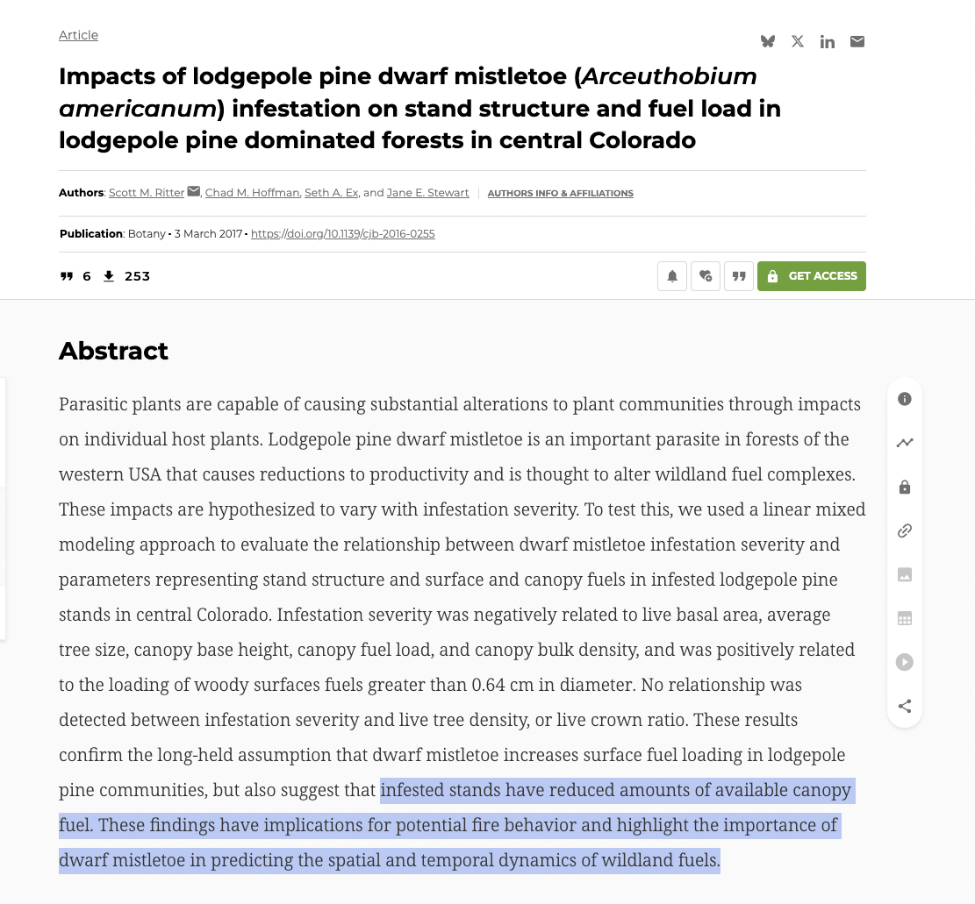

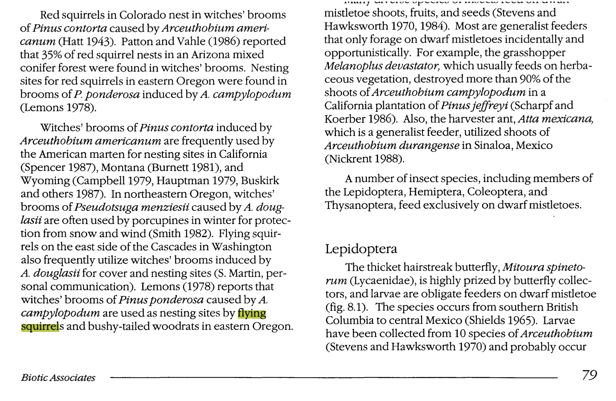
Above excerpt describes Marten use of Mistletoe from, is from Hawksworth, Frank G.; Wiens, Delbert. 1996. Dwarf mistletoes: Biology, pathology, and systematics. Agricultural Handbook 709. Washington, D.C.: U.S. Dept. of Agriculture, Forest Service. 410 p.
How much has Marten habitat in the SNRA been altered by recent fires, and past fuels and other projects? What is the population of Martens in the SNRA? Please identify current occupied Marten habitats and territories.
Please consider this as part of WildLands Defense, Alliance for the Wild Rockies and Native Ecosystems Council comments on the Sawtooth Forest 2026 Wapiti Post-Fire Recovery Fire project.
Also, here is an excerpt from comments WL:D submitted to the Salmon-Challis Forest in 2019 regarding proposed purges of mistletoe wildlife habitat. Note that the links to USFS documents no longer work, as the agency revamped its website and removed much scientific information in 2025 with the new administration.

