February 22, 2022

Manti-La Sal National Forest
599 West Price River Drive
Price, UT 84501

Comments on Draft EA and FONSI: Forest-wide Prescribed Fire Restoration Project

Dear Manti-LaSal National Forest,
Here are comments from WildLands Defense, Alliance for the Wild Rockies, Native Ecosystems Council and Yellowstone to Uintas Connection on the Manti-La Sal Forest-Wide Prescribed Fire Restoration Project.
The MLNF Prescribed Fire EA Scoping document stated:
Currently, the Forest is mechanically thinning and burning approximately 10,000 acres a year, however; there are over 1.1 million acres on the Manti-La Sal National Forest that can be characterized as being moderately or very highly departed from their natural (historic) regime of vegetation characteristic, fuel composition, and fire frequency; severity and pattern where there is a considerable risk of losing key ecosystem components. Key ecosystem components at risk of being lost are pinyon-juniper woodland, aspen and aspen mixed- conifer forest and woodland, spruce-fir forest and woodland, and ponderosa pine woodland and savanna, as well as Gambel oak-mixed montane shrublands and big sagebrush steppe, and a wide variety of lesser prevalent mixed conifer and deciduous tree and brush species across the Forest.
This turns the matter on its head. It’s the proposed massive use of prescribed fire, (including unnatural jackpot and pile burning, chain-sawing, mastication and other cross-country motorized use, re-seeding (with no mandatory requirement to use native plant seeds), unassessed project-linked herbicide use, and other associated activities that are likely to cause a “loss of key ecosystem components”. The EA aims to radically alter and fragment sagebrush, Pinyon-Juniper and other forested communities, and will expand flammable invasive annual grasses that result in highly unnatural frequent fires dooming recovery of complex native woody vegetation communities.
Silvicultural Report Table 3 shows 1,002,608 “Total Treatment Acres”, with treatments apparently planned to extend over the next 32 years. The MLNF contains approx. 600,000 total Roadless acres. There are 84 Roadless Areas within the project area, with 475,450 roadless acres (according to the EA) or confusingly contradicting that acreage is the roadless report apparently showing a chart with 349,445 acres - proposed for potential intensive treatments. Close to 100,000 acres of sagebrush communities are to be destroyed., plus an unknown amount of collateral damage from all the deforestation activity impacts to sagebrush such as pile bruinigg, being driven over and crushed, bladed into a fireline, etc.
It also appears that no MLNF vegetation community is to go unscathed/unburned – even greasewood, salt desert shrubs and “barren” areas are targeted because the spurious Landfire models claim they haven’t burned enough.
This MLNF EA is the latest in a series of cookie cutter EAs being issued all across Intermountain Region 4 Forests. The FS must full evaluate the massive amount of carbon that will be released into the atmosphere in the near-term, the loss of carbon sequestration ability from burning of vast areas of mature forests, and the associated massive amount of habitat loss for sensitive species, important species and migratory birds across the Rocky Mountain region if these EAs come to fruition.
There will be extreme impacts to North American forest and shrubland wildlife species. This includes native carnivores including the potential for Gray Wolf recovery across the MLNF as protective woody cover is seriously reduced and cleared away thus allowing expansion of the human disturbance footprint. Removal of protections for Gray Wolves was recently struck down by a federal court. https://earthjustice.org/news/press/2022/gray-wolves-regain-federal-endangered-species-act-protections .
“A federal district court today struck down a 2020 decision by the U.S. Fish and Wildlife Service that removed federal protections from gray wolves across much of the U.S. The Trump administration delisted the gray wolf after 45 years of protection under the Endangered Species Act despite the strong disagreement from experts who noted that the wolf’s recovery hinged on continued protections”.
The MLNF contains suitable habitat for Gray Wolves. The EA wildlife report essentially claims there are now too many elk, Wolves would be a natural solution for addressing some Elk problems. The FS fails to consider the value of the existing vegetation communities in providing a habitat connectivity corridor and dispersal for many native species – including species completely ignored in the EA. Also, what native carnivores have been extirpated from the forest, and what habitat types do these species require? Why isn’t the Forest managing for recovery of such species?
Imagine the impacts of burning a million acres here to migrating birds whose food sources are greatly diminished by past FS and BLM treatments and/or livestock grazing, and by wildfires (which will continue and will not be stopped by agency projects such as this), drought and the climate crisis. See Rosenberg et al. 2019 describing the serious declines of the North American Avifauna. The project’s high level of burning plus other deforestation and woody vegetation destruction treatments are planned/taking place all along the migration route. This will lead to drastic declines in mature and old growth woody shrubs and forest types that produce insects/fruits/seeds needed in fall migration have been burned up under these huge EA schemes. See for example, a Smithsonian article describing starvation as a cause of the massive migratory bird die-off last fall. Birds are already facing immense threats from habitat loss, megadrought, climate stress and extreme weather, insecticides and herbicides impacting food sources on nesting, wintering and migration habitats.
https://www.smithsonianmag.com/smart-news/southwest-bird-die-caused-long-term-starvation-180976643/
“Desmond tells Audubon that the birds may have arrived in the southwestern U.S. already starving in part because of severe drought afflicting the region.
“It’s been extremely dry here this year, so seed production is low and insect numbers are low,” says Desmond, who helped organize research efforts to study the die-off. With less food, the birds would have lacked the stores of energy needed to complete their grueling migrations”.
Despite the unprecedented array of threats migratory birds face, and the serious declines taking place, here’s how the FS views migratory birds:
The Terrestrial Wildlife BE p. 27 states:
“Migratory birds are agile species and are generally able to move away from disturbances and find adjacent habitat areas when displaced”.
This exposes the MLNF’s attitude toward ‘inconvenient” wildlife species like migratory songbirds - the birds who aren’t burned up (as many nestlings will be given the lack of any spring-early summer mandatory burning and treatment avoidance periods in the EA) are claimed to be “agile” and will move away. Somewhere across the rainbow – to a promised land of unburned mature forest? There is no spring early summer nesting prohibition on burning. Region 4 is working over time to drastically alter and simply habitat everywhere, and as described in these comments, so is BLM. Only some TES species get mentioned as receiving (hollow) protections that can be waived anyway. See EA “Design Elements” The list of “Design Elements” is full of loopholes. Nest sites and prime nesting habitat for any species can be burned up when birds are not nesting
The FS’s attitude toward migratory birds (and in reality all other wildlife here) violates NFMA’s sustainability and population viability mandates. Nearly all migratory birds have nesting territories that they defend from other birds of the same species, and they nest in specific complex habitats that contain the species-specific essential elements of food, cover and space they require are present. The FS can’t just cram more birds into an area of habitat. This shows the lengths the Region 4 FS will go to in covering up the very significant impacts of its massive prescribed burns and other treatments on declining migratory birds of high conservation concern. See Rosenberg et al. 2019, See all the species in te Terrestrial BE Table 6 that rely on the specific habitat types – like Pinyon-Juniper or Sagebrush – that the EA targets and will also harm, fragment or destroy as collateral damage.
The MLNF’s attitude and this shallow self-serving circular reasoning EA is precisely why so many wildlife species are in such sharp decline. Agencies will make any excuses necessary to justify continuing to destroy habitat.
Region 4 FS is planning to similarly burn 6 or 7 million or more acres (in just current projects!), including vast portions of Roadless Areas crucial for biodiversity protection across the regions’ forests. See following discussion and attached comments and/or NEPA documents on CD for the Sawtooth the Caribou-Targhee, Humboldt-Toiyabe, Fishlake and Dixie Forests Fire EAs. These are in addition to all the other “treatments that have taken place, are authorized, or foreseeable. The full range of indirect, cumulative and synergistic and additive adverse effects to migratory birds and all other species of concern and impacted National Forest values impacted by these Region 4 infernos must be fully examined in an EIS here
Federal agency prescribed fire and treatment zealots across the Intermountain region will create conditions for massive migratory bird die-offs during continued drought and harsh weather conditions during migration. For localized resident species. Forest-inhabiting native carnivores and aquatic species struggling in the region’s tiny streams will face grave imperilment as watersheds are converted to hotter, drier, winder, weedier bleak burn-scapes - that also continue to be grazed by over-stocked cattle and sheep which cause cheatgrass expansion. Post-treatment, livestock would have even more ready access to areas previously less protected by woody vegetation.
The proposed MLNF project would authorize multiple prescribed burns on NFS lands across the Forest per year, up to 31,248 acres per year across 1,002,608 acres (This is what the Aquatics BE states).
All manner of often overlapping and/or consecutive and cumulative disturbance is planned across this fragile landscape. Yet critical baseline information on soil condition , erosion susceptibility, watershed health, water quality and quantity, microbiotic crust condition, health and integrity of grazed native plant communities, areas actually occupied by sensitive species (see Dobkin and Sauder 2004) – describing how sagebrush species may be much more limited in actual occurrence than gross habitat-typing mapping would indicate), whether migratory bird and TES species populations can withstand drastic FS-imposed loss of maturing, mature and old growth veg communities, the myriad harms to cultural sites, and myriad harms and losses recreational uses and enjoyment of these lands.
“Smaller burn units could be used where infrastructure or other high value resources and assets are present; larger burn units could be designed where the prescribed fire objectives permit. Multiple treatment entries may be required for moving vegetation and habitat characteristics toward desired conditions. In the context of this proposed action, treatments include not only the type of fire applied to achieve an objective, but also the pre-fire actions, also known as burn preparation, needed to facilitate the application of fire.
The decision may be implemented across approximately 1,220,283 acres of the Manti-La Sal National Forest on National Forest System (NFS) lands. (This is what the EA states).
Underburning—a kind of low intensity prescribed fire used to reduce ladder fuels in order to remove surface fuels but not all of the overstory vegetation. It is used as both a first entry and maintenance burning primarily in conifer forests. [Is the plan here to burn and reburn until a sold thatch of cheatgrass takes hold?].
- Broadcast burning—a type of mixed intensity prescribed fire that uses surface fire on a broad area of a burn unit, often when no overstory trees are present to increase structure, age, and species diversity (such as sagebrush, pinyon-juniper vegetation communities). In some instances, broadcast burning is used to remove overstory vegetation to create openings and optimal conditions for regenerating vegetation, such as in subalpine conifer or aspen vegetation communities.
- Jackpot burning—a modified type of underburn or broadcast burn, where there are concentrations (or “jackpots”) of vegetative fuel that create pockets of higher intensity burning (most often in pinyon-juniper or other conifer vegetation communities). The result would be a mosaic burn pattern. It can also be used in lieu of broadcast burning to burn smaller pockets of surface fuels to meet key objectives (for example, when used in sagebrush vegetation communities). [This creates severe and often uncontrollable roaring cauldrons of fire destroying crusts, splitting boulders apart, and creating hydrophobic soils – see Owyhee burn photos. Junipers were cut down all around beautiful mature and old growth junipers, left to dry out for a couple years, and then napalmed].
- Pile burning—prescribed fire that burns discrete piles of fuels with some surface fire allowed to spread between them. This is used primarily in conifer and pinyon-juniper vegetation communities. It is used near fireline construction, near values at risk such as the wildland urban interface, or during initial burning where fuels reduction is needed to achieve the objectives of a future underburn. [Each pile site at mid to lower elevations is an epicenter for new cheatgrass infestation and spread. This also kill surrounding sage and/or trees.
- Tree well burning—the burning of open patches of surface fuels, beneath the canopy near tree wells, where the snow has melted or pulled back allowing surface fuel to become available to burn. Tree well burning is intended to reduce the threat of mortality to the trees by utilizing a low intensity surface fire near the bole of the tree and low hanging limbs. This type of burning reduces surface fuels (needles and/or smaller limbs). Tree well burning aids in the restoration of fire adapted ecosystems, while reducing the potential for tree mortality from wildland fires that may occur in the summer months. [So why not just cut some lower limbs off? Wouldn’t that be more efficient?].
- Select methods of mechanical thinning, chipping and mastication of ladder fuels, including mountain brush, may be used to reinforce control lines or as a pre-treatment to increase safety where people are working;[Will this take place across roadless areas?]
- Limited cross-country motorized vehicle travel, where resource conditions allow. [When and where will they “allow” and how will this be determined?]
- Slash lines for subalpine fir to modify the fuel bed for the purposes of extending the burn
window into moist conditions. [What are these “slash lines” – are they similar to jackpot burn inferno sites? Is’nt a lot of subalpine fire or Douglas fir already dead due to insects? If so, why is there a “need” for treatments – we can find no EA or report mapping or baseline info on existing forest mortality across the project area. How much does insect or pathogen-caused mortality decrease fire “risk”].

The Silvicultural Report reveals use of extremely short Landifre fire return intervals in these models. It lays out dozens of targeted vegetation communities – from Salt desert shrub, Mojave shrub, all types of sagebrush habitats to alpine habitats.
Conditions in many areas of the MLNF are harsh, arid and are getting harsher and drier all the time under climate change stress and the most extreme drought in 1200 years. https://www.npr.org/2022/02/14/1080302434/study-finds-western-megadrought-is-the-worst-in-1-200-years

“The Western U.S. and northern Mexico are experiencing their driest period in at least 1,200 years, according to the new study, published in the journal Nature Climate Change. The last comparable — though not as severe — multidecade megadrought occurred in the 1500s, when the West was still largely inhabited by Native American tribes”.

“Williams, the study author, said roughly one-fifth of the current megadrought can be attributed to human-caused climate change. Greenhouse gas emissions are warming the world, speeding evaporation and disrupting weather patterns”.

Williams paper:

https://www.nature.com/articles/s41558-022-01290-z.epdf?sharing_token=mCYpYW7ncvHU28E8rotUNNRgN0jAjWel9jnR3ZoTv0OkweMbawmVFM1UCLmLxuyBpGKtFJa1_BxzJ7UFQSQZ6HoKWiVpxr-PXXpBdXS0aLJYrb-T2bjp5Y_Cku7vSenHblt81qi9olu_1s3zBCVWxhOj7h1yPvukczp8OW-fMInax-64I97Ydyz8yOYptdpaLuUfk5JMXGjlcK0iPR_bAbZezMr6HR87nF1y-C5ApXrPDDheDZbRuS7KnTcwWcPIrhf0J4AhCj_Wfnpjfu1E0l7NQOLUa0ML_ePi86pomeHatjFjn70nb0XEMjerDCbB&tracking_referrer=www.npr.org

Snowpack is essential to provide sustainable water flows, and climate change is reducing snow pack persistence. Drastic MLNF-caused reduction in shading forest and other woody watershed cover will also reduce snow persistence and result in a longer fire season, reduced aquifer recharge. See Hammond Dissertation 2018, describing
https://mountainscholar.org/bitstream/handle/10217/193128/Hammond_colostate_0053A_15153.pdf?sequence=1
“Loss of concentrated melt from persistent snowpacks may lead to lower streamflow and compromise deep drainage, and thus aquifer recharge, in semi-arid cold regions. The consequences of streamflow and groundwater recharge loss could be severe in regions already water-stressed, and this needs to be addressed in long-term water supply planning”.
Also see Biederman et al. 2015, “Recent tree die-off has little effect on streamflow in contrast to expected increases from historical studies”.
http://naes.agnt.unr.edu/PMS/Pubs/687_2015_04.pdf
“Time-trend analysis revealed post-die-off streamflow decreased in three catchments by 11–29%, with no change in the other five catchments. Although counter to initial expectations, these results are consistent with increased transpiration by surviving vegetation and the growing body of literature documenting increased snow sublimation and evaporation from the subcanopy following die-off in water-limited, snow-dominated forests. The observations presented here challenge the widespread expectation that streamflow will increase following beetle-induced forest die-off and highlight the need to better understand the processes driving hydrologic response to forest disturbance”.
What are current baseline flows and water quality across the stream systems of the project area? How does this compare to historical flow data? There has been speculation that rampant agency “treatments” clearing woody vegetation are being done in part under the unproven claim that stripping forests will increase water flows for downstream users. Is that the case here?

Additionally, the project will generate large amounts of dust for years following burning (and livestock grazing soil disturbance and trampling-caused destruction of microbiotic crusts is also a serious concern. The fire and other activity destroy crusts, the grazing prevents or retards crust recover, excessive dust is produced.

See for example, https://yaleclimateconnections.org/2018/03/dust-on-snowpack-a-gas-pedal-for-snowmelt/ , “Dust on snowpack a gas pedal for snowmelt”.

How much will the Fire EA activities increase dust? What is the current baseline dust production? What is the erosion hazard for all project area soils? How is grazing currently impacting erosion rates?

Cheatgrass and other flammable invasive annual grasses and weeds, which thrive in burned/grazed/disturbed lands, are already exploding across many lower elevation areas of this region - in grazing-disturbed, sites in past treatment-disturbed areas, in fire-disturbed sites, and in road margins and other areas subject intensive human disturbance The Forest must critically examine and provide monitoring data for the current extent and amount of annual grass cover, and predicted risk of increase under climate change stress as a baseline. The FS must provide data and monitoring from its own and adjacent BLM burned and treated and other sites to determine the extent to which cheatgrass and other weeds are capable of dominating sites post-fire (either wild or “prescribed” fire) and post-treatment.

This project is made even more risky due to potential use of aerial fire ignitions – note the FS never specifies how anything in this project will actually take place. How much of the activity will be aerial ignition? How may this harm and impact wildlife populations with noise? How much will use of aerial ignition result in in expanded collateral damage – as winds and weather vagaries in steep, rugged terrain may result in significant burning of non-targeted areas, and sites largely immune from fires due to cliffs. Use of aerial ignition in spring and summer makes incineration of nests, eggs. Nestling, small mammal and other mammal young even more likely. In these aerial ignitions, ping pong balls with napalm-like highly flammable material are spit out of a spinning device on helicopters. This type of ignition can have devastating impacts to forests. Please see following photos and info on cd illustrating the severe impacts that aerial ignitions in agency arid forest “prescribed” fire in the Owyhee region. Photos below show impacts caused by aerial ignition in rugged mountainous terrain in the Juniper Mountain area of Idaho - both jackpot burning and broadcast burning. Ancient trees and groves of old growth were destroyed after the napalm ping pong balls ignited the forest. We stress that the EA lacks any hard look at all of this.

This mammoth burning project will reversibly harm these MLNF Roadless and other wild areas, and the essential migratory bird, wildlife habitats and rare aquatic species habitats and recreational uses and aesthetic natural settings currently present in the MLNF. The MLNF currently contains often highly diverse complex vegetation communities at differing elevations, slopes and aspects and with often complicated past disturbance histories. The project will also cause collateral damage – and harm additional unplanned acres of sagebrush, PJ and other habitats as collateral damage. It will irreversibly alter lands that become engulfed with cheatgrass or other flammable exotic weeds in the aftermath of the prescribed fire and continued grazing disturbance under climate stress. Other areas will be damaged for centuries or longer – until forests regain complex structure required for many sensitive species – from Mexican Spotted Owl to Flammulated Owl.

Only Wilderness area lands, RNAs, a block of Greater sage-grouse habitat and expanded Bears Ears areas) are not targeted for radical disturbance:
• _Woody plant communities across the Forest could be burned by the agency --- pinyon-juniper forest, aspen forest, aspen mixed-conifer forest and ‘woodland”, spruce-fir forest and woodland, ponderosa pine woodland and savanna, big sagebrush steppe, Gambel oak-mixed montane shrublands, and a dozens of other mixed conifer and deciduous tree and brush species. See Silvicultural Report.
• _Prescribed fire types to be used include under-burning, broadcast burning, jackpot burning, pile burning, and tree well burning. This includes types of burning that cause severe damage to microbiotic crusts and soils, including creating hydrophobic conditions.

The EA greatly fails to address harmful; effects of helicopter napalming, ground ignition of “broadcast” burning and the very harmful effects of both jackpot and pile burning.

• Burn “preparation”/pre-treatment actions include mechanical and hand thinning, chipping and mastication slashing, piling, pruning and pile burning.

This entails a large amount of extensive mechanized activity, cross-country driving, severe soil disturbance smothering ground in wood chips, and there is also cross country driving with highly damaging soil scalding pile burning.

• Pre-treatment timber harvesting could be planned under “a separate NEPA process and decision”. This means the FS plans to log an unrevealed expanse of the Forest, too? How many acres is the FS foreseeably planning additional treatment actions in, including logging? Where? Will that separate NEPA be done at least at the level of an EA and likely a necessary EIS? Will it be a mere CX that tries tier to this extremely deficient EA and Landfire modeling - piling logging into fuels reduction - despite this EA greatly lacking in high quality (or often any) baseline biological and sensitive species habitat quality and quantity information; population viability information; watershed condition, water quality and quantity/flow data - including conditions being affected by grazing degradation invasive species presence and expansion risk including as exacerbated by grazing (see Beschta et al. 2012, 2014, Carter et al. 2014), and a host of other necessary baseline information.

• _Post-treatment actions include replacing livestock grazing-associated infrastructure, revegetation, re-seeding, addressing invasive species populations, and monitoring to resume grazing and see if there is recovery of “forage” and native vegetation. Will this seeding involve large-tractor-pulled drill rigs? How much herbicide of which types will be applied, and where and by what means – cross-country driving by tractors pulling giant ‘Amazon” drills - which rip up native grasses and forbs and shrubs hat may have survived fires? By risky drift-prone aerial applications? How much risk of site dominance by cheatgrass is there from each of these treatments? From multiple and overlapping treatment disturbances in the same watersheds? How is this risk increased by chronic annual grazing disturbance? Please provide all current MLNF NEPA coverage and risk assessments covering FS herbicide use of all types.

The re-seeding only commits to seeding what is growing in the surrounding area -so if there is crested wheatgrass or smooth brome – apparently more of these aggressive harmful exotic species can be used,. Further, this extensive FS re-seeding plan also further cements in harmful and often lethal-to-wildlife livestock infrastructure. Connelly et al. 2004, Knick and Connelly 2009/2011 – West Nile virus (stock ponds, troughs, trampling pocked wet soils), Van Lanen 2016 – marked and unmarked fence mortality. There is no baseline data and analysis on the location, condition and environmental impacts, including on wildlife and recreational uses, of the huge livestock infrastructure burden on the MLNF. Please provide a detailed baseline of this infrastructure burden, and a hard science-based look at all direct, indirect and cumulative effects and synergistic effects.

This massive re-seeding and fortifying livestock infrastructure indicates that this burning project is at its heart a huge livestock forage increase project. If the FS plans to burn so severely that livestock projects need “replaced” – then it is clear the agency knows it will be unable to control its hellish jackpot burning and pile burning, and the broadcast burning and other fire it seeks to unleash on mature and old growth native woody vegetation communities that right now provide essential and irreplaceable habitat for a host of sensitive species, migratory birds and other native biota of significant conservation concern.

What sites currently contain exotic aggressive rhizomatous grasses like smooth brome or intermediate wheatgrass – io crested wheatgrass? Please provide detailed mapping and analysis. These have often been lavishly used in the past on Utah forests. They will thrive in the aftermath of fire and often preclude recovery of shrubs and trees because they grow so thickly and/or out-compete natives. Does the FS plant to seed more aggressive rhizomatous species or crested wheat? What sites currently contain crested wheatgrass – which is harmful to many species of native wildlife? Will the FS be seeding even more cwg? If so, where? Please also review and assess how much adjacent BLM land has been treated, and/or seeded with exotics, the density of livestock facilities, etc. This is necessary to understand what a serious threat even more agency treatments are to species persistence and potential impacts of the large-scale proposed habitat destruction and fragmentation, and to understand if proposed MLNF impacts can be effectively mitigated with certainty.

Some recent MLNF deforestation projects are shown on this MLNF “Storymap” site:
https://usfs.maps.arcgis.com/apps/MapJournal/index.html?appid=59f0c090440b44d4b1446f46ff8b428e

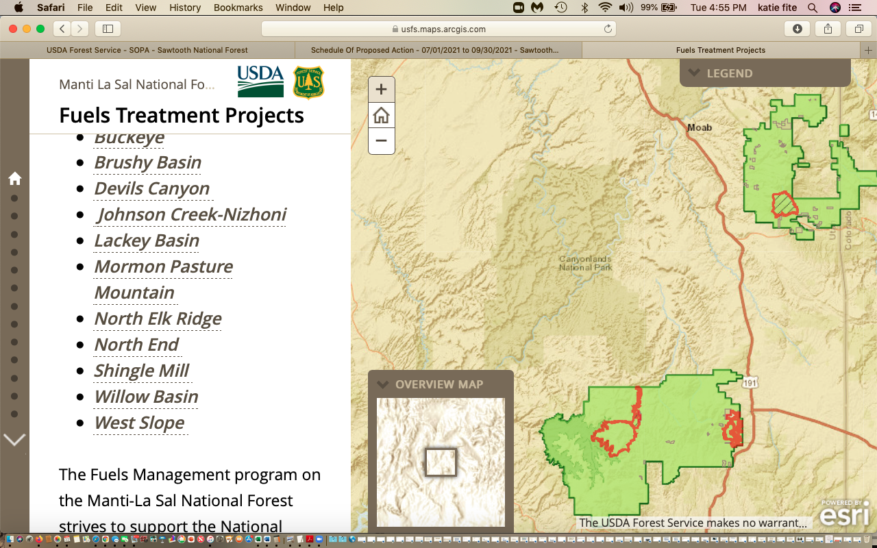
The EA states that purposes are to (1) reduce the risk of uncharacteristic wildfire, (2) increase resiliency of existing vegetation groups, and (3) improve the ecological function.
The flawed Landfire models use wildly inaccurate much too short fire return and disturbance intervals and do not accurately determine “uncharacteristic” vs., “characteristic” fire. This is highly likely to decrease resilience by making hotter, direr, weedier, windier longer fire season sites and greatly reducing the ability of lands to buffer climate stress. What assumptions doe the FS make with its sweeping claim of “ecological function”? How does grazing currently impact “ecological function” of terrestrial and aquatic systems and the species that rely upon them across the Forest?
The FS considers no alternatives such as actively planting trees in areas that are not recovering from past fires or from agency treatments. There is not even any alternative to actions in the loose, uncertain laundry list of “Design Elements”, many of which are unsupported by current scientific research and basic common sense.
Use of the flawed Landfire models, with fire return intervals based on out-dated Tausch, Rick Miller or other sage, PJ and other forest short fire return intervals, the use of the FRCC categories, the techniques of manicuring the forest and burning up moisture-holding downed wood in huge piles, or obsessively attempting to thin with fire denser forested areas that retain moisture longer, is NOT based on the reality of how wind-driven large acreage mega-fires actually burn in the West. These models are relics of the past. They are relics that will do tremendous damage to the most important forest and woody vegetation communities for combatting climate change and that are essential for sensitive species and biodiversity, while failing to ever meet fire control promises.
The FS can’t predict where fires will start. It can’t fireproof the National Forest. Instead of endless treatments making lands hotter, drier windier and choked with cheatgrass and other highly flammable weeds and more likely to burn over a longer period, the FS must take a hard honest look at how mature forests, dense forests, and downed woody vegetation help moderate fire impacts. And the FS must address the very serious livestock grazing stress across the MLNF lands that is causing significant ecological damage, fostering cheatgrass and making lands more fire-prone.
FS Purposeful Release of Large Amounts of Carbon into Atmosphere, and FS Purposeful of Carbon-Sequestering Mature Forests and Other Mature Woody Vegetation Communities
Now, during the crucial near-term period of the ever-worsening climate crisis, when it is most imperative that greenhouse gas emissions be reduced, the Manti-La Sal Forest itself proposes to burn up 31,000 acres more per year and release large amounts of additional carbon into the atmosphere on purpose! Moreover, elements of this “prescribed burning” are highly damaging – such as cutting down trees in roadless areas and conducting massive burns in roadless areas opening them up to motorized use and high levels of recreational disturbance across all seasons including winter and thus greatly expanding in sensitive wildlife habitats and watershed areas (snowmobile use, ATV use, expanded human intrusion) roading, and mountain bike cross-country use. Many of these activities punching in new trails and routes further diminishing wildlife habitat security and wild lands values including in roadless areas). Creating tens of thousands of scorched earth sites by pile burning and focusing burning/treatments on denser moister old growth and mature vegetation communities which are in fact the primary communities that the Forest models claim are “departed” --- is all highly unnatural. These areas are the least likely to burn under wildfire conditions – but the most likely to be burned up or otherwise radically “treated” by the FS. This is because the bogus Landfire models and model inputs based on out-dated and often “range” and not forestry literature – doom them.
Extensive Motorized Activity - and Expanded Human Motorized and Other Roadless Area and Habitat Intrusion Unassessed
Mastication involves heavy equipment driving cross-country tearing soils, destroying and/or smothering protective carbon sequestering microbiotic crusts, crushing nests and eggs and young animals, and displacing rocks and harming -including breaking and dislodging cultural materials.
The Fire EA is in reality also a mechanical treatment EA too – authorizing an unspecified amount of mechanical activities - with chainsaws cutting down trees and mastication heavy equipment grinding native forest and ancient PJ into wood chips inches deep choking protective microbiotic crusts on the forest floor. There is no limit on how much of this mechanical activity can occur. The EA allows these “treatments” all over roadless areas, which the Landfire models find greatly in need of radical fire intervention – yet these are the areas that would have suffered the least fire suppression, so should have the most “natural” fire regimes, shouldn’t they? The combined EA actions will greatly alter the natural character, visual setting/scenic beauty, wild lands values and rare species habitats within roadless areas. They will significantly diminish wilderness characteristics. The EA contains no baseline data and analysis of the degree to which the FS has already allowed portions of roadless areas to be compromised by motorized or other routes, other veg treatments, livestock facilities, and other disturbances. Further the EA contains no information on the area Travel Plans including travel plans that control winter motorized use and cross-country use cross-country. Native carnivores and other wildlife present in winter may be seriously impacted by forest treatments and burns opening up more country to high intensity off-road motorized use, skiing and other human intrusion. For example, a new fad is motorized winter mountain biking.

The EA also contains no current information on the number of unauthorized routes and trails across the forest, and has no baseline monitoring information to assess compliance and the FS”s ability to enforce any Travel plans or restrictions. There is no information on across snow motorized use, and how that is controlled (or not controlled) under any travel plan. ALL forms of motorized, and increasingly mountain bike, activity are likely to be expanded into previously less accessible fragile habitat areas and watershed headwaters as a result of this large-scale burning.

Since the FS is planning to clear woody vegetation that currently helps greatly limit off-road and cross-country motorized use, mountain bike use and other recreational intrusions having a solid current baseline is crucial to understand the magnitude of direct indirect and cumulative effects on roadless areas, rare wildlife seasonal habitats, big game seasonal habitats sensitive watersheds, etc.
Weed Baseline Data and Weed/Invasive species Treatment Methods and Impacts Void in EA
EA p. 9 states:
“Non-native invasive species: There are 21 non-native invasive plant species currently being tracked in the Natural Resource Information System database and targeted by the forest weed management program across all districts where project activities are proposed. There are treatment activities and monitoring for non-native invasive plant species occurring on national forest system lands across the project”.
Does the forest “track” cheatgrass, medusahead, bulbous bluegrass and other flammable exotic grasses location and changes in cover over time? The EA lacks baseline mapping information and analysis of these grasses occurrence and percent cover, and of their rate of increase. Where are these grasses present and at what percent cover within the area is identified as needing “treatment”? Has the FS been herbiciding these ecosystem-dooming grasses? Of so, where, and how was success or failure over time monitored? Does the FS contemplate herbiciding them in the aftermath of these massive burns?
Weeds, especially flammable annual grasses that unnaturally alter fire regimes --- will significantly increase in many of the project-disturbed sites including under continued grazing disturbance stress with impacts worsened by climate change making lands less resilient too. The FS claims that use of herbicides is “restoration” Please map all these “tracked” species including cheatgrass/bulbous bluegrass/exotic flammable grasses. Please take a hard look at and delineate the success of all of these treatments across the project landscape. By success, we mean the weeds are no longer present - not just that they’ve been killed back for a year or two. Please provide a hard look risk assessment of flammable and other weed proliferation in the wake of treatments across all veg types, aspects, intensively grazed lands vs. ungrazed lands, etc.
For all the many “treatment” methods, the site-specific details of what specific actions will occur in the landscape in what sensitive species habitats at each site are absent. The EA really doesn’t analyze any concrete project – it’s all nebulous, vague lists of species with minimal info and lists of uncertain loose actions that may or may not take place with projects.
Severely Flawed Landfire Models Are Used to Claim “Departure”
How has “departure” been determined? How has a “characteristic” vs. an “uncharacteristic” fire been determined? How is this defined? What specific fire return and disturbance intervals based what specific studies are the inputs used in Landfire modeling to arrive at these “departure” claims and other categories? Given the steep, rugged terrain, cliffs, canyons, etc. wouldn’t many fires naturally be extinguished and burn very little area, and most of this landscape burn any significant acreage only under naturally severe fire weather events? So wouldn’t that mean that the natural fire regime is one of very infrequent fires? How frequently does the USFS claim lands here should burn? How does that differ among vegetation communities? What is the natural plant climax community for sites in the Forest and adjacent BLM lands? How long does it take for that climax native plant community to develop?
FS claims of “uncharacteristic” or “departed” conditions are used to villainize mature woody plant communities and sing the praises of benefits of destruction of mature and old growth communities.
The EA appears to be a form of “condition-based management” that has been struck down by courts. It thwarts the very purpose of NEPA, and any informed “Look Before You Leap” decision-making, and informed public participation in agency processes. The FS essentially asks the public to put blind faith in future closed cursory site reviews (as far as 32 years in the future???) as the basis for deciding what specific land areas and habitats across the immense and highly diverse HTNF are targeted for high levels of project disturbance. There are no thresholds of sensitive species habitat loss from this and other FS projects to prevent extirpation or extinction. And of course, there are no baseline population and habitat quality assessments so that a reasonable person could determine of these species can withstand ANY additional habitat loss, let alone the colossal disturbance from this project, on top of all the other agency “treatments” in the Intermountain region.
Planned Destruction of Native Biota with Utterly Minimal Minimization and Mitigation Actions Violates NFMA
The massive deforestation scheme will overwhelmingly burn and fragment vast areas of mature and old growth native woody vegetation community essential species habitats – because these are communities that the EA’s spurious Landfire modeling claims are “departed” from the modeled ideal. Beautiful native plant communities and all the essential wildlife habitat they provide - will in fact soon be “departed” from the face of the earth if this project goes forward and if the FS has its way. Their molecules will soon be swirling around in the atmosphere helping cook the planet and worsening the climate crisis.
If this project moves forward, it will deal an immense blow to nearly all native species of concern listed in EA Table 4 ESA Species, in Table 5 Rare Plants, and in Table 6 Sensitive Species, plus to nearly all migratory birds on the Forest because it is the species that rely on mature and forested communities that are often the most numerous and most imperiled already. The “Impact Determinations” for all of these species in EA Tables 4 to 6 are severely flawed, limited and self-serving - and fail to consider a huge range of additional direct. indirect and cumulative impacts of the EA actions. The FS EA “analysis” consists merely of typically less than 100 words in a cell in a table with the FS “mitigation” and “protection” being the loophole-ridden Design Elements. This violates NEPA’s hard look requirement.
Potential MLNF ESA Species include: Utah Prairie Dog (FS claims not present), California Condor, Gunnison Sage-grouse (range not currently occupied), Mexican Spotted Owl, Southwest Willow Flycatcher (FS claims not present), Yellow-Billed Cuckoo (FS claims not present although the species certainly could use Forest habitats for foraging and connectivity between breeding sites). Bonytail Humpback Chub, Pikeminnow, Razorback Sucker, June Sucker (all of these preceding fish the FS claims aren’t present – but will water pollution and likely desertification and aridification from loss of forested cover impact their downstream habitats?), and Greenback Cutthroat Trout. For all rare and sensitive aquatic species, this project is likely to increase sediment and turbidity in aquatic habitats, increase extremes in erosive and downcutting runoff events, decrease sustainable cold water flow from destabilized burned watersheds, remove cover that cools the ground and allows water to sink into the ground and be slowly released and replenish groundwater, etc. The project activities may also pollute and contaminate the water with toxic substances like fire retardant if use in firelines and/or when prescribed burns rage out control. The FS ignores the impacts of use of unspecified types of toxic herbicides very foreseeably used to try to deal with project-caused weeds – and these toxics polluting water/soil/vegetation in unknown and unrevealed amounts.
The aquatics info greatly fails to address native fish and amphibian species. What are the specific habitat requirements for all treatment-impacted aquatic species?
Treatments will exacerbate threats to native aquatic species, and the specific habitat requirements of other aquatic biota of concern. Non -native competitors like Brook Trout will thrive in warmer waters that will result from this massive treatment scheme (less shade, earlier and more violent erosive runoff events leaving reduced and minimal flows in summer-fall and also reducing wetted lengths of stream segments). Reduced flows (megadrought, climate change, treatments, grazing degradation -caused will also reduce the ability to migrate, and have significant adverse harmful consequences for metapopulations.
What are the species numbers in each occurrence? How fragmented and isolated are these aquatic populations? What is the current status of all metapopulations of rare amphibians across the forest? How will massive prescribed burns+wildfires+grazing+climate stress+ recreational disturbance+mining+ energy development impact these metapopulations and those of other sensitive aquatic and terrestrial species?
With Mexican Spotted Owl p. 12, the FS shows the deficient EA owl avoidance: “Prey species may be displaced in the short-term but are expected to rapidly repopulate. Activities associated with treatments can directly affect a nesting or foraging Mexican spotted owl in the short term through auditory or visual disturbance. However, no prescribed fire or burn prep activities would occur in suitable habitat during the breeding season unless cleared by survey prior to implementation”. But evidently, outside the breeding season the habitat can be torched.
Don’t different types of prey species live in different veg communities? How may Owl prey species type and numbers be altered? It is absurd to claim just because the FS won’t burn up the habitat when Owls are nesting, habitat will be protected. Large areas of the forest are already highly fragmented or altered and are unsuitable owl habitat. Now this project will significantly add to both habitat loss and habitat fragmentation. Have surveys for winter habitat use been conducted across the Monticello RD? where? This glib analysis ignores that in the non-nesting season the habitat can be torched – destroying forests and Owl habitat that will take centuries to recover.
Regarding Sensitive Species: Much of these species habitats will be up in smoke, and even more fragmented and tattered. In many of these woody vegetation types, it will take a century and often multiple centuries to regain the forest structure sufficient to support these species. With irreversible flammable grass invasion and dominance in the wake of the project massive treatment disturbance; with hotter temperatures under climate stress and prolonged unprecedented drought; and with continued high levels of grazing all across the project area --- recovery in many areas is likely to be impossible.
The FS uses black box Landfire models to justify what appears, first and foremost, to be a giant livestock forage grass expansion scheme on overstocked and forage-depleted grazing allotments. The EA plan actually appears to be to have no concrete site-specific plans for the public to comment on. Just long lists of loose and uncertain loophole riddled “design elements” and various checklists,
The FS opaquely describes: “Specific treatment areas would be identified through a hazard classification and landscape prioritization process. Prior to using any prescribed fire, verification of specific treatment areas would be conducted by an interdisciplinary team of resource specialists to ensure treatment location and design are consistent with prior planning decisions and direction. The design elements and implementation checklist are key elements of the proposed action which help to ensure statutory and regulatory requirements would be met”.

We note that the SOPA shows the MLNF is preparing a new Forest Plan. If this Fire EA is completed prior to adoption of that Plan, the elements of the existing plan that the FS relies on will have been changed. This is another mammoth future analysis void if the FS proceeds with this Fire EA – which shuts the public out of FS “interpretation and implementation” of any new Forest Plan while conducting this pre-authorized massive burning destruction of sensitive species habitats.

And, if the FS proceeds under the current FS plan, it may be necessary to conduct numerous land use plan amendments to address numerous harms to any claimed “restoration” of burned sites – such as long-term reduction of AUMs or closure of significant areas to prevent cheatgrass inundation. We stress that the current 1986 Forest Plan never made allocations on, or considered, climate change stress now known to be causing serious harmful impacts on the forest, and these will likely be worsened by this huge treatment disturbance.

We Urgently Need to Reduce Emissions – Not Increase Emissions and Destroy Carbon-Sequestering Mature Forests
This massive burning would be a huge and tragic waste of federal funds that will accelerate the climate crisis right now in the immediate future – the most critical time where we must REDUCE emissions, not concoct ways to drastically increase near-term emissions and simultaneously reduce carbon sequestration ability of our National Forests. Prescribed burns, just like wildfires, release both C02 and black carbon. https://www.newscientist.com/article/2245038-huge-amounts-of-carbon-from-forest-fires-ends-up-in-the-ocean/
https://www.pnas.org/content/115/50/E11595
“Wildfires inject large amounts of black carbon (BC) particles into the atmosphere, which can reach the lowermost stratosphere (LMS) and cause strong radiative forcing. During a 14-month period of observations on board a passenger aircraft flying between Europe and North America, we found frequent and widespread biomass burning (BB) plumes, influencing 16 of 160 flight hours in the LMS. The average BC mass concentrations in these plumes (∼140 ng·m⁻³, standard temperature and pressure) were over 20 times higher than the background concentration (∼6 ng·m⁻³) with more than 100-fold enhanced peak values (up to ∼720 ng·m⁻³) … The observed high concentrations and thick coatings of BC particles demonstrate that wildfires can induce strong local heating in the LMS and may have a significant influence on the regional radiative forcing of climate”.

So too does prescribed burning which would dramatically increase acres burned acres per decade across the arid HTNF landscape. And, at the same time, wildfires would continue. We note that clearing woody vegetation impediments to motorized use, is likely to result in more human-caused fires because of increased ease of motorized access. The majority of fires on public lands are human-caused.
The project will release copious and unrevealed amounts of carbon into the atmosphere, and at the same time reduce carbon sequestration by Forest vegetation by destroying the very vegetation communities – mature and old growth woody vegetation– that are sequestering higher amounts of carbon. See Mildrexler, for example. https://www.frontiersin.org/articles/10.3389/ffgc.2020.594274/full
“Large-diameter trees store disproportionally massive amounts of carbon and are a major driver of carbon cycle dynamics in forests worldwide. In the temperate forests of the western United States, proposed changes to Forest Plans would significantly weaken protections for a large portion of trees greater than 53 cm (21 inches) in diameter …”.

And: “Given the urgency of keeping additional carbon out of the atmosphere and continuing carbon accumulation from the atmosphere to protect the climate system, it would be prudent to continue protecting ecosystems with large trees for their carbon stores, and also for their co-benefits of habitat for biodiversity, resilience to drought and fire, and microclimate buffering under future climate extremes”.

AND: “Forest carbon accumulation is crucial for mitigating ongoing climatic change, with individual large trees storing a substantial portion of the overall carbon in living trees. Globally, forests store about 862 Gt carbon in live and dead vegetation and soil, with 42% of it stored in live biomass (above- and belowground; Pan et al., 2011). Globally, forests removed the equivalent of about 30% of fossil fuel emissions annually from 2009 to 2018 (Friedlingstein et al., 2019), and 44% of that was by temperate forests. Temperate forests of the United States are the largest category of land sinks in the country, consistently offsetting about 14% of the Nation’s CO₂ emissions (EPA, 2020). Projections indicate that ecological systems have significant additional climate mitigation potential, with forest carbon accumulation serving as a central component of a natural climate solutions framework (Griscom et al., 2017; Fargione et al., 2018; Moomaw et al., 2019; Cook-Patton et al., 2020)”.

There are 84 Roadless Areas within the project area, totaling around 600,000 acres, with 475,450 roadless acres proposed for potential prescribed burn treatments. Instead of managing these precious areas for climate mitigation, the FS seeks to burn them up and very foreseeably seed livestock forage grasses.
The vegetation communities that will be “treated” because the flawed Landfire models and the arbitrary inputs to the models find they are “departed” --- are nearly always maturing, mature and old growth woody vegetation This intentional burning and other associated vegetation killing activity will differentially destroy vegetation communities currently sequestering and containing the most carbon. This is different from more “natural” wildfires – as the wildfires do not “target” the forest sites with more carbon. In fact, the mature dense unfragmented forest areas are often the least likely to burn or carry fires – except under the most extreme weather events when anything will burn – and fire “control” is largely in the hands of wind and weather.
Clearing woody vegetation makes lands hotter, drier, weedier, windier and more fire prone. See Bradley et al. 2016. https://esajournals.onlinelibrary.wiley.com/doi/full/10.1002/ecs2.1492

Does increased forest protection correspond to higher fire severity in frequent-fire forests of the western United States?
Curtis M. Bradley, Chad T. Hanson, Dominick A. DellaSala
First published: 26 October 2016

https://doi.org/10.1002/ecs2.1492

Abstract:
“There is a widespread view among land managers and others that the protected status of many forestlands in the western United States corresponds with higher fire severity levels due to historical restrictions on logging that contribute to greater amounts of biomass and fuel loading in less intensively managed areas, particularly after decades of fire suppression. This view has led to recent proposals—both administrative and legislative—to reduce or eliminate forest protections and increase some forms of logging based on the belief that restrictions on active management have increased fire severity. We investigated the relationship between protected status and fire severity using the Random Forests algorithm applied to 1500 fires affecting 9.5 million hectares between 1984 and 2014 in pine (Pinus ponderosa, Pinus jeffreyi) and mixed-conifer forests of western United States, accounting for key topographic and climate variables. We found forests with higher levels of protection had lower severity values even though they are generally identified as having the highest overall levels of biomass and fuel loading. Our results suggest a need to reconsider current overly simplistic assumptions about the relationship between forest protection and fire severity in fire management and policy”.
How much hotter will soil surface temperatures be in burned PJ forests or sage habitats vs. pre-burn forested sites? What are estimates of maximum temperatures in summer now? What are estimates of post-burn temperatures?
See Wuerthner 2021:
“The non-partisan Congressional Research Service, in a review of thinning and fuel reduction effectiveness, came to the very same findings: “From a quantitative perspective, the CRS study indicates a very weak relationship between acres logged and the extent and severity of forest fires. … the data indicate that fewer acres burned in areas where logging activity was limited.” [iv] That same finding was reached by another review of 1500 blazes in pine and mixed conifer forests. They discovered that the places with the most significant fuels like parks and wilderness had the least severe
burns. “We found forests with higher levels of protection had lower severity values even though they are generally identified as having the highest overall levels of biomass and fuel.

Another counterintuitive finding is that forests that had presumably missed fires due to fire suppression or other factors burned at lower fire severity. Van Wagtendonk looking at Yosemite’s fire patterns, reported: The most long-unburned, fire-suppressed forests—those that had missed 4 or more fire return intervals (in most cases, areas that had not burned since at least 1930)—had only about 10% high-severity fire”.
https://www.counterpunch.org/2021/03/18/the-active-forest-management-scam/
The MLNF EA reports use language claiming that areas have “missed fires” – as if the fact that a fire has not appeared like clockwork every 44 years is a ‘problem”. This all demonstrates how divorced from teal world reality these modes are. The FS uses far too short fire return intervals from the Landfire models as if fires were to take place exactly every 44 years or 127 years or whatever the average fire return interval is claimed to be – in each site in each veg community on the forest. This is irrational, arbitrary and highly damaging.

The MLNF analysis also ignores that climate and weather, particularly wind, drives all large blazes, and not fuels. There is no baseline information provided on climate change effects, such as summer temperatures, in impacting fire control efforts.
See also:
“Forests are our only means for removing atmospheric carbon dioxide and storing the carbon long term at the needed scale. Burning wood in place of coal is accelerating global warming and decreasing the capacity of forests to counter the buildup of heat trapping carbon dioxide,” said Dr. William Moomaw of Tufts University. Dr. Chad Hanson, a forest ecologist with the John Muir Project, observed, “The dangerous excess CO2 that we’ve put into the atmosphere with fossil fuel consumption and logging will stay there for far too long if we don’t take serious steps to bring it down, and forest protection is our best and most effective way to do that.” Dr. Dominick DellaSala, Chief Scientist with the Geos Institute, added, “The vast majority of scientists warn that in order to avoid catastrophic climate impacts in the decades ahead, including new pandemics potentially linked to deforestation, we need to keep dinosaur-carbon in the ground and store atmospheric carbon in forests.”
https://forestlegacies.org/featured-projects/scientist-network/
How much carbon will be released into the atmosphere from this project?
How much carbon sequestration ability will be lost for decades or centuries from this project? What is the current baseline of carbon sequestration taking place across the Forest in maturing, mature and old growth vegetation communities?
Research shows forests are not regrowing following significant disturbance:
“New studies show drought and heat waves will cause massive die-offs, killing most trees alive today.” (Source: We Need to Hear These Poor Trees Scream: Unchecked Global Warming Means Big Trouble for Forests, Inside Climate News, April 25, 2020)
According to Bill Anderegg, a forest researcher at the University of Utah: “Global warming has pushed many of the world’s forests to a knife edge… in the West, you can’t drive on a mountain highway without seeing how global warming affects forests,”.

https://www.counterpunch.org/2021/12/03/burned-out-forests-are-not-re-growing/

So what does the MLNF propose to do? Create huge areas of new heavily disturbed and deforested/cleared hotter, drier, windier weedier sites that will fast-forward this process, destroy trees and shrubs that are sequestering carbon, release large amounts of carbon into the atmosphere through prescribed burns and mechanized activity and expand potential for motorized use in roadless areas.

Research and on the ground and on-line observations of how several recent mega-fires in CA, OR and elsewhere have burned are revealing this is the case. Large climate-driven wildfires have not been stopped by past agency treatments and grazing - which in fact have been singularly ineffective in stopping such fires, as the recent mega-blazes in CA and OR have shown.

See, also video with Dr. Chad Hanson describing Paradise Fire situation and GF claim that logging and tree thinning would protect them from fire, and that it was a “fuelbreak” Start at Video Minute 35. Yet the Paradise Fire that killed 85 people whipped right through the fuelbreaks which had given the Paradise residents a false sense of security. Minute 40. Beyond 100 ft. of structure, “treatments” make no difference. Defensible space is what matters. Minute 42. Emerging scientific evidence that thinned areas burn more intensely and fires move faster. Minute 47. Bond describes need for woody debris on the forest floor. It holds some water helping reduce fires and fire effects, is an important part of forest health, and downed logs are important wildlife habitat. Yet the Fire EA seeks to burn this up and destroy it – including with scorched earth pile burning manicuring the forest. Minute 49. Chad Hanson describes the importance of downed wood and wildlife habitat, and increased erosion in thinned areas. Winds whip through thinned areas and drive flames more rapidly there because there are fewer trees to act as windbreak. Denser stands of forests act as a wind break against winds that drive the fire. There is a cooler, moister, micro-microclimate because of higher canopy cover in non-thinned forests – emphasizes the value of intact forest canopy.
Listen to: https://wildearthguardians.org/brave-new-wild/news/wildearth-webinar-fire-and-forest-ecology-in-the-american-west/
Yet the series of Region 4 Fire EAs are obsessed with manicuring the land surface and purging the Forest of downed woody debris, a further serious loss for biodiversity and micro-habitats associated with it - through pile burning and what is basically incineration by the severe heating that results from jackpot burning. (See Owyhee broadcast and jackpot burn photos).
See also: https://grist.org/fix/forest-thinning-logging-makes-wildfires-worse/

Logging in disguise: How forest thinning is making wildfires worse

“The U.S. Forest Service clears trees from public lands in the name of fire prevention, but t doesn’t work. There are better strategies to protect communities, but don’t expect to hear about them from the logging industry
“Wildfires can always turn tragic, but the greater tragedy in Greenville and Paradise, which was largely destroyed during the 2018 Camp Fire, and other towns is that they put their faith in logging operations miles away rather than proven, community-based fire prevention measures”.

… The idea of felling trees and hauling them to lumber mills in the name of fire prevention has many deceptive names: fuel reduction, forest health, ecological restoration, thinning, and even reforestation. As I detail in my book, Smokescreen, the Forest Service began using these terms in the mid-1990s as the public became more aware of the horrific realities of widespread clearcutting of mature and old forests on public lands in the Pacific Northwest, and the northern spotted owl became a household name’.

AND re: recent 2021 fires: “Proponents of thinning often cite specific locations that burned lightly, but these selective examples do not reflect the broad base of scientific evidence. For example, following the Bootleg Fire in south-central Oregon earlier this year, a representative of The Nature Conservancy claimed that a combination of thinning of “small” trees and prescribed burning effectively curbed the fire. But the Conservancy also has a conflict of interest: For years, it has conducted extensive commercial logging operations in the Sycan Marsh “Preserve,” north of Beatty, Oregon, under the banner of thinning. Thousands of mature trees have been removed under an expansive definition of “small”: up to 21 inches in diameter. Weather is always the biggest factor in fire spread, and the Bootleg Fire began in particularly hot, dry, windy conditions. Even so, according to the Forest Service’s daily rate-of-spread maps, the Bootleg fire spread fastest through Conservancy lands with extensive recent forest management, mostly thinning.

Last week, the Caldor Fire swept through a large area that had been recently logged in Eldorado National Forest in the central Sierra Nevada, under the rubric of commercial thinning. It destroyed the town of Grizzly Flats.

The forests with the most logging, of both live and dead trees, typically burn in the hottest fires, especially when extreme fire weather interacts with heavily logged landscapes.
Yes, there are exceptions, but when we look at the data on a larger scale, the pattern holds: the more trees pulled out of a forest, the more quickly and intensely a fire burns. My colleagues and I published the largest scientific study yet on this topic, analyzing three decades of data representing more than 1,500 fires that burned 23 million acres. We found that while weather and climate were the primary factors in fire intensity and spread, forest management was a significant secondary factor. As we noted in a letter to Congress, signed by 200 other scientists, “Reduced forest protections and increased logging tend to make wildland fires burn more intensely …”.
The MLNF Fire EA wants the public to believe that creating innumerable hotter, drier, windier weedier sites and openings that dry out sooner in spring through fire and other methods (mastication, cutting trees down in firebreaks, unknown amounts and type of herbicide use etc.) -will stop wildfires. Such antiquated management paradigms are revealed by western wildfires in recent years to be flawed.
The FS can’t predict where fires will start, so it can’t effectively site burns in big wild lands like roadless areas. In addition, recent research is showing that right on the border with private lands – similar to the basic limited WUI concept – should be a primary target – and not these sprawling Fire EAs that target huge roadless acreages. The effects of treatments will only increase frequent fire and cause widespread biodiversity loss. Please also review the work of Jack Cohen and the vital importance of focusing efforts on defensible space.
The new paper indicating private lands, and not FS lands are primary sources of wildfires:
https://www.fs.usda.gov/treesearch/pubs/63810
“Results show that cross-boundary fires were primarily caused by humans on private lands. Cross-boundary ignitions, area burned, and structure losses were concentrated in California. Public lands managed by the US Forest Service were not the primary source of fires that destroyed the most structures. Cross-boundary fire activity peaked in moderately populated landscapes with dense road and jurisdictional boundary networks”.
RE: WUIs. Where is mapping and information on all WUI zones in this landscape? How were they determined? We find that often WUI zones are drawn by countries or agencies to be much too large – and used to justify severe veg removal form males away from any habitations.
https://www.fs.usda.gov/nfs/11558/www/nepa/116195_FSPLT3_5899218.pdf
A Colorado Persistent PJ Forest fire return interval are shown in an NPS report:
https://www.nps.gov/articles/ncpn_colm_firehistory.htm
“Colorado National Monument (NM), on the northeastern edge of the Uncompahgre Plateau, supports a persistent pinyon-juniper (Pinus edulis - Juniperus osteosperma) woodland that has not been disturbed by large, stand-replacing fires since modern fire recordkeeping began. In fact, when researchers from Colorado Mesa University examined fire history and woodland structure on over 1,600 hectares of the monument, they found no evidence of large, stand-replacing fires (e.g., charred wood or truncated stand structures) in the entire study area”.
AND: “Multiple lines of evidence indicated that large, stand-replacing fires have been absent from the study area (see map) for time periods approaching a millennium. For example, junipers estimated to be >900 years old were found at 44% of sampling points (see figure, next page). In addition, when 11 charcoal layers, sampled from the major canyon draining the easternmost boundary of the study area, were dated with 14C techniques, the most recent date of fire shown was 1,180 YBP (years before present)”.
What is the basis for the extraordinarily short PJ fire return intervals in the silvicultural report?
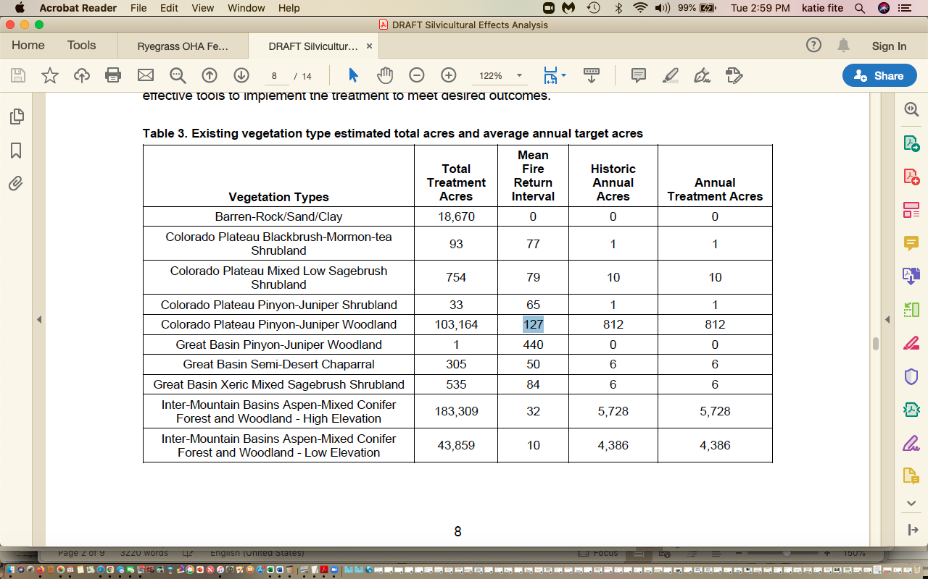
We note that the FS claims there is only 1 acre with a 440 yr. fire return interval - apparently blind to the similarity of PJ communities in the Great Basin and Colorado Plateau., and because Bauer and Weisberg careful study exposes the falseness of the Landfire info and models.

See Bauer and Weisberg that disturbance intervals in PJ are extremely long:

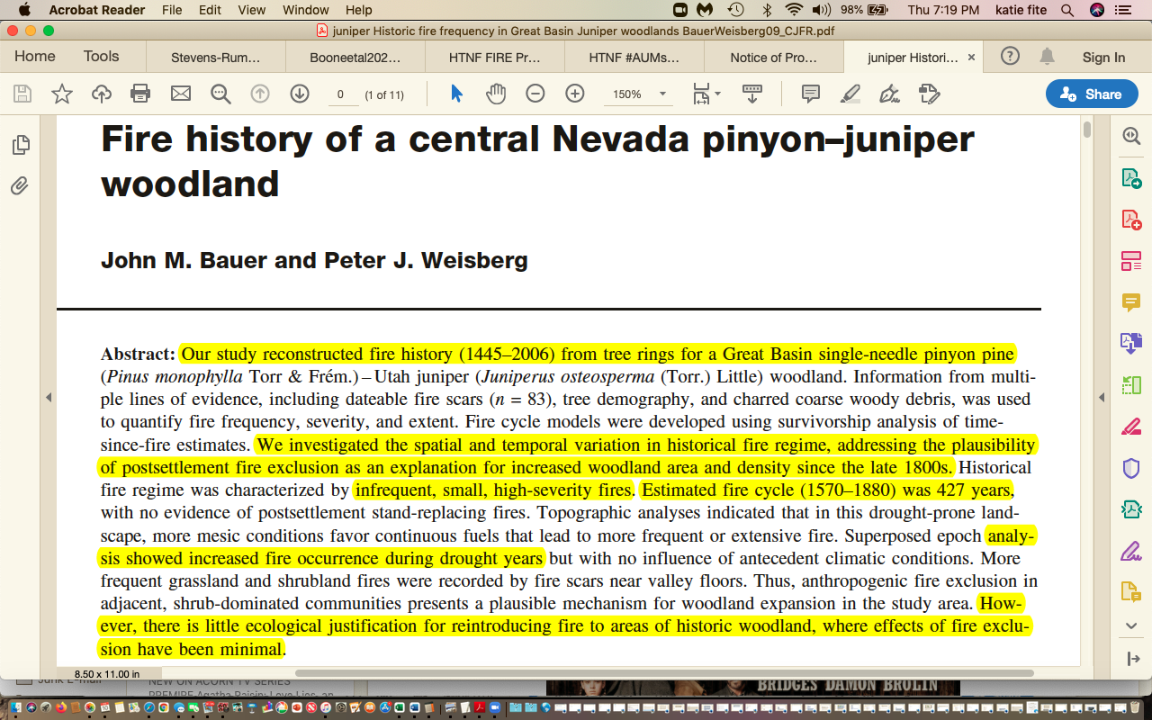
The Silvicultural Report Table 2 appears to use the artifice of mapping PJ as Sagebrush, because of smaller acreages of PJ vs. what is on the land. Please detail whether the acres of each veg community in Table 2 are actually what is present on the land now – or if they are modeled veg communities using Landfire info to claim the veg community is what SHOULD be there, based on models. See WLD BOSH comments describing how mapping - as of Landfire BPS – does not show what is on the land – only what the models claim should be there, after an agency plugs in very short fire return intervals to models.
WHERE is a map that allows the public to clearly understand where each of the Silvicultural Report Table 2 and table 3 veg communities and sites are found on the Forest? That is necessary for informed public comment and for the FS to provide info sufficient for the public to effectively comment.

We incorporate by reference into these comments the WLD and other groups comments on the BLM Restoration PEIS, Fuelbreaks PEIS and Pinyon Juniper Categorical Exclusion CX Attached here on cd. These comments further expose the many biases and erroneous claims of the MLNF and other region 4 Fire EAs, and the flawed Landfire models. The FS very negligently misrepresents arid forest ecological processes, the importance of undisturbed mature forests to biodiversity, and their great value to the public.
Recent “prescribed fire” in mature and old growth juniper forest in the Owyhee region of Idaho illustrates the severe impacts of prescribed burning by federal agencies. The photos illustrate what often happens with prescribed fire given the vagaries of sudden wind shifts and unpredictable weather events in steep, rugged mountainous terrain, and where napalm coated ping pong balls land.
Here is how use of prescribed fire in “departed” mature and old growth PJ typically happens.
See Fite Owyhee Scalded soils, severe fire intensity mature and old growth forested Juniper, mountain mahogany and sagebrush burned to a crisp, at times no wood on ancient trees remains at all - just ash and scalded soils.
https://www.counterpunch.org/2019/10/08/owyhee-ecocide-anatomy-of-blms-ancient-juniper-forest-destruction/
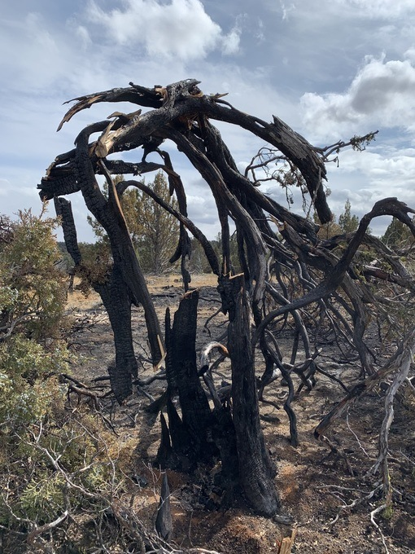
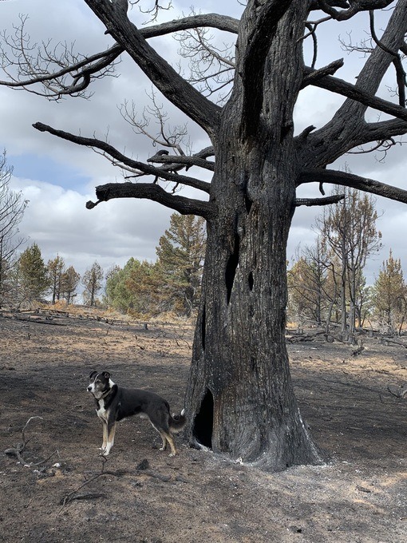
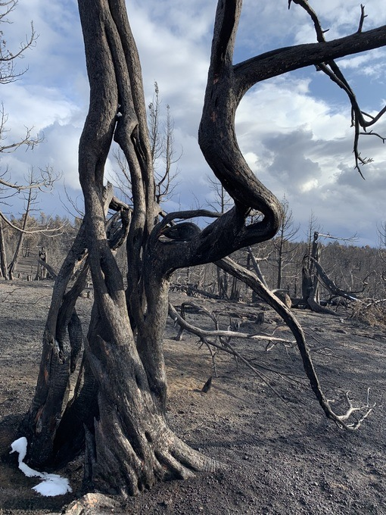
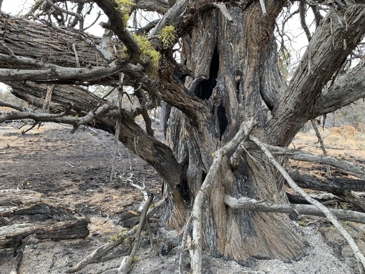
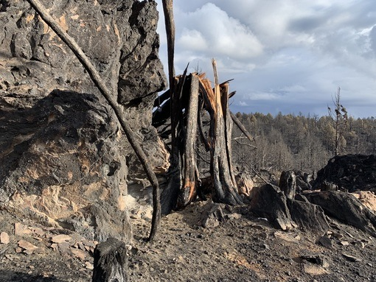
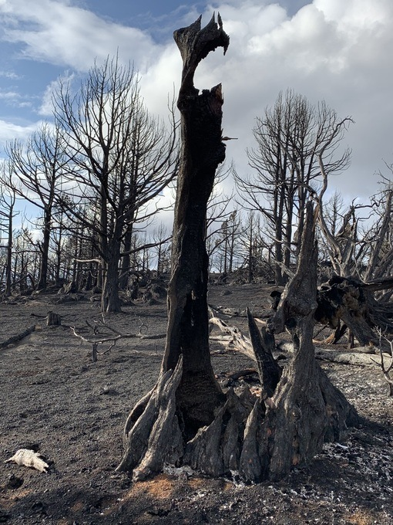
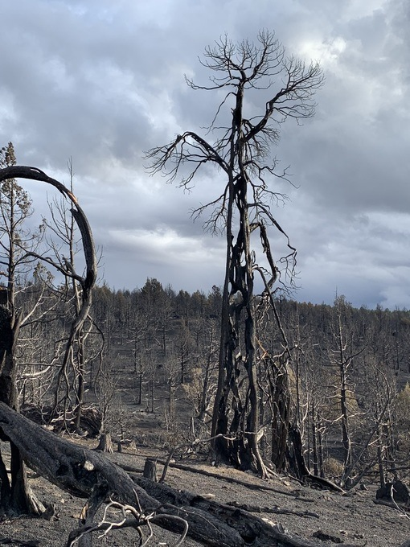
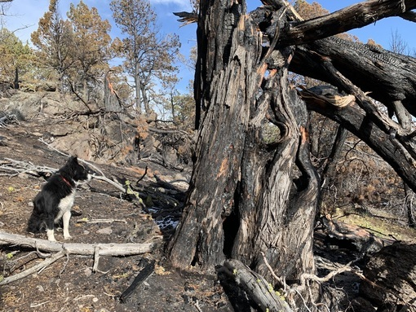
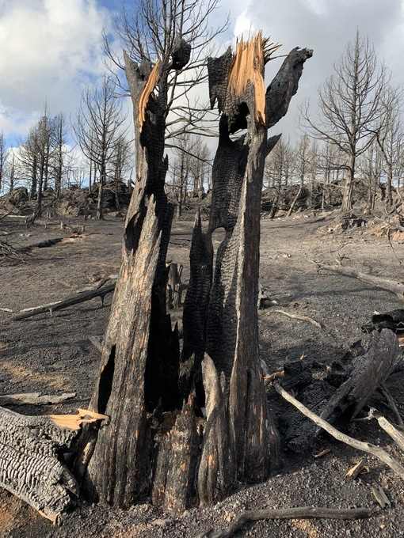
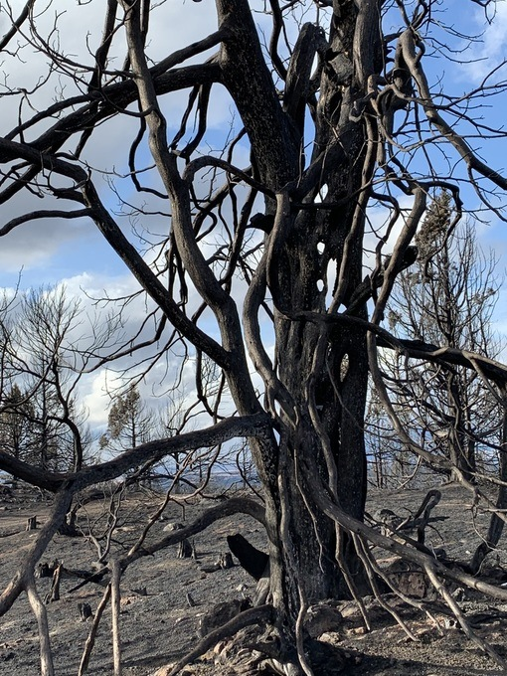
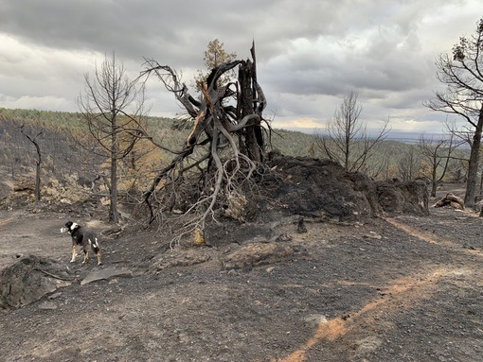
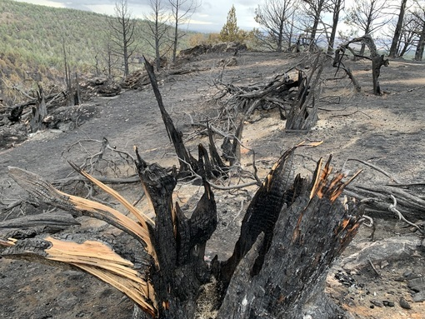
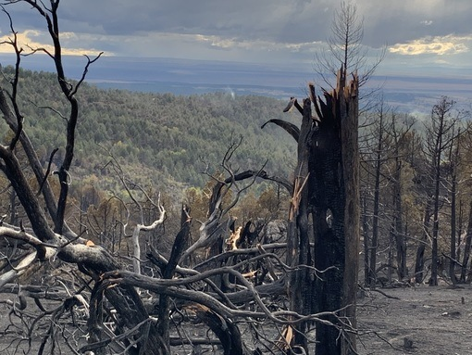
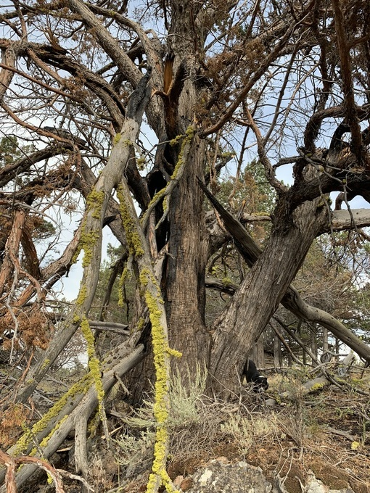
Beautiful lichens (also sequestering carbon) and an ancient juniper killed by proximity to the scorched earth burn.
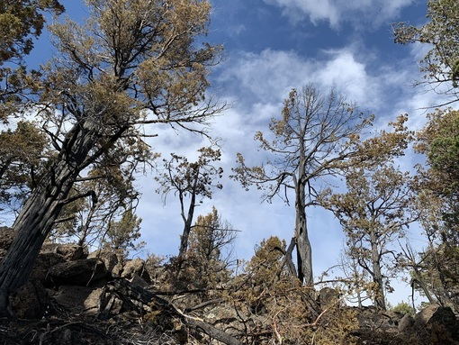

Beautiful ancient forests destroyed – tremendous migratory bird habitat including nesting cavities destroyed. Forested previously secure deer and elk fawning and security/escape habitat from an area with a significant poaching threat was obliterated. Now big game species (Mule Deer and Elk) are much more susceptible to human intrusion and disturbance in previously secure habitats. Soils were severely burned and scalded trees in what should be fire refugia like rock outcrops. But these were purposefully torched– as “prescribed” fire and helicopter napalming burned it all.
The 2022 Region 4 HTNF Fire EA claims:
“The most departed vegetation types are in the conifer, shrubland, and hardwood vegetation communities. For wildlife this translates to the eastern Sierra mixed conifer/pine, yellow pine, Great Basin pinyon-juniper, chaparral, aspen, riparian woodland, and some sagebrush habitat types.” HTNF Fire EA.
Now the 2022 MLNF EA claims:
“The most departed vegetation types are in the aspen forest, woodland and parkland community and the pinyon-juniper community”.

Also: LANDFIRE data were also used to compare historic range mean fire return interval as well as approximate acres burned for each vegetation type (LANDFIRE 2016). This information provides an approximation of how many acres should be targeted for burning on an annual basis to restore a more resilient stand composition and structure. Based on the natural fire regime and the proportion of the Forest that is highly departed from these conditions, the data supports an annual prescribed fire objective of up to 31,248 acres per year on the Manti-La Sal National Forest.

Note that the FS varies what vintage of Landfire it uses - in the series of Region 4 EAs – 2014 or 2016. Is there also 2020 version available?

When one views the sources cited, the Landfire link in the Silvicultural and EA Lit. does not provide any clarity on how the FS modeled supposed “departure”. See:

https://landfire.gov/fuel.php

Review of Opaque LANDFIRE (LF) “Fuel Product”: When one clicks on the land fire links in the Citations, there’s 6 surface fuel types, 4 canopy fuel categories, and others.

It is also seems that that the FS used old information because there appears to be newer 2020 Landfire info???
We also stress that the FS relies on extremely minimal scientific information. Yet somehow the FS plows ahead to make sweeping assertions about project impacts on TES and sensitive species, and the use of highly uncertain minimal EA “Design Elements” list that jeopardize the sustainability of sensitive species watersheds, cultural sites and recreational and aesthetic uses on the Forest, violating NFMA. Perhaps the extreme lack of scientific literature and lack of real world current baseline inventories of ecological condition such as the extent of grazing degradation, the lack of surveys for sensitive species and migratory birds and the lack of crucial watershed water flow and quality information is because any actual hard look under NEPA would reveal how circular and arbitrary the EA is.
The FS basically plans a “type-conversion” of veg communities. This is overtly stated in the HTNF Fire EA. In MLNF, the re-seeding (which can be done with aggressive exotic livestock forage species that effectively exclude native veg recovery), actions to further cement in livestock facilities, etc. will help lock in high levels of grazing – which means converting it in a “baptism by fire” like in the Owyhee example above, into scalded soil and after a while – some grass for cattle and sheep forage with minimal to no residual woody native veg. community remaining.
Such extreme amounts and types of fire and other treatments violate NFMA which requires sustainability of forest resources – and not obliteration. The MLNF Must openly reveal if it seeks “type conversions”. We note that the silvicultural report Table 2 lists veg communities and acres across the Forest – but it is unclear of these are actual current on the ground acres of veg types, or if these are modes acres of what the models predict should be present. This is important for the FS to describe - as in these slippery Landfire-derived projects, we have seen BLM when using Landfire churn out maps that show “sagebrush” all over sites with mature and even old growth Juniper communities – and then use the mapping to claim that because junipers are wrongfully present under the modeling scheme, the site must undergo massive deforestation. See WLD BOSH Comments (attached on CD) for example.
Which sensitive species will have their essential seasonal or year-round habitats converted to a new uninhabitable state? Which species will be the losers here?
Sadly, the FS is most likely to achieve across sage, PJ, mountain mahogany, is cheatgrass, medusahead, red brome and other weeds. We are aware of no areas where the BLM and/or FS has successfully “treated” and stopped such flammable annual grass invasions in the West over any significant acreage – no matter how much toxic herbicide is applied.
At the same time, arid forests across the West, and the species that inhabit them, are under grave threat from climate change. This has worsened with the extreme heat and mega-drought of the past several years. But this Fire EA is firmly rooted in past using murky Landfire modeling as the backbone of a massive planned conflagration that will dramatically impact this landscape for centuries.

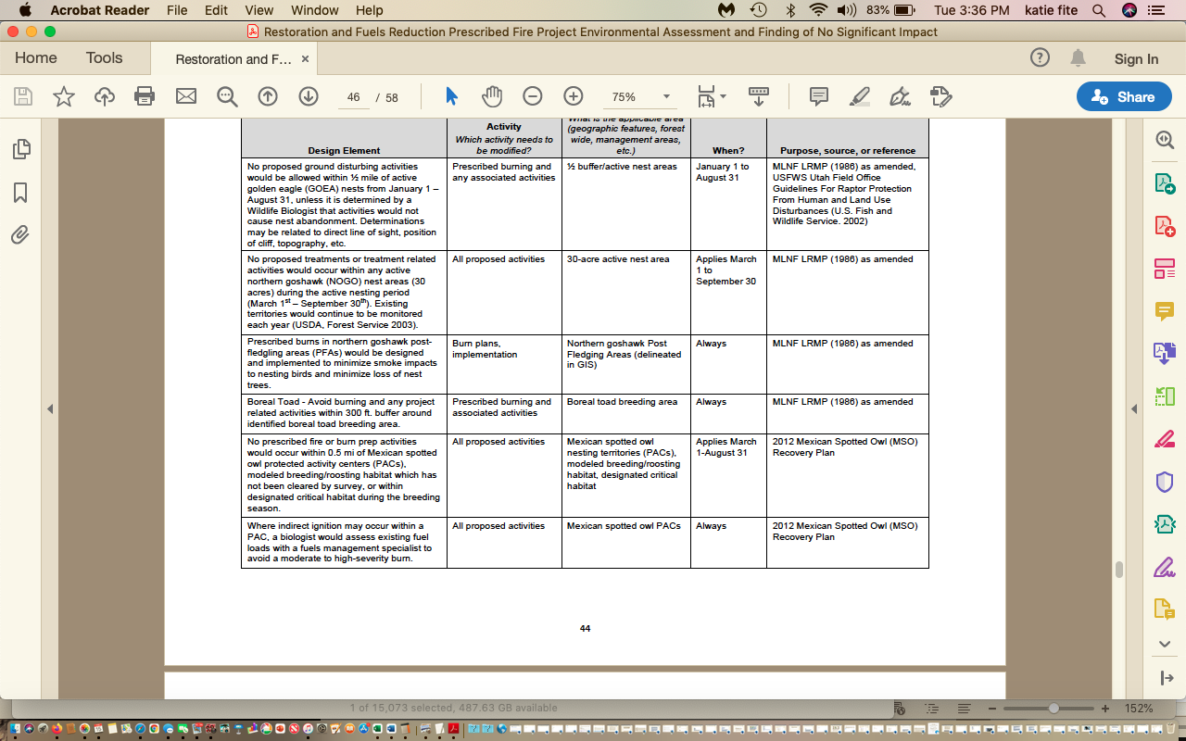
The above screenshot of the laundry list of Design Elements shows how widespread habitat burning in essential seasonal habitats would be authorized under the flimsy and highly uncertain EA.
EA Design Elements p. 49 states:

Wildlife biologist would review the proposed locations and:
▪ _Review existing data for forest sensitive species and priority migratory bird species in and adjacent to the specific burn area.
▪ _If burning or ground-disturbing activities would occur between February 15 and August 15, determine if pre-implementation surveys for active migratory bird or raptor nests are needed. If needed, these surveys would be completed before implementation activities occur.

There’s no prohibition against burning throughout nesting period. This means that burning can indeed take place when birds are nesting, and so countless migratory birds would have nests and eggs burn. How much “take” of what species in each habitat type will take place? The FS is required to protect migratory birds under the migratory Bird Treaty Act? What is population status and trend of all affected migratory bird species whose habitat may be burned up during nesting season?
FS should draw a 10 mile buffer zone around all Sage-grouse habitats. To prevent risk of escaped fire decimating sensitive species habitats.
Are there Pygmy Rabbits on the Forest? Why aren’t they treated as a sensitive species? Where are all historical records of Pygmy rabbit on the Forest and/or adjacent BLM lands?

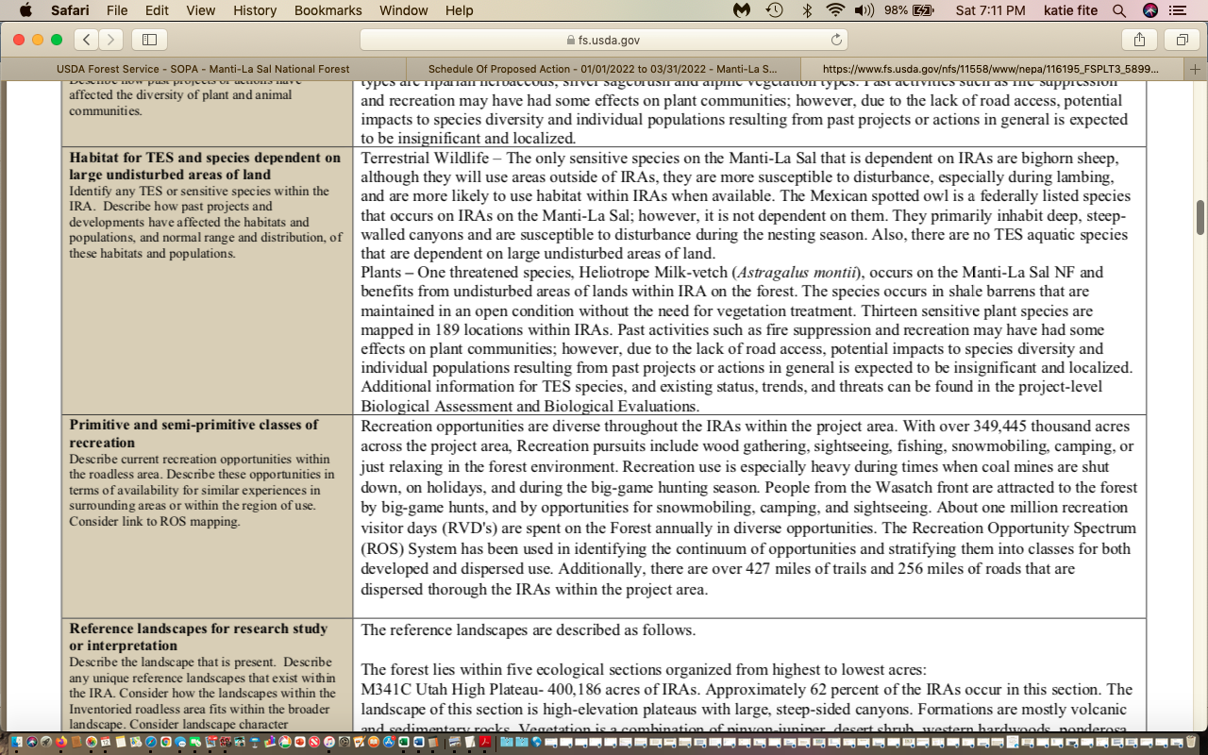

How does the FS know that the population of Northern Goshawk, Flammulated Owl, Mexican Spotted Owl, and all the other TES species are NOT significantly dependent on roadless areas? The EA provides not even a map of the species habitat and land area actually occupied by ESA-listed, sensitive and MIS species here – let alone any actual baseline data on each species occurrence and abundance across the MLNF, livestock grazing degrades soils priming them for erosion with treatment. The FS also fails to provide any data on specific areas of high soils erosion potential, and any monitoring of current erosion rates (in wind and water) across watersheds in the project area. We can also find no sediment data as a baseline in streams home to sensitive/TES species and other important values.

The FS provides no baseline data on current water quality and quantity – and no analysis of how burning a million acres will make watersheds hotter, drier windier weedier less able to retain moisture on site, and expand watershed desertification and aridification processes.

In fact, the Design Elements specifically allow burning of intermittent and ephemeral drainages – opening areas protected by woody vegetation up to intensive livestock impacts and destroying cooling shade and protective stabilizing vegetation on banks.

The Report states that habitat for TES species is dependent on large undisturbed land areas.

Well, that now includes the need to analyze habitat for the Gray Wolf, whose de-listing in Utah was just overturned by a federal court. What other native carnivores are of conservation concern? Don’t Goshawks have large territories – and need large undisturbed areas? What is “large”?
Pinyon Jays also need large areas largely undisturbed due to the large variations in Pinyon seed production. Despite the FS seeking to destroy vast areas of Pinyon Jay habitat including ion roadless areas, the FS has no MIS species for this essential arid forest habitat type home to a large number of migratory birds and that provides extensive habitat for big game and other wildlife. See Cornell data documenting a 85% decline, and Boone et al. 221 describing Pinyon Jay using a wide variety of areas of PJ forest

The IRA report claims “no impacts to soil, water, air”. This ignores the extreme damage to microbiotic crusts protecting soils from wind and water erosion, and the effects of the burning and other disturbance in greatly expanding shallow-rooted very poor watershed stabilizing cheatgrass - resulting in a long-term and unnatural increase in soil erosion across the project area.

Please provide mapping of the 427 + 256 mi. of trails and roads in IRAs. When were these inventoried? How much has roading increased since then? The FS Must provide a current up to date route inventory as part of this project that will greatly increase risk of route expansion and motorized and bike intrusion on previously inaccessible wildlife habitats and wild primitive landscapes. This must occur across all of the Forest lands. Has there been Oil and gas leasing or mining explo and development here that may have added new routes?

What is the current road density on the forest in sensitive wildlife species habitats? Or in sensitive big game winter, fawning and other habitats?

How will sediment, ash, fire retardant, herbicide use and other water pollution impact macroinvertebrates? How will loss of shade and increased water temperature also – including cumulatively- impact macroinvertebrates? How will livestock grazing exacerbate these impacts? Please provide current macroinvertebrate sampling data from across the MLNF. How ill high and medium severity fire in watershed areas impact macronvertebrate communities and other aquatic biota?

The MLNF is not meeting mule deer population objectives – yet proposes to radically alter crucial habitats. Where are all mule deer wintering habitats? All fawning habitats? How much will these projects impact security, escape and thermal cover?

How will cheatgrass invasion of burned sites impact bighorn sheep herds? Where are all current bighorn herds? What is each herd’s current population status (is it viable) and population trend?

Where have bighorn herds succumbed to pneumonia-like diseases since the Forest Plan was adopted? What areas have been identified as bighorn habitat but are currently unoccupied? Has the MLNF run the Payette NF modeling of bighorn sheep =domestic sheep disease conflicts? If so, please provide that information. It is essential that this be done to serve as a baseline for understanding current potential transmission - and how burning large areas may facilitate bighorn-domestic sheep contact. Since dense forested cover may inhibit bighorn movement to some extent- clearing mature veg communities would appear likely to increase disease risk.

How will large-scale burning foreseeably expand domestic livestock use of bighorn habitats?

Goshawks relay extensively on forests with closed canopies, and like thermal protection. The project will create harsh, hot, sites for decades – and at times centuries until a mature forest recovers (in those areas not over-run by cheatgrass and general aridification from the results of climate stress, grazing stress and project deforestation.

The FS cites a Wasatch study that found that 80% of goshawk nests in mixed conifer – aspen forest. Yet the FS burning is highly likely to purge conifers from aspen in quest of a “pure” newly burned aspen stand. The Silvicultural report shows bast areas of aspen and mixed conifer to be torched.

We stress that the FS Range report and review of the Forest Plan shows the antiquated 1986 plan includes grazing of young aspen as “forage”. It is clear that large areas of the Plan must be amended, as they clash greatly with current forest and ecological science. The Pan never considered climate change stress, the unprecedented western megadrought, ad stacks of new scientific information about aspen community sensitive to disturbance.

treats aspen as a livestock forage plant -

See Charles Kay report, “Aspen management guidelines for BLM lands in North-Central Nevada showing the significant negative impacts that livestock grazing can have on aspen communities.

Shinneman et al. re: Aspen and fire dependence Abstract described:

Aspen typically regenerates asexually and prolifically after fire, and due to its seral status in many western conifer forests, aspen is often considered dependent upon disturbance for persistence. In many landscapes, historical evidence for post-fire aspen establishment is clear, and following extended fire-free periods senescing or declining aspen overstories sometimes lack adequate regeneration and are succeeding to conifers. However, aspen also forms relatively stable stands that contain little or no evidence of historical fire. In fact, aspen woodlands range from highly fire-dependent, seral communities to relatively stable, self-replacing, non-seral communities that do not require fire for persistence.

Forest ecology and Managemnt . Fire regimes of quaking aspen in the Mountain West
Douglas J. Shinneman, William L. Baker b, Paul C. Rogers c, Dominik Kulakowsi

We also note that Shinneman et al. describe how some communities don’t recover following fire. The FS runs a high risk of eliminating lower to mid elevation clones in some areas with the combo of burning creating a hot, dry, harsh site and chronic livestock grazing under a Forest pan that views aspen as livestock forage.

The FS refers to beetle-killed spruce. How has the FS factored current and foreseeable conifer insect death and sagebrush Aroga moth or other sage killing insects into its plans to radically alter nearly all the mature woody veg communities outside Wilderness?

How do the models the FS uses deal with patches of insect-killed trees? Are they targeted to be burned up – even though ‘natural succession” is likely taking place - by aspen or regenerating seedlings? How many acres of beetle-killed or other dead tress are currently found on the MLNF – and where?

How will this project exacerbate forest health problems – for example, by wounding trees, spreading pathogens in cross-country travel by heavy equipment, creating harsher hotter and drier sites that result in hotter drier local microclimates?

See for example, Forester Position paper, describing: Mechanical activities in pinyon stands infected with black stain root disease can result in spread of the disease, and there are currently no known control measures …

The project includes an unknown amount of mastication heavy equipment, highly foreseeable bulldozer activity if fires rage out of control, and other mechanical equipment crosscountry travel.

The EA reveals that MLNF does not currently identify old growth.

“A stand of trees that is past full maturity and showing decadence; the last stage in forest succession (USDA, Forest Service. 1986). However, currently there are no stands formally classified as old growth”.

How many stands like this were present in 1986? How many now?

What timber sales have taken place and where were they located - please provide mapping -between 1986 and 2022?

What vegetation manipulation treatments have taken place and where were the located – please provide mapping – between 1986 and 2022?

Where have wildfires burned since 1986? Again here, please provide mapping.

“Vegetation Classification, Mapping, and Quantitative Inventory VCMQ data indicates 50 acres having trees >24” DBH; and about 7,800 acres having trees between 18-23.9” DBH, mostly occurring among ponderosa pine types, and the amount of acres represent less than 1% among all forested types”. The Forest Plan describe two distinct conditions of ponderosa pine types: The first is mature to overmature stands open grown and generally poorly stocked, which need to be harvested and the areas regenerated. [[Define an overmature stand?], The second is stands released from an overstory which was removed during the earlier accelerated harvest. These stands are young, becoming stagnated or are stagnated and in need of thinning. [How is stagnated defined?] Many of them are of minimum merchantability, being available for commercial thinning entries (USDA, p. II-13). However, describing conditions as “mature” or “overmature” seem to speak to timber and volume viability but provide little insight into old growth conditions.
The Forest Plan also applies “old growth” to characterize the amount of mature sawtimber size class within lands suitable for timber (USDA Forest Service. 1986), however this is generally not the shared vision of old growth. The shared philosophy among most research managers regarding what is old growth imagines old growth forests varying extensively in tree size, age classes, possessing a presence and abundance of structural elements, stability, and presence of understory (Helms 1998). Old growth refers to specific habitat components that occur in forests and woodlands- old trees, dead trees (snags), downed wood (coarse woody debris), and structure diversity (Franklin and Spies 1989, Helms 1998, Kaufmann et al. 2007). These important habitat features may occur in small areas, with only a few components, or over larger areas as stands or forests where old growth is concentrated (Kaufmann et al. 2007). Old growth has been considered “transitional” (Oliver and Larson 1996), given that the location of old growth shifts on the landscape over time because of succession and disturbance (tree growth and mortality). Some species, notably certain plants, require “old forest” communities that may or may not have the amount of typical old growth components (large trees) but have escaped significant disturbance for lengths of time necessary to provide the suitable stability and environment.

[OK- so where are these specific forest stands located, across all vegetation communities? Please provide mapping and analysis??? Where all stands containing old growth? All stands containing mature forested communities?].

To cover up for the drastic new forest fragmentation the project will cause, the FS states;:

In frequent, mixed severity-fire forests, old growth is naturally fragmented, and occurs as tree groups, clumps, individual trees, and occasional patches in an uneven-aged forest landscape. Research has demonstrated an inverse relationship between fire frequency and old growth contiguity. In the ponderosa pine and frequent-fire ecosystems, research has shown that old growth did not occur in large contiguous areas, but rather as fine-scale components of the uneven- aged system (Reynolds et al. 2013). There is no scientific basis to support managing for contiguous old growth conditions at larger scales for these vegetation types; however, large contiguous areas may exist over time due to management for desired conditions of goshawk nest areas and their frequency across the project area.
On a stand, or mid- and eventually landscape scale level, the proposed action would likely provide for a flow of old growth conditions and function over time. Spatial shifting or transition of old growth on the landscape over time would remain somewhat consistent with historic conditions. While the proposed action may likely remove some large, mature, and old trees for safety reasons or to prevent fire spread across holding areas, it would be foreseeable that the proposed action would result in a net gain of large trees over time. Minimal mortality to trees in this size class would be anticipated because large, older ponderosa pine (and to a similar but slightly less extent Douglas fir) are more fire resistant than young, thin barked trees”.

First, there won’t be minimal mortality with jackpot burning, or helicopter napalming in many instances – especially in this drought-stressed landscape.
The FS goes to great lengths to cover up the serious adverse impacts of this scheme on any older or mature forests – and ignores the fact that the supposed ”flow” of old growth will be only be in one direction – backwards to further loss - as the Landfire models - based on “fuels” specifically target areas with more older trees.

We note that the silvicultural report refers to veg classes that are not shown specifically in Table 1, and the 3 “departure’ categories are so broad and overlap that the info is largely meaningless. This shows the high degree of uncertainty with this project, and this further shows the need for an EIS analysis under NEPA.

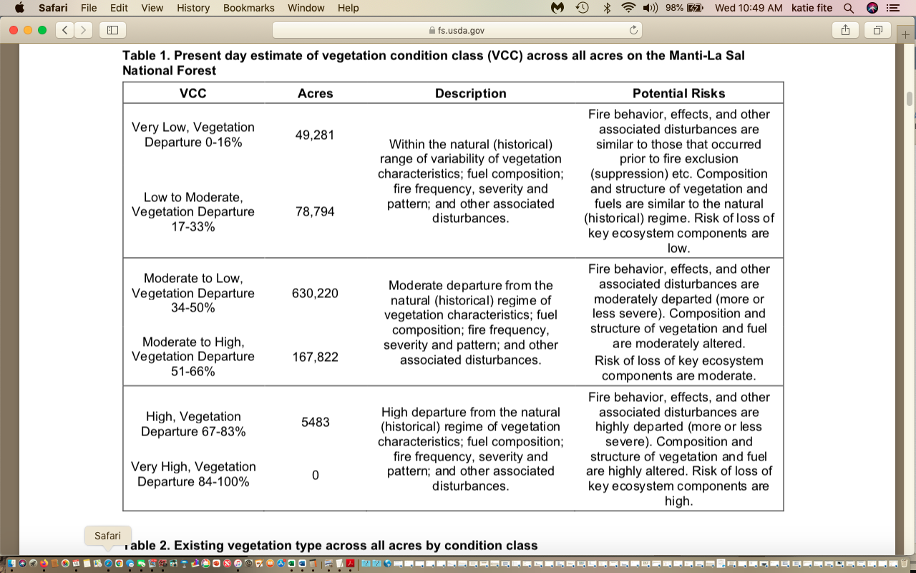

Look at the “Moderate” to low range – Yet this is described as “moderate departure”. Why not “low departure”???

Table 2 shows the extreme degree to which the FS targets PJ communities – see “Colorado Plateau PJ Woodland”. Plus other Conifer forest types, Aspen-Mixed conifer Woodland and Ponderosa Pine , and Intermountain Basins Montane steppe. And again, the categories here are not the same as categories in Table 1.

We are alarmed that it appears the FS may be planning to b urn up limber pine and bristlecone pine stands, since the flawed models pigeonhole 10,000+ acres is in what looks like a sentenced-to-be burned – VCC IIa category.

So now that the FS has tables with “departure” – WHAT were the inputs to modeling to determine “departure”?

There is no science-based rationale provided for the “Degree of effect” determination. Just “no”.

We are very concerned about the FS management of old growth.

https://www.sciencedirect.com/science/article/abs/pii/0006320795001301

Lesica (1996) evaluated fire regimes in the Northern Rockies, and determined that old growth forests ranged from 20-50% of the forested landscapes. How has the MLNF evaluated fire regimes of all affected vegetation communities so that a comparison can be made between historical presence of old growth, and what certainly appears to use to be a very large and increasing deficit in old growth communities? How does the FS define mature veg communities? If both old growth and mature communities are “treated” and/or suffer significant collateral damage, won’t this result in a far greater Please provide this information for all affected communities – sagebrush, mountain shrubs, Pinyon-juniper, subalpine fire, Douglas fir, aspen etc. For example, see Baker chapter in Knick and Connelly, eds. 2009/2011, Studies in Avian Biology, Lanner the Pinyon Pine, Lanner and Frazier 2011, Bauer and Weisberg, Intermountain Foresters Position paper on PJ. It is impossible for the public to understand how the FS arrived at claims of treatment “needs”.

Lanner, Ronald M. 1981. The Piñon Pine: A Natural and Cultural History. University of
Nevada Press, Reno. 208 p.

The Intermountain Foresters Position Paper lists many analyses that must take place to responsibly and sustainably “manage” PJ forests. For example, it is necessary to identify Persistent PJ forests. The EA lacks any mapping and analysis of local and extent of persistent PJ forests.

“Persistent PJ sites: those where pre-settlement aged trees may be present, trees can be
expected, or trees will regenerate in a very short time after a disturbance event. They may
also be categorized as sites where woody vegetation can be expected to dominate due to site
conditions (soils, etc.). Persistence relates closely to the ecological potential for long term site dominance by PJ”.

Please explain how the Landfire models and model inputs used by the FS here identify Manti-La Sal Persistent PJ sites. Where are these Persistent PJ sites located? Please provide current baseline detailed mapping and analysis. What areas of Persistent PJ have suffered FS treatmwents in recnet decades?

Review of historical survey and mining records is also critical. See for example, Bukowski and Baker 2013 describing dense big sagebrush, and sagebrush interspersed with juniper. See Dr. Ronald Lanner the Pinyon Pine and Svecjar and Young, and Svecjar Thesis describing large-scale deforestation. What areas of the MLNF suffered historical mining era deforestation? Note an important older paper by Young describes promiscuous burning by sheepherders – including in Utah – to get spring grass the next year – the forest would be lit on fire as the herds left in the fall. The FS claims of large-scale fire suppression appear to not accurately reflect what really went on in the historical aera.

Further, Baker and others have done important work on fire scar studies, critiquing how fire scar studies bias determination of past fire return intervals. Basically many studies conducted were based on selection of sites with noticeable fire scars. For a variety of reasons, these may have been sites most likely to burn more frequently.

Fire scientists fight over what Western forests should look like
https://www.hcn.org/issues/44.16/fire-scientists-fight-over-what-western-forests-should-look-like
“If that sounds counterintuitive, it is. Conventional wildfire wisdom is generally the opposite. Many scientists say that dry Western forests were once open and park-like, with large, widely spaced trees and little undergrowth. Now, however, due to fire suppression and logging practices, they've become overgrown with small trees and shrubs. The result is that frequent low-severity fires have been replaced by a new era of megafires that are hotter and more severe than ever before.
That's true in some parts of the West, say Baker and Williams, a recent Ph.D. student, but not everywhere; many dry forests throughout the region historically were more dense and prone to severe fires. They also disagree with the idea that thinning and prescribed burns can prevent such fires. That kind of treatment, applied in the wrong places, is not only misguided, they say, but could do more harm than good”.
AND: “A set of laws, policies and initiatives that aim to uniformly reduce fuels and fire severity is likely to (have) adverse effects on biological diversity," wrote Baker and Williams in their recent paper in Global Ecology and Biogeography”. The FS has greatly failed to take a hard look at a broad range of current science.

AND: “It's important to tailor treatment work to local conditions, says Hutto, the Montana biologist, because the federal government is spending money thinning forests that actually have a long history of dense stands and severe fires. "If they knew severe is natural, there's less justification for that kind of behavior," he says. "I think it's very important to taxpayers to be worried about whether we're going about things in a way that's kind of a waste."
Reference: Spatially extensive reconstructions show variable-severity fire and heterogeneous structure in historical western United States dry forestsgeb_750 1042..1052
Mark A. Williams and William L. Baker
https://lpfw.org/wp-content/uploads/2020/06/2012_Williams-and-Baker_Variable-severity-fire-and-heterogeneous-structure-in-western-forests.pdf

Also see: Smokescreen: Debunking Wildfire Myths to Save Our Forests and Our Climate
By Chad T. Hanson

Another serious flaw in the FS’s claims about nearly all areas requiring massive disturbance because they haven’t been disturbed/burned enough due to ‘fire suppression” is that nearly all roadless area lands are considered by the flawed Landfire modeling to “departed” and thus in need of being reduced to ashes. However areas without roads are the LEAST likely sites to have undergone significant fire suppression in the past – due to the difficulty of “fighting” fires in roadless wild lands in rugged western terrain.

Also, the Intermountain Forester’s paper cautions:
“Fire may be a silvicultural tool in some vegetation types, but is typically detrimental to
pinyon and juniper. Fires in PJ are typically wind-driven crown fires. Pinyon is very
intolerant of fire and even moderate to low intensities of surface fire will cause mortality,
either directly or indirectly. Most juniper trees are typically killed in fires, however, some
few may escape as juniper can tolerate some fire and survive, as long as a substantial
portion of the crown survives and the trunk is not totally girdled …”.

See also attached WLD and other environmental group comments on cd on the BLM Pinyon-Juniper Categorical Exclusion and the BLM Restoration PEIS.

The IM Forester’s Position paper also describes managing for pine nut production in sites, as well as identifying lands in need of tree planting - i.e. actual forest restoration work. This is another alternative that the MLNF has completely ignored.

Where are all current sites with cone-bearing Pinyon Pine? Please provide detailed mapping and analysis of how much of this habitat is targeted for destruction under the EA.

EA p. 7 shows the FS specifically rejected an alternative that would protect old growth vegetation and some other values. Of course, that’s because the out-dated flawed black box Landfire models focus on eliminating fuels (and thus woody vegetation required by nearly all FS sensitive species). They use out-dated limited studies with extremely short fire return intervals as justification. This is all hidden by the FS, as there is no clear explanation of the specific steps and specific assumptions made and the specific inputs into the Landfire models.
What are the various fire categories, fire return intervals, and other information used in drafting up this proposal? What are the scientific and site-specific studies these are based on? How has the Forest determined that an individual site is to be treated? Have you conducted fire scar and other studies, as described in work by William Baker and others? How do these assumptions take into account the natural patchy and variable patterns of wildfires? Have you reviewed General Land Office Records (see Svecjar and Young and Svecjar, and Bukowski and Baker 2013, and other Baker papers) and early settlement era accounts and mining records to try to understand historic vegetation communities in the region and project area? We request that you do so before making sweeping claims about Potential vegetation or fire/disturbance intervals. Further, the Forest cannot only look at the specific project area – yet ignore the many past and proposed veg treatments and fires in the surrounding BLM, state and private landscape in recent decades. Full and detailed mapping and analysis of the scale and effects of recent fires on these communities at a landscape basis must be provided.

The FS refers to “fire-adapted” veg communities? Please provide a detailed explanation and analysis of which communities are fire-adapted, and how the FS determined this. What species or subspecies of sagebrush is considered “fire-adapted”? What specific literatures is this based on? Are PJ forests fire-adapted? If so, what specific literature is this based on?

What certainly appears to be a current deficit in old growth and mature forests is also shown by the MLNF sensitive species, many of these require expanses of mature and/or old growth forests. These species are sensitive because they require mature and/or old growth forests.

Mature and post-mature stands may be under-represented in many modern forest landscapes as a result of preferential harvest of these age classes. It is important for land managers concerned with protecting biological diversity to know the approximate proportion of old growth in forest landscapes prior to European interference.

How much recreation activity is from “coal mine[r]s” vs. other users?

How many of the roadless areas are grazed? Just about all of them? If so, why isn’t the grazing disturbance footprint and facility footprint and linked adverse effects on natural, biological values and wildlands values as well as negative effects on solitude and primitive and unconfined recreation described? Please provide detailed analysis of these negative impacts.
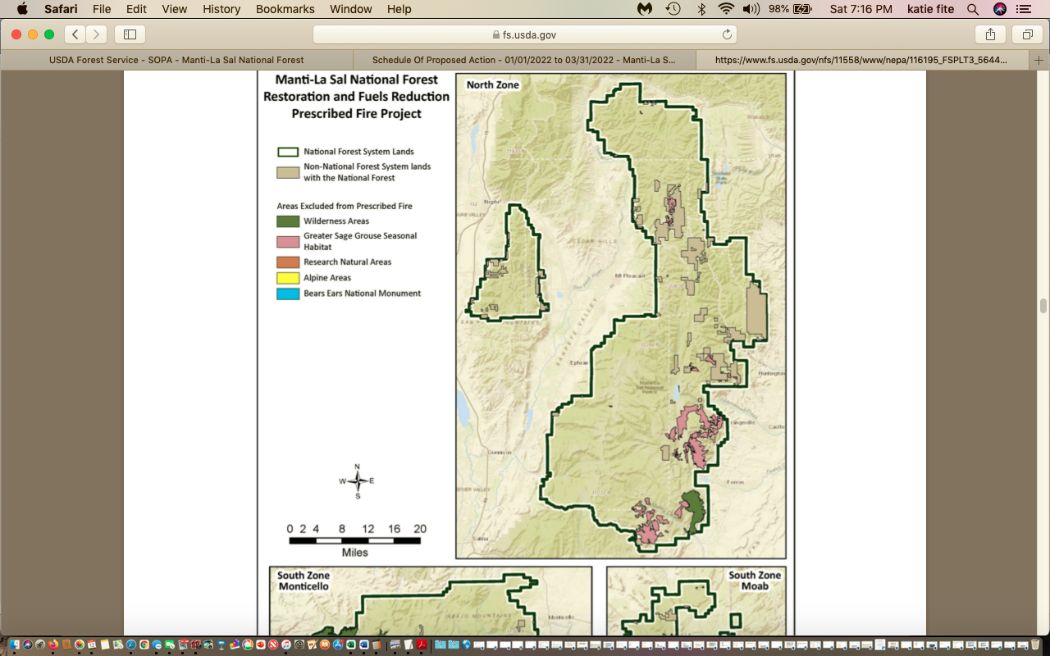

The Report claims this is consistent with the MLNF forestry elements – but does not provide any evidence of sustainability and there is no hard look, or consideration of any negative information or opposing points of view regarding the project.
Silvicultural Report Table 3 “Average Annual Target Acres” : Table 3. Existing vegetation type estimated total acres and average annual target shows extraordinarily short fire return and disturbance intervals.
The FS plans to burn 18,670 barren acres, some water areas, and even plans to burn up some greasewood and also Mojave veg. is the agency desperate to get cheatgrass and/or red brome established on the Forest?

The FS plans insanely to burn up 4,474 acres of salt desert shrub! No one in their right mind would propose burning highly cheatgrass-vulnerable salt desert shrub communities in 2022. Please provide the studies this modeling was based on. Is salt-desert shrub too considered a “fire adapted” veg. community? Where are the ciiations for this?

Sadly, this project appears based on the same severely flawed modeling that involved TNC data that is described here for the Dixie Forest. Was TNC or TNC modeling involved in this project? What is TNC’s role associated with the Landfire site and Landfire models and data?

Also the FS claims a need to destroy103,164 acres of Pinyon-Juniper based on a mere 127 year fire return intervals. This is contradicted by Lanner and Frazier 2011, Bauer and Weisberg, Romme et al. 2009, Intermountain Foresters Position paper 2015.

See Bauer and Weisberg 2009 – exposing how the FS modeling is severely flawed – as fire return and disturbance intervals in PJ are extremely long:

“There is little ecological justification for reintroducing fire to areas of historic woodland, where effects of fire exclusion have been minimal” – note the fire history study from 1445 to 2006.

83,951 acres. Intermountain Basin montane sagebrush steppe – mountain big sagebrush.

Intermountain Basins big sagebrush shrublands. 9,043 acres.

Low sagebrush. 754 acres. FS claims fire return interval is 79 years. Yet sagebrush experts agree it is typically much longer. See Knick and Connelly Baker chapter.

16,440 acres Intermountain Basins big sagebrush steppe. So the FS is planning to burn up an immense acreage of sagebrush.

Kitchen, S, and D. MacArthur. 2007. Big and black sagebrush landscapes. Chapter 4 in Fire Ecology and Management of the Major Ecosystems of Southern Utah. USDA Forest Service Gen. Tech. Rep. RMRS-GTR-202. 2007. https://www.fs.fed.us/rm/pubs/rmrs_gtr202/rmrs_gtr202_073_095.pdf

Even the FS’s own publications show: Prescribed fire should be limited to stands where perennial grasses and forbs are sufficiently abundant to preclude the risk of expansion by cheatgrass or other fire tolerant invasives. WHERE are all sites on the MLNF where native perennial grasses and forbs are currently sufficiently abundant to effectively resist invasion?

183,309 acres intermountain basins aspen-mixed conifer high elevation. The Report ridiculously claims the mean fire return interval was 32 Years! What in the world is the basis for this? High elevations are the least likely to burn.

Intermountain Basins Aspen-mixed Conifer low elevation. 43, 859 acres.

Rocky Mountain Gambel oak 42,202 acres. Has the FS not noticed the proliferation of cheatgrass across many areas of burned Gambel Oak communities along the Wasatch Front and canyons – right on Region 4 Headquarters doorsteps in Ogden.

Rocky Mountain Big Tooth Maple. 10,046 acres.

Southern Rocky Mountain Ponderosa Pine. 57,321 acres.

Rocky Mountain Dry Mesic Woodland, 37,527 acres.

Intermountain Curlleaf Mountain Mahogany and shrubland. 16,440 acres and claims a 64 year fire return interval which is far too short, as this is an extremely slow growing species.

85,328 acres. Subalpine dry-mesic-spruce,

30,840 acres. Rocky Mountain Riparian.

It is clear that the FS plans to burn many fragile grazing-damaged riparian areas, de-stabilizing watersheds, releasing copious amounts of sediments into streams, and increasing water temperatures during a period of ever-hotter temperatures under climate change stress.

In fact, the FS flat out rejected alternative actions that would have protected riparian areas, stating: “Some commenters suggested that there should be an alternative that specifically addresses climate change, livestock grazing impacts, old growth protection, burning in riparian areas and pinyon jay and boreal toad locations. Alternatives were considered but not analyzed …

The FS then states, when casting aside serous concerns about project impacts on Bonneville Cutthroat Trout, Colorado Cutthroat Trout and Leatherside Chub and several other aquatic species, stated: “Design elements include protections for streams, riparian areas, and water quality.

The only “protection” is that the FS would not set the fire in the riparian zone – NOT that the fire would be prevented from burning up substantial areas in and near the riparian zone.

Design elements preclude direct ignition within 100 feet of riparian vegetation near perennial streams”. The FS doesn’t even bother to protect the most fragile sites and often sites that are most highly degraded by livestock on the Forest - springs, intermittent and ephemeral drainages – even though all of these areas are highly vulnerable to fire harms, retardant, herbicide use, and the burning here will open up habitats to increased concentration of cows and sheep all over areas that were previously protected by riparian vegetation.

Similarly, each and every one of the highly uncertain wildlife protections we reviewed can be waived and/or has a loophole in it that allows burning to proceed – even the design element for Golden Eagles, Mexican Spotted Owl. “No ignitions within 0.5 miles of PAC – yet of “cleared by a survey” this area can be burned up at any time of year. There are no mandatory surveys prior to burning in the Design Elements.

The Silvicultural Report’s migratory bird analysis is flat out insane. The FS claims, in defiance of common sense and reason, that the impacts of its conflagrations will mainly be limited to the year in which a burn occurs – ignoring that decades or centuries of development of complex woody vegetation structure is essential to provides the necessary and essential habitat features for a host of migratory bird species – from Hermit Thrush to Black-throated Gray Warbler to Ash-Throated Flycatcher to Pileated Woodpecker to Flammulated Owl.

Under the 1982 Planning Rule, the Act states “Fish and wildlife habitat shall be managed to maintain viable populations of existing native and desired non-native vertebrate species in the planning area” (36 C.F.R. § 219.19). A viable population is defined as, “[a population] which has the estimated numbers and distribution of reproductive individuals to ensure its continued existence is well distributed in the planning area”. In order to ensure that viable populations will be maintained, habitat must be provided to support, at least, a minimum number of reproductive individuals and that habitat must be well distributed so that those individuals can interact with others in the planning area.
A requirement under this Act was the development of MIS which states “In order to estimate the effects of each alternative on fish and wildlife populations, certain vertebrate and/or invertebrate species present in the area shall be identified and selected as MIS and the reasons for their selection will be stated. These species shall be selected because their population changes are believed to indicate the effects of management activities” (36 C.F.R. § 219.19 (1)). “Population trends of the MIS will be monitored and relationships to habitat changes determined” (36 C.F.R. § 219.19 (6)).
What is the current population of all MIS species on the Forest? What specific types do they use, and what is the habitat quality and quantity? Please provide detailed mapping and analysis in an EIS.
Pity the poor Pinyon Jay here. The FS has no MIS species for its much-maligned PJ habitat type. The FS is clearly not managing for viability as it proceeds to lay waste to PJ across region 4. The Pinyon Jay is a species of great conservation concern. It is declining at an average rate of 3.6% from 1968 to 2015. See Cornell Website, and Boone et al. 2021.

Here is the abstract from Boone et al. 2021, Behavior-specific occurrence patterns of Pinyon Jays (Gymnorhinus cyanocephalus) in three Great Basin study areas and significance for pinyon-juniper woodland management. John D. Boone, Chris Witt2, Elisabeth M. Ammon1
“Pinyon Jays used a distinct subset of available pinyon-juniper woodland habitat, and further suggested that Pinyon
Jays used different but overlapping habitats for seed caching, foraging, and nesting. Caching
was concentrated in low-elevation, relatively flat areas with low tree cover; foraging
occurred at slightly higher elevations with generally moderate but variable tree cover; and
nesting was concentrated in slightly higher areas with high tree and vegetation cover. All
three of these Pinyon Jay behavior types were highly concentrated within the lower-elevation
band of pinyon-juniper woodland close to the woodland-shrubland ecotone. Woodland
removal projects in the Great Basin are often concentrated in these same areas, so it is
potentially important to incorporate conservation measures informed by Pinyon Jay occurrence
patterns into existing woodland management paradigms, protocols, and practices”.

The Fish and Wildlife Service Conservation Strategy for the Pinyon Jay (Somershoe et al. 2020) guides managers to minimize impacts to Pinyon Jay. This includes:

Avoid nest colony sites, which are characterized by large trees with dense crowns used year after year. A 500-meter buffer of undisturbed habitat around a known breeding colony is recommended by Somershoe et al. 2020.

Avoid nut-bearing age trees that produce pinyon nuts, which are critical to species survival. These are often older trees, plus trees that are younger are important to retain for future pinyon nut production.
The MLNF greatly fails to consider and analyze potential significant cumulative impacts to Pinyon Jays and other PJ woodland birds from vast acres of treatments combined with ongoing wildfire and all manner of other (past, ongoing and foreseeable) mechanical PJ treatments in the region, livestock grazing impacts, mining and energy impacts, climate stress and drought. In its recent “Restoration” Programmatic EIS, the BLM asserted that Pinyon Jays and other species can simply move away. This, in fact, is the same reprehensible claim made by the MLNF for migratory birds in the MLNF Wildlife Report in its recent large-scale “Restoration PEIS” where BLM seeks to destroy vast areas of Pinyon-Juniper on lands it manages.
The FS must fully assess the local and regional indirect, cumulative, additive and synergistic impacts of BLM’s proposed massive treatments – which seek to “treat” 38 million acres of PJ, Sage and other arid lands veg in the Great Basin Region and parts of the Colorado Plateau.
https://eplanning.blm.gov/public_projects/122968/200314561/20030350/250036549/FRRR_FinalPEIS-VolumeI.pdf

The Fuelbreaks EIS will impose giant weed corridors on sagebrush and arid forest habitats across a huge region. As CBD et al. described in a 60-Day Notice Letter for the BLM fuelbreaks EIS:
“The Fuel Breaks PEIS and the Fuels Reduction PEIS authorize large-scale disturbance of vegetation, soils, and wildlife habitat across a six-state, 223-million-acre project area. The Fuel Breaks PEIS would allow for the construction of 11,000 miles of linear fuel breaks, each up to 500 feet wide, while the Fuels Reduction PEIS would permit high-impact vegetation removal methods including chaining, mastication (wood-chipping), prescribed fire, so-called “targeted” livestock grazing, and herbicide application across 38.5 million acres of public lands. Both the Fuel Breaks PEIS and Fuels Reduction PEIS rely on unproven methods and untested assumptions, meaning that both projects together comprise a grand experiment in intensive land management on a scale never before attempted. See D.J. Shinneman, et al., A Conservation Paradox in the Great Basin— Altering Sagebrush Landscapes with Fuel Breaks to Reduce Habitat Loss from Wildfire, USGS Open File Report 2018-1034 (2018); A. Jones, Do Mechanical Vegetation Treatments of Pinyon- Juniper and Sagebrush Communities Work? A Review of the Literature (Wild Utah Project 201
Notwithstanding the ambitious and unprecedented nature of these projects, BLM and FWS have ignored or minimized potential impacts to threatened and endangered species, in violation of the ESA. According to BLM’s own analysis, the project area is home to over 130 listed species. Many of these threatened and endangered species are endemic to isolated and ecologically unique environments, meaning that even seemingly small impacts fuel break construction or fuels reduction could have significant implications for their long-term survival and recovery. BLM, however, failed to even consider impacts to listed aquatic species, assuming without analysis that “design features” such as riparian buffers will prevent all direct, indirect, and cumulative impacts across the entire project area for the foreseeable future. BLM and FWS also failed to adequately consider impacts to listed terrestrial species, focusing only on direct impacts from project activities and ignoring various foreseeable indirect and cumulative consequences of the large-scale ecological manipulation authorized under each PEIS”.
https://www.biologicaldiversity.org/programs/public_lands/grazing/pdfs/Fuel-Breaks-Fuels-Reduction-NOI-Draft.pdf
These massive region 4 Prescribed Burn EAs - within the same landscape areas and veg communities as as the BLM Fuelbreaks PEIS and BLM Restoration PEIS - were plagued with all these same issues, and are even worse analysis-wise as the FS uses a series of segmented cookie cutter EAs to sweep the colossal biodiversity loss, desertification, full throttle weed expansion, and massive releases of carbon and destruction of the very veg communities that are typically sequestering the most carbon – all under the rug in this severely flawed NEPA process.
Other Mammoth Region 4 Burns
Dixie Forest
Burn 1.5+ million acres of 1.9 million acre DNF, burn 52,000 acres/year.
https://www.fs.usda.gov/nfs/11558/www/nepa/116786_FSPLT3_5672608.pdf
https://www.fs.usda.gov/nfs/11558/www/nepa/116786_FSPLT3_5672609.pdf
Please see critique of a previous plan to destroy nearly all the maturing, mature and old growth Dixie Forest lands, based on similar spurious Landfire and TNC modeling claims of “departed” conditions:
https://www.counterpunch.org/2019/12/20/voodoo-vegetation-modeling-dooms-native-forests-and-wildlife-habitat/

“TNC’s Pine Valley modeling for Wyoming Sagebrush (85,000 acres, 100% “departed”) and other communities follows the Serviceberry pattern in lockstep. Areas occupied by trees are categorized as sage sites, found to be highly “departed” and “uncharacteristic”. In the immortal words of Ely BLM whose massive PJ killing projects have long relied on TNC methods, the forests are “out of whack”. This can only be cured by laying them to waste. For the 100,000 acres of Pine Valley Pinyon-Juniper forest that TNC concedes is present, 83% of the PJ is in a state of “Departure”. Across the landscape, TNC finds “an out of balance build up of conifers”.

Now, fast forward a couple years to 2022 and the Dixie Forest Scoping is nearly identical to the previous proposal.
Sawtooth Forest
https://www.fs.usda.gov/project/?project=59503
https://www.fs.usda.gov/nfs/11558/www/nepa/115235_FSPLT3_5720172.pdf
950,000 acres, (55 percent of analysis area) burn 40,000 acres/year.
Note the STNF and other EAs term this a “large-scale” action.
Caribou-Targhee Forest
https://www.fs.usda.gov/project/?project=59025
https://www.fs.usda.gov/nfs/11558/www/nepa/114677_FSPLT3_5749952.pdf
Prescribed fire may be implemented across approximately 266,000 acres of the Caribou part of the Caribou-Targhee NF. Large burn blocks (averaging about 12,000 acres in size) - and as with all these Fire EAs, the specific locations for prescribed fire within the burn blocks have not been identified at this time.
Fishlake Forest
https://www.fs.usda.gov/project/?project=59899
https://www.fs.usda.gov/nfs/11558/www/nepa/115632_FSPLT3_5670474.pdf
Landscape-scale Fire Modeling
LANDFIRE data were also used to compare the current and historic ranges of mean fire return interval … Based on the natural fire regime and the proportion of the Fishlake that is highly departed from these conditions, the data supports an annual prescribed fire objective of approximately 40,000 acres per year on the Fishlake.
The Fishlake Forest has 1,000,000 acres targeted – and plans burn 40,000 acres/year. Total Forest size: 1.8 million acres. Of course, a HUGE acreage has already been authorized for massive mechanical manipulation and deforestation.
Note that in 2019, the Fishlake Forest just approved a PJ “Restoration” EA aimed at killing and/or drastically altering 341,722 acres out of 1.8 million on the Forest!
Humboldt-Toiyabe Forest

Flammulated Owl Threatened – Illustrates Serious Threats to TES Species
The HTNF Forest Walton Wildlife report described:
“Flammulated owls are small, insectivorous, migratory raptors with a breeding distribution extending from the highlands of Mexico (and possibly as far south as Guatemala and El Salvador) north to southern British Columbia and east to the western edge of the Great Plains (McCallum 1994). Flammulated owls forage almost entirely on insects such as moths, grasshoppers, and beetles (McCallum 1994), which they glean from vegetation or from the ground. They breed in coniferous and deciduous forests in montane habitats. Although flammulated owls have been closely associated with yellow pine species (Pinus ponderosa, P. jeffreyi), in Nevada they are also found in mature aspen stands, in riparian zones with other poplar species, and may occur in whitebark pine-subalpine fir (P. albicaulis, Abies lasiocarpa) stands. They prefer mature stands of forest with relatively high densities of snags and woodpecker activity. Flammulated owls are known to nest in conifer patches less than 123 acres (50 hectares) in size (Neel 1999). In Nevada, mature aspen with a somewhat open understory is often a nesting habitat component (Mika and Riddle 2007).
Flammulated owls arrive on Nevada breeding grounds in mid-May (Neel 1999). Fall migration begins in late July, and migrants have been recorded in Nevada from August through early October (Neel 1999). There is evidence of a connection between available food resources in a breeding territory and number of young (Mika 2003). Flammulated owls tend to be quite tolerant of human presence and activities, including during nesting season and while feeding young (McCallum 1994).
Historical sightings of flammulated owls have been recorded throughout Nevada, and in the Jarbidge Mountains (Dunham et al. 1996). A three year study of flammulated owls in Nevada (2003-2006) recorded their presence in the project area …. State-wide, canyons surveyed in Wilderness Areas had significantly higher flammulated owl territory densities compared to canyons surveyed outside Wilderness Areas (Mika and Riddle 2007). Corporate GIS data shows one flammulated owl nest location west of Bear Creek Meadows within the Jarbidge Wilderness. The location was surveyed in June 2009 and yielded a positive response. At least one pair of flammulated owls nested in the Bear Creek Meadows area during 2009. Seven other areas were surveyed for flammulated owl in the northern part of the district but did not yield a positive result (Breckel and Keehn 2009).
Using remote sensing data from 2006, areas of potential habitat were assessed across the Jarbidge Ranger District. The parameters of the habitat model included aspen and conifer habitats at all elevations. More specific parameters were not used since little is know about this species in northeastern Nevada (Mika and Riddle 2007). See the following figures and tables for more information regarding suitable habitat …”.
The FS must conduct systematic current surveys and survey-based, habitat assessment (quality and quantity, fragmentation, need for expansion, actions needed to increase habitat connectivity) for Flammulated Owls and all other species of concern. The FS must fully assess project risks and jeopardy to Flammulated Owl and all species of concern – and their habitats and populations. Full consideration of grazing harms, plus climate change stress, plus treatment habitat loss and habitat expanded fragmentation must be fully examined in an EIS.

The project is likely to expand concentrated livestock use degrading Flammulated Owl and other sensitive and important species habitats.

Goshawks – percent occupied territories.
Abert’s Squirrel lives in the Abajo and La Sal mountains – the population is impacted by drought, snow, declining areas of denser of trees. The FS plans large-scale manipulation of Ponderosa pine and essential habitat elements. The FS analysis claims: “Abert's squirrels will be able to escape proposed prescribed fires” – and only takes a minimal, cursory self-serving look at how the large-scale manipulation and simplification of their habitat – including disruption of soil and soil fungi food through fire and wood chips smothering soil surface, will impact Abert’s squirrel food supply and ability to survive, find enough to eat and escape predation. The squirrels also build nests high up on pine trees. If the pine trees are killed, there will be no food, and no live pine tree nest sites.
How will all of effects of climate change exacerbate habitat declines and loss of resilience of grazed, burned habitat? Seed failures?
Terrestrial BE Table 6, Migratory Birds. Brewer’s Sparrow, Cassin’s Finch, Calliope Hummingbird, Evening Grosbeak, Ferruginous Hawk, Fox Sparrow, Grace’s Warbler, Gray Vireo, PJ, Juniper Titmouse PJ, Lewis’ Woodpecker, Loggerhead Shrike, Long-Eared Owl, Olive-sided Flycatcher, Pinyon Jay, Prairie Falcon, Sage Thrasher, Virginia’s Warbler (PJ_ Williamson’s Sapsucker, Willow Flycatcher.
Why is Blue Grouse crossed out in the Forest plan -this project will destroy vast areas of habitat for this declining native forest grouse. They must have conifer needles - typically in large mature and old growth conifers to eat all winter long. What is the current population status and trend of Blue Grouse across the forest?
For Goshawk, the FS must address a desired percent of the land area in mature or old growth forest. 40% conifer, 30% aspen. But the as the silviculture report shows, the FS intends to burn up nearly all the maturing mature and old growth conifers. The FS is also required to manage for enhanced structural attributes – yet fire destroys structural attributes, and the FS even plans to manicure any downed wood that might provide prey refugia by heaping it all in a big pile and torching it.
When is the last time the MLNF has been intensively surveyed for Goshawk nesting territories? Note that Goshawks may have alternate nest sites. The active nest period is March 1 to Sept. 30, yet the design elements allow the FS to burn up the habitat outside these periods, and to waive any avoidance period as well. Please provide current Flammulated Owl inventories across the Forest. How many territories are there, and where are they located? What did past surveys show? See attached on cd WLD et al. HTNF Fire EA comments and Jarbidge HTNF wildlife report demonstrating serious losses of Flammulated Owl habitat with fire.
For all sensitive and/or MIS species, the FS must take a hard data-based current look at where there currently is and isn’t habitat connectivity. How fragmented is the habitat at present?
The FS is supposed to adjust grazing where it is contributing to risks.
Are raptor territories remaining occupied? How has the FS been tracking raptor territories over time? How many known raptor territories are within veg communities deemed “departed” by the EA Landfire modeling?
How old does the FS estimate the trees are where the Goshawk nests are found/ Flammulated Owl nests? Other forest raptors – including those like Cooper’s hawk?
The FS is supposed to manage the habitat for sensitive species to keep them from being listed.
Even Golden Eagle nest protections can be waived under the design elements, and all the area around the nest can be burned up outside the nesting period anyway.
The Mexican Spotted Owl inhabits the western half of the Monticello RD. it requires mature, mixed conifer forest, and dense stands. It is intolerant of high temperatures. Examples steep canyons, Douglas fir, mixed conifers. These are the very habitat types the Silvicultural report targets. There is 203,825 acres of critical habitat, The FS plans to burn 1,929 acres, plus 11,682 acres of ‘available” habitat. Noise is to be kept ½ mile away. Certainly the fire fragmenting habitat will allow increased ease of livestock disturbance of prey base, noise associated with herding including by ranchers who often ride ATVs cross country these days,
See FWS 2012 map, and FWS states:
“The lack of mapped sites within potential owl habitat is an artifact of a lack of data and does not necessarily indicate absence of owl sites”.
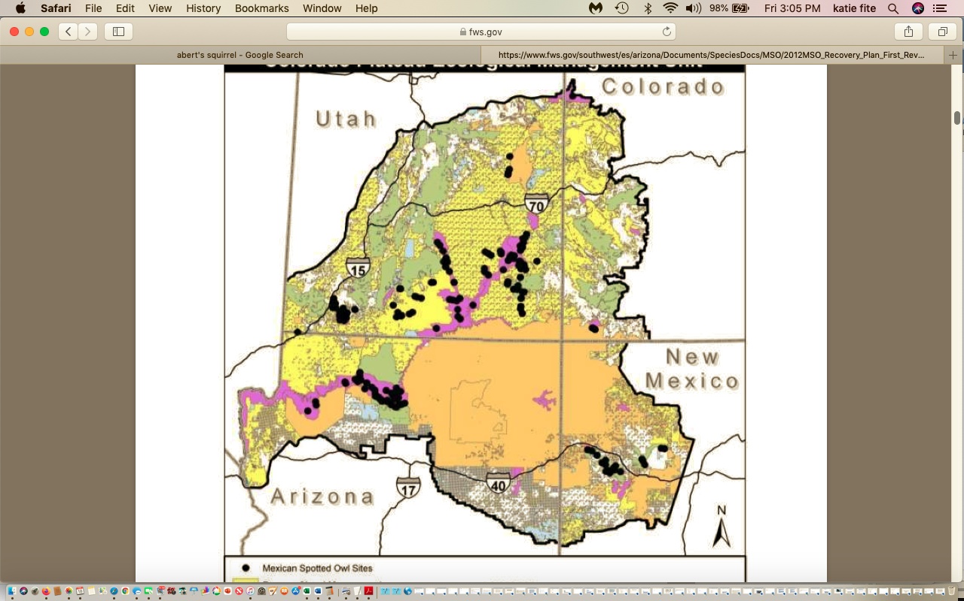
The FS admits:
“Although Mexican Spotted Owls have been observed to nest, roost, forage, and disperse among a diverse array of biotic communities, the owl is typically considered a “habitat specialist” in that roost and nest habitats classically occur in late seral forests or rocky canyon habitats. Some Mexican spotted owls undergo altitudinal migrations during winter to areas where habitat structure and composition differ from that used during breeding (refer to Appendix B for a more comprehensive discussion).
These are the forest types the Landfire models find “departed” and fit only for treatment destruction:
1. Nesting and Roosting Habitat
Owls occur in both forested and rocky-canyon habitats. Forests used for roosting and nesting often contain mature or old-growth stands with complex structure (USDI FWS 1995:26). Forests used by spotted owls are typically uneven-aged, are multistoried, and have high canopy cover (USDI FWS 1995:27).
These are the habitat types the spurious Landfire models claim are “departed”.
Migration and Wintering Areas
Although most radio-marked adult Mexican spotted owls have been found to remain on or near their breeding territory throughout the year, some territorial owls migrated during winter. This migration generally entailed a change in elevation as Mexican spotted owls moved down slope in winter (Willey 1998a, Ganey and Block 2005b). Migrating radio-marked owls typically left study areas in November or December and returned from January to April. Distances moved typically ranged from 5 to 50 km (3 to 31 mi), although Gutiérrez et al. (1996) recorded a color- banded adult moving >160 km (>99 mi) south of its breeding territory. At present, there is little information on specific habitat features that migratory Mexican spotted owls use in wintering areas. Further, wintering owls are unlikely to vocalize (Ganey 1990), thus reducing detection. Low winter detection rates make it difficult to locate migratory or wintering areas, and thus, we are left with no rigorous methods to identify such areas for protection (Ganey and Block 2005a). The types of lowland areas in which wintering owls have been observed cover vast areas, and we presently have no evidence that suitable wintering areas are limiting. Nevertheless, this is a topic on which further research would be valuable.
Mexican spotted owls nest in caves, in stick nests built by other birds, on debris platforms in trees, and in tree cavities (Johnson and Johnson 1985, Ganey 1988, Gutiérrez et al. 1995, Seamans and Gutiérrez 1995, Johnson 1997, Willey 1998a). They do not build nests; instead they rely on existing structures. Spotted owls exhibit one of the lowest clutch sizes among North American owls (Johnsgard 1988, Gutiérrez et al. 1995). Females normally lay one to three eggs, two being most common, and four observed rarely (LaHaye 1997, Gutiérrez et al. 2003). Re- nesting following nest failure is uncommon, but has been observed (Kroel and Zwank 1992, Gutiérrez et al. 1995).
Predation. Mexican spotted owls are preyed upon by great horned owls, northern goshawks, red-tailed hawks, and golden eagles. Which habitat features directly influence reproduction and/or survival of Mexican spotted owls?
How might expanded fragmentation affect potential predation? How do stochastic environmental disturbances alter key habitat constituents and owl demography? Which habitat features help buffer the influence of weather effects on reproduction and survival? How do various planned management activities alter key habitat constituents (including prey) and owl demography? This question is particularly important relative to landscape-scale restoration projects currently in planning, because these projects have the potential to impact vast acreages in short time frames. What proportion of Mexican spotted owl populations migrate seasonally, where are winter habitats located, what habitat features do owls use to select these areas, and how important are these areas for owl dispersal and survival? How will climate change alter distribution, structure, and composition of owl habitat? How will climate change influence owl and prey distribution and activity? If livestock grazing occurs within owl nesting, roosting, and foraging habitats, what livestock grazing strategies can be implemented to best maintain suitable habitat conditions for owl prey species and alleviate grazing impacts on the development of future owl nesting/roosting habitats (e.g., oak/cottonwood/willow/alder trees)? What are the effects of various recreational activities (hiking, climbing, OHV use) on Mexican spotted owl behavior, habitat use and demography?
All of this information in not critically examined with a hard look for the MSO or any other species in the EA and reports. The FS must maintain habitat for viable populations of fish, and instream flows, and not detract.
Baseline Grazing Information Void
The FS is to manage grazing to reduce conflicts – yet there is no actual current information on ecological conditions in relation to grazing, and the level and intensity of grazing conflicts with sensitive species, clean and sustainable water flows, roadless and other recreational uses, etc.
There are 118 grazing allotments 144,205 AUMs and 214 permittees. The FS claims there could be a “temporary:” suspension of AUMs post-fire. What about resting in advance of fire? What is the current actual use across all allotments – as it is critical that the FS not merely shift and INCREASE AUMs far exceeding actual use in unburned areas while burned areas are being rested? What is the current carrying capacity of which pasture? of each allotment? Does the FS count cheatgrass in determining carrying capacity and stocking rates? What are mandatory or aspirational standards of use that are applied across all allotments? What has actual use stocking been in all MLNF units and allotments over the past decade? Where does spring grazing conflict with nesting migratory birds, Sage-grouse, Pygmy Rabbits and ither wildlife? Or fawning and birthing small and large mammals? Where is mapping and analysis of the harms caused by the already very dense fence and livestock facility network on MIUS and sensitive species wildlife habitats and populations? Will the FS consider alternatives of reducing the livestock facility density – rather than rebuilding all facilities and further cementing in lethal and injurious projects?
A full analysis of ecological conditions as currently affected by the livestock grazing burden on these lands, and of grazing of capability, suitability, grazing conflicts, grazing weed spread, competition with wildlife for food/cover/space, effects on all species of conservation concern including rare plants, aquatic and riparian species and migratory birds must take place. How and where are livestock are damaging soils, protective microbiotic soil crusts (fix carbon, prevent erosion in wind and water, help prevent irreversible flammable cheatgrass), water quality (hotter temperature from grazing stripping riparian vegetation, preventing willow/alder/cottonwood growth and altering potential of wetted areas and floodplains – see Belsky et al. riparian paper, hotter temperatures from treatments within and adjacent to – including on sideslopes riparian areas that reduce and destroy cooling shade and moderate micro-site conditions as well as allow livestock readier access to waters and riparian zones;) - and now the EA’s contemplated treatments with adverse effects amplified by climate change stress (Catlin et al. 2011, Livestock grazing management in the face of climate change, Beschta et al. 2012 Adapting to Climate Change on Western Public Lands: Addressing the Ecological Effects of Domestic, Wild, and Feral Ungulates, and 2014) – and similarly shade loss, sedimentation and cobble embeddedness increases with adverse effects on aquatic biota, algae including potential toxic algae from the combination of heat and livestock pollution (manure, urine, dead livestock) in and near waters, etc.) and reductions in flows and water quantity.

Site-specific data and analysis are critical. For example, where are headcuts in impacted springs/meadows/streams and stream tribs? Is the drainage network stable or unraveling – especially given the highly erodible granitic soils across much of the project area? How much have streams become entrenched? Will the combined effects of deforestation + “regular” permitted livestock grazing + potentially hordes of additional livestock (goats, sheep, cows, horses if the FS tries to sneak in “targeted grazing” after the fire ROD is signed) grazed repetitively in unknown places in an unknown ways and with no specified trampling standards and very high watershed-destabilizing herbaceous use levels in upland and riparian areas - and turned out anticipating basically a scorched earth style intensity of impacts taking place,? How much grazing-attributable degradation and flow loss is there/ What are underlying trends in flows and perennial vs. intermittent vs. ephemeral stream lengths?), watershed health and integrity and processes - including the watershed’s ability to cope with weather extremes under climate stress, ecological condition of habitats for aquatic and territorial species, cultural sites, etc. must be established as a baseline for understanding where any “treatment” of livestock-impacted and often highly damaged sites/watershed/habitats may be appropriate, and where lands have the ability to recover under climate stress and on top of the current levels of grazing/road/logging/treatment disturbances.

Excessive Forest Grazing Standards Fail to Protect Lands Pre and Post-Treatment. These Aid on Significant Pre-Treatment Degradation Making Lands More Vulnerable to Irreparable Harm from Treatments

The FS grazing “standards” allow very high levels of livestock riparian use – such as 65% upland utilization when much lower use standards are desperately needed, and must be applied post-treatment. and even 60% utilization on riparian sites. The FS also applies no bank trampling standards whatsoever, and allows highly vulnerable spring systems to suffer 60% utilization. Please specify that these standards are what is applied to springs and meadows across the forest?

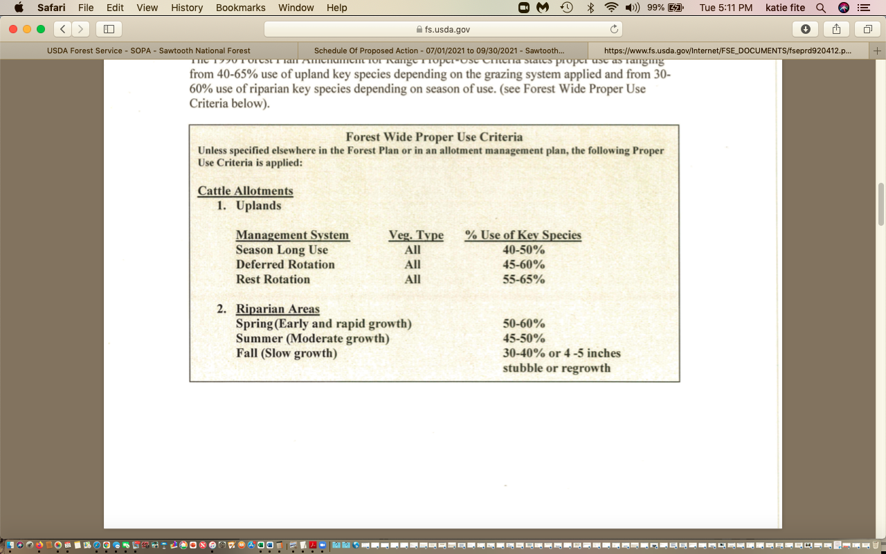

This adds to the risk and uncertainty with this project - as the fire treatments will create highly weed-vulnerable soils, will destroy crusts, will level protective woody vegetation, and will denude watershed slopes. Removal of protective woody vegetation will make any areas currently protected from cows by woody vegetation highly vulnerable to new and expanded cow damage. The treatments will seriously de-stabilize the majority of watersheds. As the FS broadcast and other burning will also remove not only riparian cover, but also adjacent cover making it easy for livestock herds to have access to previously less accessible areas, this wil be even worse.

These same slopes/springs/seep/meadows/headwaters have been suffering and will continue to suffer these over-stocked numbers of cattle and sheep post-treatment with typical minimal and insufficient “rest” of only a couple to few years. The Fire EA fails to adequately quantify rest periods and specific recovery standards

With any treatment disturbance actions here, the FS must consider a broad range of alternatives to remove livestock from the entirety of project-disturbed watersheds for a significant period of time until native woody vegetation, protective microbiotic crusts and other crucial stabilizing elements can recover. This will take decades. See for example Baker chapter in Knick and Connelly, eds, 2011, Studies in Avian Biology.

Specific adequate protective measurable recovery criteria for soils, crusts, upland and riparian shrubs/trees, and essential species habitat elements must be met prior to any livestock grazing resuming.

Sample AOIs (on cd) and nearly all AOIs see:https://www.fs.usda.gov/detail/mantilasal/landmanagement/resourcemanagement/?cid=STELPRDB5305896

are used to illustrate how deficient the riparian protections are, and how densely stocked areas of often steep, rugged HTNF watershed terrain are. The end result is that large numbers of cattle and sheep use drainages to trail along – worsening any post-treatment recovery prospects, and worsening biodiversity loss from additive, synergistic and cumulative effects of the massive fire treatments the HTNF seeks to impose based on use of deeply flawed out-dated Landfire models.

Analysis must be conducted under NEPA for all affected allotments so that treatment risks can be understood. This project must consider a range of alternatives and mitigation actions placing much more conservative use standards post-treatment on all riparian areas affected by the massive treatments to reduce site vulnerability to grazing damage.

Many MLNF watersheds are steep and rugged. Watersheds thus experience significant erosion in snowmelt and following spring storms and summer thunderstorms. Grazing threats that worsen erosion include: Livestock-disturbed streambanks and side slopes, of livestock trails that spill sediment into drainage networks, and also sediment pouring down minor roads linked to grazing activity. There are extensive upland watershed fragmentation by piecemeal livestock water pipelines (many of which have become motorized routes, as the FS backdoored in different grazing systems piece by piece as livestock projects expanded) and salt/supplement feeding sites. Significant areas of non-capable lands are also being grazed. Because of topographical constraints - livestock chronically damage the very same areas of the landscape – particularly deeper soil sites and drainage networks. Where are current baseline grazing capability and suitability analyses? Please provide these.

Herbicide Use and other Invasive “Treatment” Analysis Void

The FS describes that it has been “treating” noxious weeds with herbicides. Please provide baseline Forest-wide noxious weed inventories and risk assessments associated with this massive project. Please detail herbicides being used and amounts at present, and herbicides and amounts that can be anticipated to be used under this project treating a million acre. Please provide current risk assessments for all herbicide chemicals involved – active ingredients, carriers, adjuvants, break down products. Please assess specific herbicide threats to aquatic biota (for example, does the herbicide infiltrate ground water? See recent Round Up studies showing impacts to insects and birds. The surfactant ingredient in Roundup is more acutely toxic than glyphosate itself and the combination of the two is yet more toxic. Glyphosate is suspected of causing genetic damage. Glyphosate is acutely toxic to fish and birds and can kill beneficial insects and soil organisms that maintain ecological balance.
How do the herbicides the FS currently uses and will foreseeably use under this EA impact aquatic species? Or impact migratory and resident birds that rely on native insects harmed by these chemicals, or that suffer other forms of exposure. The FS must take a hard look at harms to sensitive and MIS species that consume sprayed herbaceous vegetation, and to collateral damage t ono-target species. See attached Sawtooth Forest herbicide comments. Please apply all of these concerns to MLNF analysis of direct indirect and cumulative effects. What current NEPA document does the FS rely on for herbicide use – when was it prepared, what is the vintage of the risk assessments, is the science used stale? How much will the FS herbicide use increase under this massive project disturbance? How much more of each herbicide may be used?
How will any herbicide use occur? Will there be aerial herbicide application? If so, what NEPA analysis is this based on, and where will this use occur? What is the potential for drift and collateral damage to non-target species?
“Targeted” grazing is increasingly being foisted on public lands by BLM and FS offices that seek to placate grazing permittees. Does the FS plant to, or may it foreseeably, impose so-called “targeted grazing” to deal with weeds spawned by the massive project treatments? Will this be done in a segmented NEPA manner. Please see attached Scientist Fuelbreak letter describing harms caused by intensive grazing – which begets even worse weed problems. Also see Williamson et al. 2019 describing how grazing causes cheatgrass.
The FS must maintain viable populations of existing vertebrate species (what ARE the baseline 2022 current populations of vertebrates of concern so a hard look analysis can determine if they can withstand in some cases a likely 80% or more reduction in habitat from burning and other project activities?).
The FS must maintain key species habitats - please map, assess and identify quality and quality of key species habitats, and identify which species are key species – where are all monitoring reports on habitats and other Forest plan elements? How is livestock grazing impacting species viability for species of concern?). The Forest plan requires that riparian habitat must be maintained or improved. Where is all current ecological monitoring on riparian condition including riparian vegetation/water quantity/water quantity and aquatic habitat condition across affected watersheds (both perennial and intermittent systems)– including streams, springs? See Sada et al. BLM Tech. Bull on Great Basin springs, and Sada and Lutz 2016, Belsky et al. 1998 riparian paper. What are the adverse impacts in each ranger district of livestock water developments, pipelines, and water diversions? What is the project density, and how are these facilities impacting TES species, ecological conditions, recreational uses, cultural sites? How might facility impacts be exacerbated by this project What adverse impact is grazing in the 100+ allotments having on riparian and upland ecological conditions? Where are watersheds being degraded and at significant risk from accelerated runoff events?
For big game, the FS must maintain adequate hiding cover, with at least 25% hiding cover, and 15% thermal cover. What are the current percentages of these cover types across the forest? The FS claims of “short-term disturbance” ignore the very long recovery times – and risks of climate stressed forests and grazing-stressed forests non-recovery as current scientific literature shows some forests are becoming treeless in the aftermath of disturbance. How will this impact TES species, migratory birds and big game – if sites fail to recover? See Fusco et al. 2019. Kerns et al. 2020.
Fusco et al. 2020 describe:
Fire-prone invasive grasses create novel ecosystem threats by increasing fine-fuel loads and continuity, which can alter fire regimes. Here, we quantify the effects of 12 nonnative, invasive grasses on fire occurrence, size, and frequency across 29 US ecoregions encompassing more than one third of the conterminous United States. These 12 grass species promote fire locally and have extensive spatial records of abundant infestations.

Nonnative invasive grasses can promote fire, creating new fire regimes that are unsuitable for native species and lead to lower diversity and localized extinctions (1, 2). The altered fire regimes also create favorable conditions for the invasive grasses, which recover and spread quickly postfire, resulting in a “grassfire cycle” (1). Despite the ubiquity of invasive grasses identified as fire-prone (e.g., ref. 3), alteration of fire regimes at a regional scale has been quantified for only a single species, cheatgrass (Bromus tectorum; refs. 4–6).

Grass invasion adds abundant and novel fuels to ecosystems, altering fuel properties in ways that promote fire (1, 2). For example, invasive grasses can increase rates of fire occurrence by providing continuous fine fuels which cure quickly relative to other vegetation types (1, 2, 10), increasing the range of conditions favorable for fire ignition (1). The presence of invasive
grasses can increase fire size by creating horizontal and vertical fuel continuity, resulting in faster fire spread and the potential for crown fires (1, 2). Larger fuel loads from grass invasion can also lead to higher fire intensity (2), and hotter fires have been documented in areas occupied by grass species currently invading the United States (e.g., refs. 11–13). Finally, invasivegrasses can increase fire frequency because they recover quickly postfire, providing renewed fuel sources and potentially resulting in shortened fire-return intervals …

People undoubtedly influence fire regimes (24, 41): increasing fire occurrence by providing ignition sources (e.g., refs. 9 and 42– 44), changing climate (e.g., refs. 7 and 45), and altering fuels through the introduction of nonnative, invasive species (1, 2, 5).

Kerns et al. 2020.
Invasive grasses: A new perfect storm for forested ecosystems?
Becky K. Kernsa,, Claire Tortorellib, Michelle A. Dayc, Ty Nietupskib, Ana M.G. Barrosb,
John B. Kima, Meg A. Krawchukb
From the Kerns et al. Abstract:

“ …invasive grasses could create a “perfect storm” that threatens forest resilience. Invasive grasses can be successful in forested environments or develop strongholds within forested mosaics and could provide the literal seeds for rapid change and vegetation type conversion
catalyzed by wildfire or changes in climate. Although invasive grass populations may now be on the edge of forests or consist of relatively rare populations with limited spatial extent, these species may disrupt stabilizing feedbacks and disturbance regimes if a grass-fire cycle takes hold, forcing large portions of forests into alternative non-forested states. In addition, forest management actions such as thinning, prescribed fire, and fuel reduction may actually exacerbate invasive grass populations and increase the potential for further invasion, as well as broader landscape level changes through increased fire spread and frequency. Lack of understanding
regarding the ecological consequences and importance of managing invasive grasses as a fuel may lead to unintended consequences and outcomes as we enter an age of novel and rapid ecological changes”.

“Almost three decades ago D'Antonio and Vitousek (1992) published a landmark paper cautioning that invasive grasses may become widespread and effective enough to alter regional and global aspects of ecosystem function. There is ample evidence to suggest that we are now
living in that future”.

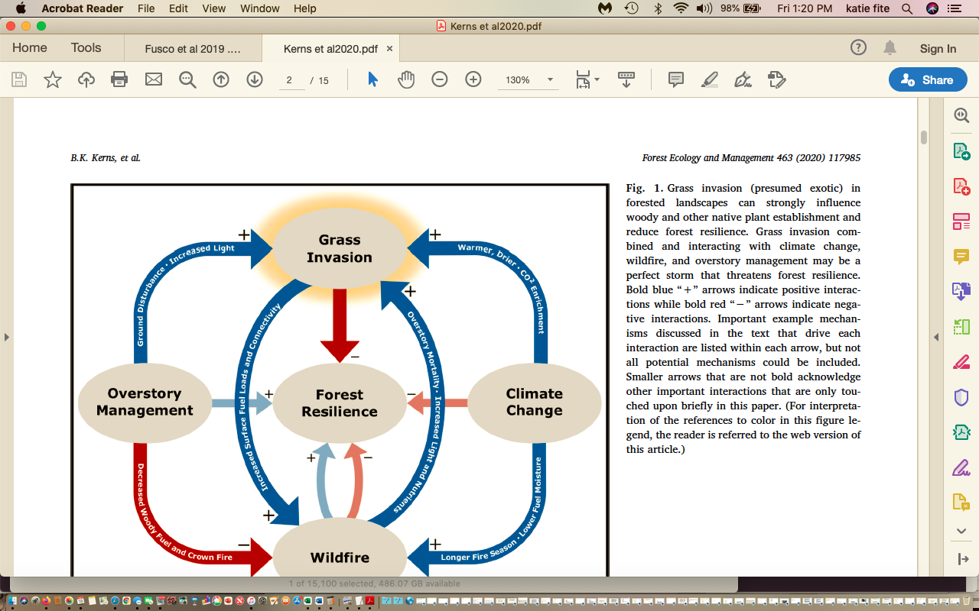

Beyond the dire cheatgrass/flammable weed consequences of massive prescribed burning is the fact that Pinyon Pine and increasingly Juniper in many areas – are under great stress. See, for example, Ronald Kyllo, Piñon-Juniper Woodlands of the Western United States: Are we on the Brink of Piñon Oblivion?
https://nau.edu/wp-content/uploads/sites/140/2016.RonaldKyllo.PinonJuniperWoodlandsWesternUS.pdf

“Most mortality in piñon-juniper woodlands is due to a web of interactions between drought, diseases, and insects (Allen & Breshears 1998; Shaw et al. 2005). While there was extensive mortality in the 1980s and 1990s, a majority of mortality has occurred since 2000 (Hicke et al. 2016). Landscape-scale mortality in piñon-juniper woodlands are expected to increase in the future due to climate change, causing dramatic shifts in ecotones (Breshears et al. 2005).
The resulting stand structure after drought shows a decrease in overall canopy cover (Clifford et al. 2005), large amounts of woody debris on the ground, and a change in dominant species (Shaw et al. 2005). These changes often will have lasting effects on stand characteristics. The severe drought of the early 2000s caused widespread mortality of Colorado piñon many magnitudes higher than the associated juniper species (Mueller et al. 2005; Floyd et al. 2009). The shift in species dominance in these areas will have a profound effect on stand dynamics into the future (Mueller et al. 2005).
… higher elevation piñon-juniper woodlands, but were infrequent (~300+ years) and high-severity. Other studies have also shown evidence of long fire return intervals, suggesting a frequent low-intensity fire regime was uncommon (Baker & Shinneman 2004; Huffman et al. 2008). Romme et al. (2003) suggested a combination of topography and fuel patchiness makes it difficult for a fire to be carried through the system until large amounts of woody debris have accumulated.
The total proportion of yearly precipitation during the growing season is one of the many climatic factors that dictates variability across piñon-juniper woodlands by mediating types and abundance of understory cover (Jacobs 2008; Poulos et al 2009; Bauer & Wiesberg 2009; Kennard & Moore 2009; Margolis 2014).
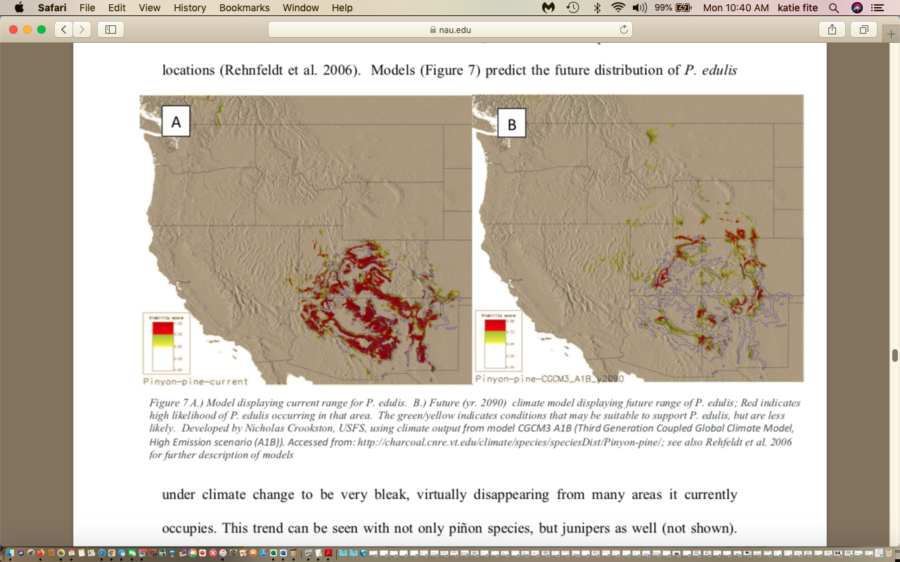

There is clear scientific evidence for large-scale uncertainty and risk with these massive treatments. It is frankly alarming that the FS would embark on such an extreme region-wide deforestation crusade as climate change stress and drought bears down hard on the Region.

This all demonstrates that the FS can’t possibly sign a FONSI for this massive burning and mechanical disturbance “treatment” and deforestation EA planned to be used by the agency for decades without any additional NEPA and public involvement. In reality an EIS (actually whole series of EIS’s with much more detailed baseline information and greatly reduced disturbance footprints, are what the FS must apply/
FS Sage-grouse Habitats Are Threatened by Massive Burning Scheme
The EA and Wildlife Report seek to dismiss harms caused by this project to both Gunnison and Greater Sage-grouse habitats – by claiming no GSG are present, and GRSG habitat will be avoided. This is despite serious adverse impacts to sagebrush
Gunnison Sage-grouse
First, portions of the southeastern project area lie within the Historic range of Gunnison sage-grouse? If so, the FS must work to recover and restore habitat, as the species is already listed as threatened under the ESA, and in reality this separate species desperately needs Endangered status, as the actions and management of federal agencies are greatly failing it. Agencies make endless excuses to not take effective action to preserve the species on federal lands -such as removing or greatly reducing grazing and exotic crested wheatgrass seedings. The FS is to manage grazing to reduce conflicts – yet there is no actual current information on ecological conditions in relation to grazing, and the level and intensity of grazing conflicts with sensitive species, clean and sustainable water flows, roadless and other recreational uses, etc. By using large-scale prescribed burning and mechanized heavy equipment “treatments” and aggressive “seeding”, as well as purposeful targeting of large expanses of sagebrush for destruction under the flawed models, the FS is highly likely to expand areas of domination by annual grasses and further degrade, destroy and fragment sagebrush habitats needed for eecovery of GSG - and foreclose on effective restoration actions on FS lands. It is FWS’s goal to recover this species. Yet the FS dismissively states in the Wildlife BE:
No Occurrence. Gunnison Sage-grouse occur in sage-brush steppe habitat. Although there is habitat within the forest, Gunnison sage-grouse are not known to occur on the Forest (USDA Forest Service 2018). Designated critical habitat does not occur within the project area. Therefore, it is my determination that the proposed project will have No Effect on the Gunnison sage grouse or its habitat and it will not be evaluated …
Greater Sage-grouse:
Predictably, the FS also writes off any analysis of effects on Greater Sage-grouse. BLM and the FS are required to manage sagebrush habitat to conserve, enhance and restore Greater sage-grouse. The EA also ignores that it is to manage to prevent ESA listing.
https://eplanning.blm.gov/public_projects/lup/68351/87600/104856/Utah_ARMPA.pdf
There is only extremely fragmented habitat still remaining on the project area. Look at how tenuous connectivity is in the project area. How has this changed since the MLNF Forest Plan was adopted? Where have leks blinked out across BLM and FS lands in this area?
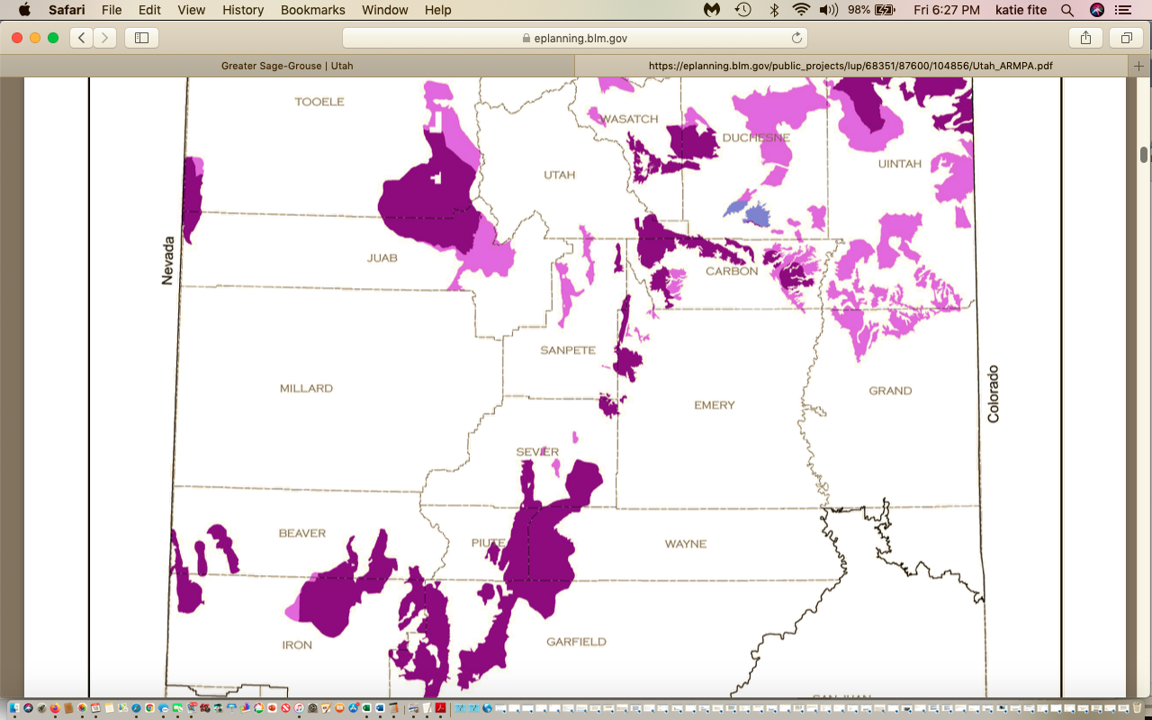
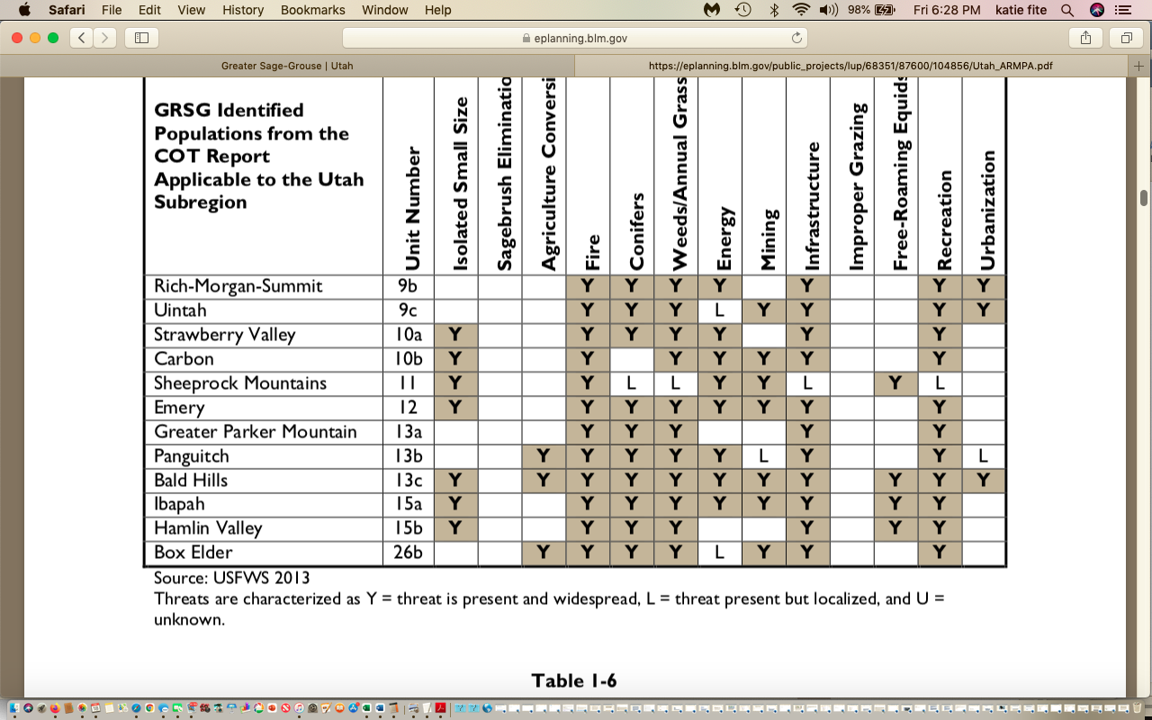
What is the current number of birds in the PACs identified here? What is the trend in the PACs? Have population triggers been tripped? See Garton et al. 2015, Connelly et al. 2019 “agencies in denial of Sage-grouse declines paper 2019, and more recent USGS reports, Remington et al. 2021, Herren et al. 2012, Coates et al. 2021.
How much “treatment” and removal or thinning of sagebrush has already taken place in the GRSG habitats? How has that impacted GRSG population numbers? Please provide individual lek aad lek route counts and trends for all periods available. Is the population currently viable? What is the current population? Have population triggers been tripped?
Were there historic lek sites within the areas of sagebrush, or within 5 miles, of the areas if sagebrush that WILL be treated under this EA? If so, where? What caused them to blink out? Is there seasonal habitat or movement areas in the treatment zone?
We are concerned that livestock AUMs may be substantially shifted, and in fact increased for a while, in and near Sage-grouse habitats as the project-treated lands are “rested” to recover from the massive EA treatments. We are also concerned that this project plans to rebuild an unknown number of often injurious and lethal livestock facilities.
What livestock grazing upland and riparian standards does the FS apply across GRSG - and all other sensitive Forest species habitats? Please provide specifics. Please provide monitoring reports that show standard effectiveness and compliance. The standards shown in the AOIs will not leave 7 to 9 inches of residual nesting cover. See Braun 1998, Connelly et al. 2002, Connelly et al. 2004, Braun 2006, Knick and Connelly 2009/2011, Coates et al. 2016, Connelly et al. 2019, and the recent USGS reports by Herren, Remington, Coates and associates.
Our review of the MLNF permits show greatly excessive riparian use allowed, no trampling standards, no browse standards and upland use that will not provide adequate nesting cover for Sage-grouse or essential habitats for many other sensitive species and migratory birds. In fact, some of the AOIs like in Monticello RD don’t even have standards on them.
There are also large numbers of sheep in many areas, which means a large amount of native predator killing. This massive deforestation will greatly increase conflicts between native predators and conflicts with other wildlife – as sheep will be able to move unencumbered over cleared and downed wood purges MLNF lands. Please provide a detailed analysis of Wildlife services current predator-killing activities here, and the toll on native predators and ecosystems.
There also appear to be serious conflicts with aquatic species and riparian condition with excessive hot season use, and extensive spring use that conflicts with breeding period needs for many wildlife species.
These concerns represent serious adverse impacts on sensitive species and habitats that will be targeted by this massive use of fire, and these cumulative and synergistic adverse impacts must be fully assessed in an EIS.
It is essential that a full accounting of livestock actual use numbers over the past decade by pasture and allotment on both FS and BLM lands be laid out and assessed. Actual use is the number of AUMs actually grazed which may often be far less that active pr permitted use which is very often greatly over-allocated. This is very important, as we’ve frequently seen agencies shift high levels of grazing impacts into unburned areas after wildfires, and stock unburned pastures greatly in excess of actual use following fires to the detriment of wildlife species (which are already suffering from fire loss). This is done for the sole benefit of already greatly subsidized public lands ranchers. See Donahue Capture paper, Moskowicz and Romaniello 2001.
The project does not place an adequate buffer around currently occupied GRSG habitats – in the event of fire escape, or significant cheatgrass/medusahead infestation that would spill over (including weed seed transport by livestock0 into project area lands that are not to be treated. The extremely poor EA mapping does not provide sufficient
Please identify where all historic Sage-grouse habitat is located on and/or in proximity to the project area land, and all potential habitat?
With the new process to update the failing Obama era Sage-grouse plans, BLM stated:
In order to protect the long-term health of Greater sage-grouse populations, consider new science and comply with court direction, the BLM is beginning to consider updates to the range-wide management plans for sagebrush habitat adopted in 2015 and amended in 2019.

See: Herren, V., E. Kachergis, A. Titolo, K. Mayne, S. Glazer, K. Lambert, B. Newman, and B. Franey. 2021. Greater sage-grouse plan implementation: Rangewide monitoring report for 2015–2020. U.S. Department of the Interior, Bureau of Land Management, Denver, CO, and other recent compiled information. We stress that populations have continued to decline in the past couple years. GRSG habitats and populations thought to be secure a little over a decade ago, are increasingly in significant trouble.
Agencies (BLM, USFS, individual western state Game agencies and WAFWA) long been in denial of serious recent Sage-grouse population declines, See Connelly et al. 2019 for example: https://www.researchgate.net/publication/337818762_CONSERVATION_NEWS_Sage-Grouse_Population_Declines_Species_in_Crisis_and_Agencies_in_Denial .
These agencies and entities habitually minimize info on the extent of ongoing sage-grouse declines. They also make public access to information on population status increasingly difficult for the public to access, don’t provide it at all or block public access.
See also Remington et al. 2021, and Herren et al 2021: https://eplanning.blm.gov/public_projects/2016719/200502020/20050224/250056407/Greater%20Sage-Grouse%20Five-year%20Monitoring%20Report%202020.pdf .
“The report focuses on Priority Habitat Management Areas and Important Habitat Management Areas, as defined by the BLM’s land use plans, in the Rocky Mountain and Great Basin Regions. The analysis determined that sagebrush availability in all land ownership categories declined by approximately 3% (approximately 1.9 million acres total; 1.4 million acres in the Great Basin Region and 529,000 acres in the Rocky Mountain Region) between 2012 and 2018. Wildfire accounted for approximately 72% of the sagebrush loss in both regions and represents the largest driver of sagebrush loss in the Great Basin Region (87% of the loss in the Great Basin was from wildfire) …
Rangewide … nonbeneficial habitat attributes (e.g., nonnative/ invasive species and annual grasses) displayed an increase in presence and abundance”. P. vii.
Herren, V., E. Kachergis, A. Titolo, K. Mayne, S. Glazer, K. Lambert, B. Newman, and B. Franey. 2021. Greater sage-grouse plan implementation: Rangewide monitoring report for 2015–2020. U.S. Department of the Interior, Bureau of Land Management, Denver, CO.
The Herren et al 2021 Report also found that 42 habitat triggers had been tripped, indicating that habitat losses have exceeded thresholds set in the respective land use plan. Vii-vii.
“Greater Sage-Grouse populations are declining in some areas of their range more markedly than in others. For adaptive management, the BLM includes soft and hard population triggers in land use plans. Altogether, 42 population triggers have been tripped, indicating that population declines have exceeded thresholds set in the respective land use plan’s adaptive management appendix. These findings align with population trends in the U.S. Geological Survey’s rangewide population monitoring report (Coates et al. 2021).
The results presented in this report, in combination with the U.S. Geological Survey’s rangewide population monitoring report (Coates et al. 2021) and sagebrush conservation strategy (Remington et al. 2021), emphasize the urgent need to expand ongoing efforts to conserve currently functional habitat and restore currently degraded habitat. Expanding these efforts aligns with Executive Order 14008, which calls for the conservation and restoration of public lands and waters”. Herren et al. pp. 1-2.
We request that BLM provide clear and detailed mapping of each of these populations and describe in detail the habitat management taking place and management conflicts. (livestock grazing conflicts, mining conflicts, energy/transmission conflicts, fires)

The Herren Report describes habitat degradation and intensity of activities.

Questions that apply to this project: What is the current population estimation of Sage-grouse and what is its viability? Please use data up to and including 2022 in project analysis. What number of the birds is considered to be a viable population? How much have local and regional populations declined since the plans were adopted? How are the BLM and USFS contributing to changes in the amount of sagebrush, and significant declines in sagebrush? How much more disturbance is being planned or foreseeable? How are agency activities contributing to disturbance activities? How are BLM and USFS contributing to weed expansion? Please see Attached Summary of Public Lands Habitat Disturbance Projects. Many of these are Orwellianly branded “restoration” when instead they are habitat degradation, habitat destruction and habitat fragmentation projects that render “treated” lands highly vulnerable to cheatgrass and other weed invasion and expansion, as well as INCREASE fire risk. Grass is more likely to burn readily and dry out quicker than sagebrush. Cheatgrass and other flammable exotics notoriously cause fires to flash across landscapes.

The Herren report also states:
“… invasive plants are a threat to Greater Sage-Grouse habitat condition that appears to be increasing within type I Greater Sage-Grouse habitat areas. Invasive plants were present on nearly 70% of habitat in 2018, a number that has increased from a little over 50% in 2013 (figure 9). The percent of rangelands where invasive plants were abundant (≥25% of vegetation cover) has also increased, from about 10% in 2013 to nearly 30%in 2018 (figure 10). Annual grasses such as cheatgrass (Bromus tectorum) and medusahead (Taeniatherum capitatum) are important components of invasion that make up about 15% of vegetation on average, an increase of 7% over the last 5 years (figure 11). The proportion of vegetation that is composed of all invasive plants is also steadily increasing from 7% in 2013 to 17% in 2018 (figure 12)”. Herren et al. p. 16.
The report describes fire effects. Yet it glosses over livestock grazing as a highly significant cause of cheatgrass and then causing frequent flashy fires locking in cheatgrass monocultures with no shrub (and increasingly as described by Kerns et al. 2020 no forested site) recovery. The Williamson et al. 2019/2020 study, as did Reisner et al. 2013 demonstrate this. Over two decades ago, Belsky and Gelbard described the many ways in which livestock grazing causes weeds in arid western landscapes whose sagebrush vegetation communities did not evolve with large herds of large, hoofed mammals, see Mack and Thompson 1982. It is quite shocking that the MLNF in this day and age when the great vulnerability of sagebrush to post-fire wed invasion is known, and the impacts of climate stress on exacerbating grazing effects in causing cheatgrass is known , that the FS would propose such profligate fire use (see Reisner et al. 2013, Reisner Dissertation 2010, Williamson et al. 2019, fusco et al. 2019, Kerns et al. 2020, and the recent USGS reports).
Basic on-the-ground ecological observations across sagebrush landscapes show that sites more intensively grazed by livestock are highly susceptible to cheatgrass, medusahead, bulbous blegrass, etc. More intensively disturbed sites are not even evaluated in nearly all agency land health assessments. These assessments are plagued by myriad biases that favor the livestock industry.
The USGS Williamson 2019 et al cheatgrass and grazing research exposes how grazing (including following fire) increases fire-causing cheatgrass risk. See for example, “Study shows grazing encourages cheatgrass growth”.
https://www.boisestate.edu/news/2020/03/13/study-by-matthew-williamson-shows-grazing-encourages-cheatgrass-growth/ .
“A group of scientists led by Matthew Williamson, an assistant professor in Human-Environment Systems at Boise State University, has found that grazing plays a major role in determining the prevalence of cheatgrass; even in places that have not burned. Their results suggest that grazing increases the potential for cheatgrass occurrence by 10-20 percent and that more frequent grazing can almost double cheatgrass prevalence when controlling for variation in climate, topography, fire history and site variation. These results highlight the challenges associated with using grazing as a land management tool for reducing fire and cheatgrass spread”.
Sage-grouse clearly face a cheatgrass emergency that is ever-worsening under climate change stress.
The 2015 plans have been singularly ineffective in conserving, enhancing and restoring Sage-grouse habitats and populations. The “livestock grazing” section was weak and toothless and was basically a template for continuing grazing practices as usual. To make matters worse, as implemented by BLM and FS offices, it was used as an excuse to pepper and fragment the landscape with more lethal and injurious habitat fragmenting fences, more harmful water developments, expanded salt/supplement destruction of sagebrush uplands creating even more epicenters for cheatgrass infestation and spread, and to continue grazing livestock at very high levels of even 50% utilization. not reduce AUMs, conduct assessments with biases downplaying adverse impacts of chronic livestock degradation and disturbance effects, seed even more exotic crested wheatgrass, and generally make matters Worse for Sage-grouse – all while focusing agency actions on radical deforestation and habitat manipulation schemes (many of which both expanded cheatgrass and increased fire risk and are pushing species like Pinyon Jay closer to ESA listing), while also distracting from livestock damage to habitats by excessively blaming wild horses for degradation.
Manier et al. 2013 emphasize the importance of de-stocking, yet BLM has increasingly used the plans as an excuse to increase stocking and neatly always to issue new grazing decisions far exceeding actual use levels during the assessment period.
Region 4 Condition-Based Management Schemes Violate NEPA
NEPA prohibits uninformed agency actions. “An EIS must ‘reasonably set forth sufficient information to enable the decisionmaker to consider the environmental factors and make a reasoned decision. The agency meets this obligation if its EIS “contains a reasonably thorough discussion of the significant aspects of the probable environmental consequences.” The NEPA process “serves two fundamental objectives”: “First, it ‘ensures that the agency, in reaching its decision, will have available, and will carefully consider, detailed information concerning significant environmental impacts,” and “second, it requires ‘that the relevant information will be made available to the larger audience that may also play a role in both the decision-making process and the implementation of that decision.

The court found this method did not provide the clear hard site-specific look that NEPA requires. Now in these cookie cutter region 4 NEPA, each of these is a mere EA, with no alternatives, and with a false FONSI where the FS makes the ridiculous claim that there will be no significant impacts. In the AK case that was overturned, the FS had first prepared a NEW Forest plan that included “condton-based management score cards/lists, and then an EIS to apply them,
The Court evaluated the analytical method that the agency employed and determined whether the Project EIS, a landscape-level long-term planning document, adequately evaluated the site-specific impacts of as-yet undefined timber sales that could potentially occur on certain acreage.
NEPA requires that environmental analysis be specific enough to ensure informed decision- making and meaningful public participation. The Region 4 Fire EAs omission of the actual location of proposed burn treatments and the near-total lack of baseline ecological data on fish and wildlife, grazing degradation and many other critical elements within the Project Area also falls far short of that mandate.
https://earthjustice.org/sites/default/files/files/40-order-granting-msj_3-11-20.pdf
Crucial Crusts Greatly Threatened BY Massive Burns, Treatment and Continued Livestock Grazing
The FS ignores the drastic fire and project impacts to microbiotic crusts, a very important component of PJ communities, sagebrush and arid shrub communiites, and many forested sites that the project will harm – through heavy equipment cross-country travel damage, covering and killing with wood chips, and other methods. Crusts in arid communities and forests stabilize soils, protect them from erosion in wind and water, and are a frontline defense against cheatgrass and other invasive species. They also sequester carbon. Both fire and livestock grazing destroy crusts. See for example:
Beymer et al 1992. Effects of cattle grazing on microbiotic crusts. The project’s clearing trees and shrubs gives cows access to previously ungrazable sites protected by tree limbs, These sites are very often covered in mosses, lichens and native grasses or forbs.
Bowker et al. 2008. Crusts as soil function indicators. Yet the project ignores and completely sacrifices crusts – heavy equipment, pile burning, jackpot burning, broadcast burning kill crust. Mastication wood chips smother them, and deforestation exposes sites to even more intensive cow impacts such as weed-causing soil/crust trampling, deposition of weed-causing manure, eating fragile native plants previously protected.
Bortherson et al. 1984. This describes adverse effects of long-term grazing on crusts.
Concostrino-Zubiri et al. describe effects of exposure and grazing - example Bryophytes (mosses).
Deines et al. 2007.Lichen cover resulted in a significant decrease in cheatgrass.
Evans and Belnap 1999. Effects of loss of nitrogen from soils in arid communities. The project includes pile burning with loss of nitrogen from the system and resultant air pollution too, severe pile and jackpt burning damage to crusts, heavy equipment cross-country travel damaging crusts.
Fernandez et al. 2007. Results show that areas used by domestic livestock have 20% less plant cover and 100% less soil organic carbon and nitrogen compared to relict sites browsed by native ungulates. In actively grazed sites, domestic livestock grazing also appears to lead to clustered, rather than random, spatial distribution of soil resources.
Kettering 2009. Soil crusts were not totally recovered following 40 years of disturbance. Also impacts carbon sequestration.
NRCS 2007. This describes microbiotic crusts and disturbance impacts. It’s too bad NRCS veg models (such as those used in the Ecosites or the, Landfire disturbance intervals, and other info the FS relies on) today greatly ignore the natural occurrence of, and role, of crusts.
Ponzetti and McCune 2007. This describes adverse effects of soil disturbance increased incident radiation, increased heat load, and topographic position in crust recovery. Of course, the project area will drastically increase heat load (by how much? – 30 to 40 degrees or more on a summer day? And how much will it increase incident radiation?).
Rosentreter et al. Field Guide. Lichens and mosses typical of the region. Which species have been found, and where, in the Goose Creek project area and surroundings? What about lichens growing on trees?
Serpe et al. crusts. 2008. Crusts tend to reduce the spread of invasive species. The project will harm and/or destroy or lead to the cow-caused destruction of crusts – over vast areas, and the Forest ignores this harm.
USDI BLM Belnap et al. 2001. Tech. Ref. on Biological Crusts. Describes grazing and mechanical impacts to crusts, and their vital role in the ecosystem protecting soils from erosion in wind and water and other ecological functions.
Enormous Additive and Cumulative Impacts to Biodiversity, Sensitive Species, Wild Land Roadless Areas and Public Uses of Public Lands
We can’t over-emphasize how large losses from all the Region 4 burning will be. In most EA instances.
MLNF Roadless areas:
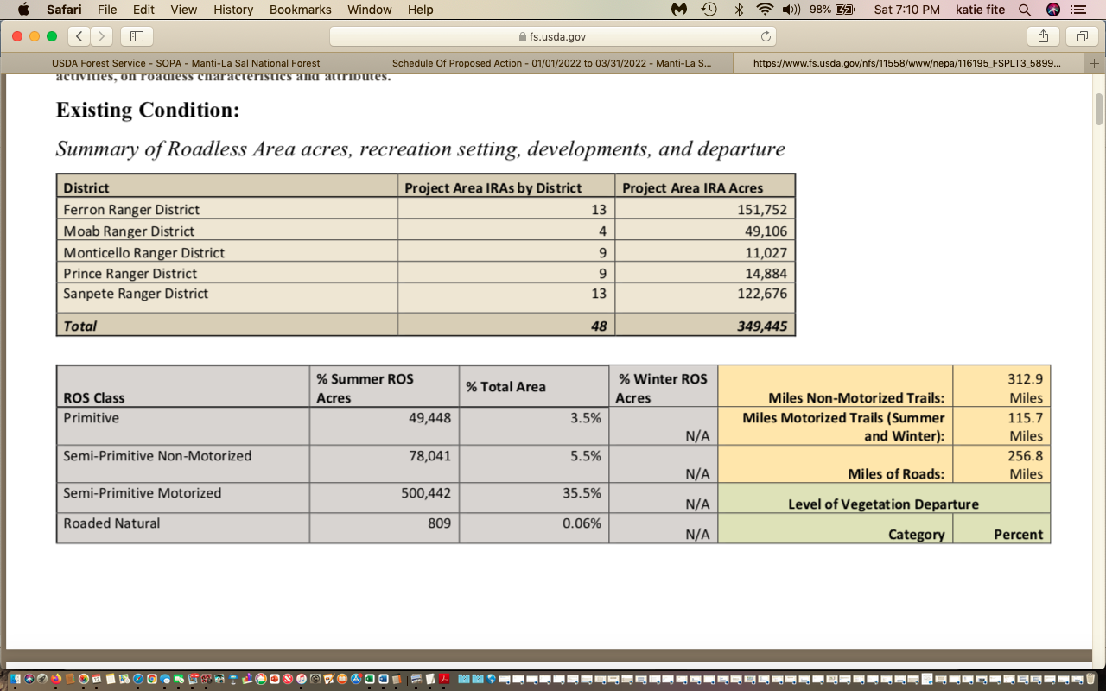
This shows 349,000 Roadless acres. The EA states there are approximately 600,000 total MLNF Roadless acres, and 84 Roadless Areas within the project area, with 475,450 roadless acres proposed for potential prescribed burn treatments. EA p. 9. What is the difference here? Is it the Bears Ears acreage?
The FS targets close to 100,000 acres of sagebrush communities. MLNF Silvicultural Report.
https://www.fs.usda.gov/nfs/11558/www/nepa/116195_FSPLT3_5899218.pdf
Humboldt-Toiyabe:

EA: https://www.fs.usda.gov/project/?project=57860
There are 5.1 million acres outside wilderness in project area, and the EA targets approx. 4 million acres, burning 100,000 acres each year. The Fire EA targets 342 roadless areas totaling approximately 3 million acres across all Ranger Districts. This is about 60 percent of the National Forest System lands outside of designated wilderness (the project area). Landscape analysis using LANDFIRE shows us that about 84 percent of this [Roadless] area is at moderate to very highly departed.
The FS claims with Sagebrush: In sage-grouse habitats, burn plans for broadcast burns, and jackpot burns will be designed to retain at least 15% sagebrush canopy cover. In wintering, breeding, and nesting habitat, sagebrush removal or manipulation should be restricted unless necessary to facilitate restoration of habitat … The FS cannot “underburn” sagebrush. The sagebrush plants are highly susceptible to fire. The HTNF drastically underestimates mortality impacts. The bottom line is that this, as with the loopholes in the MLNF Design Elements allows widespread burning of sagebrush.
The FS even plans to “broadcast burn” sagebrush: Broadcast burning—a type of mixed intensity prescribed fire that uses surface fire on a broad area of a burn unit ..
Vast acreages targeted in the HTNF are highly vulnerable to cheatgrass invasion and spread with use of fire disturbance – in particular, sagebrush and PJ communities.
Sawtooth:
EA: https://www.fs.usda.gov/nfs/11558/www/nepa/115235_FSPLT3_5720172.pdf
Analysis area is 2 million acres. Acres in Wilderness, and the FS plans to burn approximately 40,000 acres annually.
Fifty-nine percent of the analysis area is within inventoried roadless areas, including 26 areas (1.04 million acres)
There are 33 rivers determined to be eligible for designation as wild and scenic rivers in the Sawtooth Forest Plan, Appendix D. Approximately 221 miles occur within the potentially affected area. There are no congressionally designated wild and scenic rivers. Note that none of the other Fire EA Forests mention potential WSRs. Are there potential WSRs on the Manti? Is there any current review of potential WSRs?
There are over 950,000 acres on the Sawtooth National Forest within the project analysis area (or 55 percent of the analysis area) that can be characterized as being moderately to very highly departed from their natural (historic) regime of vegetation characteristics. Much of the southern Sawtooth is highly vulnerable to cheatgrass and other weeds with fire use.
No specific roadless area “departure” is provide in the documents provided to the public, but the acres targeted for burning up will obviously be immense.
The Sawtooth also plans to attack sagebrush: The LANDFIRE analysis shows that sagebrush communities (specifically mountain sagebrush) are some of the most highly departed non-forested vegetation types and may benefit from limited application of prescribed fire. In addition, sagebrush communities exist adjacent to other vegetation types where we may want to implement landscape burning, so fire may be used to develop holding lines or support management of those burns
Caribou Targhee:
Roadless Report: Total acres of 22 burn blocks are 266,034 acres in the Caribou portion of the CT with approximately 81% of the acreage designated as roadless.
https://www.fs.usda.gov/nfs/11558/www/nepa/114677_FSPLT3_6371833.pdf
From the CTNF EA:
This information provides an approximation of how many acres should be targeted for burning on an annual basis to restore a more resilient stand composition and structure. Approximately 98 percent of the forest stands in the project area are classified as mature/late seral age class, while the 2003 Revised Forest Plan for the Caribou National Forest (Revised Forest Plan) identifies a desired condition of 20 to 40 percent mature/late seral stands across the forest. Prescribed fire is a management tool that can introduce disturbance incrementally into forest stands to create a greater diversity of age classes to improve resiliency. When considering this information and guidance from the Revised Forest Plan, the Caribou Prescribed Fire Restoration Project proposes to treat approximately 6,000 acres annually, with up to 60,000 acres to be treated over the next decade.
https://www.fs.usda.gov/nfs/11558/www/nepa/114677_FSPLT3_5749952.pdf
Prescribed fire may be implemented across approximately 266,000 acres of the Caribou-Targhee National Forest in both Idaho and Wyoming (figure 1). Large burn blocks (averaging about 12,000 acres in size) have been identified as areas to be evaluated for treatment, although the specific locations for prescribed fire within the burn blocks have not been identified at this time.
Broadcast burning of sagebrush communities: Broadcast burning—a type of mixed intensity prescribed fire that uses surface fire on a broad area of a burn unit, often when no overstory trees are present to increase structure, age, and species diversity (such as sagebrush, pinyon-juniper vegetation communities)
Suffice it to say that a very large amount of sagebrush here too will be burned up and sites subject to weed invasion: Non-Forested vegetation types accounts for approximately 32 percent or 85,000 acres within the project area. The predominate non-forested vegetation type is sagebrush/mountain brush, which accounts for 94 percent of the non-forested acres. There is an annual prescribed fire objective of up to 21,000 to 26,000 acres per year in the Caribou Prescribed Fire Restoration Project Area.
Salmon-Challis: Every larger recent burn project includes a significant portion of Roadless areas. One CX alone, for the cheatgrass-prone Southern Lost River Range, targets 100,000 acres with no actual analysis. The Big Creek CX targets 71,000 acres, much if it roadless, in the Lemhi Range.

The condition of lands prior to any treatment affects the condition of lands following a project, and vulnerability to irreversible erosion, weed dominance, etc. Very long periods of rest are needed for recovery of arid western watersheds from disturbance. The EA greatly suffers from a lack of systematic science-based current baseline data and have no hard look analysis of grazing degradation. The EA relies on a laundry lists of possible uncertain actions with many loopholes rendering them ineffective. This makes any coherent NEPA “hard look” at what exactly will take place at each site in the context of each site’s unique characteristics impossible to determine. This thwarts the whole purpose of NEPA – and informed agency decisions with harm effectively mitigated or minimized.

Sincerely,

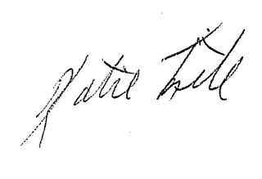

Katie Fite
Public Lands Director
WildLands Defense
PO Box 125
Boise, ID 83701
208-871-5738
katie@wildlandsdefense.org

/MG
Mike Garrity
Alliance for the Wild Rockies
PO Box 505
Helena, MT 59624
wildrockies@gmail.com

/SJ
Sara Johnson
Native Ecosystem Council
PO Box 125
Willow Creek, MT 59760
sjjohnsonkoa@yahoo.com

/JC
Jason Christensen
Yellowstone to Uintas Connection
PO Box 363
Paris, ID 83261
jason@yellowstoneuintas.org

Photo Attachment:

WLD Photos documenting rampant cheatgrass and medusahead infestation at Hart Mountain NWR in SE OR following juniper cutting and pile burning in sagebrush habitats. This demonstrates the consequences of the proposed pile burning. Also, Photos documenting domestic sheep being run all over scalded soil burn piles on the Region 4 Humboldt-Toiyabe Forest Bridgeport RD in 2021.

Pile Burning and Juniper Deforestation Hart Mountain 2016 – Or How to Cause Rapid Cheatgrass Invasion Across a Landscape with Federal Agency Vegetation Manipulation Treatments

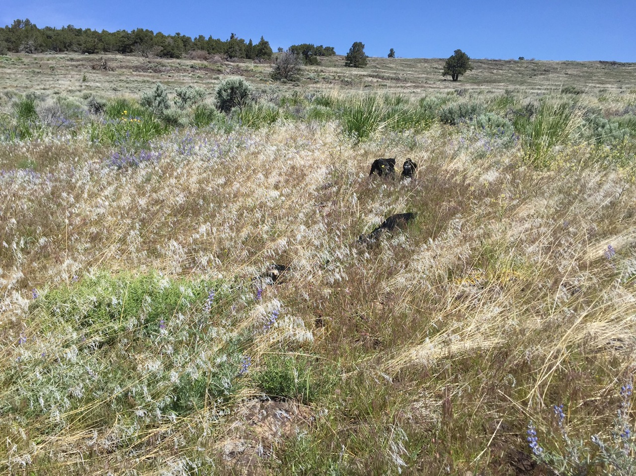

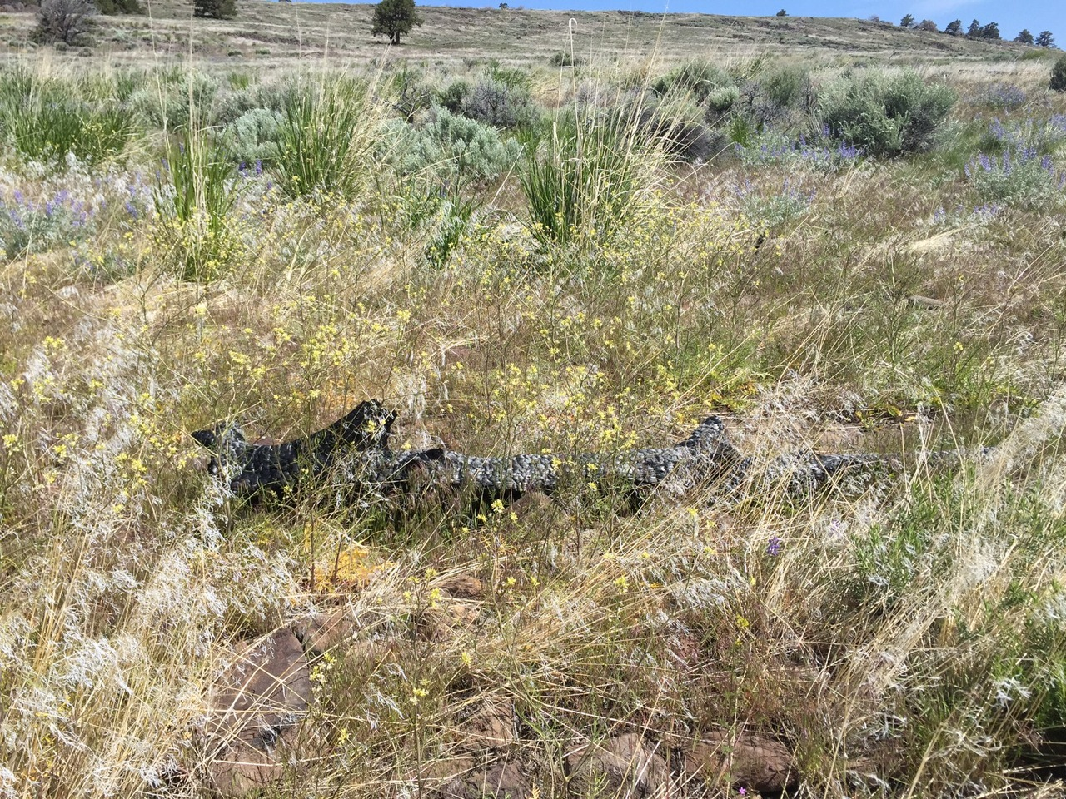

Cheatgrass and exotic Mustards at Pile Burn Site

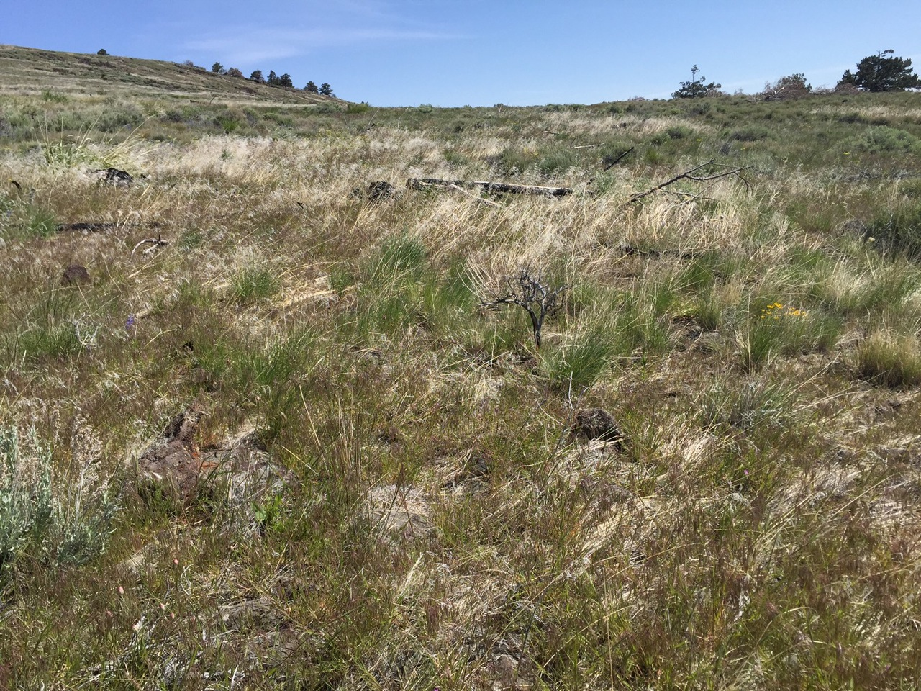

Pile burn sites are areas with pale cheatgrass mottling the landscape.

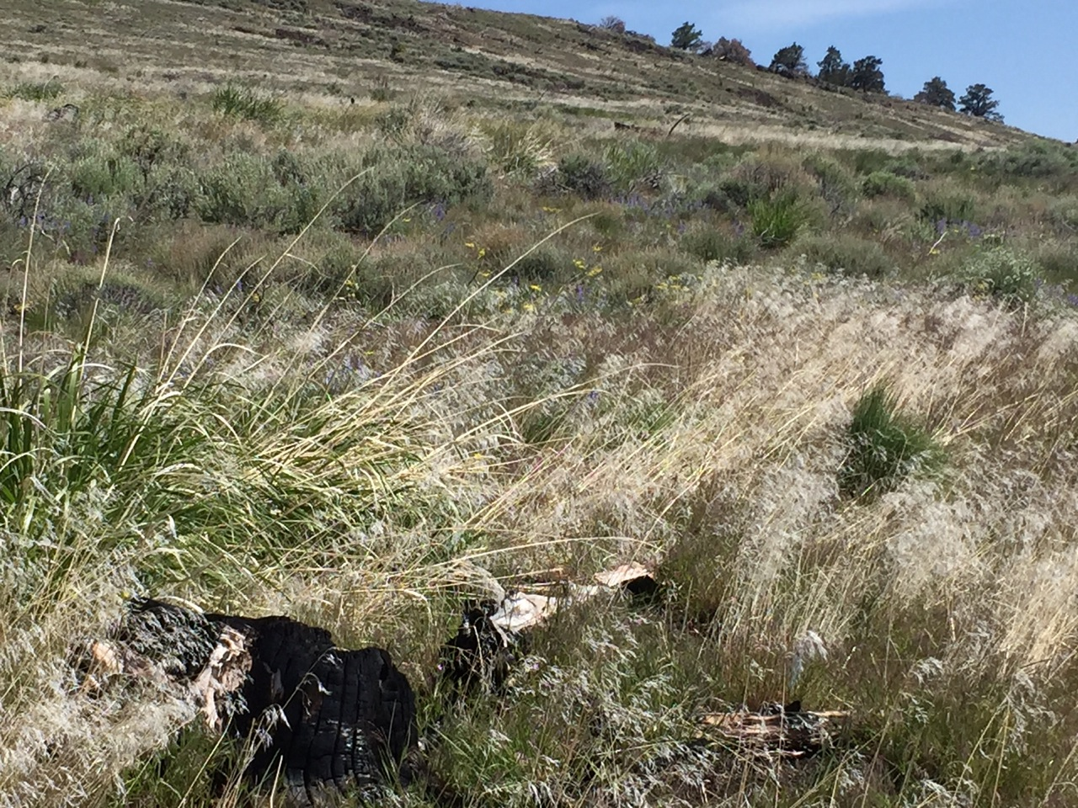

More pile burn sites with cheatgrass mottling the landscape.

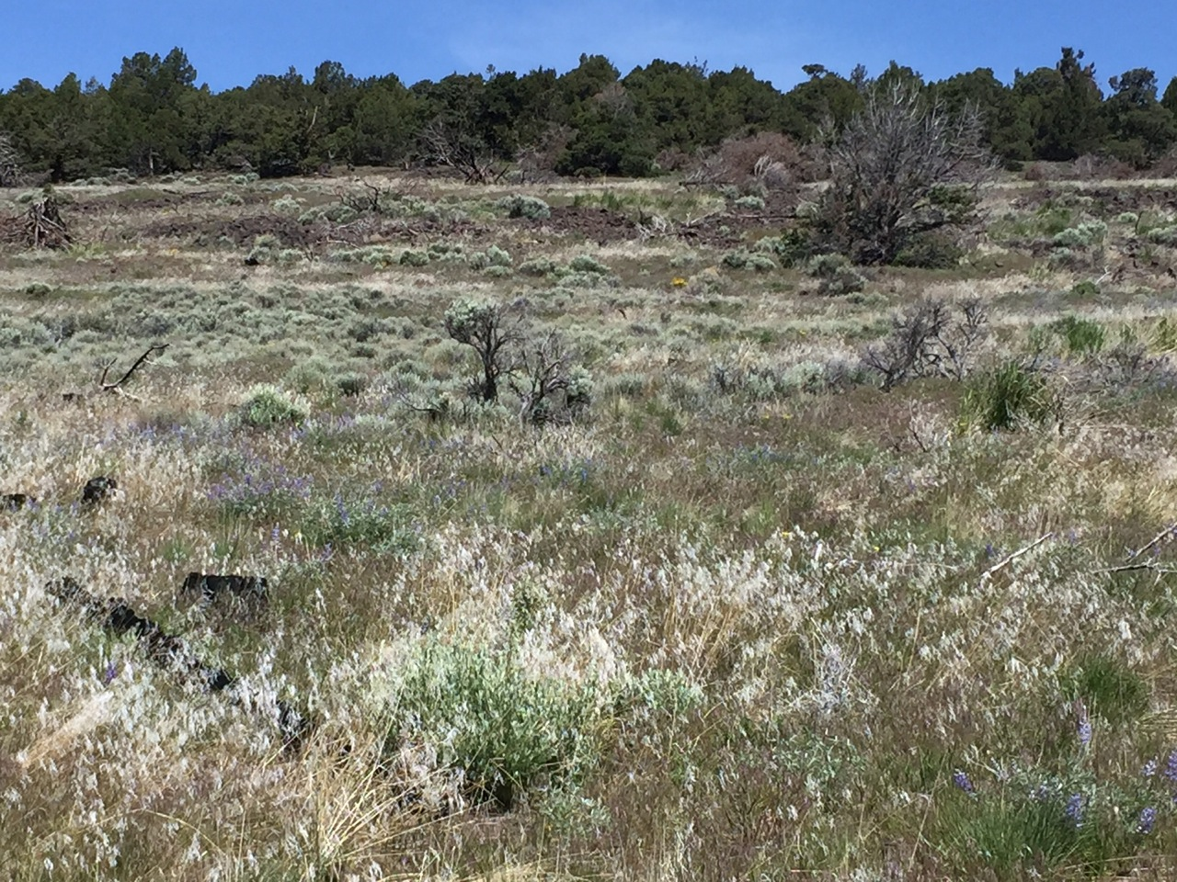

More deforestation pile burn sites mottling the landscape. You can detect where the piles were by the dense pale tan-colored flammable annual grasses.

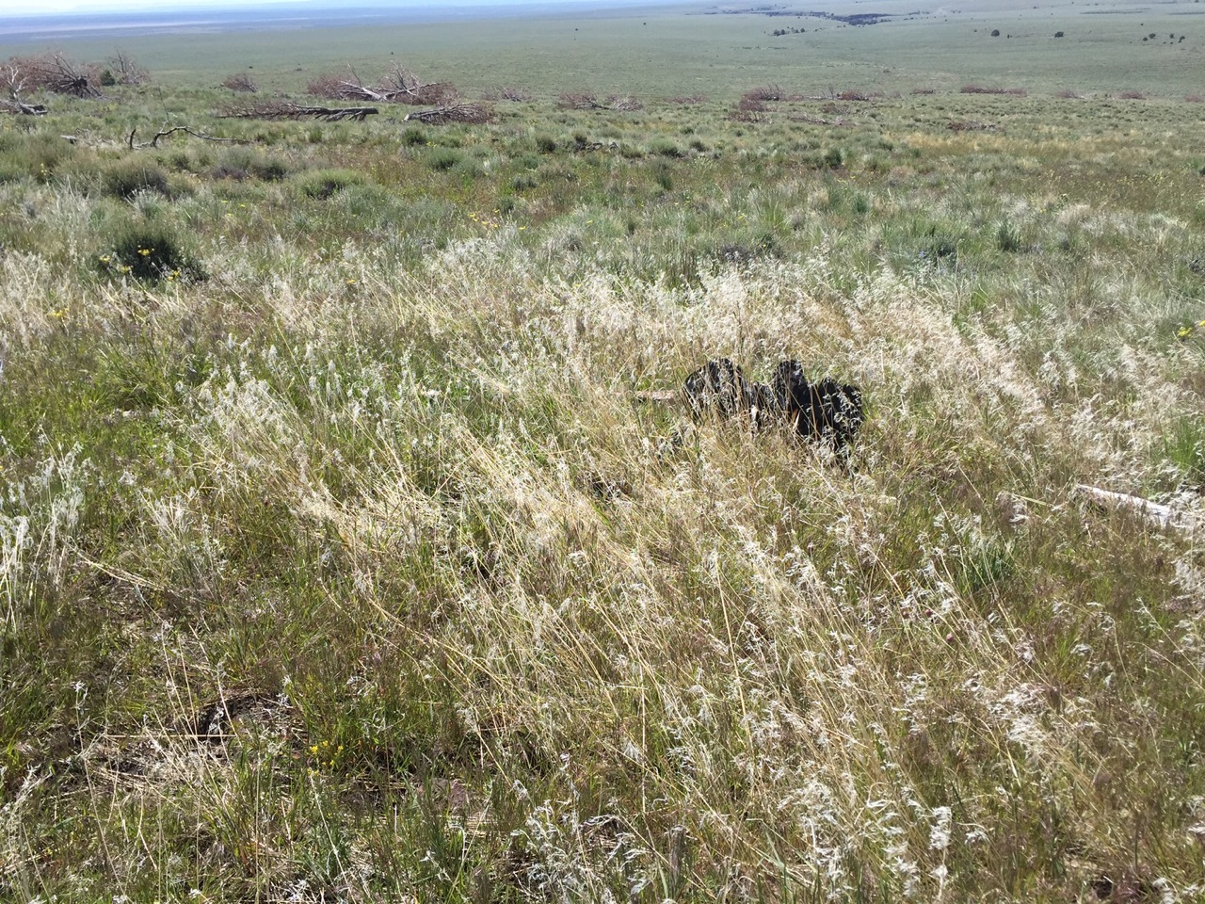

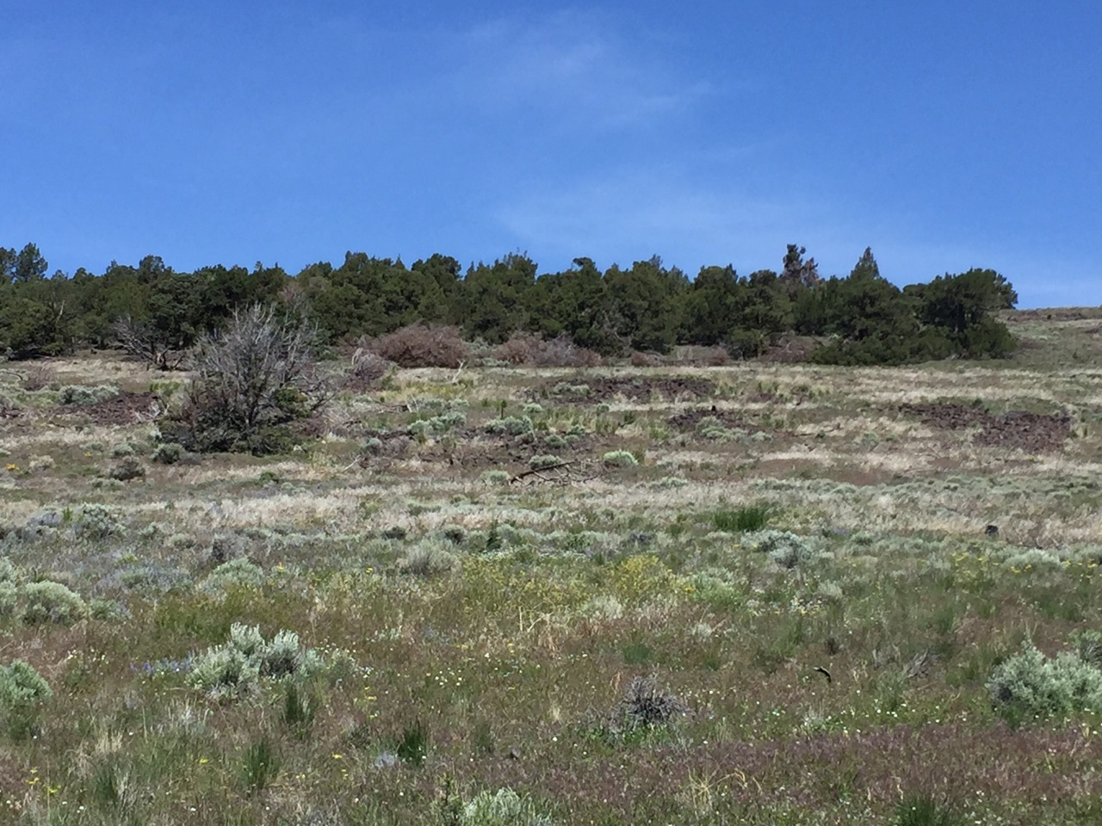

2021 PILE BURNING in Region 4 Humboldt-Toiyabe Forest Bridgeport RD

The FS, in an effort to manicure the Forest, burned old piles of cut wood that had been in place for many years. The sheep grazing operation then ran the sheep all over top the scalded soil burn pile ash.n The FS burned years old piles of wood, some of it already rotting. This very predictably burned extremely hot, and scalded soils.

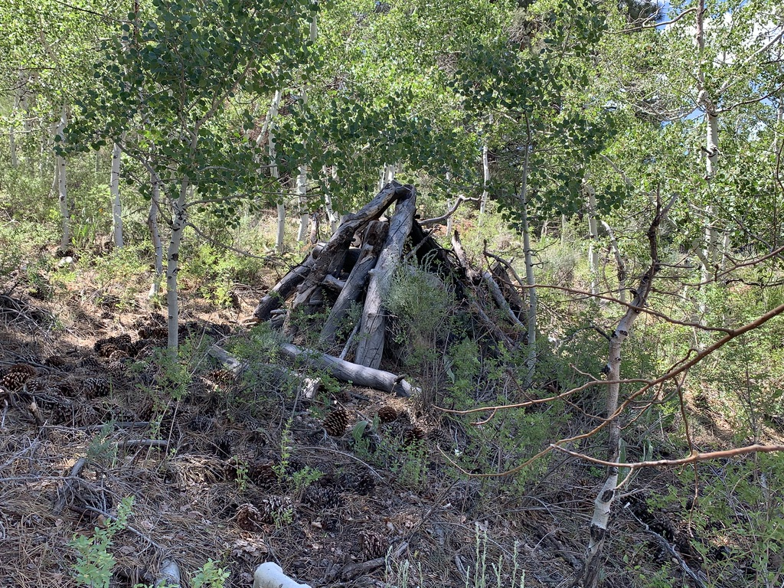
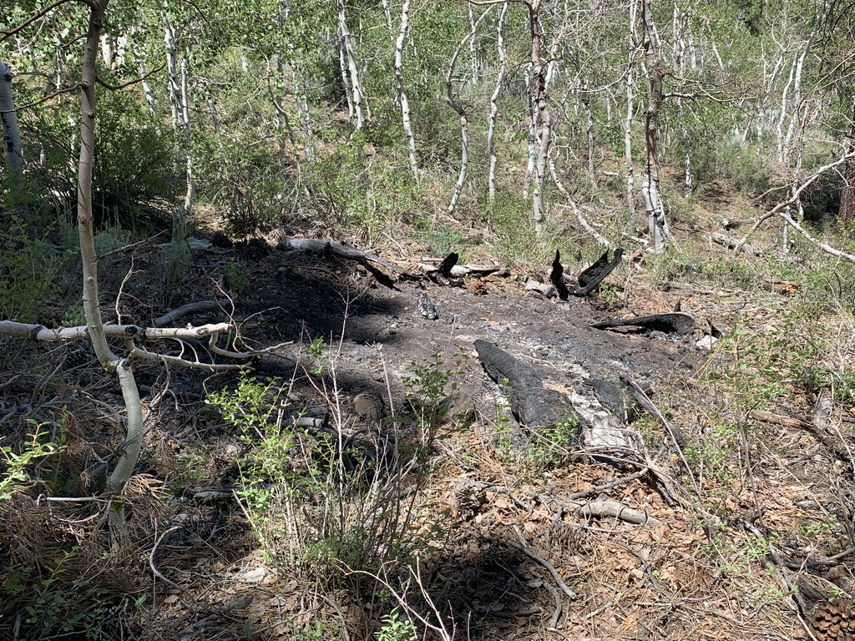

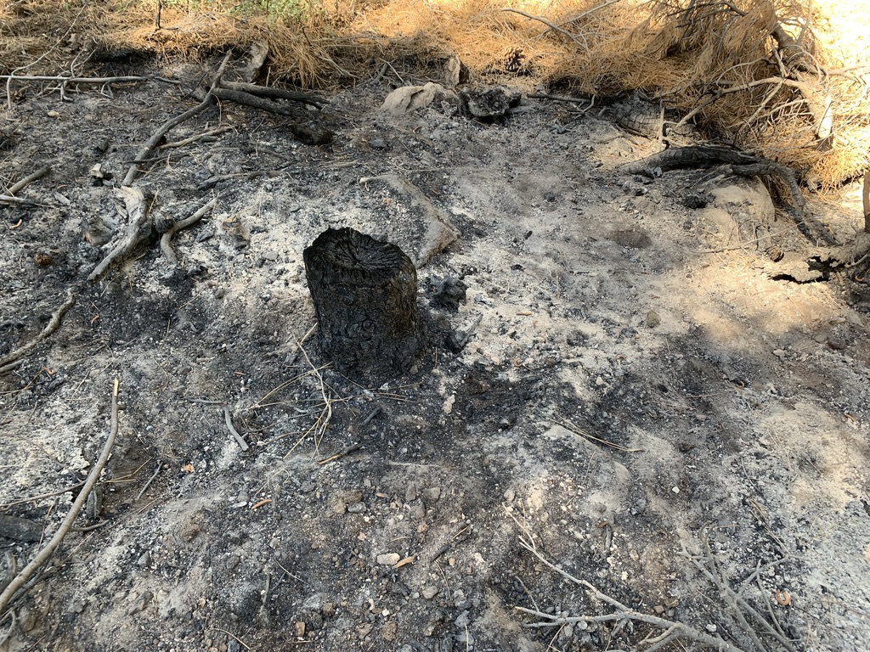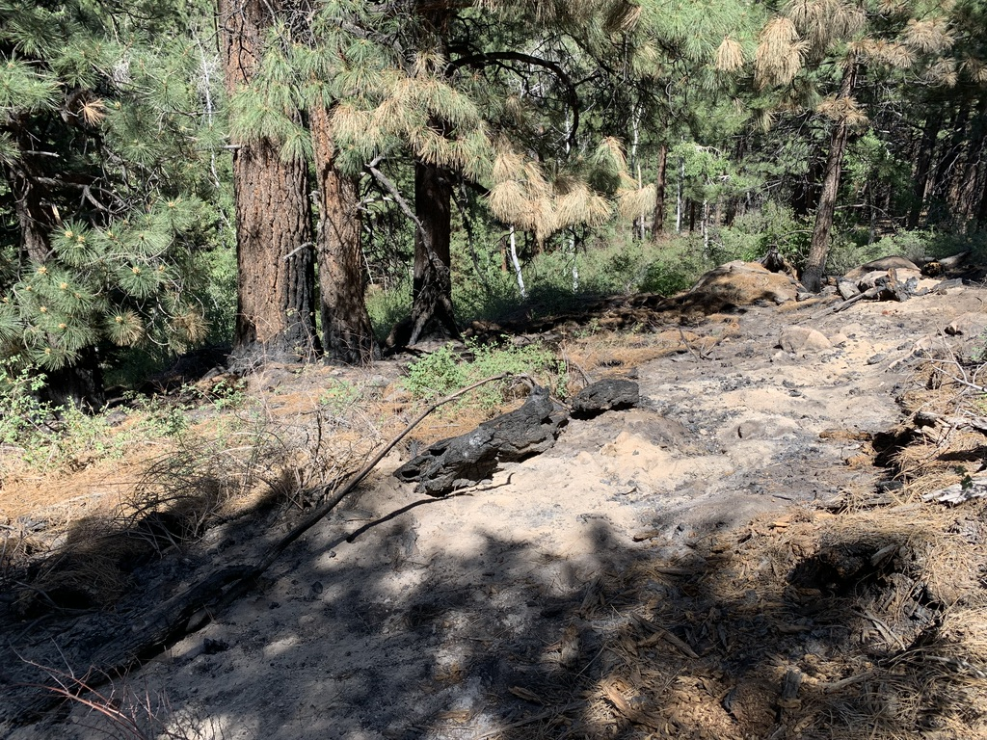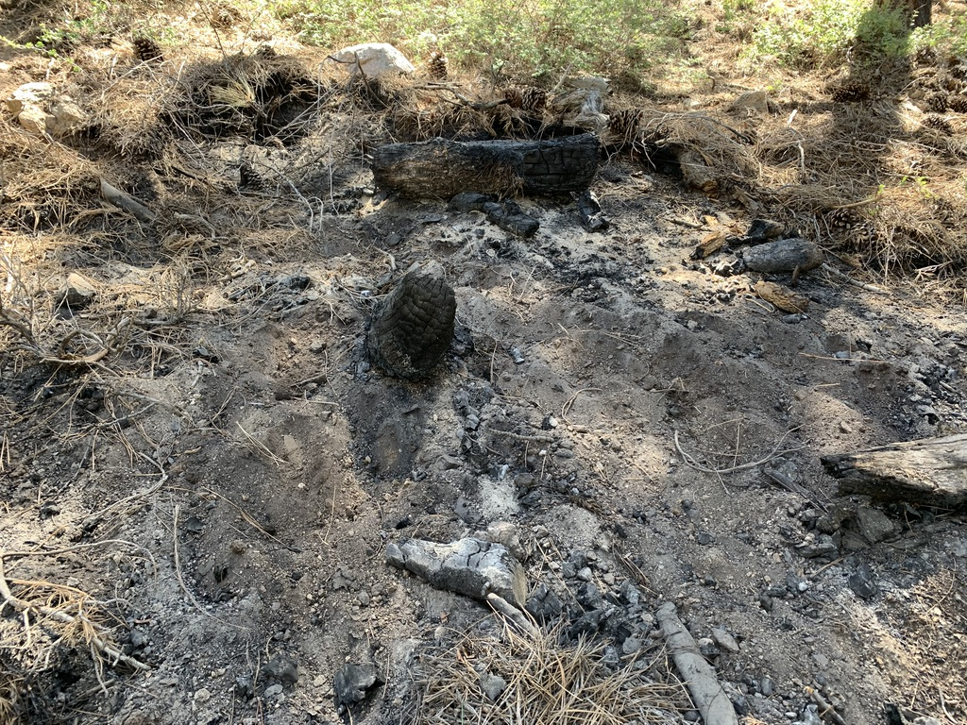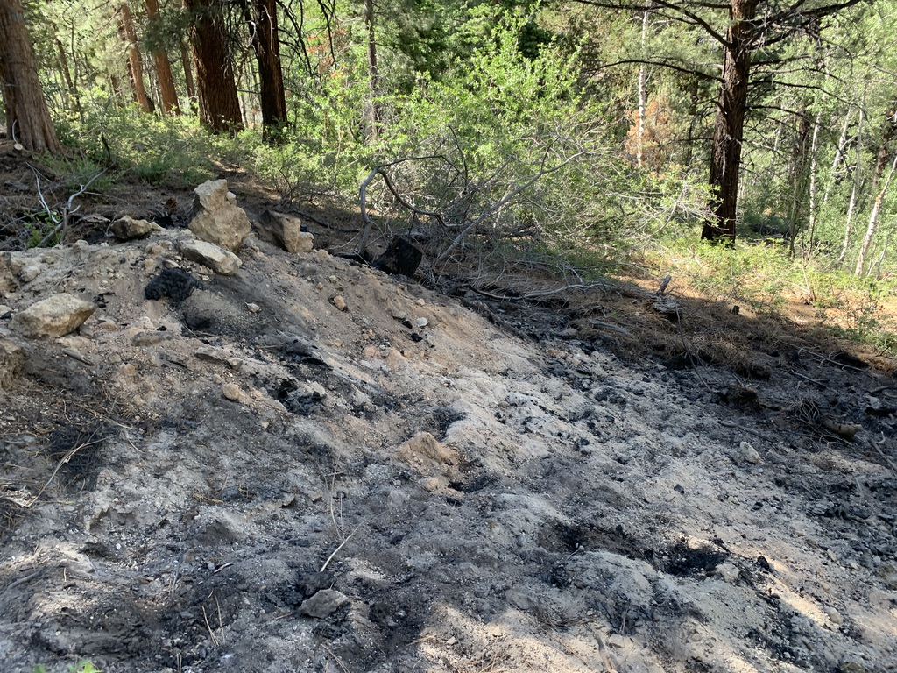

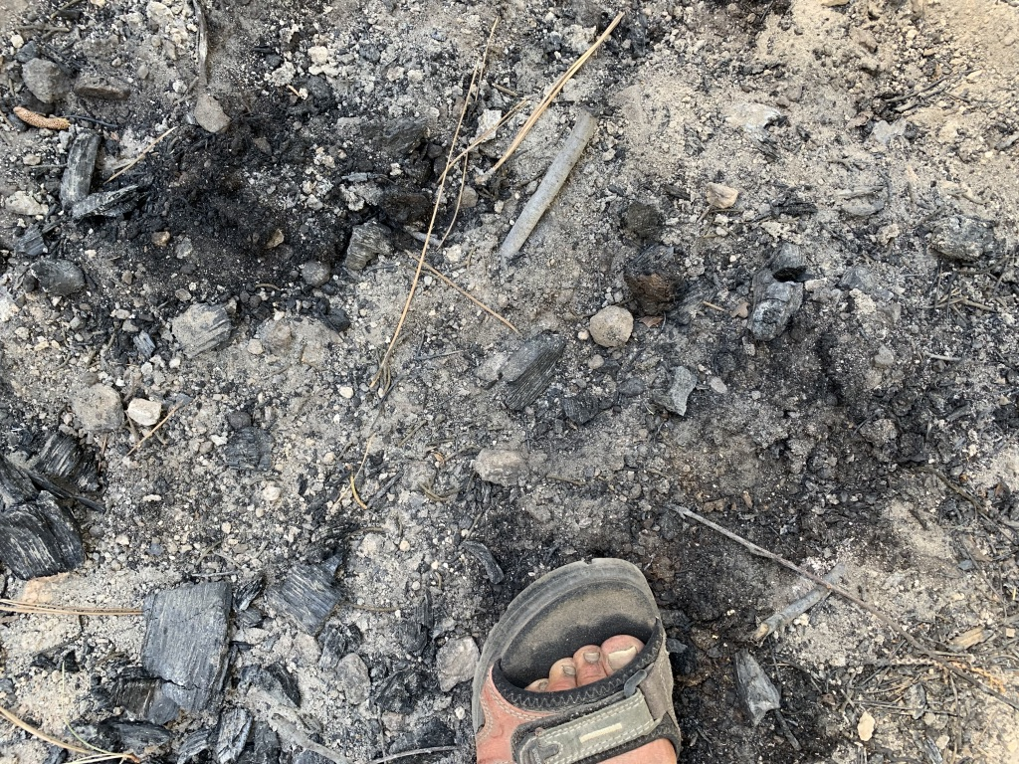

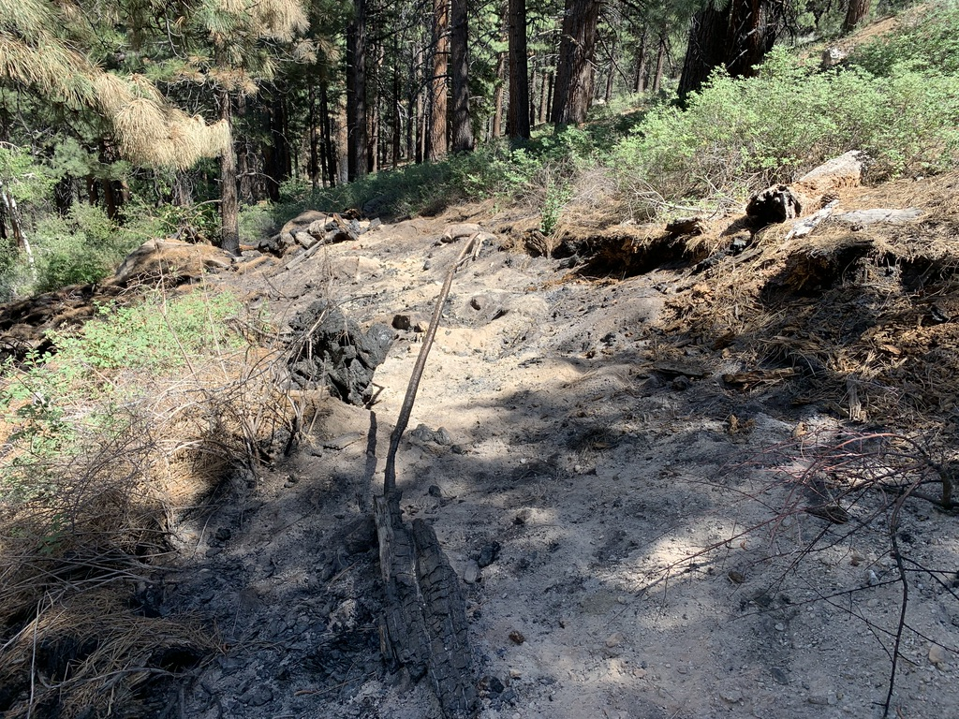

ATTACHMENTS SUBMITTED ON CD IN SUPPORT OF COMMENTS
WLD, AWE, NEC, Y2U et al. Region 4 Sawtooth Forest Prescribed Fire EA, Caribou-Targhee Prescribed Fire EA, Humboldt-Toiyabe Prescribed Fire EA, Salmon-Challis South Lost River Restoration Treatment CX and other comments/Objections, and FS documents on cd. Also see Region 4 Dixie Forest Prescribed Fire EA Scoping, and Fishlake Forest Fire EA
Extensive scientific ecological literature references.

