January 30, 2026
RE: US Fish and Wildlife Service Data Call for Pinyon Jay Information
Submitted to: Amanda Holland amanda_holland@usfws.gov and scott_somershoe@usfws.gov
USFWS Pinyon Jay Petition Reviewers Holland and Somershoe,
WildLands Defense, Allian ce for the Wild Rockies and Native Ecosystems Council are submitting information in response to the USFWS Data Call for information on the Pinyon Jay,
\The Service request states:
To ensure the Service has the most current and best available information, we are seeking the following specific information on the Pinyon Jay:
- Species’ distribution, biology, life history;
- Positive and negative survey data;
- Information on habitat quality and quantity within the Pinyon Jay’s range;
- Information on other potential threats and stressors to the species; and,
- Planned or anticipated conservation and management actions or protections implemented that may benefit or harm the species.
We have underlined the categories of information that we will primarily be submitting to you.
We are concerned that there was little publicity about the data call, which apparently was announced over the holidays. We only learned about it last week and have had very little time to assemble information especially on the vast Pinyon-Juniper and other treatments, including logging/“restoration” projects impacting species like limber pine and Ponderosa pine, that are taking place across the species range.
We are very concerned about the status of habitat and populations of the Pinyon Jay. There is constant and relentless decimation of Pinyon-Juniper forests taking place, especially across Nevada, Utah and portions of eastern California where we have extensive experience tracking and often commenting on, and at times appealing or litigating, federal agency land management actions. We are also greatly concerned at the removal of limber pine and pinyon pine forest habitat Montana in the northern extent of the species range.
We are submitting on thumb drive:
- BLM and US Forest Service project documents and other records showing some of the enormous acreages of PJ deforestation projects that have already been authorized by federal agencies to take place over the next decade or longer. We will try to provide links to agency websites where available. However, major changes were made to the USFS website early in 2025. This has made information for projects already authorized - and to be carried out over a period of 10 or more years - more difficult to unearth. The USFWS must probe the full extent of Pinyon Jay habitat loss, degradation and fragmentation that is foreseeable under stacks of already authorized projects that are not yet completed. Also, some previously archived authorized project information with BLM projects may have gone missing with the recent 2026 BLM website update.

- Observations/Comments/Appeals/Objections on BLM/USFS projects describgin project threats and environmental stressors
- Articles and photo summaries with observations of PJ deforestation and manipulation projects on public lands in recent years detailing project threats and stressors.
- Scientific articles and information on threats to PJ forest persistence, and to Pinyon Jay populations and viability.
We are also providing our observations and concerns about conclusions that may be drawn from recent more intensive and more widespread monitoring of populations, and some potential biases. When public interest and concern rises for a species, it is highly likely that biologists and birdwatchers and general members of the public will increase reporting of a species to sites like iNaturalist.
This is certainly what happened with Sage-grouse – lek searches and intensity of lek counts increased in the 3 or so years preceding the 2015 USFW ESA non-listing decision. Landscapes were scoured for leks by state Game agencies who opposed ESA listing, thus boosting known lek numbers and population estimates at that time. Further, the public is more likely to take the time to record an observation on the iNaturalist site if they are aware of concern for the species. USFWS must use caution in sightings to indicate increases in abundance. Further, many vast area treatment projects are being undertaken in more remote areas not covered by BBS routes. This may especially be the case with PJ deforestation projects claimed to be conducted to benefit Sage-grouse – as Sage-grouse avoidance of more intensively disturbed areas is well known.
It is also critical that USFWS take a probing look at the vast number of PJ projects that are claimed to be benefiting Sage-grouse, but in reality are often being conducted in areas of marginal Sage-grouse habitat and/or sites that do not have the full complement of habitat attributes to support the complex seasonal habitat needs of Sage-grouse. Likely hundreds of thousands, if not millions of acres, of PJ have been targeted for “treatment” and green-lighted due to a project’s purported benefit for Sage-grouse, with no regard given to the project’s detrimental impacts to PJ forest species habitat loss/degradation/fragmentation and adverse population impacts. PJ and western juniper habitats have been viewed as sacrifice e areas and throwaway habitats by both federal and state agencies, particularly state Game agencies in the Intermountain West.
And then there is the fact that long-term increases in Sage-grouse populations due to deforestation projects have not been shown to occur. PJ projects often cause collateral damage to sagebrush communities. In addition, many of the large-scale projects that have taken place, have been authorized but not yet completed or are foreseeable, also include significant purposeful removal and reduction of sagebrush cover – yet increasing scientific evidence points to the Sage-grouse need for larger blocks of relatively dense sagebrush for nesting success.
Vegetation Community Baseline -What Is the Reality on the Land vs. What is Being Modeled in Agency Project NEPA Documents and Planning
Confusion over forest and sage habitat baseline confusion associated with BLM/USFS extensive use of vegetation models, and abandonment of the concept of natural p[lant succession. There is often difficulty in understanding and accurately tracking WHAT specific vegetation community BLM/USFS are actually “treating” when reading NEPA or land health analyses, and viewing maps, of “treatment” projects designed to substantially alter PJ forest habitats. That is especially the case in the past 15 or so years.
Extensive modeling is used in BLM and USFS PJ forest and sage manipulation documents. The Nature Conservancy, for example, in Nevada and Utah, has been deeply involved in the multi-agency Landfire site modeling of “departure”, FRCC and other constructs, and gets paid for reports that serve as a basis for projects.
The models used by agencies/TNC change depending on the inputs, and differ over time. For example, Landfire 2017 model outputs aren’t the same as 2022 modeling versions.
In many instances, short fire return intervals are plugged into the models. These short intervals are used to say a particular site should not be PJ forest, because it would have burned too frequently. Hence the claim is made that the site is really a sagebrush site, and PJ has invaded, encroached, etc. Then the agency/TNC go on to claim that sites need massive human intervention to purge the trees is needed to make the site “healthy”, i.e. the sites are being treated to fit the assumptions made in the ever-changing models.
With projects on public lands, viewing aerial images on Google Earth and/or visiting the manipulation-targeted site is the only way to factually determine what is growing on the land in the real world.
Biophysical Setting (BpS) is one of the artifices used to damn PJ communities. More recent NRCS soils information also reflects these biases. See attached Counterpunch and several other articles by Katie Fite that describe these modeling artifices.
What is a Natural PJ Forest Site under Natural Succession Processes?
“Invasion”, “expansion”, “encroachment”, and other pejorative descriptions reflect a long-standing “range” and agency bias and animus towards PJ communities.
We are concerned that the narrative of PJ expansion, invasion, encroachment, etc. continues to be used. This interjects an inherent bias against PJ in agency management of public lands and in public lands processes.
Until there is fundamental change in land grant school “natural resources” departments (which educate most of the staff in BLM/USFS/state agencies), and PJ trees and the lands that occupy are assessed as a forest, rather than range with the highest and best use being for cattle commodity production, major projects for purposeful destruction of PJ forests will continue, and they will very often be based on false and spurious pretexts, and models designed to support these pretexts.
Claims of invasion, encroachment, etc. often ignore the evidence on the land (stumps, charred wood, etc.) or in an agency’s own older project files – of past manipulation - circa 1950-1990s; of large-scale White settlement era wood use and deforestation during the 1800s mining boom/wood use for homes/railroads/fence posts, etc. The also ignore the documented history of promiscuous burning by sheepherders and cattlemen.
In project after project, agencies use early 1900s photos with few trees (often where a viewer that looks closely can determine trees were cleared away) – from several decades after White settlement forest exploitation and stockmen burning, wood-cutting, charcoal production. Thus, the photos don’t prove anything about what the natural climax plant community vegetation on a site actually is, but these photos are used as some kind of “proof” to justify large-scale prescribed burns, mastication, chaining, etc.
Types of Information Needed to Determine Rate, Extent and Consequences of PJ Forest Projects and Habitat Impacts, Degradation, Fragmentation or Loss
We request that USFWS acquire from agencies, and/or conduct, comparative mapping of PJ forest cover for all periods of time for which aerial imagery is available.
We request that USFWS ask agencies to compile the hard copy data in BLM/USFS files showing past wood cuts, chainings, and subsequent seedings with crested wheatgrass or other forest “conversion” projects.
BLM/USFS/NRCS/states continue to heavily rely on a tiny number of “experts” on PJ who have an extensive range background and bias, and who do not have a forest ecology background. Examples are Robin Tausch, Rick Miller, who have long promoted of the invasion/encroachment narrative, extensive human manipulation in ways that benefit commodity production, and/or have promoted very short fire return intervals in both PJ and sage. For example, the 2025 HTNF Fire EA relies extensively on Tausch’s categorization of PJ forest for manipulation purposes.

Short-term implications of manipulating PJ forests include both direct loss of target trees, and unintentional collateral damage to non-target leave trees and patches. Agencies often claim they are mitigating effects of large-scale tree removal by leaving small “mosaics” or patches of trees. The newest trend y term being used by agencies is “feathering” a forest area. Injury and death to non-target trees is caused by injury to bordering trees, as sap attracts pest insects and injuries from heavy equipment and sawing make surviving trees more susceptible to pathogens. Often, leaving “mosaics” and “feathering” are claimed mitigation – but the affected remaining trees clumps in mosaics and the “feathered” area trees may be dead in a few years due to these effects. There are also harmful effects to neighboring remnant forest of the alteration of the local micro-climate resulting in harsh, hotter, windier and drier sites with longer fire seasons where impacts of climate stress may be amplified.
There are many of other impacts – such as project disturbance resulting in herbicide use that prevents forest - or sage- recovery. An ever-growing number of chemical herbicides are claimed to limit cheatgrass/medusahead/weeds that thrive in the wake of forest manipulation disturbance. Whole these are claimed to be used to control weeds. these herbicides also prevent tree and sage seeds from germinating or growing (and often do very little to prevent flammable annual weeds from proliferating- especially in ubiquitously grazed landscapes that receive very little or no post-treatment “rest”. Thus, this herbicide use increases the likelihood the forest loss may be permanent, and the project really is a PJ forest eradication project.
Many of the more recent landscape-scale Forest Service Region 4 Fire EAs, like the Humboldt-Toiyabe Forest Fire EA, include reference to repeated or “maintenance treatments” in very short time periods. See for example information in HTNF Appendix G. “Initial Treatment Area and Vegetation Condition” and mapping.
BLM often phrases this as project “maintenance”, i.e. going back into chainings, mastication, wood-cuts and/or rapid re-burning to remove any younger trees several years after an initial deforestation project. Here are examples:
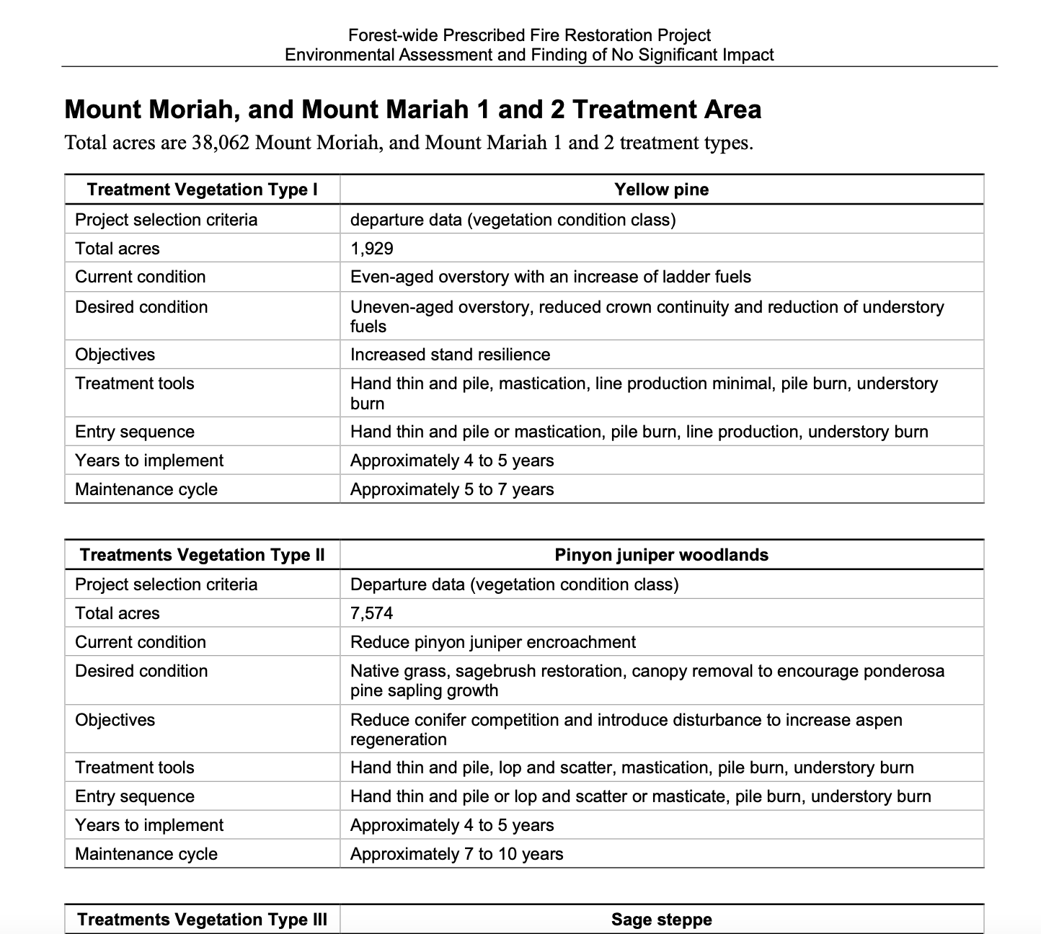
It’s also designed to eradicate sageb rush, too.
No sagebrush community can survive “retreatment” this frequently, either. Note that the HTNF is not only a PJ forest eradication EA, it’s a sagebrush eradication EA, too.
And the HTNF Fire EA also appears to be purposefully eradicating not just PJ and other forested vegetation, but sagebrush too.
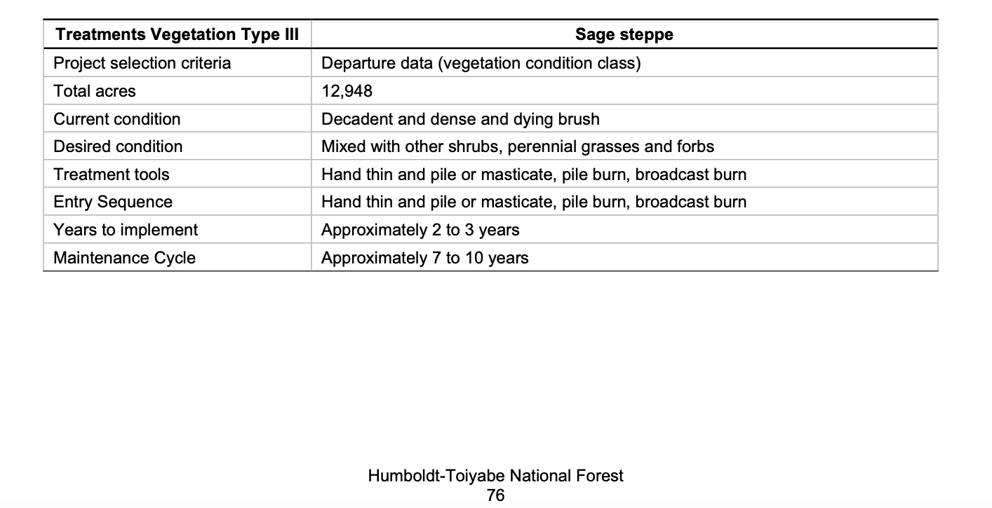

Significant Contraction of Pinyon Pine and other Forest Tree Range Under Climate Stress
Various Great Basin and Nevada region climate assessments such as Comer et al. 2013 had predicted contraction of pinyon pine range under climate stress as temperatures climb. Despite the predicted loss of pinyon pine in many areas, large-scale vegetation manipulation projects have continued, and expanded, with the ready availability of copious federal fire funds across the Great Basin.
See: Comer, P., P. Crist, M. Reid, J. Hak, H. Hamilton, D. Braun, G. Kittel, I. Varley, B. Unnasch, S. Auer, M. Creutzburg, D. Theobald, and L. Kutner. 2013. Central Basin and Range Rapid Ecoregional Assessment Report. Prepared for the U.S. Department of the Interior, Bureau of Land Management. 168 pp + Appendices
Regrettably, Comer et al. p. 45 shows used the flawed “departure” modeling, “Encroachment of pinyon-juniper woodlands into sagebrush or other ecosystems was not a component of the “invasive species” assessment; rather was assessed via fire regime departure and succession class analyses (see detailed methods in Appendix A Section A-1.1.3)”. Though it is not clear how this affected various percent veg cover tables and figures. This would have been based on older models and inputs than a Landfire model today – so one would have to resurrect the version of the modeling used to understand what this was actually based on. Regardless, the point is that the 2013 Comer climate assessment predicted significant problems for pinyon pine.
Comer et al. p. 140: “Looking further upslope, the climate envelope for Great Basin pinyon-juniper woodland is forecasted to retreat northward to some degree …”.
Here is a screenshot of that 2013 mapping showing significant northward contraction expected. This modeling was based on assumptions of less rapid increases in temperatures.
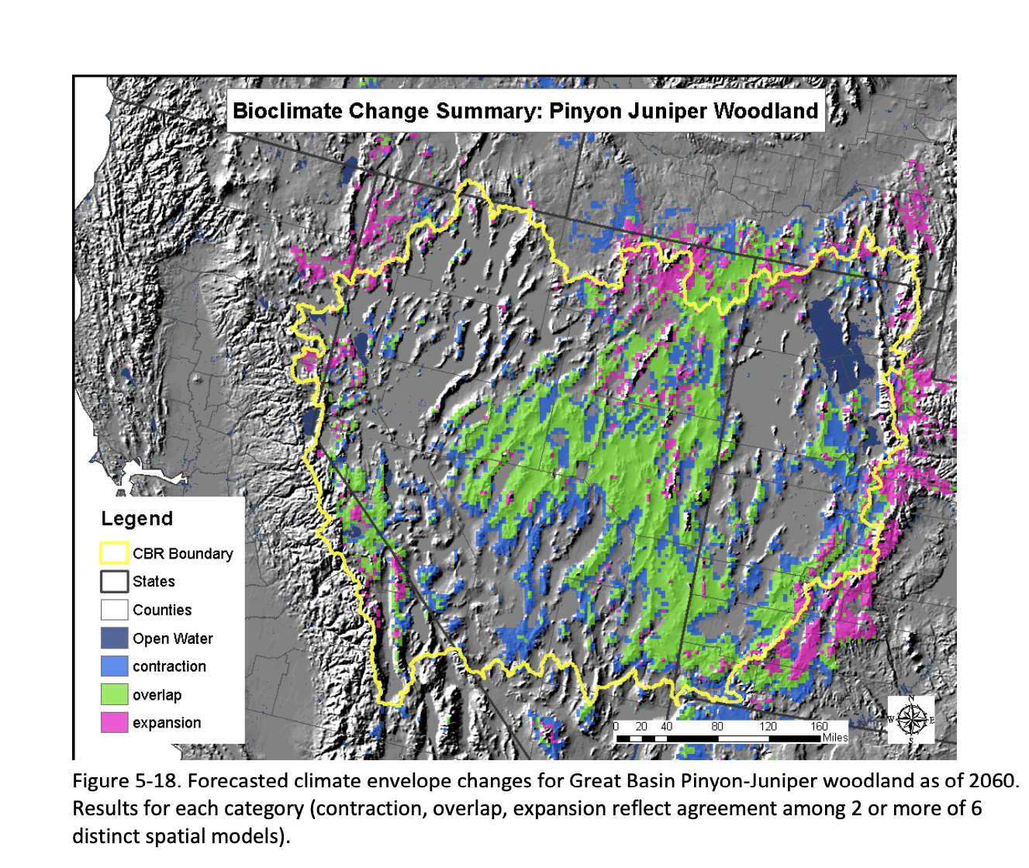
This highlights the need for preservation of existing PJ stands, and the need for a moratorium on PJ killing projects across much - or all - of PJ range in the Great Basin. This is especially the case since the Comer et al. 2013 predictions of potential northward pinyon pine expansion do not take4 into account 1) Vast areas shown in this Figure in northern Nevada and Utah have lost both pinyon and juniper cover, and are increasingly infested with cheatgrass and other flammable annual weeds, due to significant wildfires from the 1990s up to the present. On top of this wildfire loss, Nevada, Utah, and Idaho BLM and the southern Sawtooth Forest have been rapidly wiping out remaining arid forest cover in a series of projects. See Wells BLM O’Neil EA, Sawtooth Forest Fire EA project, Sawtooth Forest Minidoka RD. Fires keep burning through crested wheat seedings and failed grazed fire rehabs, where BLM has continued to densely plant crested wheatgrass combined with large-sized “cultivars” of native grasses in fire rehabs, and spread into forested lands.
The bottom line is that a seed source for recovery and/or “expansion” has already been lost in many areas, due to fire, weeds, and BLM and USFS continued arid forest eradication policies are adding to the fire losses. There also appears to be a risk of reduced habitat in NE Nevada and southern Idaho connectivity for Pinyon Jays as BLM implements its O’Neil and other projects. Not only are the past and potential projects on the southern Sawtooth Forest managed by the Minidoka RD - Goose Creek targeting Utah juniper -there have also been a series of Caribou-Targhee Forest projects in Idaho - including the current Caribou-Targhee Westside RD Lower Portneuf EA that has no clear vegetation community analysis of the forest trees that are present, and many earlier CX projects.
A 2024 paper by Noel et al. predicted significant Pinyon-Juniper community shrinkage in most areas, but said that conditions may be better in the Great Basin. Below we describe both wildfire-caused loss of PJ forests in the Great Basin, as well as some of the recent past, and already authorized or planned, and foreseeable large-scale deforestation and manipulation projects that we are aware of. This is by no means a complete list.
In many areas of PJ forest has burned in wildfires over the past 30 years, and forests haven’t recovered. BLM continued “treatments” in right by these areas to expand loss of forest cover. Often the last remnants patches of forest are being removed in many areas – and the O’Neil project highlights this
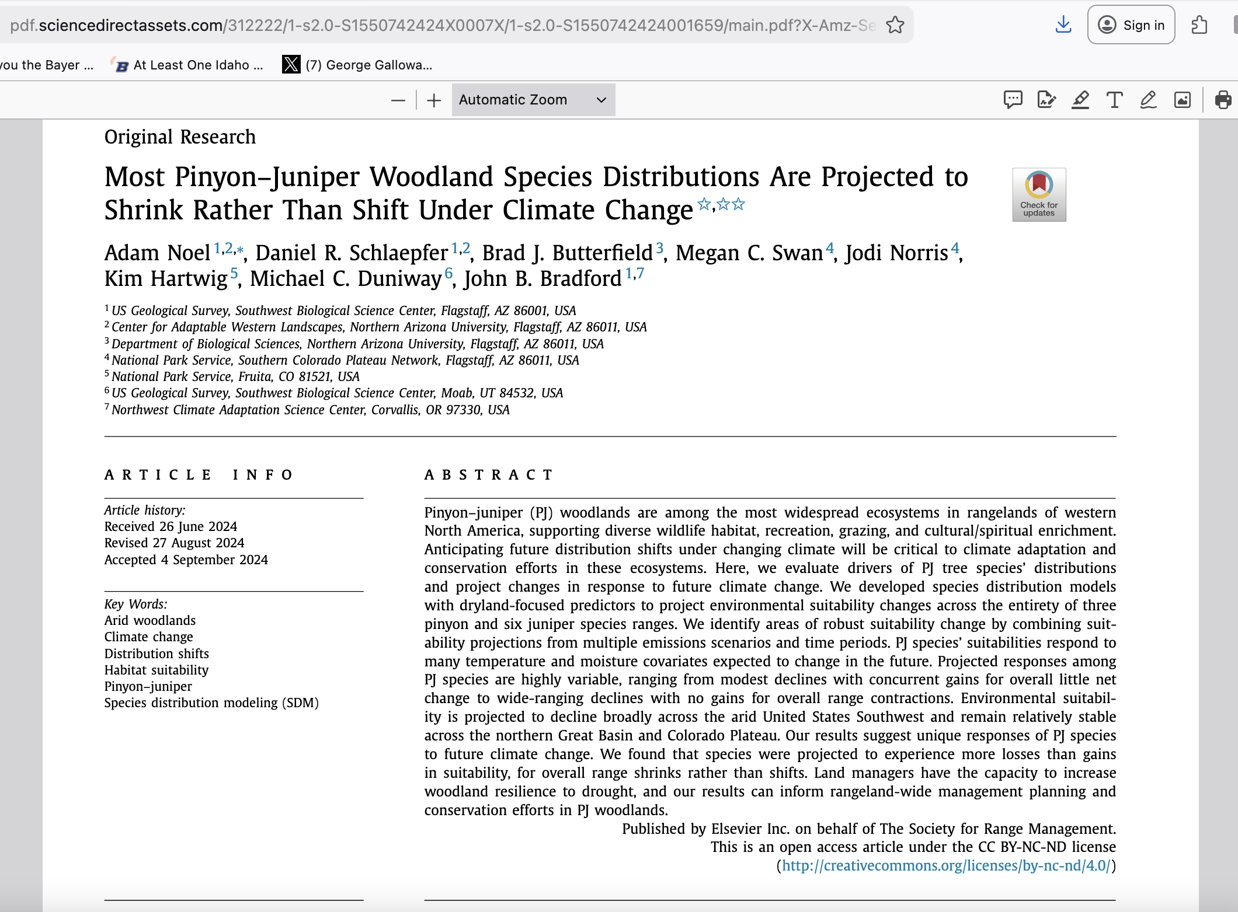
Scale of Existing and Authorized/Proposed Great Basin PJ Forest Loss
The Noel et al, paper ignores the effects of the purposeful agency deforestation and manipulation projects, and/or wild fires, that are decimating the remaining PJ forests across much of the Great Basin – such as the O’Neil project, the continued whittling away at PJ forests on BLM and HTNF lands in the proposed East Humboldt-Soth Ruby Vegetation projects, and the 2025 HTNF Fire EA. This is on top of a large number of past Elko, Ely and some Battle Mountain and Carson City BLM District projects, from around 2010 on, that have been eating away at the forests in the Great Basin.
Pinyon pine has been greatly reduced north of I-80 in Nevada. Note that areas of western Nevada and eastern California (such as the Applegate BLM office, western juniper habitat is being largely eliminated by a huge series of CXs for wood clearcuts, mastication and other manipulation projects – conducted as supposed “Sage-Steppe Restoration”.
Below is a screenshot of Map Figure 6from Somershoe et al.
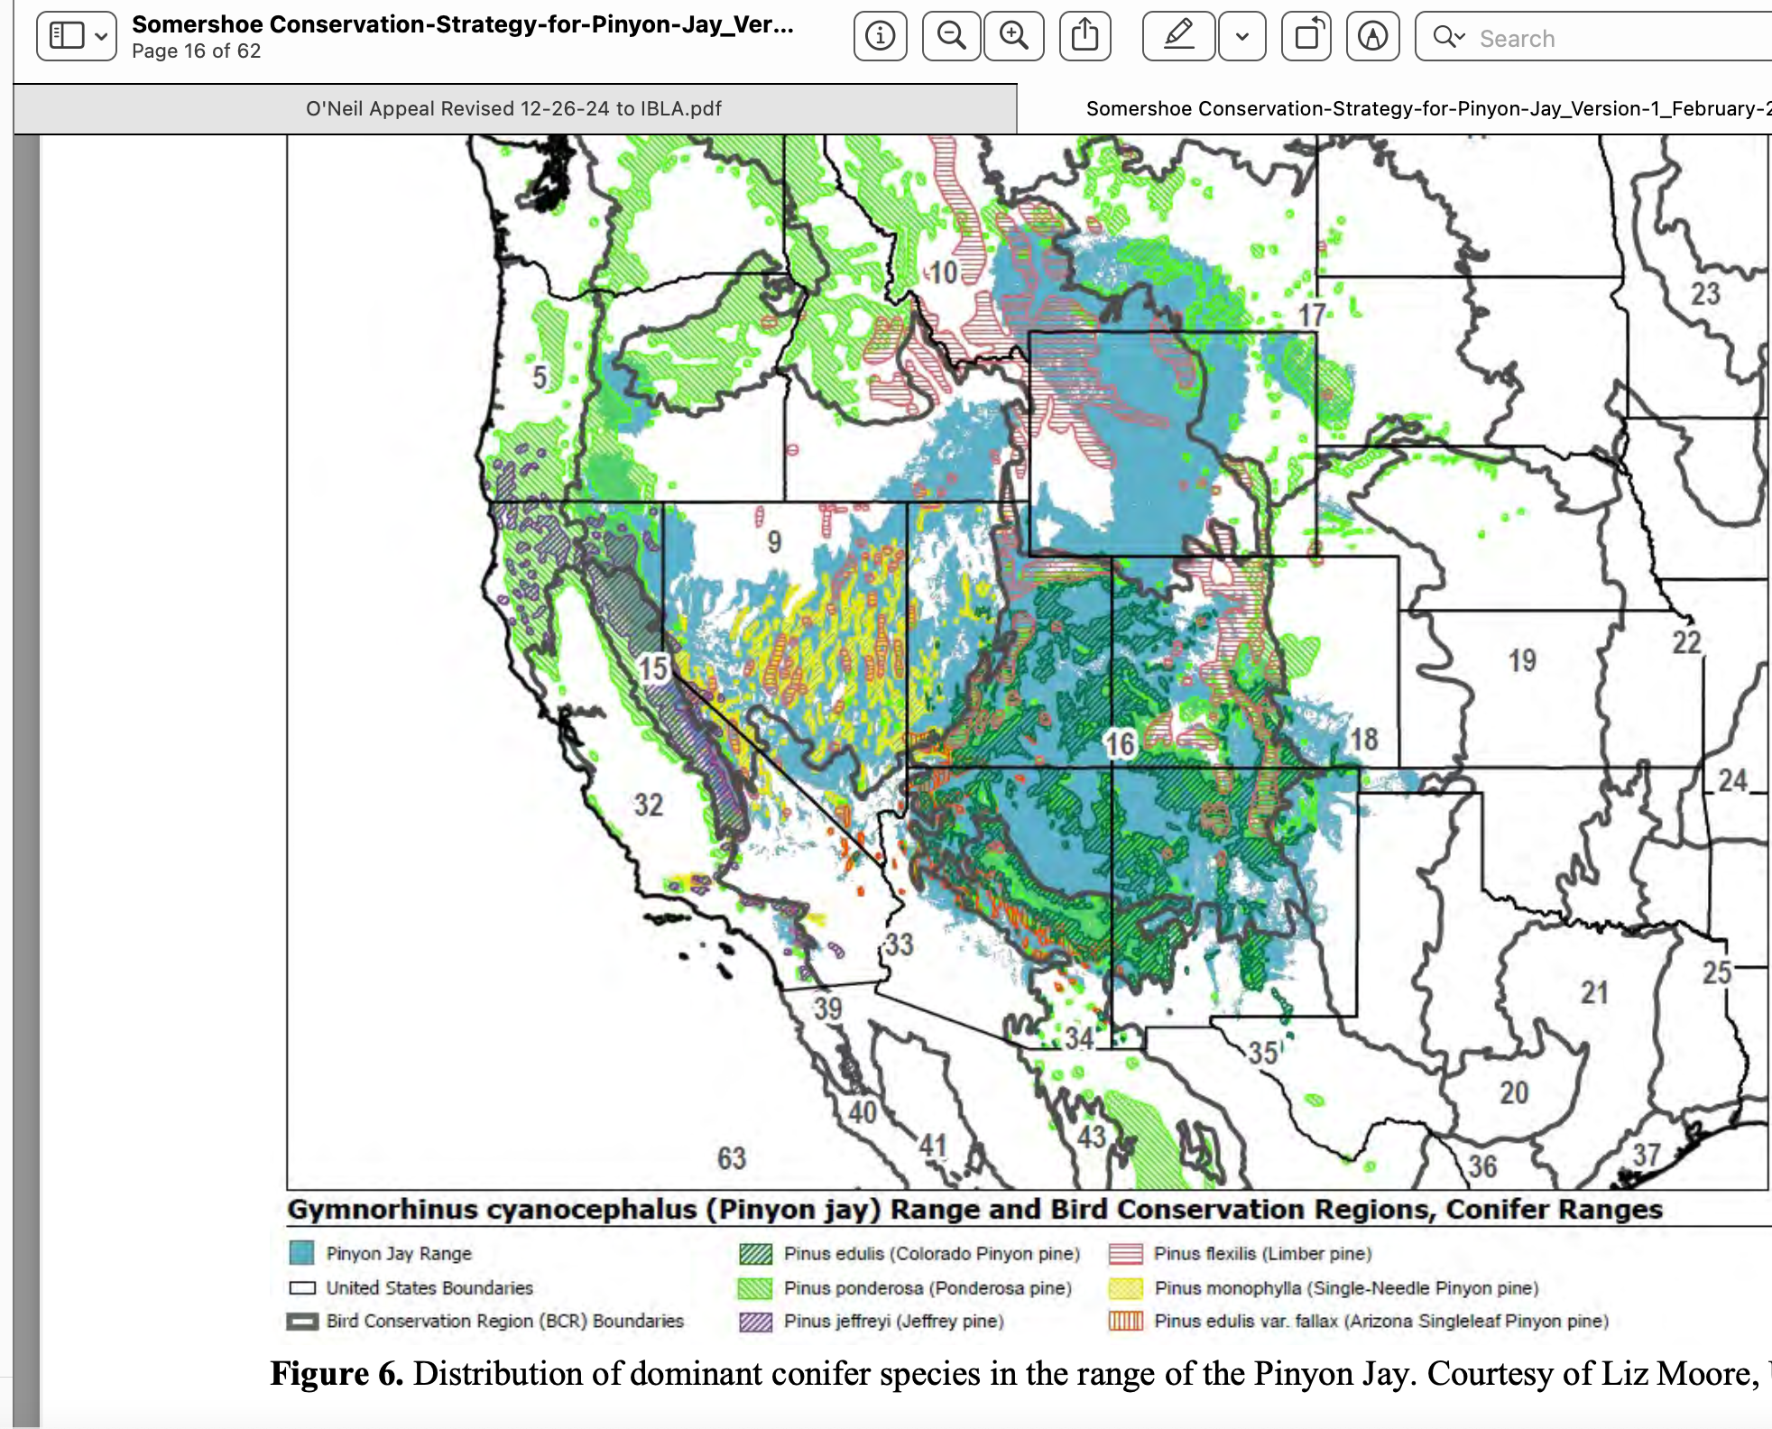

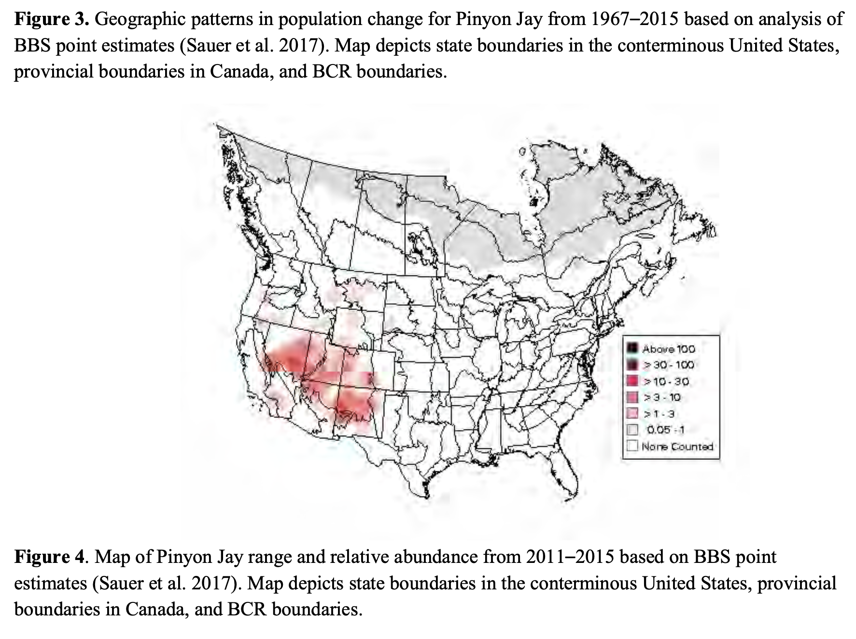
The screenshot of the Figure 4 map from Somershoe shows the low Pinyon Jay population across the northern extent of its range – outside areas where pinyon pine occurs, or is present in any abundance. Areas with already low bird numbers are particularly susceptible to extirpation as forest food sources are incrementally reduced by batteries of “restoration” and logging projects that destroy pine seed producing trees, such as limber pine and Ponderosa pine. For example, here are examples of recent habitat damaging projects in Montana:
Helena-Lewis and Clark Forest wide prescribed fire project.
https://www.fs.usda.gov/r01/helena-lewisclark/projects/63783
Dillon Field Office BLM wide burning project which we are suing to stop.
https://www.blm.gov/press-release/blm-dillon-field-office-completes-programmatic-vegetation-management-environmental .

Here is a rough overview of some (but not all) of the PJ manipulation projects and some threats in the Great Basin region, starting with NE Nevada, where the Somershoe mapping shows already low abundance
O’Neil EA, Winecup EA, Toano CX, and Lithium and other Mining expansion, Fires.
While maps with BLM”s O’Neil project on the surface appear to show limited and patchy deforestation sites, these are often the only locations where with any appreciable PJ forest remains at all. Juniper is dominant in the northern portion of this area. Pinyon still persists in the southern portion, but the project takes aim at those remnant patches. There has already been significant wildfire loss of both pinyon and juniper – including across much of the formerly forested little mountain ranges and ridges in the Winecup-Gamble grazing allotment that largelt lies within the O’Neil project area. An Elko BLM EA for Winecup Ranch owner billionaire Stan Kroenke’s grazing herds also drew a bullseye on the remaining patches of PJ forests in this region.
There is also lithium mining exploration by Surge and claims held by many mining speculators. Private land areas in the Salmon River allotment region where lithium exploration drilling is mow is taking place have just been aggressively chained - with both juniper and sage destroyed. Fite, field obs. fall 2025.
NW Utah. This area is contiguous with Utah BLM lands managed by the Salt Lake District. There has been large-scale “treatment”: of remaining PJ forests, on top of large-scale wildfire loss. On-line sources show BLM using Pheasants Forever as a “pass through” for funding in the northern Utah area to circumvent federal contracting regulations. This appears to be an increasingly widespread tactic by federal agencies. It raises questions about the quality of work, compliance with NEPA project analyses, and with the welfare of the workers including potential human rights abuses. The latter is especially associated with woodcutter crews which are often not US citizens. The Raft River mountain region has also suffered “treatments” – including in various CXs. It’s managed by the southern division of the Sawtooth Forest, which has issued a ROD for an Intermountain Region USFS “cookie cutter Fire EA that includes extensive clearing and burning, and the uses modeling based on much very short fire return/disturbance intervals for forests. The Sawtooth EA claims to avoid pinyon removal, but authorizes burning, cutting, mastication of juniper, limber pine and other potential Pinyon Jay food sources, and prescribed fires can readily spread into areas not intended to be burned.
Just north of I-80, there was a Toano woodcut killing PJ in the Toano Range. Then to the south in Pequops Range a major new gold mine (since shuttered since there’s not enough water) dynamited away PJ habitat.
Since there are WSAs in the Goshute, BLM has not conducted woodcuts and mastication projects, but there have been significant fires in some areas. To the south is the area of one of the initial major Ely BLM “Watershed” deforestation EAs – the North Antelope Watershed EA. This has destroyed and fragmented significant areas of PJ habitat in this little-visited remote landscape, and there also has been significant wildfire.
Also south of I-80 an d Wells Nevada lie Spruce Mountain and Valley Mountain. BLM has been cutting, chaining forests and destroying sagebrush and, planting crested wheatgrass here for 15 years under more recent NEPA, and otherwise destroyjng PJ forests all around the Spruce area in decades past BLM. It has tiered DNAs off an old EA. BLM has also converted large areas of sagebrush, and replaced it with crested wheatgrass or coarse “native” cultivars of grass. That includes what had been the best remaining Pygmy Rabbit habitat in Elko County - according to NDOW biologist Pete Bradley, who got in trouble with his bosses at the time for revealing the impacts to Pygmy Rabbits of Elko veg killing and re-seeding treatments. This reveals how difficult it is for “nongame” species biologists to have a voice in agency vegetation project claimed to be for mule deer and livestock forage.
There may have been an Ely BLM North Spring Valley area EA (am not finding a specific document) that peeled back lower elevation trees on the east side of the North Schell Creek Range. In the north Schell Creek Range, a prescribed fire was ignited by the USFS in late June. The USFS “prescribed fire” predictably blew up and became a large wildfire and burned over the top of the Schell range from west to east, down to the access route in the valley.
There have been many USFS and BLM tree killing projects in the north Schell Creek range area. For example, Duck Creek area has been riddled with PJ killing projects.
On the west side of Highway 93, there were a long series of smaller cheatgrass-producing “treatments” in the Cherry Creek Range in the 2000s and early 2010s. Then these were followed by the Egan-Johnson major deforestation and sage killing project. In addition, there have been some wildfires here.
There have also been various tree killing projects near the BLM/USFS boundary in the North Snake Range, along with PJ wildfire loss in the northern Snake Range all around Mount Moriah outside Wilderness areas, which is threatened by the HTNF Fire EA.
Great Basin National Park has also aggressively burned and “treated” PJ.
Areas on the north side of the southern Snake Range near the BLM-USFS interface have been variously masticated and/or burned, and there are mats of thick cheatgrass. “Leave” tree patches and thinned areas are seeing significant tree mortality following this manipulation.
To the south in South Spring Valley there were numerous past large-scale chainings and other PJ manipulation/eradication projects around the base of the Fortification Range. The old chaining areas run south – and appear to overlap the Ely BLM South Spring Valley-Hamlin massive PJ and sage kill treatments.
More recently, Ely BLM finalized the immense South Spring Valley-Hamlin Watershed EA.
https://eplanning.blm.gov/Project-Home/?id=ea0d08bf-a7f2-f011-8407-001dd806295a
https://www.biologicaldiversity.org/species/birds/greater_sage_grouse/pdfs/South-Spring-Valley-and-Hamlin-Valley-Watershed-Restoration-Plan-Complaint.pdf
“BLM’s EA states that any of these so-called “treatments” could occur anywhere within the 384,414-acre project area, and that some areas may be subject to multiple “treatments” (e.g., hand-cutting of pinyon-juniper combined with Dixie Harrow to eliminate sagebrush and herbicide application)”. This project extends east to the Utah border, and includes portions of the Wilson Creek allotment, where a separate EA was authorized by Ely BLM. BLM allowed permittees to write alternatives and adopted the cattle permittee alternative almost entirely. The adopted cattlemen alternative includes vast areas of PJ deforestation and sagebrush killing.
There are already chainings, wood cuts an d b urn projects that have been conducted since 2002 or so in the Wilson Creek allotment area, and the Wilson Creek grazing EA major projects would be conducted in addition to this.
A significant portion of the Fortification Range on the west side burned in a wildfire. On the west side of the Fortification is the eastern edge of the major Ely BLM Cave Valley and Lake Valley Watersheds Restoration EA. That project extends north almost to the area of Cattle Camp Wash and South Steptoe Watershed EAs, where there have been a series of earlier smaller PJ and sagebrush killing projects. The Cave-Lake EA includes pretty much all forms of PJ killing, including proposed extensive “prescribed” burning. The appeal project record shows the major deforestation projects were heartily promoted by the SNWA Ranch Manager – because it would make it easier to move domestic sheep herds around in the south Egan Range. This and so many other PJ deforestation projects cannot be separated from the desires of the public lands cattle and sheep industry. https://eplanning.blm.gov/Project-Home/?id=1350bc81-a7f2-f011-8407-001dd80c29f3
In lands south of Carlin – the Pinion Range (now largely pinyon-less less) and Sulphur Springs Ranges east of Highway 278 have experienced large-scale fires from circa the early-mid 2000s.
The South Ruby area on both BLM and USFS lands has been subjected to a long series of PJ forest and sage manipulation EAs since 2010 or so. Now the HTNF has a sprawling new East Humboldt-South Ruby (EHSR) project (separate from its 4 million acre “Condition Based Management” Fire EA) that will destroy many remaining areas of PJ forest. There’s already been large-scale loss of PJ on the west side of the Ruby Mountains, as well as portions of the east side readily visible from the County road running from north of Ruby marsh south to the Bald Mountain mine. There has been both wildfire loss of PJ forest in area around Harrison Pass, as well as non-stop cutting of PJ all along the eastern face of the Ruby Mountains extending south to Overland Pass. The immense Kinross Bald Mountain gold mine is devouring Pinyon-Juniper forest with no mitigation.
Then, from the Bald Mountain mine south is the Ely BLM Long and Ruby Valleys Watershed EA project. https://eplanning.blm.gov/Project-Home/?id=a5f814ad-a7f2-f011-8407-001dd806295a
There is overlap between the Long and Ruby Valley EA and areas proposed for deforestation and/or sagebrush killing for the Uhalde sheep and cattle grazing operation. The Bald Mountain mine has a huge and ever-growing footprint in this region, and large amounts of unmitigated new PJ habitat destruction is taking place. This lack of mitigation for PJ destruction habitat destruction from mines, transmission lines, geothermal projects, soon industrial solar projects, is made even worse, because the Nevada Sagebrush Ecosystem Council sacrifices PJ habitat as supposed “mitigation credits” for impacts to Sage-grouse habitat. The Nevada state Sagebrush Ecosystem Council credit system is a threat to Pinyon Jays and PJ forests.
The Ely BLM proposed Uhalde grazing EA project is located south of the Bald Mountain mine and extends south of Highway 50 too. It overlaps portions of the Long and Ruby project, yet includes additional large-scale PJ and sage brush killing projects for livestock forage purposes. It includes the area of the path of Greenlink, and is also by the solar lease areas of Jake’s Valley. See also discussion of 2025 Solar EIS, with 11 million acres of Nevada allocated for industrial solar development (discussed below). The Uhalde project, like Wilson Creek, Cave and Lake Valley and other Ely BLM projects, exposes the continuing link between BLM PJ killing and eradication projects, and efforts to eke out more livestock forage on public lands, especially in areas here livestock have depleted understories.
BLM Solar EIS site, withy 11 million acres of Nevada public lands allocated for potential industrial solar development under the Record of Decision.
Greenlink transmission line that will development full bore solar and other exploitation of Nevada sage, salt desert shrub, and PJ habitats: : https://www.blm.gov/announcement/blm-issues-final-proposed-plan-greenlink-north-transmission-project .
Now in 2026, BLM announced there will be a new brief comment period: https://eplanning.blm.gov/Project-Home/?id=748efbca-a7f2-f011-8407-001dd806295a . This very likely may be because the BLM Nevada Sage-grouse EIS for Nevada has now been modified, and weakened. This will make it easier for BLM to push Greenlink through by weakening potential legal challenges. This appears to be the reason for the BLM doing an updated analysis.
NOTE that rumor now has it that the northern leg of OnLine transmission line (SWIP North) is imminently to be built – under a 1990s EIS. This ill open up vast areas of NE Nevada from industrial “renewable” energy exploitation between Ely area and the Idaho line, impacting PJ habitats. Also, the ROD was recently signed for the Cross-tie transmission project impacting areas of eastern Nevada and western Utah.
Just to the south of Highway 50 in the landscape facing potential major industrial energy development if Greenlink is authorized is the Illipah area in the northern edge of the White Pine Range. Here, Ely BLM recently issued a decision for more PJ deforestation around the base of the White Pine Range, on top of a considerable area of past PJ killing “treatments” at the BLM-FS interface. SNPLMA funding is part of this.
Link to Ely BLM’s recent Illipah project: https://eplanning.blm.gov/Project-Home/?id=473135e9-a7f2-f011-8407-001dd803d7d3
The Illipah project adds to the planned additional deforestation in the landscape impacted by the contentious Greenlink North transmission line that will pave the way for massive development of industrial solar, geothermal and other “green energy” projects on public lands in central Nevada. While industrial solar development will likely be focused primarily on sagebrush habitats, lower elevation PJ forests and sage habitats used by Pinyon Jay will be impacted as well. Greenlink North, if built, is certain to lead to very significant expanded loss and fragmentation due to access routes connecting powerlines and other developments.
Huge sums of SNPLMA funding were used for planning the South Spring Valley-Hamlin watershed project, and many other significant deforestation projects. We are attaching just a few records of this, and have not had time to examine SNPLMA reports. Funds from the sale of BLM land in Clark County Nevada under Harry Reid’s Clark county legislation of the late 1990s are supposed to be used for conservation. What SNPLMA funds have long been used for in recent years is federal agency plotting/planning major PJ deforestation projects, helping drive Pinyon Jays and other PJ forest dependent species towards extinction.
See for example: https://www.blm.gov/sites/blm.gov/files/docs/2022-05/SNPLMA%20Round%2019%20ENLRP%20Nominations_0.pdf
“Southern Nevada Public Land Management Act Eastern Nevada Landscape Restoration Project Round 19”, South Spring Valley and Hamlin Valley Watershed Restoration Implementation Amount Requested: $3,072,000.
This is just the tip of the iceberg. We request that USFWS determine how much SNPLMA funding has facilitated reduction of PJ forest cover in Nevada, including to BLM/USFS directly, or through the eastern Nevada Landscape Coalition, or other parties. We have not had time to compile that information. As with the state of Nevada state Sagebrush Ecosystem Council (SEC), whose development was heavily influenced by mining and ranching interests, the SNPLMA “conservation” funds have been used to destroy PJ forest. We again emphasize there is an extreme bias against protection if PJ forests that is part of western land grant school range and natural resources Department and federal and state agency culture that results in treatment of PJ forests as sacrifice zones for development and a throwaway landscape. If the Pinyon Jay is to survive, a sea change in on the ground management must take place, and the bias in management must be openly described and exposed.
There has been significant wildfire-caused sage and PJ forest loss in areas on the west side of the White Pine Range. To the east, by Ward Mountain, there is of course the Robinson Mine and its ancillary facilities, roading, etc. devouring PJ habitat, and a recent series of PJ treatments show up on the Reshape TWIG viewer site. We are not certain what NEPA project they are part of. The Ward Mountain area BLMN and USFS lands have long been targeted by federal agencies for deforestation, under claims of invasion, encroachment, fuel reduction. The agencies are in denial of the history of deforestation in the region with the 1800s mining boom and other development, as shown by the Ward Charcoal Oven site.
In the White Pine Range, there have been both past PJ chainsaw cutting, mastication and pile burning projects as well as considerable burning by the Ely USFS. Examples; lands on the east side of the range, extending south towards Currant and Highway 6.
Also under the USFS Ely RD, portions of the north Quinn Range burned (2000s). The USFS followed that up with significant prescribed burning in the Quinn Range, I can’t recall the name of the project the new burns were done under.
There have also been significant deforestation projects in the Battle Mountain BLM District lands. Less PJ forest has been destroyed and/or targeted for destruction than the Ely District. One project was the circa 2010 Antelope Range project south of Eureka – here PJ killing continued a decade or more after the decision, and may still be occurring. This is the case with nearly all the larger projects, such as the series of Ely BLM Watershed Assessments – it is unclear if any of these sprawling projects have been completed, or if BLM and the USFS can use projects authorized a decade or longer ago to continue to “treat” PJ forests. We request USFWS investigate this, and ask BLM and the USFS to compile a comprehensive list and accounting of authorized projects where PJ manipulation is still occurring and more is foreseeable.
The 3 Bars Project included lands in the Simpson Park and adjacent Ranges, and the area around Roberts Mountain north of Eureka, targeted for decades by mining companies who are running up against a lack of water in the ever-more desertified/aridified and desiccated Great Basin. The region is facing large-scale depletion of both ground and surface waters in many areas. To the north, there’s been large-scale fire loss and huge gold mines devastating landscapes. We do not have sufficient time to discuss the full footprint of mining across much of northern and central Nevada – please see attached comments on the Golden Eagle take permits for the Phoenix and Cortez mines that discuss some of the huge impacts of nearly always foreign-owned mega-mines in Nevada, man y of them impacting PJ habitats – active mines sites, exploration projects, roads accessing sites, powerlines and even “mitigation” (the NV SEC) that sacrifices PJ communities as mitigation for Sage-grouse mini nig-caused harms.
The usual invasion/encroachments/weeds arguments were made about the Battle Mountain Antelope project and 3 Bars project Roberts Mountain area trees. This all ignored historical research that had found PJ had been denuded for 50 miles around Eureka during the 1800s mining boom.
Across much of this landscape, gold mining, and increasingly other forms of mining, are a major threat to biodiversity. There are dozens of hard rock mines in Nevada, and. many have impacts interfacing with PJ communities. Exploratory drilling is rampant. Mine claims occur all over both PJ forest and sage habitats.
Under antiquated BLM mining regulations, exploration drilling and road building under 5 acres of “disturbance” can take place with no environmental review – and a new “exploration” road could be bulldozed right through ha Pinyon Jay nesting colony site, or drill pads could be bulldozed in its midst. BLM defines disturbance as outright removal or destruction of vegetation. So 5 acres of mining disturbance can fragment, and in real world terms disturb vast areas. The effects of habitat fragmentation disturbance, and loss - including things like bulldozer or chainsaw injuries to trees attracting insects that infest surrounding live trees can occur and of course are not accounted for in the BLM definition of “disturbance”. BLM analysis at the level of an EA may encompass hundreds of acres of exploration disturbance. This in reality is an enormous habitat degradation and fragmentation footprint. Extensive soil disturbance often results in infestation, and expansion of flammable exotic weeds. “Improvements” often occur to access routes and these are often not effectively accounted for in agency tallies of “disturbance”.
Further since Pinyon Jays nest so early, typical agency migratory bird avoidance periods do not effectively protect Pinyon Jay habitat This is the case
In addition, agency deforestation project migratory bird avoidance periods, and indeed nearly all supposed wildlife habitat protections used as supposed minimization and mitigation measures in BLM PJ and sage manipulation plans do not have mandatory binding language and waivers of all kinds are allowed. This includes minimal and deficient in-front-of-the-bulldozer “surveys”., And nesting areas can be readily destroyed by mining, energy development and other activity outside nesting periods.
This is very much increasingly the case with PJ deforestation and other vegetation manipulation projects. Moreover, even if a nesting colony or nest sites are “avoided”, setting fire to PJ forest in the vicinity can result in dense smoke drifting in and enveloping nest sites. This may harm, weaken or even cause mortality of nestlings, and/or adult birds if they stay in nests. BLM and USFS completely ignore the very significant susceptibility of birds to smoke inhalation, due to anatomical differences. It is highly unnatural for PJ forests and adjacent sage or other vegetation to burn in late winter and spring – yet many vegetation manipulation projects conduct burning in that time period – including broadcast burns, or long-smoldering pile burns, and other intentional fire activity. This not only risks outright immediate take of nests, eggs, chicks, and disruption of breeding behavior – it may injure or kill birds through smoke drift into unburned areas.
See for example, https://academic.oup.com/auk/article/141/4/ukae023/7686085
“Wildfire smoke impacts the body condition and capture rates of birds in California Anna Nihei, Olivia V Sanderfoot, Katie LaBarbera, Morgan W Tingley. Ornithology, Volume 141, Issue 4, 1 October 2024, ukae023, https://doi.org/10.1093/ornithology/ukae023 . Note literature citations showing human and animal smoke effects.
“Across all study species, we found a negative effect of acute PM_{2.5} exposure and a positive effect of chronic PM_{2.5} exposure on avian capture rates. Together, these findings are indicative of decreased bird activity or local site removal during acute periods of wildfire smoke, but increased activity or site colonization under chronic smoke conditions. Importantly, we also observed a negative relationship between chronic PM_{2.5}exposure and body mass change in individuals with multiple captures per season. Our results indicate that wildfire smoke likely influences the health and behavior of birds, ultimately contributing to a shift in activity and body condition, with differential short-term versus long-term impacts. Although more research is needed on the mechanisms driving these observed changes in bird health and behavior, as well as validation of these relationships in more areas, our results suggest that wildfire smoke is a potentially frequent large-scale environmental stressor to birds that deserves increasing attention and recognition”.
We stress that prescribed burning is being conducted in a highly unnatural seasonal time period for avian exposure to fire – when nestlings may be present, and adults incubating eggs or expending a lot of energy feeding young. Agency prescribed burns may drag out over several weeks, and smoke drift and accumulate in various ways depending on weather, predominant wind direction, topography (where does smoke settle into overnight, or in mornings, for example?) and other interacting site conditions. Agency burning methods may also impact smoke production. Thus, merely temporarily avoiding burning up a PJ nest colony site by a short distance, yet going ahead and still burning in a landscape area near a nest site may injure or “take” Pinyon Jays and many other birds.
The loose and non-mandatory language in nearly all agency vegetation manipulation documents in the Great Basin these days allows for forest species nest site areas to be deforested in various ways - outside nesting seasons.
Monitor-Toquima -Hot Creek USFS landscape. This is one region of Nevada that has experienced fewer wildfires, and fewer treatments, even though there have been some in the Austin-Tonopah RD. A Savory b urning project on USFS lands just south of the Antelope Range BLM project, and Indian Springs project and others we cannot find records of. Predictably, because there are maturing, mature and old growth PJ forests here, the HTNF Fire EA targets vast areas of this less-disturbed and fragmented forest. The HTNF EA finds nearly the entire area of these mountain ranges outside Wilderness in categories needing “treatment” (“moderate to high departure” from the contrived modeling ideal.
We are very concerned that the HTNF appears to be gearing up for massive PJ deforestation and other “treatments” in the Monitor-Toquima-Hot Creek landscape. A separate HTNF Monitor-Toquima EA re-issued one of the old Sagebrush Rebel Wayne Hage allotment permits (Pine Valley) to the current owner of the Pine Creek Ranch. Germane to the Pinyon Jay data call, the HTNF Monitor-Toquima EA converted 5 vacant old Hage allotments to “forage reserves” for grazing use in the event of fire. This appears to be the Forest service staging for a place to put livestock displaced by massive “treatments” under the HTNF Fire EA, especially deforestation projects in this one area of Nevada that is doing just fine without “treatments”.
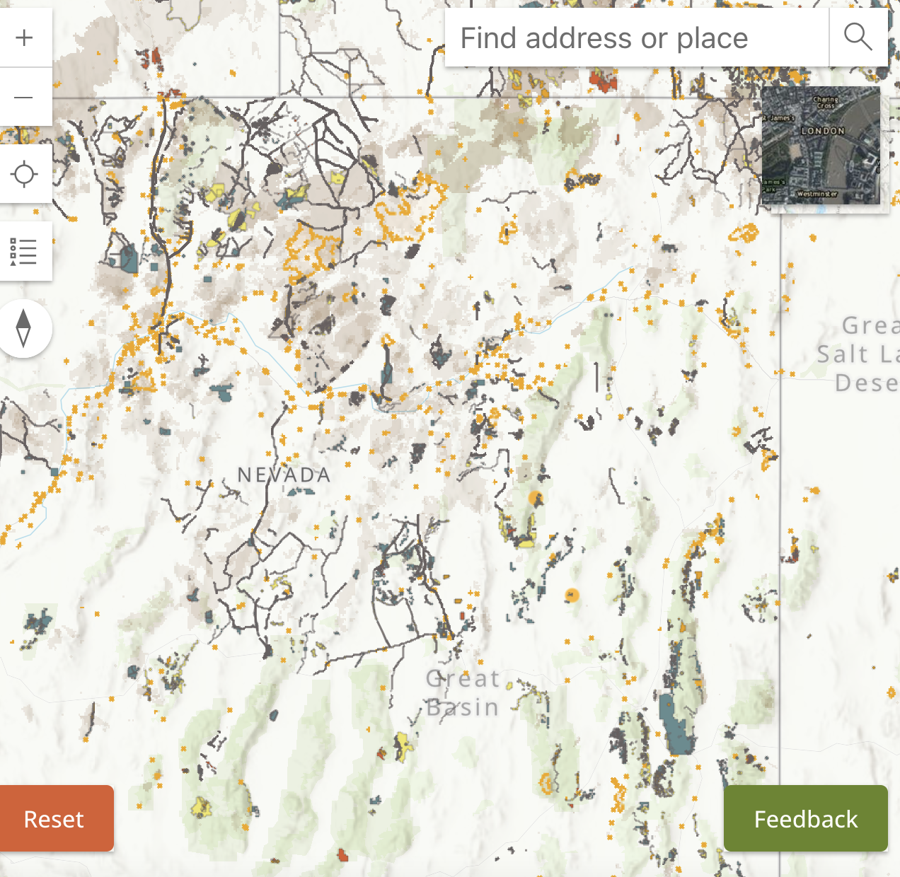
The above map is from Reshape Twig viewer. Look at all the veg manipulation projects (and wild fires just to the north (though barely visible in pale tan) in much of Nevada -vs. the lack of treatments and lack fires in the lower LEFT of the map – which is the Monitor-Toquima Hot Creek Ranges country. One might well wonder if all the past agency “treatments” and ubiquitous post treatment grass seedings, have accelerated wildlife habitat loss.
The HTNF Fire EA finds nearly all areas that haven’t burned in recent fires or been “treated” to the max to be departed, uncharacteristic, and be subjected to potential burning, mastication and chainsaw “treatments” under a loose, uncertain Condition-Based Management (CBM) scheme - with PJ and sagebrush killing projects potentially occurring across these sites over the next 15 or more years, and no site-specific analysis, with decisions made out of the public eye behind closed doors.
There have been many. PJ deforestation projects, and. any wildfires, in Carson City BLM District lands – ranging from the Desatoya project to the Pine Nut range and beyond. We do not have the documents for many of these, and request USFWS assemble them from BLM.
Also, there have been many projects near Bodie, Aurora and other areas of eastern California in the range of Bi-state Sage-grouse, where BLM and the Bridgeport RD of the HTNF have been particularly aggressive in destroying native arid forests here. We do not have many of the documents, and request that USFWS assemble and review those, too to determine how much current and foreseeable PJ habitat loss, destruction and fragmentation may take place in this very important PJ and sage habitat landscape.
The Noel paper we discussed above and its speculation about Pinyon Jays in the Great Basin area forests faring the better under climate stress, is very likely greatly over-optimistic and contradicted by the evidence of ongoing massive manipulation being massively applied – as well as looming industrial energy, transmission line and ever-expanding mining disturbance. In fact, if one were to look at forest cover across the Great Basin in nearly all areas, taking into account wildfires over the past 30 years, one can see forest cover has been substantially reduced and lost altogether in some areas.
Further, since Nevada contains a very significant proportion of the remaining Pinyon Jay population, the myriad projects that are already authorized to destroy vast areas of PJ forest habitat pose an immense threat to this species.
Agency Mapping of Past Treatments and Planned Treatments/Authorized Project Sites Not Yet Completed
The Reshape Twig viewer site is accessible here (works on Firefox, but not Safari):
https://reshapewildfire.org/twig/search
There are a shocking number of more recent “treatments”. It’s unclear how far back in time the “treatments” go. There may be some differences in how thorough information is for various B:M offices for “treatments”. Fires seems much more consistent.

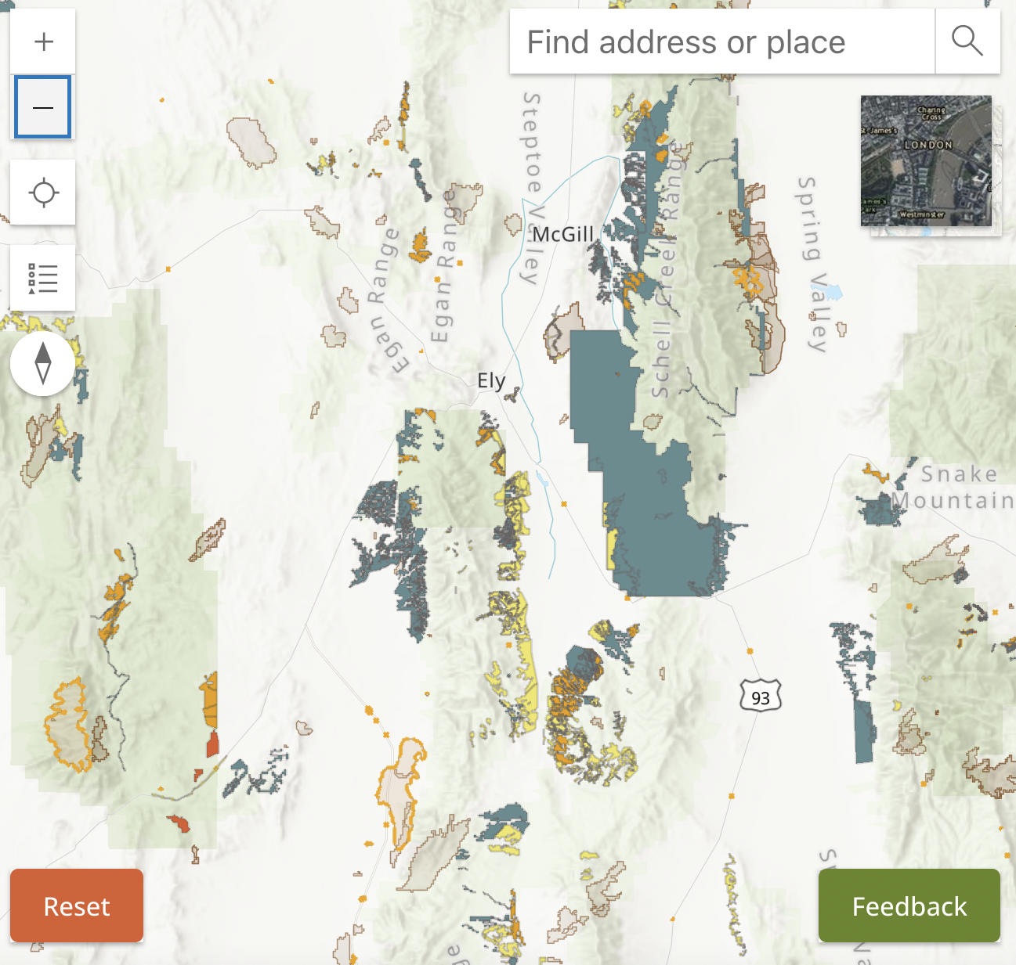
This shows how Ely BLM, at times combined with the Forest Service, has been inflicting major deforestation projects on low-mid-elevation PJ forest sites. These are often the deeper soil most “productive” sites for trees – and thus are coveted for cattle forage grass. The trees are pretty much being wiped out here. Little leave patches or stringers of a “mosaicked” or “feathered” forest are subject to increased mortality as a result of insects/diseases fostered by sap and tree injuries from “treatments”, as well as the alteration of the surrounding forest micro-sites making lands hotter, drier, windier and weedier. The BLM and USFS are actually creating more fire prone landscapes, threatening the persistence of the still-“untreated” forest and sage sites. USFWS must take a hard, science-based look at the ever growing body of ecological science that contradicts “natural resources” fire dogma, as well as common sense observations (for example, how much hotter are soil temperatures in “thinned” forest than dense forest, and how flammable are PJ forests vs. sage. Vs. grass? PJ forests are actually the least likely to burn, and typically burn only under extreme weather conditions (climate driven mega-fires) – when anything will ignite.
The USFWS must also recognize the threat to PJ forest persistence of the growth of what is best described as a “treatment-industrial complex”, with contractors and many agency staff dependent on pumping out more and mo0re vegetation manipulation projects that impact remaining PJ forests. Since around the time of the Bush “Healthy Forests Initiative”, treatments have been much better funded and favored in agencies than other management activities. Just look at the 2025 fall shut down, when BLM continued with its PJ deforestation and other vegetation manipulation projects,
This is resulting in ever-shrinking forest habitat in the Great Basin and other regions, and creating conditions more conducive for frequent fires. The lower to mid elevation sites are also the areas that would be under greater stress from climate change’s hotter temperature stress.
Note that a recent Nevada college study conducted at Topaz Lake near the California border found that pinyon pine on west facing slopes was more vulnerable to forest insect pests and diseases than trees on east faces. Of course, west faces would be hotter and harsher sites. By creating hotter sites, BLM/FS thinning, burning and other “treatments” are causing a proliferation of hotter, harsher and drier sites in “treated” forest areas, and forest insects/diseases may spread into remaining “untreated” sites.
Here is a link to the Topaz Lake Story map with the research project information:
https://storymaps.arcgis.com/stories/5565df4c2b124b2182ad83f282177afb
Pejorative Language
Agencies attempt to make deforestation treatments sound better by using terms like “feathering” treatments. The feathering still means a loss of forest cover, and a more extensive area of remaining subject to insects/diseases due to deforestation. BLM/USFS have long used the term “mosaic” to try to make these project sound less harmful and harsh. A mosaic “treatment” equates to forest habitat fragmentation. Do Pinyon Jays really “need” more open areas?
The claim that this all is better for the birds, reminds us of the claims some BLM offices (like Ely BLM) have made about Sage-grouse benefiting from sagebrush clearing “treatments”, by saying “Sage-grouse need open areas for leks, so we are making more potential leks sites. There appears to be no concern for the added stresses of hotter temperature and climate change and the harmful insect/pest and “edge” effects of the various forms of deforestation fragmentation being imposed to existing PJ forests.

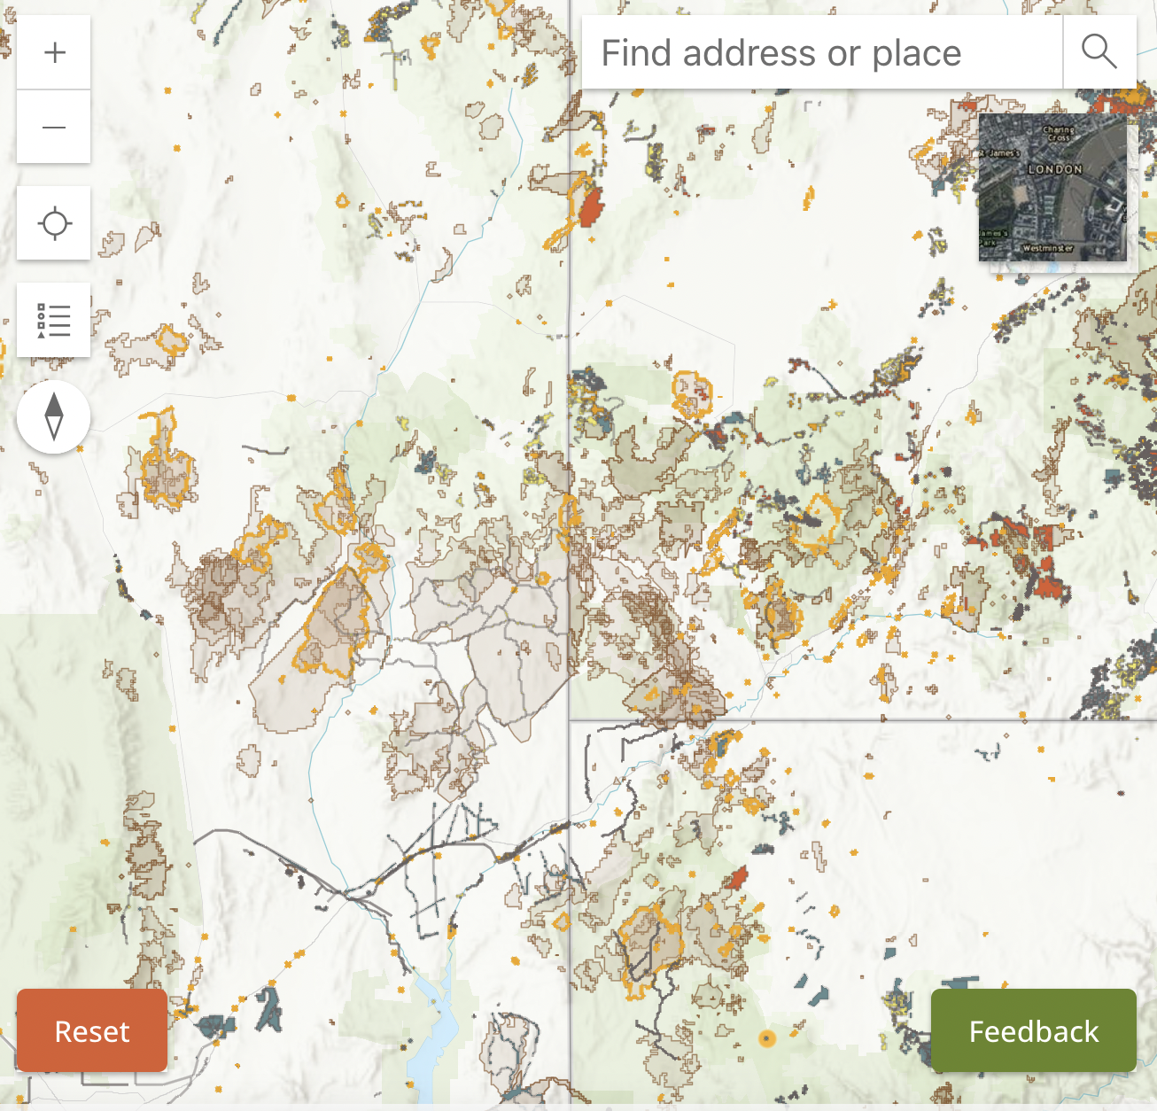
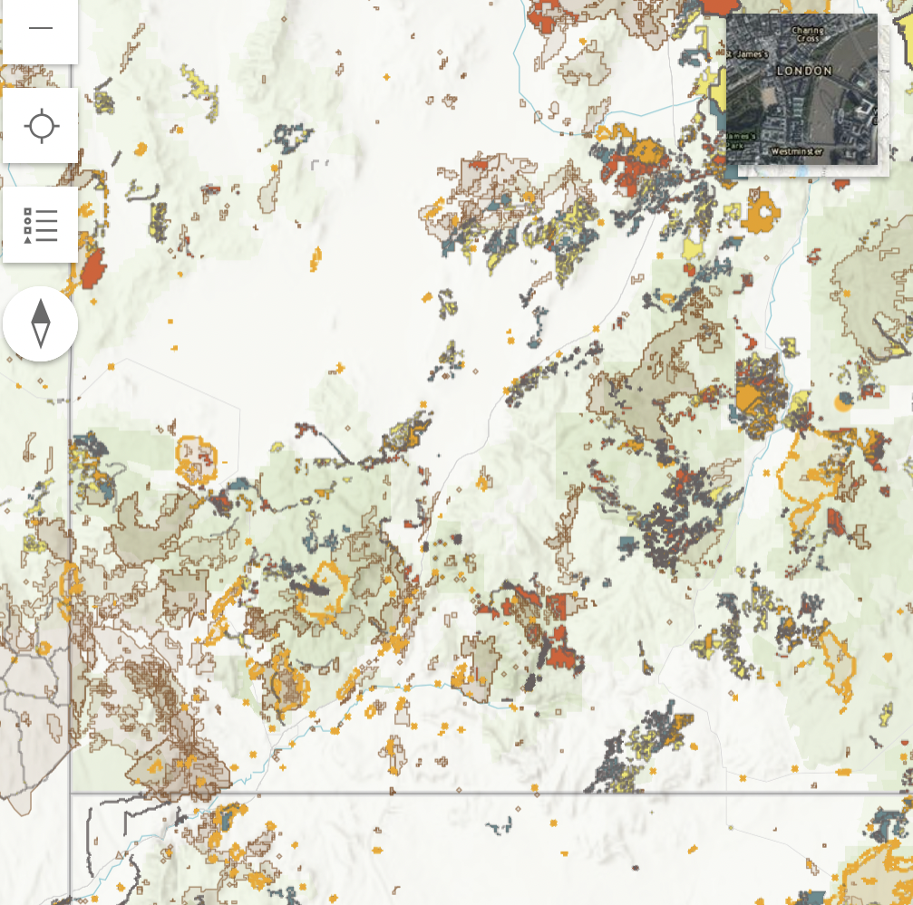
This is a ReShape twig viewer map of SW Utah. It shows many fires, and many treatments. Note that the mid-2025 approved pine Valley Dixie Forest project’s proposed deforestation and “treatments” are not yet mapped here.
In addition, the Dixie Forest has adopted an Intermountain USFS region cookie cutter Fire EA that authorizes large-scale prescribed burning, often accompanied by mastication and chainsawing across this landscape – on top of the host of projects shown on Dixie Forest lands to the east of Pine Valley on this map, and that are included in the Boulder Mountain (part on Fishlake), Hungry and other projects\.
Here is a bit larger scale map showing vast “treatments” extending north into portions of Fishlake and more of the Dixie forest.
Above ReShape site map is of the Nevada-Utah-Arizona border, Look at all the wildfire and treatments. Note: This does NOT show the PLANNED large-scale new Dixie Forest “treatments” that are part of Utah’s Dixie Forest Pine Valley EA.
And just to the north on BLM lands the Cedar City BLM Hamlin project has been proposed, based on a TNC modeling report based on very large-scale manipulation, lots of herbicide use, chaining, cutting, burning, etc. that predictably finds vast areas in need of large-scale vegetation manipulation. This is described in our attached comments on that BLM project, along with the project’s lack of clarity about what the current vegetation cover community actually is, vs. what the models say it is, and what is shown on maps. TNC modeling “forecasting” has been used in much of this existing, proposed and planned vegetation manipulation. That modeling ends up with results just like the same old 1960s style PJ chaining, chainsaw cuts and other tree killing which used to be plainly described as livestock forage projects.
Having only been aware of the data call for a week, we haven’t had time to delve into the massive number of PJ manipulation projects in Utah that have been funded – at least in some part – by the Utah Watersheds Restoration Initiative. See https://watershed.utah.gov . USFWS must track the large-scale loss of PJ forest that has resulted from this program.
Likely Consequences of Agencies Continuing to Greenlight PJ Deforestation/Thinning/ Burning Projects, and Treat PJ Forests as a Throwaway landscape
Forest “thinning” and other treatments make lands hotter, drier, windier, weedier – more fire prone - and this all works against PJ forest recovery on sites. They prolong the fire season because sites dry out earlier,
PJ is the more fire resistant than sagebrush, and far more fire resistant than grass. Given that temperatures have been increasing more rapidly than predicted under climate change stress back when the Comer et al. Central Great Basin climate document was prepared, the situation for Pinyon Pine, and arid forests in general, appears even more dire.
Continuing with PJ “treatments” will likely result in long-term and very likely irreversible ecological impacts of more frequent fires, and ever-dwindling Pinyon Jay populations.
Pinyon pines typically begin producing seed cones around 25-35 years of age. Significant, large-scale nut production generally does not occur until the trees are 75 to 100 years old. Once trees are established, it takes approximately 2-3 years for cones to mature, with good seed crops occurring every 2-7 years. See: https://www.fs.usda.gov/rm/pubs_rm/rm_gtr258/rm_gtr258_191_197.pdf
The best recent mapping source we have found to understand the extent and footprint of recent PJ killing projects in the past 15-20 years is the Twig viewer ReShape site, but some agency office information may not be complete.
There is now a NIFC website of PJ treatments and fires, but it only has information from 2020. This mapping shows only a small proportion of the wildfires and a very large number of projects that have taken place
Pinyon Pine takes a long time to produce cones and seeds. If USFWS really wants to get to the bottom of habitat modification, alteration and loss – both historical, existing and based on large-scale projects already authorized but not yet all carried out:
-First, read the historical accounts of mining and early settlement era deforestation and settler burning for livestock.
-Second, request BLM and USFS pull hard copy files for projects they have conducted prior to those on current NEPA registers – i.e. for all periods of time available,
-Third, have NIFC produce maps with wildfires for the past 30 or more years. \
Difficulty in Accounting for, and Mapping, the Very Large Number of Projects Already Approved
This mapping also fails to show the extent of wide-open nebulous project NEPA analyses – like the Region 4 cookie cutter Fire EAs. In these, site-specific vegetation manipulation projects are not laid out. This has now gotten worse. Federal land management agencies have gone from generalized “programmatic” analyses with promises of later CXs or other often minimal NEPA analysis, to wide-open “Condition-Based Management”.
In CBM projects, typically, a very large project area is identified. Then Landfire or other modeling is applied. The modeling finds that half or sometimes nearly all of the woody vegetation communities of all types – from PJ forest to Cliffrose to Subalpine Fir is ‘uncharacteristic” or “departed”, and needs drastic human intervention and disturbance over the next 10-20 years. (Note that the “inputs” into Landfire modeling that the USFS and BLM use, change over the years – so several hundred thousand acres of future projects based on older Landfire modeling of short fire return and disturbance interval inputs when the overarching project decision was signed - may have now have different results in newer version modeling inputs, if agencies use longer fire return/disturbance intervals or other differing inputs. This maximizes uncertainty.
These projects often include purposeful significant sagebrush destruction, too – often unfolding for 10-20 years into the future. Both purposeful destruction – because sage is mature and branded “decadent” or it gets destroyed in a “treatment”, or it gets destroyed as collateral damage.
There are already millions of acres of PJ forest and other native vegetation communities on USFS lands across the Intermountain Region Forests of Utah, Nevada-E. California (HTNF), southern and central Idaho, and eastern Wyoming.
A Vermont Law Review article describes
Also: https://westernlaw.org/groups-urge-biden-administration-rein-forest-service-undermining-americas-bedrock-environmental-law/
CBM is a “growing practice by the U.S. Forest Service and other federal land managers dubbed “condition-based management,” in which agencies put off evaluating or disclosing the “where,” “when,” and “how” of logging projects until long after the agency has approved them. This makes it impossible for the public or agency decision-makers to understand how our public lands will be affected until it’s too late”.
It is impossible to conduct full integrated analysis of a project’s impacts.

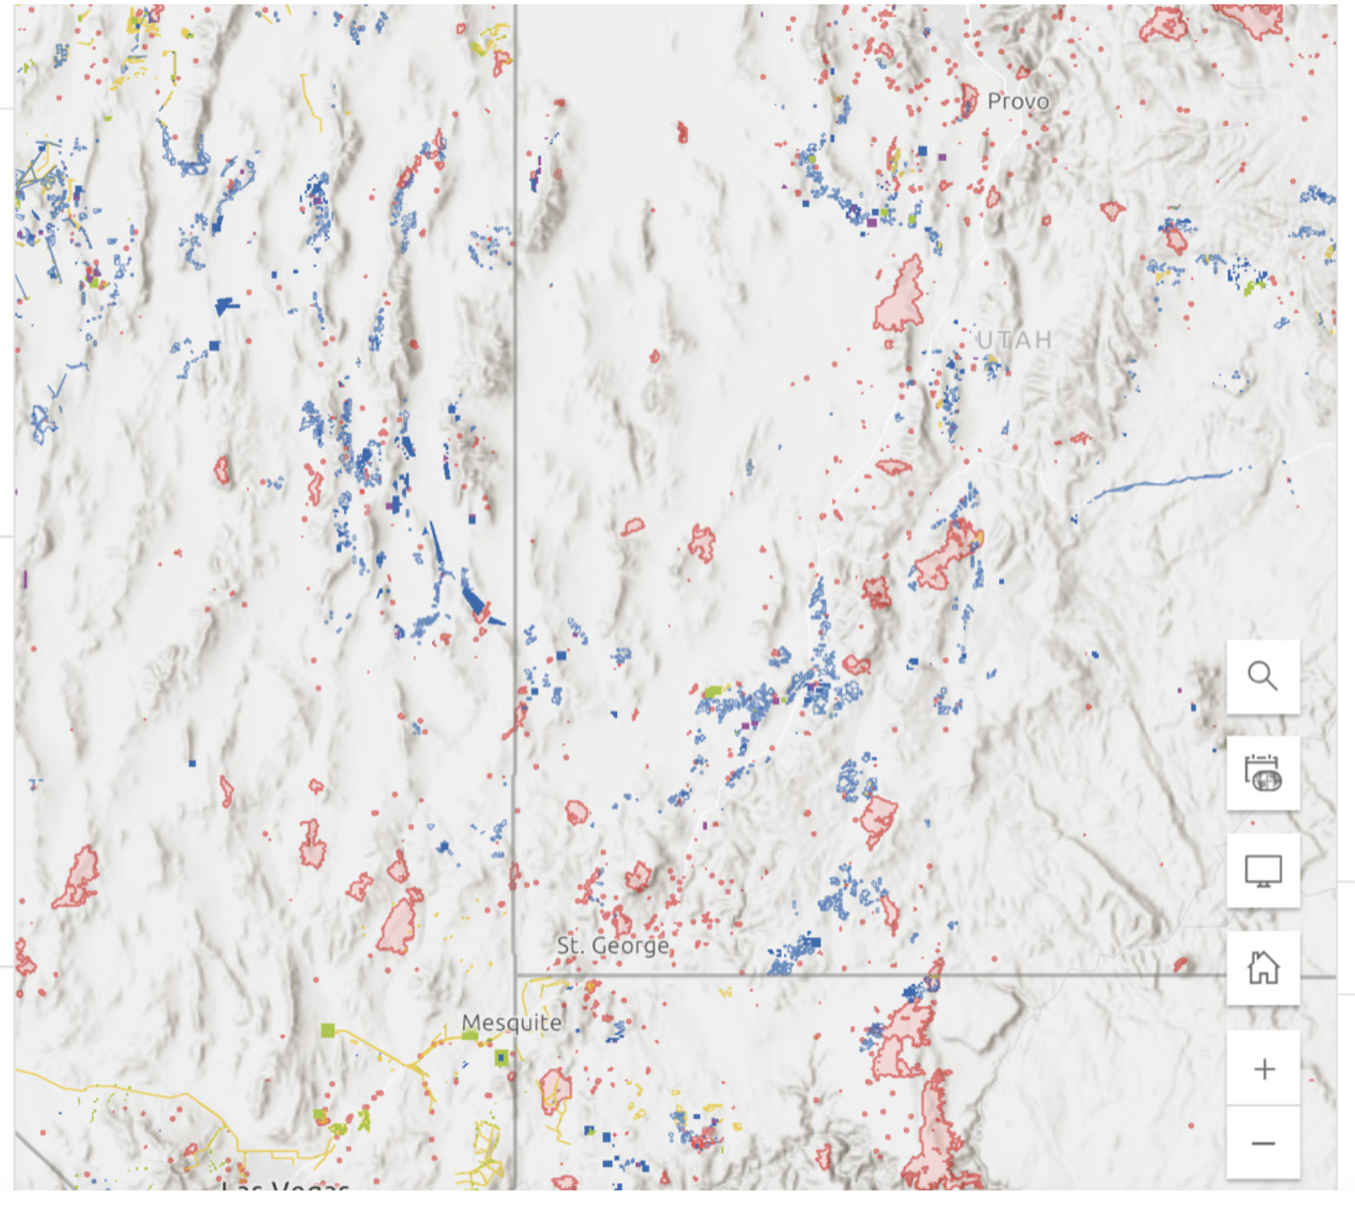

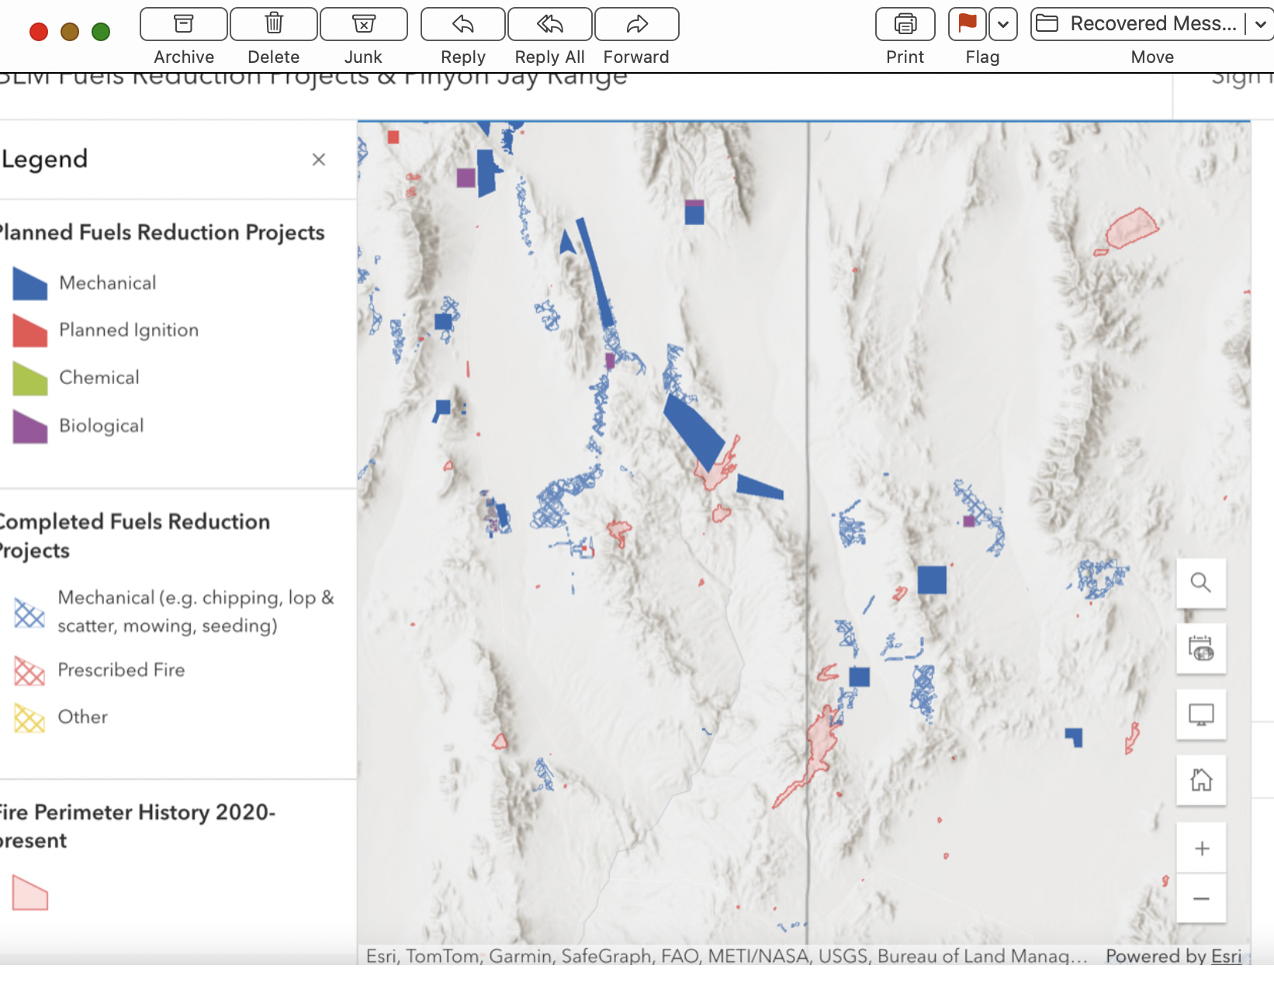
These are planned projects - on top of all the PJ deforestation and sagebrush “treatments” that has taken place in the past that are not shown. And again, these are lower to mid-low elevation PJ forests,
https://nifc.maps.arcgis.com/apps/mapviewer/index.html?webmap=a4fb6996215b4b91aa3ca7ae75a5f941
Increasing Agency Use of “Wildland Fire for Resource Benefits” Poses Additional Threat
Agencies have increasingly been using “wildland fire for resource benefit”. A significant concern with this is the prejudice that managers in BLM and/or USFS offices may have against PJ forests. All those decades of claims the trees are “invaders’, “encroachers”, etc. when in nearly all instances natural plant successional processes are occurring, and/or management degradation and desertification resulting from livestock grazing soil erosion has fundamentally altered made sites (such as degraded drying out meadows) more
Basically, in some BLM Office, fires may be nursed along to increase and maximize acres of PJ burned, and PJ sacrificed in backfires to try to stop sage-grouse habitats from burning up. This is a common practice in “regular” wildfire suppression. Ely BLM just finalized a NEPA process to increase this in Wilderness areas.
Anti-PJ Language and Biases – Part of Land Grant University Range and Natural Resources Department Dogma, and Federal Land Management Agency Culture
There is now become a deep-seated agency cultural bias, reinforced by land grant school range Departments, against native arid forests. There was brief period in the late 1980s to early 2000s when agencies had attempted to protect PJ forests to some extent. That appeared to end when the Healthy Forests Initiative funds became abundant, and as Sage-grouse numbers declined. PJ forests became easy scapegoats
Agency efforts claimed to be “saving” Sage-grouse have increased and fostered anti-PJ forest biases in federal and state agency decision-making processes. Despite hundreds of millions of not billions of dollars having been spent on PJ deforestation treatments, any gains in Sage-grouse numbers have been minimal, and populations continue in long-term decline.
We have discussed the invasion, encroachment language and other manifestations of anti-PJ forest bias throughout these comments. Efforts to protect Pinyon Jays will need to include effective methods to change agency culture.
Governor Lombardo and Maersk PJ Biomass Deforestation Scheme Reflects Current State and often County Government View of PJ Communities and Pinyon Jay Habitat in Nevada
We are attaching an LA Times article by Louis Sahagun describing the current Nevada Governor promoting massive deforestation of Nevada PJ forests to essentially mine wood to be used o brew some kind of natural gas/PJ wood fuel mix for global shipping firm Maersk, and the company would then get to claim it was using “green” fuel, viewed by many as a carbon credit scam of sorts. This embodies the current Nevada leadership view of PJ copmmuni9tes as utterly disposable. Burning wood from very slow growing arid forests in the southern Great Basin that are undergoing increasing climate stress could not be viewed as “sustainable” in any way, and this certainty wood have constituted “mining” of the forests. This is made even more outrageous by the flammable annual weed threats these forest face – especially in the wake of disturbance.
For over 25 years, various Lincoln County office also have been promoting massive deforestation and various forms of biomass schemes – in the past in association with a proposed but not built power plant. This local; antipathy to native PJ forests is likely to continue.
We note that western Game agencies, like NDOW, are often sharply constrained by politics in their actions. Given the attitude of their boss, the Governor, and the long-standing denigration of PJ forests in natural resources programs, it’s hard to envision the agency standing up for Pinyon Jay habitat protection to a sufficient extent – especially when PJ protection is counter to the desires of the public lands livestock industry and Governor. Debra Donahue described this state of affairs effectively in her paper on “Capture” that afflicts the management paradigms and policies of local, state and federal agencies in the West. Attached. “WESTERN GRAZING: THE CAPTURE OF GRASS, GROUND, AND GOVERNMENT”.
Recent Large-scale Slashing and Cuts to Federal Environmental Protections
It’s hard to keep track of all the cuts and changes to environmental oversight and protections that have taken place in the past year. This includes significant gutting of NEPA, policies to fast-track and streamline development project reviews on public lands, an ever-expanding “critical minerals” list that is used to speed. Up mining reviews, the ever more lax federal grazing policies such as “outcome based grazing”, and endless fire fearmongering that threatens sustainability of both sage and PJ habitats at present.
There are also a series of very harmful pieces of legislation being considered, and often moving forward, in Congress – including even worse mining regulations Mining Regulatory Clarity Act (what some have called the Mining Law of 1871). See https://amodei.house.gov/news-releases/house-passes-amodeis-bill-strengthen-domestic-mineral-supply-chain .
The bipartisan “Fix Our Forests” Act, which will speed up environmental; reviews, increase logging, expand “treatment” deforestation and disturbance, and aims to expand flammable weed-causing livestock grazing disturbance in PJ and other forests used by Pinyon Jays. This will highly foreseeably speed up Pinyon Jay habitat loss and population declines, as will the very likely imminent effort to amend the grazing regulations and expand and lessen controls and management oversight of cheatgrass and flammable weed-causing livestock grazing disturbance,
Ongoing administration efforts to ax Roadless Areas. Very interestingly, Roadless Areas are often these least burned in wildfires in many places. It is critical to note that over 80-90% of wildfires are human-caused, so increasingly ease of motorized or other human access to roadless areas likely to reduce the habitat refugia they may provide.
PJ Deforestation and manipulation PLUS Grazing Exacerbates Climate Stress and Irreversible Weed Invasions.
Please review the information in the attached Beschta et al. 2012 and 2014, Reisner et al. 2013, Carter et al. 2014, Williamson et al. 2019, Kaufmann et al. 29022 and 2023, and Molvar et al. 2024 scientific information on the link between livestock gra98ing disturbance and weeds. A particularly alarming aspect of these PJ deforestation projects is that agencies provide utterly minimal and greatly deficient “rest” from livestock grazing disturbance – while aggressive treatment methods clear away impediments to livestock use of previously less disturbed and less weedy sites, and if course the treatment disturbance fosters weeds – by destroying protective soil biocrust – a critical part of PJ communities, and disturbing and. displacing soils, as well as potentially transporting weeds cross-country in equipment.

The minimal 2 or 3 years “rest” following fire, and sometimes no rest at all following “treatments” is completely inadequate to ensure PJ forest sites are not converted to annual weed lands.
BLM Land Health Analyses Scapegoat Trees and Dense Sage – Blind to Natural Plant Successional Processes
BLM land health assessments, based on “
Biophysical Setting” and other models, model PJ communities out of existence, and claim sites where PJ is present are various types of sagebrush communities – ignoring natural plant successional processes.
Then the FRH land health assessment project finds lands to be unhealthy merely because trees are present, and then goes on to absolve cattle and sheep grazing from having any negative impacts to land health. This is now ubiquitous in FRH assessment processes across Nevada and Idaho, as well as in western juniper habitats in Oregon. It is likely the case in other states. As with agency endless claims of saving sage-grouse by scapegoating and destroying PJ forests, agencies claim the trees are harming land health and so they need are scapegoated and blamed for livestock erosional and other impacts, and targeted for deforestation. See for example the attached Wilson Creek information for 800,000 acres of BLM lands including substantial areas of PJ forests, the Ely BLM Uhalde documents, the Elko BLM Winecup documents and m any others.
There are a host of additional concerns related to livestock grazing and the impacts of disease-fostering livestock water developments (West Nile virus that differentially impacts Corvids, and now Avion flu and potentially other diseases) and overall grazing degradation and weed expansion impacts and threats to native arid forests.
Please contact me if you have any questions about any of this information. We hope to submit additional information for this very important USFWS effort.
We will be submitting BLM and USFS project documents and scientific and other information for the Pinyon Jay listing process to you on a thumb drive.
Thank you,
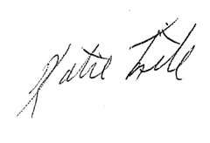
Katie Fite
Public Lands Director
WildLands Defense
PO Box 125
Boise, ID 83701
208-871-5738
katie@wildlandsdefense.org

/mg
Mike Garrity
Alliance for the Wild Rockies
PO Box 505
Helena, MT 59624
406-579-5986
wildrockies@gmail.com

/se
Sara Johnson
Native Ecosystems Council
PO Box 125
Willow Creek, MT 59760
406-579-3286
sjjohnsonkoa@gmail.com

