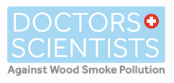

Aug. 4, 2026

Reggie Swenson
c/o Manti-La Sal National Forest
599 W. Price River Dr. Ste. A
Price, Utah 84501

Comments on Project #364235

Utah Physicians for a Healthy Environment (UPHE) and Doctors and Scientists Against Wood Smoke Pollution (DSAWSP) jointly submit these comments on Project #364235. We oppose the project for multiple reasons, many of which have been identified by others. But we wish to focus on two reasons.

Climate consequences

The climate crisis was called the greatest threat to global public health by more than 200 medical journals (Attachment #1) in 2021.

The science and empirical evidence behind global warming and the climate crisis are indisputable. Last year was globally the third hottest year ever despite the cooling effect of La Nina which typically causes temperatures to drop. The year before, 2024, was the hottest year in recorded history, and the past ten year span has been the hottest decade ever. Warning from climate scientists are increasingly dire.(Attachment #2). The World Meteorological Organization’s State of the Climate 2024 Update, released in Nov. 2024, once again issues a Red Alert:

…at the sheer pace of climate change in a single generation, turbo-charged by ever-increasing greenhouse gas levels in the atmosphere. 2015-2024 will be the warmest ten years on record; the loss of ice from glaciers, sea-level rise and ocean heating are accelerating; and extreme weather is wreaking havoc on communities and economies across the world.”

Perhaps the most important pillar of climate science is the concept of tipping points creating positive feedback loops such that beyond a certain increase in global warming, these feedback loops will kick in resulting in an irreversible climate catastrophe. That threshold has been widely accepted as 1.5º or at least well below 2.0º C global average increase, acknowledged by most global nations in the Paris Climate Accord.

More evidence that the world is already barreling towards those tipping points was published recently with scientists finding (Attachment #3) a blob of cold water in the North Atlantic, best explained by weakening of the Atlantic Meridional Overturning Circulation, which would cause major climate disruptions, especially in Europe.

The general consensus among climate scientists is that global warming is accelerating, the rate of increase has nearly doubled in ten years, and that if we have any window in which to avoid crossing that key threshold, that window is very short (Attachment #4). A study published in 2025 estimated that window is only three years (Attachment #5). Therefore, the only rational approach to dealing with the climate crisis is that everything possible must be done now to reduce CO₂ emissions immediately.

The climate crisis, bringing increased temperatures, drought, and declining snow pack, is also the dominant threat to our forests, including in the Wasatch Mountains. And that threat will grow even more so in the future. Any policy however well-intended or otherwise meritorious, is irrational and a betrayal of humanity across the globe unless it prioritizes above all else, its impact on climate, especially the short-term impact.

That means, for example, even policies intended to improve certain wildlife or vegetative habitat, but require forest thinning, must be suspended if they also worsen the short-term atmospheric carbon equation. For virtually any public policy that impacts our climate, those climate consequences must be given priority, especially those with immediate impact on atmospheric carbon concentrations.

Thinning and prescribed burns under the premise of wildfire reduction or control are not just misguided but are counterproductive. Fuel reduction forest management is associated with high forest carbon storage losses. (Attachment #6) Forest thinning and prescribed burns exacerbate the climate crisis directly and immediately in two ways. One, the carbon absorption by trees and vegetation is immediately ended when they are cut down. Two, burning, as with prescribed burning or pile burning, immediately releases that carbon into the atmosphere. These projects result in a net tree mortality (Attachment #6)—i.e., they kill more trees and carbon storage vegetation than they prevent from being killed, and therefore they only add to the climate crisis, and at the worst possible time.
Any argument that forest thinning is so effective in reducing wildfire carbon emissions that it more than offsets the two factors mentioned above is completely lacking in supportive evidence. (Attachment #6)

One study (Attachment #7) found that global warming increases the incidence of lightning strikes, about 12% for every one degree increase in atmospheric temperatures. Obviously that increases the risk of wildfires.

Vapor pressure deficit, VPD, is the amount of moisture in the air compared to the moisture that air could hold if it were saturated, i.e. how thirsty the atmosphere is. If the VPD increases in an area over a forest then so does the risk of wildfire. VPD has increased in Western forests in the 41 years between 1979 and 2020. A study (Attachment #28) in the prestigious Proceedings of the National Academy of Sciences found that two thirds of increase in VPD in the Western US is caused by anthropogenic global warming (Attachment #20). The National Oceanic and Atmospheric Administration (NOAA) stated that “this study shows that western United States has passed a critical threshold since about 2000, and human-caused climate change is now the dominant contributor to the increase of wildfire risk.”

Even Forest Service researchers acknowledge (Attachment #8) that “wildfire reduction strategies” reduce carbon sequestration in the near term. The EA specifically acknowledges on page 27 that the project will release an estimated 3.56 Tg of CO₂ eq over 15 years, but then makes a vague claim, contrary to research cited above, that the project would increase forest carbon storage long term.

The EA at least acknowledges in several places that the climate crisis is making forests more vulnerable to wildfires. But the climate crisis is the overwhelming driver of the epidemic of wildfires. Therefore, even if the Forest Service’s analysis is correct (something that is highly disputed by researchers not connected to the agency, pointed out by other commenters) that like other Western forests the Manti/LaSall forests are uncharacteristically dense, this project will only aggravate the primary driver of wildfire risk, and in the worst possible time frame.

In other words, the climate science community has been sending one very clear message to the public for the last several decades—the climate crisis is an emergency, and mitigating now should be the priority of all relevant public policy.

Perhaps the most widely accepted dictum in the practice of medicine is “First do no harm.” It applies to the Forest Service’s “fuels reduction” strategy. Consider this analogy. If a patient comes into our hospital bleeding profusely from trauma, stopping the bleeding is virtually the only task that matters for the next several minutes or even hours. What we don’t worry about in that setting is their cholesterol levels. And what we certainly don’t do is give the patient who is in danger of exsanguinating a blood thinner that will make the bleeding worse, even if long term he may benefit from a blood thinner. The very best spin the Forest Service can use to justify their strategy is that it is giving a blood thinner to the forest, when the climate is bleeding out.

Public Healh Consequences: air pollution

Physicians at UPHE specialize in air pollution and its health effects. We strongly object to the cavalier dismissal of public health impacts from this project.

Air pollution kills people. Researchers estimate that up to 8,000 people die (Attachment #9) in Utah every year because of the various sources of air pollution, some are unique to this state. Air pollution also causes or exacerbates a list of chronic adult diseases and poor pregnancy outcomes as long as those caused by smoking cigarettes, which is a similar type of air pollution.

As we write this, much of the state of Utah is beseiged by wildfires A brush fire in the foothills over Salt Lake City eventually reached about 500 acres over about three days. The smoke caused significant symptoms among people who were more than 10 miles away. Air quality readings on surrounding purple air monitors reached over 100 AQI. The blaze was in readily accessible foothills, involving essentially just grass and brush, yet became very difficult to control.

Putting this issue in context is the experience of residents of Helena, MT two months ago from a Forest Service prescribed burn. On April 9 of this year, the agency conducted a prescribed burn on 330 acres near Helena, MT. By 9:00 pm, the nearest PM2.5 monitors at about 2.5 miles away read a shocking and highly dangerous 732 ug/m.³ The air pollution remained significantly elevated until noon the next day.

PM2.5 levels that high (and they would have been even higher closer to the burn plot) indicate a severe, immediate, and deadly concentration of air pollution, capable of causing heart attacks, strokes, and sudden death from a variety of causes. Similar impacts would have been inflicted on wildlife. It would be consistent with thousands of studies on air pollution if there were otherwise unexplained fatalities in Helena for the next 1-2 months beginning on the evening of April 9. Miscarriages, still births, and a myriad of other poor pregnancy outcomes could have been caused, all of which would have been entirely consistent with thousands of medical studies on air pollution.

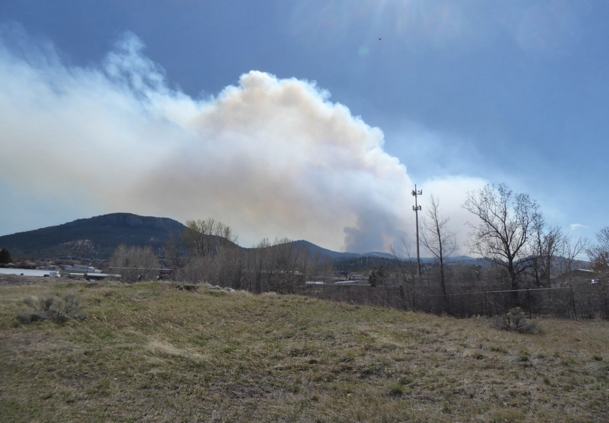
Smoke from the prescribed burn near Helena on April 9, 2026

Obviously, the public in Helena was in extreme danger from the smoke from the prescribed burn. Despite all the planning and approvals from the relevant state agencies, the Forest Service put the entire town of Helena in a life-threatening situation from a prescribed burn. Whatever the goals of the intentional burn, they could not have justified the outcome. When we communicated with the director that ordered the burn, Emily Platt, she responded that “the forecasted winds were expected to be stronger overnight” as the only explanation or excuse for the outcome. But she went on to downplay the extreme pollution as “an unavoidable reality of any prescribed fire,” a shocking dismissal of the gravity of what her agency had done. Outcomes like that in medicine would get a physician sued mercilessly for malpractice, possibly criminally charged, and lose his/her license.

The agency’s EA on this project is similarly dismissive. The Forest Service only points to a “burn plan” as a reason to claim the public will be protected from harm. On page 65 of the EA, there is a list of state agencies and other entities that were “consulted ” in developing this proposal. But there is no entity on that list that remotely represents any public health expertise. Certainly, there is no entity listed that specializes in the health consequences of air pollution. The agency does a profound disservice to the public by broadcasting a perfunctory grasp of the human health consequences of their actions and a tunnel vision with regard to the collateral damage of their seemingly predetermined choice.

While air pollution events from prescribed and pile burning may be short-lived, the health consequences are often not. Decades ago, the EPA recognized this which resulted in two different air quality standards, one for 24 hours and another for annual average. Acute exposure to air pollution from any source can have a wide variety of health consequences from trivial to lethal (Attachment #10). Because the physiologic response set in motion (to simplify, a nearly immediate release of inflammatory chemicals) only dissipates slowly, the health consequences can persistent long after the exposure ends. That’s why with intense events, like the one in Helena, exposing a large number of people, results in an epidemiologic footprint (like increased mortality) that does not return to normal for weeks or even months later. So, the Forest Service should not attempt to placate the public that its pollution from intentional burns can in any way be dismissed as short-lived or trivial.

This is also true of fetal exposure to short term pollution events (days or weeks) because the impact can have life-long consequences (Attachment #11) to the integrity of any and all critical organ development.

For multiple reasons wood smoke from any source is the most toxic type (Attachment #26, Attachment #29) of air pollution the average person ever inhales, whether it comes from a fireplace, wood or pellet stove, wildfire, or a prescribed burn.

Several studies found that smoke from biomass burning (both wildfires and prescribed burns) becomes more toxic over time. Smoke particles can remain in the atmosphere for weeks and become oxidized and highly chemically reactive as they age in the atmosphere.
Beyond greenhouse gases, burning biomass emits pollution gases like sulfur dioxide (SO₂) and ammonia (NH₃), ozone precursors nitrogen oxides (NO_{X})), volatile organic compounds (VOCs). and both filterable and condensable particulate matter, primarily smaller than 2.5 μm, and an array of many of the most toxic chemicals known, including dioxins, furans, and dioxin-like polychlorinated biphenyls, benzene, polycyclic aromatic hydrocarbons (PAHs), formaldehyde, and acrolein.

In total, on a national, epidemiologic scale, emissions from prescribed burns are just as damaging to human health as those from wildfires. A recent study (Attachment #12) concluded that annually, nationwide, wildfire smoke and prescribed burns combined to cause the deaths of 20,000 Americans a year, and slightly more than half of those deaths were caused by prescribed burns. Another study (Attachment #13) published in one of the most prestigious medical journals in the world, was even more stark. It found that per hectare burned, the overall health burden and daily health care costs were nearly five times higher for prescribed burn smoke compared to wildfire smoke. This contradicts claims that human health is being protected by prescribed burns.

A review article (Attachment #14). of research on characteristics of biomass burning emissions establishes several important factors on the issue of whether or not the more intense wildfires that prescribed burns are supposed to prevent, are in fact more harmful to human health. It is not just the amount of particulate pollution being emitted, many factors influence toxicity of biomass burning emissions: the size and shape of the particles, their chemical composition, the age of the particles in the atmosphere, and the type and species of biomass being burned. In turn, many factors influence those characteristics, such as the intensity or temperature of the burn, the amount of oxygen in the flame, combustion efficiency, and the progression phase of the burn, i.e. flame or smoldering.

The review found that very intense fires, as opposed to lower-intensity burns like prescribed burns, had higher concentrations of incomplete combustion, and created larger particles. Particle size is extremely important in assessing toxicity of the particles. Smaller particles are more easily inhaled, more difficult to exhale, more easily picked up by the blood stream in the lungs, and then more easily penetrate organs, tissues, and individual cell membranes once those particles are distributed systemically in the blood stream. Moreover, the smaller the particle the greater the surface area for an equal amount of particle mass. The greater surface area allows more toxic chemicals and heavy particles to be adsorbed on to the particle and greater chemical surface reactivity with body molecules. The smallest particles trigger the most oxidative stress, inflammation, tissue injury, and DNA damage. (Attachment #25).

Fire temperatures and severity are not directly proportional to health hazard. Although inhaled particulate matter of any size can cause health problems, in general, the smaller the particles the more damage they can do compared to an equal amount of particle mass consisting of larger particles. On that basis alone, the larger particles of more intense wildfires are less toxic than smaller particles typical of prescribed burns. Other studies have shown that per ton of biomass burned, low intensity burns produce more smoke emissions (Attachment #27) than higher intensity burns.

It is well known by every relevant medical organization and governmental regulatory agency in the world, there is no safe level of air pollution, (Attachment #15), it is harmful at even very low concentrations. Furthermore, it is also well known that the dose response curve between air pollution concentration and adverse health outcomes is not linear, but hyperbolic, i.e. steepest at the lowest concentrations. Every critical organ system can be harmed by air pollution, including every cell in the body. (Attachment #16).

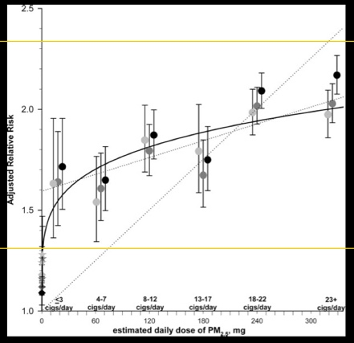

Peters, A. Air Quality and Cardiovascular Health:
Smoke and Pollution Matter. Circulation. 2009:
120:924-927

Hyperbolic, air pollution dose response curve. This graph
demonstrates there is no safe level of particulate pollution,
and that the relationship between dose exposure and disease
is the strongest at the lowest doses.

This means that even small increases in exposure to communities in rural areas is harmful to their health, and that includes from prescribed burns and slash pile burning from forest thinning.

The residual ash from thousands of slash pile bonfires are essentially unlined, unregulated, mini-superfund sites, loaded with highly toxic concentrations of PAHs, PFAS, dioxins, furans, and heavy metals, which can eventually make their way into the watershed and ultimately the water.

We are also concerned for the health of Forest Service workers or contractors exposed to the smoke on a regular basis. We see videos and pictures of employees engaged in burn projects, and we seldom if ever, see any of them wearing any respiratory protection. It is abuse of these workers to not thoroughly inform them of the personal health risks of being around fire constantly without respiratory filters, and the need to faithfully wash their clothes daily because they can adsorb through their skin, significant amounts of chemical pollution from the smoke, including clothes that have been saturated with smoke.

Public Health Consequences—Herbicides and PFAS

On page 9 of appendix 1 the agency states they plan to use herbicides as part of the “fuels reduction” strategy. This is typical of agency managers who often use massive amounts of herbicides as part of their projects, even extoling their use as an “integral part” of modern forestry practice claiming it increases forest wood volume and even biodiversity.

Ten years after their use, herbicides (typically glyphosate, i.e. Roundup) can still be shown to reduce plant species diversity (Attachment #17) in the understory. But the human health impacts are far more alarming, and are usually dismissed or completely misunderstood by those who make decisions on their use in forestry. In the EA we could find no acknowledgement whatsoever of any consequences to herbicide use.

As biologic poisons, pesticides (herbicides and insecticides) have always been recognized as a hazard to human health, and their use has been controversial since at least 1962 with the publishing of Rachel Carson’s Silent Spring. The idea that widely distributing biological poisons would leave beneficial plants, animals, and humans unharmed never made scientific sense, and in recent decades, a growing body of research confirms they do damage to far more of the biological world than just pests. But now the danger of the use of pesticides is likely exponentially greater.

A second dimension of concern emerged in the 1990s with research that showed many pesticides (including the most commonly used herbicides containing glyphosate) were also endocrine disruptors (Attachment #21), i.e. they mimicked or antagonized critical human hormones at extremely low dose exposure, adding an entirely new level of scientific evidence of their harm to human health. Endocrine disruptors have been identified as causing a wide spectrum of harm, especially at the earliest, most critical stages of human development; in utero, infancy, and childhood. Clinical consequences include developmental disorders, reproductive toxicity, multiple cancers, immunosuppression, and damage to the brain and nervous system. Many pesticides degrade into metabolites that have even stronger endocrine disrupting characteristics. (Attachment #18)

Because of this research, in 1996, Congress mandated EPA test all pesticides for endocrine disruption potential. Thirty years later that still has not happened and EPA’s regulatory process largely ignores the issue (Attachment #23). Independent researchers meanwhile have strengthened the evidence of harm from endocrine disruptors. Glyphosate is still the most commonly used herbicide, despite increasing resistance developing in many plant species. A detailed case against the use of glyphosate can be found here.

A third dimension of public health harm from pesticides has emerged in the last few years that almost certainly dwarfs the previous two. Scientists from throughout the world are finding PFAS in many of the most commonly used pesticides (Attachment #24). The presence of PFAS can be both intentional and inadvertent, i.e. intentionally incorporated into the active ingredient, as inactive ingredients used to enhance efficacy, or from leaching from storage containers.

Three years ago, the CDC made an unprecedented recommendation that physicians consider testing their patients’ blood for PFAS or “forever” chemicals. That they have never made any such recommendation for any other toxic chemicals speaks volumes about the unprecedented danger of these chemicals. In 2022, EPA made stunningly strict drinking water guidelines for forever chemicals; for the two main categories .02 and .004 parts per trillion (ppt). To give that a visual context, that is the equivalent of 1 drop of water in a lake the size of six Rose Bowl stadiums, and one drop of water in a lake the size of 30 Rose Bowl stadiums.

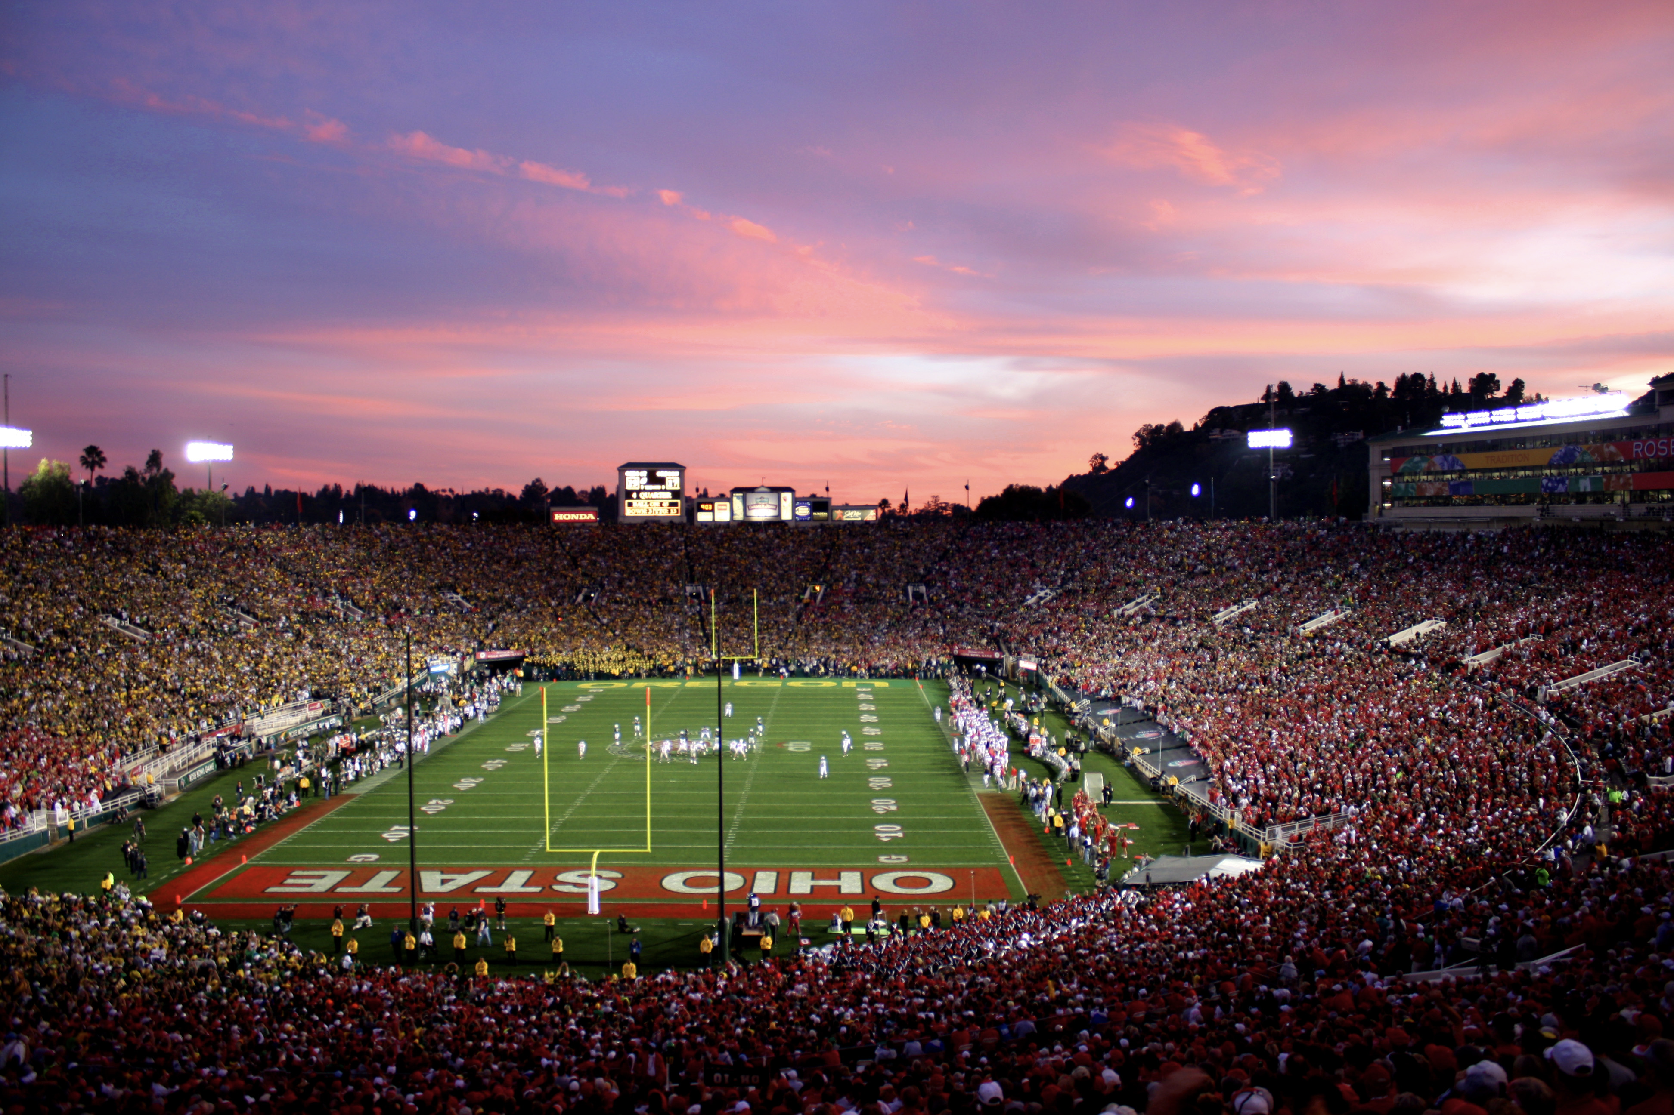

Then in April last year EPA made enforceable, nationwide drinking water standards for these chemicals that are so strict it means EPA essentially believes there is no safe level of PFAS exposure. They made the standard equal to the detection capability of current technology, i.e. 4 ppt (parts per trillion).

Reflecting growing worldwide alarm in the scientific community, a pollution researcher at the UK's Liverpool John Moores University, Patrick Byrne, said PFAS are “probably the greatest chemical threat the human race is facing in the 21st century.” Twenty-nine states have adopted at least some laws to protect their residents from PFAS in consumer products and more is being planned.

Global contamination with PFAS now intersects with pesticide use because the evidence is overwhelming there is wholesale contamination of pesticides with PFAS chemicals, and many pesticides break down into still toxic, short chain PFAS (Attachment #19). type chemicals. Seventy percent of pesticides introduced to the market since 2015 qualify as PFAS compounds. As a former EPA scientist, Kyla Bennett said, “If the intent was to spread PFAS contamination across the globe there would be few more effective methods than lacing pesticides with PFAS.”

There is already widespread PFAS pesticide contamination of every component of the global environment, including drinking water and the food supply. (Attachment #19). Nearly 100% of humans carry PFAS in their blood in very disturbing amounts, including newborns, and pesticides are a major reason. Women, fetuses, infants, and children are more susceptible to the health hazards of pesticides and PFAS. European scientists said, “The extent of this contamination is shocking. It is a result of political failure at many levels.”

Pesticide use in forested areas is largely unrestrained, and decisions about mass spraying are made by private contractors, lumber companies, and agency employees who have no expertise in the health consequences of the products they are exposing the public to. This lack of oversight or caution is irrational, and it is now wholly unacceptable. There is strong evidence that the mass use of pesticides is now a serious, global public health threat on an unprecedented level because of endocrine disruption and now PFAS contamination.

Because these chemicals so environmentally persistent and refractory to thermal destruction, they are likely to also be found in any smoke emitted from the pile burning and prescribed burns depending on the timing of their use. Pesticides can drift thousands of miles (Attachment #22) from where they are applied, and have been linked to over 50% reductions in wild plant diversity within 500 m of fields. Typically about 25% of sprayed pesticides become airborne and capable of contaminated ecosystems hundreds and even thousands of miles away (Attachment #22).

Given the extensive use of pesticides by the agency, it is worth considering their presence in smoke from landscape prescribed burns and slash pile burns. Based on studies 35 years old, the Forest Service has stated that pesticides are chemically destroyed in fires with temperatures greater than 500º C, presumably high intensity wildfires, but that with the presumed lower temperatures of prescribed burns, pesticides may not be thermally destroyed. Despite that, the agency then claims that still does not represent any public health harm. In other words, the agency is admitting that prescribed burns are more likely to have intact pesticides emitted from the smoke of intentional burns.

But since those studies cited by the agency were done, we have learned the two characteristics mentioned above that challenge their claim of no harm, i.e. their endocrine disruption and contamination with PFAS. So there is every reason to believe that the agency’s intentional burns are more toxic than wildfire smoke because of the likely higher concentrations of pesticides and PFAS chemicals.

Conclusion

This fuels reduction project should be abandoned because it is likely counterproductive in controlling or mitigating wildfires spread or intensity (as others have pointed out) and because of its contribution to the climate crisis, and harm to public health.

Sincerely,

Dr. Brian Moench
President, Utah Physicians for a Healthy Environment
Board Chair, Doctors and Scientists Against Wood Smoke Pollution

