June, 5th 2026

Traci Zimmerlee, Forest Supervior
Shasta Trinity National Forest
3644 Avtech Parkway
Redding, Ca 96002

RE: Comments on the North Trinity County Community Risk Reduction Project Preliminary Environmental Assessment (PALS Project 66894)

Dear Acting Forest Supervisor Traci Zimmerlee,

My comments and concerns are all based on, how can our forest stay healthy and how can our forest become healthier while conducting this Risk Reduction Project. I think we all agree, this should be the number one goal moving forward. All of us, no matter what side we are on, want to archive the same at the end, a resilient, healthy forest that is thriving. Maintaining and improving wildlife habitat while conducting fuel reduction. That goal got lost in the process of drafting this plan and here is why:

I am a resident of Long Canyon and walk the forest in this area daily, on and off trail, year around. I have a very good understanding of fauna and flora in the area and its biodiversity. – After witnessing the timber sale operations up in Long Canyon Area and Rainier area, a US Forest Service telling me, how devastating Long Canyon looks after logging and that really someone should complain about what has been done, as well as neighbors pulling back a planned logging project, due to how devastating the logged area (Long Canyon) looks, I figured it is a good idea to comment on why Timber Sales should be excluded as a part of the North Trinity County Community Risk Reduction Project. – Peoples advice is not to comment, because nothing is going to change anyways – the US Forest Service won’t care – they are going to do what they are going to do because they can! I would really like to proof those people wrong, deep inside I believe that the US Forest Service does care, that we all share the same interest by heart maintaining/creating a healthy forest ecosystem that thrives, not losing the magnificent biodiversity existing within North Trinity and find a solution to reduce forest fuels in a manner that won’t disturb the balance of the forest.

I am splitting my comments into two parts. While part one includes the general Project, part two focus mainly on Long Canyon Timber Sale area (assuming parallel can be drawn to other Timber Sales proposed).

Part one general North Trinity County Risk Reduction Project

How many acres are subject to Timber Sales?

This assessment and the previous proposal fail to mention anything about Timber Sales. This is misleading. It fails to state that some of the fuel reduction, “removal of trees” and/or ”thinning”, is conducted by commercial logging. Most people in the community I spoke to about the North Trinity County Community Risk Reduction Project have no clue that Timber Sales are in fact a part of this project. When they read or hear about thinning the forest, creating a resilient forest, to their understanding, it means roadside thinning, removal of underbrush, removing small trees up to 10’’DBH and ladder fuels. Commercial logging, reducing canopy cover to a min of 40% in most areas did not cross their mind. Everyone is pro fuel management along roads, creating fuel breaks along US Forest Service roads, logging plantations and carefully manage forest fuels but is against commercial logging as a part of this plan. There has to be a better less invasive way, especially when it comes to fuel reduction in our late successional reserves.

Reducing canopy cover to 40% as proposed has its problems, it won’t create nor sustain a healthy thriving forest. Let me explain why.

A forest is a complex structure, every part counts, if parts are missing, the forest can no longer function properly as a whole. Think of a forest as a community. Trees care for each other, they teach each other. An abrupt change, such as quick removal of a large portion of healthy med/big trees causes future problems to the remaining trees, so does soil disturbance. The quick change is a shock to their system. About the same as if we plunge on a hot day into ice cold water. Trees learn as they grow, and how to live in a certain given environment. A tree that grows in a cool shady spot with a certain amount of water/moister content in soil knows how to function in that given environment. If this suddenly changes and the tree is exposed to more sunlight, heat and a hotter, drier forest floor it gets stressed and becomes vulnerable to disease & beetle infestation. Furthermore, it uses a lot of energy trying to help its fallen partners. Studies have shown that surviving trees keep feeding stumps long after their neighboring trees have been cut. This again adds stress to all the trees left because they use all their energy trying to revive their dead neighbor. Trees adapt very slowly and need time to adjust to change. Trees are in no hurry. They in fact love to take their time, something people don’t seem to understand. In our world everything has to happen quick and right now. If we really want to create a healthy forest, we got to slow down. This fast push and quick fix of fuel reduction just won’t work. It’s not magically going to create a resilient forest. The opposite will happen trees left in logging areas are going to struggle to survive.

In your plan you mention that the forest is overcrowded and needs to be thinned. As I count trees in any given area around these woods it’s clear that the overcrowding is mainly caused by small trees up to 10’’ DBH. By removing trees up to 10’’ DBH and the unhealthy med/big trees the goal of fuel reduction would be archived, the forest floor still in takt, trees won’t be stressed and the forest can still function as a whole.

Quoted from “Hidden Life of Trees” written by Peter Wohlleben, forester and author page 155

“Its health depends on the stability of the forest ecosystem. It’s better if temperature, moister, and light conditions don’t change abruptly, because trees react extremely slowly. But even when all the external conditions are optimal, insects, fungi, bacteria, and viruses are always lurking, waiting for the change to strike. That usually happens only when a tree gets out of balance.”

Drastic removal of canopy cover will affect the trees balance.

Quoted from “Hidden Life of Trees” page 44

“The most severely affected trees are those that grow in soils where moisture is usually particularly abundant. These trees don’t know the meaning of restraint and are lavish in their water use, and it is usually the larger and most vigorous trees that pay the price for this behavior.”

Have you walked in a freshly logged area during the middle of a hot summer day? Have you hiked up a trail going from nicely shaded cool areas to an open hot area? – Less canopy cover equals more sunlight exposer, more open areas, a drier forest floor. That is not all, removal of med/big trees on ridges causes wind patterns to change, again more wind equal drier conditions for areas below.

Commercial logging as proposed by removing trees larger than 10’’ DBH and opening up the canopy to 40% in the majority of the timber sale areas won’t create a healthier forest. Too much sunlight enters the area heating the forest floor and individual trees. Leaving some big trees standing alone (as witnessed on Long Canyon Timber Sale/Rainier Timber Sale) without shade from neighboring trees, exposed to sun and wind, dry soil conditions will struggle to survive. Can we afford to lose more med/big trees after harvest is done? I doubt it. A stressed forest is a dead forest. We got to find a better solution. The North Trinity Community Fuel Reduction plan can’t be driven by profit, money and timber. That is not its purpose. Instead, it should focus on maintaining and creating a healthier forest. We need more collaboration and better solutions, that are less invasive before proceeding. Let’s slow down and do what is best for our forest.

My understanding is that the US Forest Service has land set aside for timber production. Let’s not commercially log areas set aside for wildlife habitat. Their habitat is already shrinking. Every acre taken is too much. Animals depend on us for survival. They don’t have a voice. They can not speak up. We the people need to act in their behalf. – Let’s protect as much wildlife habitat as we can. Many animals depend on a dens intact forest. Who is willing to stand up and make a change for the better? If you, “the US Forest Service” is turning your back to our forest and its animals than who is still going to protect them? Be their ally. All they have is us. This is their home, that we are either destroying or protecting.

For our wildlife let’s create a Fuel Reduction Program that enhances habitat.

- Focus on plantation Timber Sales (look at Long Canyon Timber Sale map, logging plantation creates great fuel breaks) and everyone is okay with that
- Up canopy cover to 60%
- Thinning and removal of trees up to 10’’DBH, as we private landowner are doing
- Slow down. A little at the time vs. all at once… give trees time to adjust

Part two – Long Canyon project

Pacific Fisher

- Page 39

Table 11. Determinations for Forest Service Sensitive Species.

Pacific Fisher – Not enough is being done to protect the habitat of the Pacific Fisher. Already classified as “Sensitive Species” the Fisher’s survival in our area is being jeopardized by opening up Late Successional Reserves to commercial logging. Logging as proposed, clearly destroys their habitat (photo of Long Canyon Timber sale showing most area is colored orange, only small areas are pink). Too much canopy cover is being removed assuming most Timber Sales proposed are following a similar pattern.

Pink 60% canopy cover (a min for Fisher habitat)
Orange 40% canopy cover (devastating to Fisher habitat)

Wayne D. Spencer, PH. D. Chief Scientist Emeritus / Conservation Biology Institute, Corvallis OR, responded to an e-mail about logging/thinning concerns in our area,

“…fishers need dense forest with large trees. The biggest threat in your region is further fragmenting the core and linkage areas, which are already small and convoluted.”

“…as for effects of thinning and logging. It is complicated, but largely detrimental to fisher habitat..”

Wayne D. Spencer, PH. D. Chief Scientist Emeritus has conducted studies on Fisher population/habitat in Northern California. He has led large teams working to conserve the endangered distinct population of fishers in the Sierra Nevada.

Please consider consulting with this expert regarding Fisher habitat and needs. Cleary, the presence of the Fisher is being overlooked and not fully implemented. The Fisher’s habitat is shrinking, there is no place for them to go.

Since the Pacific Fisher is classified as a Sensitive Species wouldn’t the US Forest Service have to follow the Sensitive Species – Key Policies and Requirements USDA Forest Service guidelines?

Which states:

Quoted from the Sensitive Species – Key Policies and Requirements USDA Forest Service

Forest Service objectives for designated sensitive species (FSM 2670.22, 2670.44 and 2672.32): 2670.2 – Objectives
2670.22 – Sensitive Species

- Develop and implement management practices to ensure that species do not become threatened or endangered because of Forest Service actions.

Management for sensitive species, and delegation of sensitive species designation (FSM 2672.1):
2672.1 - Sensitive Species Management. Sensitive species of native plant and animal species must receive special management emphasis to ensure their viability and to preclude trends toward endangerment that would result in the need for Federal listing. There must be no impacts to sensitive species without an analysis of the significance of adverse effects on the populations, its habitat, and on the viability of the species as a whole. It is essential to establish population viability objectives when making decisions that would significantly reduce sensitive species numbers.
North Trinity County is one of their last refugees. Let’s help this species thrive in our area.

- Fishers need a canopy cover of 60% =/> with medium to large trees present
- All areas logged maintain a 60% =/> canopy cover
- Only remove small trees 10’’ DBH and less
- No Timber Sales on any Late Successional Reserve to protect Fisher habitat

Old Pacific Yew trees

No under burning Long Canyon as highlighted red on map (due to presence of old Yew trees):

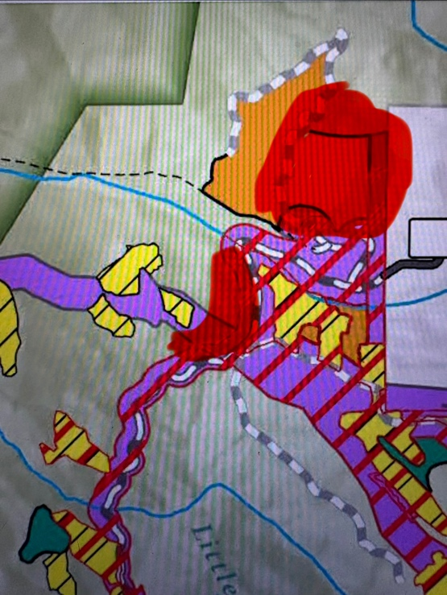

Old Pacific Yews are present in the red highlighted area. Pacific Yews are an important part of a healthy forest ecosystem. They will not survive a controlled burn. Fire damages them greatly. Please preserve all Pacific Yews in Long Canyon. They are very old! I measured most of them, some are over 200 years old. Most likely due to absence of fire and great growing conditions, shady covered areas. Please create exclusion area around Yews.

Pacific Yews need shade. Sun and wind exposer can damage them greatly. Please help preserve those beautiful trees by not logging in their proximity. Not exposing them to too much sunlight. They grow in the shade of medium/big fir trees. Long Canyon shows perfect growing conditions for these amazing trees. Please avoid disturbance, destruction in their surrounding! Pacific Yews are brilliant trees. They are of ecological importance in Old Growth Forests we do have here in the Long Canyon/Rainier Road area. Please preserve those areas as are!!!!

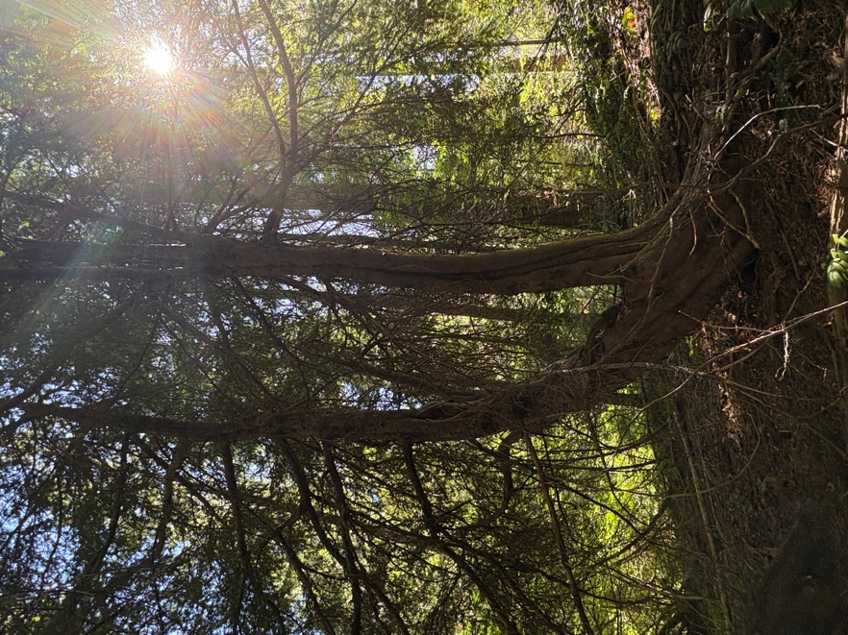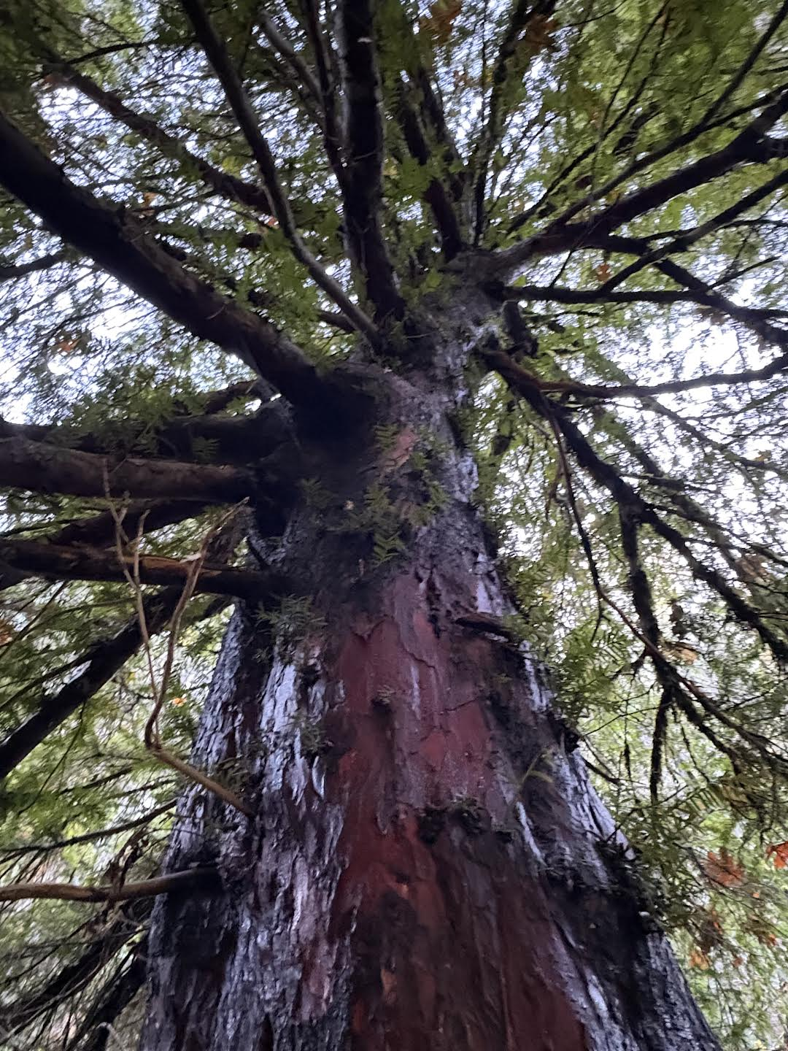

(Photos of Yews Long Canyon red marked area)

I noticed along Rainier Road, past the bridge going up towards Lake Forest turn off, a lot of old Pacific Yews are present. Most of them are flagged with a red/black striped pattern. What does the flagging mean?

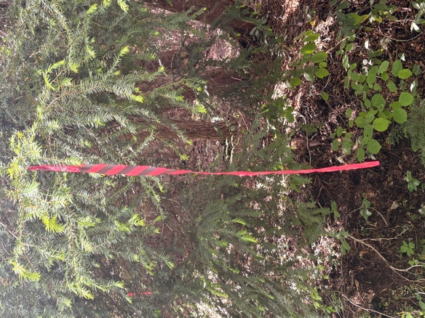

Thank you for reading my comments and please add me to the list for future meetings and notifications regarding the North Trinity Community Risk Reduction Project.

Sincerely,

Nicci Belter

