Tongass USFS Draft Plan — Survey 123 Data Summary
Quantitative response distributions for both forms
Plan-content form n=86 · management-area form n=65 · individual-MA comments n=126

About this document. This is a strict descriptive summary of the Survey 123 response data — the format produced by the Survey 123 Analyze tab, expanded into a single document. No interpretation, synthesis, or recommendations are included here. For thematic analysis and audience-specific recommendations, see the companion Synthesis Report. All percentages are computed against responses received (i.e., excluding blanks) unless explicitly noted.

1. Respondent Demographics

1.1 Plan-content form (n=86)
Communities represented (n responding to community question only):
Community | n | % of form respondents
Sitka | 25 | 29%
Juneau | 23 | 27%
Petersburg | 8 | 9%
Gustavus | 6 | 7%
Yakutat | 4 | 5%
Tenakee Springs | 2 | 2%
Pelican | 1 | 1%
Thorne Bay | 1 | 1%
Ketchikan | 1 | 1%
Angoon | 1 | 1%
Wrangell | 1 | 1%
Craig | 1 | 1%

Self-identified interests (multi-select, up to 3 per respondent):
Interest tag | Count of selections
Recreation | 42
Conservation | 38
Fishing | 32
Subsistence | 30
Tourism | 18
Forest User | 14
Timber | 8
Indigenous | 7
Other Interest | 5
Local Business | 4
Mining | 3

1.2 Management-area form (n=65)
Communities represented:
Community | n | % of form respondents
Sitka | 22 | 34%
Juneau | 11 | 17%
Tenakee Springs | 9 | 14%
Gustavus | 5 | 8%
Ketchikan | 2 | 3%
Skagway | 1 | 2%
Wrangell | 1 | 2%
Petersburg | 1 | 2%

Self-identified interests (multi-select, up to 3 per respondent):
Interest tag | Count of selections
Conservation | 36
Recreation | 31
Subsistence | 29
Forest User | 21
Tourism | 8
Fishing | 8
Timber | 6
Local Business | 3
Indigenous | 3
Other Interest | 1
Mining | 1

2. Plan-Content Form — Aggregate Statistics

2.1 Agreement distribution across 63 statements
Metric | Value
Plan statements presented | 63
Statements receiving any agree/disagree response | 63
Mean % Yes across statements | 79.7%
Median % Yes | 83%
Min % Yes | 16%
Max % Yes | 100%
Statements at 100% Yes | 4
Statements below 50% Yes | 7

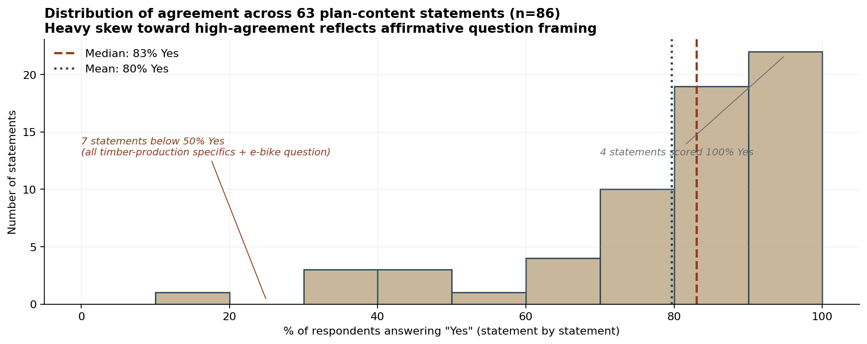
Distribution of % Yes across the 63 plan-content statements (n=86).

2.2 Section-level summary
Section | Statements | Mean % Yes | Range
Timber & Forest Mgmt | 19 | 65% | 16% – 100%
Recreation & Tourism | 25 | 83% | 35% – 100%
Subsistence | 10 | 92% | 81% – 100%
Tribal Relations | 9 | 89% | 79% – 97%

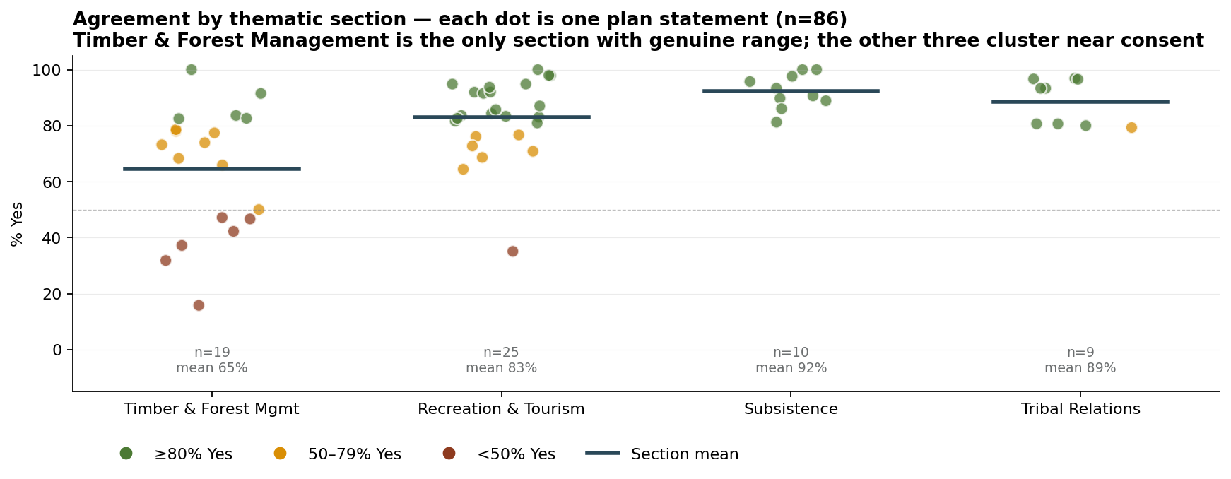
Each dot is one plan statement, plotted by section.

2.3 Free-text response fill rates
Average percentage of respondents filling each field across the 63 statements.
Field | Mean fill rate
Yes/No agreement question | 53%
"What works well?" free-text | 11%
"What would you change?" free-text | 10%

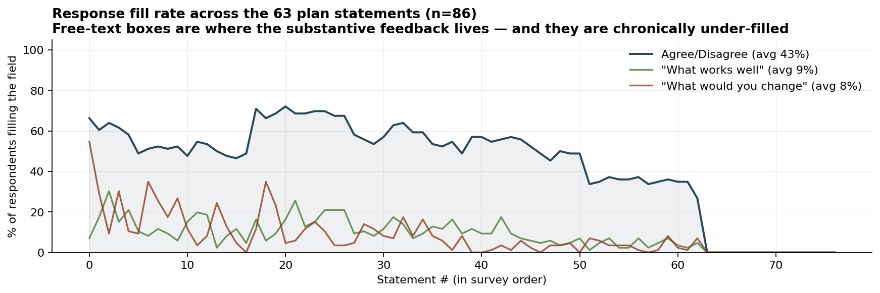
Per-statement fill rate across the survey order.

2.4 Most-contested and most-agreed statements
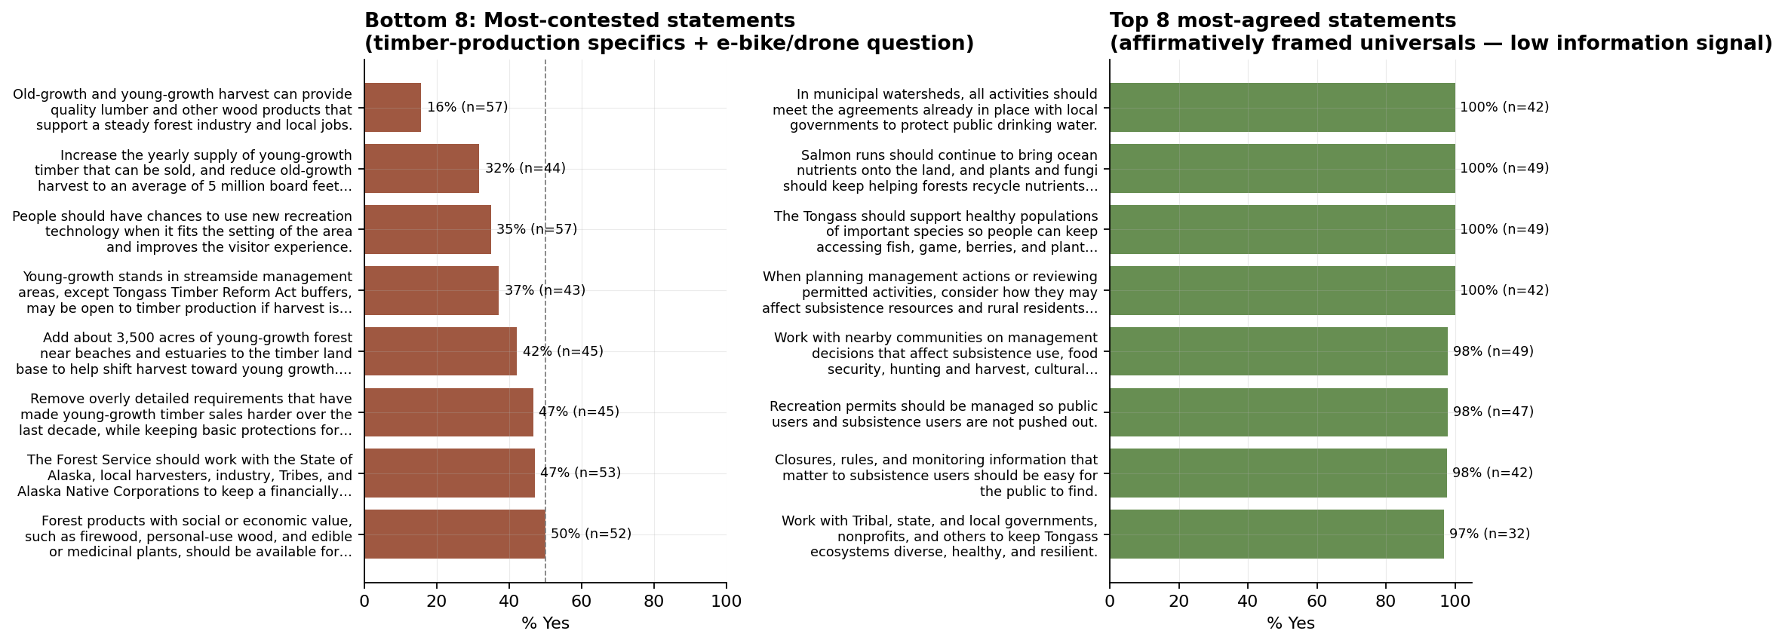
Bottom 8 (left) and top 8 most-agreed statements (right).

3. Plan-Content Form — Statement-by-Statement Results
Each statement was preceded by a section header in the form. Columns: Yes count, No count, Total scored, % Yes, n filling each free-text box. Statements are listed in survey order within each section.

3.1 Timber & Forest Mgmt
Statement | Yes | No | n | % Yes | "Works" n | "Change" n
Old-growth and young-growth harvest can provide quality lumber and other wood products that su… | 9 | 48 | 57 | 16% | 6 | 47
Forest products with social or economic value, such as firewood, personal-use wood, and edible… | 26 | 26 | 52 | 50% | 15 | 25
Young-growth forest work should help restore and maintain habitat where needed. | 46 | 9 | 55 | 84% | 26 | 8
The Forest Service should work with the State of Alaska, local harvesters, industry, Tribes, a… | 25 | 28 | 53 | 47% | 13 | 26
The Forest Service should work with Tribes and Alaska Native Corporations on cedar management,… | 39 | 11 | 50 | 78% | 18 | 9
Work closely with Tribes to create a cultural tree strategy during the life of the plan. | 33 | 9 | 42 | 79% | 9 | 8
Increase the yearly supply of young-growth timber that can be sold, and reduce old-growth harv… | 14 | 30 | 44 | 32% | 7 | 30
Remove overly detailed requirements that have made young-growth timber sales harder over the l… | 21 | 24 | 45 | 47% | 10 | 22
To keep sediment out of streams, do not build new roads or landings in streamside areas unless… | 29 | 15 | 44 | 66% | 8 | 15
Add about 3,500 acres of young-growth forest near beaches and estuaries to the timber land bas… | 19 | 26 | 45 | 42% | 5 | 23
On lands open to timber production, reforestation should help the next forest stay healthy ove… | 30 | 11 | 41 | 73% | 13 | 10
These designated areas should not be open to timber production: wilderness areas, national mon… | 43 | 4 | 47 | 91% | 17 | 3
These management areas should not be open to timber production: community use areas, high comm… | 38 | 8 | 46 | 83% | 16 | 7
Young-growth stands in streamside management areas, except Tongass Timber Reform Act buffers, … | 16 | 27 | 43 | 37% | 2 | 21
During the life of the plan, work with Tribes and Alaska Native Corporations to develop guidan… | 28 | 13 | 41 | 68% | 7 | 11
Before commercial timber sales, check whether cultural trees are present so access to those tr… | 33 | 7 | 40 | 83% | 10 | 4
In municipal watersheds, all activities should meet the agreements already in place with local… | 42 | 0 | 42 | 100% | 4 | 0
Maintain enough old-growth red and yellow cedar of the right quality to support Tribal cultura… | 24 | 7 | 31 | 77% | 6 | 7
Old-growth timber may be harvested for cultural trees, such as trees used for totem poles and … | 17 | 6 | 23 | 74% | 4 | 6

3.2 Recreation & Tourism
Statement | Yes | No | n | % Yes | "Works" n | "Change" n
Recreation settings, opportunities, and facilities should balance the needs of local residents… | 51 | 10 | 61 | 84% | 14 | 10
People should have chances to use new recreation technology when it fits the setting of the ar… | 20 | 37 | 57 | 35% | 5 | 30
Recreation cabins should support safe public use. Cabin maintenance should reflect how much ea… | 38 | 21 | 59 | 64% | 8 | 20
Wildlife viewing areas and related facilities should protect wildlife, support local economies… | 57 | 5 | 62 | 92% | 14 | 4
Special use permits for recreation should support good public experiences on the Tongass. Guid… | 54 | 5 | 59 | 92% | 22 | 5
Helicopters, fixed-wing aircraft, and drones should be managed in ways that protect wildlife. … | 49 | 10 | 59 | 83% | 11 | 10
Roads and trails, both motorized and non-motorized, should connect people to places they want … | 46 | 14 | 60 | 77% | 13 | 13
New trails should improve access from local communities to the Tongass and connect communities… | 50 | 10 | 60 | 83% | 18 | 9
Keep current partnerships and build new ones that strengthen local communities, respect cultur… | 55 | 3 | 58 | 95% | 18 | 3
Permit processes for commercial recreation services should be clear and timely. They should su… | 55 | 3 | 58 | 95% | 18 | 3
New recreation sites and updates to existing sites should fit the setting of the area and foll… | 46 | 4 | 50 | 92% | 8 | 4
Old or outdated recreation sites, facilities, or cabins that are hard to maintain should be re… | 34 | 14 | 48 | 71% | 9 | 12
Informal recreation sites that damage forest resources should be grouped, designated, or impro… | 35 | 11 | 46 | 76% | 7 | 10
Commercial aircraft use on National Forest lands, including helicopters, fixed-wing aircraft, … | 40 | 9 | 49 | 82% | 10 | 7
Commercial recreation in designated wilderness should not interfere with other wilderness uses… | 47 | 7 | 54 | 87% | 15 | 6
New trails should focus on sustainable recreation and should benefit local communities or comm… | 40 | 15 | 55 | 73% | 12 | 15
Road crossings and clearings should be placed away from trails when possible to protect the tr… | 43 | 8 | 51 | 84% | 6 | 7
Outside the main commercial recreation areas, the plan should adapt to changing recreation and… | 35 | 16 | 51 | 69% | 8 | 14
Access to subsistence resources should be maintained or improved during subsistence seasons. T… | 38 | 8 | 46 | 83% | 11 | 7
Roads should be managed and maintained to support forest management, subsistence use, recreati… | 34 | 8 | 42 | 81% | 8 | 7
The Tongass should support healthy populations of important species so people can keep accessi… | 49 | 0 | 49 | 100% | 8 | 0
Recreation permits should be managed so public users and subsistence users are not pushed out. | 46 | 1 | 47 | 98% | 8 | 1
Permits connected to cruise ships, yacht tours, and other large groups should fit the setting … | 45 | 3 | 48 | 94% | 15 | 3
Work with nearby communities on management decisions that affect subsistence use, food securit… | 48 | 1 | 49 | 98% | 8 | 1
Wildlife viewing sites, related facilities, and visitor levels should not interfere with subsi… | 36 | 6 | 42 | 86% | 4 | 4

3.3 Subsistence
Statement | Yes | No | n | % Yes | "Works" n | "Change" n
Habitat improvement and other management work should help keep fish and wildlife populations h… | 40 | 5 | 45 | 89% | 10 | 5
Indigenous knowledge, subsistence user knowledge, and local community knowledge should be cons… | 45 | 2 | 47 | 96% | 14 | 1
Salmon runs should continue to bring ocean nutrients onto the land, and plants and fungi shoul… | 49 | 0 | 49 | 100% | 10 | 0
Build more capacity for fish and wildlife monitoring, access infrastructure, and community ski… | 39 | 9 | 48 | 81% | 6 | 5
Consult Tribes and the Southeast Subsistence Regional Advisory Council on projects and permitt… | 42 | 3 | 45 | 93% | 5 | 2
When planning management actions or reviewing permitted activities, consider how they may affe… | 42 | 0 | 42 | 100% | 4 | 0
To support subsistence wildlife populations, vegetation projects should mimic natural disturba… | 35 | 4 | 39 | 90% | 5 | 3
To reduce impacts on subsistence resources and access, plan project work to avoid key subsiste… | 37 | 6 | 43 | 86% | 3 | 3
Closures, rules, and monitoring information that matter to subsistence users should be easy fo… | 41 | 1 | 42 | 98% | 6 | 0
The Tongass should protect the traditional character of places that Tribes use for ceremonies,… | 29 | 3 | 32 | 91% | 6 | 3

3.4 Tribal Relations
Statement | Yes | No | n | % Yes | "Works" n | "Change" n
The Tongass should work with Tribes and Alaska Native Corporations in a lasting and respectful… | 23 | 6 | 29 | 79% | 1 | 6
Indigenous knowledge should be considered in Tongass projects, including planning, alternative… | 24 | 6 | 30 | 80% | 4 | 5
Work with Tribes and Alaska Native Corporations to look for ways to share stewardship of lands… | 25 | 6 | 31 | 81% | 2 | 3
Work with Tribes to teach Forest Service staff and leaders about culturally respectful practic… | 25 | 6 | 31 | 81% | 2 | 3
Work with Tribal, state, and local governments, nonprofits, and others to keep Tongass ecosyst… | 31 | 1 | 32 | 97% | 6 | 1
Build partnerships with Tribes, organizations, scientists, and others who work on karst and ca… | 28 | 1 | 29 | 97% | 2 | 0
When land management actions may affect nearby state, Tribal, Alaska Native Corporation, or pr… | 29 | 1 | 30 | 97% | 4 | 1
Work with Tribes, state and federal agencies, and schools to update soil, ecology, and landsli… | 28 | 2 | 30 | 93% | 3 | 2
Work with Tribal, state, federal, and local governments to map, protect, reduce harm to, and i… | 28 | 2 | 30 | 93% | 2 | 1

3.5 Additional plan topics requested (multi-select)
Question: "Are there any additional draft plan topics you think should be more clearly addressed in this form or in the plan revision process?"
Topic | Count of selections

4. Management-Area Form — Aggregate Statistics

4.1 Agreement with the intent of each proposed Management Area
Question: "Do you agree with the intent / description of this management area?" (up = agree, down = disagree). Respondents could skip individual MAs.
Management Area | Agree (up) | Disagree (down) | n scored | % Agree
Community Use | 20 | 10 | 30 | 67%
High Commercial Recreation | 18 | 15 | 33 | 55%
Low Commercial Recreation | 20 | 9 | 29 | 69%
Key Fisheries Watersheds | 19 | 15 | 34 | 56%
Old-growth | 21 | 6 | 27 | 78%

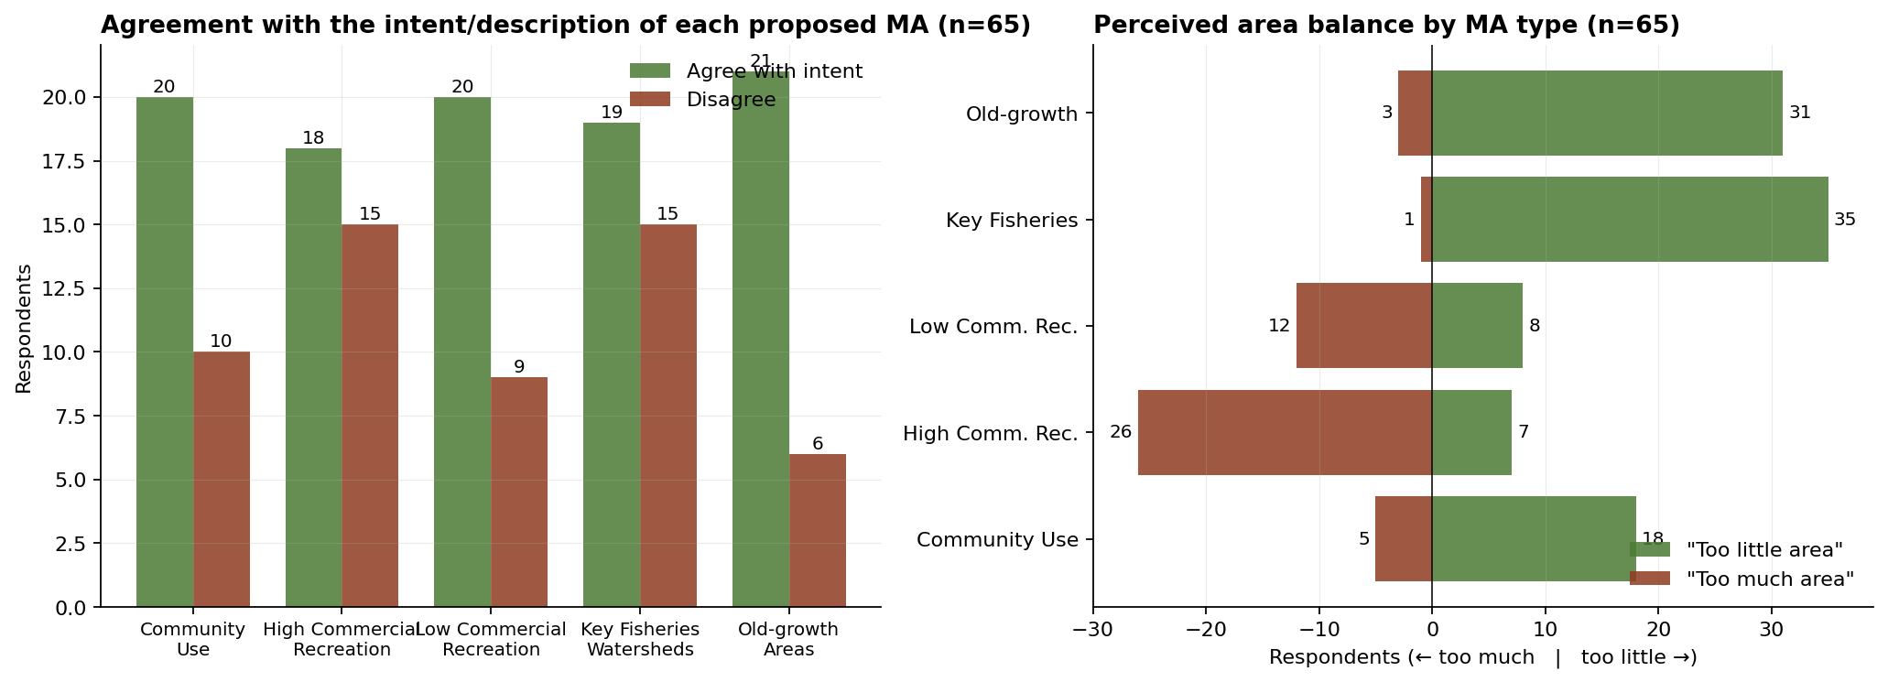
MA-level intent agreement (left) and perceived area balance (right).

4.2 Coverage question — do all 5 MA types together cover what the Tongass needs?
Response | n | % of form respondents
yes | 30 | 46%
no response | 19 | 29%
no | 16 | 25%

4.3 Perceived area balance (multi-select)
Question: "Which proposed MA types seem to have too little / too much area mapped?" Respondents could select multiple MA types.
Management Area | "Too little area" (n) | "Too much area" (n)
Community Use | 18 | 5
High Commercial Rec. | 7 | 26
Low Commercial Rec. | 8 | 12
Key Fisheries | 35 | 1
Old-growth | 31 | 3

5. Individual MA Comments (Sub-form, n=126)

5.1 Approval distribution across individual-MA comments
Approval | n | % of sub-form comments
down | 60 | 48%
no response | 33 | 26%
up_plus | 20 | 16%
up | 13 | 10%

5.2 Distribution by ranger district
Ranger District | n | % of sub-form comments
Sitka R.D. | 48 | 38%
Juneau R.D. | 13 | 10%
Sitka R.D. & Hoonah R. D. | 7 | 6%
Sitka R.D. & Hoonah R.D. | 7 | 6%
Petersburg R.D. | 3 | 2%
Wrangell R.D. | 2 | 2%
Ketchikan Misty Fjords R.D. | 1 | 1%
Juneau R.D. & Admiralty Island National Monument | 1 | 1%
Craig R.D. | 1 | 1%
Thorne Bay R.D. | 1 | 1%
Petersburg R.D. & Juneau R.D. | 1 | 1%

Authorship & Methodology: This data summary was authored solely by Bob Christensen. Technical formatting was facilitated by generative AI tools used as analytical instruments. All outputs have been independently verified for factual accuracy by the author.

