April 4, 2026
RE: Black Pine Mine 2026 Scoping
Project site – Comments submitted electronically
https://www.fs.usda.gov/r04/sawtooth/projects/68766
https://cara.fs2c.usda.gov/Public/CommentInput?Project=68766
Dear
Sawtooth Forest Service and Burley BLM,
Here are initial comments from WildLands Defense on the Black Pine Mine.
Some major issues of concern include:
The full range of harmful environmental impacts (harms to ground and surface water, wildlife habitats and populations, native vegetation communities, etc. must be fully assessed. There has been an immense and alarming amount of past drilling and road building that has been authorized, piecemeal, by agencies at this site
Much better information on the status and trend of local and regional groundwater/aquifers, and surface waters must be provided.
The Sage-grouse population in the local and regional area is in serious trouble, and the mine disturbance impacts will make this worse.
There is a shocking lack of adequate information in the FS documents about ALL wildlife species potentially harmed by the project – and about local and regional threats to them, and the status of their populations.
Are there past or foreseeable geothermal or other energy development impacts to groundwater?
Climate change and drought stress impacts to public lands, waters and wildlife populations also threatened by this project.
Full range of impacts to cultural values.
Are there remnant Pinyon Pines in any areas?
Location and current condition of Roadless Areas.
Noise and light pollution harms to Sage-grouse, migratory birds, big game.
Dust, and harms from dust deposition.
Arsenic tailings and other existing toxics at the site, and the full range of additional toxics and pollution generated.
How is a site determined to be reclaimed? Will local native ecotypes be required
Migratory bird and wildlife impacts from cyanide heap leach ponds, road kills, electrocution, habitat loss and degradation – and all other direct, in direct and cumulative mortality sources?
How much energy will this project use, and what will the source be?
How will the adequacy of mercury pollution prevention be determined? Will mercury “fallout” on streams and reservoirs or marshes downwind? What are the wind patterns?
What will the greenhouse gas and full pollution footprint of this project be each year? In total? What happens if some of these many pits collapse into each other?
Adverse Impacts of Huge Amount of Recent and other Piecemeal Disturbance
The FS provides an account of a huge amount of recent drilling and road destruction at the site. Please provide before and after mapping in detail that shows the impacts of this massive ripping apart of the land. How much has been reclaimed? What plant species were used in reclamation?
“A new Plan of Operations (2017-072046; Liberty Gold, 2017) was submitted to the USFS on May 11, 2017, and approved on February 12, 2019. This plan allowed for construction of roads and up to 370 drill sites, 29.8 miles of drill roads, and 141.1 acres of disturbance surrounding the historical mined pits and two satellite areas to the northwest and southeast.
“In September 2021, Liberty Gold submitted a Plan of Operations to the BLM which was subsequently approved in September 2022 (case numbers IDI-039411 and IDI-039412). This BLM approval was additional to the existing Plan of Operations authorized by the USFS for current exploration activities at Black Pine. BLM approval allowed for 35.1 acres of disturbance including 11.7 miles of new and existing roads and 117 drill pads in the Section 36 lease area (BLM administered surface/State mineral), on unpatented mining claims, and on the private mineral lands (BLM administered surface) located to the east of the Project area. As part of the overall approval, Liberty Gold was authorized to install hydrologic test wells to support water resources baseline characterization on portions of BLM’s Bankhead-Jone Act lands within the Project area.
In July 2022, Liberty Gold received an approved Notice of Intent (NOI) from the USFS permitting a drill site on the high priority regional Gully Target, located approximately 1.2 miles north of the current area of exploration.
In March 2023, Liberty Gold applied to the BLM and USFS for an HPP for surface disturbance on land subject to the Weeks Act and the Mineral Leasing Act for Acquired Lands (1,760 acres). Liberty Gold received the HPP from the USFS in September 2024 authorizing mineral exploration”.
ALSO: “In May 2023, Liberty Gold submitted a new modification to the USFS Plan of Operations to include 252 new drill sites and 33.4 miles of drill roads surrounding the existing Plan of Operations area. The USFS granted approval in June 2024.
In October 2023 Liberty Gold received a Categorical Exclusion from the USFS allowing for site characterization of the legacy HLF to evaluate geochemical, hydraulic and physical conditions … .
It appears the FS and BLM have allowed this landscape to be incrementally roaded and drilled to pieces - in advance of this mine EIS – making it easier to write off the habitat and other values of the lands.
Has all of this “exploration” been completed? Will more of this be taking place during the EIS process?
Here is what we found for the “Weeks Act”: “The Weeks Act permitted the federal government to purchase private land in order to protect the headwaters of rivers and watersheds”
When the FS acquired these lands, it was supposed to protect headwaters of watersheds – but instead here the FS allowed Weeks Act lands to be torn to pieces! How was that legal? WHAT specific mitigation was done, and how was its adequacy determined?
What is “site characterization”, and what land/earth and habitat disturbance took place in doing it?
The FS states:
Surface water resources in the Curlew Valley east of the Project area are limited and consist mainly of several small springs located southeast (downgradient) of the Project area (Figure 2-2). These springs provide stock water as well as domestic water supply for several residents in the valley.
Lost Tunnel and Silver Hill springs are located within Black Pine Canyon on the west side of the Black Pine Range. Silver Hill Spring (located in the Project area) has been developed for stock watering purposes and monitored periodically by the USFS since 2006.
What has the spring and flow data shown about flow rates at this and any other springs across this landscape? What season of the year have flows been measured at? Wed request that they be monitored at all seasons. What damage has been done to springs being dug into or altered for livestock grazing? How is livestock trampling and herbivory impacting the springs/areas of surface water? Has the FS measured trampling/utilization/browse? If so, what have you found?
“Silver Hill along with a small seep in Mineral Gulch (also in the Project area) are both surface water expressions emanating from backfilled adits associated with the Silver Hills and Hazel Pine operations. Silver Hills flows less than 0.5 gallons per minute (gpm). Mineral Gulch sampled in 2017 flowed less than 0.10 gpm and does not sustain appreciable flow (USFS, 2024). Mineral Gulch continues to be monitored …”.
So this adit flow appears to mean groundwater and stratigraphy has been irreversibly altered, doesn’t it? How much worse damage is it estimated all the recent drilling and roading bouts have caused cause?
How have all the bulldozed (or blasted???) roads altered snow deposition? What types of springs are present? How many are dependent on snowmelt for recharge? Are any releasing surface water from deep aquifer areas?
How much blasting has been conducted here in the past, and where?
Questionable Use of FAST-41
The FS states: “This Project is a “covered project” under section 41 of the Fixing America's Surface Transportation Act (FAST-41). FAST-41 provides increased transparency and predictability by requiring Federal agencies to publish comprehensive permitting timetables for all covered projects. FAST-41 also provides procedures for modifying permitting timetables to address the unpredictability inherent in the environmental review and permitting process for significant infrastructure projects”.
We are dismayed that this is considered a “FAST-41” project. Why in the world is “gold” being rammed through? It certainly isn’t because this is “transportation”. We challenge the use of Trump’s order to extend “FAST-41” to mining, and particularly to gold mining. We are concerned that political favors are being done for some companies in “red” states like Idaho by granting miners this status. It is designed to squelch differing views and perspectives from federal agencies on mining damage and harms.
Proposed Mega-Expansion
The FS describes: “The expansion of four existing open pits and the construction of four new open pits as well as development of mine infrastructure, ore stockpiling, an support facilities. Gold and silver bearing ore extracted via open pit mining methods, would be processed by way of a cyanidation heap leach facility to be constructed on adjacent BLM- administered lands. Additional support infrastructure such as mine office facilities, access roads, utilities, and water supply pipelines would also be constructed on BLM administered lands. The MPO incorporates reclamation and closure, monitoring, and mitigation activities throughout the life of the mine. Mine life is estimated at 17 years. Upon completion of mining operations, closure, drain-down of the heap leach facility, and final reclamation phases would occur over approximately 25 years with environmental monitoring and maintenance until reclamation is demonstrated.
Under the No Action alternative, the USFS and BLM would deny approval of the applicant’s MPO.
https://usfs-public.app.box.com/v/PinyonPublic/file/2184365721002
We request that a range of alternatives with much stronger minimization and mitigation actions be assessed.
“As described in Stantec (2018; 2020), most of the undisturbed vegetation/wildlife habitat found within the USFS administered land of the Project area consists of sagebrush, grasses, and juniper in the lower elevations on generally south and west exposures. Mixed conifer and aspen communities generally occur on the north and east exposures at the higher elevations. Surveys within the BLM-administered land of the Project area included a characterization of vegetation types (Stantec, 2022). Vegetation is primarily composed of three basic vegetation types: areas dominated by live juniper (Juniperus sp.) trees (Unburnt Juniper Forest), areas of shrubland and grassland matrix that recently burned with post fire vegetation dominated by cheatgrass (Bromus tectorum), sagebrush (Artemisia tridentata.), and rubber rabbitbrush (Ericameria nauseosa) (Shrubland and Grassland), and stands of burnt juniper trees with an understory of rubber rabbitbrush, and mixed native/non-native grasses (Burnt Juniper Forest). Recently burned shrubland and grassland matrix composes most of the area surveyed. No vegetation associated with surface water, seeps, or springs were noted on BLM-administered land within the Project area (BLM, 2022)”.
This is much too simplistic a description of vegetation communities. How much mature and old growth native sagebrush (species and sub-species), mountain shrubs, mountain mahogany, Juniper, Pinyon, Aspen and other communities are there? And where specifically? What sub-Are there old growth trees? Old growth sagebrush? How much mature and old growth native woody vegetation will be altered or destroyed? Is there low sage present? If so, are Sage-grouse using windswept ridges in winter? What specific studies have been conducted on the local and regional Sage-grouse populations?
WHAT role has past livestock grazing play in degrading springs and seeps and loss of vegetation, and slowing or preventing recovery of upland vegetation from fires? What are the riparian and upland controls on current liv stock grazing? What standards are applied, and where? What has FS and BLM monitoring of impacts shown in the past decade re: use standards.
Please provide detailed hard look specific mapping and analysis of the current presence of cheatgrass, bulbous bluegrass and other flammable annual grasses in project site and broader the landscape, and where they are located and their current density? Please do the same from exotics like Crested wheatgrass and aggressive rhizomatous exotic grasses like smooth brome and intermediate wheatgrass.
This sounds like the project will greatly impact some of the last CSTG and GRSG leks left in this region:
“Habitat in the Project area is known to have been affected by habitat fragmentation from r roads,invasive species, mining, and fire (Stantec, 2018;2020). Habitat within the general Project area is primarily summer/late brood-rearing habitat, although locations with denser stands of sagebrush, for example in the lower elevations on the east side (i.e., closer to the known leks) may also be used as nesting/early brood-rearing and winter habitat (USFS, 2024). On USFS land, habitat is mapped as General Habitat Management Area (GHMA) (Figure 2-4). The BLM administered land east and immediately adjacent to the Project area was mapped as Important Habitat Management Area (IHMA). However, due to Idaho reaching a hard population trigger in the greater curlew fine scale area under its Approved Resource Management Plan Amendments (ARMPA; BLM, 2015)", the IHMA must adhere to stipulations and management practices of a Priority Habitat Management Area (PHMA).
Based on the Idaho’s Sage-Grouse Habitat Quantification Tool (HQT) evaluation completed in 2020 (Stantec, 2022), general suitability of undisturbed GRSG habitat in the Project area is low (the most suitable habitat is east of the Project area). In addition, the Project area was rated as having low suitability as late brood-rearing habitat. These results are supported by the site-scale habitat data that determined the Project area is mostly unsuitable as nesting/early brood-rearing habitat, mostly marginal or unsuitable as summer/late brood-rearing habitat …
Also: “Habitat in the Project area is known to have been affected by habitat fragmentation from roads, invasive species, mining, and fire (Stantec, 2018;2020). Habitat within the general Project area is primarily summer/late brood-rearing habitat, although locations with denser stands of sagebrush, for example in the lower elevations on the east side (i.e., closer to the known leks) may also be used as nesting/early brood-rearing and winter habitat (USFS, 2024). On USFS land, habitat is mapped as General Habitat Management Area (GHMA) (Figure 2-4). The BLM administered land east and immediately adjacent to the Project area was mapped as Important Habitat Management Area (IHMA). However, due to Idaho reaching a hard population trigger in the greater curlew fine scale area under its Approved Resource Management Plan Amendments (ARMPA; BLM, 2015)", the IHMA must adhere to stipulations and management practices of a Priority Habitat Management Area (PHMA).
Based on the Idaho’s Sage-Grouse Habitat Quantification Tool (HQT) evaluation completed in 2020 (Stantec, 2022), general suitability of undisturbed GRSG habitat in the Project area is low (the most suitable habitat is east of the Project area). In addition, the Project area was rated as having low suitability as late brood-rearing habitat. These results are supported by the site-scale
habitat data that determined the Project area is mostly unsuitable as nesting/early brood-rearing habitat, mostly marginal or unsuitable as summer/late brood-rearing …”.
Again, what about winter habitat use? This includes sage-grouse and potential CSTG use of the aspen that is briefly mentioned. And with the aspen, there is no info on the age class and stand characteristics, and migratory birds and other wildlife present. Full and detailed site-specific inventories must take place - during all seasons of the year when these species might be present.
Please provide mapping that roughly shows where all leks are and detailed mapping of ALL seasonal habitats. Please provide detailed information on all leks known for all periods of time in the affected local populations of both GRSG and CSTG. How many birds were countered on each lek known for all periods of time?
Noise studies must be conducted – under all weather conditions. How does sound travel vary under various weather conditions? Please see attached Coates paper on harms caused to Sage-grouse by noise and visual intrusion from geothermal operation disturbance.
https://www.sciencedirect.com/science/article/pii/S0006320722004426
How much blasting will take place? How much road noise? What is the full range of motor noises? How much light pollution and disturbance? Are leks in a line of sight and/or sound travel with the mine, access routes, gravel pits or other areas of potentially linked disturbance? etc.
We note that the Freeway lies to the east, so there is already a highly significant disturbance zone with noise and lights there.
FAST-41 appears to be a politicized – and potentially– a corrupt process under the current administration. What are the specific criteria that were used to get this mine on the FAST-41 list? Please provide full details. We are concerned that there may be political favors being done, and deals made behind the scenes, to get this gold mining project greased through the process.
Golden Eagles In Trouble
Please provide detailed information on local and regional Golden Eagle populations. How closely have they been monitored? Have there been radio-collared birds? What is the status of Jackrabbits, preferred GE prey? Please see the recent Nevada GE study by Golden, Barnes et al. describing how nest occupancy does not provide sufficient information to understand the status of a population. We have noticed a great decline in the number of GEs we have been seeing on public lands across Idaho, NV and eastern Oregon in recent years. Not only is there a large amount of sagebrush burned in fires and in failed BLM fire rehab efforts– there is a deadly new disease killing Jackrabbits, the Eagle keystone prey. All native leporids can succumb to RHD – a new extremely deadly exotic disease. This new disease is in addition to all the habitat development and loss.
See: https://bioone.org/journals/journal-of-raptor-research/volume-59/issue-4/jrr2521/Estimating-Survival-and-Population-Trajectories-of-Golden-Eagles-in-Nevada/10.3356/jrr2521.full
Also: https://www.sciencenews.org/article/golden-eagles-desert-death
We request that the area surveyed for Golden Eagles be greatly expanded – to, at a minimum - 10 miles outward from all project area borders. We request that winter Eagle and other avian counts also be conducted. This is necessary to understand the relative importance of the remaining habitat hat faces direct, indirect and cumulative threats from this project’s huge new land destruction, vegetation destruction, sound, light, dust and pollution footprint – as well as potential drowning in cyanide heap leach waters.
Also, please provide full and detailed analysis of all recent information on habitat and population status of the GE population within 100 miles of the project site, and the array of threats to this habitat quality and quantity, and the population. Similar to the “LAP” Local Area Population we discuss in comments we’re attaching.
In mining projects we’ve worked on in Nevada, USFWS has used an approx. 100+ mile “LAP” in its “take” population analysis. We are attaching our comments on mine “take” permits for some NC gold mines. Please apply all relevant direct indirect and cumulative environmental concerns to the EIS for the Black Pine project. NOTE that these comments were submitted before the Golden et al. paper on the Nevada Golden Eagle population sink.
WHY is there deafening silence on Ferruginous Hawks? This used to be a prime nesting area for them. Then Burley BLM, Utah BLM, and the Sawtooth FS started wiping out their Juniper nesting habitat trees. How much Juniper habitat has burned in the past 30 years in this region? How much has been purposefully burned, thinned “treated” in the past 30 years? Where – please provide mapping. This is necessary to understand
Please provide detailed hard look analysis of the amount of “take” of Eagles, other raptors, migratory songbirds and native avifauna that will unfold over the curse of the mine/access road use, ancillary facilities and materials sites, etc.
Please be sure to do this for birds in ALL habitats, including Black-throated Gray Warblers.
Have there been surveys for birds, including Pinyon Jays, overt all periods of the year?
NPS states that Pinyon Pine is found in the Black Pine Mountains.
https://www.nps.gov/ciro/blogs/pinyon-pine-in-idaho-a-brief-overview.htm .
“Pinyon pine does not venture north into Idaho more than 15 miles. It is found at mid-slope on the Albion, Jim Sage, and Black Pine Mountains”.
From Red Willow/Miriam Austin “Pinyon-Juniper & Juniper Birds of Southeastern Idaho:A “Two-Season SWG Survey Project for Idaho Department of Fish & Game. With an Emphasis on Pinyon Jay and Virginia’s Warbler”.

Please post on-line all the bird and mammal surveys that Miriam Austin/Red Willow conducted when she was a consultant for the company who conducted the earlier active e mining effort here. From Red Willow pp. 18-19:
“Pinyon-juniper and juniper woodlands provide important breeding habitat for the above-noted high priority species as well as for a wide variety of other birds. Saab and Rich (1997) indicate that 43 Neotropical migrants breed within juniper woodlands of the Interior Columbia River Basin. Sauder (2002) notes that over 70 species are known to breed in pinyon-juniper woodlands; with any one area typically supporting from 12-24 species. In specific relation to junipers, Martin and others (1951) state that junipers (often referred to locally or regionally as “cedars”) provide important protective and nesting cover for a variety of species:
Chipping sparrows, robins, song sparrows, and mockingbirds use these trees as one of their favorite nesting sites. Juncos, myrtle warblers, sparrows of various kinds, and other birds use the dense foliage as roosting cover. In winter, their dense protective shelter is especially valuable.
Martin and others (1951) also note the importance of pinyon pine and juniper to birds and other wildlife as a forage resource. Avian species known to consume pinyon seeds include Pinyon Jay, Stellar Jay, Wild Turkey, Black-capped Chickadee, Northern Flicker, Oregon (Dark-eyed) Junco, Black-billed Magpie, Clark’s Nutcracker, Red-breasted Nuthatch, Pine Siskin, Juniper Titmouse, and Lewis Woodpecker (Martin and others 1951.) PIF (200b) notes that both pinyon nuts and juniper berries provide important forage for birds. As juniper berries remain on trees for extended periods of time, this also provides an important winter resource for Cedar Waxwing, Townsend’s Solitaire, Pinyon Jay, Clark’s Nutcracker, Western Scrub Jay, Stellar Jay, Grosbeaks, and American Robin (Martin and others 1951; Johnson 1998; PIF 2000b).
Also: “However, pinyon-juniper and juniper woodland habitats have rarely been recognized for, or managed in light of, their inherent habitat value to Great Basin and other western wildlife species. The vast majority of western pinyon-juniper and juniper woodlands have been substantially altered by anthropogenic activities (Hamilton 1993). Frequently referred to by many as “invasive weeds,” pinyon pine and juniper have long been targets of vegetative treatments throughout the Great Basin and other western regions. As Welsh and others (2003) note in relation to single-leaf pinyon pine, “Stands of this species and Utah juniper in the Great Basin have been devastated similar to those of the two-needle pinyon to ‘improve’ rangelands for grazing purposes.”

Also: “Extensive alterations within Idaho’s pinyon-juniper and juniper habitats include the cumulative results of over 100 years of livestock grazing, natural and prescribed fire, historic and modern post-cutting, a variety of vegetative “treatments” carried out to enhance grazing objectives (e.g. spraying, chaining), conversion of natural habitats to agricultural croplands, habitat loss due to rural and suburban residential development, impacts due to large-scale quarrying and mining, and other anthropogenic activities (Hamilton 1993; Shiflet 1994; Hitchcock and Cronquist 1998; PIF 2000a; Rust and Coulter 2000; Sauder 2002.) As Hamilton (1993) notes, the majority of “negative” impacts to pinyon-juniper woodlands have occurred within the last 150 years”.

Red Willow/Austin pp. 28-31:
“The Black Pine Mountains and adjacent lands support four major plant communities or associations: conifer/mountain mahogany, sagebrush-grass, Utah juniper (including limited amounts of pinyon-juniper), and subalpine. Aspen and aspen/conifer habitats are present in the more northern, interior, and western portions of the Black Pine Mountains. Area habitats include a variety of native shrubs, forbs (herbaceous plants), and graminoid (grass-like) species. Native vegetation has been altered or replaced within the Black Pine Mountains and on adjacent lands through mining, timber harvest, fire, livestock grazing, exotic weed invasion (e.g. cheat grass), and through vegetative “treatments” that have including crested wheatgrass seedings (USFSb).
Watershed values of the Black Pine Mountains are limited by low annual precipitation. Surface water is lacking for most of the Black Pine Mountain region, with much of the annual surface water value relating directly to ephemeral events such as winter snowmelt or summer precipitation. Many area riparian zones are identifiable by vegetation type, but no longer support significant surface flows if any. A few seeps and springs still exist within the Black Pine Mountains, although most have been “captured” or otherwise developed for livestock purposes (RWR 2000). While several perennial streams or stream segments still exist on the west side of the Black Pine Mountains, there are no longer any perennial streams on the east side as had been described historically (Anderson 1924).
Limited riparian habitat and limited water resources greatly increase the value of the remaining natural resources for birds and for other wildlife. The Black Pine Mountains host a variety of resident, summer breeding, and migratory bird species. The Black Pine region supports lek sites and important wintering grounds for Columbian Sharp-tailed Grouse and for Sage Grouse (IDFG 2000, personal communications, unreferenced)”.

“Red Willow Research Inc. has performed 2 riparian point counts and 2 forest patch surveys within pinyon-juniper and/or Utah juniper habitats of the Black Pine Mountains. These surveys have been carried out on the west side (Kelsaw Canyon), along the southwest edge (below Green Canyon), in the south-central portion (Black Pine Canyon), and along the southeast edge of the mountain range (below and east of Black Pine Canyon)”.

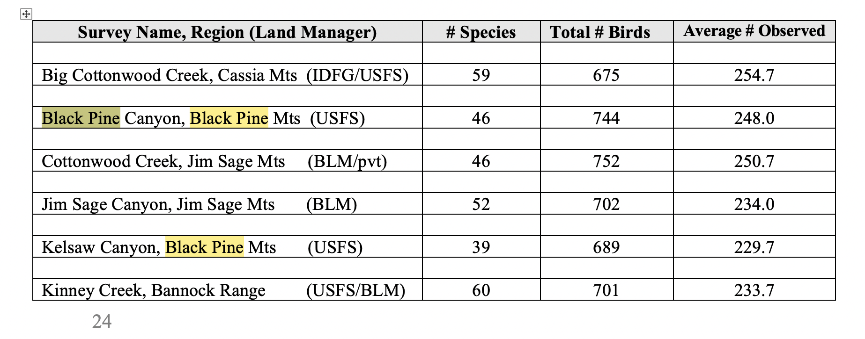
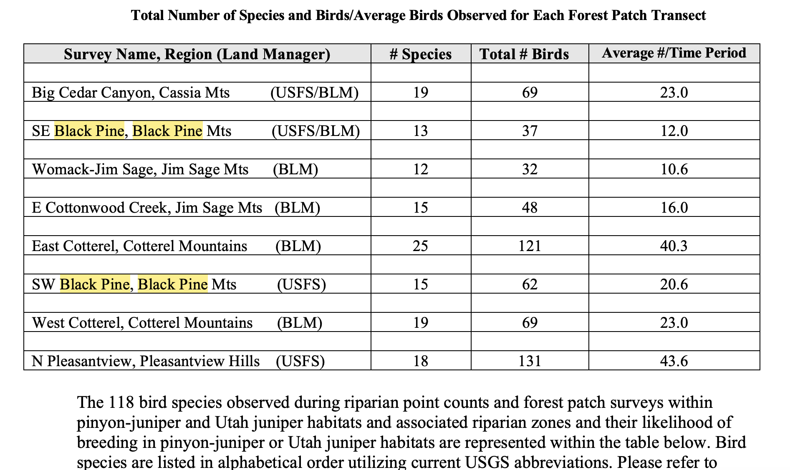

Black Pine
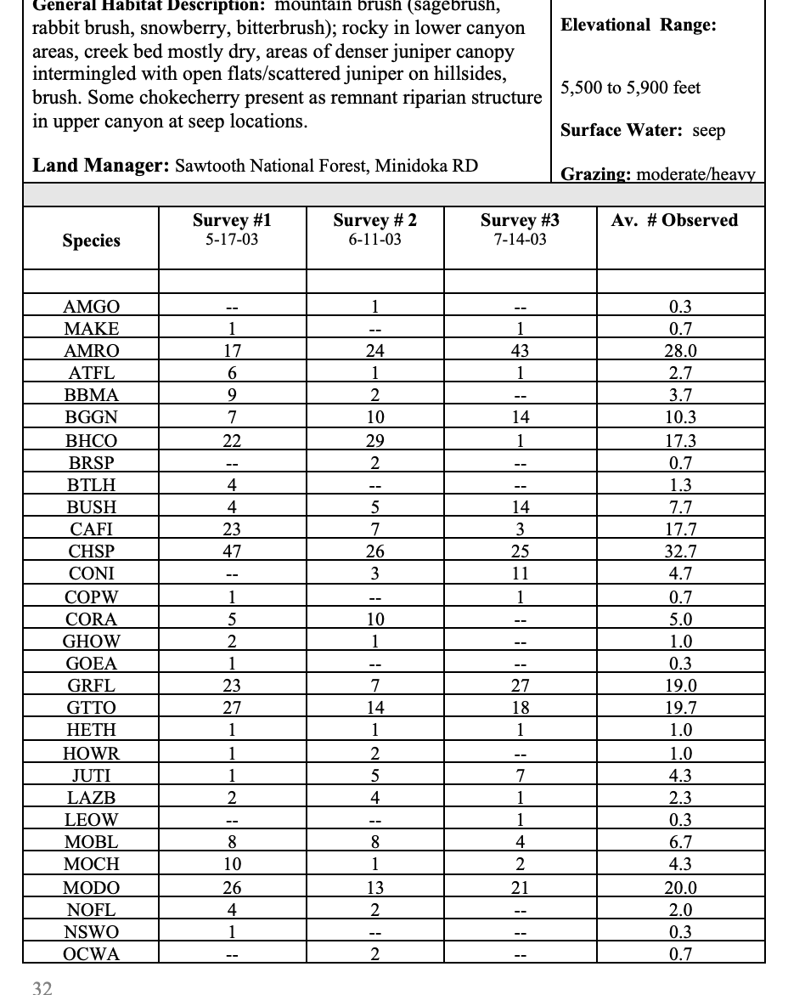
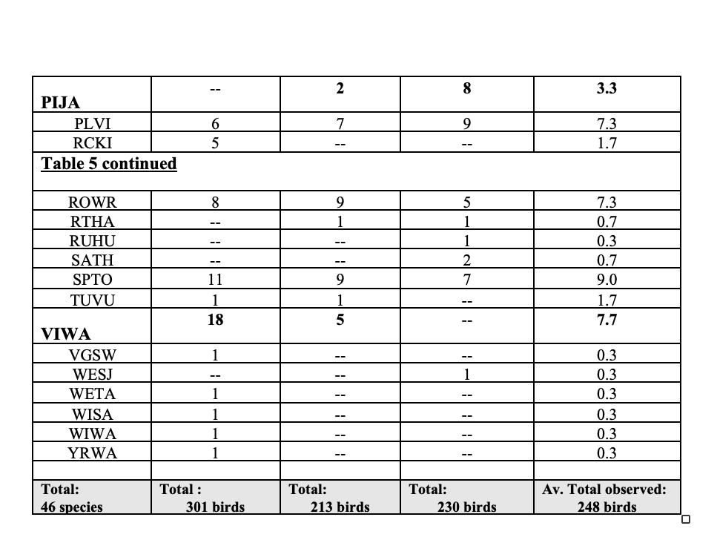
Well Questions
The FS states: “The location of wells in proximity to the Project area are shown in Figure 2-2. Exploration drilling completed to date did not encounter any measurable groundwater at depths between 300 and 700 feet below surface (Morrison-Knudsen, 1988; USFS, 1994; USFS, 2024). The wells identified in the area average approximately between 100 and 550 feet deep. Irrigation wells in the alluvial valley are between 300 and 500 feet and are generally deeper than wells located along the base of the Black Pine Range, which are approximately between 300 and 400 feet deep. One domestic well (Romero) drilled in 1999 has a finished depth of 100 feet. Depths to water vary between 100 to 250 feet according to well log information. Direct measurement of the Mine Well in September 2017 indicated a static water level of 163 feet below ground surface (BLM, 2022; USFS, 2024). The Gold Mine (Duvall) Well drilled in 1952, reported a static water depth of 228 feet. No recent water level data exists to indicate if the depth to water has remained static or if water levels have changed”.
WHY isn’t there current information this? It must be collected for the DEIS. The FS/BLM allowed these lands to be torn to pieces piecemeal yet never established any baseline to detect changes. This appears to much negligence.
Please explain what causes the difference between all the wells drilled recently, and are than the areas 2017 and 1952.
Did exploratory drilling drill holes hit groundwater? If so, please provide information on depths at all locations encountered.
How have agencies ensured that capped and sealed drill holes stay capped and sealed? How often is this checked – there appear to be so many drill holes into the earth here that there may be thousands of sites. How many holes were drilled at each drill pad site for which records have been kept? Was drilling horizontal or vertical? How many holes of each type were drilled at sites, and where? Will blasting in the area potentially break up the material used to seal wells? What can uncap wells? Earthquakes? More drilling changing pressures in various water lenses or aquifer types?
Some Additional Questions/Concerns Regarding Water Use and Aquifers Impacts
How will the BLM and FS ensure that harmful, adverse and degrading effects of the project will be mitigated sufficiently?
How much water will be needed for all phases of the project? Do the mine’s water rights cover this?
What is the recharge rate of the local and regional aquifers?
The document refers to the water source as a ‘private well”. Is it owned by this mining company or another party? Where is it located? How deep is it? Is there a pipeline to it? Is there a fallback plan if the well goes dry?
How much water will be required for all aspects of the project, and all phases? Please include dust suppression, processing, any rehab water use, etc.
How will FS/BLM ensure adequate bonding is provided for the date far in the future when reclamation and closure will take place?
How much, and what kind, of irreversible losses will there be?
Will there be aquifer drawdown, and if so, how much and what will the contours be?
Drawdown caused by dewatering is imposed on top of the natural water table and its fluctuations. In areas with significant natural fluctuation, drawdown may simply increase the time that the stream or spring is dry, which is just as important as causing a perennial source to go dry.
Please fully analyze the effectiveness of each mitigation for any springs and streams and existing water rights.
What mitigation measures may limit impacts of flow reduction or loss?
Are there any potentially impacted springs or seeps on federal lands? On Weeks act lands? How will flows be maintained?
The project must fully protect reserved water rights, waters, springs and water holes, related withdrawn lands, and public uses of these lands and waters, violates PWR 107, the SHRA, and BLM’s duty under FLPMA to “by regulation or otherwise, take any action necessary to pre- vent unnecessary or undue degradation of the [public] lands.” 43 U.S.C. § 1732(b).
BLM must also review and fully protect these resources pursuant to FLPMA’s mandate that: “the public lands be managed in a manner that will protect the quality of scientific, scenic, historical, ecological, environmental, air and atmospheric, water resource, and archeological values.” 43 U.S.C. § 1701(a)(8). The FS must do the same for its applicable regulations.
Will there be arsenic, antimony or other toxic minerals released from backfilled waste rock? Will the waste rock be acid-generating?
What is the water quality at existing mine wells?
Will the waste rock be placed on lands chiefly valuable for minerals? How was the value of the proposed waste rock site identified?
Additional Significant Migratory Bird Concerns
The little very dry “sky island” ranges in SE Idaho region may be important for migrating birds. For example, the Pleasantview Hills Range was shown to be important when so many migratory birds were found drowned in cattle water tanks. This is part of the reason why we’re so concerned about mine toxics in water at mine facilities, any leach and waste ponds, etc.
Please provide detailed analysis of all the ways this operation will directly, indirectly, and cumulative “take” migratory birds and raptors. Please assess a wide and effective range of measures to identify and ensure adequate mitigation measures.
What does radar show about migration over the Black Pine Range?
The FS and BLM must:
(1) support the conservation intent of the migratory bird conventions by integrating bird conservation principles, measures, and practices into agency activities and by avoiding or minimizing, to the extent practicable, adverse impacts on migratory bird resources when conducting agency actions;
(2) restore and enhance the habitat of migratory birds, as practicable;
(3) prevent or abate the pollution or detrimental alteration of the environment for the benefit of migratory birds, as practicable;
(4) design migratory bird habitat and population conservation principles, measures, and practices, into agency plans and planning processes (natural resource, land management, and environmental quality planning, including, but not limited to, forest and rangeland planning, coastal management planning, watershed planning, etc.) as practi-cable, and coordinate with other agencies and nonfederal partners in planning efforts;
(5) within established authorities and in conjunction with the adoption, amendment, or revision of agency management plans and guidance, ensure that agency plans and ac- tions promote programs and recommendations of comprehensive migratory bird plan- ning efforts such as Partners-in-Flight, U.S. National Shorebird Plan, North American Waterfowl Management Plan, North American Colonial Waterbird Plan, and other planning efforts, as well as guidance from other sources, including the Food and Agri- cultural Organization’s International Plan of Action for Reducing Incidental Catch of Seabirds in Longline Fisheries;
(6) ensure that environmental analyses of Federal actions required by the NEPA or other established environmental review processes evaluate the effects of actions and agency plans on migratory birds, with emphasis on species of concern;
(7) provide notice to the Service in advance of conducting an action that is intended to take migratory birds, or annually report to the Service on the number of individu- als of each species of migratory birds intentionally taken during the conduct of any agency action, including but not limited to banding or marking, scientific collecting, taxidermy, and depredation control;
(8) minimize the intentional take of species of concern by: (i) delineating standards and procedures for such take; and (ii) developing procedures for the review and evaluation of take actions. With respect to intentional take, the MOU shall be consistent with the appro- priate sections of 50 C.F.R. parts 10, 21, and 22;
(9) identify where unintentional take reasonably attributable to agency actions is hav- ing, or is likely to have, a measurable negative effect on migratory bird populations, focusing first on species of concern, priority habitats, and key risk factors. With respect to those actions so identified, the agency shall develop and use principles, standards, and practices that will lessen the amount of unintentional take, developing any such conservation efforts in cooperation with the Service. These principles, standards, and practices shall be regularly evaluated and revised to ensure that they are effective in lessening the detrimental effect of agency actions on migratory bird populations. The agency also shall inventory and monitor bird habitat and populations within the agency’s capabilities and authorities to the extent feasible to facilitate decisions about the need for, and effectiveness of, conservation efforts;
(10) within the scope of its statutorily-designated authorities, control the import, export, and establishment in the wild of live exotic animals and plants that may be harmful to migratory bird resources;
(11) provide training and information to appropriate employees on methods and means of avoiding or minimizing the take of migratory birds and conserving and re- storing migratory bird habitat.
Moreover, BLM and USFS have additional responsibilities under MOUs with USFWS.
As part of FLPMA and NFMA compliance, agencies must ensure that all aspects of the Black Pine project comply with the applicable RMPs and Forest Service plans, including any Amendments such as for the Greater Sage Grouse.
Full and detailed hard look visual analysis using adequate Key Observation Points must be provided.
Roading
Where are any roadless areas in the Black Pine Range located? If there are any, what is their condition?
What is the status of current USFS and BLM Travel Plans in the area?
Has Burley BLM ever done a travel plan? If any travel plans exist, ho have agencies dealt with compliance?
How have agencies monitored compliance with route closures and travel plans? Where are all unauthorized routes in this Black Pine landscape? Roads fragment and degraded wildlife habitats, serve as conduits for weeds to invade, and increase human disturbance and displacement of wildlife – as well as increase risk of human-caused fires.

Sincerely,
/KF
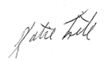
Katie Fite
WildLands Defense
PO Box 125 Boise, ID 83701
katie@wildlandsdefense.org

Please provide the drawdown by feet., not by 10 ft. intervals, as some miners try to get away with.

