IDAHO GOVERNOR’S OFFICE OF ENERGY & MINERAL RESOURCES
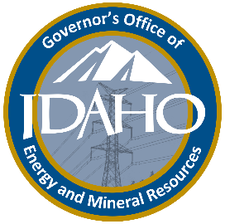
BRAD LITTLE 304 N. 8th Street, Suite 250
Governor P.O. Box 83720
Boise, Idaho 83720-0199

CALLY YOUNGER (208) 332-1660
Administrator FAX (208) 332-1661

March 6, 2026

United States Forest Service
Glenwood Brittain
11 Casey Rd
North Fork, Idaho 83466

Subject: State of Idaho Comments on the 2026 North Fork Sheep Creek Placer Project

Thank you for the opportunity to provide comments on Mr. Hoover’s (Proponent) scoping notice for the 2026 North Fork Sheep Creek Placer Project (Project) Environmental Assessment. These comments were developed in coordination with Idaho State Historical Preservation Office (SHPO), Idaho Department of Water Resources (IDWR), Idaho Department of Fish and Game (IDFG), Idaho Department of Parks and Recreation, and Idaho Governor’s Office of Energy and Mineral Resources (OEMR). OEMR submits these comments on behalf of the State of Idaho pursuant to its authority to lead coordination of state comments on documents and processes involving energy and mineral projects and regulation in accordance with Executive Order 2024-09.

Idaho State Historic Preservation Office

SHPO is responsible for consulting with federal agencies and project proponents to consider what effects their actions may have on historic properties, including archaeological sites and the built environment. SHPO is part of the Idaho State Historical Society established under Idaho Code Title 67, Chapter 41. These comments and recommendations are submitted pursuant to that authority.

USFS should initiate consultation with SHPO. It is recommended that the federal agency contact SHPO early in the process to discuss their obligations under 36 CFR Part 800. Consultation requests should be submitted to SHPO through the Idaho Cultural Resource Information System (ICRIS).

Helpful links to start consulting with the SHPO:
- ICRIS information and tutorial videos: https://history.idaho.gov/shpo/icris/
- How to create and submit a project in ICRIS: https://history.idaho.gov/shpo/icris/guidance/
- Questions can be emailed to: shpo@ishs.idaho.gov

Idaho Department of Water Resources

IDWR appreciates the opportunity to comment on the scoping notice for the Project Environmental Assessment. IDWR’s mission is to serve the citizens of Idaho by ensuring that water is conserved and available for the sustainability of Idaho’s economy, ecosystems, and resulting quality of life pursuant to Idaho Code Title 42, Chapter 2.

IDWR has authority for the state-wide administration of the rules governing well construction and the licensing of drillers in Idaho. IDWR’s Well Construction Standards Rules IDAPA 37.03.09, specifically exempts certain borings from driller licensing and drilling permit requirements, however, those exempt borings still must be decommissioned in accordance with well construction standards and using approved seal material. Refer to IDAPA 37.03.09.45 for more information.

The Idaho Stream Channel Protection Act requires that the stream channels of the State and their environment be protected against alteration for the protection of fish and wildlife habitat, aquatic life, recreation, aesthetic beauty, and water quality. IDWR must approve, in advance, any work being done within the beds and banks of a continuously flowing stream. This Project may include the potential need to file permits such as a Joint Application for Stream Channel Alteration Permit (U.S. Army Corps of Engineers, Idaho Department of Lands, and IDWR), a Letter Permit, and/or an Application for Temporary Water Use.

Additional information can be found on the IDWR website at www.idwr.idaho.gov. For assistance with the Joint Application, the Stream Channel Protection group can be reached at the IDWR State Office at (208) 287-4800. For all other questions, please contact the Eastern Regional Office at (208) 525-7161.

Idaho Department of Fish and Game

Resident fish and wildlife species are the property of the State of Idaho and are managed for the benefit of its citizens. IDFG and the Idaho Fish and Game Commission are statutorily charged with preserving, protecting, perpetuating, and managing all fish and wildlife in Idaho pursuant to Idaho Code Title 36, Chapter 1. In fulfillment of this responsibility, IDFG offers the following comments and recommendations. IDFG’s comments are intended to provide technical assistance regarding potential impacts to wildlife, fisheries, and habitats, as well as to recommend measures to avoid, minimize, or mitigate adverse effects.

General
The area surrounding the proposed Project supports a diversity of priority fish and wildlife species such as big game, Idaho Species of Greatest Conservation Need (SGCN), Species of Conservation Concern (SCC), and fish protected by the federal Endangered Species Act (ESA). In addition to priority species, the area surrounding the Project is of significance to multiple user groups, including outfitters with permits, grazing permit holders, hikers, hunters and fishermen, and motorized and non-motorized users.

IDFG recommends USFS apply the full mitigation hierarchy to manage potential effects on wildlife from mine development and operations. The Proponent should consider Project siting, design, and operations that would avoid, minimize, and mitigate adverse effects on priority wildlife resources and associated wildlife-based recreation, including hunting, fishing, and trapping. USFS should consider the following in order of priority and potential effectiveness:
- Implementation of avoidance measures early in Project development offers the most effective protection for priority fish and wildlife. Project siting decisions and activity schedules that emphasize avoidance of adverse effects on priority fish and wildlife are central elements of mitigation strategies.
- Project design and best management practices for construction and operations contribute to minimizing adverse effects on priority resources.
- Compensatory mitigation is the least favored method for mitigating project effects and should be considered only when avoidance and minimization measures are exhausted. When compensatory mitigation is required or offered, as appropriate, IDFG technical assistance is intended to support efforts to offset unavoidable, residual adverse effects.

Elk and Mule Deer
Based on IDFG collar data, the proposed Project is located in a crucial winter range and migration corridor for elk and summer range for mule deer, which are particularly vulnerable to human disturbances. The proposed Project (e.g., roads, excavation, and other mining activities, etc.) can displace elk and mule deer from otherwise preferred habitats, thereby fragmenting and reducing habitat effectiveness, increasing energy expenditures, decreasing survival and reproduction, and causing long-term population impacts (Cole et al. 1997, Cook et al. 2004, Cook et al. 2013, Cook et al. 2016, Davidson et al. 2012, Lyon 1979, Lyon 1983, Naylor et al. 2009).

For example, the nutritional status of does and cows can be degraded by displacement from quality habitats, which can then impair population performance by decreasing reproductive success, fawn/calf survival, and overall survival across a larger contiguous area. Elk, in particular, are susceptible to roads and motor vehicle traffic (Wisdom et al. 2004, Wisdom et al. 2005, Montgomery et al. 2013). In areas with high road/ATV trail densities, elk exhibit higher levels of stress and increased movement rates (Rowland et al. 2005, Naylor et al. 2009).

To mitigate these impacts, IDFG recommends USFS and the Proponent analyze potential Project effects on elk and mule deer populations within and surrounding the Project. USFS and the Proponent should identify and assess measures to avoid, minimize, or mitigate near-term, long-term, and cumulative adverse Project effects on elk and mule deer (e.g., ATV and vehicular motorized activities should not occur between November 1st - May 15th to avoid disturbing ungulates on winter range). The project operating season is scheduled to start on June 1st and end on October 31st, which should address most of the migration and winter range issues, however, it does not address the mule deer and elk summer range concerns.

Idaho Protected Species
The proposed Project lies within known ESA-listed species ranges, including Chinook salmon, steelhead and bull trout, Canada lynx and candidate species, wolverine. Bull trout have been documented in Pruvan Creek, a tributary to Sheep Creek. In Sheep Creek, Chinook salmon, steelhead trout, and bull trout have been recorded extensively. Other SGCN that may be detected within the proposed Project Area include Western Bumble Bee, Suckley’s Cuckoo Bumble Bee, Morrison’s Bumble Bee, Hoary Bat, Fisher, Lolo Mayfly, Western Toad, Great Gray Owl, and Silver-haired Bat.

IDFG recommends USFS analyze potential project effects on ESA, SGCN and SCC species within and immediately surrounding the Project. If an ESA-protected species, SGCN, or SCC is found near the Project (including redds, active dens, nests, maternity colonies, individual plants or growing sites, etc.), the adaptive USFS design feature or best management practices should be implemented by USFS immediately.

Undesirable Weeds
The Project may propagate undesirable weeds. Undesirable weeds (e.g., invasive annual grasses and noxious weed species) are a leading cause of wildlife habitat degradation in the West. Further expansion of these undesirable species will cause habitat degradation and fragmentation.

USFS should consider additional design elements to address the spread of noxious weeds and annual invasive grasses. IDFG recommends USFS analyze the potential effects of propagating undesirable weeds in the areas within and surrounding the Project. USFS should work with the Proponent to perform pre- and post-project monitoring and treatment (for at least three years, if feasible) of invasive plant species (i.e., invasive annual grasses and noxious weed species). IDFG recommends USFS and the Proponent treat the area if any noxious weeds or invasive annual grasses are detected.

Water
In addition to any permits and approvals from IDWR to access water from or modify Pruvan Creek and the North Fork of Sheep Creek, the Proponent is required to have a properly functioning National Oceanic and Atmospheric Administration (NOAA) criteria fish screen at the point of diversion. IDFG recommends USFS apply the 2022 National Marine Fisheries Service requirements for pump intake screens and drafting instream work. The proposed project drafting sites may also need to adhere to a minimum streamflow requirement for their chosen waterbody. Additionally, USFS should apply NOAA fisheries best management practices to mitigate potential adverse impacts to aquatic species.

Idaho Department of Parks and Recreation

IDPR’s mission is to improve the quality of life in Idaho through outdoor recreation and resource stewardship pursuant to Idaho Code Title 67, Chapter 42.

The Proponent’s plans to use a series of existing roads and trails to access the site are not compatible with the existing infrastructure in the area. From Big Hole Pass, the Proponent plans to use NFS Roads #60079 and #60078 to reach the Idaho border on the east side of Morgan Mountain (left, red route on Figure 1). The Proponent then plans to travel “…down Bradley Gulch on the Idaho State side” and then down a “non-system jeep trail for approximately 0.60 miles, connecting to the Sheep Creek Trail (NFS Trail #6126)”. The Proponent must clarify their intended route, as there is not any road or trail, system or non-system, currently connecting NFS Road #60078 and NFS Trail #6126 (Figure 1). NFS Trail #6111 is not a feasible alternative, as it is a section of the Continental Divide National Scenic Trail (CDT) through Montana that is closed to all motorized use. Currently, IDPR is aware of only one means of motorized access to NFS Trail #6126, an undetermined road (right, orange route on Figure 1) coming from Beaverhead-Deerlodge National Forest in Montana. The Proponent will need to clarify their plan for connecting with NFS Trail #6126 from NFS Roads #60079 and #60078, as the current plan appears to require securing cross-country motorized access authorization separately from Beaverhead-Deerlodge National Forest in Montana before any decision can be made on how to manage Proponent's access in Salmon-Challis National Forest in Idaho.

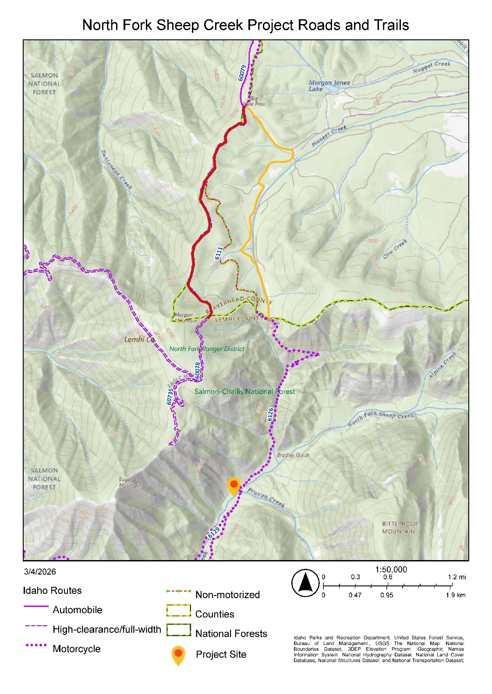
Figure 1: Map of NFS roads and trails in the area surrounding the Project site. The Proponent’s proposed route to enter Idaho is via NFS Roads #60078 and #60079 in red, while the only motorized means of access to NFS Trail #6126 is on an undetermined road in Montana, in orange. NFS Trail #6111 is the non-motorized Continental Divide Trail.

IDPR is concerned about potential impacts to NFS Trail #6126. IDPR Motorized Trail Program staff have been actively collaborating with USFS North Fork Ranger District staff over the last seven years, planning for improvements to NFS Trail #6126. NFS Trail #6126 is presently authorized only for single-track use on the Idaho side of the Idaho-Montana border and would require significant improvements to accommodate >50” or full-width vehicles. IDPR Motorized Trail Program maintenance contributions to Trail #6126 stretch back decades, fostering public access and sustainability. These investments and improvements will be impacted if Trail #6126 is widened to full-width-use purposes for actions proposed by the Proponent.

Furthermore, NFS Trail #6126 is coincident with the CDT along Sheep Creek. The 2009 CDT Comprehensive Plan recommends that the CDT only be coincident with a road “…where it is primitive and offers recreational opportunities comparable to those provided by a trail with a Designed Use of Pack and Saddle Stock” (United States Forest Service 2009, Page 8). As such, expanding NFS Trail #6126 to accommodate the Proponent’s proposed actions would contradict the 2009 CDT Comprehensive Plan. IDPR recommends that no modifications are implemented on NFS Trail #6126 and that it remains of single-track character. For more information on existing NFS Trails and Roads, see the IDPR Trails GIS Experience: https://arcg.is/vm4nz2

The State of Idaho appreciates the opportunity to submit these comments. Please feel free to contact me should you have any questions.

Sincerely,
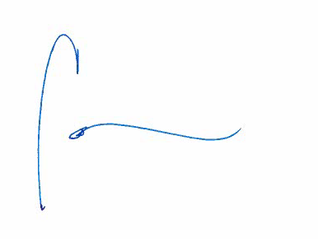
Cally Younger
Administrator
Idaho Governor’s Office of Energy and Mineral Resources

Literature Cited

Cole, E. K., M.D. Pope, and R.G. Anthony. 1997. Effects of road management on movements and survival of Roosevelt elk. Journal of Wildlife Management 61:115-1126.
Cook, J.G., B. K. Johnson, R.C. Cook, R.A. Riggs, T. Delcurto, L.D. Bryant, and L. L. Irwin. 2004. Effects of summer-autumn nutrition and parturition date on reproduction and survival of elk. Wildlife Monographs 155:1-61.
Cook, R.C., J.G. Cook, D.J. Vales, B.K. Johnson, S.M. Mccorquodale, L.A. Shipley, R.A. Riggs, L.L. Irwin, S.L. Murphie, B.L. Murphie, K.A. Schoenecker, F. Geyer, P.B. Hall, R.D. Spencer, D.A. Immell, D.H. Jackson, B.L. Tiller, P.J. Miller, and L. Schmitz. 2013. Regional and Seasonal Patterns of Nutritional Condition and Reproduction in Elk. Wildlife Monographs 184:1-44.
Cook, J.G., R.C. Cook, R.W. Davis, and L. L. Irwin. 2016. Nutritional Ecology of Elk During Summer and Autumn in the Pacific Northwest. Wildlife Monographs 195:1-81.
Davidson, G.A., B.K. Johnson, J.H. Noyes, B.L. Dick, and M.J. Wisdom. 2012. Effects of archer density on elk pregnancy rates and conception dates. Journal of Wildlife Management 76: 1676-1685.
Lyon, L.J. 1979. Habitat effectiveness for elk as influenced by roads and cover. Journal of Forestry 79:658-660.
Lyon, L.J. 1983. Road density models for describing habitat effectiveness for elk. Journal of Forestry 81:592-595.
Montgomery, R.A., G.J. Roloff, and J.J. Millspaugh. 2013. Variation in elk response to roads by season, sex, and road type. Journal of Wildlife Management 77(2):313-325.
Naylor, L.M., M.J. Wisdom, and R.G. Anthony. 2009. Behavioral response of North American elk to recreational activity. Journal of Wildlife Management 73(3):328-338.
Rowland, M.M., M.J. Wisdom, B.K. Johnson, and M.A. Penninger. 2005. Effects of Roads on Elk: Implications for Management in Forest Ecosystems. Pages 42-52 in M.J. Wisdom, technical editor. The Starkey Project: a synthesis of long-term studies of elk and mule deer. Reprinted from the 2004 Transactions of the North American Wildlife and Natural Resources Conference, Alliance Communications Group, Lawrence, Kansas.
United States Forest Service. 2009. The 2009 Continental Divide National Scenic Trail Comprehensive Plan.
Wisdom, M.J., H.K. Preisler, N.J. Cimon, and B.K. Johnson. 2004. Effects of off-road recreation on mule deer and elk. Transactions of the North American Wildlife and Natural Resource Conference 69.
Wisdom, M.J., A.A. Ager, H.K. Preisler, N.J. Cimon, and B.K. Johnson. 2005. The effects of off-road recreation on mule deer and elk. Pages 67-80 in M.J. Wisdom, technical editor. The Starkey Project: a synthesis of long-term studies of elk and mule deer. Reprinted from the 2004 Transactions of the North American Wildlife and Natural Resource Conference, Alliance Communication Group, Lawrence, Kansas.

