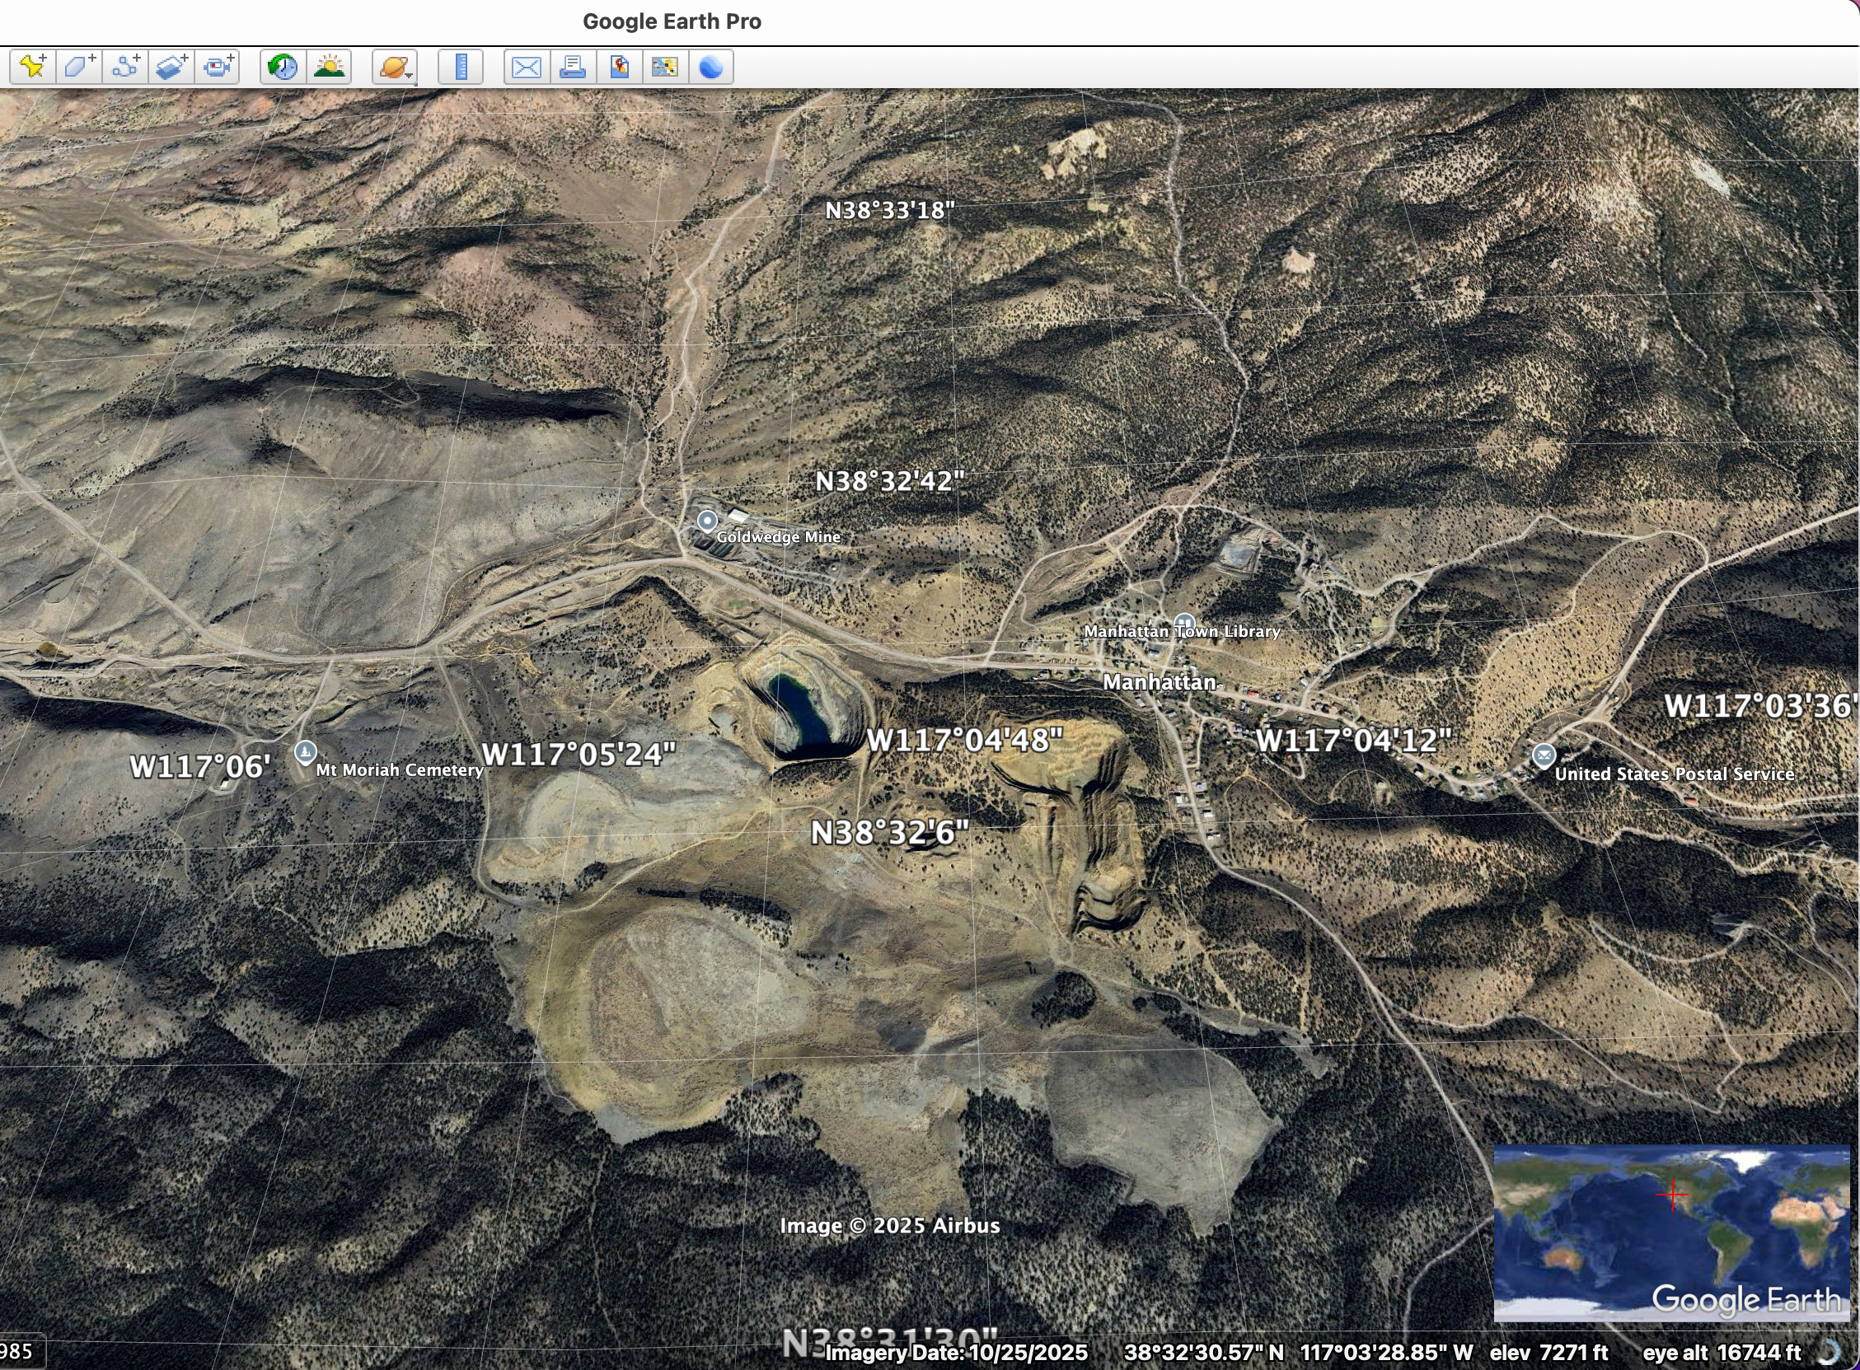
“Goldwedge” mining area disturbance is shown west of Manhattan, Currently, Scorpio Gold is claiming to be doing $50 million in drilling in this area. To the northwest of Manhattan is the Pegasus drilling site.

