The Manhattan townsite is shown on the bottom of this map, and the image shows the near-current mining surface and groundwater disturbance of the Round Mountain site. The project area lies between Manhattan and the Round Mountain mining disturbance.
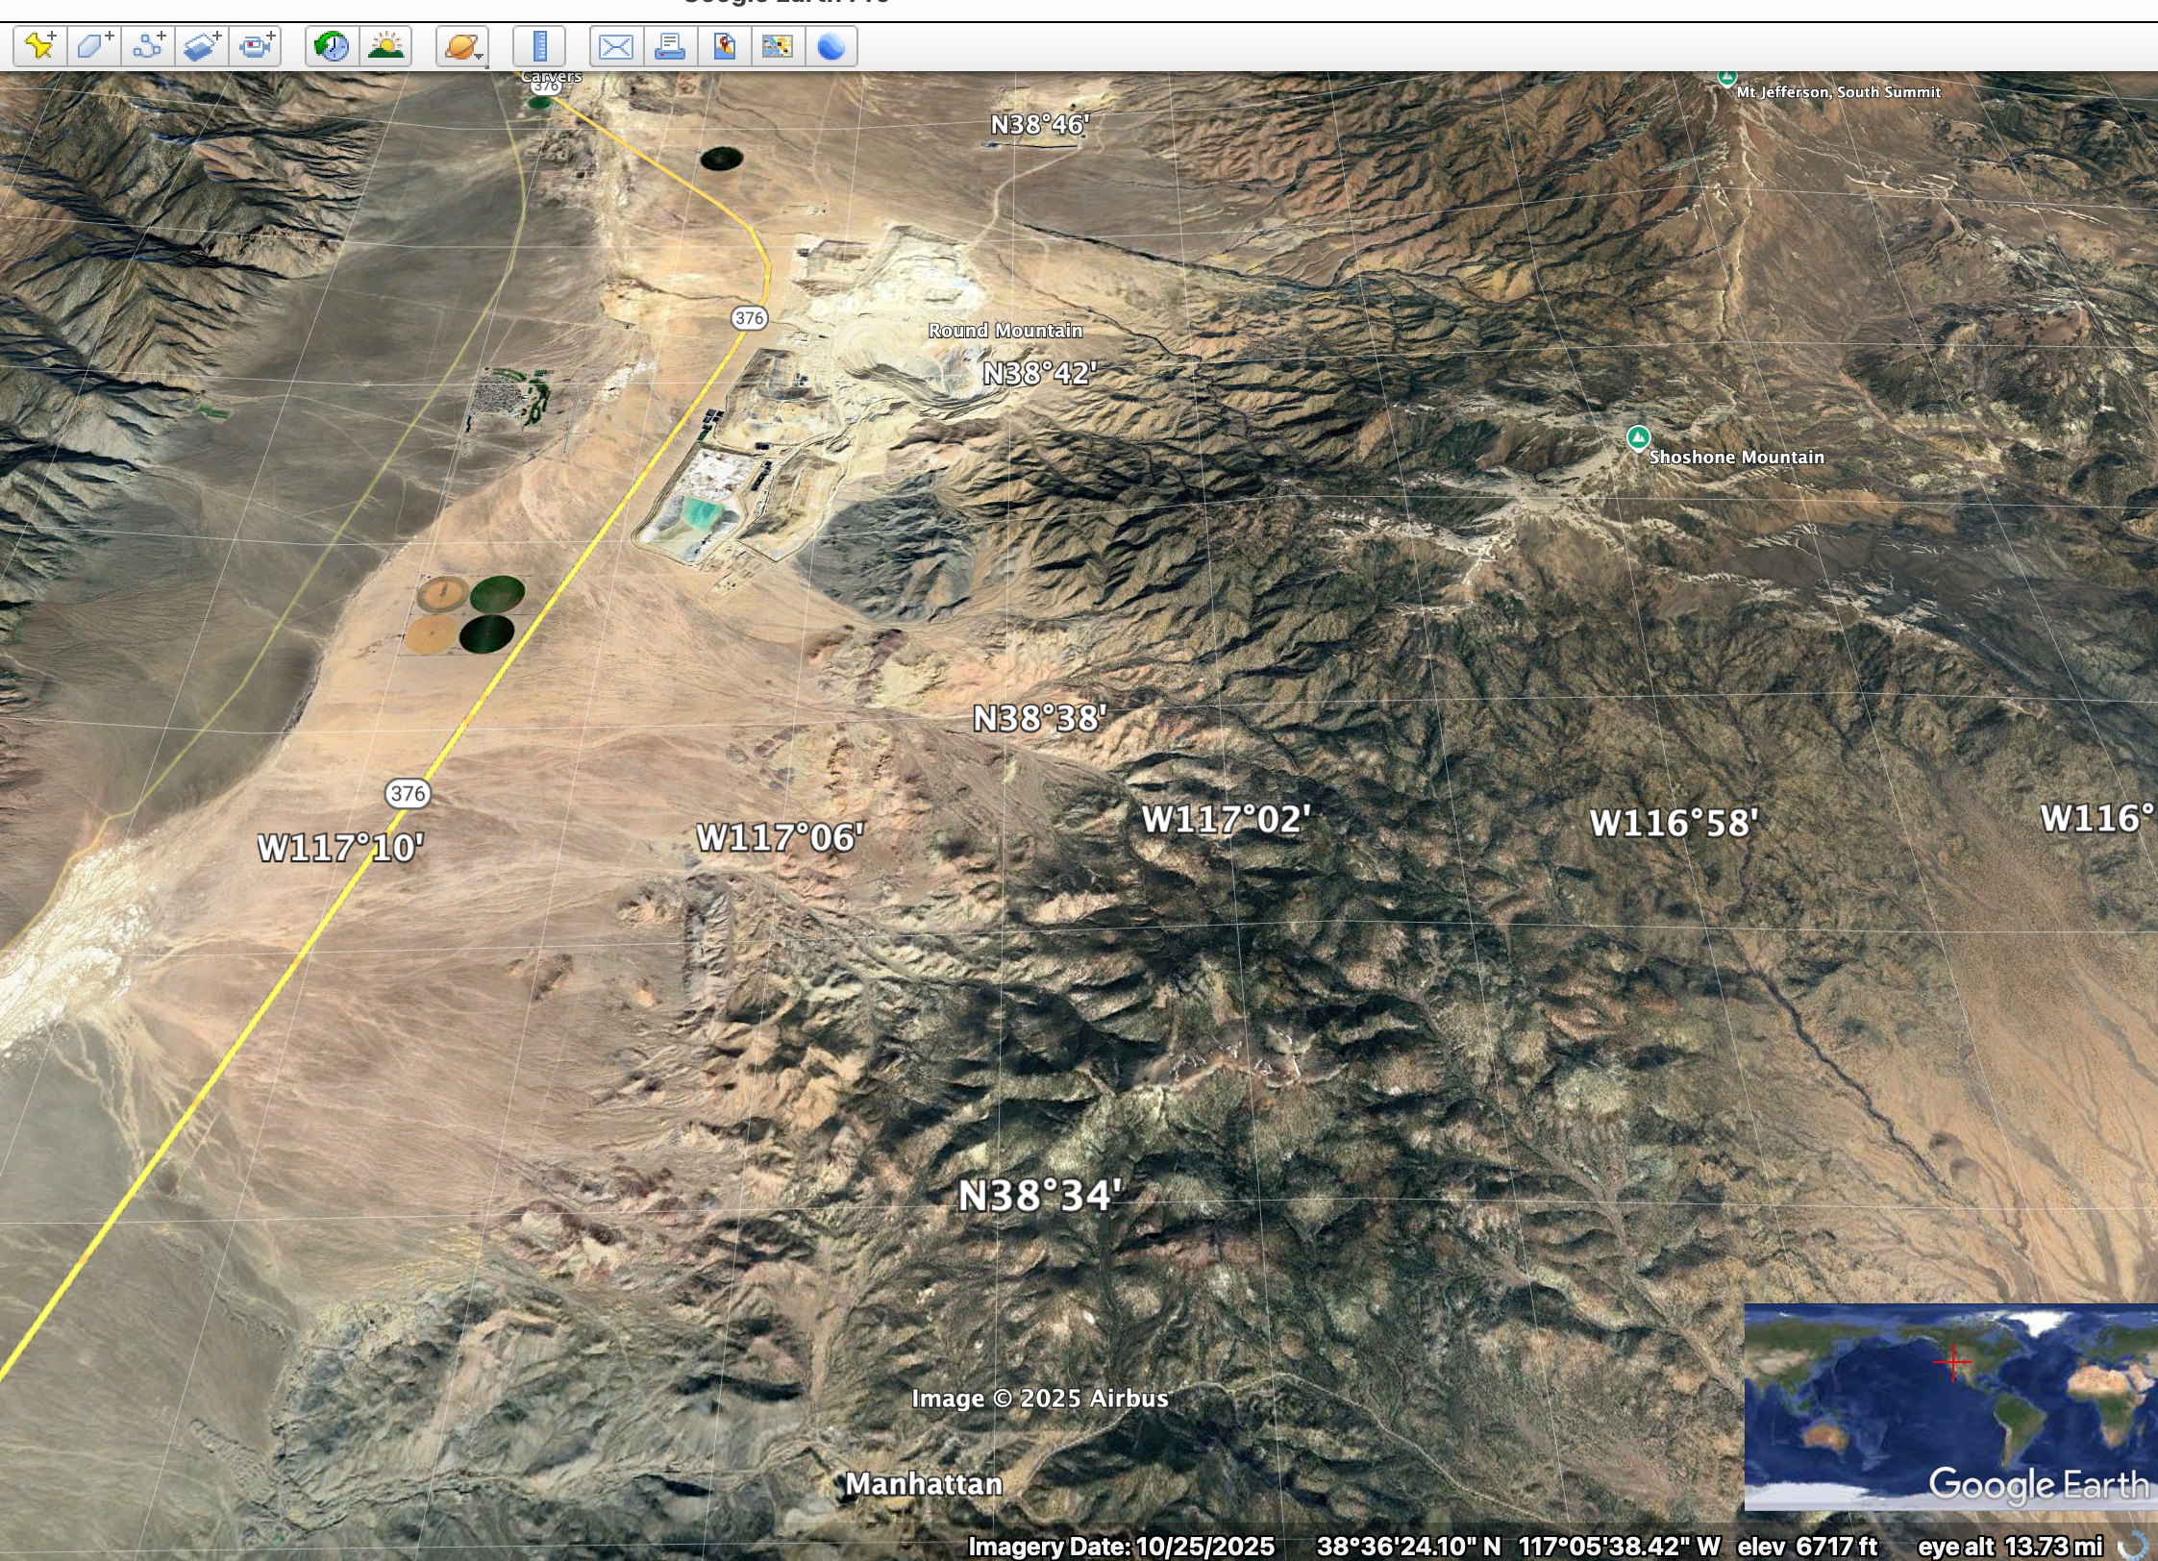
What is the current status of the groundwater basin in this area? Is it declining? Have BLM and the USFS and/or state officials been monitoring the water levels and flow rates at springs in this region? If so, where, and what are the results?

