January 17, 2026

Dear Forest Service,

Here are additional comments on the Pegasus EA regarding the brief mention of Lahontan Cutthroat Trout in the EA.

Please clarify if there any occupied LCT habitats, or unoccupied potential habitats or tributary drainage networks within the Pegasus project area. If so, what is the ecological condition of the habitat? What is the status of the LCT population? How many fish were present in the most recent NDOW or other surveys/inventories? Were surveys done for the Pegasus project?

Livestock grazing has a significant impact on both upland and riparian habitats, and may significantly compound and exacerbate the soil erosion, biocrust loss, weed risk, loss of native forbs, bunchgrasses and shrubs, and increase degradation of drainage networks and riparian habitats.

Livestock grazing affects LCT both directly and indirectly. These fish require well-vegetated and stable stream channels, clean gravel, cold water, and complex cover. Livestock grazing degrades these conditions, including by removing riparian vegetation, destabilizing stream banks, widening and incising stream channels, lowering water tables, reducing pool frequency, increasing soil erosion, and degrading water quality. These effects reduce cover, increase summer water temperatures, promote formation of anchor ice in winter, and increase sediment that suffocates redds (spawning nests) and irritates fish gills. Grazing harms LCT through these adverse habitat effects.

The ecological conditions of the uplands and tributary drainage networks is important in maintaining LCT stream habitat conditions.

A 2023 status review determined conditions were quite bad over much of the Reese River LCT habitats, including the Marysville and other nearby allotments.

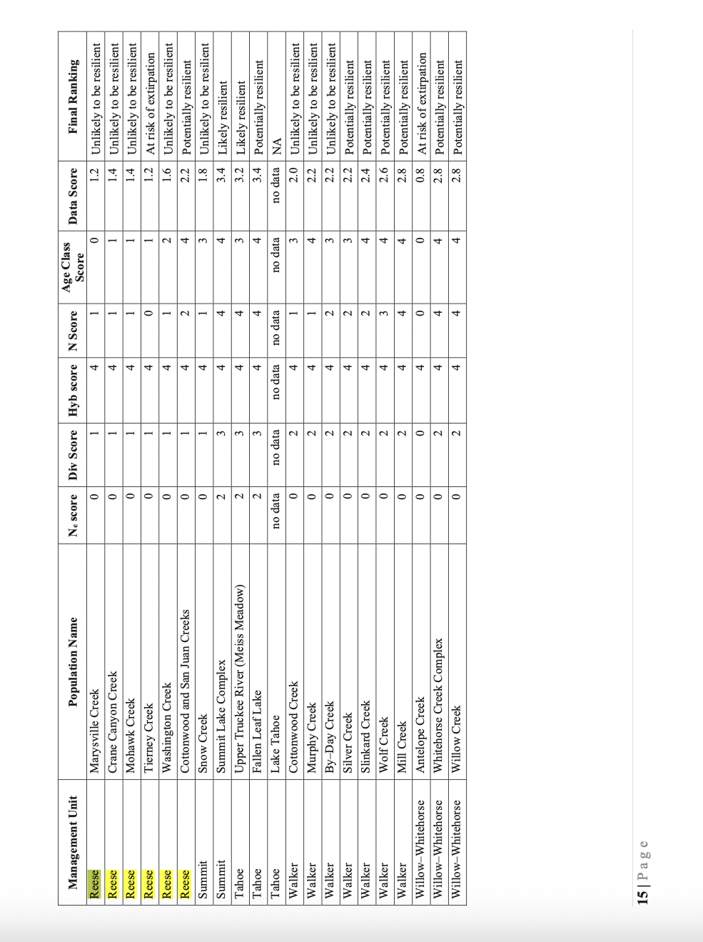

Grazing may cause unstable eroding streambanks/diownbcutting/gullying, erosion, sedimentation, lack of riparian vegetation regeneration, lowered water tables, and headcuts.

Are there exclosures in or near the project area constructed to protect springs, wet meadows, and riparian habitat on LCT-occupied streams. If so, hat is their condition and are they intact?
Livestock can also harm LCT by directly trampling on redds, which contain thousands of eggs. A single trampling incident can kill a majority of those eggs. Wading livestock also crush and dislodge vulnerable young, which remain in the gravels near the redd for weeks after hatching. Livestock access to LCT spawning habitat from April through at least July places redds at risk. Livestock displace juvenile fish from protective streamside cover, increasing the risk of predation, and harass spawning adult fish, causing them to move from their nests, disrupting spawning activities and forcing them to expend vital energy. This harm and take occurs or potentially occurs in the allotments at issue because permitted grazing seasons overlap potential spawning and rearing periods for LCT.
New scientific information on the importance of habitat recovery to LCT has emerged in recent years, as has increased recognition of the effects of climate change on salmonids including LCT. Drought has also increasingly negatively affected these species. Updated information on local populations of these species shows that some local populations have decreased in number, and other local populations have been extirpated.

We note that several populations in the Reese River sub-watershed disappeared between 2009 and 2018.What does the most recent data show about population persistence of LCT in Freese River streams?

Please conduct a hard look NEPA analysis of potential impacts of this prolonged drilling operation combined with ongoing livestock grazing.

One of our many concerns is that livestock use may be shifted and intensified into other areas of allotments outside the project area per se, as a result of drilling disturbance, or due to efforts to hasten reclamation to benefit the Pegasus drilling operation, etc. This means if there occupied LCT Habitats, or watersheds identified for LCT but where fish may have been wiped out, livestock use could worsen there, So a much more detailed NEPA hard look at grazing impacts and ecological conditions in this landscape must be taken.

Map from USFWS 2023 Status Review

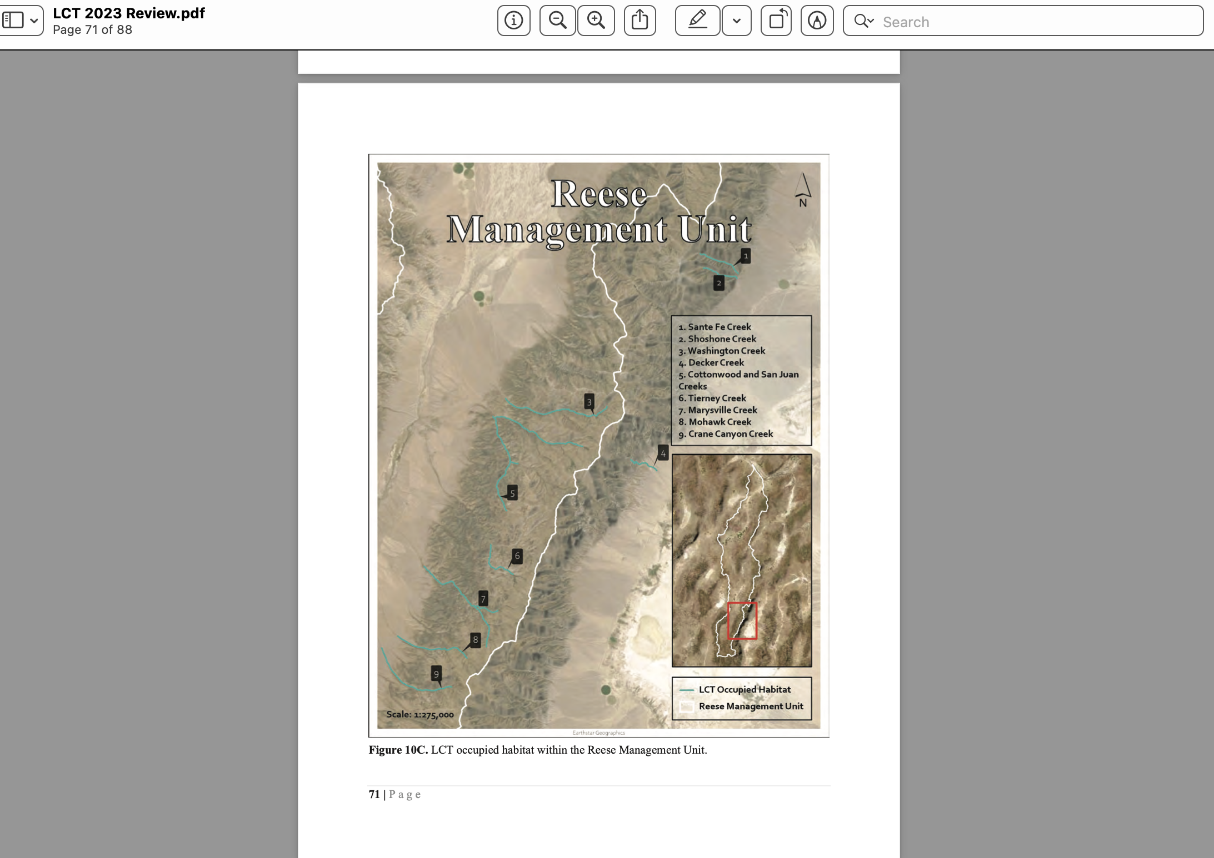

And again, we are concerned about sustainability of streams and springs in this landscape that is significantly threatened by existing historic and modern Kinross and other mega-mining impacts.

Sincerely,

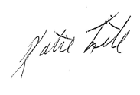

Katie Fite
Public Lands Director
WildLands Defense
PO Box 125
Boise, ID 83701
208-871-5738
katie@wildlandsdefense.org

