Locations of minerals permits newly acquired by Nexus Uranium, and boundaries of new proposed uranium exploration permit proposals (Chord Project, Deadhorse Project, Wolf Canyon Project).
- All three projects are located primarily on US Forest Service (federal) land.
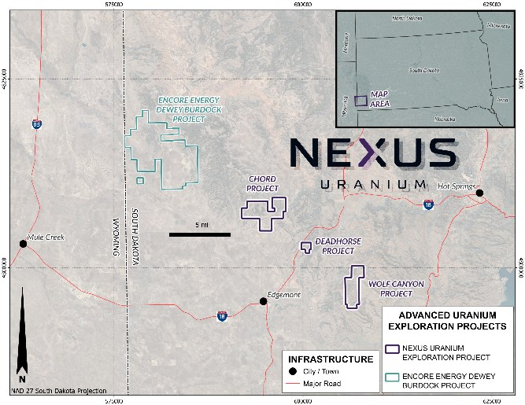

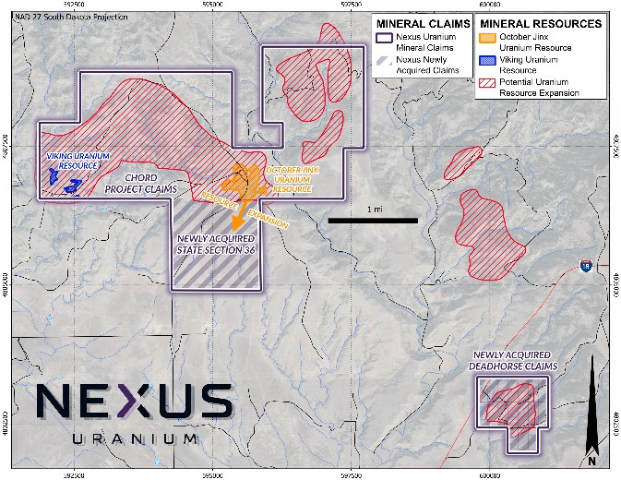

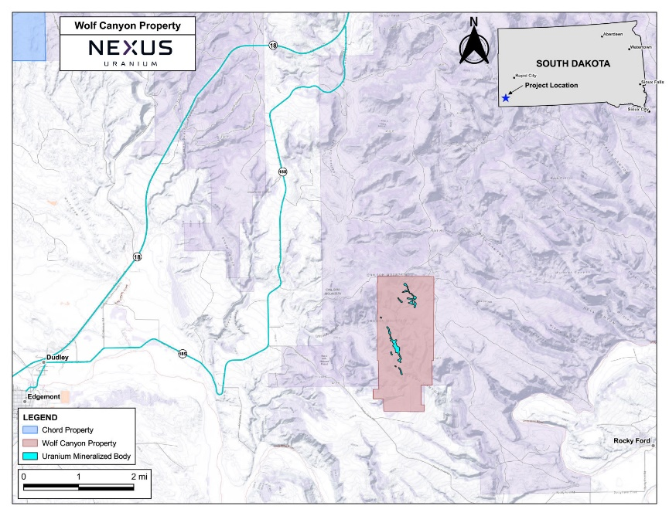

https://nexusuranium.com/projects/

