Appendix A

In a recent master’s thesis, using radio-telemetry, Eyes (2014) reported that California spotted owls in Yosemite National Park had a tendency to avoid high-intensity fire areas for foraging, contrary to the findings of Clark (2007) and Bond et al. (2009). Because the Eyes thesis makes a number of unsupported and misleading statements about the relationship between fires and owls, and because the Forest Service has used this thesis to promote post-fire logging, we address it here.

First, an inspection of Figure 2 of Eyes (2014) reveals that its conclusions about high-intensity fire do not follow from the data. Most of the study’s territories had no high-intensity fire (see Fig. 2 of Eyes 2014), and the only three territories that did show high-intensity fire areas appear to show use that exceeded availability in the home ranges (see the two territories immediately south of Highway 120, and the second most southerly territory, in Figure 2 of Eyes 2014). Moreover, Eyes (2014) underreported use of high-intensity fire areas by not divulging that numerous detection locations shown in Figure 2 of her thesis as low/moderate-intensity areas were actually in a large high-intensity fire patch from a 1990 fire that later reburned at low-moderate intensity, and this is complex early seral forest (e.g., compare Figure 2 of Eyes 2014 to Figure 2 of van Wagtendonk and Lutz 2007).

Based upon Figure 2 of Eyes (2014), and after including high-intensity fire areas (and associated detections) excluded by Eyes (2014) (using the same fire severity categories used by Eyes 2014), we conducted a GIS analysis of the detection points and fire severity within the three home ranges that contained high-intensity fire (Figures 33 and 34 below). The combined area in the 100% minimum convex polygons (MCPs) for those three is 843 hectares, including 184 hectares of high-intensity fire (21.8%). There are a total of 82 detection locations, with all three territories combined, that can be identified from Figure 2 of Eyes (2014) (it is possible that a small number of detection locations shown in Fig. 2 of Eyes 2014 had essentially complete overlap—i.e., were directly on top of one another—in which case we could have missed a few such points; however, this would be equally true for all fire severity categories). We assessed how many of the 92-meter detection location/uncertainty-buffer areas contain 21.8% or more high-intensity fire, and how many contain less than 21.8%. If there is no selection or avoidance of high-intensity whatsoever, one would expect 17.9 (out of the total of 82 detections) with 21.8% or more high-intensity fire (0.218 x 82 = 17.9). The actual number with 21.8% or more high-intensity fire is 21. So, use of high-intensity fire is numerically higher than expected based upon availability in the Eyes data, indicating some level of selection, not avoidance. A statistically robust analysis, however, would compare each owl’s selection for high-intensity fire within its own available habitat (e.g., foraging range circle, Bond et al. 2009), which has not been done with this dataset. Data may be insufficient given only three territories contained high-intensity fire.
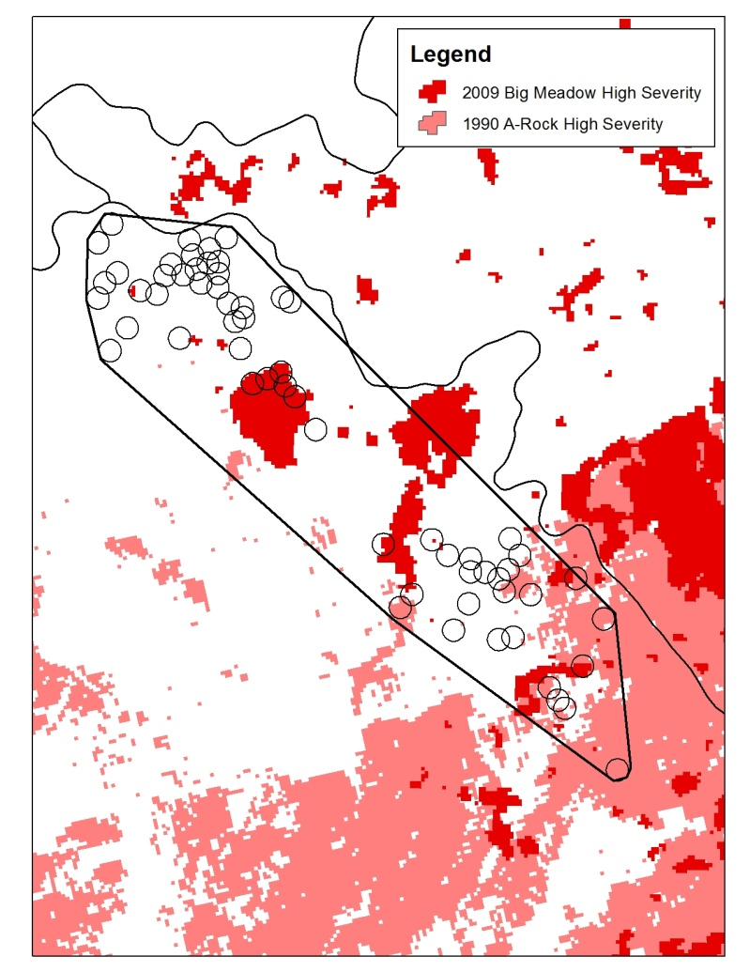
Figure 33. High-intensity fire areas in two spotted owl home ranges in Eyes (2014). The high-intensity fire areas (and associated detections) shown in light red were excluded by Eyes (2014).
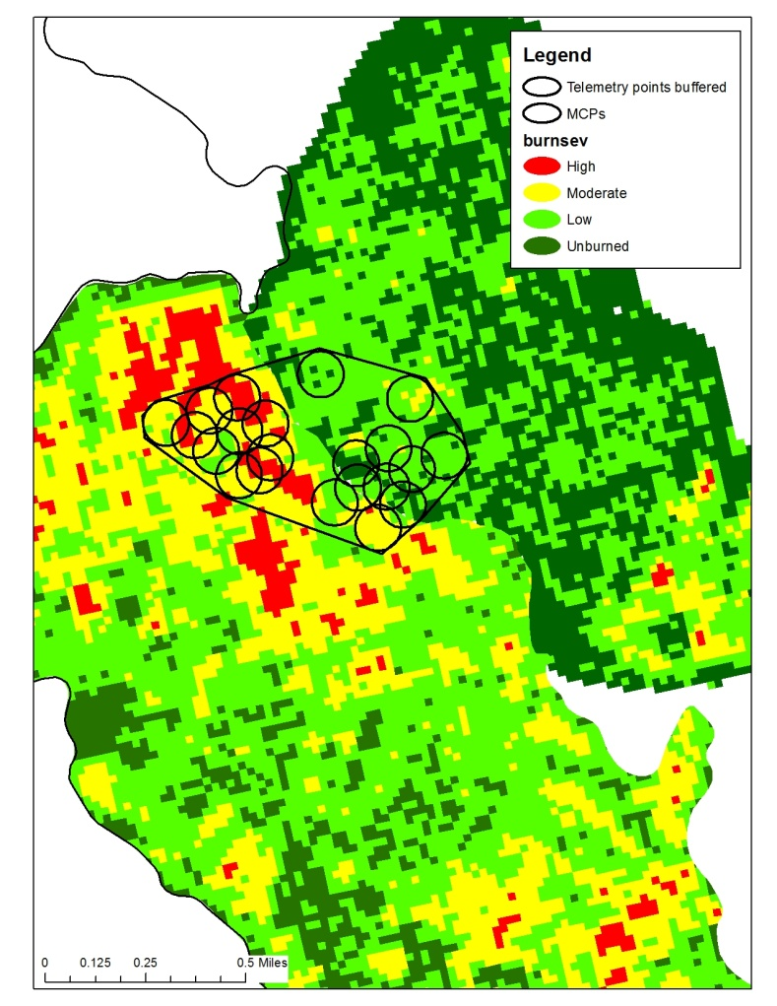
Figure 34. High-intensity fire areas, and detections, in the third territory with high-intensity fire in Eyes (2014).

The Eyes thesis also is suspect because it pooled all foraging and random locations in its analysis and did not analyze each owl independently. An owl-specific analysis has repeatedly been shown to be necessary because habitat use patterns vary among individual owls (Glenn et al. 2004, Bond et al. 2009, Williams et al. 2011). Eyes (2014) pooled all owl locations because she “did not expect owl foraging behavior to differ between sites, and thus did not treat owl identity as a random effect.” But Glenn et al. (2004), Bond et al. (2009), and Williams et al. (2011) found individual owls varied in their foraging habitat selection. Each owl has a different set of available habitat (including each owl in a pair, given their different foraging behaviors and different home ranges) and therefore will have different selection. It is incorrect not to include owl as a random effect and not to analyze owls independently.

Eyes (2014) also summed all values within a foraging location into a single “fire severity index” (FSI). This washes out any real information about selection for different fire severities at the foraging location. By making a single compound variable of the proportion of different fire severities in the location error circle, it is impossible to see the selection effects of each severity type independently. In other words, if there is a positive association with high-intensity fire and a negative association with unburned forest, as found in Bond et al. (2009) for foraging, the analysis using FSI is in essence fighting against itself, and the positive and negative selections for the different severities are confounded. For example, given a location error circle that contains 50% high-intensity fire and 50% unburned forest, the FSI would categorize that location as moderate severity, thus rendering the FSI portion of the analysis largely uninformative. Interestingly, Eyes’ definition of high-contrast edge was simply the presence of high-intensity fire within the foraging location error circle, and this was positively selected for in the top model (Page 31 says “relative probability of use was highest for high contrast edge” although confidence intervals overlapped zero).

Eyes (2014) also makes incorrect statements about the literature in her discussion section. For example, fire did not decrease site occupancy of Mexican spotted owls (Jenness et al. 2004), and that study did not analyze survival. And, Tempel et al. (2014, cited as in press) did not have sufficient data to determine occupancy effects of fire, and their sites were heavily post-fire logged (as discussed in the Threats section below). Moreover, Bond et al. (2009) used the owl as the individual study unit, not territory, as owl pairs forage independently. Thus, in Bond et al. (2009), there were 7 study units, not 4, as Eyes (2014) incorrectly states (see also other telemetry studies that consider the owl the unit (e.g. Glenn et al. 2004, Irwin et al. 2007, Williams et al. 2011)). Bond et al. (2009)’s results were not “confounded” by anything, as Eyes (2014) mistakenly claims; the nature of the pre- and post-fire forests available to the owls is representative of all national forest lands because all have been logged and fire-suppressed. In addition, an average of only 4% of high-intensity fire was available for owls to select in the home ranges in the Eyes (2014) study. This makes it difficult for owls to select the high-intensity habitat type at all given it was such a small proportion of the ranges. Further, Lee et al. (2012) looked at surveyed sites throughout the Sierra Nevada, so the assertion in Eyes (2014) that “results should not be extrapolated outside of their particular study area” is meaningless because Lee et al. (2012) applies throughout the Sierra Nevada. Further, in the Discussion section, Eyes (2014) states that Clark (2007) found that spotted owls “avoided” high-intensity fire areas, while Clark (2007: Figure 6.2) found precisely the opposite, as discussed above. In the beginning of the Discussion section, Eyes (2014) also mischaracterizes studies regarding northern spotted owls in fire areas in southwestern Oregon, claiming that these studies found reduced occupancy/use as a result of high-intensity fire, while these studies (including Clark 2007) actually found reduced occupancy/use where extensive post-fire logging had occurred following mixed-intensity fire.

