https://www.nytimes.com/2026/01/02/climate/glyphosate-roundup-retracted-study.html

A Study Is Retracted, Renewing Concerns About the Weedkiller Roundup
Problems with a 25-year-old landmark paper on the safety of Roundup’s active ingredient, glyphosate, have led to calls for the E.P.A. to reassess the widely used chemical.
Listen to this article · 8:08 min Learn more
- Share full article

- 1k
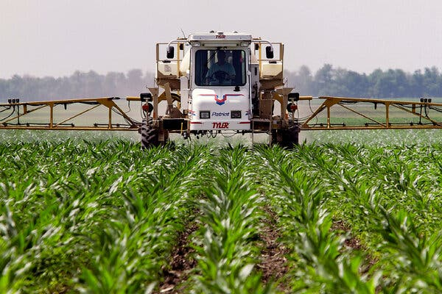
U.S. regulators consider it safe, but the World Health Organization has said glyphosate is probably carcinogenic.Credit...Seth Perlman/Associated Press

By Hiroko Tabuchi
Published Jan. 2, 2026Updated Jan. 5, 2026
In 2000, a landmark study claimed to set the record straight on glyphosate, a contentious weedkiller used on hundreds of millions of acres of farmland. The paper found that the chemical, the active ingredient in Roundup, wasn’t a human health risk despite evidence of a cancer link.
Last month, the study was retracted by the scientific journal that published it a quarter century ago, setting off a crisis of confidence in the science behind a weedkiller that has become the backbone of American food production. It is used on soybeans, corn and wheat, on specialty crops like almonds, and on cotton and in home gardens.
The Environmental Protection Agency still considers the herbicide to be safe. But the federal government faces a deadline in 2026 to re-examine glyphosate’s safety after legal action brought by environmental, food-safety and farmworker advocacy groups.
The E.P.A. has also faced pressure to act on glyphosate from the Make America Healthy Again movement, led by supporters of the health secretary, Robert F. Kennedy Jr., who once served as co-counsel in a lawsuit against Monsanto over exposure to Roundup.
Advertisement
SKIP ADVERTISEMENT
The 2000 paper, a scientific review conducted by three independent scientists, was for decades cited by other researchers as evidence of Roundup’s safety. It became the cornerstone of regulations that deemed the weedkiller safe.
But since then, emails uncovered as part of lawsuits against the weedkiller’s manufacturer, Monsanto, have shown that the company’s scientists played a significant role in conceiving and writing the study.
In the emails, Monsanto employees praised each other for their “hard work” on the paper, which included data collection, writing and review. One Monsanto employee expressed hope that the study would become “‘the’ reference on Roundup and glyphosate safety.” The pharmaceutical giant Bayer acquired Monsanto in 2018 for $63 billion.
In retracting the study last month, the journal, Regulatory Toxicology and Pharmacology, cited “serious ethical concerns regarding the independence and accountability of the authors.” Martin van den Berg, the journal’s editor in chief, said the paper had based its conclusions largely on unpublished studies by Monsanto.
There were indications that the authors had received financial compensation from Monsanto for their work, he said. There was no disclosure of a conflict of interest on the part of the authors beyond a mention in the acknowledgments that Monsanto had provided scientific support. As a result, Dr. van den Berg said, he “had lost confidence in the results and conclusions of this article.”
Advertisement
SKIP ADVERTISEMENT
Brian Leake, a spokesman for Bayer, said Monsanto’s involvement with the 2000 paper “did not rise to the level of authorship and was appropriately disclosed in the acknowledgments” and that the listed authors “had full control over and approved the study’s manuscript.”
He said that glyphosate was “the most extensively studied herbicide over the past 50 years” and that “the vast majority of published studies had no Monsanto involvement.”
The sole surviving author of the 2000 article, Gary M. Williams, a former professor at New York Medical College, did not respond to requests for comment.
Traces of glyphosate have been detected in foods like bread, cereal and snacks, and in the urine of both adults and children, though there are signs that levels in food have dropped after public pressure led some companies to stop applying glyphosate shortly before harvest, a practice that leaves behind more chemical residues.
Editors’ Picks


How Did Tucker Carlson Get This Way? How Did America?

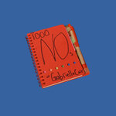
For This Influencer, Rejection Is the New Perfection

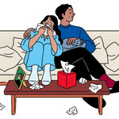
I Let My Wife Have an Affair. Do I Have to Console Her Now That It’s Over?

Advertisement
SKIP ADVERTISEMENT
The World Health Organization’s International Agency for Research on Cancer in 2015 classified glyphosate as “probably carcinogenic to humans.”
Image
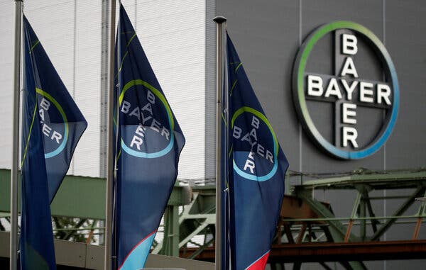
Bayer, which acquired Monsanto in 2018 and has since paid out billions of dollars in settlements, defended the study.Credit...Wolfgang Rattay/Reuters
“This is a seismic, long-awaited correction of the scientific record,” said Dr. Philip J. Landrigan, who is a pediatrician and epidemiologist and the director of the Program in Global Public Health at Boston College.
Dr. Landrigan recently chaired an advisory committee for a global glyphosate study that found that even low doses of glyphosate-based herbicides caused leukemia in rats.
“It pulls the veil off decades of industry efforts to create a false narrative that glyphosate is safe” he said. “People have developed cancers, and people have died because of this scientific fraud.”
Laboratory tests first flagged potential risks posed by exposure to glyphosate as far back as the early 1980s, and soon after, studies of Midwestern farmers exposed to herbicides started to show an increase in certain cancers. A U.S.-backed effort to eradicate coca fields in Colombia by spraying glyphosate from planes onto hundreds of thousands of acres of cropland led to widespread reports of illnesses among residents.
Advertisement
SKIP ADVERTISEMENT
The 2000 paper declaring glyphosate safe was published against that backdrop.
As the E.P.A. faces its 2026 deadline to reconsider the safety of the weedkiller, the agency’s critics are likely to highlight that the retracted paper appears in the bibliography of past E.P.A.’s risk assessment on glyphosate.
The E.P.A. “should reopen the decision immediately,” said Dr. Bruce Lanphear, an expert in environmental neurotoxins at Simon Fraser University outside Vancouver who specializes in infant exposures. “There also need to be consequences, real financial penalties that reflect medical costs and human suffering,” he said.
An E.P.A. spokesman, Mike Bastasch, said the agency was aware of the article’s retraction. He said the E.P.A.’s assessment of glyphosate’s risks had not relied solely on the study, and that the agency did not intend to rely on it going forward. “It’s our statutory obligation to ensure agency-approved chemicals and pesticides are totally safe for approved uses listed on the label based on rigorous, gold standard science,” Mr. Bastasch said.
Thousands of plaintiffs, including farmers and gardeners diagnosed with non-Hodgkin lymphoma, have sued Monsanto alleging that Roundup caused their cancer and that the company had covered up the risks. In an early case, a jury in a California state court awarded $289 million to Dewayne Johnson, a school groundskeeper, after concluding that glyphosate had caused his cancer. Monsanto, jurors said, had failed to warn consumers of the risk.
Since then, Bayer has paid out more than $10 billion to settle approximately 100,000 Roundup claims, and faces the potential of further costly lawsuits and jury verdicts, given the many thousands of people who may have been exposed. The settlements have not included admissions of liability or wrongdoing, and Bayer has continued to sell the product.
Advertisement
SKIP ADVERTISEMENT
Bayer has also pushed Congress to pass a provision that would effectively shield pesticide makers from potentially having to pay further damages to plaintiffs. The Trump administration recently urged the Supreme Court to hear a case that could also shield manufacturers from liability.
The retraction points to a wider problem of research secretly funded by industries like tobacco and lead, said David Rosner, co-director of the Center for the History and Ethics of Public Health at Columbia University. “Shading the science to favor the corporate interest,” he said, was likely “the rule rather than the exception.” Journals needed to “press scientists more forcefully to identify conflicts of interest,” he said. “Huge financial interests are at stake.”
The withdrawal of the 2000 paper came after two Harvard scientists, Sasha Kaurov and Naomi Oreskes, urged the journal to re-examine the article. They estimated in a recently published analysis that the 2000 paper was in the top 0.1 percent of cited academic literature on glyphosate.
What was surprising, they said, was that other researchers continued to cite the 2000 paper even after the emails were disclosed in litigation, starting in 2017. “This paper has been one of the most cited papers ever written on the topic of glyphosate safety,” Professor Oreskes said.
A correction was made on
Jan. 2, 2026
:
An earlier version of this article used an outdated affiliation for Philip J. Landrigan. He is currently the director of the Program in Global Public Health at Boston College. He was formerly the dean of global health at the Icahn School of Medicine at Mount Sinai in New York City.
A correction was made on
Jan. 5, 2026
:
An earlier version of this article stated incorrectly the occupation of Gary M. Williams. Dr. Williams is retired from New York Medical College and no longer a professor there.

When we learn of a mistake, we acknowledge it with a correction. If you spot an error, please let us know at corrections@nytimes.com.Learn more
Hiroko Tabuchi covers pollution and the environment for The Times. She has been a journalist for more than 20 years in Tokyo and New York.

