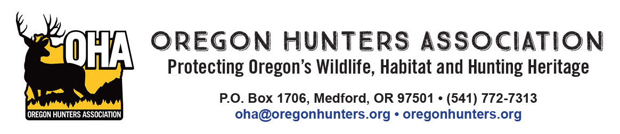
December 17, 2025

Detroit Ranger Station
Michelle King, District Ranger
Attn: Divide
44125 N Santiam Hwy
Detroit, OR 97360

Re: Oregon Hunters Association input on the Divide Project draft Environmental Assessment

The Oregon Hunters Association (OHA) is a sportsmen’s conservation organization with over 12,000 members in 26 chapters across Oregon. OHA values our National Forests as a public place to hunt and recreate, and as a valuable asset providing habitat for the wildlife we care about. As such, the management and access of these lands are of critical importance to OHA. We have been engaged in numerous projects to improve and protect habitat conditions, and we value our partnership with the U.S. Forest Service (USFS) and the Willamette National Forest. We are providing comments and input on the Divide Project draft Environmental Assessment (EA).

First and foremost, OHA supports active management for a variety of reasons that were articulated in the “Need for the Proposal” including improving/maintaining stand health, improving riparian/aquatic systems, ensuring there is a well managed and appropriately sized transportation system, and specifically the needs for high quality early seral habitat. For these reasons, OHA supports the proposed action.

OHA’s primary interests in the project are specific to big game habitat and recreational access. The desired condition articulated in the EA for both early seral vegetation habitat and meadow and wetland habitat would be beneficial, albeit at a minor scale. Management actions identified in the EA to achieve the desired condition seem appropriate.

As the Divide project moves forward, OHA would urge the Forest to consider the following. Elk populations on the Willamette National Forest (which includes the Santiam and McKenzie Wildlife Management Units) are below the management objectives set by the Oregon Department of Fish and Wildlife. This points to a need for work to develop or improve elk (and deer) habitat on the project area. While OHA believes that there is a very limited opportunity to improve habitat for ungulates with the Divide project, this may be the only opportunity to address some of these needs for quite some time. With that, we offer the following:

- OHA wants to encourage the USFS to use of the westside elk model when developing both stand specific and project wide stand prescriptions.
- Where using the creation of gaps in the stand treatment prescriptions, the Forest should favor using larger gaps and at an abundance to actually promote (temporarily at least) some semblance of early seral habitat.
- OHA strongly recommends that gaps be a minimum of three acres in size. Smaller gaps, in Douglas-fir stands, on high sites, will close in so rapidly that understory will be excluded within a decade.
- OHA would like to see the Forest employ heavier thinning prescriptions where possible to allow understory vegetation to develop and persist as long as possible before the stand closes in again. Once again, Douglas-fir stands on high sites will rapidly close in any openings in the overstory canopy. Using heavier thinning prescriptions on at least a portion of the project area will allow understory forage to persist longer.
- OHA supports the proposed actions related to roads. Specifically where temporary non-system roads would be closed, rehabilitated, and seeded with native seed. OHA recommends that the USFS consider adding seasonal road closures in areas where gaps are developed in the stands to avoid disturbance of elk.

Thank you for the opportunity to provide our input on this project.

Mike Totey
Conservation Director
Oregon Hunters Association

