10/31/2025
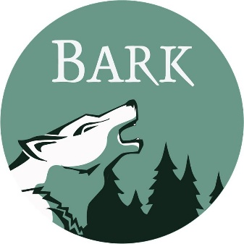
Bark
PO Box 12065
Portland, OR 97212
www.bark-out.org
503-331-0374

Phil Monsanto, District Ranger
Anvil ID Team
Clackamas River Ranger District
Mt. Hood National Forest
16400 Champion Way
Sandy, OR 97055
RE: Anvil Vegetation Management Project
Dear Phil,
As you are aware, Bark's mission is to transform the lands now known as Mt. Hood National Forest into a place where natural processes prevail, where wildlife thrives, and where local communities have a social, cultural, and economic investment in its restoration and stewardship. Our supporters live in the many communities surrounding Mt Hood National Forest. They rely on the Forest for drinking water, economic opportunities, recreation, forest products, spiritual renewal, connection to the land, and more. We submit these comments on behalf of our supporters.

TRIBAL INCLUSION

The Anvil project area is located within the ancestral homelands and ceded territories of three confederated northwest Tribes. Though it is not our place to speak on behalf of these Tribal members and their governments, we encourage and support meaningful collaboration between the Tribes and the federal government that holds these lands in trust. Bark believes that incorporating Tribal perspectives and values into all aspects of project design and implementation will lead to better outcomes for the land and its people.

COLLABORATION

Bark wants to recognize and thank the IDT for introducing this project to Clackamas Stewardship Partners and for planning/hosting a field tour of the project area in August 2025. Further, we appreciated the continued project updates and responsiveness to questions/concerns from you, Phil, and the rest of the IDT. Thank you.

PUBLIC COMMENT PERIODS

Public transparency and input in public land management is a foundational belief of Bark. Bark appreciates the inclusion of a public comment period now and when the draft EA is published. While a 15-day comment period is not sufficient for meaningful public input, we still appreciate the opportunity. Public comment periods are essential for allowing the public to provide input and identify anything missed by FS staff. Projects developed without public involvement are at increased risk for litigation. Thank you for allowing the public to comment on this project. We urge you to continue this practice for future projects.

AGREEMENTS WITH REGULATORY AGENCIES

The Public Engagement Letter mentions that the project will “…meet our
programmatic agreements with regulatory agencies…”. What programmatic agreements are you referring to?

EMERGENCY ACTION DETERMINATION

Bark rejects the need for Emergency Action and does not support the use of Section 40807 of the Infrastructure Investment and Jobs Act (IIJA).

In Secretary’s Memorandum 1078-006 the Secretary states the reason for the Emergency Action Determination:
“National Forests are in crisis due to uncharacteristically severe wildfires, insect and disease outbreaks, invasive species, and other stressors whose impacts have been compounded by too little active management.” (p. 2 of the memo)
The memo goes on to state that proposals using the special emergency action procedures at IIJA section 40807 shall:
- Reduce wildland fire risk to communities, critical infrastructure, or key ecological values; or
- Reduce/mitigate post fire risks needed to protect communities, critical infrastructure, or key ecological values; or
- Reduce hazardous fuels by removing or modifying vegetation to lower the risk of wildfires; or
- Reduce the density of fire-dependent forests; or
- Support the durability and resiliency of forests and grasslands; or
- Reduce hazardous fuels to help make wildfire response, as well as ingress or egress, safer and more effective; and
- Be authorized by the Forest or Grassland Supervisor.
Section 40807 of the IIJA lists the authorized emergency actions to respond to emergency situations:
- Salvage of dead or dying trees;
- Harvest of trees damaged by wind or ice [Note: or other natural disasters];
- Commercial and noncommercial sanitation harvest of trees to control insects or disease, including trees already infested with insects or disease;
- Reforestation or replanting of fire impacted areas through planting, control of competing vegetation, or other activities that enhance natural regeneration and restore forest species [Note: the restoration of forest species includes prevention, suppression, and eradication of insect, disease and invasive species outbreaks];
- Removal of hazardous trees in close proximity to roads and trails;
- Removal of hazardous fuels;
- Restoration of water sources or infrastructure [Note: the restoration of water sources includes watersheds];
- Reconstruction of existing utility lines; and
- Replacement of underground cables.

Let’s look at the reasoning for the Emergency Action Determination and how it relates to the Anvil project.
Uncharacteristically Severe Wildfires
The Anvil project area is within moist, western Cascades Douglas-fir and western hemlock dominated forests. The Anvil Public Engagement Letter states: “Historically, frequent low- to mixed-severity fires maintained open forest structure and species composition in this area.” This statement is incorrect. While low to mixed severity fires played an important role in creating and maintaining structural diversity and species composition, high severity fires did as well. “Fire history studies and observations of early 20th century fires indicate that large, infrequent high-severity fires are characteristic of historical fire regimes in mountainous areas of the westside”.
As mentioned above, the Secretary’s Memorandum 1078-006 states uncharacteristically severe wildfires as one of the reasons the Emergency Action Determination is warranted and needed. The Secretary also claims that “too little active management” has compounded the issue. In the Anvil project area, we reject this reasoning. As you are well aware, the Clackamas River Ranger District was significantly impacted by the Riverside Fire in 2020. Though there is no denying the significant impacts of this fire, “Early records and 20th-century maps of burned areas indicate that the 2020 fires were not unprecedented in size and severity, and either burned within, or in close proximity to, areas that burned in large fires following European colonization.”
However, to explore the argument that Emergency Actions are warranted to prevent uncharacteristic fires in the Anvil project area, let us assume that the 2020 Riverside Fire was uncharacteristically severe. Even then, the actions proposed by the Anvil project would do nothing to prevent a similar fire in the future. “The influence of forest management on fire severity was minimal and variation in forest structure or fuels played relatively little role. These results provide little evidence to support the use of fuel treatments to mitigate fire severity under extreme fire weather conditions on the westside”. Further, “…our results suggest that manipulation of stand structure is unlikely to mitigate fire effects in wind-driven fires on the westside given the minimal differences in burn severity among stand structure classes”.
Finally, commercial thinning of plantations is not one of the authorized emergency actions to respond to emergency situations (listed above).
Insect and Disease Outbreaks
The Secretary claims that Emergency Actions are warranted due to insect and disease outbreaks. Is there an insect and/or disease outbreak within the Anvil project area? Do you have data or insect traps to suggest that an outbreak is occurring within the units proposed for vegetation management?

ROADS

The IDT should analyze the closure or decommissioning of problematic roads in the project area. There are many roads in the project area that are unneeded and/or problematic. In the draft EA, please provide a table of roads needed for project implementation and their associated maintenance level.

5830-120

The team should analyze decommissioning a segment of this road. Towards the end of the road, there is water coming downhill, being intercepted by the road ditch, and being diverted by ditch relief culverts. The final 500-600 yards (~1500 feet) of ditch has been continuously wet with water flowing each time we visited this road segment during the summer (see photos below). I believe there is an unmapped steam/seep coming down the hillside and that road is improperly interfering with the normal hydrology of the area. Ditches and ditch relief culverts are intended to move water away from roads during storms. They are not intended to become hydrologically connected to streams and divert flow year-round. This road segment should be decommissioned so that the water can flow naturally to Shellrock creek.

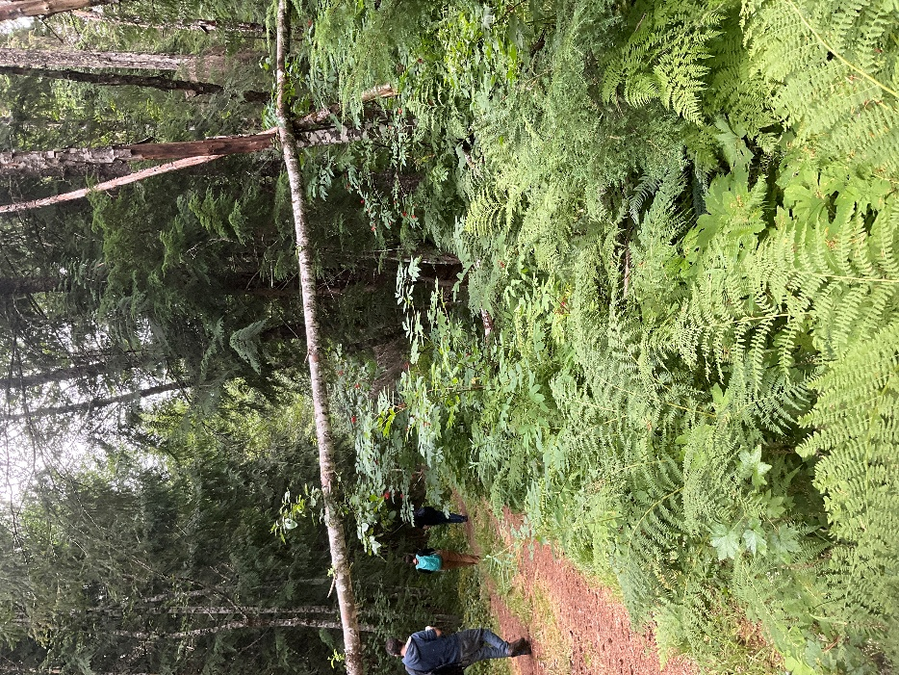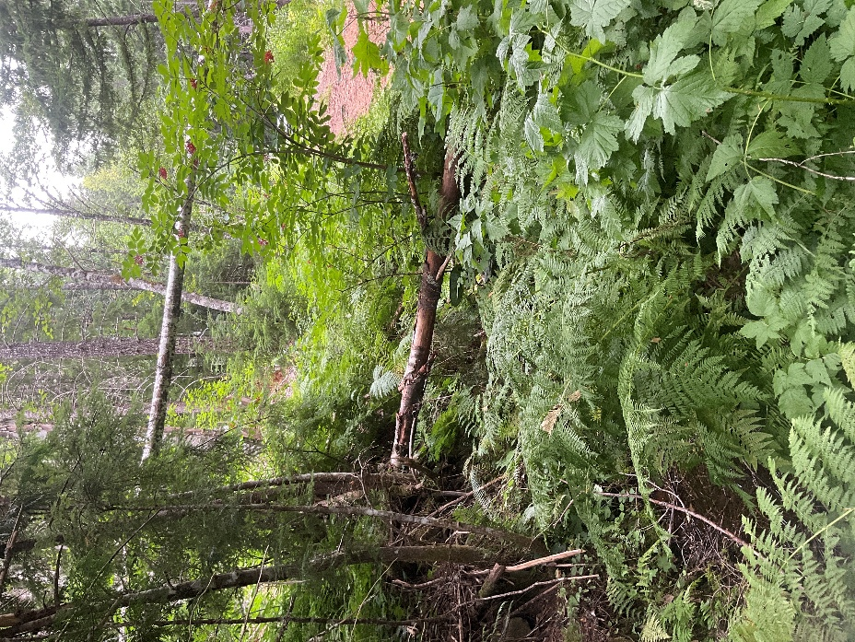
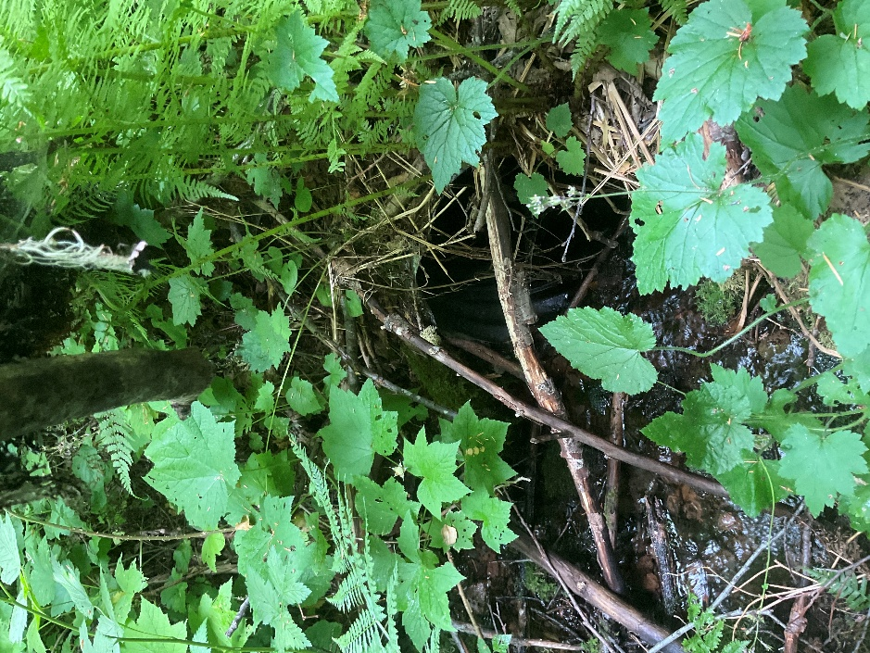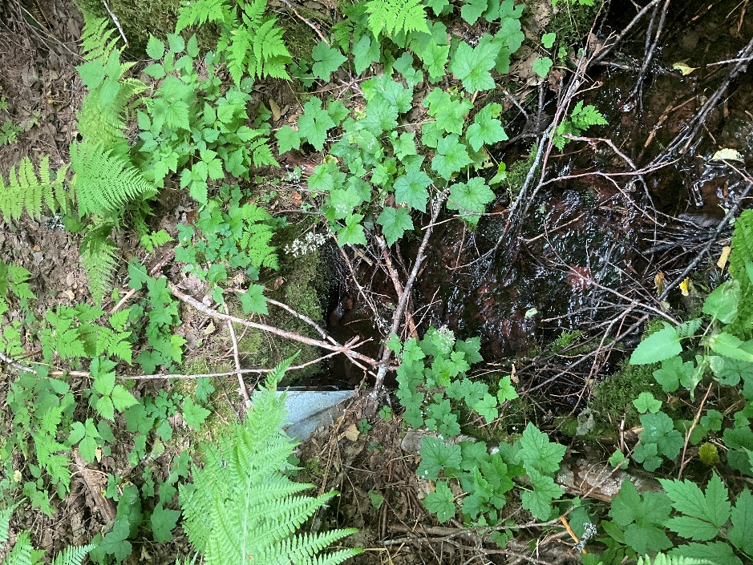

Unnamed road segment

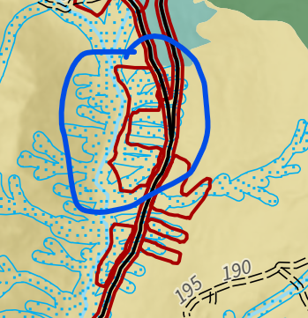
Within the unit circled above in blue (adjacent to Shellrock creek and rd 58), there is an unmapped road alignment which was found during a site visit (45.119045, -121.918009, see photos below).

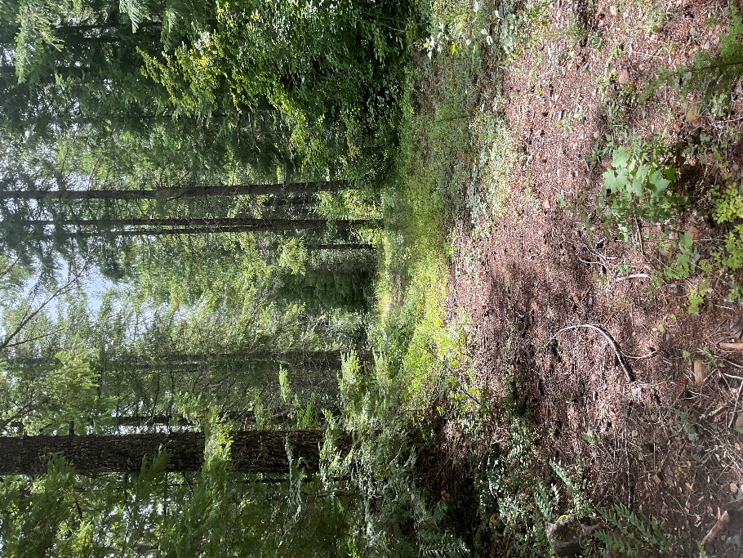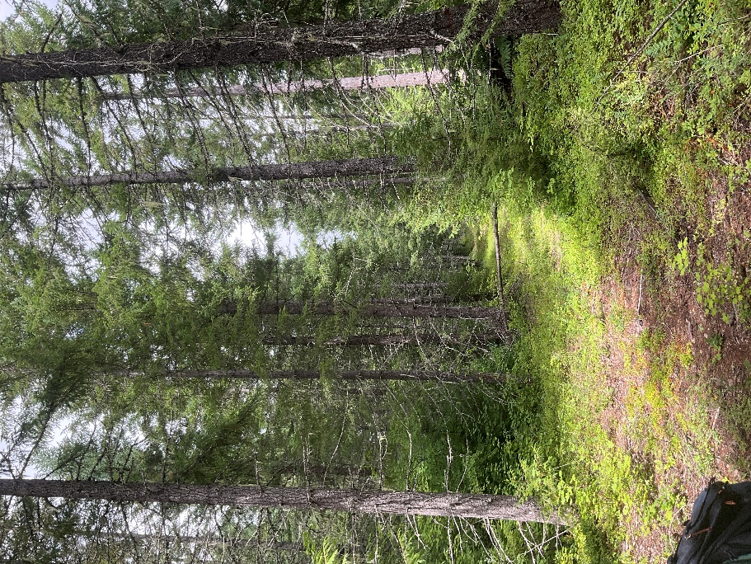
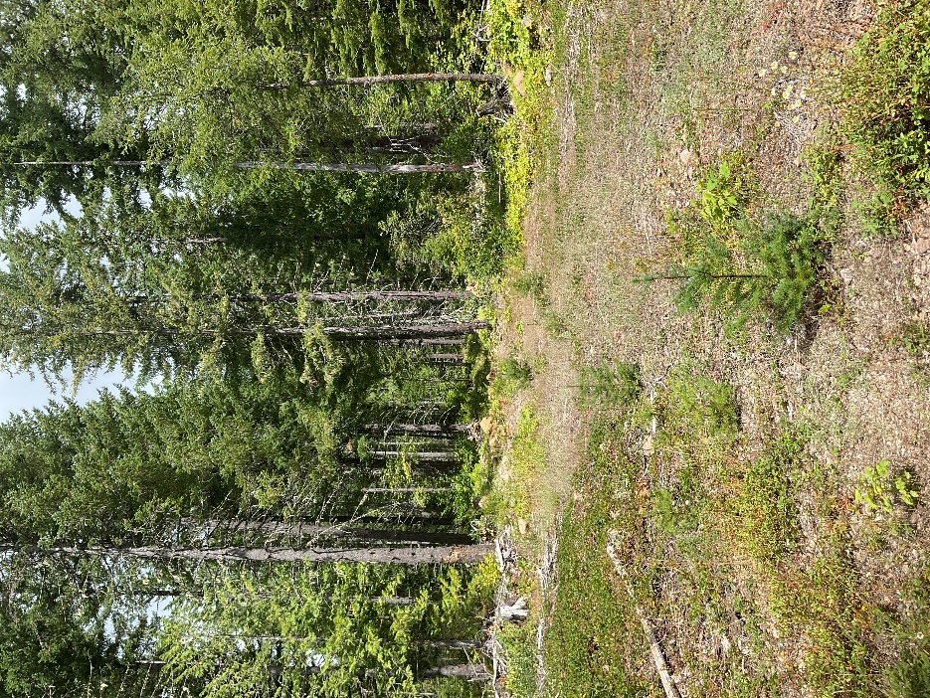

What is the ML of this road? Will it be used during project implementation?

5730-135

This road does not appear on project maps but a site visit confirmed that this appears to be functionally open, as there was no berm or cratering preventing vehicles from accessing the road. We are assuming you will utilize this road during project implementation. What is the ML of this road? Will it be closed (ML-1) after project completion?

5730-021

This road does not appear on project maps but does exist in reality. It is not currently drivable because of vegetation growth at its junction with 5730. We are assuming you will utilize this road during project implementation. What is the ML of this road? Will it be closed (ML-1) after project completion?

This road segment has water running across the road surface (45.064106, -121.907458, photos below). This issue needs to be addressed, especially if the road is used for project implementation.

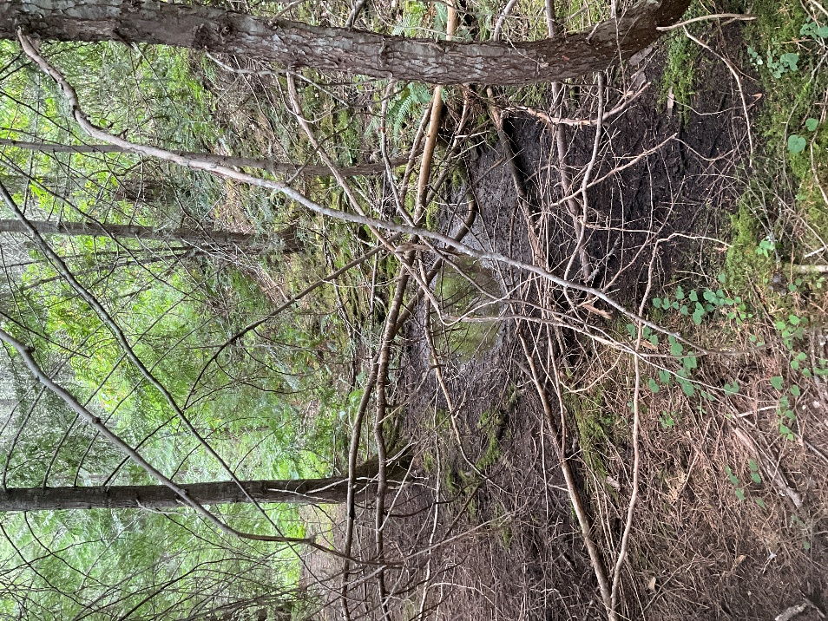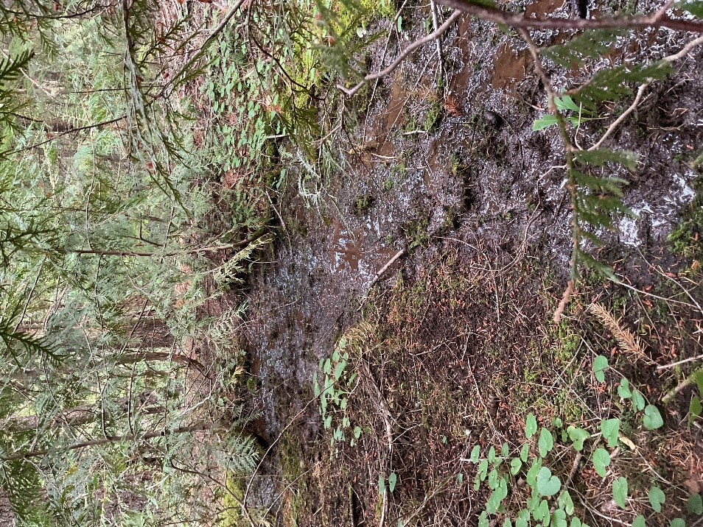

5710-130

This road does not appear on project maps but a site visit confirmed that it does exist and appears to have been closed after a past project. There is a large berm at its junction with 5710-140 and the road is cratered for some distance. What is its current ML? Will this road be needed for project implementation?

4661-120

This road does not appear on project maps but a site visit confirmed that it does exist. It appears that it was meant to be closed after a past project, but the berm is very small and has been easily bypassed by vehicles (see photo below).
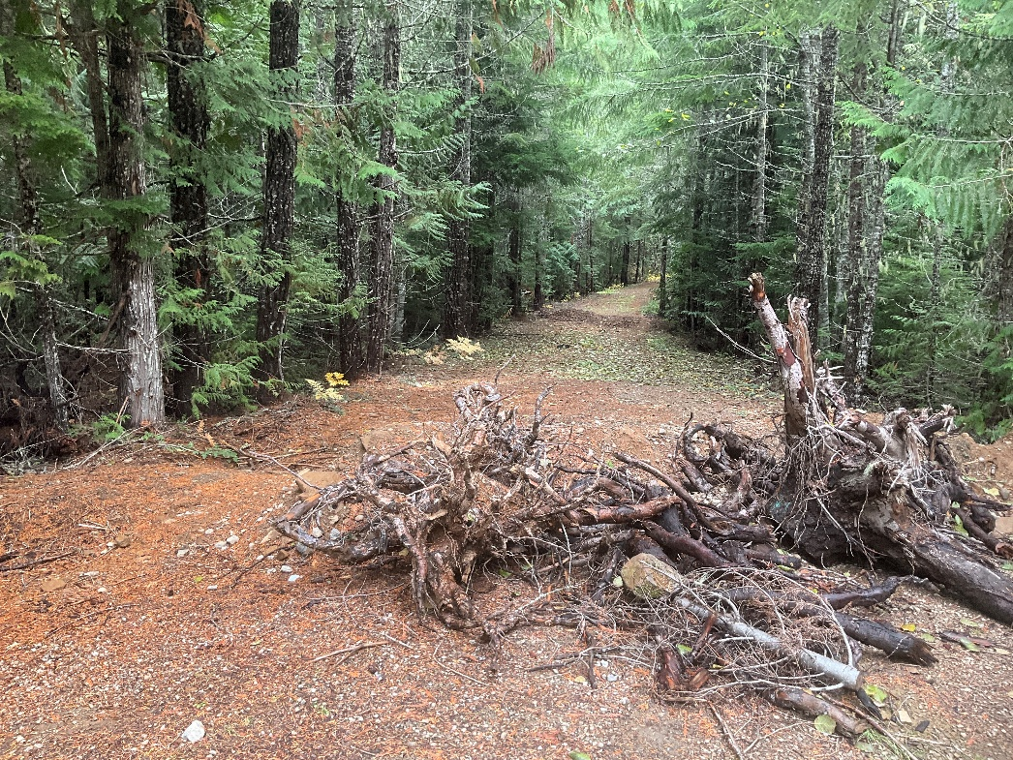

Will this road be used for project implementation? If so, Bark has concerns. The last ~2/3 of the road will need a lot of work to reopen due to trees and brush in the roadway. The road also runs through several historic spotted owl activity centers. Will there be spotted owl surveys completed to determine if there is occupancy in adjacent late seral stands?

It would seem to make more financial sense to drop the unit at the end of the road, not reopen the road, and instead wait until a future project that includes the other plantations along the road. That way when the road is closed after implementation, it can stay closed for a longer period without needing to be reopened.

Regardless of whether the road is used for this project or not, the breached berm at the junction must be addressed. The road closure is extremely inadequate and is not functional.

TEMPORARY ROADS

Please include a map of potential temporary road alignments with the Draft EA.

COMMERCIAL THIN UNITS

Please retain any biological legacies (large living trees, large snags, large downed logs) in commercial units. Though most of the proposed units spear to be historic clearcuts, some legacies (especially large logs) still exist.

FIRE

Bark appreciates your recognition of the important role fire plays in shaping these forest ecosystems, and recognizing the harm caused by a strict suppression policy. Each vegetation management project should find opportunities to return fire to the landscape. The Public Engagement Letter mentions prescribed burning as one of the proposed actions. Will this include broadcast burning? Bark would support the inclusion of broadcast burning as part of this project.

ROADSIDE FUELS TREATMENTS

Roadside fuels treatments should retain trees and brush over 7” dbh. Will roadside fuels treatments include treatment in units over 80 years old? How will you ensure that stands over 80 years will be protected from heavy machinery?

CONCLUSION
Bark has provided several suggestions for improving the Anvil Vegetation Management project. We appreciate you reading Bark's comments and finding ways to incorporate the above suggestions. If there is anything in this document that you have questions about or would like to discuss, please reach me at jordan@bark-out.org.

Thank you,

Jordan Latter
Forest Watch Program Manager, Bark

Reilly, M.J., Zuspan, A., Halofsky, J.S., Raymond, C., McEvoy, A., Dye, A.W., Donato, D. C., Kim, J.B., Potter, B.E., Walker, N., Davis, R.J., Dunn, C.J., Bell, D.M., Gregory, M. J., Johnston, J.D., Harvey, B.J., Halofsky, J.E., Kerns, B.K., 2022. Cascadia Burning: The historic, but not historically unprecedented, 2020 wildfires in the Pacific Northwest, USA.”. Ecosphere 13 (6). https://doi.org/10.1002/ecs2.4070, P. 4.
Ibid, P. 5
Ibid, P. 11
Ibid, P. 12

