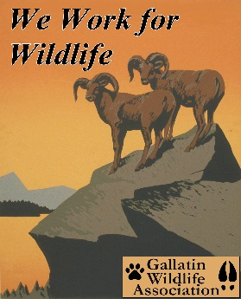

GALLATIN WILDLIFE
ASSOCIATION

P. O. Box 5317

Bozeman, MT 59717
(406) 600-1792
www.gallatinwildlife.org

October 9, 2025

Subject: “Beaverhead-Deerlodge Forest Plan Amendment Objection”

Objection Reviewing Officer, Kristin Bail
Acting Northern Region Regional Forester
Beaverhead-Deerlodge National Forest
420 Barrett Street
Dillon, MT 59725

Dear Kristin:

The Gallatin Wildlife Association has been involved in the determination process for Canada lynx habitat on the Beaverhead-Deerlodge National Forest since our scoping comments were submitted on April 5 of this year. Our comments on the Environmental Assessment were shortly submitted thereafter, dated June 29. We will continue our involvement in this process as our organization is very much concerned about the status of species in the Greater Yellowstone Ecosystem (GYE), of which we consider the Beaverhead Deerlodge National Forest a part of the ecoregion. To familiarize yourself with our organization, we present our mission statement below

Gallatin Wildlife Association (GWA) is a local, all volunteer wildlife conservation organization dedicated to the preservation and restoration of wildlife, fisheries, habitat and migration corridors in Southwest Montana and the Greater Yellowstone Ecosystem, using science-based decision making. We are a nonprofit 501(c)(3) organization founded in 1976. GWA recognizes the intense pressures on our wildlife from habitat loss and climate change, and we advocate for science-based management of public lands for diverse public values, including but not limited to hunting and angling.

Contact Information for Objection:

Clinton Nagel, President
Gallatin Wildlife Association
Phone: 406-600-1792
Email: clint_nagel@yahoo.com

Gallatin Wildlife Association
P.O. Box 5317
Bozeman, MT 59717

Rationale for Objections:

From this point forward, GWA will list our rationale for objections. Some of the reasons below are questions that we would like to have clarification. We find that during this process, our concerns have not been addressed, and we don’t see them being addressed in recent findings, therefore we await further discussion.

Historical Habitat in the GYE Ecoregion:

The basis of our objection concerns past removal of historical habitat from consideration. For when we do so, we are removing a vast array of potential habitat, are we not?

To highlight this point, GWA will reference an article by The Wildlife Society¹ dated April 24, 2024. The article is entitled “History May Point to a Brighter Future for Canada lynx” with the subtitle “Areas the Predator Once Roamed May be Able to Support Them Again”. In that article, the following is stated.

“In a study published in Biological Conservation, researchers found that lynx (Lynx canadensis) may do well in parts of Utah, central Idaho and the Yellowstone National Park region, even considering climate change and the lack of lynx in those areas now.

Lynx currently inhabit limited, northern portions of Washington, Idaho, Montana, Minnesota and Maine. Recovery plans for the species have been based on assumptions that they were never found much beyond these areas in the U.S.

Using a model validated by historical records, researchers found that in 1900, Canada lynx roamed a much larger area throughout the Pacific Northwest, Rocky Mountains, Great Lakes region and parts of New England.

“History matters even for wildlife,” said lead author Dan Thornton, a Washington State University wildlife ecologist. “As part of the criteria for species recovery, we have to understand their historic distribution. Otherwise, how can we help recover a species, if we don’t know what we’re recovering to?””

The study being alluded to is that entitled “Modeling range dynamics through time to inform conservation planning: Canada lynx in the contiguous United States” by Daniel H. Thorton² and Dennis L. Murray.

Found in the Abstract is the following statement.

“Here, we provide a case study using a threatened species, Canada lynx, which is the subject of recent conservation policy debate and species recovery planning. We use species distribution models (SDM), combined with historic observations of lynx, to estimate historic southern range limits for the species at year 1900. We then forward project our SDM to estimate lynx vulnerability and likely spatial pattern of range retraction in the future. Our analysis reveals that substantial suitable lynx habitat existed in the past beyond their current range in the contiguous USA, and many extra-limital observations fell within this habitat suggesting relatively broad historic occupancy. This finding implies substantial lynx range contraction over the 20th century and is contrary to recent species status assessment. Moreover, some areas of the contiguous USA that may remain resilient to climate change for lynx in the future, fall outside current species range limits but potentially within historically occupied areas. Our results indicate that future recovery efforts for lynx should be informed by this new evidence regarding species range dynamics through time, including investigating suitability of sites outside current range limits. More broadly, our findings highlight the need for conservation planning and species recovery efforts to consider historical range limits whenever possible.”

Found within the Introduction:

“However, knowledge of historical range limits can be critical to species conservation, by providing a better understanding of the degree of range retraction from anthropogenic factors (Hallman et al., 2021; Pöysä and Linkola, 2021), combating shifting baseline syndrome in species conservation (Rodrigues et al., 2019; Monsarrat et al., 2019), and providing more reliable estimates of climatic niches for forward projections (Faurby and Araujo, 2018).

Perhaps most importantly, ecologically relevant and ambitious species recovery targets require estimates of species ranges before substantial human modification (Grace et al., 2019). Taking this one step further, when combined with estimates of potential future distribution under climate change or other anthropogenic modifications, understanding historic distributions may provide guidance regarding where recovery and reintroduction would be most successful in the long term. Some of these areas may be outside current distributions but within historic range, which could improve prospects for large-scale recovery while minimizing concerns about reintroducing a species outside historic range (e.g., Odell et al., 2018).

Although the core lynx population in Canada is sustainable and not currently at risk, viability of southern lynx populations is precarious (King et al., 2020), especially in the context of their historical distribution, which may have been substantially larger than present day but remains uncertain.”

We highlight this point because if we don’t analyze the current status of the species or its respective habitat correctly, then we minimize the chances of recovery. One of GWA’s frustrations is the lack of acknowledgement by federal and state agencies to either recognize or flat out undermine the historical nature and distribution of a species. Thus, when doing so, they thereby hamper the potential recovery and restoration of the species on traditional landscapes. The following previous comments relate to the subject matter at hand.

The above section was included in our original comments within the EA. We include these thoughts again because they provide continuity to the overall accurate assessment of habitat potential of Canada lynx. And we want to hear from the BDNF their thoughts on the matter. We would like assurances that this historical habitat was and is to be considered for protection.

Naturally Occurring Fragmented Landscapes vs. Anthropogenic Fragmentation:

Our second area of concern revolves around the issue of fragmented landscapes. You can see from the paragraph discussion below this question remains. This paragraph was derived from our June 29 set of comments.

Secondly, the BDNF states that lynx habitat is naturally fragmented resulting in patchy distribution. While this may be true, doesn’t the practice of logging, vegetative thinning and treatments magnify that impact? Doesn’t continuing the practice of these types of treatments exacerbate the problem? We say that because the resulting impact of those treatments is the fragmentation of the landscape, causing drier habitats, and patchy distribution. Yet, these are the very same threats the U.S. Forest Service is using to justify low distribution and density of the species. That leaves us with the question, how is the draft EA proposing to deal with that conflict of purpose? Again, this is the question that we proposed during scoping.

We obviously need assurances that forest fuel reduction projects, thinning projects or whatever terminology the U.S. Forest Service (USFS) wants to use, will not be undertaken on Canada lynx habitat. What assurances in your finding that this will be the case? From our previous June 29 comments.

GWA cannot stress enough that perhaps the more current and greatest threat to Canada lynx is that of habitat fragmentation and habitat loss. With this being the case, this is an issue that BDNF does have an inordinate amount of control over. This should be highlighted in this Forest Plan Amendment on Canada lynx for the BDNF. It was brought out in our research during the USFWS’s Final Recovery Plan that the agency had planned to reduce the amount of available habitat for Canada lynx in SSA Unit 5 by 88%³. Such is reported by Mike Koshmrl of the WyoFile.com on Dec. 3, 2024.

“the U.S. Fish and Wildlife Service has classified 9,146 square miles of the Yellowstone area as critical lynx habitat for the past decade. Last week, the federal agency proposed a revision, tentatively slashing critical habitat in the region to 1,121 square miles — an 88% cut. Federal officials cite leaps in lynx habitat science as their rationale.”

Undoubtedly, it is obvious to assume that part of that reduction is dependent upon landscapes within the BDNF. With that, we raise the following question. If this is the case, then why is the BDNF magnifying, exacerbating, and perpetuating the loss of Canada lynx habitat by the approval and authorization of timber projects? We need to look in the mirror and realize, that perhaps we are the problem and the reason for loss of Canada lynx habitat.

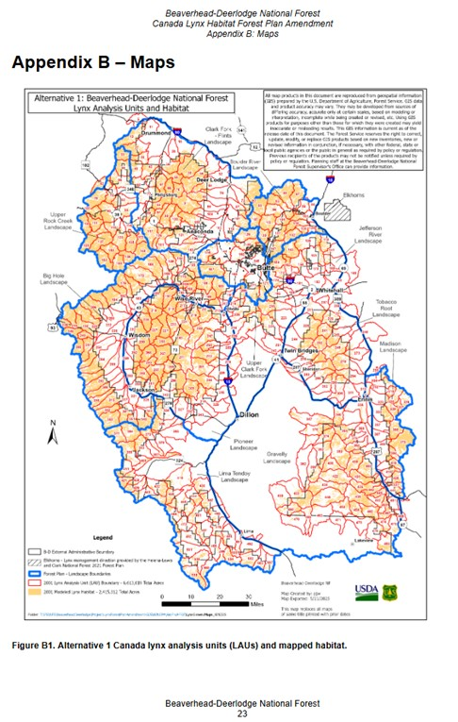

In regard to that discussion of Canada lynx habitat, this brings us to the two maps shown above and below. The map above known as Figure B1 is from Appendix B of the BDNF Draft Management Plan for Canada lynx. This is the mapped habitat of Canada lynx under the Alternative 1, The No Action Alternative. The map below is from the same source, but it represents the Proposed Action known as Alternative 2.

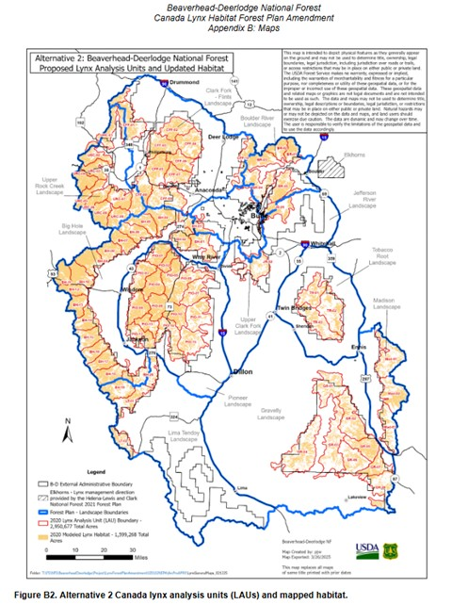

Note the dissimilarities. According to the draft Canada lynx amendment, the following is stated on page 9 of the draft EA.

“The most prominent change in LAU delineation between Alternatives is that the Lima-Tendoy Landscape and lands south of highway 324 that are west of interstate 15 did not have LAUs delineated by Alternative 2. This southwest portion of the Forest encompasses the Tendoy Mountains and southeastern Beaverhead Mountains where the inherent capability of the forested areas cannot support lynx and boreal forest where spruce fir habitat types are rare because it is a relatively dry area. Alternative 2 did not delineate the entire Forest boundary in LAUs because winter snow was included as a habitat identifier which is lacking in many lower elevation areas of the Forest”.

Further into the discussion of available habitat as comprised by Alternative 1 and 2, there was this table that provides better definition of both options.

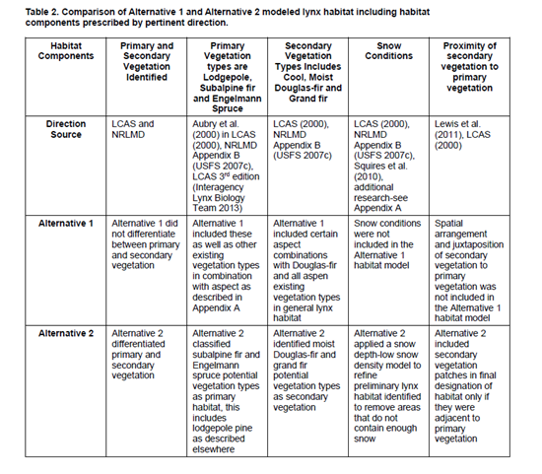
The removal of Canada lynx habitat as shown in the LAU map of Alternative 2 is very concerning when trying to establish connectivity to and from the GYE. The habitat removed could be key if for nothing else for the purpose of connectivity.

GWA cannot stress in the strongest terms our concern over this issue. Outside the issue of climate change, GWA views loss of habitat fragmentation being one of the more serious threats to the species of Canada lynx as well as many species. The continuation of forest projects, for whatever purpose, projects that remove or extract resources from public land are the greatest threats to the species. In our previous comments of June 29, GWA drew a strong relationship between loss of habitat from logging or timber extraction to the loss of Canada lynx habitat. We urge the USFS to go back and read those comments again.

Species and Habitat Connectivity:

One basis of primary concern is how are plans on paper going to be applied to the actual landscape. This is especially true in terms of species and habitat connectivity. Again, we rely on our previous statements from our June 29 letter in reference to the draft EA.

Specifically on page 23 and 24 of the Beaverhead-Deerlodge National Forest Plan Amendment for Canada Lynx Habitat Canada Lynx Effects Analysis”, we highlight a few key summary points from the text.

“Of the 3.4 million acres of National Forest ownership on the BDNF, approximately 75 percent is forested, with the remaining 25 percent in sagebrush, grass, and other open habitats. Non-forested areas are not lynx habitat, but lynx are known to move through these types of habitats when making dispersal movements between areas of suitable habitat. The NRLMD does not prescribe management direction in areas that are not lynx habitat except for linkage areas. Linkage area direction provides guidance to maintain habitat connectivity. Dispersing lynx (i.e. leaving their natal area or existing home range in search of a new home range) are known to travel through large areas of limited forest cover (Ruediger et al. 2000). Human infrastructures that are a physical block to dispersing lynx include highways, interstates, buildings, impermeable fences, and other features that would prevent a lynx from moving through an area. NRLMD includes direction limiting these features or providing mitigations for them. The entirety of the BDNF could be used by a lynx to make a long-distance movement between blocks of suitable habitat because lynx have excellent dispersal capabilities (Schwartz et al. 2002) and are known to cross large areas of non-habitat (Ruediger et al. 2000).

Linkage area defined in the NRLMD is an area that provides connectivity between blocks of lynx habitat. Linkage areas occur both within and between geographic areas, where basins, valleys, or agricultural lands separate blocks of lynx habitat, or where lynx habitat naturally narrows between blocks.”

The above description of linkage areas is fine for describing the general purpose of linkage areas and connectivity, but where are the on the ground assessments as to where these areas are, how are they going to be managed, etc. The trouble with this draft EA is that there are no detailed discussions or identifications as to where these linkage areas are. How are they going to be protected from the known threats that exist on BDNF. These are great concerns to GWA. As a wildlife advocacy organization, who has commented on many projects requiring NEPA standards. There seems to be a routine of providing as little information as possible to the public.

In the following map found on page 30 of the Biological Assessment for Canada lynx, Effects of the 2009 Revised Forest Plan and the Northern Rockies Lynx Management Direction¹³ Figure 2 in that document shows or indicates linkage areas as known at that time to Canada lynx on the BDNF. Questions remain, however, why was this not shown in the draft EA? Also, what are the latest thoughts as to the relevancy of these linkage areas. Are they still viable? If not, why not and can they be restored? Are they complete? There is much to be known and to address, but there is none that we can tell within this draft EA.

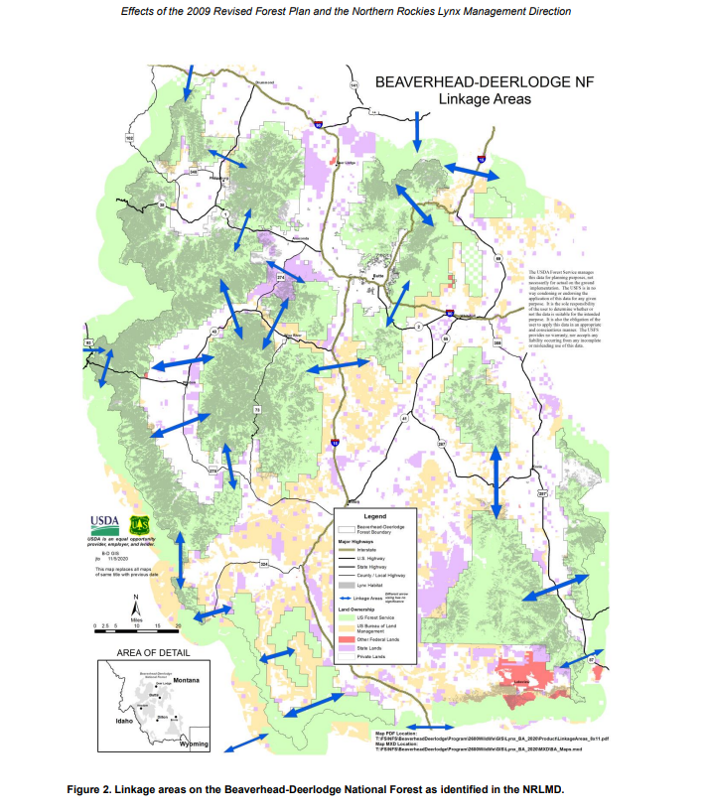

GWA needs a definitive statement that fuel reduction projects, timber projects, or any associated and relatable projects will not occur in Canada lynx’s habitat.

Comments and maps below are attributed to our friends at Yellowstone to Uinta’s Connection concerning availability showcasing habitat and connectivity for Canada lynx. These statements and maps are not new to the Beaverhead Deerlodge National Forests or to the Gallatin Wildlife Association as we signed on to these comments on behalf of ourselves as presented by John Carter of the Yellowstone to Uinta Connection⁴.

“Figures A – G below show the BHDL 2020 modeled habitat, the Olson et al (2021) modeled habitat, and the Montana Natural Heritage Program modeled habitat. By overlaying these along with the linkages developed for the NRLMD, the areas within the BHDL can be identified where linkages need to be provided.1 Figures A – E center on the Ranger Districts. Figures F and G overlay the BHDL model over the MNHP model showing additional modeled habitat that should be included and provide linkages not covered by the BHDL model. Figures H and I show aerial imagery for the Butte and Dillon Ranger Districts illustrating that higher elevation, mountainous areas excluded from the BHDL 2020 model, but included in the BHDL 2001 Model, can function as linkage and therefore should have standards for protection as linkage and that Model should be the basis for the Plan Amendment, if any. From the EA Appendices:4 “Note: Once identified as “lynx habitat,” there is no longer a distinction between primary and secondary vegetation. Conservation measures of the Lynx Conservation Assessment and Strategy (LCAS) apply to lynx habitat.””

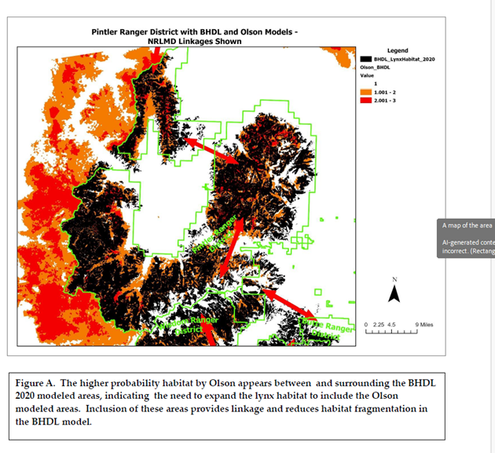

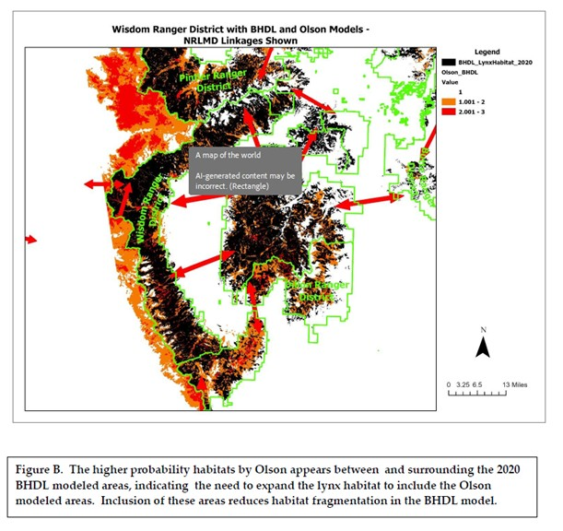

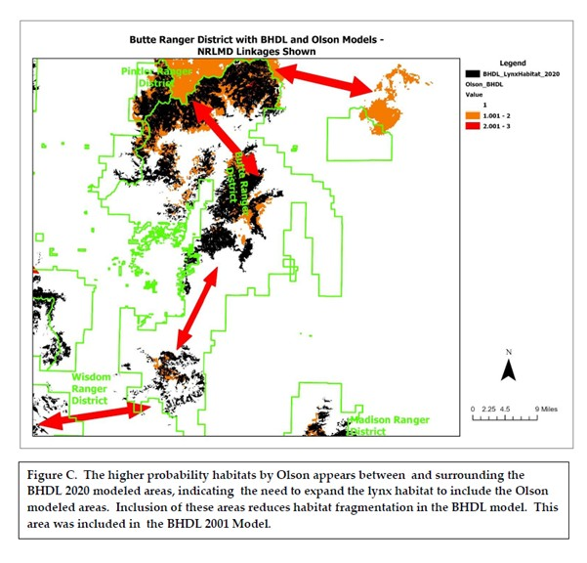

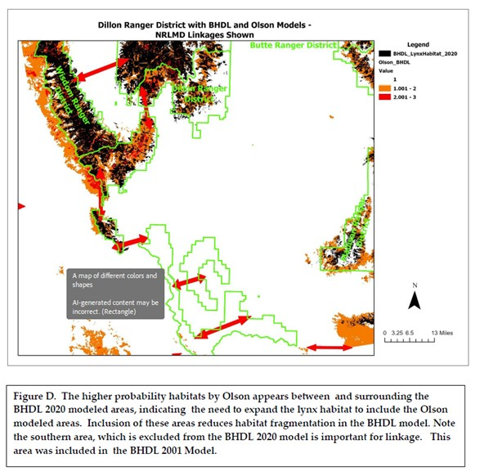

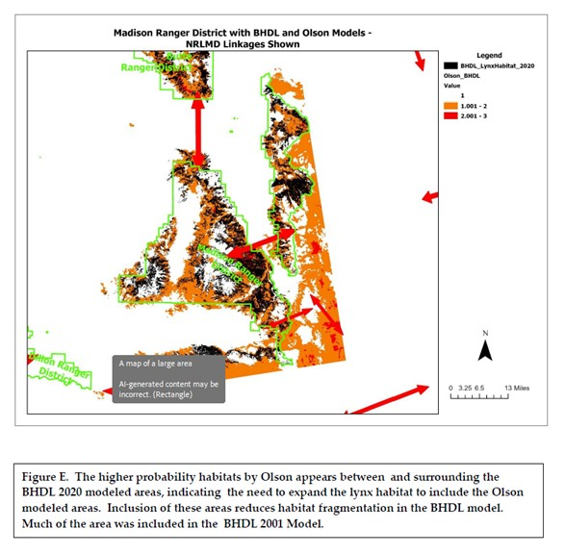

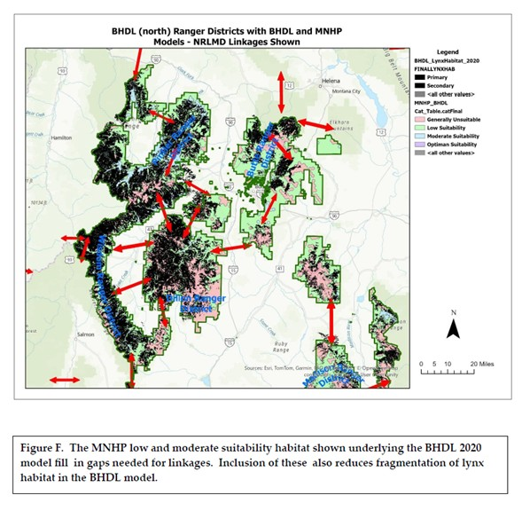

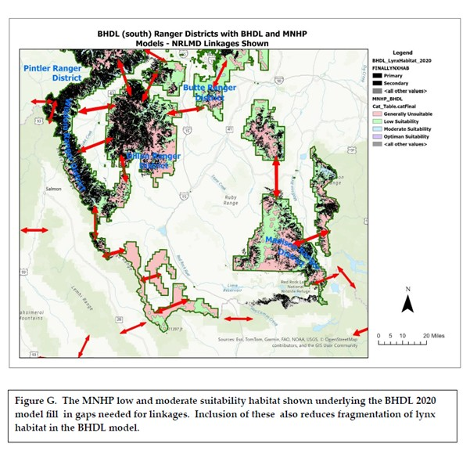

Conclusion:

We will bring our Canada lynx objections on the management plan to a close. Our concerns come down to some basic principles. One, there needs to be honest determination and assessment of historic habitat landscapes. Do the current maps contain the best and most accurate assessment of Canada lynx habitat and if not, why not? Are current conditions at all achievable to maintain sustainable lynx habitat? Can the Proposed Alternative ensure Canada lynx viability? If not, why not? Can the prior Canada lynx habitats be recovered?

Second, are forest projects going to conflict with Canada lynx habitat? How are forest projects going to be restrained from inflicting harm on the population/habitat? Will there be and can there be steps taken to avoid additional habitat fragmentation? Our unease with this project is the fact that we don’t see detailed information that will ensure the protection of Canada lynx habitat from fuel reduction projects or other timber thinning projects. The increase of habitat fragmentation is a number one threat to lynx’s viability upon the landscape. We need assurances.

Outside of these two fundamental steps, there is one more necessary requirement in order to maintain population distribution upon the landscape. Third, connectivity corridors need to be in place in order for wildlife to move freely about. At a time when climate change is so prevalent upon the world, the ability of wildlife species to move freely about is even more imperative. Changing climate will affect the world’s food supply, water, and secure habitat.

We ask what is in this plan chosen by USFS, that will ensure these concepts? Our answer is that a recovery plan drawn into the draft amendment will help prevent an erosion of habitat, but only if it is enforced and/or enacted. The haphazard circumstances that seem to continually arise in the most desirable wildlife locations need to stop and it can be and should be prevented.

In order for these management plans to work we need to establish recovery criteria and have a vision as to what goals we are to achieve. There needs to be an agreement on protecting the Greater Yellowstone Area (GYA) as a climate refugium. It is true that the GYA is gaining in popularity and by that fact alone, there are conflicting land uses, diminished land quality under the Multiple-Use Sustain Yield Act.

We started off with our first set of comments with one purpose, to prevent the loss of habitat. For we know, the greatest threats to Canada lynx were habitat fragmentation and climate change. While we may have more control over one than the other, what we do certainly can exacerbate both as both are responsive to each other. It is time to protect the land surface for the wildlife in the GYA. If we make smart decisions, we can also help make the GYA a climatic refugium, one that would benefit many species, including but especially Canada lynx.

For further scientific rationale for these objections, we advise the USFS to reread our comments dated June 29, 2025. We also advise the USFS to reread the comments made by Yellowstone to Uinta’s Connection dated June 17, 2025. We support their conclusion.

Sincerely,

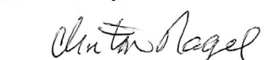

Clinton Nagel, President
Gallatin Wildlife Association

Cited References:

- “History May Point to a Brighter Future for Canada lynx”, The Wildlife Society, April 24, 2024.
https://wildlife.org/history-may-point-to-a-brighter-future-for-canada-lynx/

- Thorton, Daniel H., Murray, Dennis L., Modeling range dynamics through time to inform conservation planning: Canada lynx in the contiguous United States, Science Direct (Elsevier), Vol. 292, April 2024.
https://www.sciencedirect.com/science/article/abs/pii/S0006320724001022?fr=RR-2&ref=pdf_download&rr=9555c562cea8a3b9

- Koshmrl, Mike, “Feds seek 88% critical habitat cut for lynx in Yellowstone ecosystem”, WyoFile.com, December 3, 2024.
https://www.wyomingnews.com/news/local_news/feds-seek-88-critical-habitat-cut-for-lynx-in-yellowstone-ecosystem/article_6068f5aa-b1b7-11ef-a48e-5f14bbfe9d22.html

- Carter, John, “Beaverhead-Deerlodge Forest Plan Amendment for Canada lynx Habitat – Comments on Environmental Assessment”, Yellowstone to Uintas Connection, June 17, 2025.

