Heber Wild Horse Territory Management Plan, Project 18916
Michiko Martin, Reviewing Officer
Attn: Administrative Review Staff
USDA Forest Service, Southwestern Region
333 Broadway Blvd. SE
Albuquerque, NM 87102
Apache-Sitgreaves National Forests
Black Mesa Ranger District
Joshua Miller, Acting Forest Supervisor, of the Apache-Sitgreaves National Forests
Matthew Bullmore, Black Mesa District Ranger
Submitted online via CARA

I Object that “Adaptive Management” is the proposed solution to address the lack of use of the Territory by our Heber Wild Horses. Page 18 of the Final EA reads, “Additionally, the adaptive management components of the proposed action is designed to facilitate movement of horses to access the existing territory to address concerns about horses not utilizing the entire territory.” Adaptive Management cannot address the fact that the only way in and out of a large northern portion of the Territory is through gates in one fence line leading to that major portion of the Territory. In 2021, I submitted a Comment specific to the Territory Use (or lack thereof).

- There is no access from the north due to the towns of Heber and Overgaard. Adaptive Management will not change this.
- The western border is Highway 260. Adaptive management will not change this.
- The Territory is set in Black Canyon with its steep rock canyon walls, blocking movement within the Territory. Access to the large northern portion of the Territory where horses are not seen in any of the surveys from 2014, 2015, 2017, 2019 and 2021, is blocked by steep rock canyon walls on the east side (see photos). Adaptive Management cannot change these terrain features.
- Draws leading in and out of Black Canyon are steep, rocky and largely obstructed by downed giant Ponderosa pine trees (see photos). Any possible navigation over the steep, rocky terrain through the draws is extremely difficult and dangerous on a good day. I would argue, likely impossible, especially when the ground is saturated from rain or covered in snow and/or ice. Adaptive Management cannot change this terrain or the weather.
- The only access to the large northern portion of the Territory between Black Canyon Road (FR-86) and Highway 260 to the west is the gates along the fence line that separates the Black Canyon (cattle) Allotment to the north from the Heber (cattle) Allotment to the south (see diagram and photos). Under Adaptive Management, those gates, that have been historically kept closed, with Forest Service and Arizona Game & Fish signage, saying keep them closed, would allegedly be opened when cattle are not on the range to allow horses, that have never had access to that portion of the Territory, to have limited access to that area. When gates are closed, horses would either be trapped inside one or both of those northern pastures, or they would be blocked out of that half of the Territory. This is not a reasonable Adaptive Management strategy.

There are many other limitations and obstructions to horse movement in and out of the Territory as well as within the Territory.

  - The Territory itself is crisscrossed with barbed wire fencing, closed gates and cattleguards (see diagram and photos).
  - North/south movement within the Territory on Black Canyon Road (FR-86), the access road through Black Canyon, is further restricted by a bottleneck one lane bridge with private property and fences that border the road on both sides (see photos). Adaptive Management cannot change this. Just beyond the bottleneck is a cattle guard with closed gate and a private property on the left side of the road as you travel north. Note: There are additional private properties further south on FR-86.
  - The Territory is cut up into sections like a patchwork quilt! Ingress, egress and movement within the Territory is like trying to navigate through a corn maze. There is a blockage at every turn! It is not conducive to natural movement of wild horses that often roam several miles in a day. It is not conducive to movement for forage, water, and cover. The existing Territory puts a chokehold on natural wild horse movement and behaviors. There was obviously no sound basis for the delineation of the Territory. The lines were arbitrarily and capriciously drawn to the detriment of wild horses and arguably designed to favor cattle. The Territory needs to be expanded to allow for natural wild horse movement and behaviors and to allow for access to forage, water, cover and space.
  - Further complicating wild horse movement into, out of and within the Territory is that when cattle are on the land, gates will be closed, restricting wild horse movement to within an individual cattle pasture within the patchwork quilt; thus, restricting natural roaming for food, water, cover and natural migration. When cattle are rotated, horses will be left in a pasture where they may or may not have access to water and other wild horses for natural mingling. Historically, when there are no cattle in a pasture, there has been no regard for whether or not there was water in that pasture. That is a fact! When cattle are added, rotated and/or removed from the range, gates that were open to wild horse travel one day would be closed the next day. Gates that were closed one day would be open the next day. This will cause wild horse movement to be further restricted and confused. This is not a reasonable Adaptive Management strategy to achieve the stated objective “to facilitate movement of horses to access the existing territory to address concerns about horses not utilizing the entire territory.”
The Territory was obviously arbitrarily and capriciously delineated. There is no rhyme or reason as to how or why the Territory boundaries were determined. The Forest Service has been unable to produce any evidence of a thought process or reasoning behind it. There was no initial census. The “purported” seven horses upon passage of the Act has been shown to be a complete fallacy. The Forest Service has not been able to produce census documents, or any other evidence of a census following passage of the 1971 Act.
Water sources the Forest Service listed as “Dependable” are arguably not dependable. When I hiked the fence line from Black Canyon Road (FR-86) and east towards Highway 260 on April 5, 2021, I visually observed a dirt water tank that was bone dry (see photo). It is more likely than not that other Tanks throughout the Territory were dry as well. Many of the dirt water tanks throughout the forest regularly dry up. It’s extremely unlikely that the dirt water tanks on the Territory listed as “Dependable” have water year round. The only photos presented by the Forest Service were taken during the monsoon rain season.
The Forest Service needs to document evidence that year round “dependable” water sources currently exist throughout the Territory “before” moving forward with their Plan. Saying you will build them later indicates that the required element of adequate water on the Territory does not currently exist. Saying you’ll build them later forgets that the Forest Service is always struggling for time, manpower and funding, and that there are always competing priorities and things just don’t get done. Water is a necessity of life. The Adaptive Management strategy of building water sources later is not an acceptable strategy.
Forest Service diagram showing the Territory outline with barbed wire fencing that crisscrosses the Territory, as well as the allegedly “Dependable” water sources, many of which are arguably not “dependable” year round and would not even be accessible to our wild horses year round regardless of what “Adaptive Management” is done.
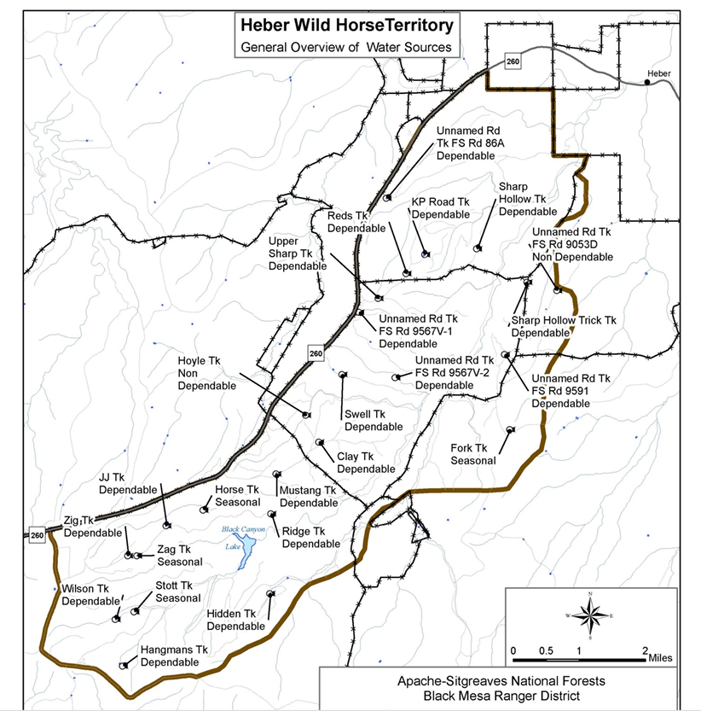
Below is a diagram I drew for one of my 2021 Comments to the Draft Plan related to Territory Use. Take note of the large northern portion of the Territory where there have been no horse sightings during any of the Forest Service surveys. Directly to the left (west) of Black Canyon Road (FR-86) are steep rock canyon walls that prevent east/west horse movement. I have included herein several photos of the steep rock canyon walls to give a visual to those unfamiliar with Black Canyon. It would take rock climbers with rock climbing equipment or mountain goats to climb the steep rock canyon walls to ingress/egress that large portion of the Territory. Horses cannot climb these rock walls up or down! The fence line that cuts through the Territory with Gates A, B and C depicted on the diagram separates the Black Canyon Allotment to the north from the Heber Allotment to the south. IF horses were able to move north through gates at that fence line, the only way out is back through the gates at that fence line IF the gates are open!
Note: Where you see Gates A, B and C, there is another gate (D) not depicted on the diagram. It is next to Highway 260.
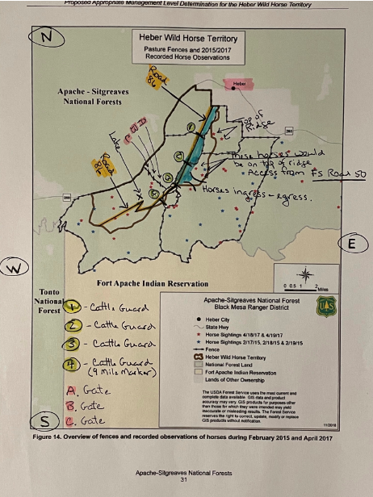
These photos of Gates A, B and C, taken on April 5, 2021, were submitted during the 2021 Public Comments period.
Gate A:
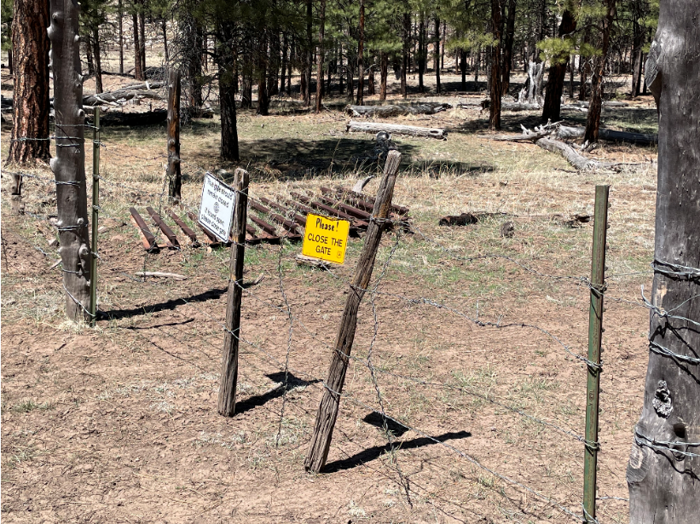
Gate B:
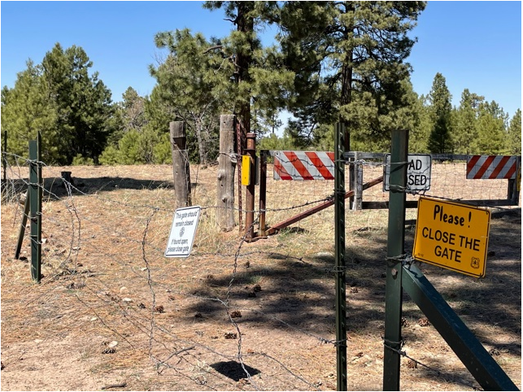

Gate C:
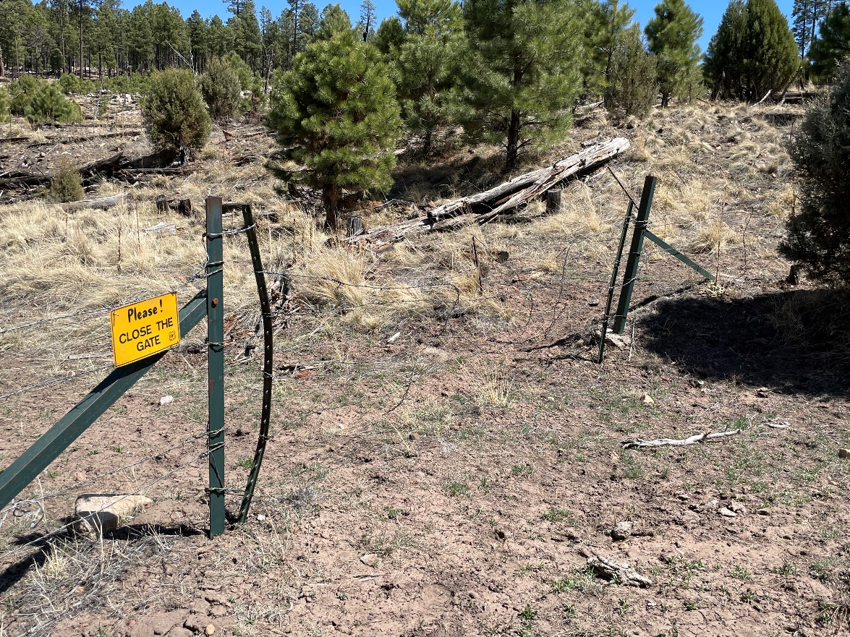
There is a 4th gate (Gate D) that is not depicted on the diagram. That gate is located near Highway 260. I was not able to make it that far on April 5th, 2021, but had to turn back. I went back sometime later and hiked from down inside Black Canyon from Forest Road 86 all the way to Highway 260. That gate did not have signage on it, but it was closed.

Here is a bone dry dirt water/stock tank I came across during my hike up along the fence line between Black Canyon Road (FR-86) and Highway 260 on April 5, 2021, where gates A, B and C are depicted on the above diagram. This is evidence that the dirt water/stock tanks are not “Dependable” as was noted by the Forest Service. If this stock tank was bone dry, it is more likely than not that others were dry as well. The stock tanks depend upon the monsoon rains to refill them. The rains typically arrive sometime in July. How long they continue to hold water depends on a number of factors such as leakage, evaporation and level of use.
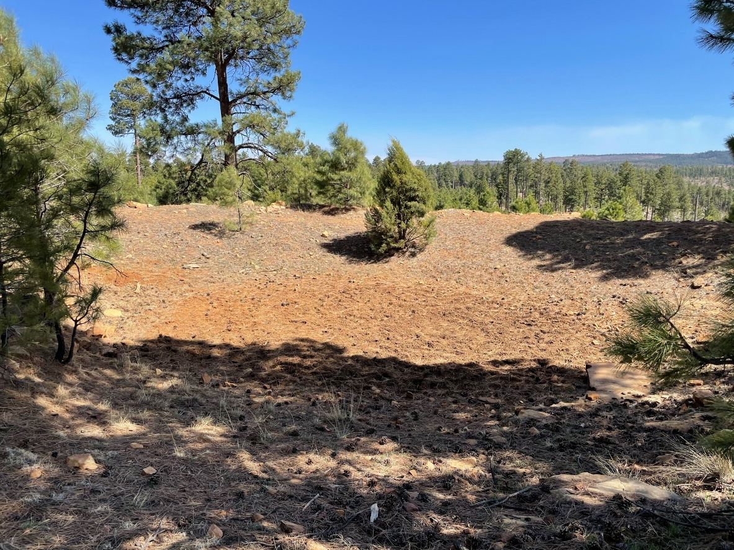

An obstruction on the east side of the Territory is this closed gate with cattle guard on Forest Road 487 which leads into Black Canyon Road (FR-86) and the Territory. Legacy Ranch (a large private property) is on the right side of the road.
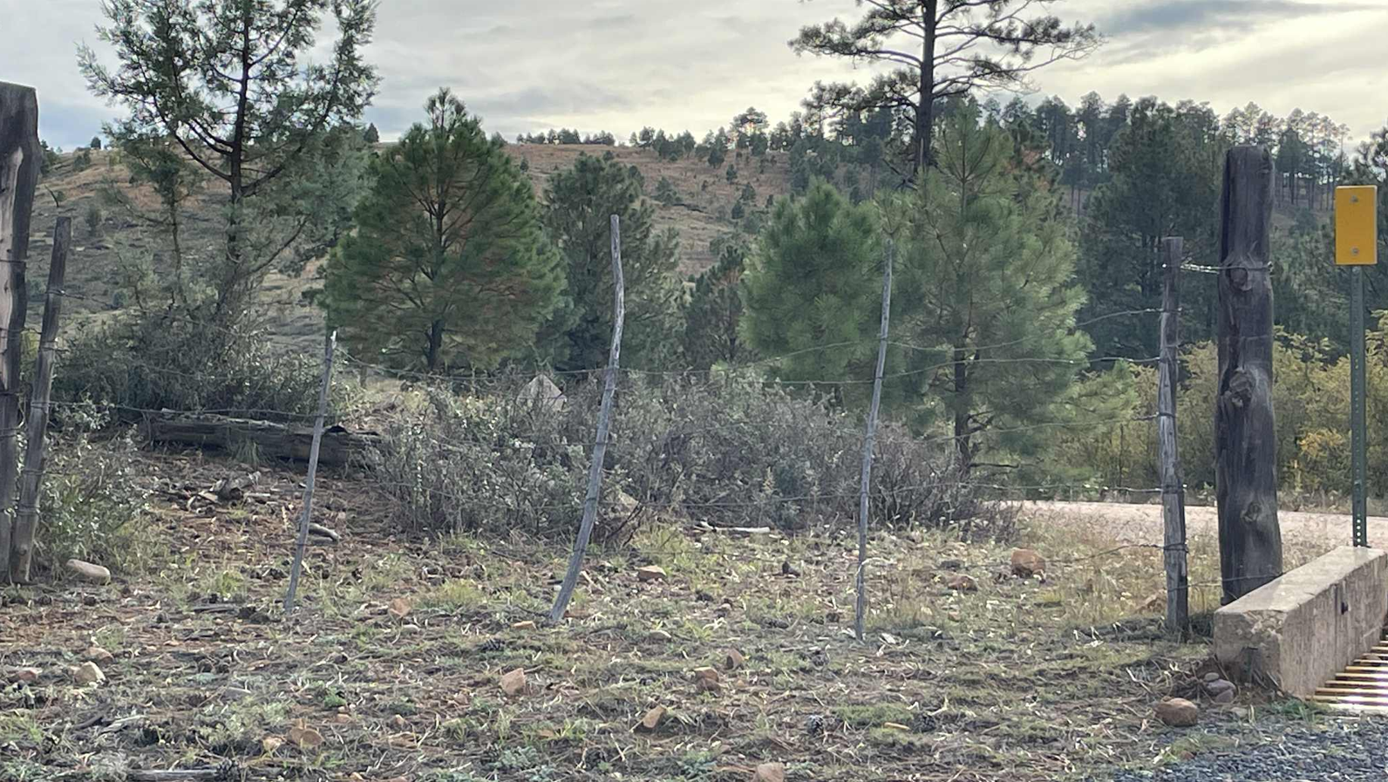
Forest Road 487 passes by Legacy Ranch. When you get to Black Canyon Road (FR-86), if you take a right, you immediately come to this bottleneck one lane bridge with private property and fencing on both sides. This bottleneck restricts north/south movement within the Territory. Adaptive Management cannot fix this restriction to wild horse movement within the Territory.
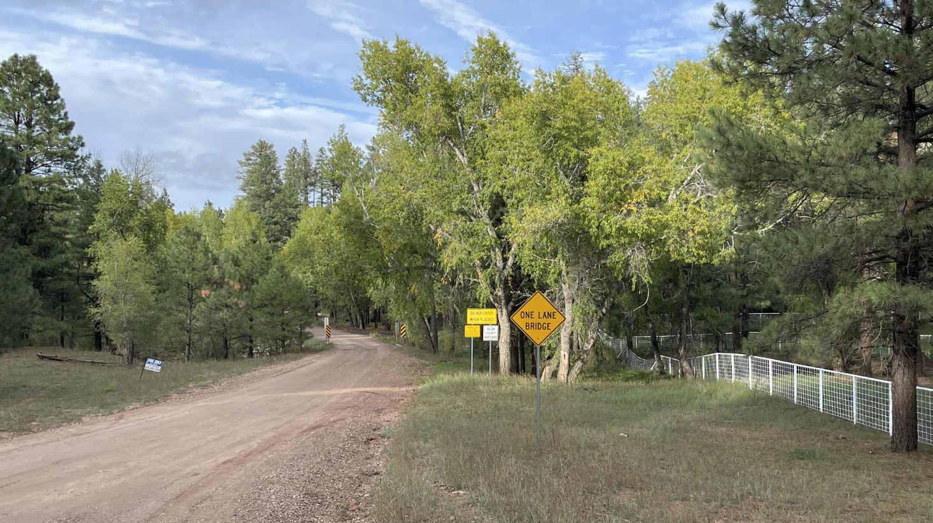

Very soon after passing through the bottleneck, you come to another cattle guard with closed gate and cattle pasture fencing (Cattle Guard 3 on the diagram). There is a private property on the left side.
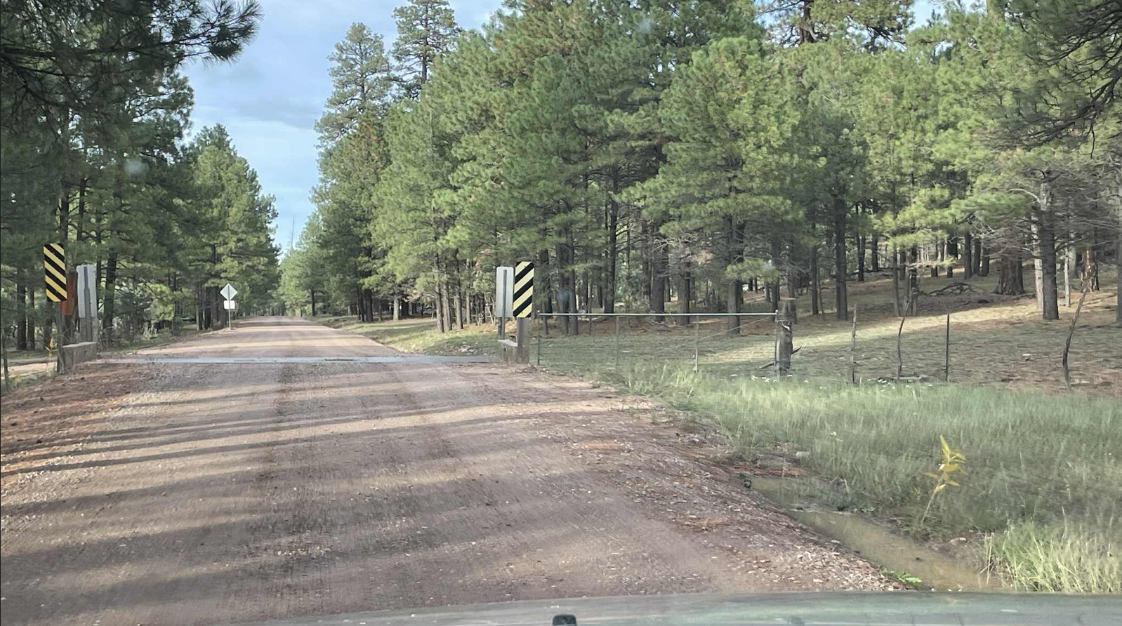
After a couple of miles, you come to another cattle guard with closed gate and cattle pasture fencing (Cattle Guard 2 on the diagram).
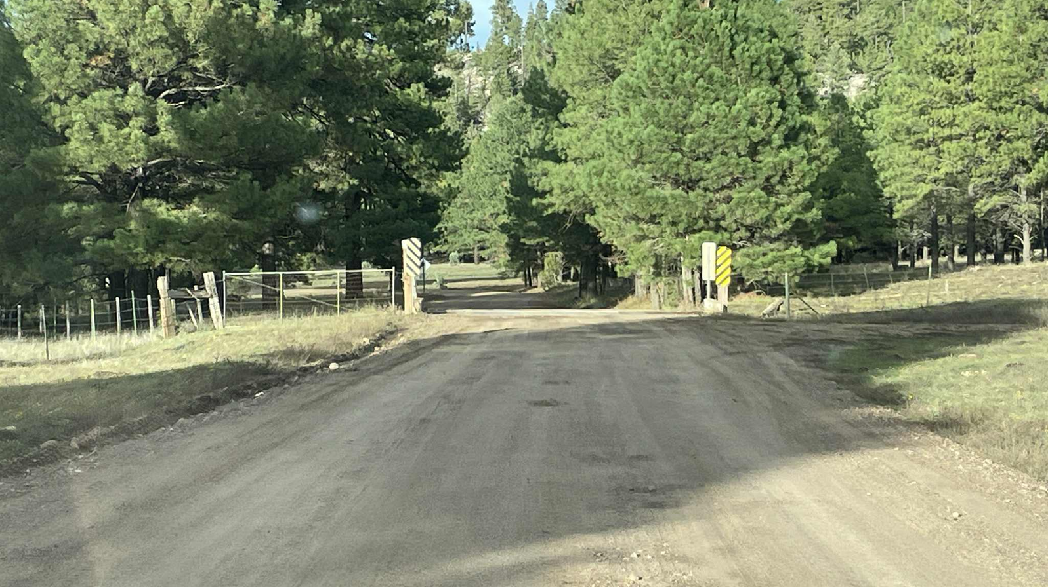

After another couple of miles, you come to another cattle guard with closed gate and cattle pasture fencing (Cattle Guard 1 on the diagram).
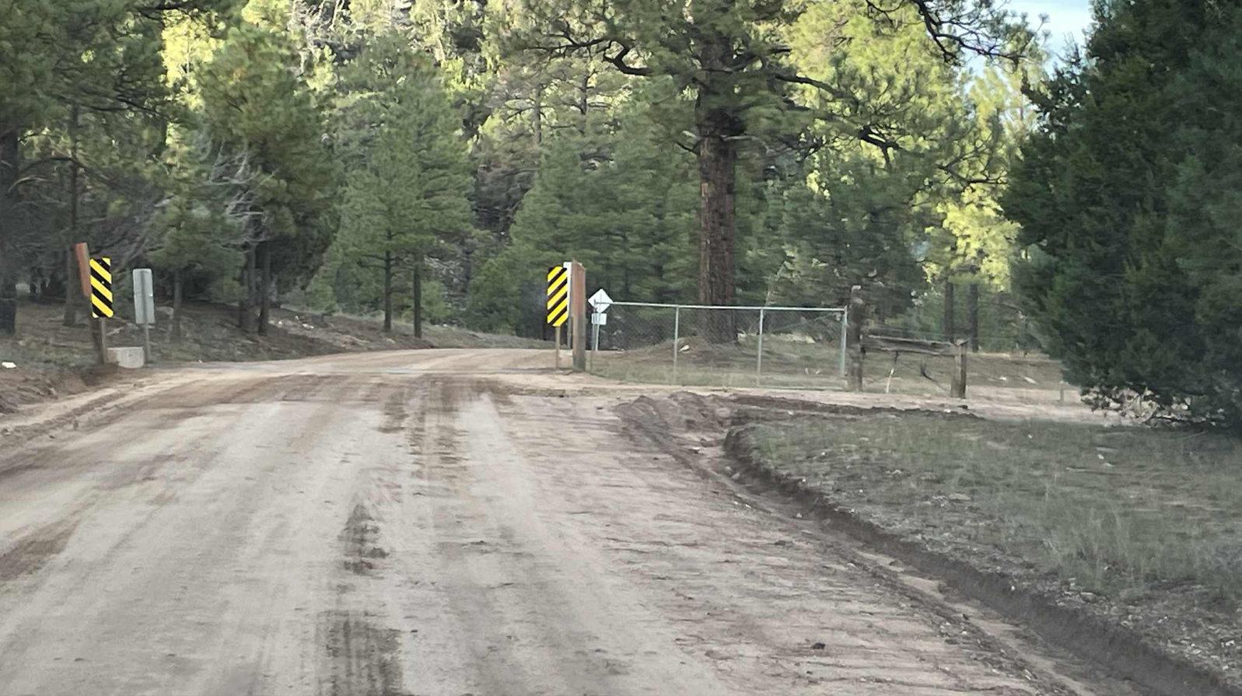
If you follow the cattle pasture fence line to the right from Cattle Guard 1, you come to a narrow 6-foot-wide closed gate inside the Territory.
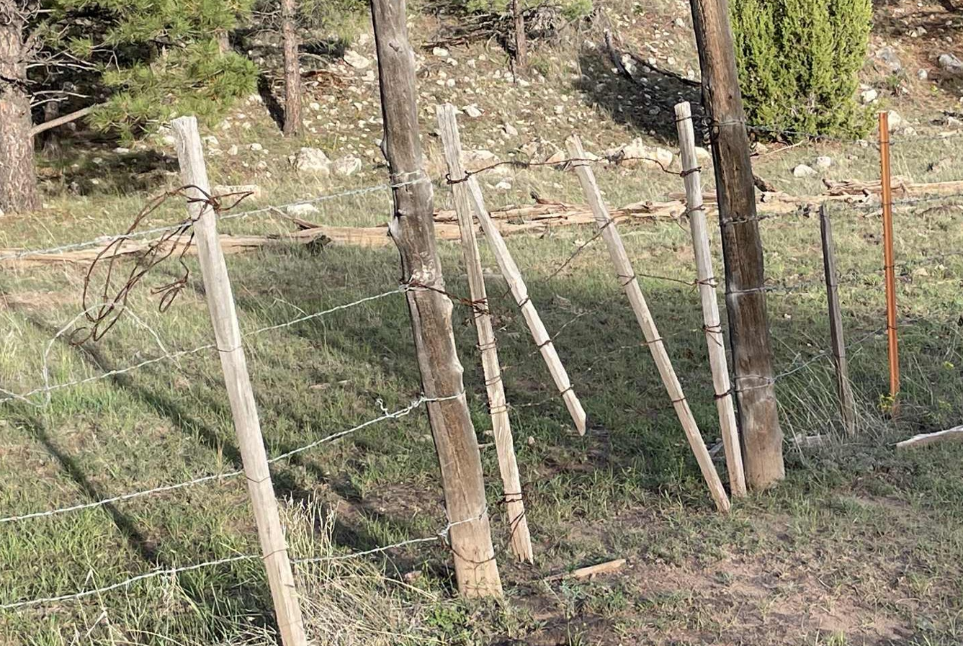

This closed gate with both Forest Service and Arizona Game and Fish signage saying to keep the gate closed is on cattle pasture fencing that runs along the left side of Forest Road 9053 on the east side of Black Canyon. This road branches off of Forest Road 50. This gate and cattle pasture fencing restricts Territory ingress and egress.
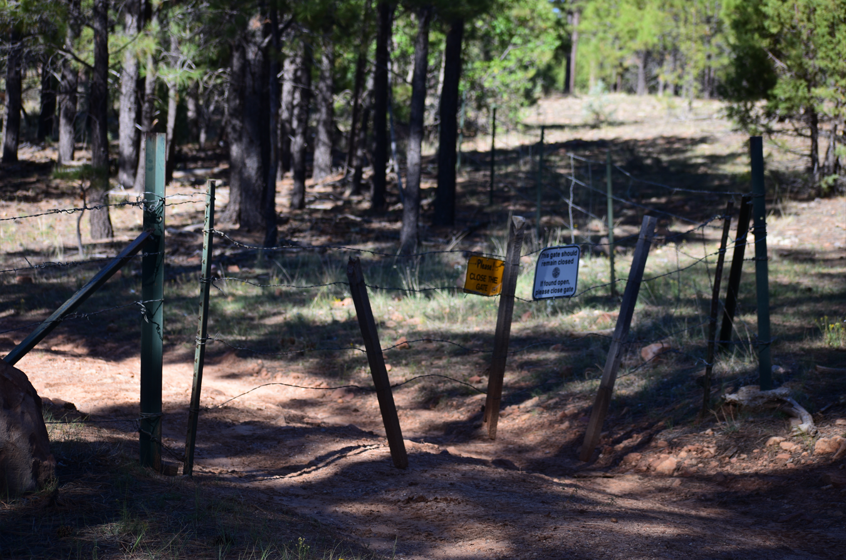
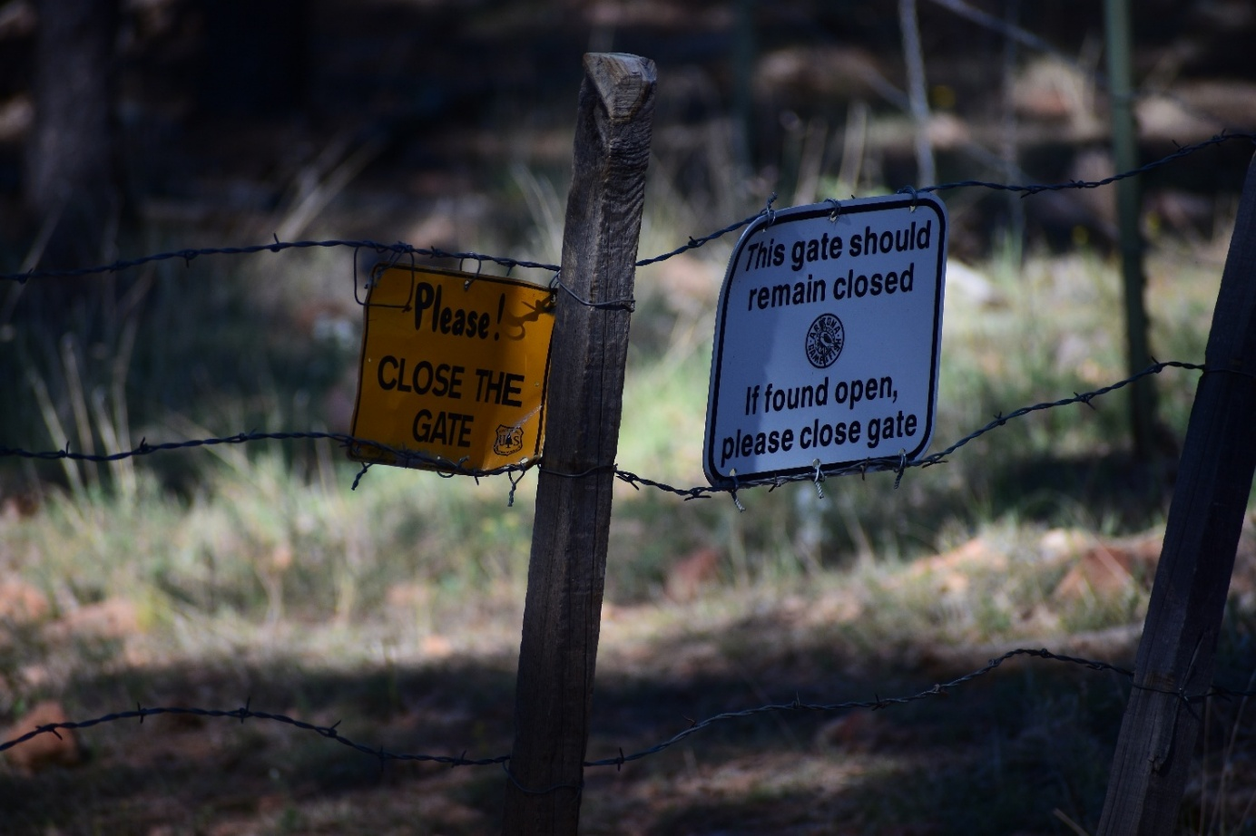

Another closed gate with cattle guard and cattle pasture fencing that runs across Forest Road 9053.
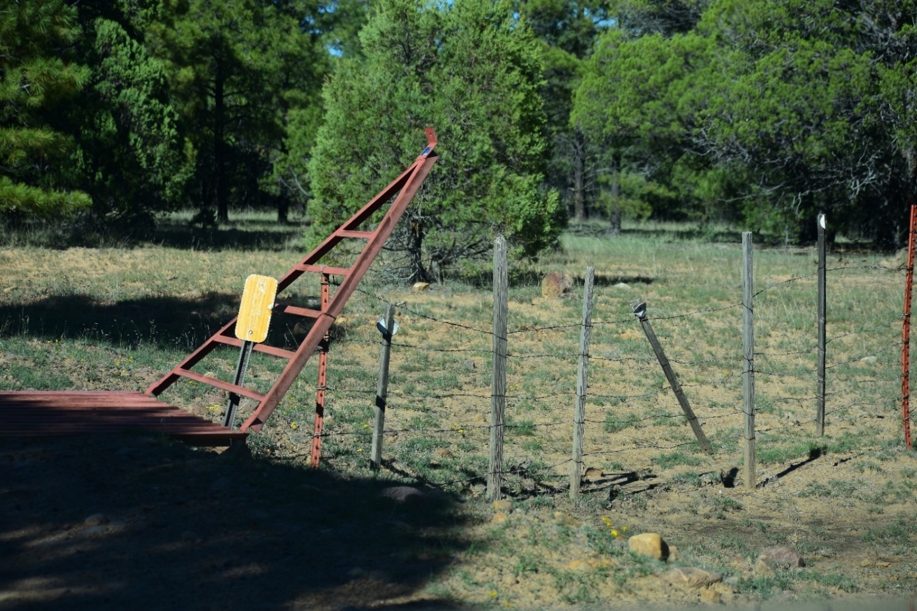
The cattle pasture fencing, cattle guards and closed gates largely restrict movement north/south within the Territory and restrict ingress/egress on the eastern edge of the Territory. I have by no means included all closed gates and cattle guards herein but have given several examples to show just how restricted wild horse movement is in this “patchwork quilt, corn maze” environment where the Adaptive Management plan is to have gates open one day and closed the next and vice-versa, and where there is no Adaptive Management plan in the world that can change terrain features, weather and man-made obstructions like the bottleneck one lane bridge and the private properties along Black Canyon Road (FR-86). Adaptive Management cannot fix all of the problems that exist with wild horse movement into, out of and within the Territory. Adaptive Management cannot provide our wild horses with the four elements of forage, water, cover and space in the Territory. The only viable solution is to expand the Territory.
Now let’s look at how the movement across the Territory is restricted by steep rock canyon walls. For anyone not familiar with Black Canyon, this gives you a “flavor” of just how difficult movement within the Territory is made by natural terrain features. This deep rock canyon runs the length of most of the Territory. This terrain is only suitable for rock climbers with rock climbing equipment and mountain goats. It is not navigable by horses! This lends further credence to the argument that the Territory was delineated arbitrarily and capriciously and arguably even to the intentional detriment of our wild horses and in favor of cattle grazing. Adaptive Management cannot fix this! The Forest Service has never shown paths of movement the horses can take around the vast number of obstacles to where they can safely ingress/egress and navigate within the Territory throughout the year. See the next 21 photos.
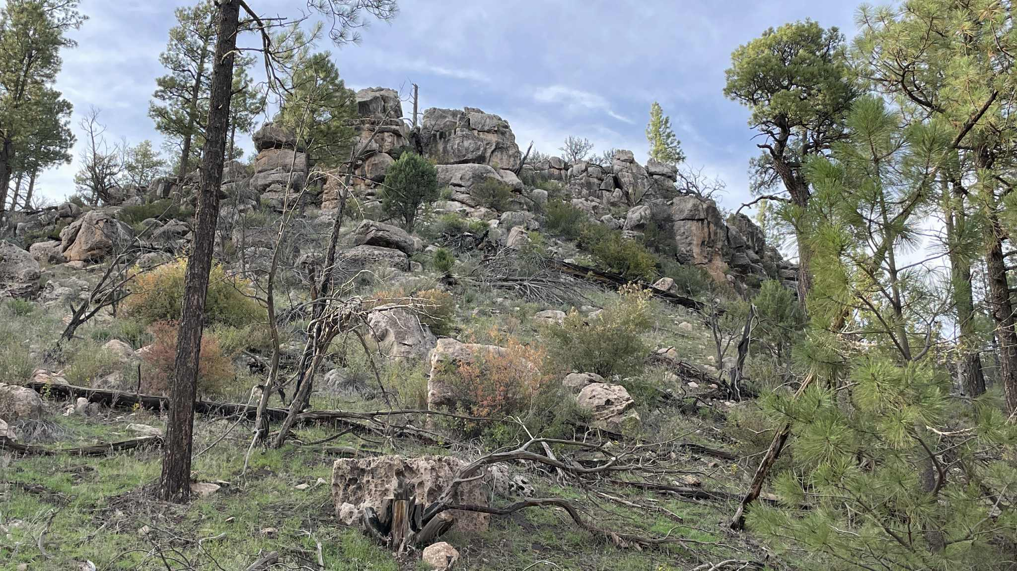
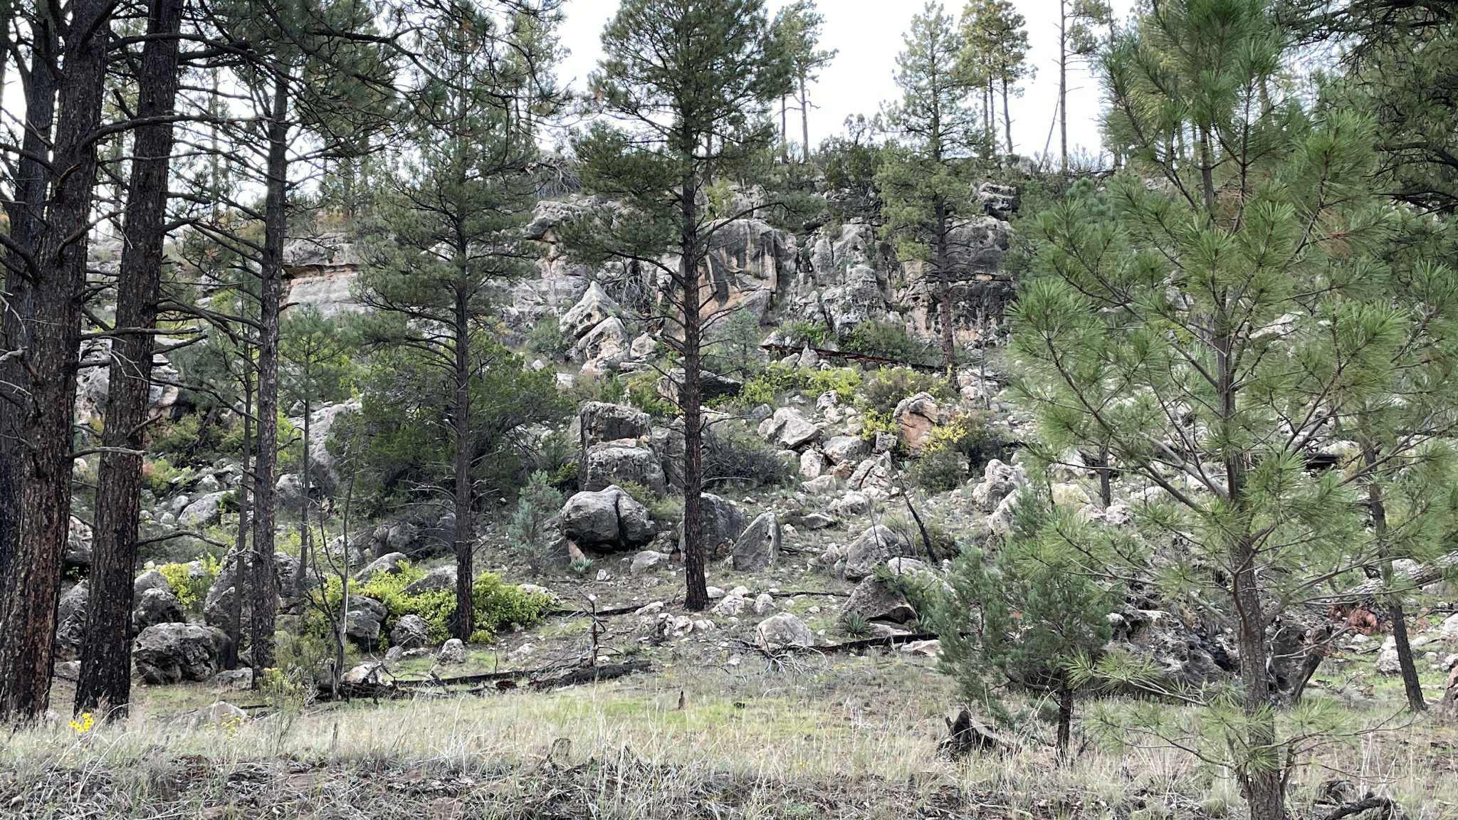
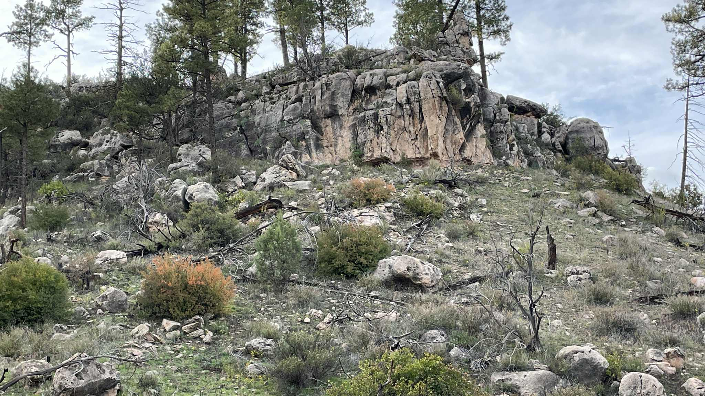
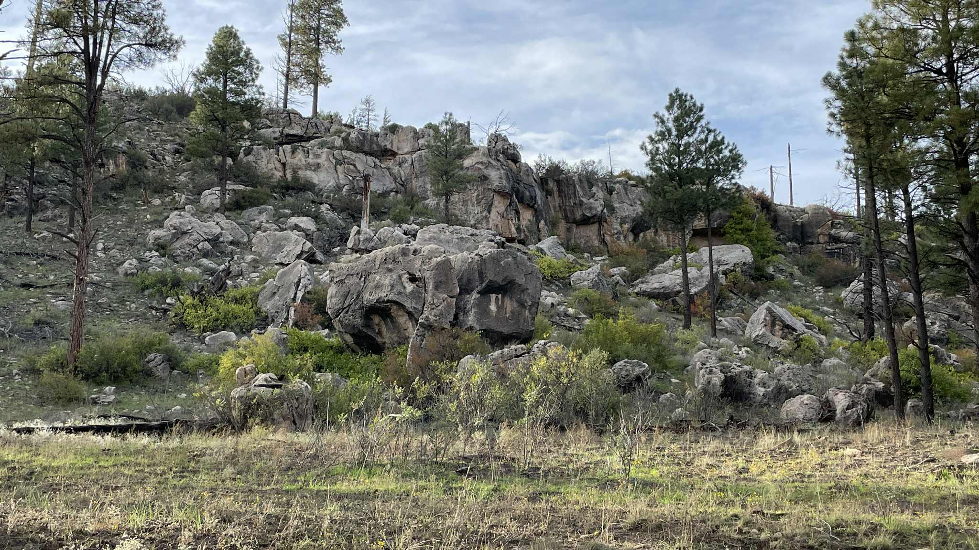

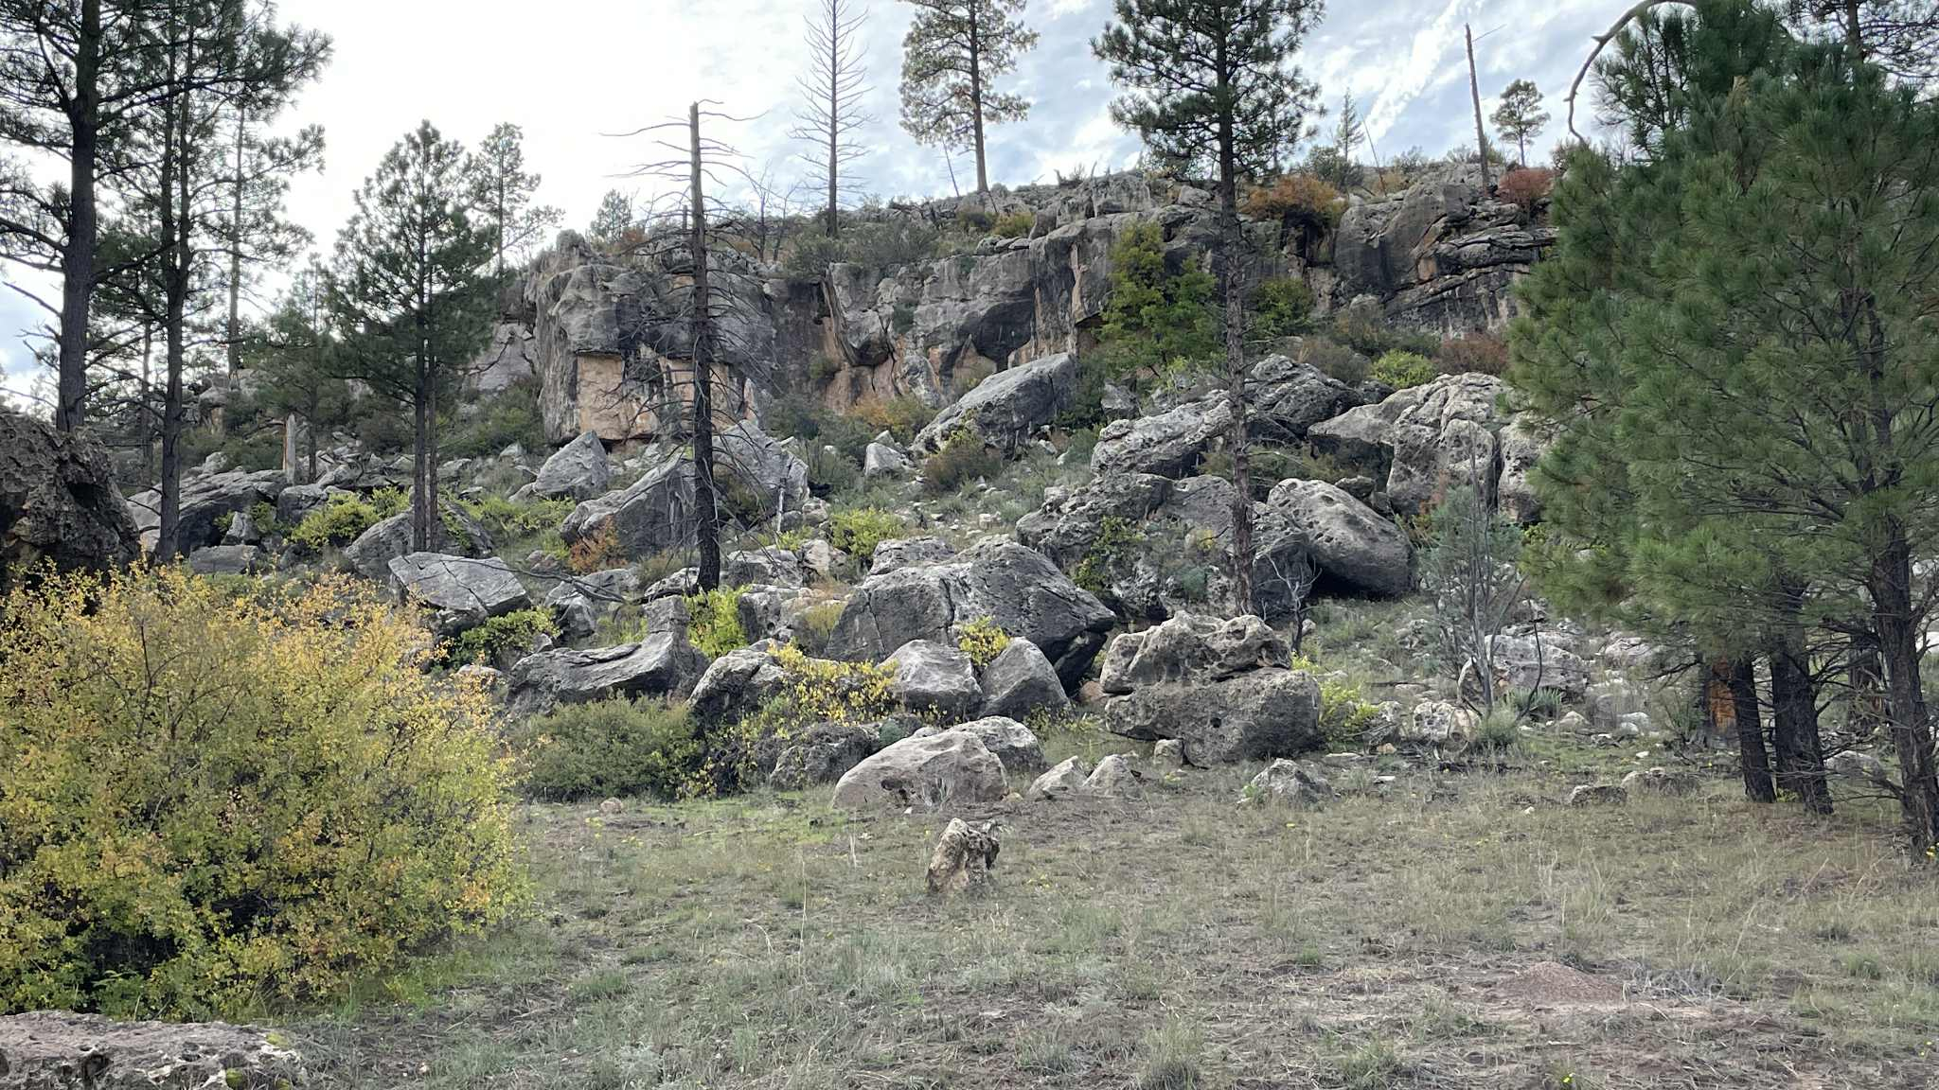
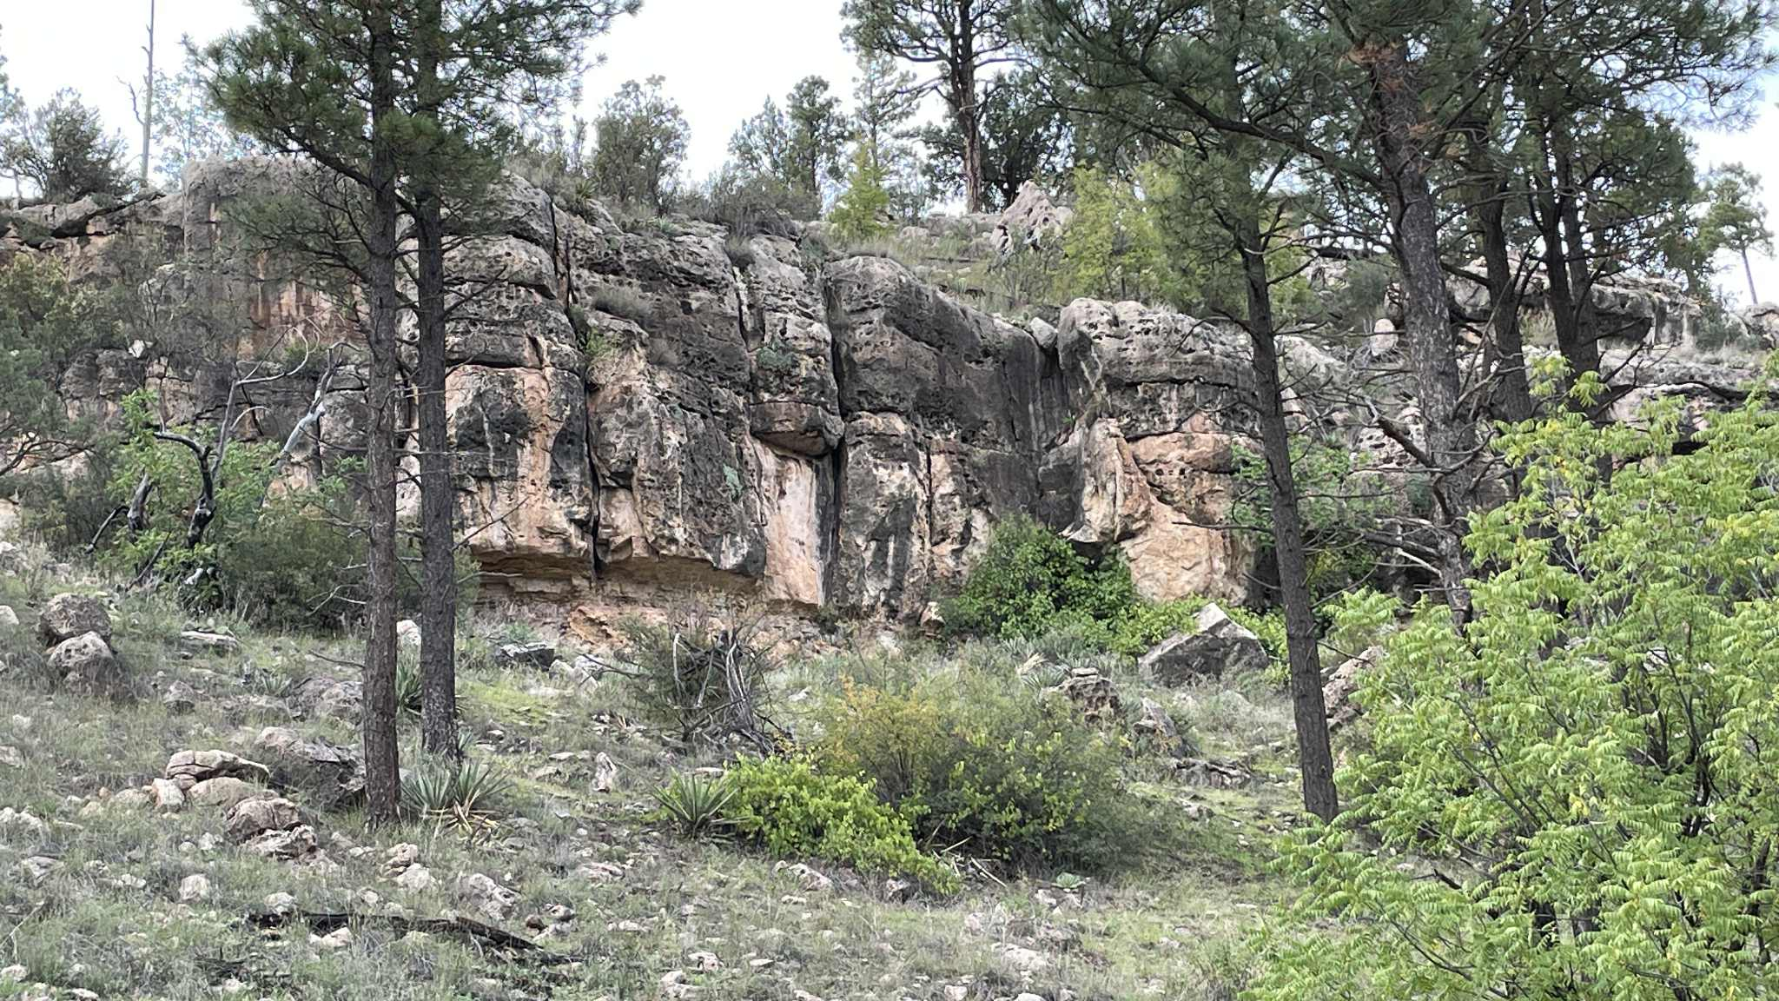
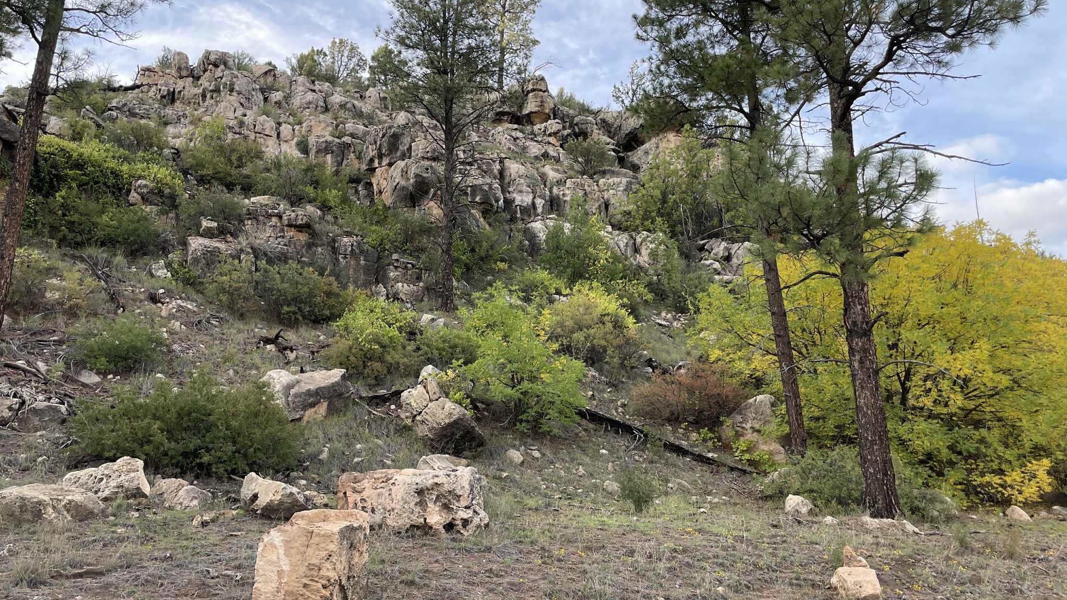
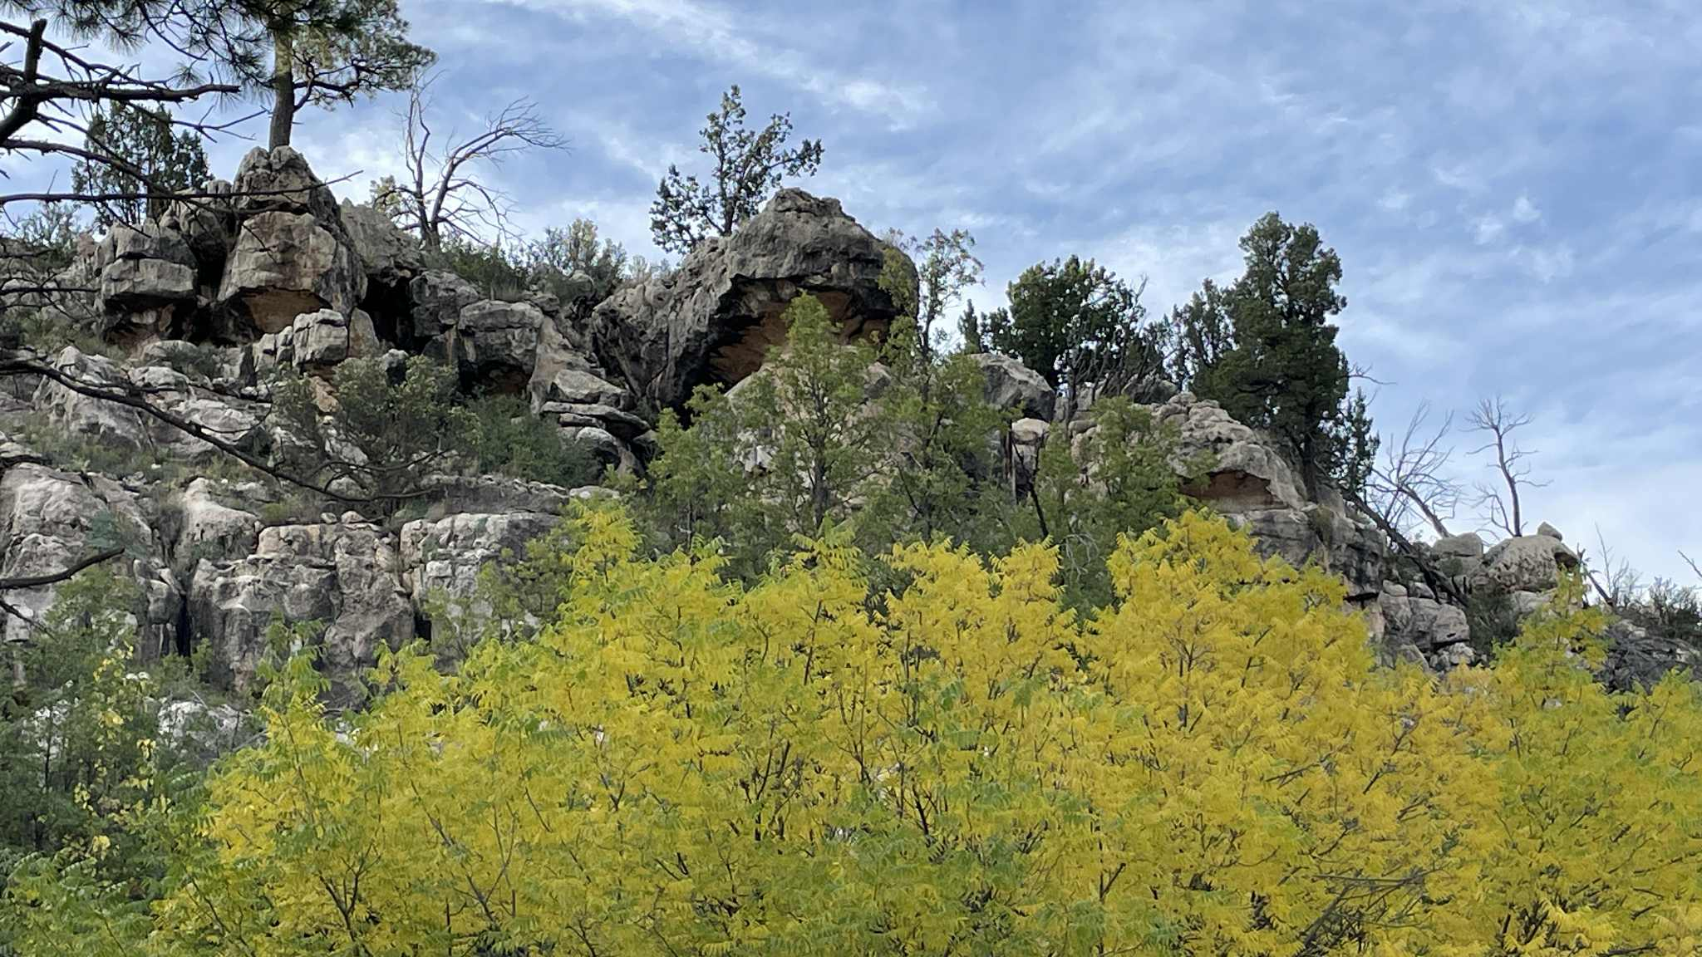
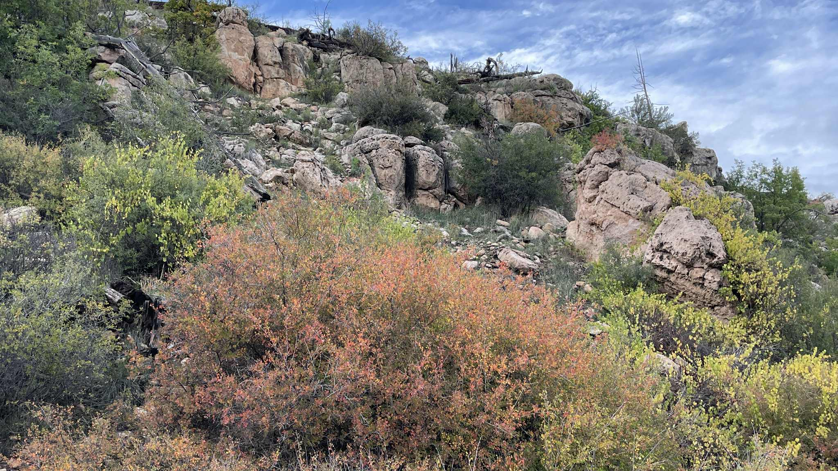
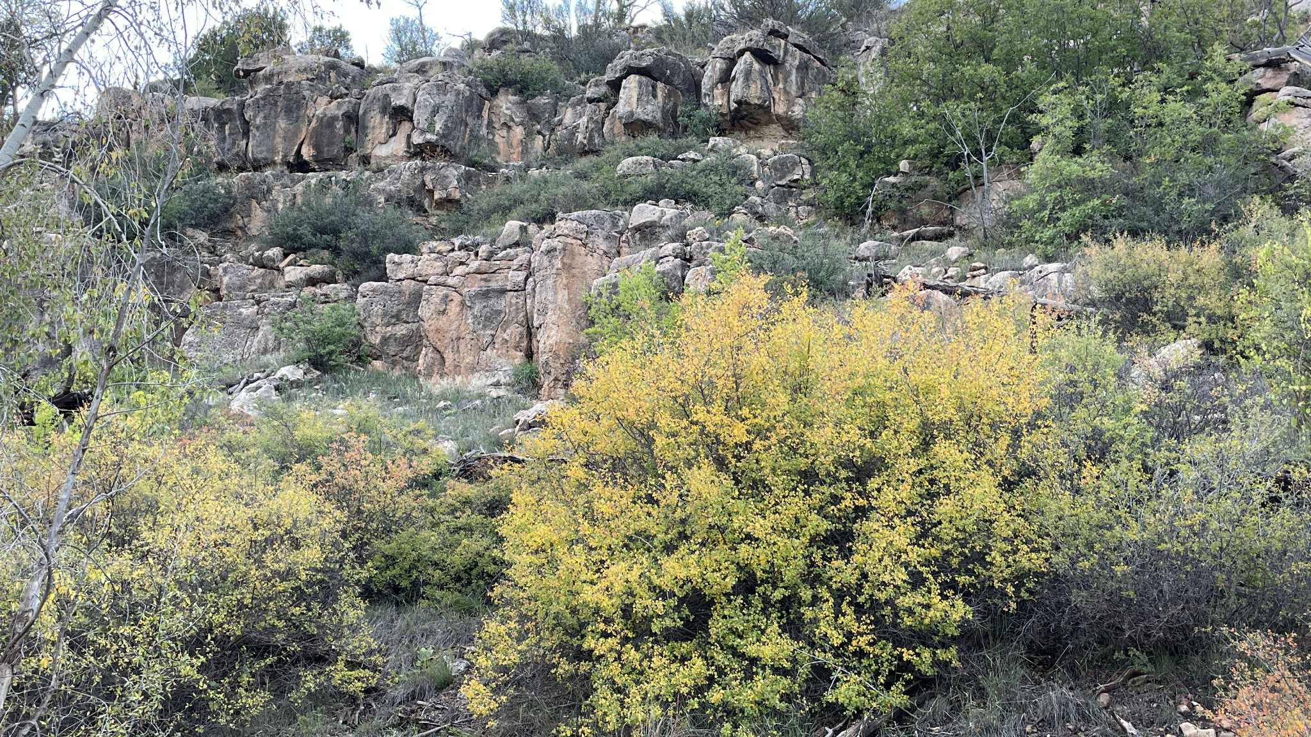
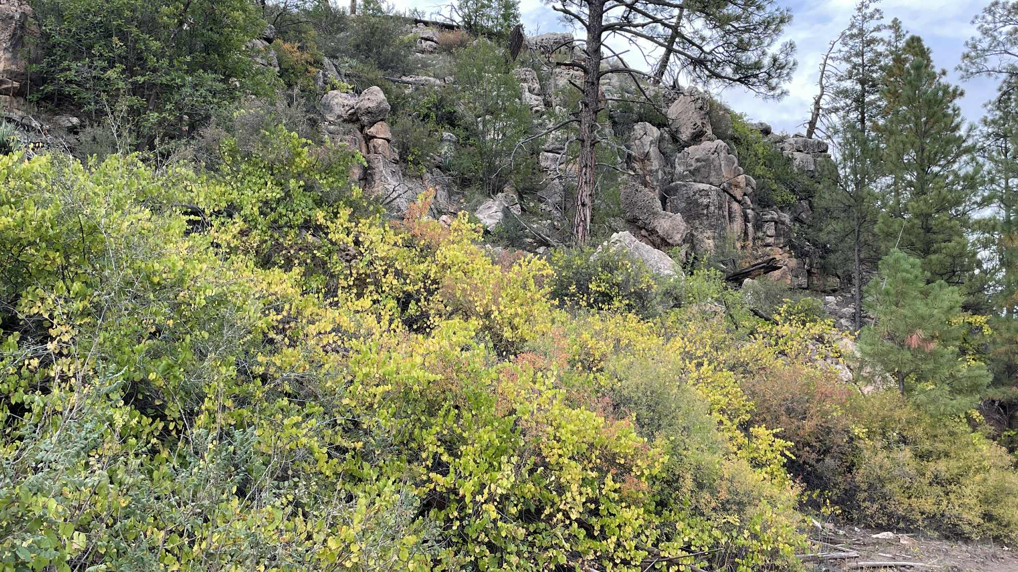
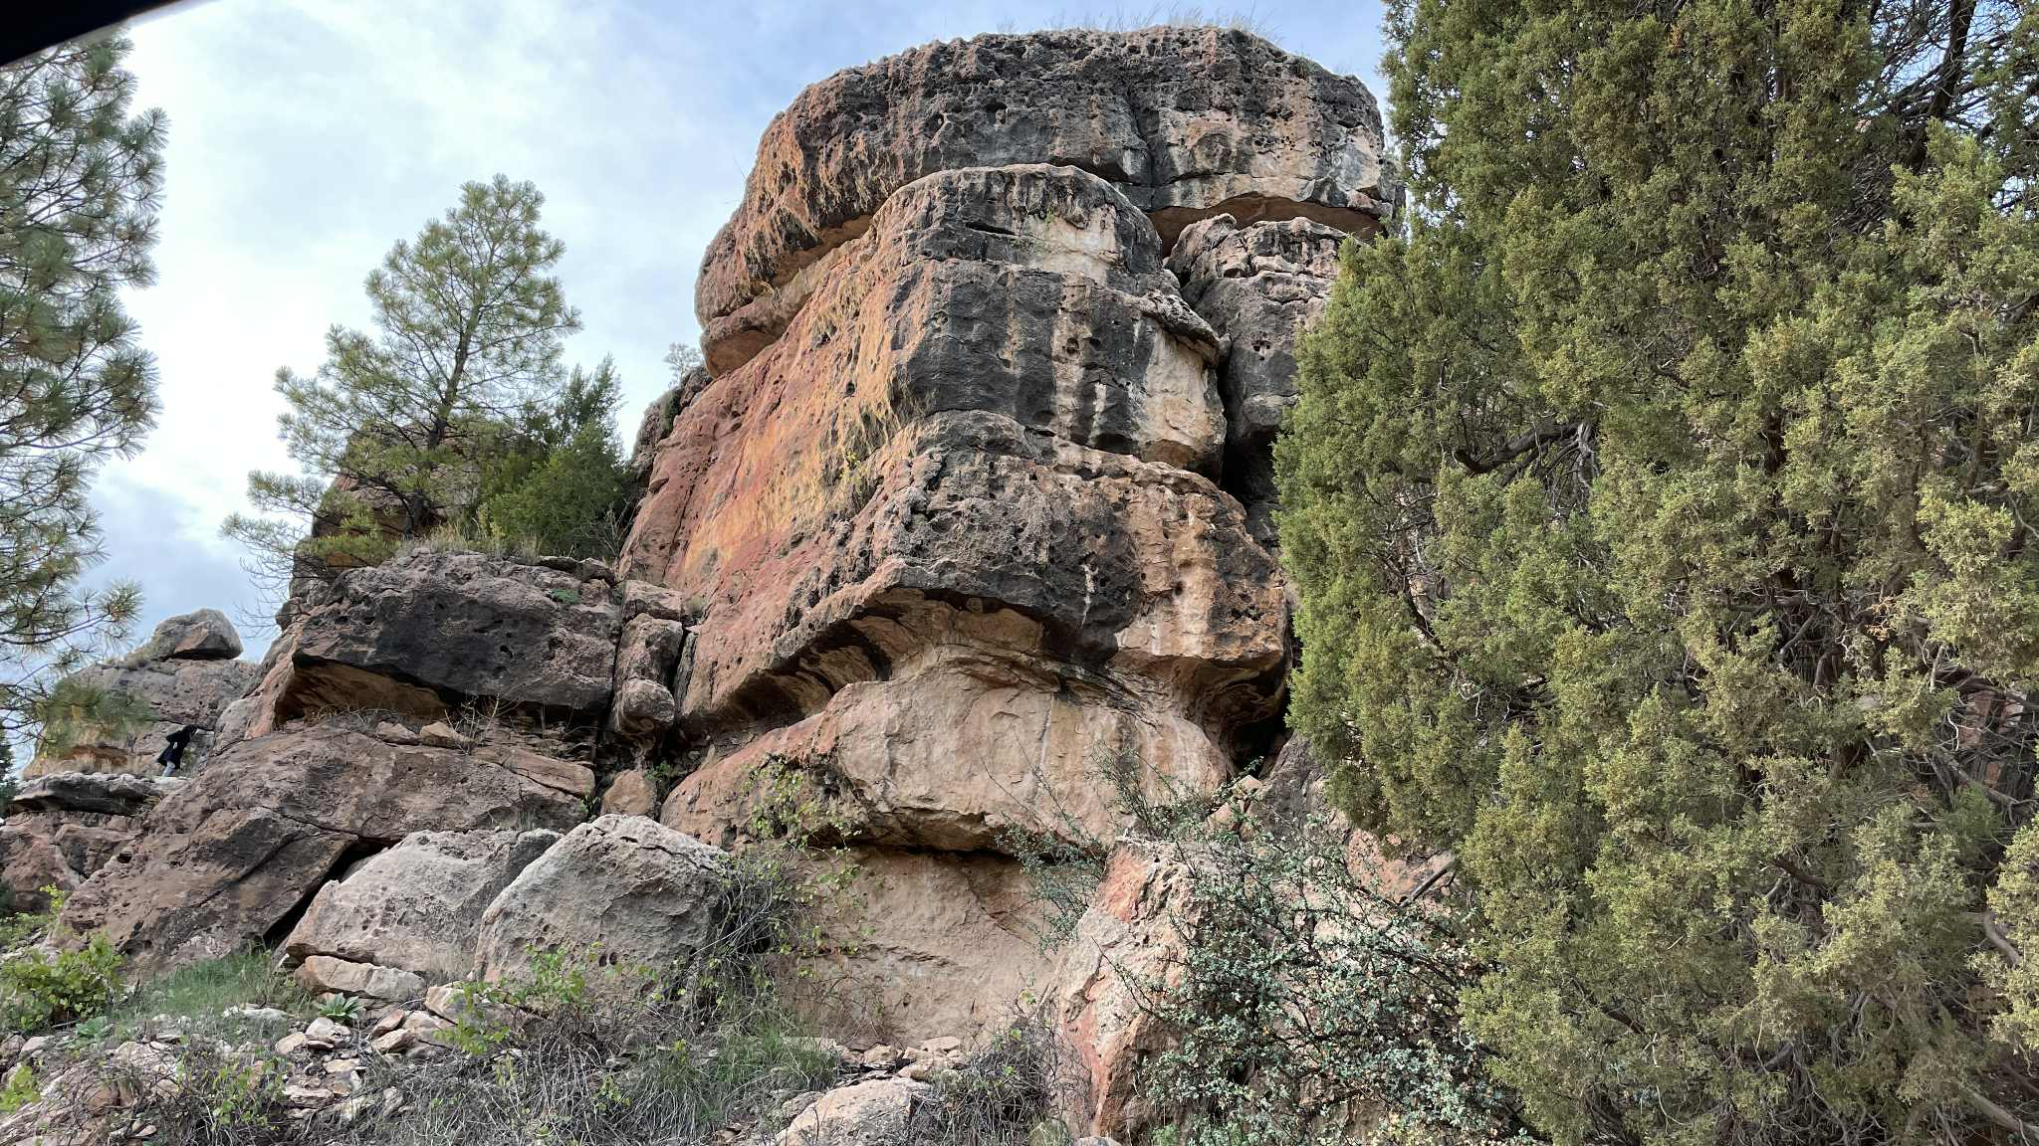
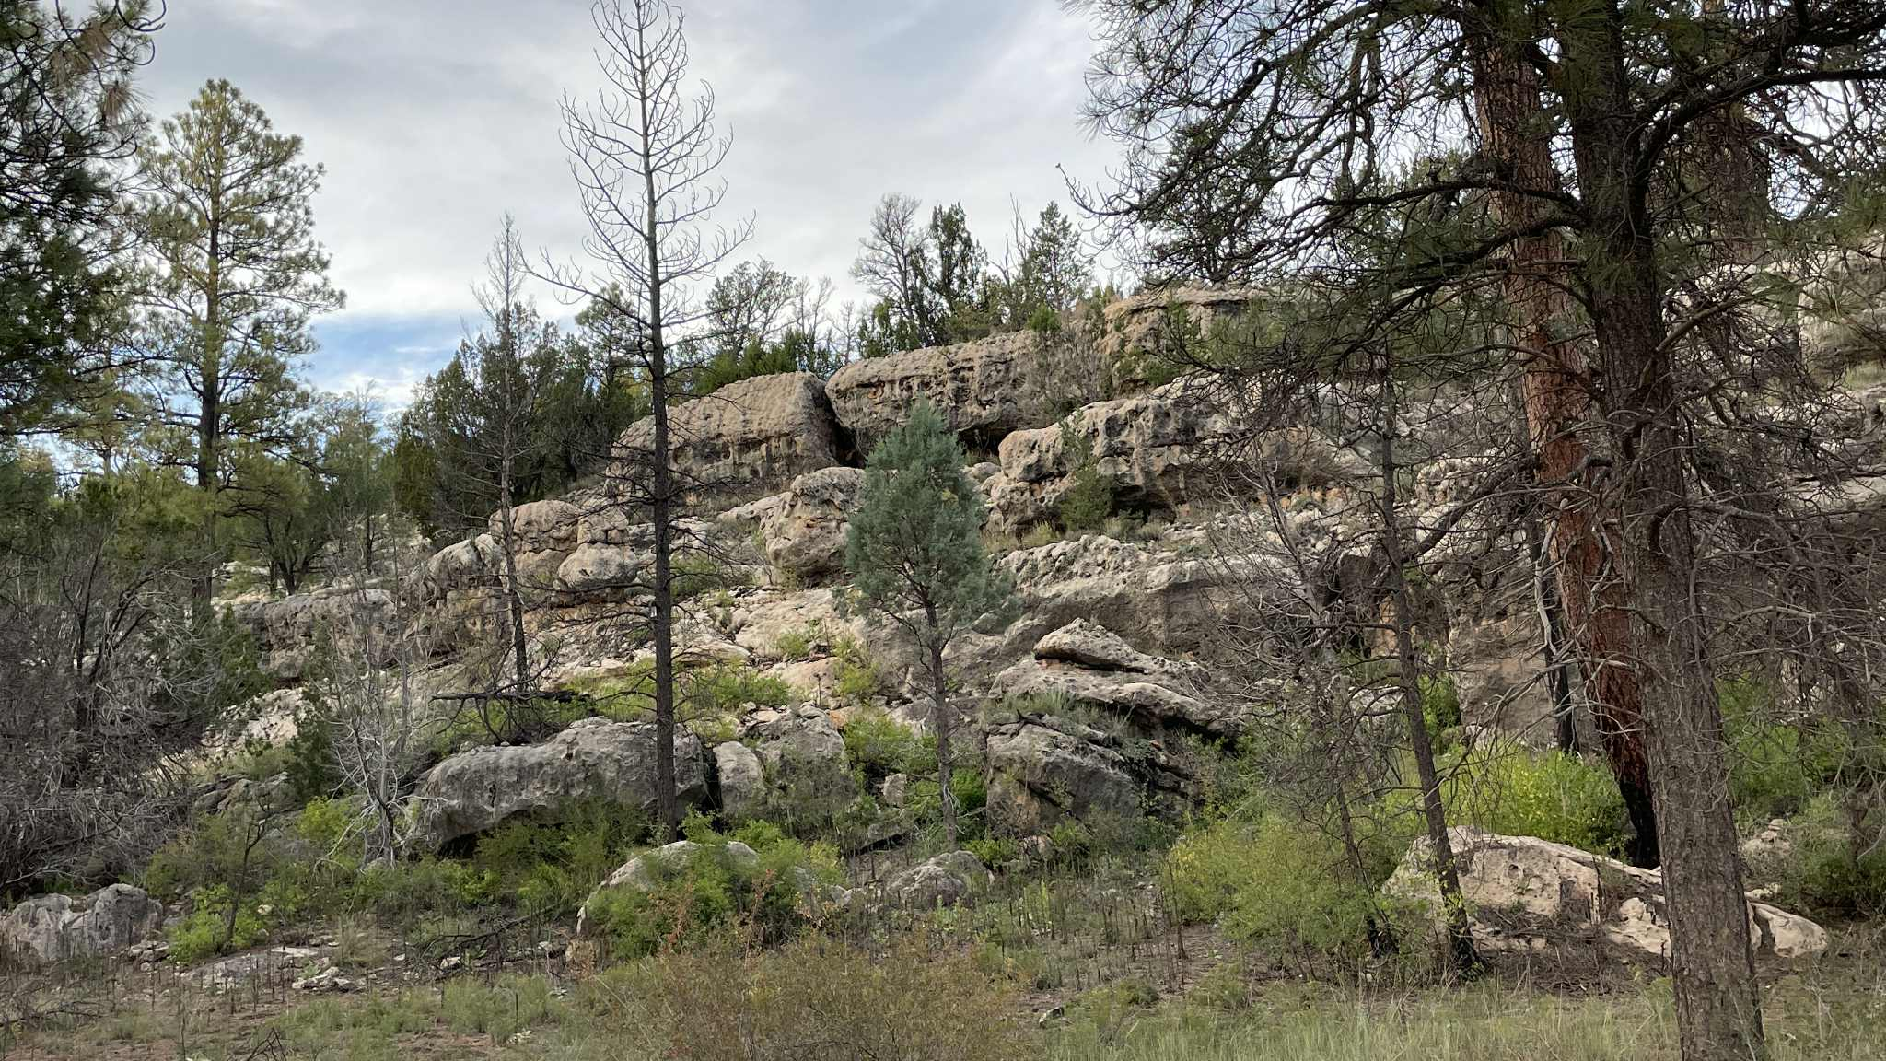
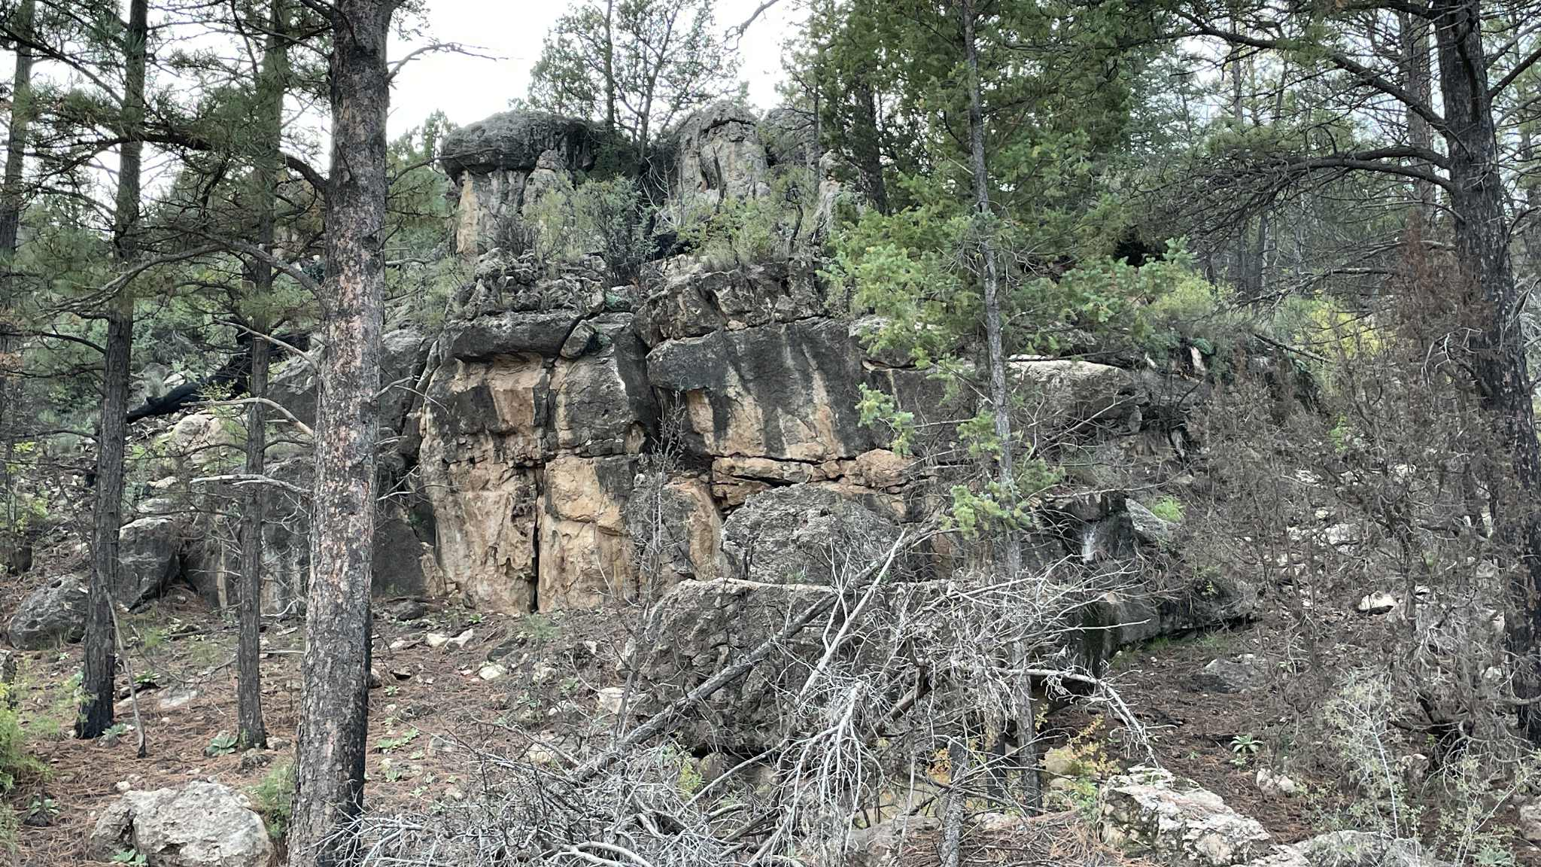
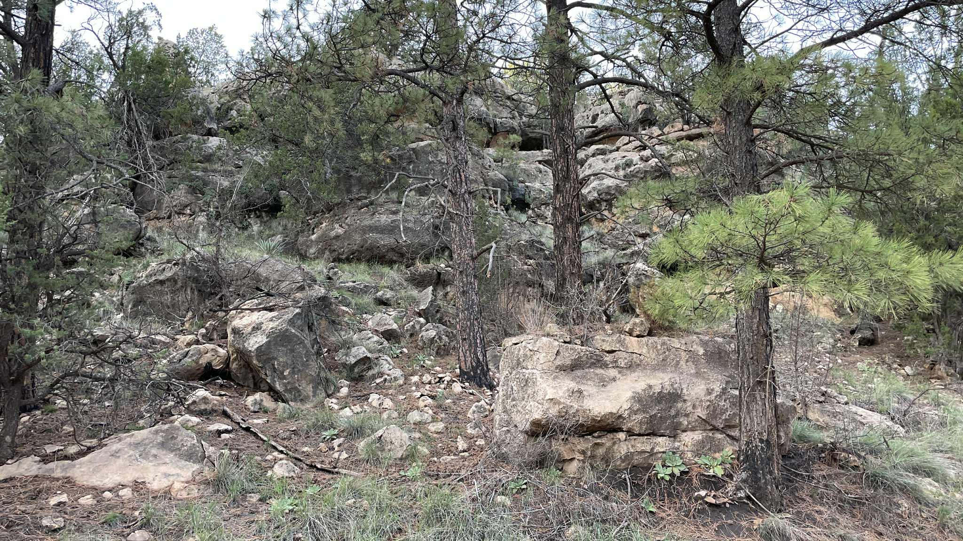
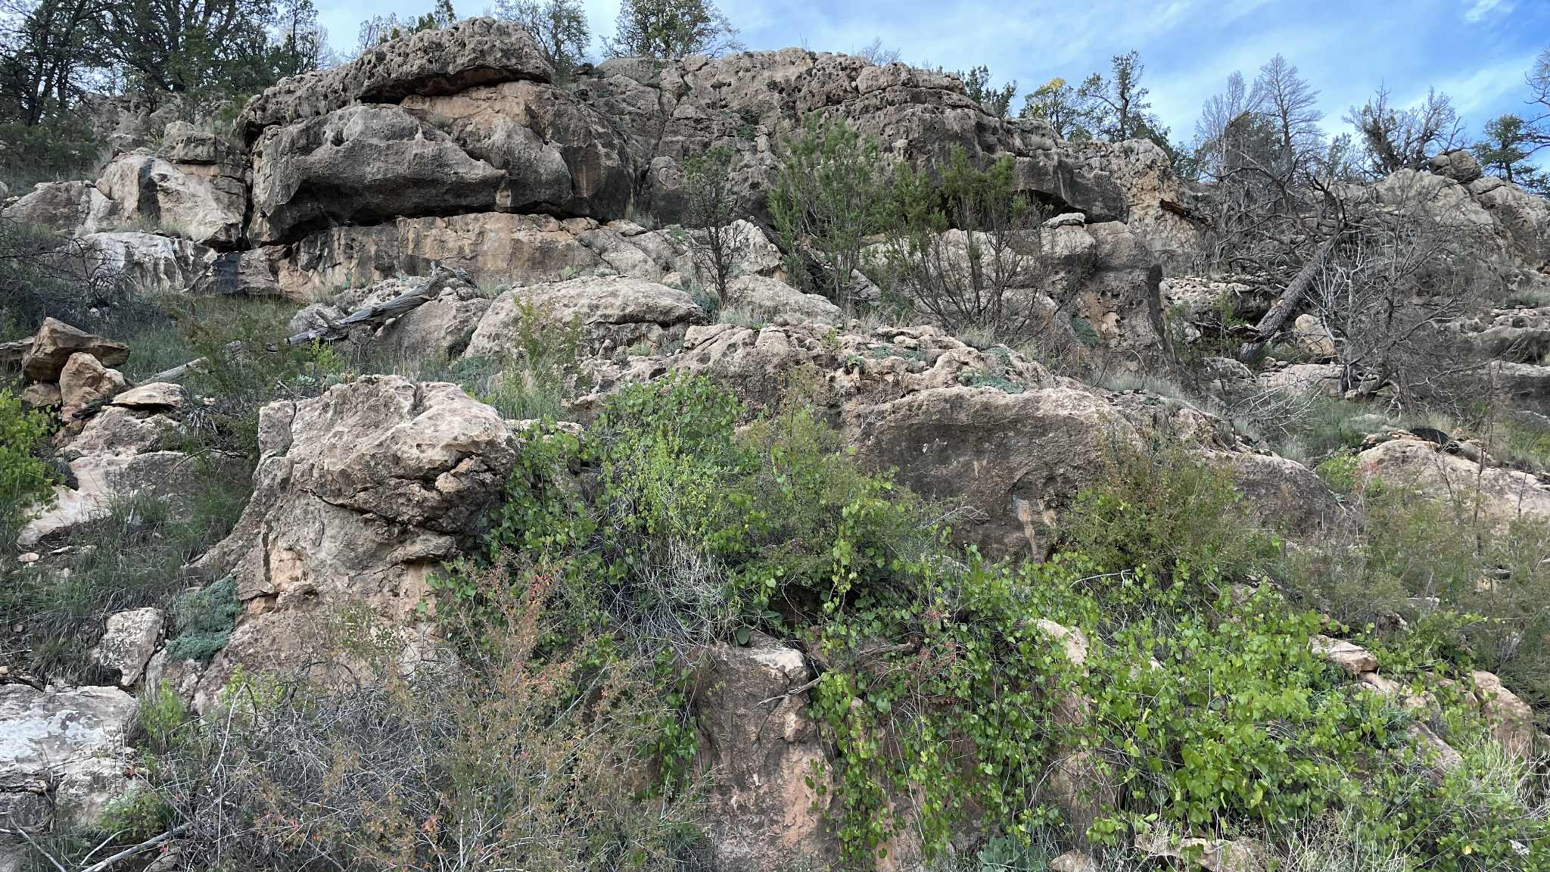
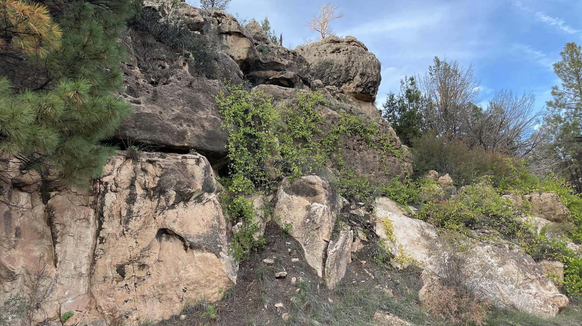
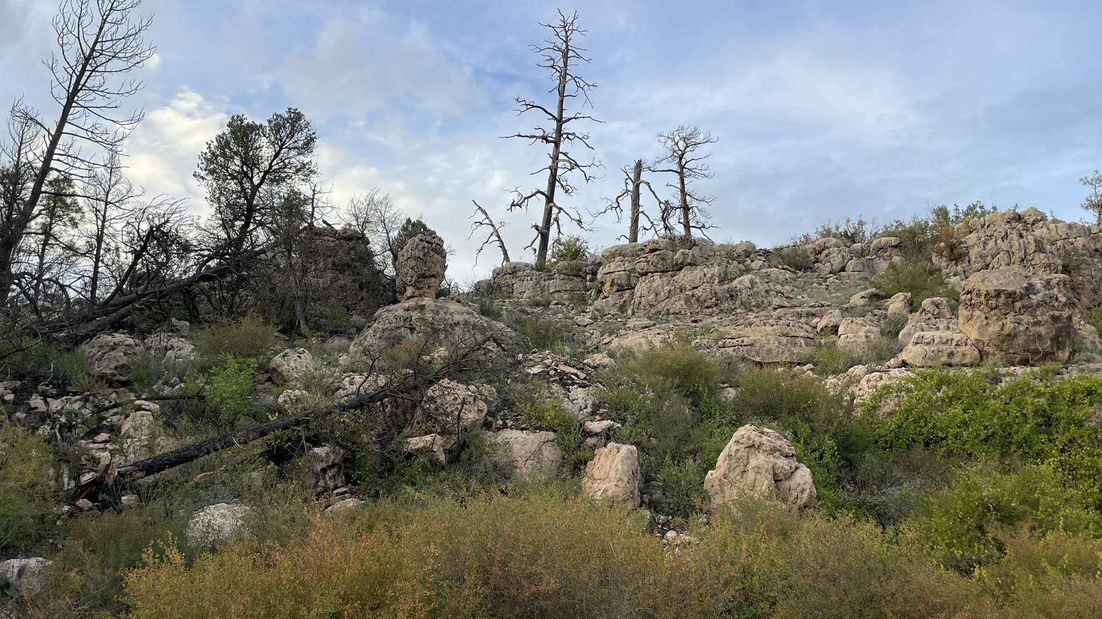
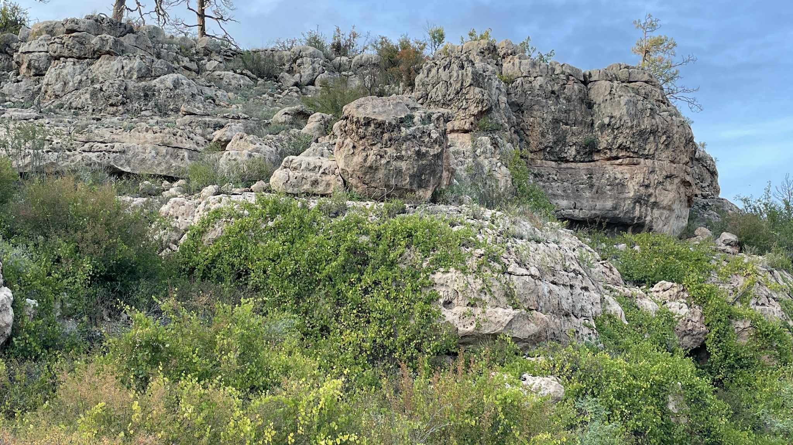
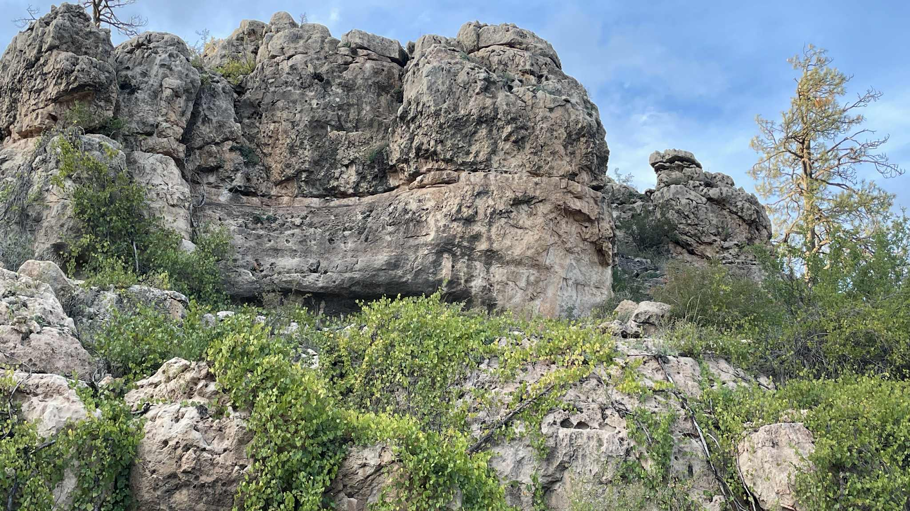
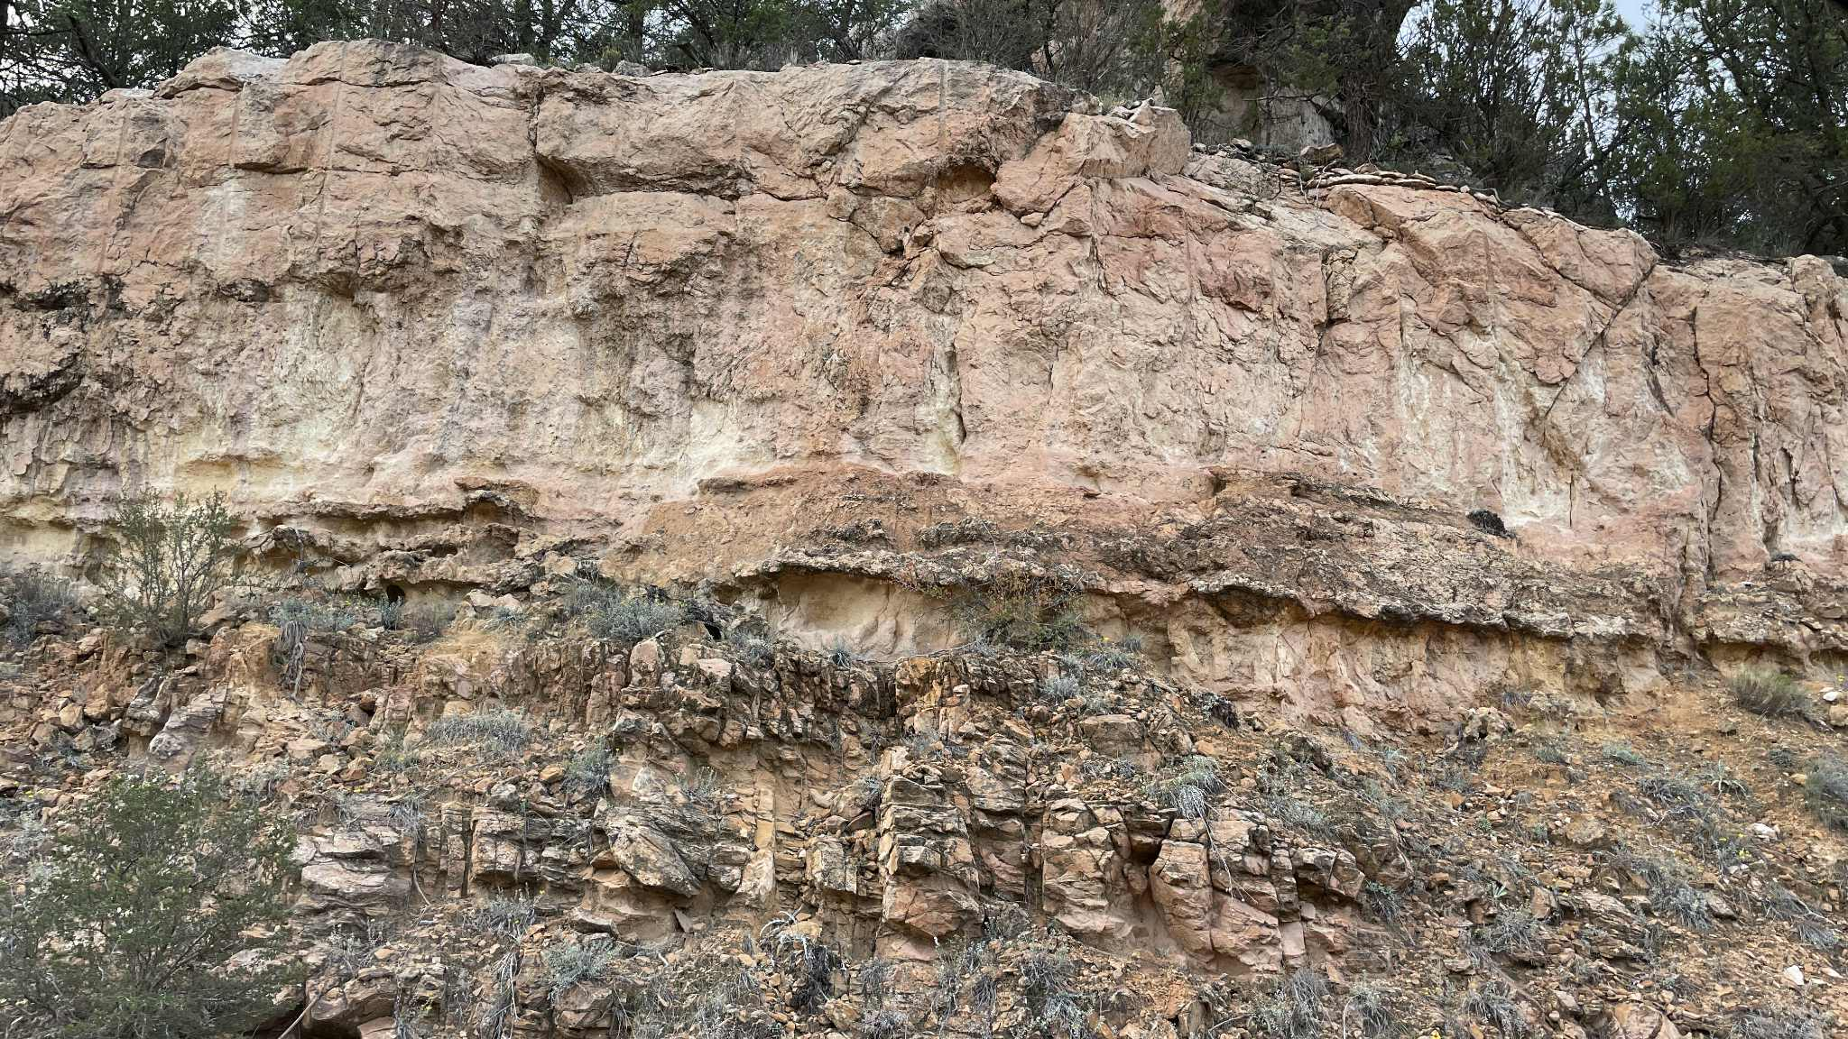
This photo taken on March 31, 2021, and included in a 2021 Plan Comment, shows how the downed Ponderosa pine trees block passage through draws leading into and out of Black Canyon. Adaptive Management cannot fix this!
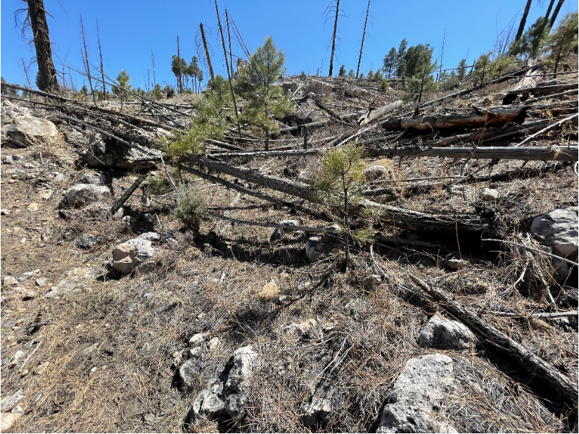
Two photos taken on April 1, 2021, show obstructions blocking passage through draws leading into and out of Black Canyon.
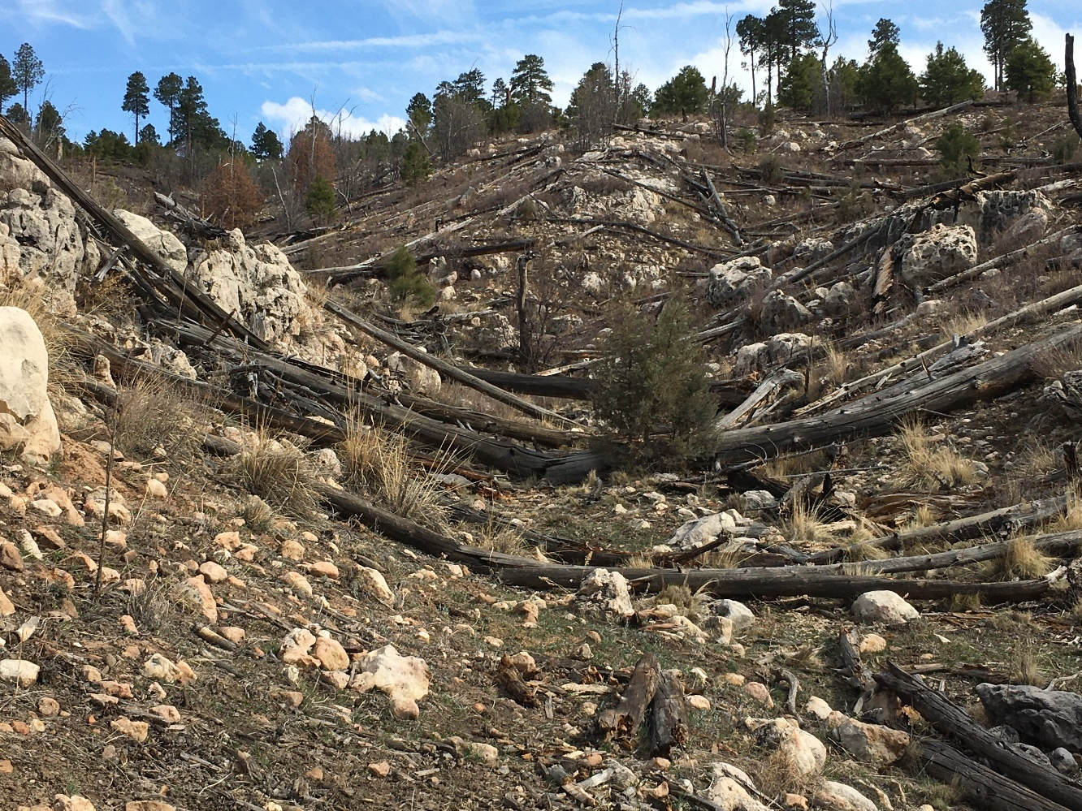
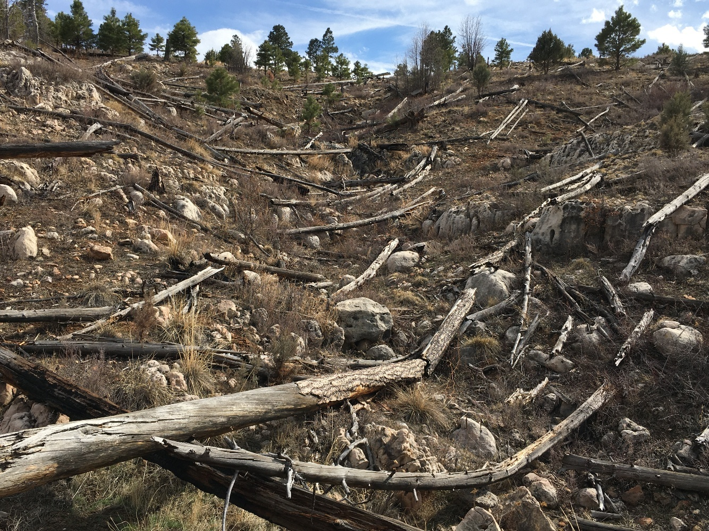
It’s clear that the Territory boundaries were initially drawn with the intention of eliminating wild horses in deference to cattle, contrary to the Wild Free-Roaming Horses and Burros Act of 1971, and with the belief that any horse found off the Territory could be summarily removed. The fact that there was no initial census conducted supports this contention. The fact that there is no information to be found on how or why the Territory boundaries were determined supports this contention. The fact that the Territory has been largely, historically “off limits” to wild horses in favor of cattle supports this contention. The unlawful removals of wild horses, starting at least as early as July 1974 (the Territory delineation was first recorded just 6 months earlier on January 15, 1974) and continuing through the late ‘80s/early ‘90s supports this contention. Rancher Doy Reidhead’s historical account that the “old ranger” “just wanted the horses gone” because “He was afraid they’d make a wild horse refuge” supports this contention.
Even now, the Forest Service has allowed in their Management Plan to give priority to cattle, contrary to the 1971 Act, by allowing “an additional 483,963 pounds of available forage for wildlife (beyond that currently utilizing the area) or for future adjustments in the livestock grazing level.” Why would consideration be given to increasing livestock when the Territory is supposed to be “devoted principally” to the wild horses’ welfare? How does adding more cattle benefit the wild horses’ welfare?
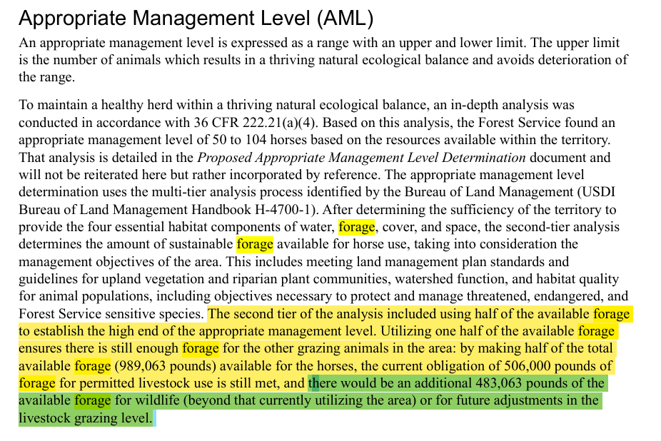

On page 167 of the Final EA, it states, “If it were determined that one of the four key elements (forage, water, cover, space) were lacking then analyzing expanding or re-drawing the territory boundary would have been justified.” Frankly, if the horses have access to all these things, why are they not using the Territory? All of the obstructions to movement and issues that I outlined above show that our wild horses do not have all four elements of forage, water, cover and space in the Territory. All the “Adaptive Management” in the world cannot impact the western boundary of Highway 260. All the “Adaptive Management” in the world cannot impact the northern boundary of the towns of Heber and Overgaard. All the “Adaptive Management” in the world cannot impact the natural terrain features, weather and man-made obstacles that impair and restrict wild horse movement into, out of and within the Territory as I have outlined in this Objection. Adaptive Management is not the solution. The only solution is to expand the Territory boundaries to allow our wild horses to move naturally with the four elements of forage, water cover and space.
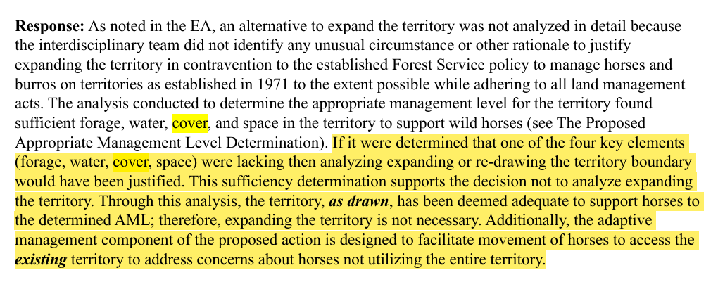
Page 18 of the Final EA reads, “Additionally, the adaptive management components of the proposed action is designed to facilitate movement of horses to access the existing territory to address concerns about horses not utilizing the entire territory.” I have shown with this Objection that Adaptive Management is not a viable solution to the problem.
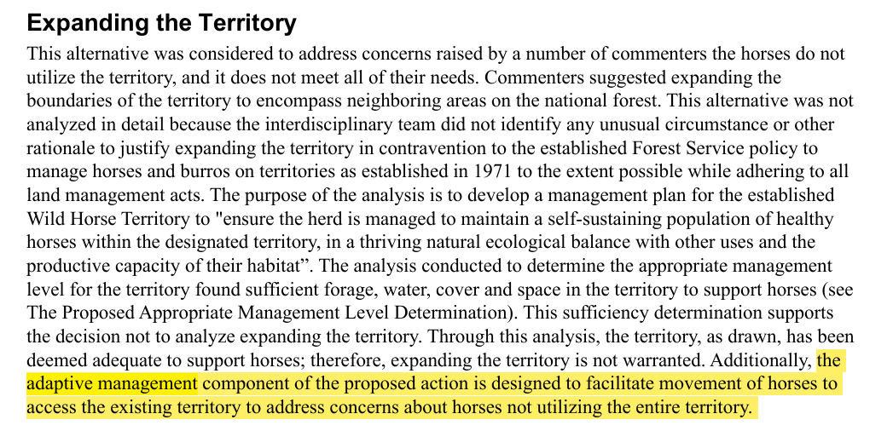
The fact that gates in the fence line that separates the Black Canyon Allotment to the north from the Heber Allotment to the south are the only access points in and out of a large northern portion of the Territory is a major problem! Adaptive Management is not a solution to the problem. The only viable solution is to expand the Territory so the horses aren’t trying to navigate a “patchwork quilt, corn maze” environment.
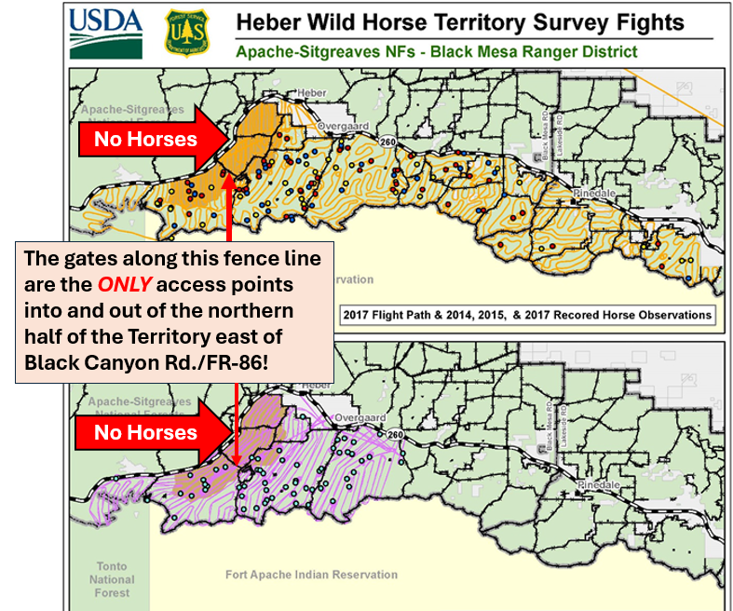
Wild horses are to be managed “as an integral part of the natural system of the public lands” and “as components of the public lands.” In addition, “All management activities shall be at the minimal feasible level.” How is this possible in a “patchwork quilt, corn maze” environment, where there is an obstruction to wild horse movement at every turn, to fulfill these promises found in the Wild Free-Roaming Horses and Burros Act of 1971? How is the promise of forage, water, cover and space fulfilled in this environment? Adaptive Management is not a solution. To fulfill these promises, the Territory needs to be expanded.

Respectfully submitted,
Betty L. Nixon

