Comment re: Population Modeling
The “Population Modeling” done via Version 1.40 of WinEquus is proven to be grossly inaccurate by the actual population FACTS of the Heber Wild Horse herd. The WinEquus modeling is based upon a beginning herd size of 420. This number was derived from the high end of the “Estimated population” established from “horses observed” during the April 18 and 19, 2017 flyovers.
The number of horses “actually” observed outside the HWHT was 272. This number was used to “estimate” the population at between 270-420. Interestingly, the highest estimated population number (420) was used as the baseline for your modeling to arrive at an estimated population of 15,882 horses in 20 years, using a 19.5 percent herd growth rate.
Here is the WinEquus model, using a 19.5 percent growth rate over 20 years:
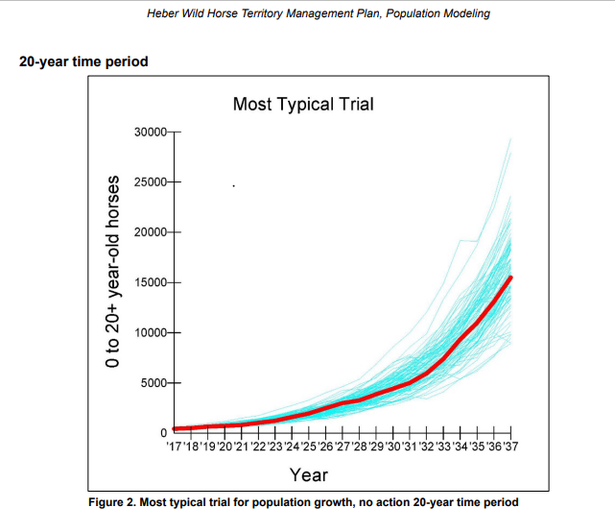
From page 3 of the Population Modeling document: “20-year time period Figure 2. Most typical trial for population growth, no action 20-year time period The distribution of outcomes summary states in 21 years and 100 trials, the lowest number of 0 to 20-plus year-old horses ever obtained was 407 and the highest was 29,292. The average population size across 21 years ranged from 2,747 to 8,091. The medians for average, minimum, and maximum populations are 4,639, 455, and 15,882, respectively. The average growth rate for the median trial is 19.5 percent.”
Here are the FACTS about the Heber Wild Horse herd population, which completely discredits the WinEquus modeling done in support of the Draft Heber Wild Horse Territory Management Plan:
I modeled the timeframe from 2002 to 2021, using as my baseline the lowest possible number I could find of claimed horses on the forest after the 2002 Rodeo-Chediski Fire. In the below correspondence, a Forest Service representative claimed over 200 (200+) horses in 2003. I used the most conservative number of 200 as a baseline to do the population growth modeling from 2002 to 2021 (19 years), using the same 19.5 percent growth rate used in the WinEquus modeling. The results of the model are shown in the chart on the following page, which depicts columns for the “Year”, “Annual Increase” (at 19.5 percent), and “Number of Horses” that would occupy the forest each year at that growth rate.
If the annual growth rate of the Heber Wild Horse herd were 19.5 percent, the horse population in 2017 would have been an astounding 2,894 horses, while the Forest Service actually observed 272 in their flyovers, and they came up with an “estimated population” in 2017 of between 270 and 420 horses; a far cry from 2,894. At a base count of 200 horses and an annual growth rate of 19.5 percent, in 2021, we would have 5,902 horses in the forest, a number not supported by any means or measures. As a matter of fact, the Forest Service conducted a 4-month “boots-on-the-ground” count of the horses beginning in September 2019 and going through January 2020. Doing the math associated with the summary on page 2 of the “Wild Horse Report” (attached to the Draft Plan), this 4-month observation revealed c. 426 horses in the forest; nowhere even near to what the modeling would suggest.
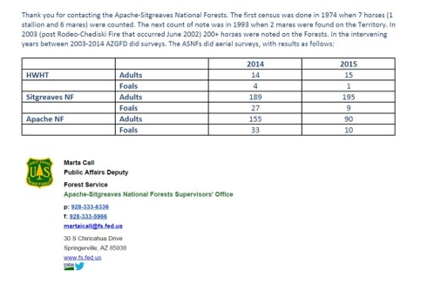

Chart depicting a baseline of 200 horses in 2002 and the annual increase if the population growth were truly 19.5 percent:
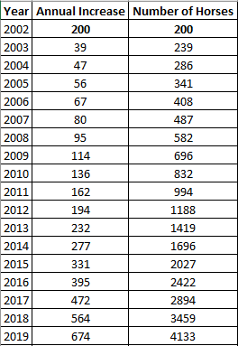
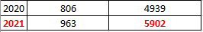
The grossly inaccurate WinEquus modeling figure of nearly 16,000 horses in 20 years was initially stated in the “Population Modeling” document and was reiterated on page 4 of the “Wild Horse Report:
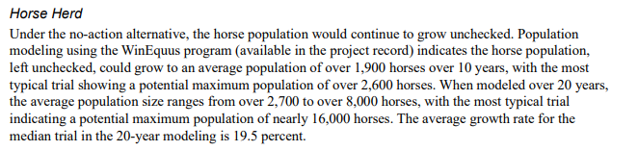
In summary, the WinEquus modeling looks good on paper, but it’s not worth the paper it’s printed on. It is insanely inaccurate as it relates to the Heber Wild Horse herd and cannot reasonably be used in the development of a sound Heber Wild Horse Territory Management Plan. The modeling is so inaccurate, it would be a gross injustice and would constitute gross negligence on the Part of the Forest Service to use it in developing and implementing the Plan. The likely result would be irreparable harm to any hope of a self-sustaining herd.

