Heber Wild Horse Territory Management Plan, Project 18916
Michiko Martin, Reviewing Officer
Attn: Administrative Review Staff
USDA Forest Service, Southwestern Region
333 Broadway Blvd. SE
Albuquerque, NM 87102
Apache-Sitgreaves National Forests
Black Mesa Ranger District
Joshua Miller, Acting Forest Supervisor, of the Apache-Sitgreaves National Forests
Matthew Bullmore, Black Mesa District Ranger
Submitted online via CARA

This Objection is based upon previously submitted timely, specific written comments regarding the proposed project. The subject of this Objection is the erroneous and grossly inaccurate WinEquus Population Modeling. My timely, specific written public comment was submitted via the CARA system o/a 4/21/2021. I will include it as an attachment for reference and for incorporation.
This Objection is being written using the Forest Service’s own horse population numbers and the WinEquus model which was based upon a beginning herd size of 420 horses. Once again, the 20 percent annual population growth rate is infinitely exaggerated and grossly inaccurate and should not be used in any aspect of this project.
Here are the Forest Service’s horse Estimated Population numbers:
2005 – August 31, 2005, News Release, Unauthorized Horses to be Removed from the National Forest, states a population of approximately 300 horses (see attached). Note: this News Release was included in my 2021 comment, Letter ID 18916-3668-159.
2014 – The aerial survey data as noted in Table 6 (see below) of the Final EA is incomplete; therefore, is not usable for population modeling.
2015 – Estimated Population on Territory 9-32 (see Table 5 below). Estimated Population outside the Territory 204-294 (see Table 6 below). Total Estimated Population 213-326.
2017 – Estimated Population on Territory 22-51 (Table 5 below). Estimated Population outside the Territory 270-420 (Table 6). Total Estimated Population 292-471. Note: The WinEquus model used a base population number of 420, so, for the sake of consistency, that is the number I am using in this Objection.

September 2019 – January 2020 (4-month ground survey) – 426 horses physically counted over the course of the four months.
I will note that the Final EA on page 42 indicates that the aerial surveys align with the WinEquus population modeling, but the only complete aerial surveys were in 2015 and 2017, meaning, that conclusion is based solely on the 2015 and 2017 difference in the Estimated Population. The difference between only two data sets is woefully inadequate for wild horse population modeling! WinEquus modeled out annually for 10 years and 20 years!
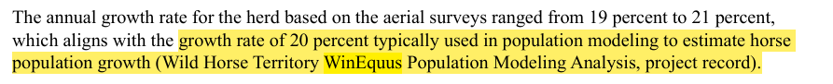
I will also note that we learned through the Final Environmental Assessment (EA) that the 2021 aerial survey is also incomplete, meaning the most current survey data is eight and a half years old! Based upon this new information arising after the designated comment opportunities, I Object that the Heber Wild Horse Territory Management Plan is based upon extremely outdated survey data.

August 31, 2025, News Release estimates approximately 300 horses:
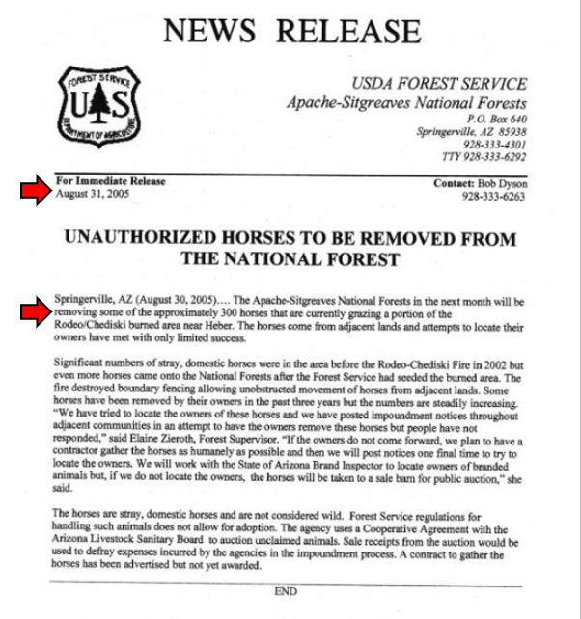

Final EA, Horse Herd, Survey Flights: 2014, 2015, 2017, p. 42:
Table 6, Horses observed outside the Heber Wild Horse Territory, Date of survey 5/12 to 14/2024 indicates by two ** next to the number 189 in the “Horses observed” column that “Only 1/3 of the Sitgreaves National Forest (off-territory) was flown.” This would make the 2014 flight survey data incomplete and unusable. As such, that leaves only the 2015 and 2017 data usable.
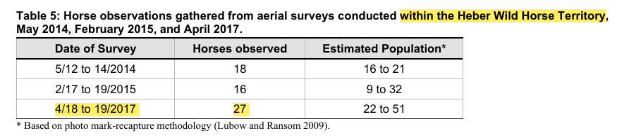
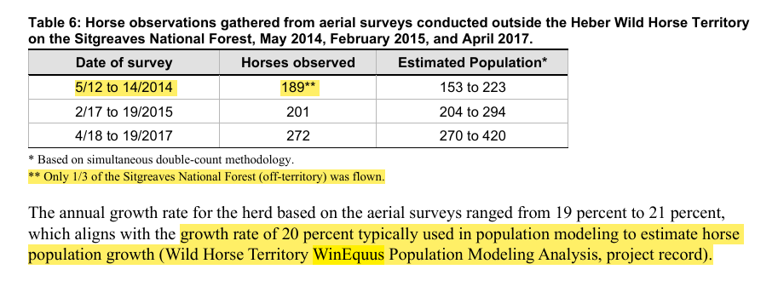

Final EA Alternative 1 – No Action, p. 47. Also found under “Effects Analysis”, p. 66:
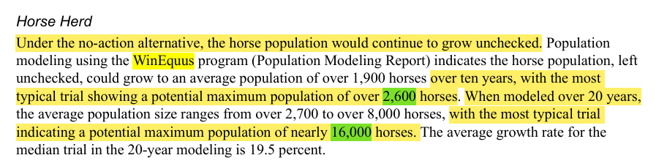
As stated in the Final EA, it is true that under the “no action” alternative, the horse population IF (and I repeat IF) the annual growth rate was 20 percent, could grow to over 2,600 horses in 10 years. Take a look at Year 2015 on the spreadsheet below which shows a 10-year growth period at 20 percent annual growth rate between 2005 and 2015 (10 years). Estimated population 2,601!
Again, I used a starting figure of 420 in my spreadsheet because that is the starting figure used by the WinEquus model. I used a starting point of 20 years ago (2005), because we can actually see with that starting figure what the outcome would be 20 years later at a 20 percent annual growth rate, and we can actually compare that outcome against the Forest Service’s own survey and estimated population numbers.
Now look at Year 2017 on the spreadsheet, which is the year the aerial survey produced an Estimated Population of 270-420 horses (again, I’m using a high of 420 in my spreadsheet for consistency, because that’s what WinEquus used). It shows that the horse population at a 20 percent annual growth rate would be 3,745 horses. IF (and I repeat IF) the annual growth rate is 20 percent, then why was the high end of the Estimated Population in 2017 only 420? Why was the high end of the Estimated Population from the 2017 aerial survey not 3,745, because that is what it would have been IF the 20 percent annual growth rate were true. That’s a difference of 3,325 horses!
Now, let’s look at what the “potential maximum population” could be after 20 years as shown in the Final EA which reads, “When modeled over 20 years…the most typical trial indicating a potential maximum population of nearly 16,000 horses.” Look at the Year 2025 in the spreadsheet below, which calculates a 20 percent annual increase between 2005 and 2025 (20 years). 16,102 horses! That’s the estimated number of horses that would be on the forest today IF (and I repeat IF) the WinEquus population modeling was correct. That bears repeating…IF the WinEquus population modeling was true, there would be sixteen thousand one hundred and two horses (16,102) on the Sitgreaves National Forest today. That’s 15,631 more horses than the Forest Service’s last aerial survey high “Estimated Population” of 471 (both on and off Territory)!
Spreadsheet:
Using the WinEquus starting figure of 420 horses, I calculated a 20 percent annual growth rate from 2005 to 2025 (20 years). This did not require any fancy modeling tool, but was easily done using Excel with 2 simple calculations built in.
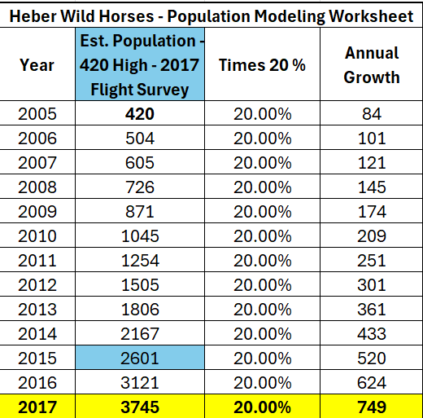
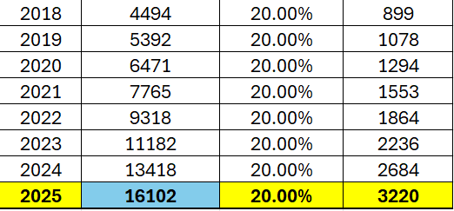

We can also alternatively start with the Forest Service’s estimate of 300 horses in 2005, and the calculations are equally outrageous. At a 20 percent annual herd growth rate, we would have 11,501 horses on the forest today. That’s a difference of 11, 030 horses as compared to the high end of the Forest Service’s Estimated Population from their 2017 aerial survey. As a reminder, the high estimate of horses both on and off the Territory was 471.
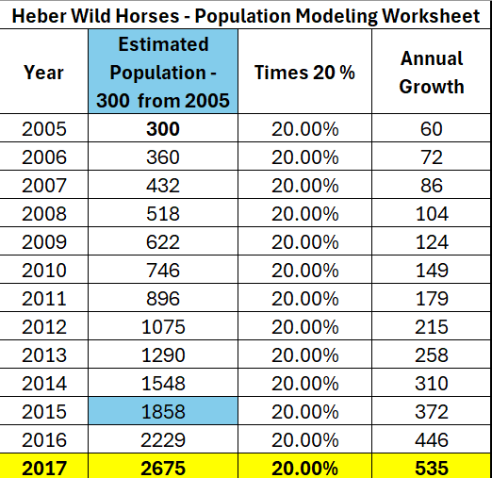
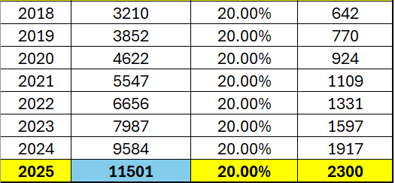

We know that a foal’s gestation period is approximately 11 months (320-380 days) and that a mare typically births one foal at a time (twins are very rare). For a 20 percent annual growth rate to be true, every mare on the forest would have to birth “litters” of foals every year, like litters of puppies or kittens, and no horse would ever die; they would all be immortal. Neither of these is true; thus, the WinEquus model is not true. The model is fatally flawed! The math, combined with the actual Forest Service population surveys and estimates prove it!
The fatally flawed WinEquus population model cannot be used in any part of the Final Environmental Assessment (EA) or in the Heber Wild Horse Territory Management Plan. I Object to its use and to every place within the EA and the Plan that uses it and/or references it.
I further Object that our tax dollars were spent on the WinEquus modeling tool when an Excel spreadsheet with two simple calculations built in produces the same result.

Respectfully submitted,
Betty L. Nixon

