Comment re: Horse Inventory, Establishment of HWHT, Horse Removals
The Timeline of Events outlined below will show that the Forest Service failed to do an initial inventory of the Heber Wild Horses; that they failed to properly establish the Heber Wild Horse Territory by failing to consider the horses “in the area where presently found, as an integral part of the natural system of the public lands” in accordance with the 1971 Wild and Free-Roaming Horses and Burros Act; that they removed horses and sold them at auction as “trespass” horses without taking any measures to identify the origin of the horses to ensure they were not removing wild free-roaming horses protected by the Act. In fact, the Forest Service entered into agreements to remove horses multiple times following passage of the Act, without ever establishing the origin of the horses being captured and removed.

The Forest Service failed to follow both the letter and the spirit of the 1971 Wild and Free-Roaming Horses and Burros Act, in which Congress found and declared that “wild free-roaming horses and burros are living symbols of the historic and pioneer spirit of the West; that they contribute to the diversity of life forms within the Nation and enrich the lives of the American people; and that these horses and burros are fast disappearing from the American scene. It is the policy of Congress that wild free-roaming horses and burros shall be protected from capture, branding, harassment, or death; and to accomplish this they are to be considered in the area where presently found, as an integral part of the natural system of the public lands.”

The Forest Service has failed these horses, and they have failed the American people. Their Plan, if implemented as written, will cause irreparable harm to our wild horses and to the American people.

Timeline of Events:
December 18, 1971 – Wild and Free-Roaming Horses and Burros Act signed into law (Public Law 92-195).

August 14, 1972 – Instruction Memorandum NSO 72-114 issued by the Department of the Interior, Bureau of Land Management (BLM) to Nevada District Managers. The Subject of the Memo was “Wild Horse and Burro Inventories “as an initial effort in the field where the Bureau has had little experience”. “These guidelines were largely developed by Milton Frei, Range Specialist, Ely District, as a result of discussions with this office and field trials in the Ely District.”

February 22, 1973 – Letter from District Manager, U.S. Dept. of the Interior, BLM to the Assistant Regional Forester, Region 3, providing a copy of the inventory procedure documents that were attached to the August 14, 1972 Memo NSO 72-114 as requested by the Assistant Regional Forester.

March 13, 1973 – Memo from Assistant Regional Forester, Region 3, to Forest Supervisors, Region 3, providing them with a copy of the inventory procedures outlined above. The Memo says, “Perhaps this technique, or a similar one, can be used to start the inventorying numbers of animals on your units.”

Note: The 1971 law, under 1333 (b) (1), states, “The Secretary shall maintain a current inventory of wild free-roaming horses and burros on given areas of the public lands.” The March 13, 1973 Memo provides for STARTING the inventory process.

The Forest Service failed for 15 months following passage of “the law” to even “start” the discussion of inventorying horses in Region 3.

January 15, 1974 – Memo from Forest Supervisor J.S. Tixier to Regional Forester, R3, providing him with a count of 7 horses “grazing on the Sitgreaves”, and a map of Territorial habitat limits”.
Note: The Memo states under paragraph 5, “There are no outside influences or problems causing the numbers to fluctuate”. In other words, no problem with horses allegedly coming from Reservation lands.
Amazingly, it took 15 months after passage of the law to even start the discussion of inventorying the horses, yet a complete inventory of the Sitgreaves was allegedly completed and the territory limits drawn after just 10 short months. Note: The Black Mesa and Lakeside Ranger Districts encompass over 883,000 acres of rugged, forested hills and canyons. The inventory they claim to have accomplished is an absolute impossibility!
In a FOIA request, I asked for documents wherein the location and parameters for the designated Heber Wild Horse Territory were determined. The Forest Service failed to find any documents related to how the determinations were made regarding the Territory location, size, boundaries, etc.
In a Freedom of Information Act (FOIA) request, I asked for inventory documents. If a proper inventory had been conducted, these are the documents that would exist, and these are the documents I requested in my FOIA. The Forest Service failed to locate any of these inventory records:

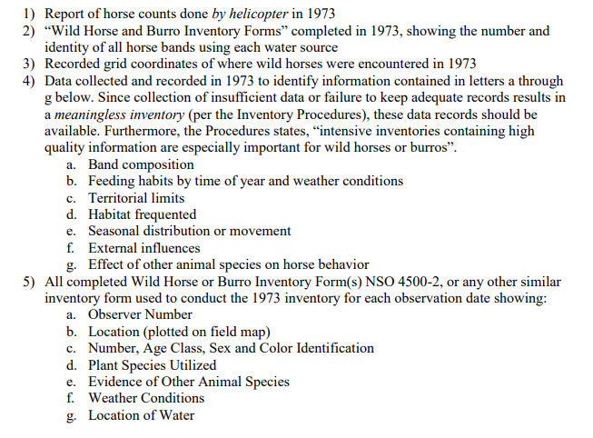
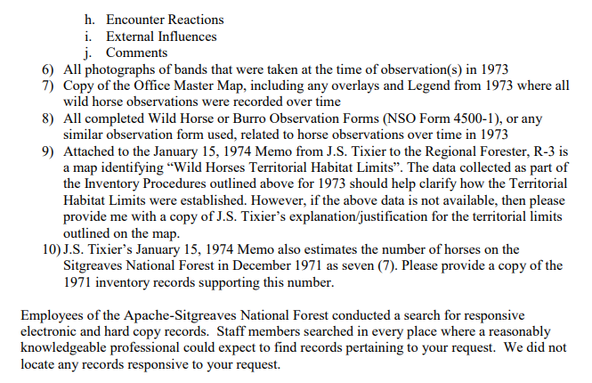
July 23-24, 1974 – Range Inspection Report of the Buckskin, Gentry, Mud Tank, Heber Allotments. Under number 11, it says, “White Mountain Apache Horse Trespass Case written – Horses rounded up and sold at public auction.”

Note: I submitted a FOIA request for a copy of the “White Mountain Apache Horse Trespass Case, which should have contained the information outlined in the screen shot below.

Forest Service failed to find any documents related to the Case. In other words, on January 15, 1974, the Forest Supervisor documented “There are no outside influences or problems causing the numbers (of horses) to fluctuate”, yet, in July of that same year, the Forest Service rounded up horses and sold them at public auction, while failing to determine the origin of the horses they removed; failing to ensure they were not rounding up and selling wild free-roaming horses protected under the 1971 Wild and Free-Roaming Horses and Burros Act.

Excerpt from my FOIA Request:

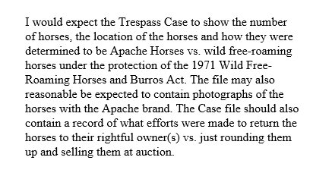
July 1974 Range Inspection Report, See Number 11:
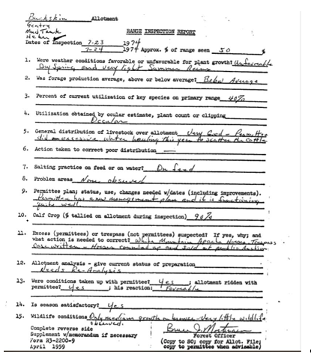

Other examples of Forest Service working with permittees (cattle growers) to remove horses without regard for their status. Forest Service has failed to show that any of the horses removed were actually “trespass” horses and not wild free-roaming horses afforded protection under the 1971 Act:
Excerpt from the Range Management Plan dated 6/1/1990 for the Buckskin, Gentry and Heber-Mud Tank Allotments under Permit #01-010:
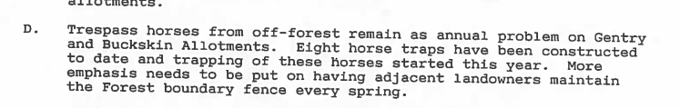
1988 and 1989 Agreements for the removal of horses without regard for their status:
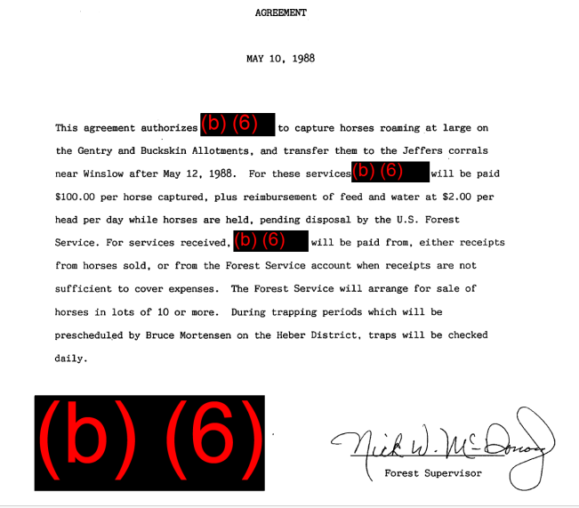

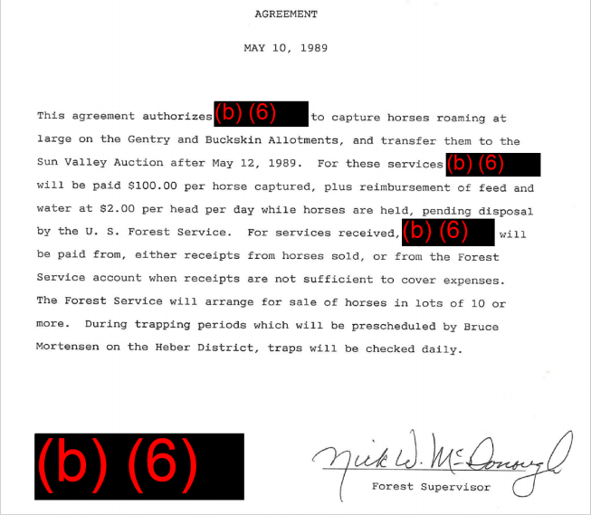
2005 News Release re: Removing horses without regard for their status (intervening lawsuit):
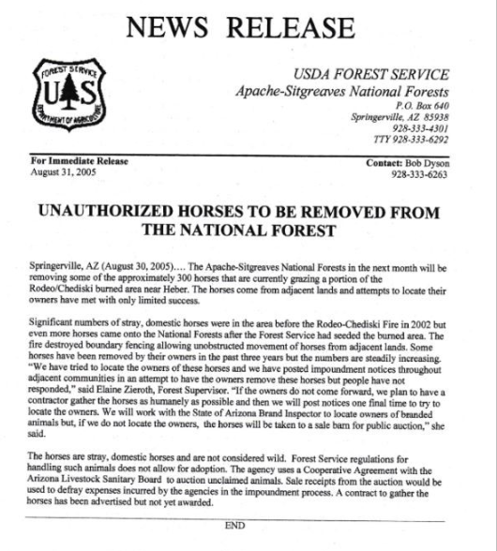
Note: Let the Administrative Record show that additional historical documents may be acquired after the comment closing period. Additional documents have been requested under the Freedom of Information Act; however, due to Covid, FOIA responses have been backlogged at the Forest Service.



