Heber Wild Horse Territory Management Plan, Project 18916
Michiko Martin, Reviewing Officer
Attn: Administrative Review Staff
USDA Forest Service, Southwestern Region
333 Broadway Blvd. SE
Albuquerque, NM 87102
Apache-Sitgreaves National Forests
Black Mesa Ranger District
Joshua Miller, Acting Forest Supervisor, of the Apache-Sitgreaves National Forests
Matthew Bullmore, Black Mesa District Ranger
Submitted online via CARA

This Objection is based upon previously submitted timely, specific written comments regarding this proposed project. See Letter IDs 18916-3668-520 and 18916-3668-159, which I will attach for reference and incorporation.

I Object that the foundation of the Heber Wild Horse Territory Management Plan continues to be built upon a “purported” census from 1973 of six mares and one stallion when information obtained via Freedom of Information Act (FOIA) requests shows no evidence of a census ever having been done and shows that horses did roam on other areas within the Sitgreaves National Forest. Additionally, there has never been an explanation or justification for how the Territory boundary limits were determined back on January 15, 1974.
“Purported” Adjective = appearing or stated to be true, though not necessarily so; alleged.
“Purported” Verb = appear or claim to be or do something, especially falsely; profess.
A “purported” census is neither scientific nor credible, especially in light of the fact that the Forest Service has not been able to produce census materials. The Forest Service has also not been able to produce anything showing how or why decisions were made on the Territory boundaries. Both the “purported” census and the Territory boundary limits appear to have been manufactured to favor cattle growers and to the detriment of the wild horses.
- The Territory is set in Black Canyon where steep canyon walls restrict wild horse movement across the territory.
- Wild horse movement the length of the Territory is restricted by cattle pasture fencing, closed gates and cattle guards. Some of these gates have both Forest Service and Arizona Game & Fish signage saying to keep the gates closed, and if found open, to close them.
- The Forest Service’s own aerial/flight path survey diagrams as found on page 44 of the Final EA (see attached) show no horse sightings on a major portion of what is designated as the Wild Horse Territory. Why? Because that area is blocked off from horse ingress by steep canyon walls, cattle pasture fencing, closed gates and cattle guards. That northern portion of the Territory also happens to be part of the Black Canyon (cattle) Allotment. At the time the Territory was delineated, the permittee that ran cattle on the Black Canyon Allotment also worked for the Forest Service, retiring in 1985 after 33 years (see “Those Days are Gone Forever – History and Stories of Heber-Overgaard” by Bobbie Stephens Hunt, Page 71). The Black Canyon (cattle) Allotment portion of the Heber Wild Horse Territory is “locked down tight” to prevent horse ingress! Clearly, when the Wild Horse Territory was delineated, there was an open and obvious conflict of interest!
- While wild horses were “locked out” of a large portion of their “Territory”, horses were being rounded up and sold at auction if they were found outside the Territory, with no evidence that any efforts were ever made to determine their legal status as “wild free-roaming horses” protected by the Wild Free-Roaming Horses and Burros Act of 1971. Why? Because the Forest Service didn’t want the horses on the forest in the first place, and they falsely claimed that protection via the 1971 Act only came from being ON the Territory!
- The first recorded delineation of the Heber Wild Horse Territory was on January 15, 1974. The earliest record of horses outside of those boundaries being rounded up and sold at public auction is in a Range Inspection Report from July 23-24, 1974, wherein it notes that “trespass” horses in the Heber Allotment (as noted by a check mark on the form next to “Heber” Allotment) were rounded up and sold at public auction (see attached). The Forest Service removed horses off the forest just 6 months after the Territory boundaries were recorded! In other words, there WERE horses on other parts of the forest. Horse removals, in violation of the 1971 Act, continued at least into the late 1980s.
- The deck was stacked against the wild horses from the outset and horses were rounded up and sold at auction in violation of the 1971 law. As recorded by rancher Doy Reidhead (see “What Has Passed and What Remains – Between the Rim and the River”, Page 138, “The old ranger that was up there, a great old guy, he just wanted the horses gone. And I’ll tell you why he wanted ‘em gone. He was afraid they’d make a wild horse refuge. Now here we’re already getting’ into some stink. You see what I mean? He said, “If these horses don’t get moved, we’re gonna have trouble with this. They’ll take this and make a wild horse refuge out of it. I’ll build the traps, and we’ll salt and catch these horses.”
“All right, that’s fine.”
“You take ‘em to sale and sell ‘em, and whatever you get is yours.”
They was unbranded, and on Forest Service land. So we built them traps and salted, and we caught 187 horses. I’d unload ‘em out of the traps and load ‘em in a trailer and haul ‘em to sale.”
- As shown in a letter from the Forest Supervisor to White Mountain Livestock, c/o Halter Cross Ranch, Irving Gibson (see attached), the Forest Service worked in cooperation with local ranchers to “retroactively” identify wild horses that fell under the protection of the Act as of December 18, 1971. See paragraph 5 of the letter which reads, “Identity of animals and their location on the day of the Act is a problem but no need to let it be a bug-a-boo. We will just have to do the best we can.” In short, the Forest Service failed to conduct a timely and proper inventory which was the foundation for providing wild horses with the protections afforded to them under the law.
- The 1971 Act, signed into law on December 18, 1971, required that the Secretary of Agriculture “maintain a current inventory of wild free-roaming horses and burros on given areas of the public lands.” I submitted a FOIA request for the initial inventory data. The 1973 documents I received in response to that FOIA request made it clear that the Assistant Regional Forester, Region 3, had reached out the Bureau of Land Management for guidance on how to conduct an inventory (see attached). The District Manager for the BLM’s Ely District responded, providing information and guidance. The Act stated that wild free-roaming horses and burros were to be “considered in the area where presently found, as an integral part of the natural system of the public lands.” The Forest Service waited until 1973 to even “start” thinking about conducting an inventory! Then on January 15, 1974, the Forest Service Supervisor reported manufactured numbers of horses and where those wild horses were supposedly located two years earlier in 1971.
- Based upon the BLM’s instructions to the Assistant Regional Forester, Region 3, I submitted yet another FOIA request on February 24, 2020 (see attached), asking for survey data that would exist had the required inventory been done in accordance with the BLM’s recommendations on how to conduct an inventory of wild horses. I asked for the explanation/justification for the territorial limits outlined on the Territory map from January 15, 1974. I asked for a copy of the 1971 inventory records used to support the estimated number as seven (7) horses on the Sitgreaves National Forest in December 1971. The Forest Service FOIA Office did not find a single document in response to my February 24, 2020, FOIA request. There is no evidence to support that an inventory was ever done! There is no explanation/justification for how the Wild Horse Territorial Habitat Limits (the Territory boundaries) were determined!

Clearly, the Forest Service understands now what they refused to acknowledge from 1971 until now, which is that “…the horses are free-roaming and the range extends beyond the territory” (see Final EA, Page 65). And “Horses may move on-and-off the territory when they are within AML” (see Final EA, Page 183). And “…fencing wild horse territories in total is considered contrary to the wild free-roaming horses and burros act. Senate report 92-242 emphasizes that the management of wild free-roaming horses and burros be kept to a minimum in part to deter the possibility of ‘zoolike’ developments.” (see Final EA, Page 187).
The question is, how do you right the wrongs of the past? The original seven horses reported on January 15, 1974, is a fallacy. There was no inventory. There is no justification or reasoning for the territorial habitat limits that the Forest Service Supervisor reported on January 15, 1974. There were horses on other parts of the Sitgreaves National Forest. Unlawful removals from other parts of the forest did occur on multiple occasions over the years, with the earliest known removals occurring in July 1974. Since we cannot turn back the clock, my suggestion would be to do a reset. The basis for an appropriate Management Plan should be doing the right thing for the right reason for this historically and culturally significant herd of wild horses that exists on the forest today. Set an AML that is not limited to the Territory boundaries that were arbitrarily and capriciously set. Set an AML that honors the multi-use policy while also affording our treasured wild horses the protections promised under the Wild Free-Roaming Horses and Burros Act.

Respectfully submitted,
Betty L. Nixon

Aerial/flight path survey diagrams as found on page 44 of the Final EA:
They show no horses in a significant portion of the Territory where the horses are “locked out”!
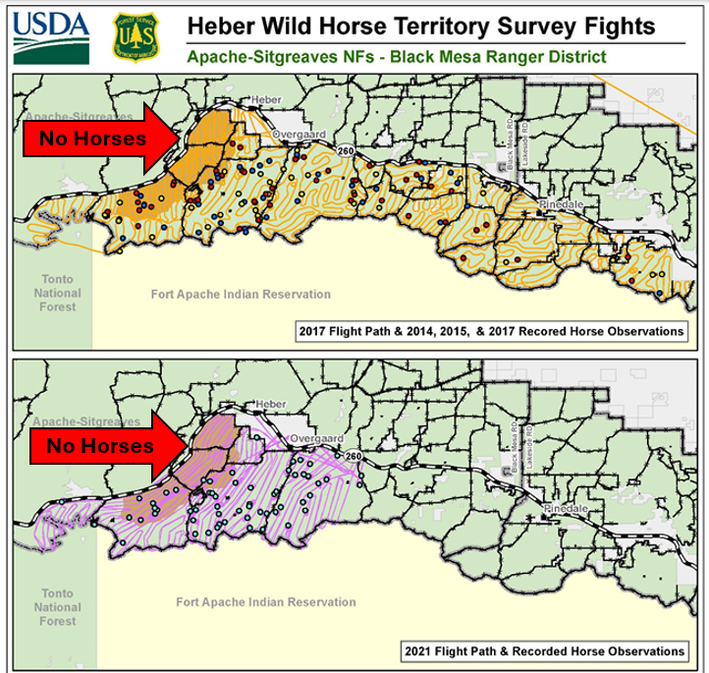

Forest Service Range Inspection Report Dated 7-23 and 7-24, 1974:
Number 11 reads, “White Mountain Apache Horses. Trespass Case written – Horses rounded up and sold at public Auction”. I submitted a FOIA request for the “Trespass Case”, but the FOIA Office found nothing!
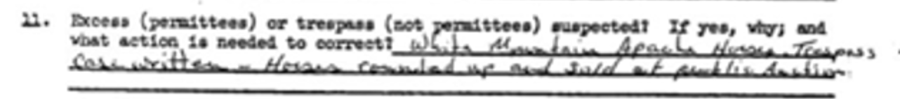

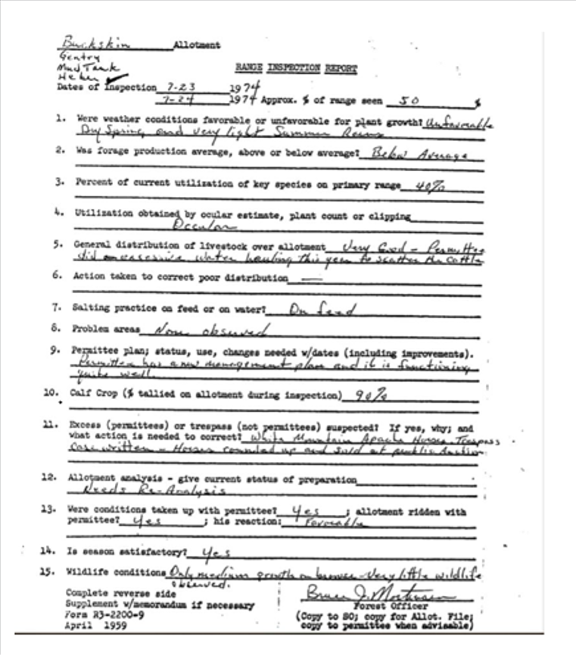

Letter from the Forest Service Supervisor, Sitgreaves National Forest to White Mountain Livestock, c/o Halter Cross Ranch, Irving Gibson. See number 5:
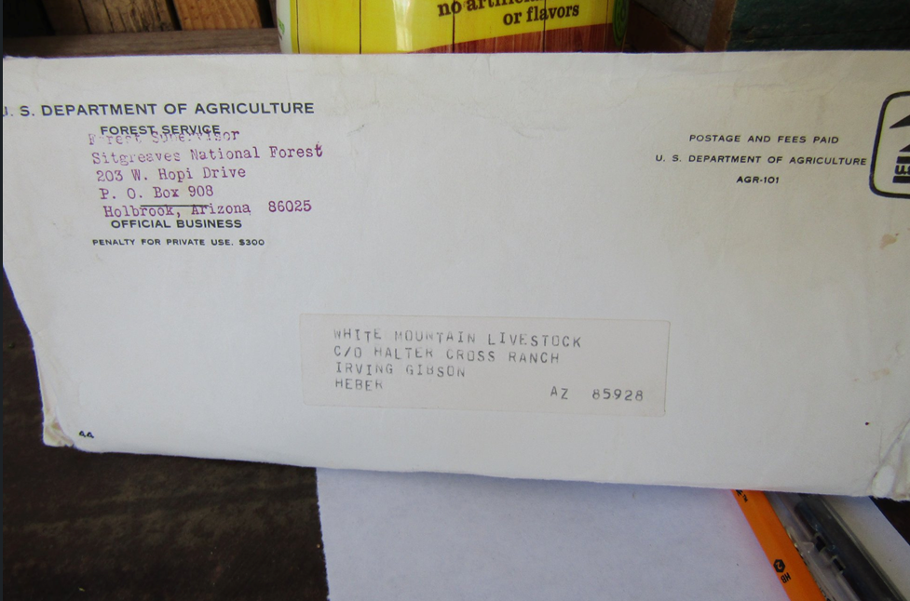
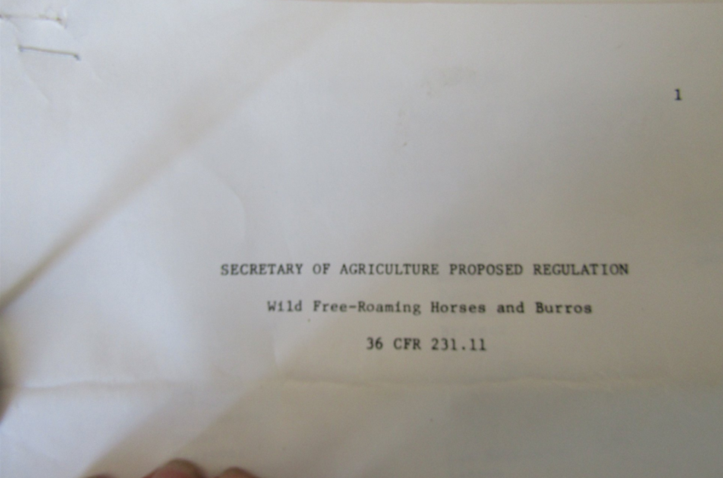
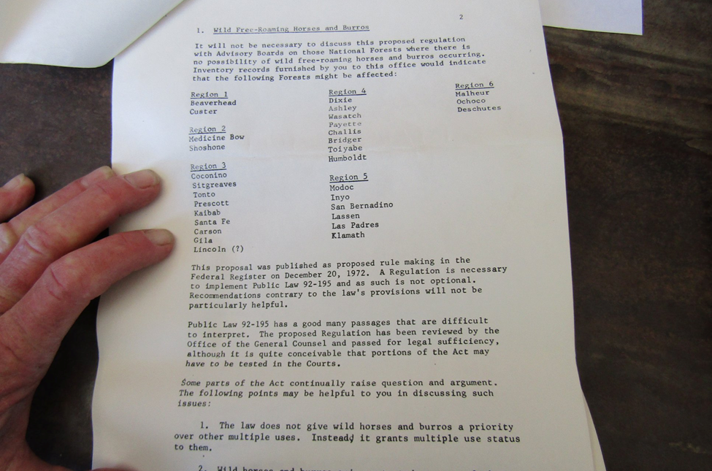
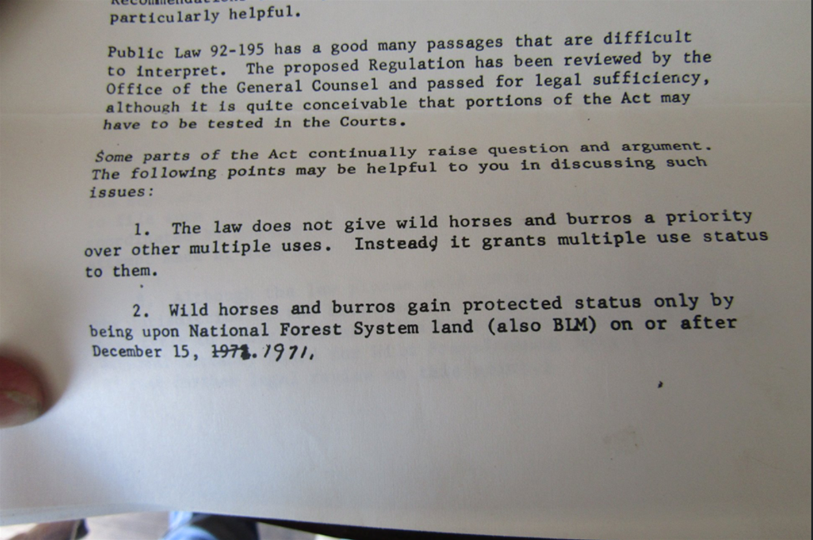
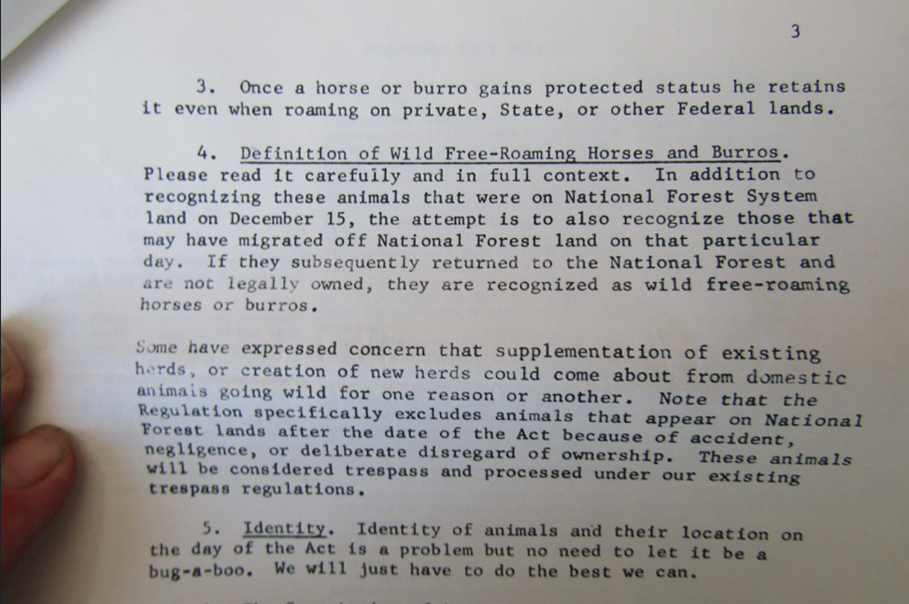

The Assistant Regional Forester, Range and Wildlife Management, for Region 3 reached out the Bureau of Land Management for guidance on how to conduct an inventory. The District Manager for the BLM’s Ely District responded, providing information and guidance. Here is the correspondence from 1973:

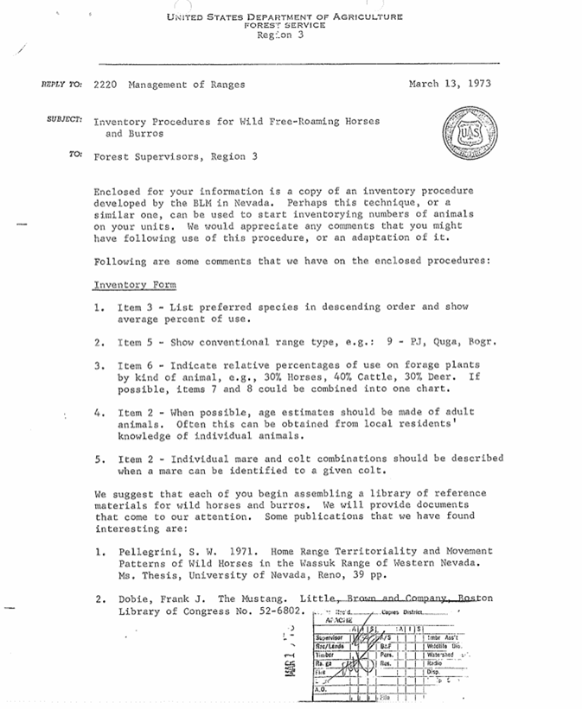
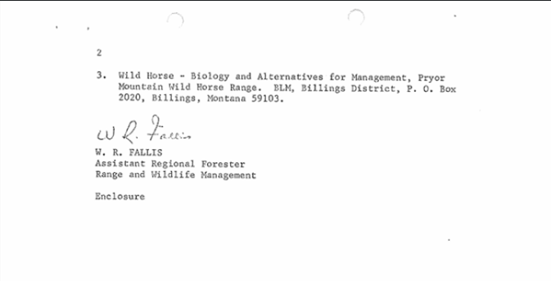
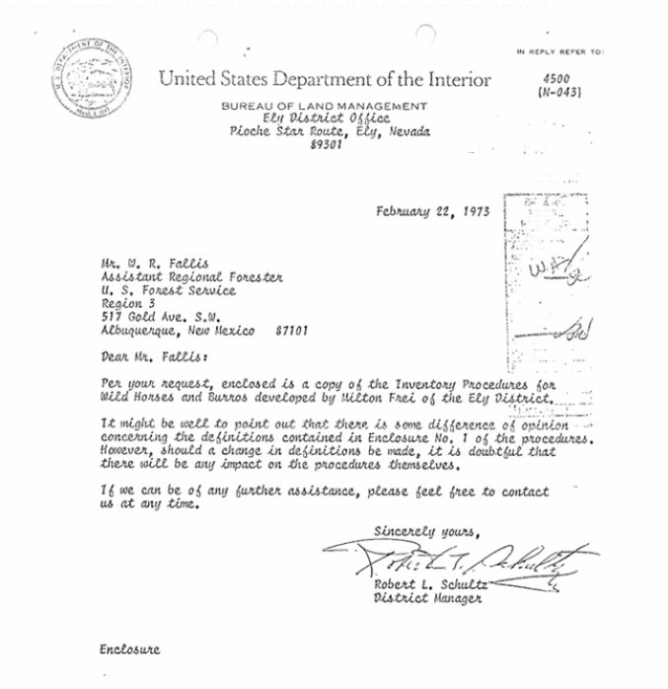
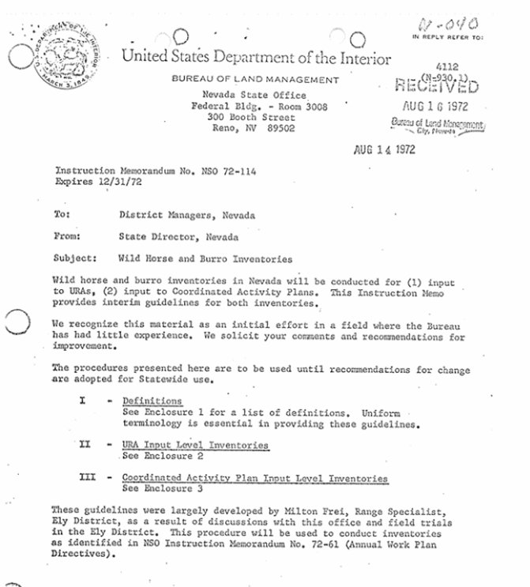
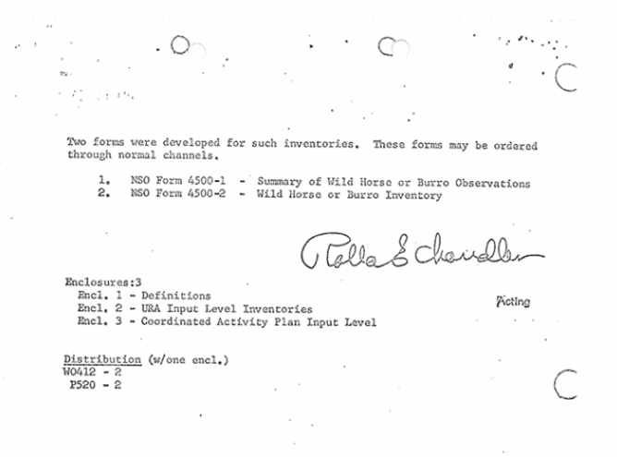
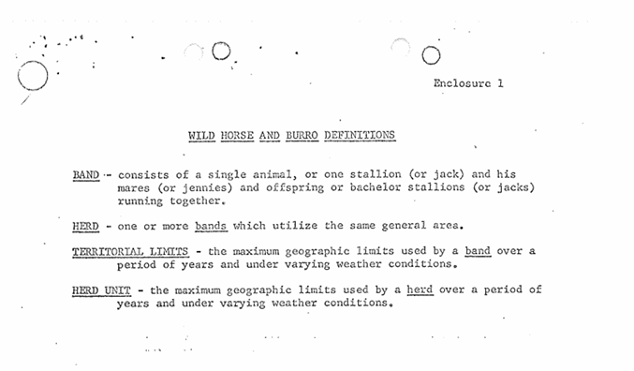
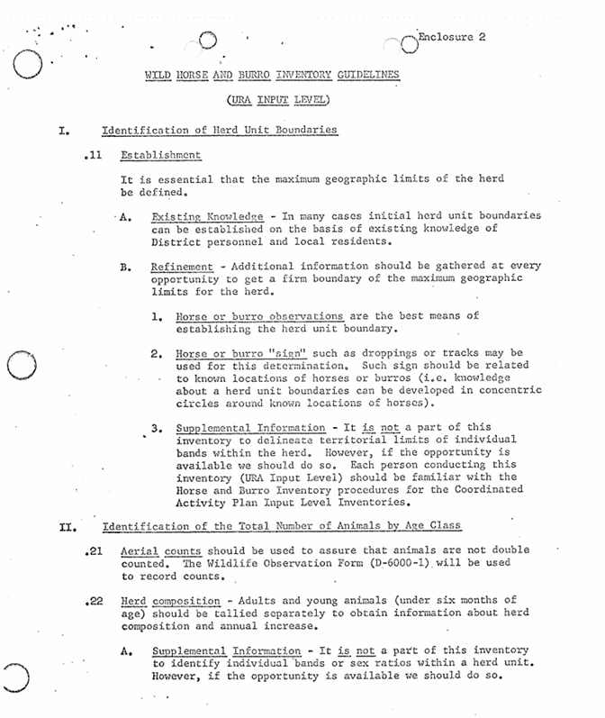
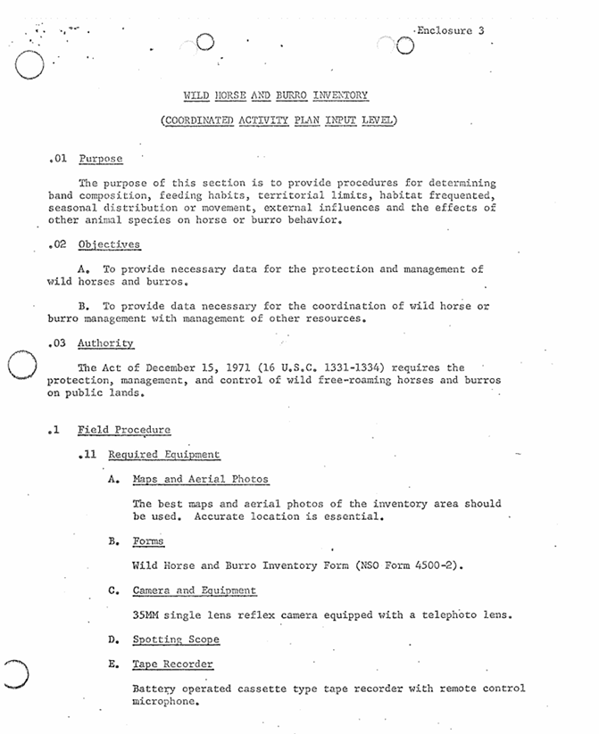
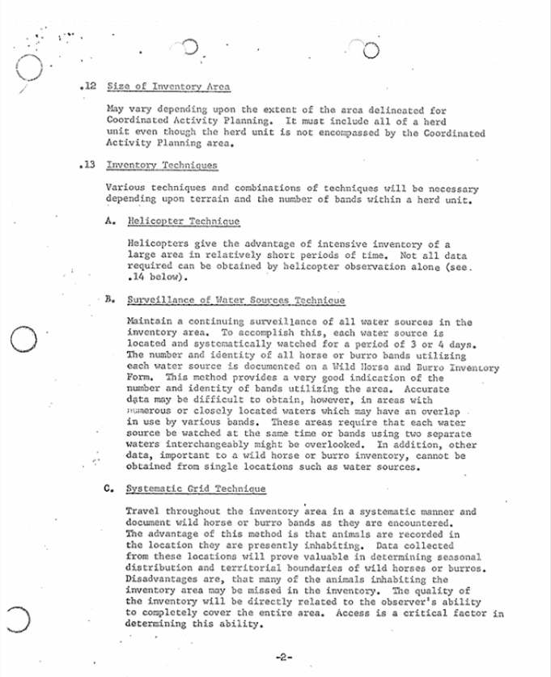
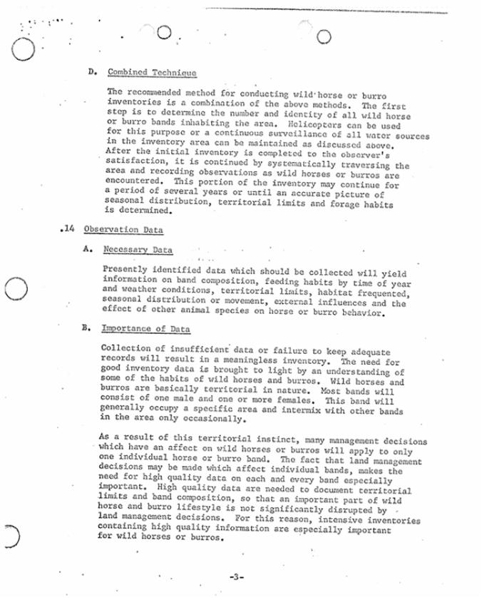
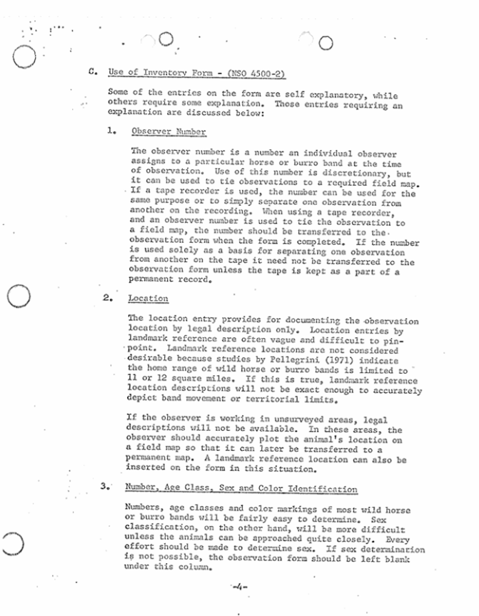
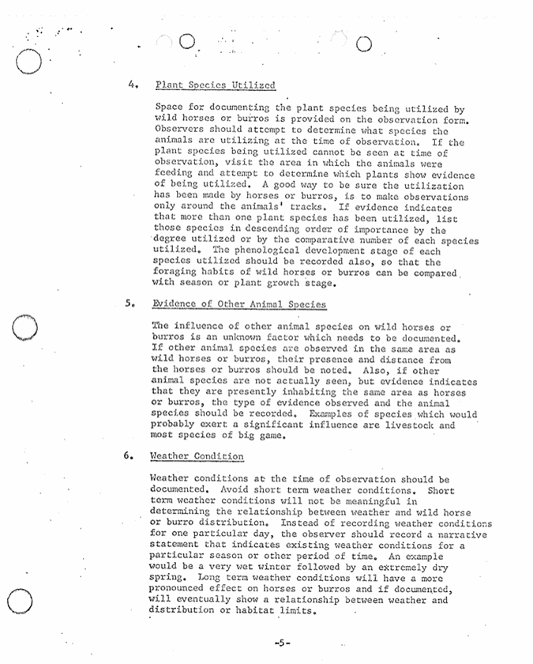
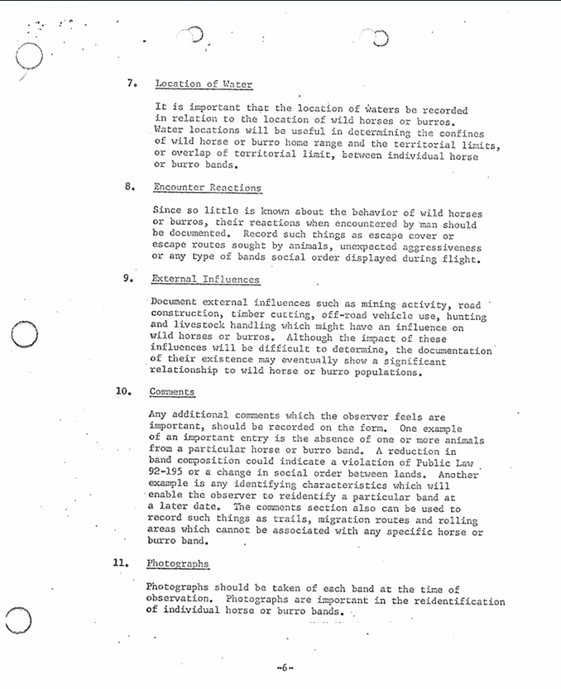
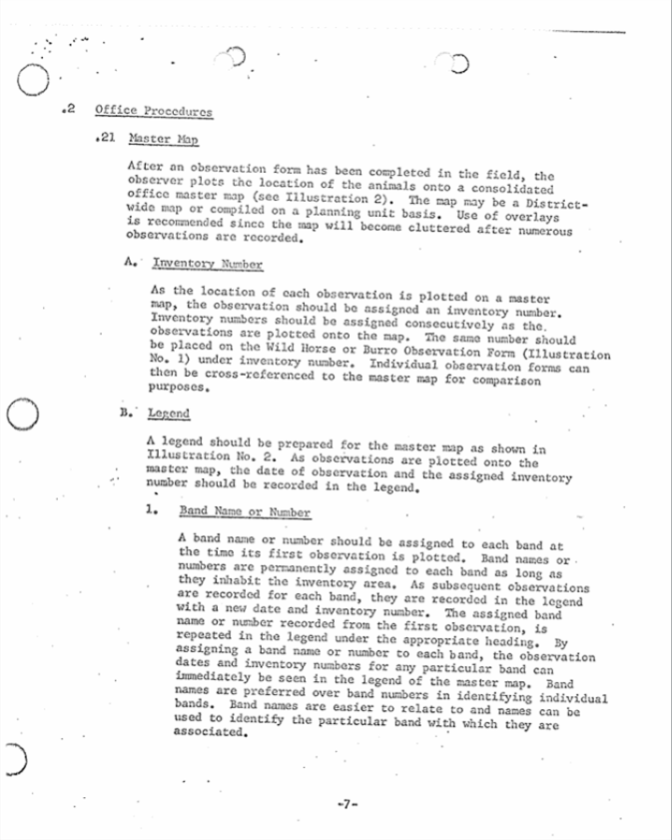
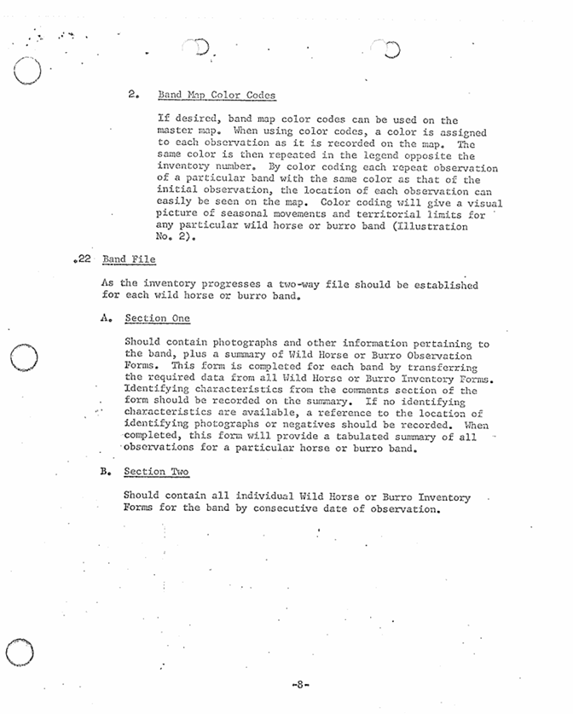
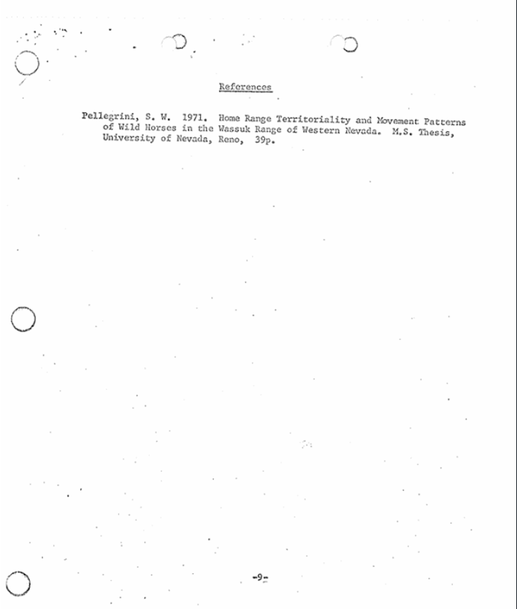
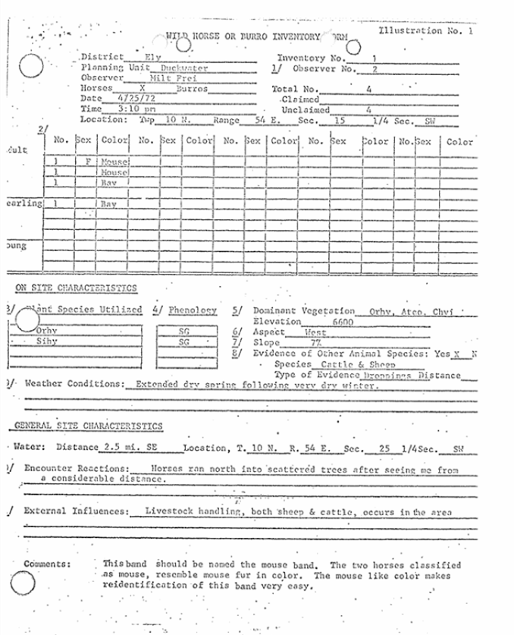
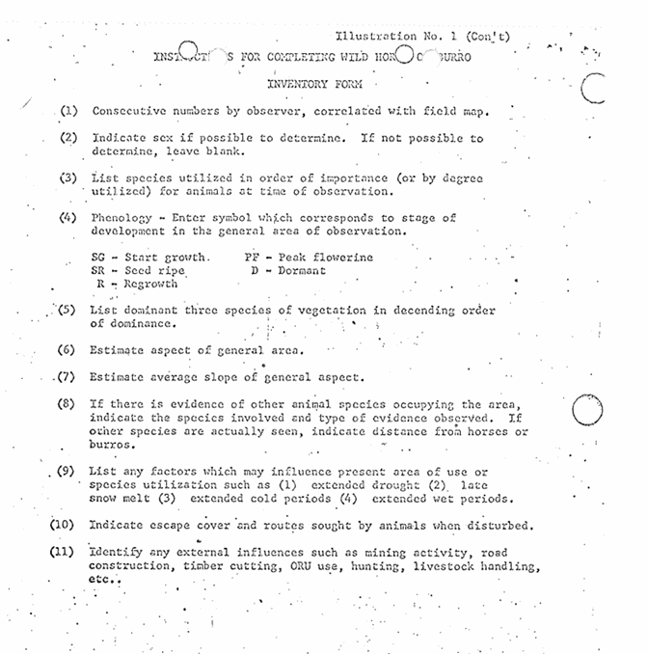
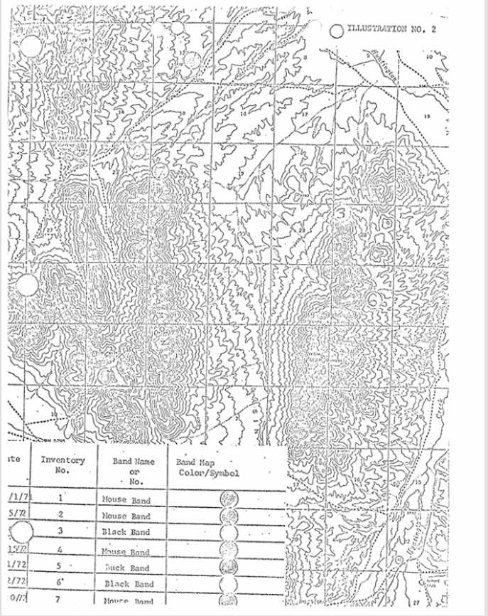

My February 24, 2020, Freedom of Information Act (FOIA) request for the wild horse data collected from “observations” in 1973 as per the “Inventory Procedures for Wild Free-Roaming Horses and Burros”:
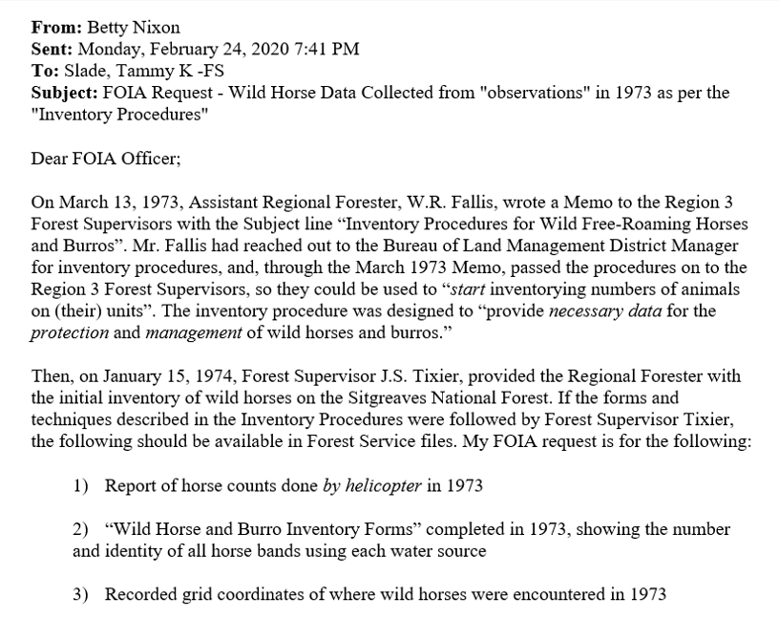
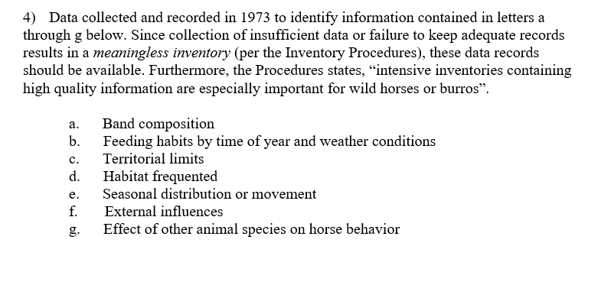

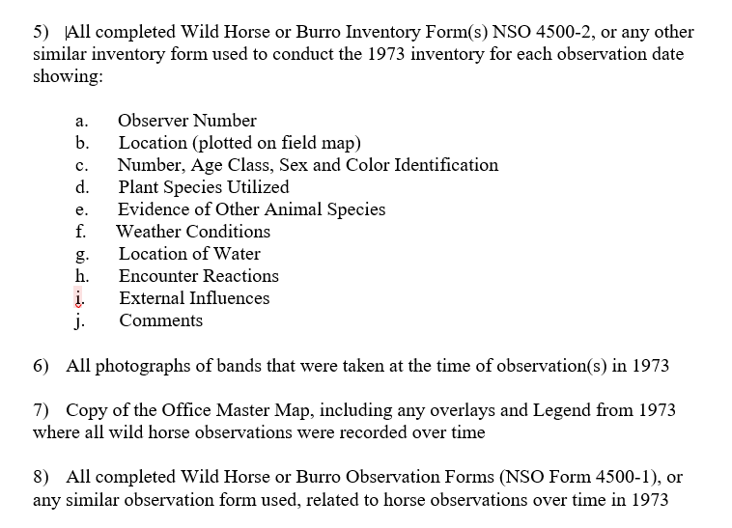
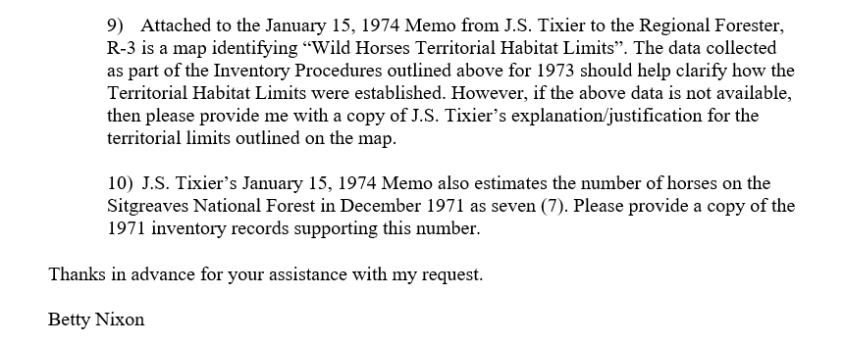

Final EA, Page 65:
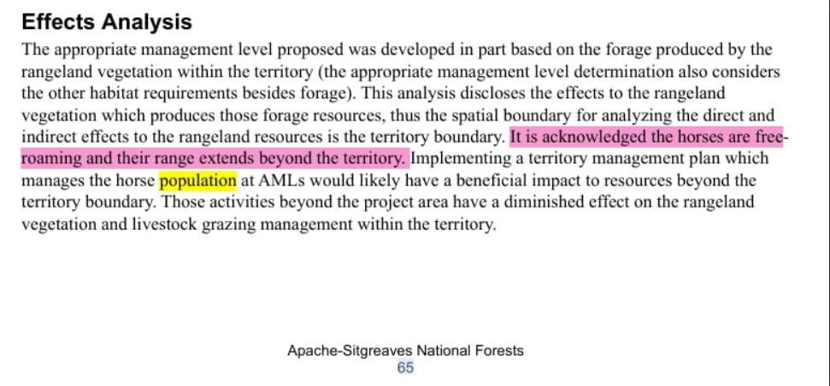

Final EA, Page 183:
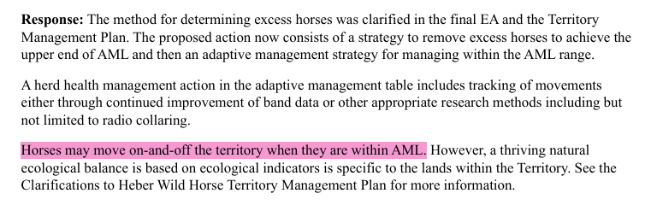

Final EA, Page 187:
