Heber Wild Horse Territory Management Plan, Project 18916
Michiko Martin, Reviewing Officer
Attn: Administrative Review Staff
USDA Forest Service, Southwestern Region
333 Broadway Blvd. SE
Albuquerque, NM 87102
Apache-Sitgreaves National Forests
Black Mesa Ranger District
Joshua Miller, Acting Forest Supervisor, of the Apache-Sitgreaves National Forests
Matthew Bullmore, Black Mesa District Ranger
Submitted online via CARA

This Objection stems from new information obtained via a Freedom of Information Act (FOIA) request following closure of the last Public Comments Period. The new information relates to the Forest Service’s 2022 and 2023 “Band Books” containing purported identifying information and photographs of the different bands that make up the Heber Wild Horse herd.
The data and photographs in the 2022 Band Book were collected by 2 “critical hires” over a 60 day period. The 2023 data and photographs contained in the 2023 Band Book, an apparent compilation of all Heber Wild Horse data collected in 2021, 2022 and 2023, were collected by 2 “seasonal employees”, one on assignment for 6 months and the other on assignment for 4 months. This is according the Band Book “Summary” for each corresponding year.
As much as these 2 critical hires and the 2 seasonal employees surely “tried” to do a good job, the Forest Service’s Band Book is fraught with errors, omissions and inconsistencies such that the Band Books cannot reasonably be used to establish a horse count, or as an appropriate or effective management or monitoring tool for the Heber Wild Horse herd. The Band Book is a “nice to have”, but the data it too fraught with significant errors and omissions. It’s comprised of inconsistent data entries by at least 4 separate individuals obviously unfamiliar with the Heber Wild Horse herd, apparently not familiar with natural wild horse behaviors, and not following standardized data entry protocols. In many instances, you can’t even tell on what date photos were taken, or how many horses make up the listed bands. Just some of the issues with the Band Book are as follows:
- Data collected by new hires and seasonal employees unfamiliar with the horses that make up the Heber Wild Horse herd, unfamiliar with herd dynamics as well as natural wild horse behaviors, resulting in stallions being identified as mares, mares being identified as stallions, multiple instances of the same band of horses being identified under multiple different band designations; thus, multiple instances of the same horses being counted multiple times within the Band Book. See Examples 1 and 2 below.
- No accounting of natural foal attrition, whereby a significant percentage of foals do not survive their first year. I personally have documented numerous instances of new foals that did not survive, yet none are recorded in the Band Book.
- No accounting for deaths from old age, injury and other natural causes. The 2023 Band Book only lists 2 stallion deaths (5/12/23 and 7/25/23). It also identifies the shooting deaths of a mare and her two offspring in December 2021. These few deaths documented in the 2023 Band Book are completely inconsistent with the numerous documented horse deaths from various causes.
- The 2023 Band Book is a compilation of 2021, 2022 and 2023. Compiling information year-over-year is not an appropriate or scientific method for counting, monitoring or managing wild horses. There is no consideration given to the numerous changes that take place within the individual band structures over time, consistent with natural wild horse behaviors. The result is that the same horses are counted multiple times. Just one example is outlined herein. See Example 2 below.
The 2023 Band Book is a compilation of band ground observation data, the initial collection of which took place between April and September 2021 (see Heber Wild Horse Territory Management Plan Final EA, p. 46) and continued during parts of 2022 and 2023 by two “critical hires” in 2022 and 2 “seasonal employees” in 2023 as outlined above. This data collection was to identify individual bands and assess their movements relative to the Territory. Per the Forest Service, data collected included date, location, total number of horses per band, sex and age classifications (studs, mares, foals, yearlings, two-year-olds, bachelor horses), color, average body condition scores, and sex ratios within age classes. Bands were identified primarily by key features of the stallions, with identifying photos taken of stallions and general photos of the rest of the band. As outlined above in this Objection, the data collection was inconsistent and was fraught with errors and omissions, which undermines its credibility and usefulness in fulfilling its very purpose as outlined by the Forest Service in the Final EA. Any information or conclusions drawn from the data has a high probability of being just as false and misleading as the data itself. This also calls into question what level of accuracy or efficacy we can expect from any future monitoring that may be implemented as part of the Heber Wild Horse Territory Management Plan.

Example #1:
This is just one example of an entire band counted twice within the 2023 Band Book. The bachelor stallion known to some as “Gus” is listed as the band stallion of the “Buckskin 10” band. He is not the band stallion here. The band stallion is “Hershey”, a well-established, well known stallion that I have observed and documented consistently from 2018 through 2025 year-to-date. In the Buckskin 10 band, Hershey is listed as a “Second stud”, but he is the band stallion. He and his band are counted a second time within the 2023 Band Book under the designation “Black 12”. Although the “general photos” of the band are not clear, I have known this band for years and do recognize this as Hershey’s well-established, well known band.
Furthermore, the bachelor stallion “Gus”, with his very recognizable facial markings, has additionally been identified/counted in the 2021 Band Book under the designations for Bachelor bands 33 and 29, meaning Gus alone has been counted 3 times!
Note: The Forest Service identifies the individual bands using designations such as “Buckskin 10”. I identify the individual bands using a name for the band stallion. I named Hershey in 2018 and have been following the band ever since. I know this band and its history very well.
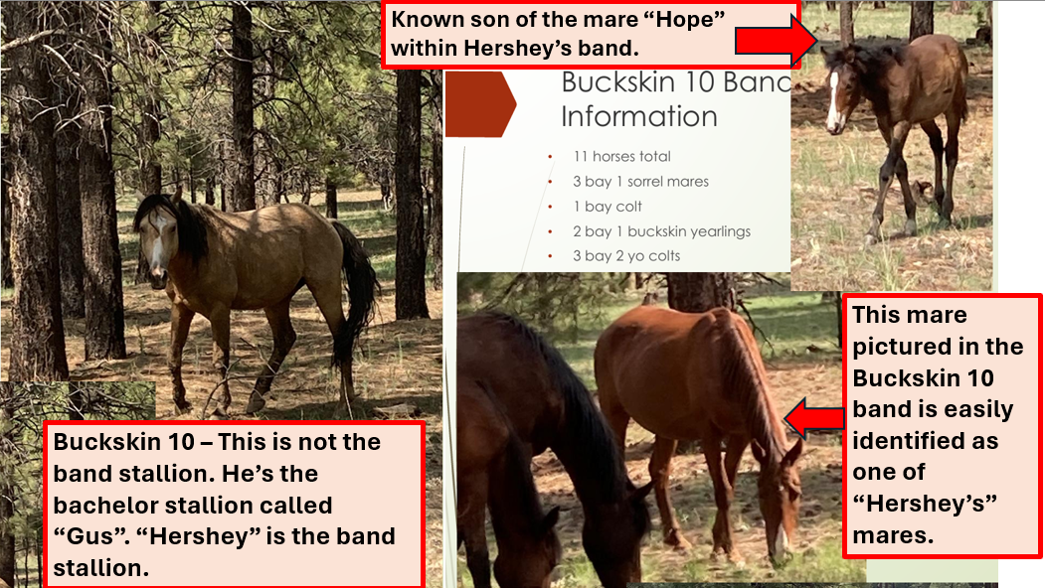
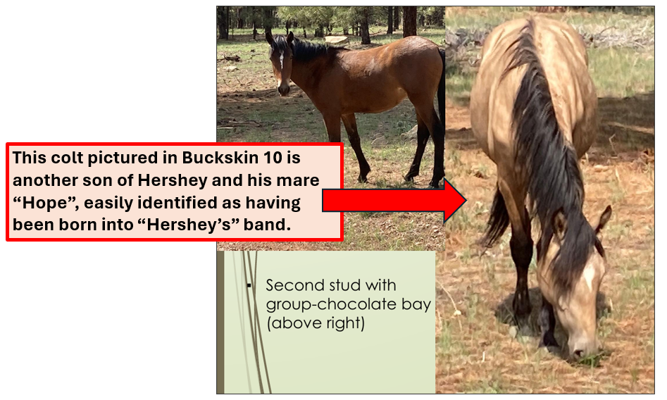
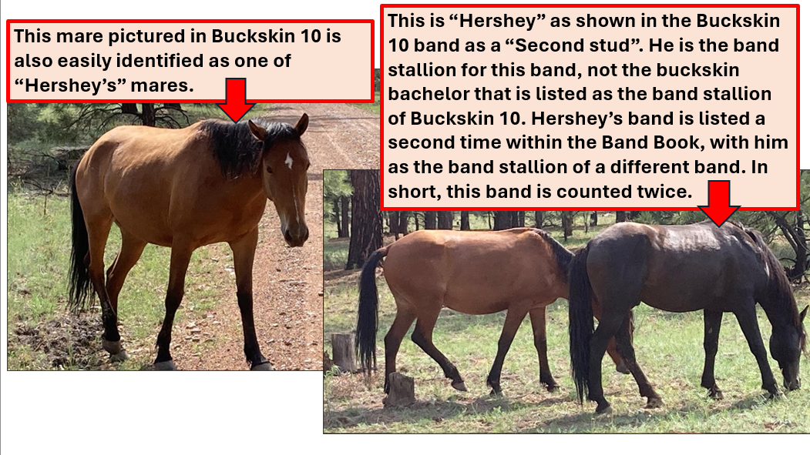
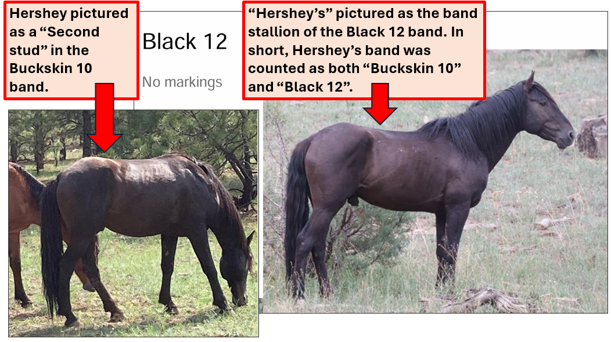
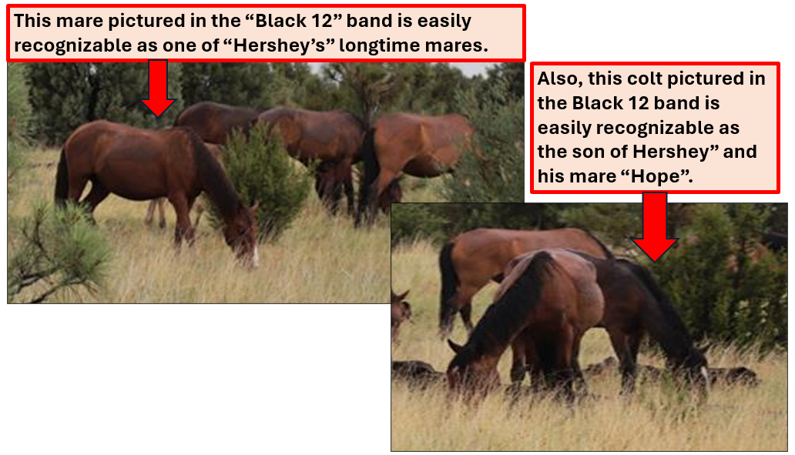

Example #2:
This “Buckskin 7” band stallion is “Chrome”. This same photos of him and his band appear in both the 2022 Band Book and the 2023 Band Book, although in 2023, Chrome was no longer a band stallion. The last time I saw Chrome leading his family band was in late June 2022. The band was stolen at that time by the palomino stallion “Golden Gait” who had been “dogging” Chrome’s band. I have photographic evidence of this.
Golden Gait is shown as the band stallion of Palomino 9. The “Buckskin stud hanging around” the Palomino 9 band is Chrome, who is following his former band now led by the Golden Gait. The Palomino 9 band is largely a duplicate of the Buckskin 7 band. Again, evidence of multiple horses that have been counted twice within the 2023 Band Book because the data collectors do not know the horses and do not recognize and consider band changes that result from natural wild horse behaviors. In this instance, a younger, stronger stallion (Golden Gait) challenged the older stallion (Chrome) for his band and won back in late June 2022. Yet, the 2023 Band Book still shows him as the band stallion, PLUS shows him and the band again, but with a different stallion as the lead.

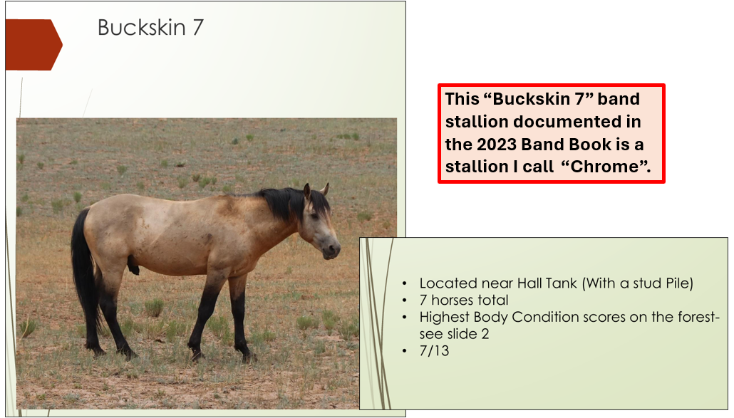
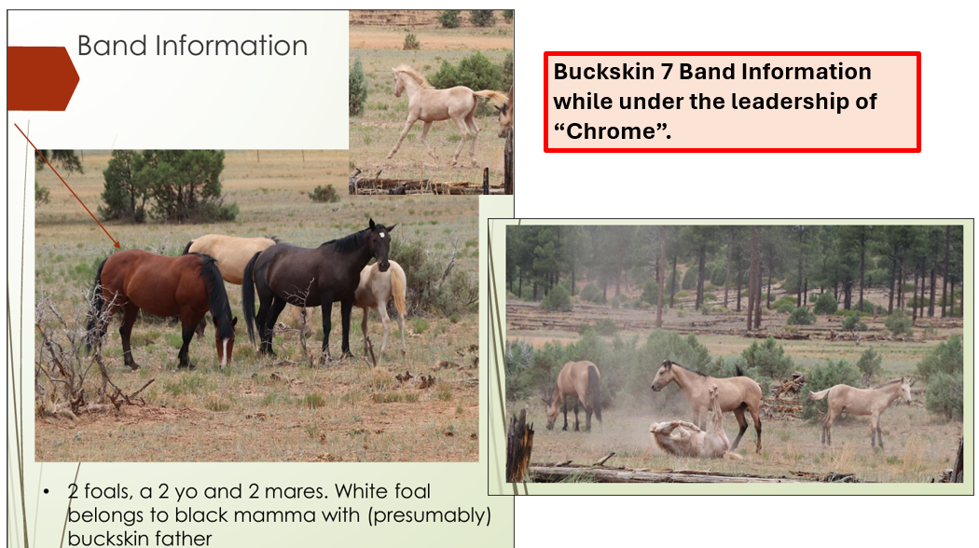
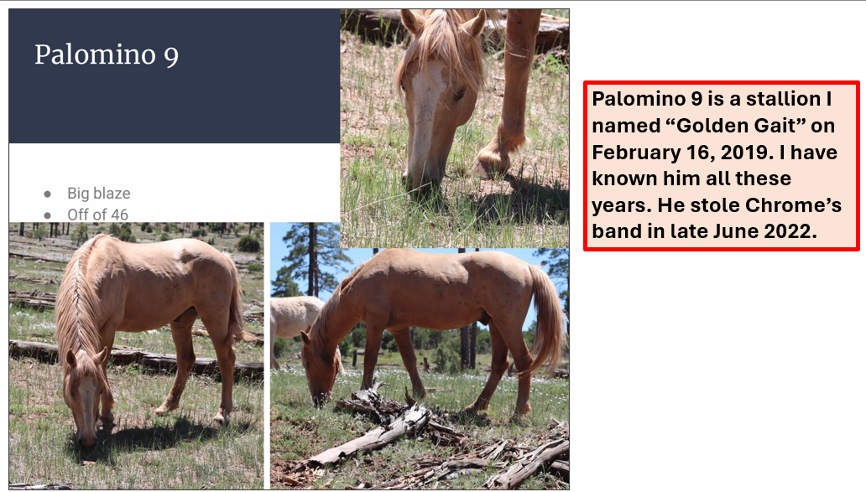
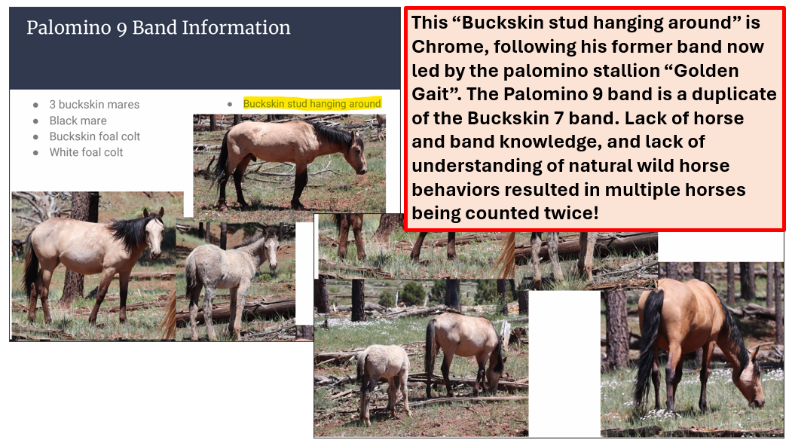

The word “monitoring” appears in the Final EA 198 times. Clearly, accurate “monitoring” is key to the success of the Heber Wild Horse Territory Management Plan and key to the very survival and sustainability of this treasured wild horse herd. Adaptive management strategies are based upon accurate monitoring. Additional management actions are based upon accurate monitoring. Management changes are based upon accurate monitoring.
See the Final EA, Page 46, which reads, “It also includes implementing an adaptive management strategy which could result in additional management actions based on monitoring results. Because an adaptive management strategy is a key part of the proposed action, the underlying basis for this analysis is monitoring would occur and management changes would occur based on monitoring if needed, to maintain or move toward meeting management objectives.” It is clear from this that monitoring cannot be an exercise of letting loose a box full of cats onto the forest and then trying to herd them. Appropriate monitoring is CRUCIAL to the Plan, yet appropriate monitoring has been reduced to just words that look good on paper but have no basis in reality. The existing Forest Service Band Books prove that!
Because the Forest Service, through its annual Band Books, has shown that it is incapable of accurate and effective monitoring of this wild horse herd from the ground using Forest Service employees, how much less likely would it be that accurate and effective monitoring would be done as outlined in the Final EA, Page 22, which reads, “As appropriate, monitoring of the horse population from the ground would be accomplished in collaboration with local volunteer groups, university students, ranchers and other forest visitors, and citizen science programs to monitor horses and their use of the territory.”
In the next paragraph on Page 22, it reads, “The Apache-Sitgreaves National Forests’ Wild Horse and Burro Coordinator would develop protocols for reporting of horse data by any non-Forest Service group and would maintain a database of horses which populate the territory. Volunteer groups would be standardized on the data they collect and report to the Forest Service.”
Now, considering the appropriate protocols and the standardization of data collected by Forest Service employees have never been put into place, although ground monitoring has been ongoing since 2019, and since the data collected between 2019 and 2023 is woefully inaccurate in the current “controlled” environment (within the Forest Service itself), what is the likelihood that these named groups outside the Forest Service would produce standardized, accurate and effectual monitoring? What this looks like to me is words that look good on paper, but that represent an impossible dream. There is no reality in this!
Suggested Remedy: First of all, any and all data collection should be standardized and complete. What you derive from the data is only as good as the data itself. As the saying goes, “Garbage in, garbage out”. Even with a standardized process of data entry, as it stands, the Band Book is a “nice to have”, but it absolutely cannot be used as a monitoring tool to propose or make management decisions, or to take management actions related to the Heber Wild Horse herd. The data it too fraught with significant errors, oversights and omissions. Without significant overhaul, the Band Book (ground monitoring) does not even remotely fulfill the purpose outlined in the Final EA. The annual Band Books further show that individuals even inside the Forest Service are incapable of accurate and effective monitoring from the ground. The Forest Service needs to remedy this before moving forward. The Forest Service needs to reassess every place in the Final EA and in the HWHT Management Plan where “monitoring” appears. Before moving forward with any Plan, this grave deficiency in ground monitoring and its critical impact on appropriate management needs to be rectified and reintroduced for public review.

Respectfully submitted,
Betty L. Nixon

